In first analysis, I found below critical features/functionalities in Buggy Rating web application. I performed exploratory testing on below features:

1. Valid login
2. Invalid login
3. Logout
4. Registration
5. Invalid registration
6. User profile
7. Update user profile (Basic, Additional Info and Change Password)
8. Vote to a Model (Make > Model)

I found most of the critical features working fine with few bugs. Bugs are listed in the next pages.

**In scope:**

Functional Testing

Web Browser: Google Chrome (Version 113.0.5672.92 (Official Build) (64-bit))

**Out of Scope:**

Responsive Testing

Visual Testing

Browser Compatibility Testing

Performance Testing

Middleware Testing

Database Testing

**GENERAL BUGS**

**GIVEN** User is on Buggy Rating Make page “https://buggy.justtestit.org/make/c4u1mqnarscc72is00ng”

**WHEN** I click on Buggy Rating icon in Header

**THEN** User should redirect to the Home page

**BUT** User is still on Make page

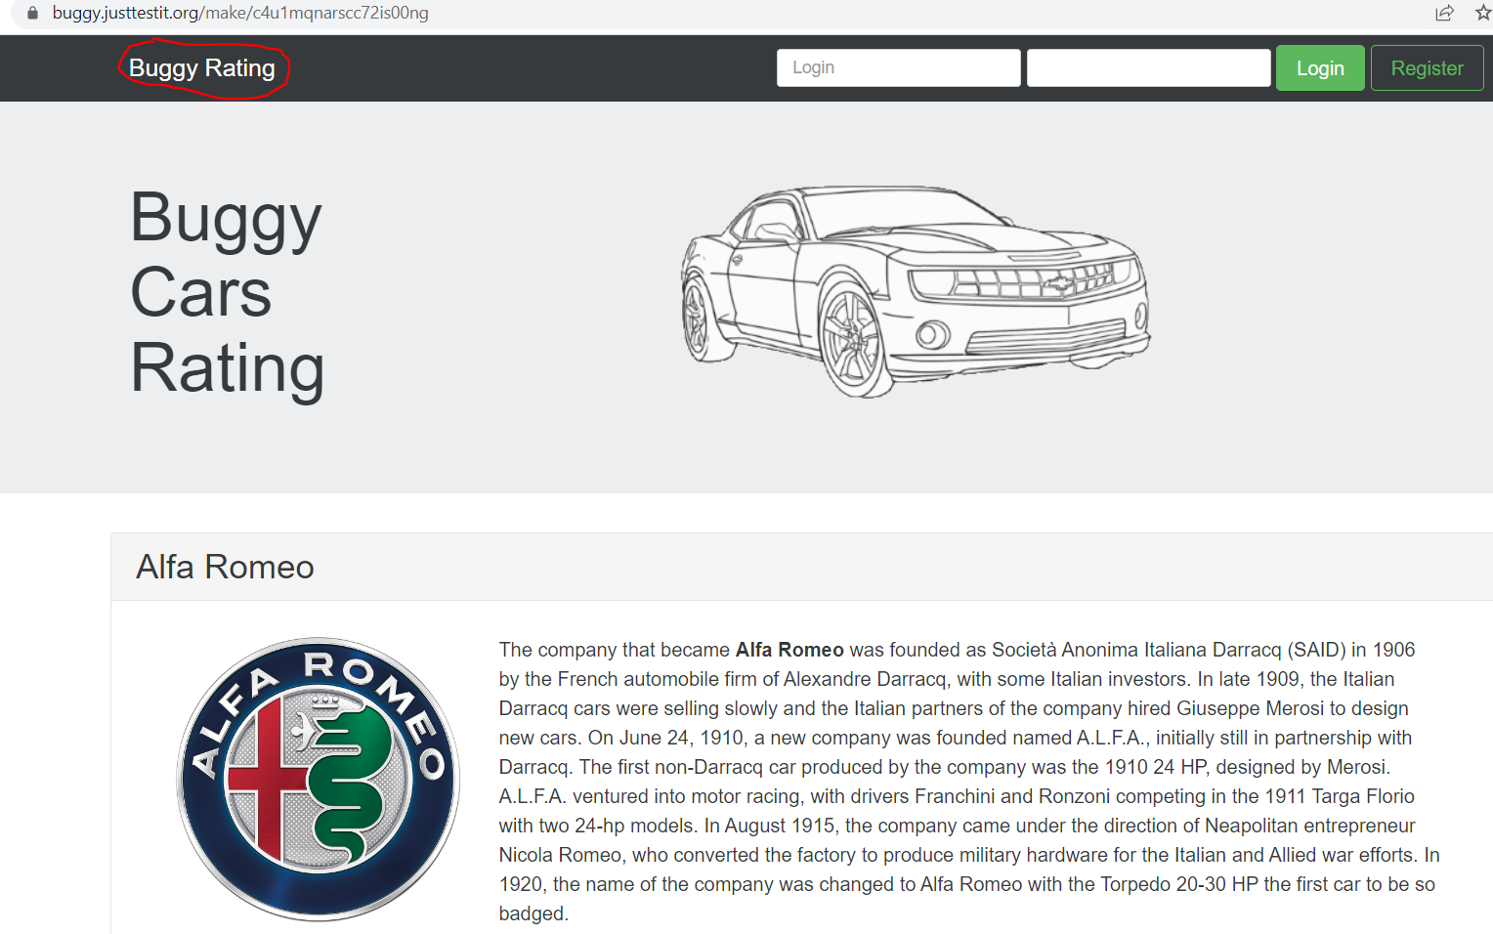

**GIVEN** User is on Buggy Rating any page “https://buggy.justtestit.org/”

**WHEN** User clicks on Facebook or Twitter icons (image links) in the Footer

**THEN** User should redirect to the Buggy Facebook or Buggy Twitter pages

**BUT** User redirected to the Facebook or Twitter home page

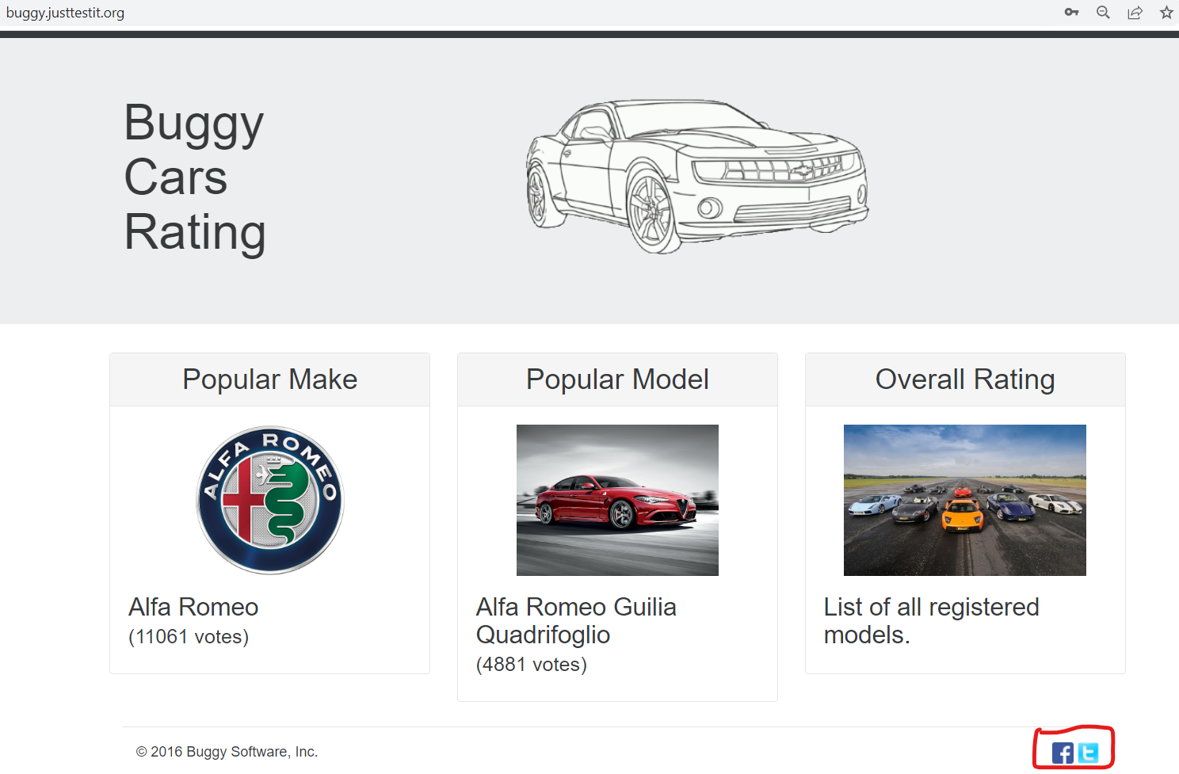

**LOGIN BUGS**

**GIVEN** User is on Buggy Rating Register page “https://buggy.justtestit.org/register”

**WHEN** User logged in with valid credentials

**THEN** User should redirect to User Dashboard or User Profile page

**BUT** User can still see Register page

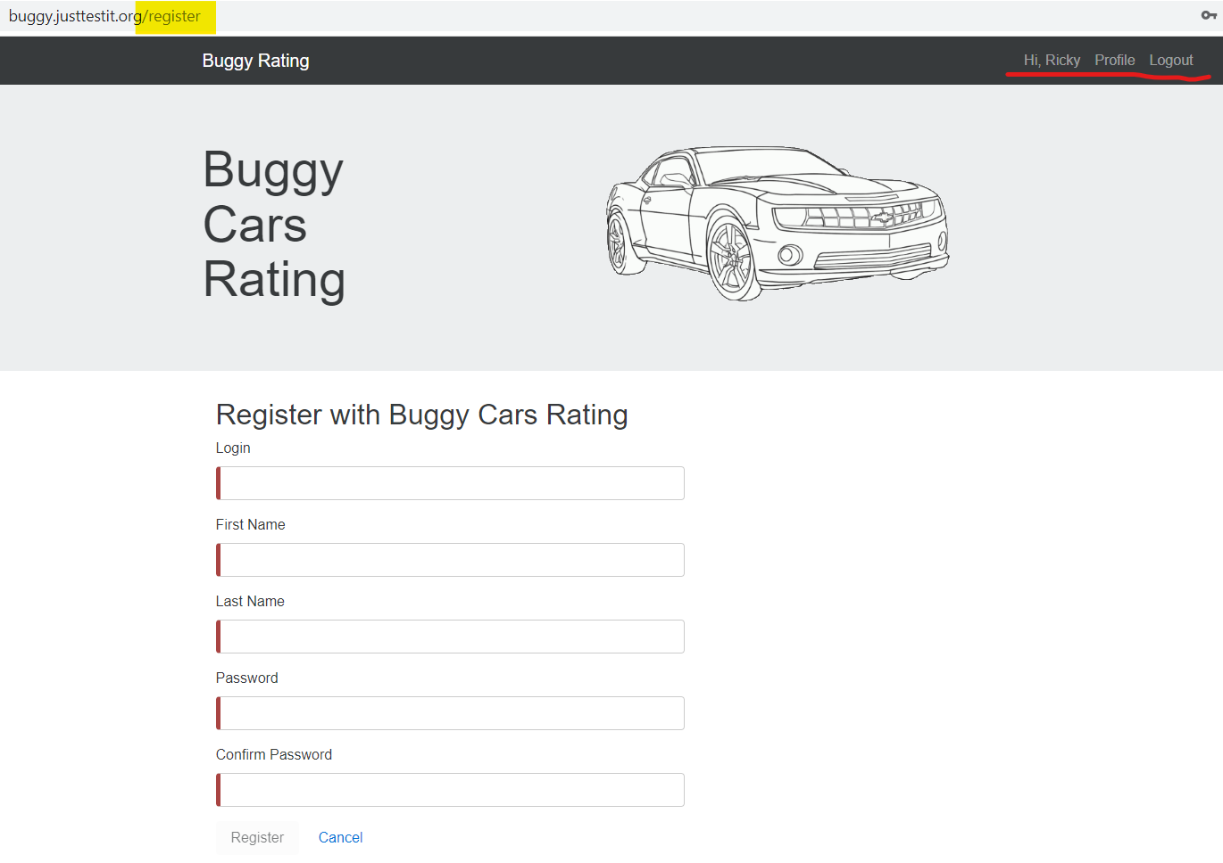

**GIVEN** User is logged in with valid credentials

**AND** User is on Buggy Rating Profile page “https://buggy.justtestit.org/profile”

**WHEN** User logged out

**THEN** User should redirect to the Home page

**BUT** User can still see Profile page

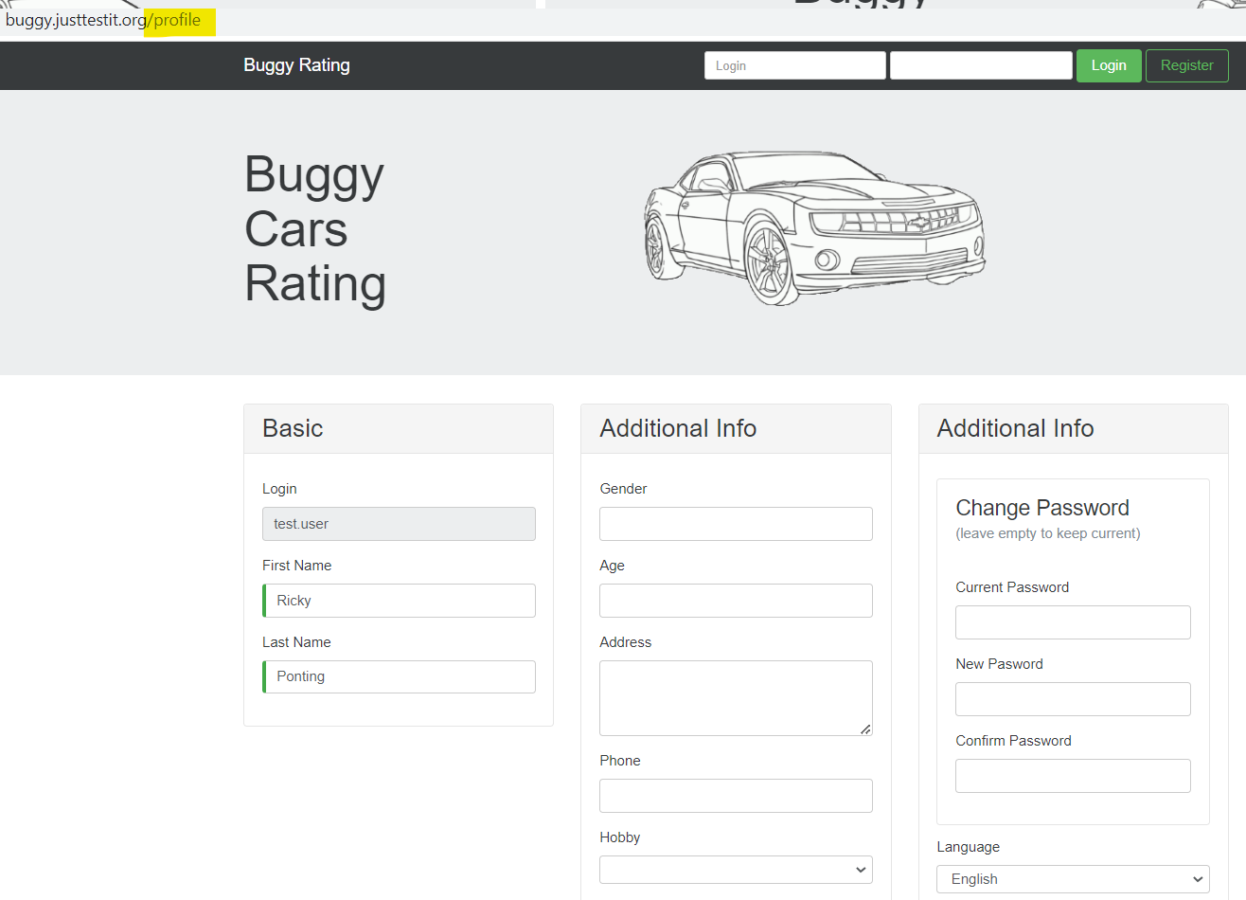

**GIVEN** User is on Buggy Rating Home page “https://buggy.justtestit.org/”

**WHEN** User try to login with invalid username and password

**THEN** The user can see error message ‘Invalid username/password’

**WHEN** User clicks on links (Register, Popular Make icon, etc.) and redirected to new pages

**THEN** The error message ‘Invalid username/password’ should not be visible anymore

**BUT** The error message ‘Invalid username/password’ is still visible

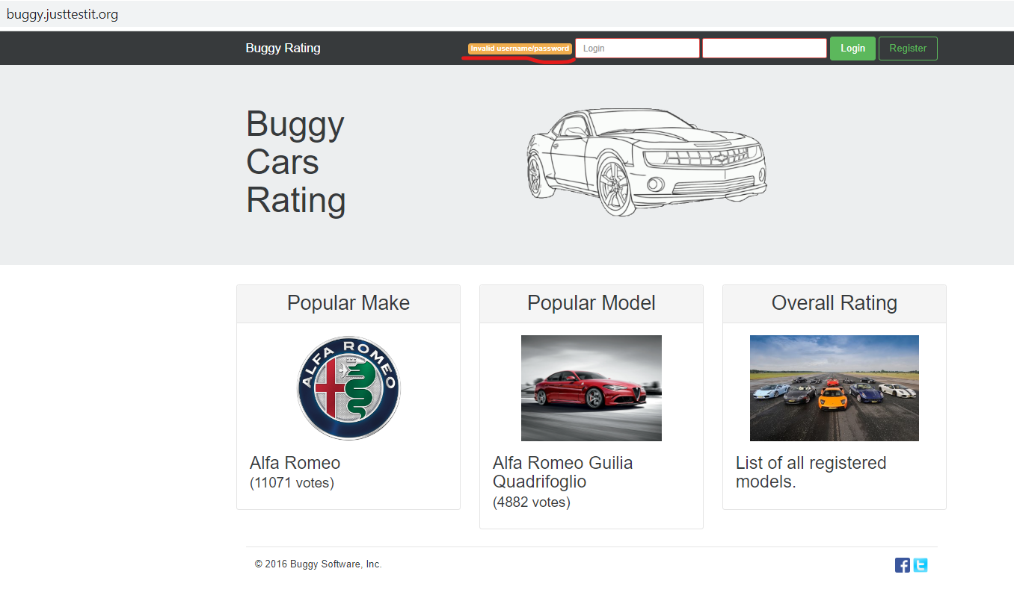

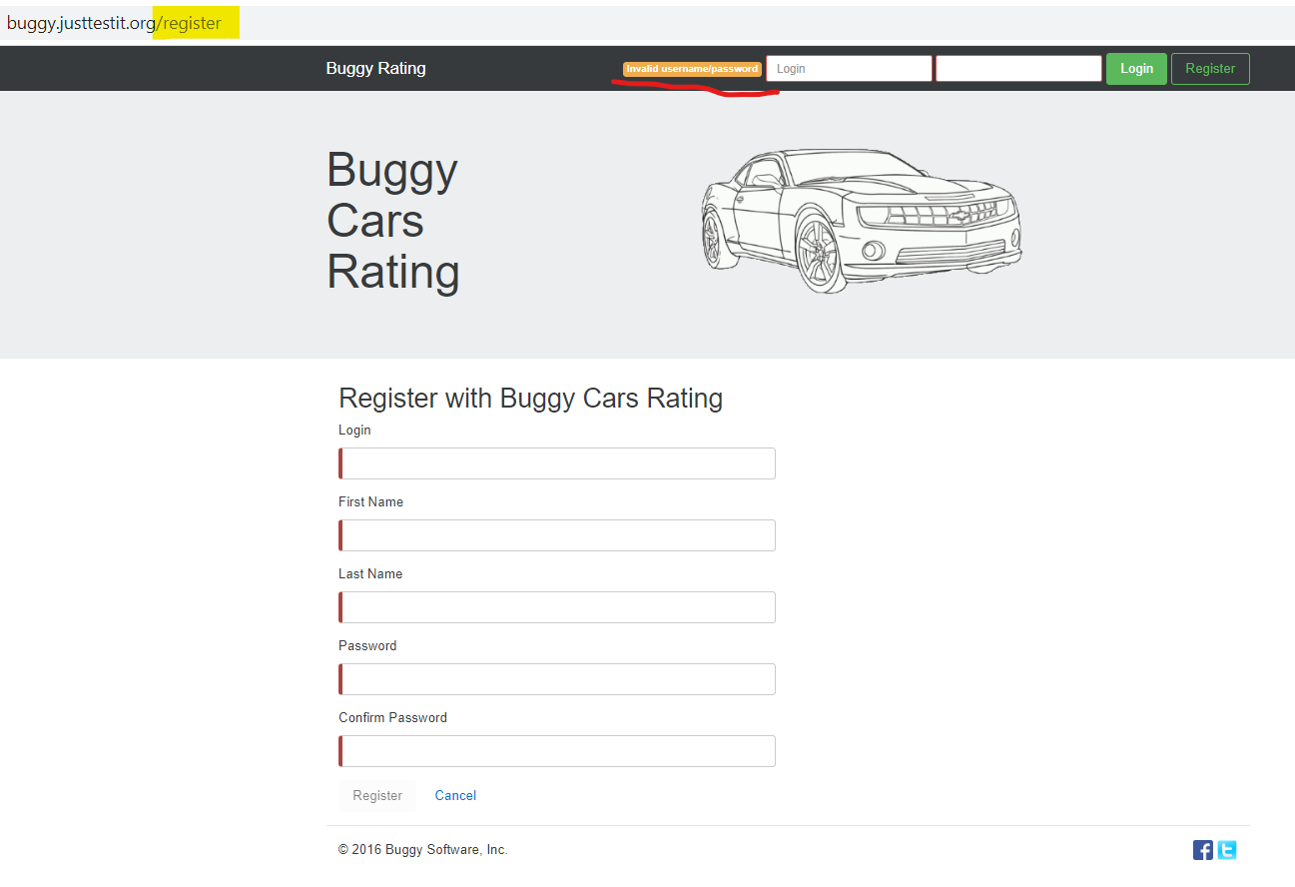

**REGISTER BUGS**

**GIVEN** User is on Buggy Rating Register page “https://buggy.justtestit.org/register”

**AND** User can see Login textbox label under Register form

**BUT** Login textbox does not make any sense. The textbox label name should be ‘Username’

**AND** Once Login label will be changed to ‘Username’ then the Login placeholder (under Login section) should also be changed to ‘Username’

**AND** There should also be an Email textbox as User’s unique identity

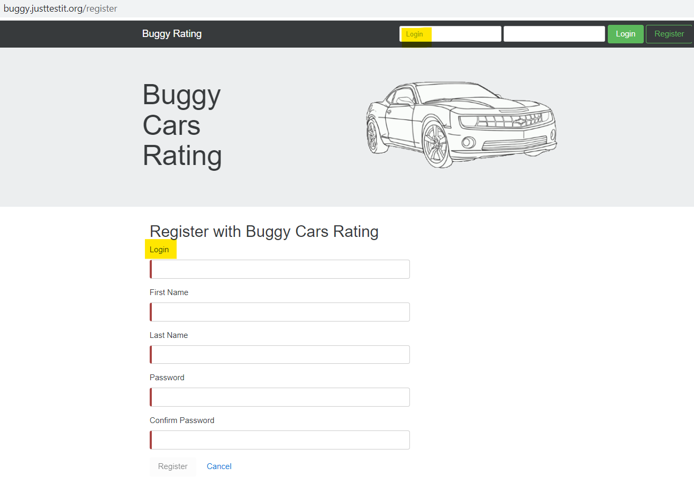

**GIVEN** User is on Buggy Rating Register page “https://buggy.justtestit.org/register”

**WHEN** User left the Last Name textbox blank

**THEN** The user should see mandatory error message ‘Last name is required’

**BUT** The user can see mandatory error message ‘First name is required’

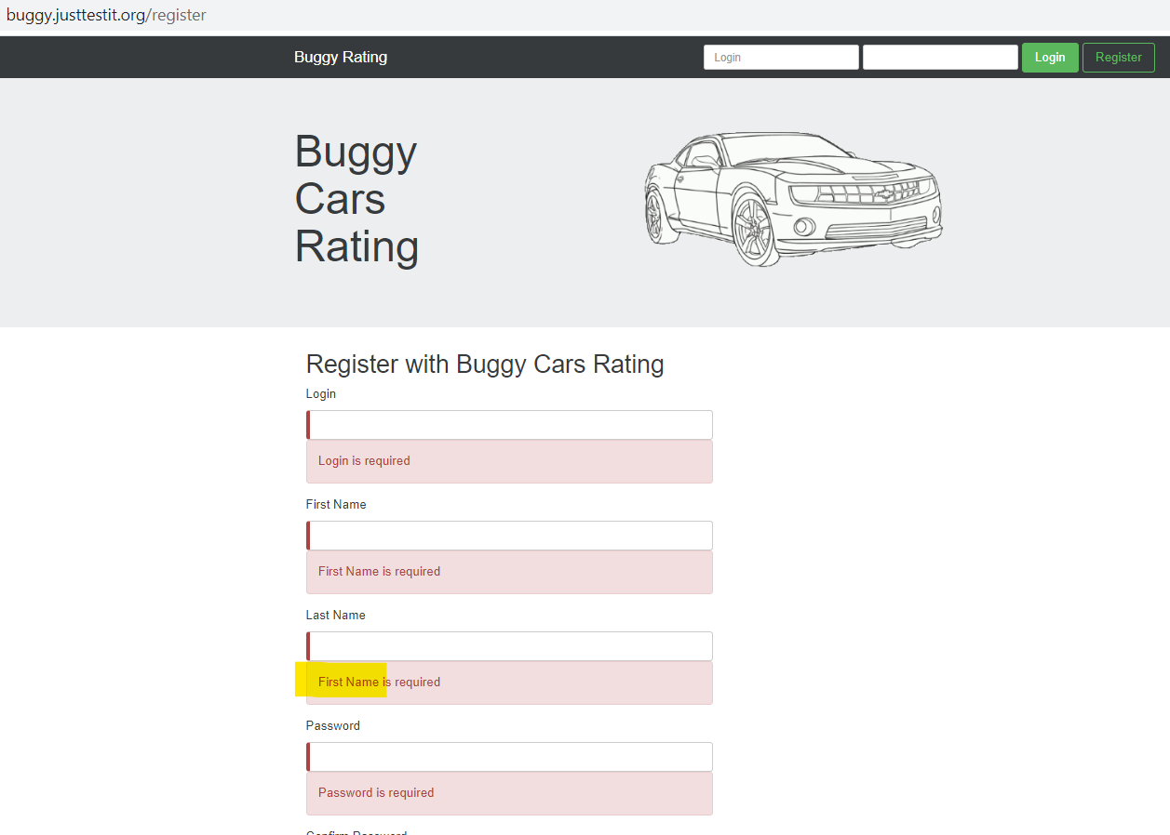

**GIVEN** User is on Buggy Rating Register page “https://buggy.justtestit.org/register”

**WHEN** User try to login with existing user

**THEN** The user should see error message ‘User already exists’

**BUT** The user can see error message ‘UsernameExistsException: User already exists’

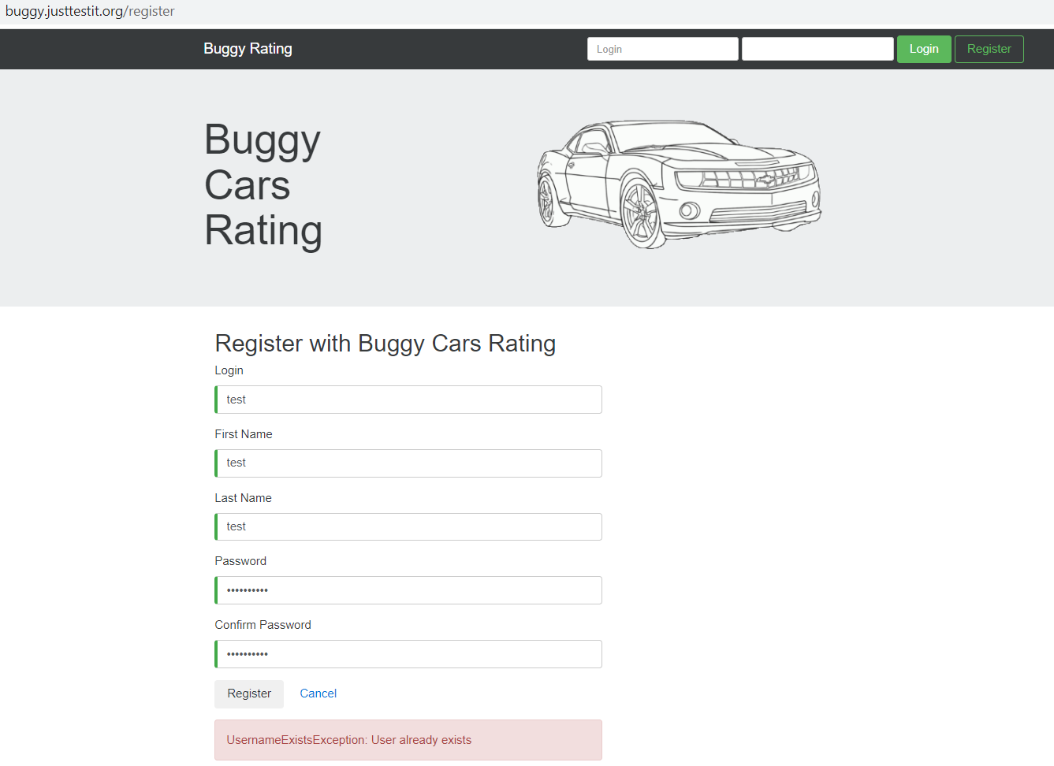

**USER PROFILE BUGS**

**GIVEN** User is logged in with valid credentials

**AND** User is on Buggy Rating Profile page “https://buggy.justtestit.org/profile”

**WHEN** User updated the First Name

**THEN** The First Name should be updated in the Header

**BUT** The First Name in the Header is still same. It only updates once user logged out and login again.

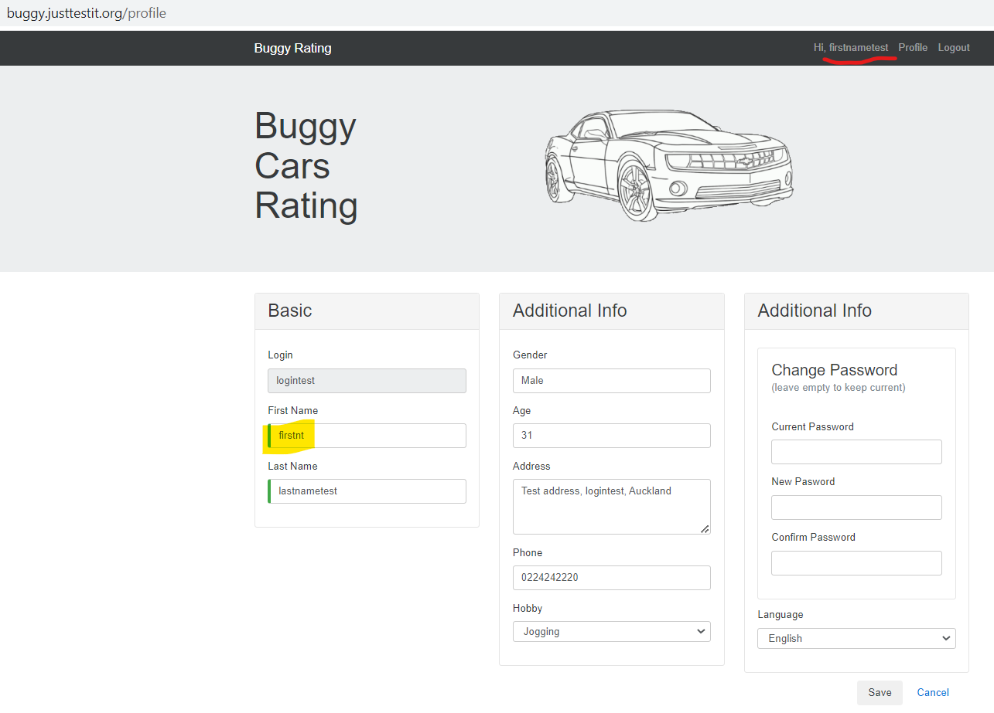

**GIVEN** User is logged in with valid credentials

**AND** User is on Buggy Rating Profile page “https://buggy.justtestit.org/profile”

**WHEN** User try to change password with invalid Current Password

**THEN** The user should see error message ‘Incorrect username or password.’

**BUT** The user can see error message ‘NotAuthorizedException: Incorrect username or password.’

