Self Assessment – Jacob Booth 221530207

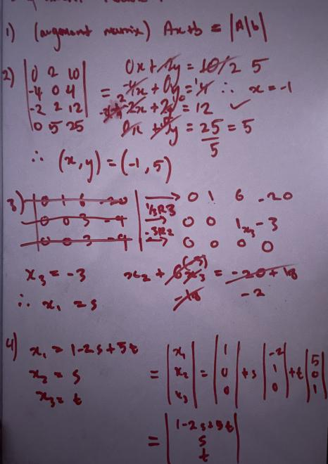
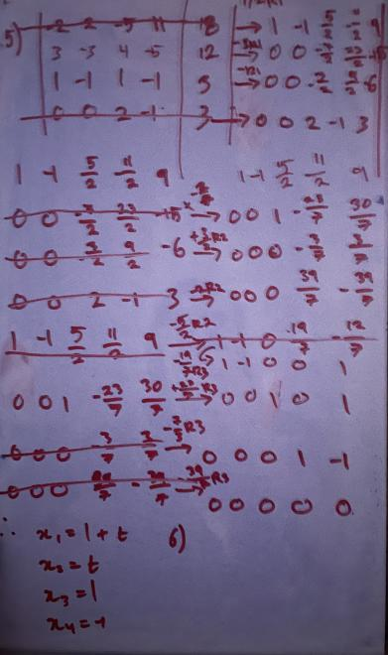
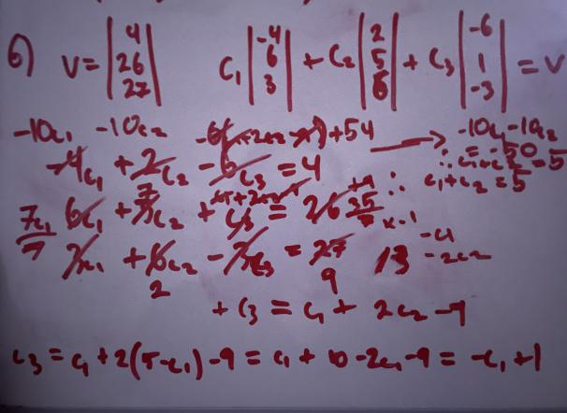
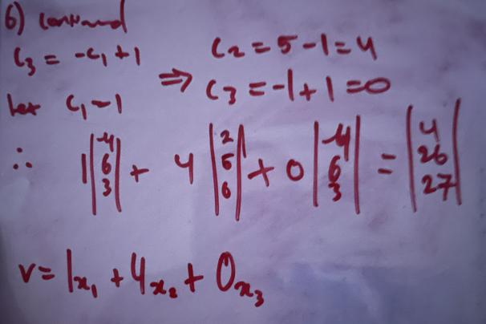
Being the first timed assessment I went in a little stressed, but I can see for next time that the best approach is to stay calm and determine my approach carefully, don’t jump into anything without thinking each problem through completely. Question 5 was definitely the longest to document all my steps, and my question 6 attempt could have been more graceful had I gone straight into Gaussian Elimination (discussed in Learning Evidence). The key takeaway is to stay calm, be confident in my abilities, and don’t over complicate anything. I used my scientific calculator app for crunching fraction arithmetic and a few other less obvious cell operations to ensure I didn’t mess up at the most fundamental level.
Calculator Infinity: https://apps.apple.com/au/app/calculator/id458535809
