**Service Fusion Queries**

1. **Create a Job:-**  
   <Url:-> <https://admin.servicefusion.com/jobs/jobsAdd>  
     
   A screenshot of a computer

   Description automatically generated  
   **Query:**  
   In the red highlighted section containing the tabs — **Payment**, **Add Info**, and **Activity** — are these sections **mandatory to use** during job creation? Or can we **skip them** based on the workflow requirements?

1. **Create an Estimate:-**  
   <Url:-> https://admin.servicefusion.com/estimate/estimateAdd  
   A screenshot of a computer

   Description automatically generated  
     
   **Query:**  
   While creating an estimate, the top-right section includes **Add Info** and **Activity Log** tabs. Should these sections always be filled in during estimate creation? Or are they **optional**, and used only under certain conditions?
2. **Estimate Template Creation:-**  
   <Url:-> https://admin.servicefusion.com/templates/estimateAdd  
   A screenshot of a computer

   Description automatically generated  
     
   **Query:**  
   While creating an estimate template, why are we required to fill in the red-highlighted fields such as:
   1. **Customer**
   2. **Primary Contact**
   3. **Service Location**

Creating templates specifically for individual customers — so requiring these fields forces us to create separate templates for each customer, which defeats the purpose of having reusable templates.

**Line Items (Product/Task/Group)**

Also, can the **Line Items (Product/Task/Group)** section be used in templates as well — or is it meant only for actual estimates?

1. **Estimation Form (Assigned Techs & Opportunity Owner):-**  
   <Url:-> https://admin.servicefusion.com/estimate/estimateAdd  
   A screenshot of a computer

   Description automatically generated  
   A screenshot of a computer

   Description automatically generated

**Query:**  
In both **Assigned Techs** and **Opportunity Owner** dropdowns, are fetching the **entire workforce list** regardless of roles? Or is there **any role-based filtering** applied (e.g., only users with technician role for “Assigned Techs” and only sales/admin roles for “Opportunity Owner”)?

1. **Customer Edit:-**  
   <Url:-> https://admin.servicefusion.com/customer/customerAdd?id=hKVx3OXVWIt7ncamC7CwvMxCuoDENYvnBo6iIxCTlq0  
   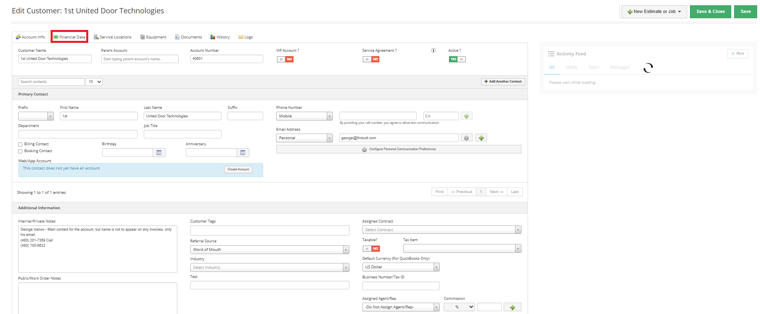

**Query:**  
On the customer edit screen, there’s a **“Financial Data”** tab at the top.  
Should this tab always be used when updating or creating customer records — or is it **only required for specific cases**, such as customers with credit terms, payment plans, or account limits?