1. Highlight the first icon in the developer toolbar (box with a curser) and then select the "Right Column"
2. Modify the background color to steel blue and the font color to white

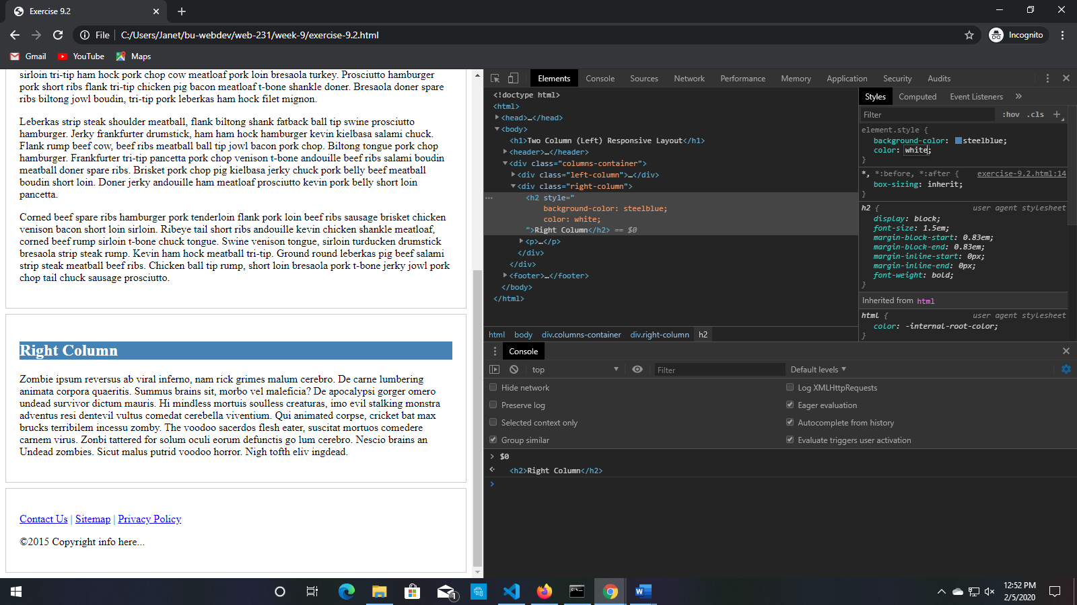

1. Select the "Left Column" div and modify the background color to steel blue and the font color to white