Screen with all changes

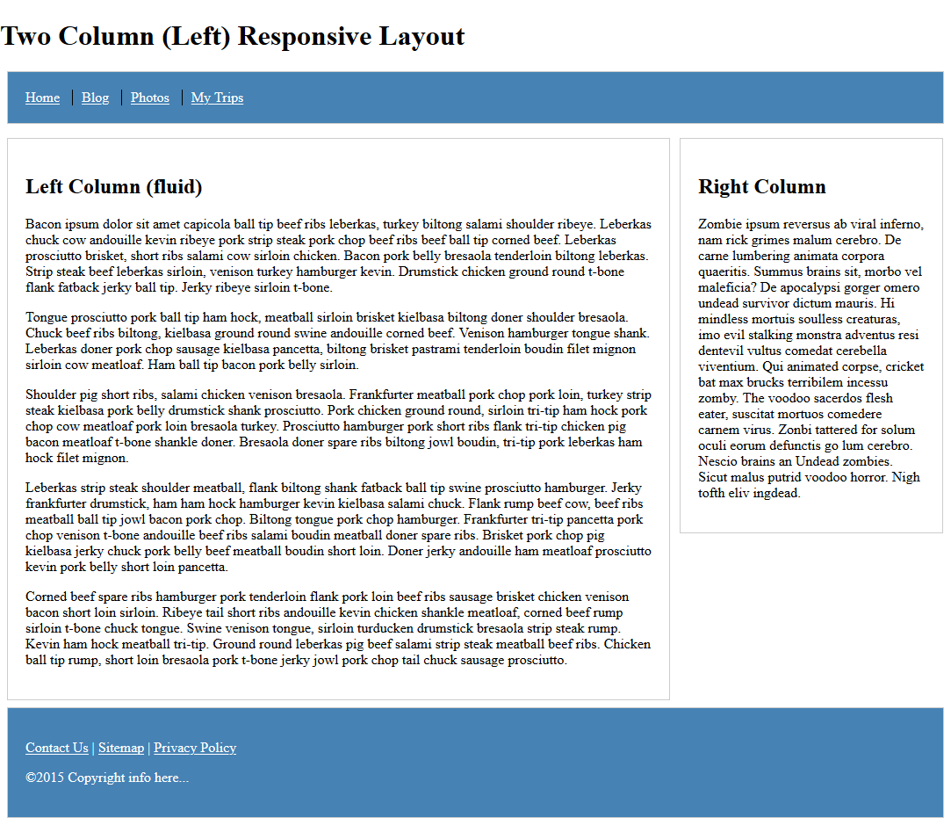

|  |  |  |  |  |  |  |  |  |  |  |  |  |  |  |
| --- | --- | --- | --- | --- | --- | --- | --- | --- | --- | --- | --- | --- | --- | --- |
| Select the top menu and modify the background color to steel blue and the font color to white | | | | | | | | | | | | |  | |
| |  | | --- | |  | | | | | |  |  |  |  |  |  | | | | | |
|  | | | | |  |  |  |  |  |
|  | | | | |  |  |  |  |  |
|  | | | | |  |  |  |  |  |
|  | | | | |  |  |  |  |  |
|  | | | | |  |  |  |  |  |
|  | | | | |  |  |  |  |  |
|  | | | | |  |  |  |  |  |
|  | | | | |  |  |  |  |  |
|  | | | | |  |  |  |  |  |
|  | | | | |  |  |  |  |  |
|  | | | | |  |  |  |  |  |
|  | | | | |  |  |  |  |  |
|  | | | | |  |  |  |  |  |
|  | | | | |  |  |  |  |  |
|  | | | | |  |  |  |  |  |
|  | | | | |  |  |  |  |  |
|  | | | | |  |  |  |  |  |
|  | | | | |  |  |  |  |  |
|  | | | | |  |  |  |  |  |
|  | | | | |  |  |  |  |  |  |  |  | |  | |
| Select the footer and modify the background color to steel blue and the font color to white | | | | | | | | | | | | |  | |
| |  | | --- | |  | | | | | |  |  |  |  |  |  | | | | | |
|  | | | | |  |  |  |  |  |
|  | | | | |  |  |  |  |  |
|  | | | | |  |  |  |  |  |
|  | | | | |  |  |  |  |  |
|  | | | | |  |  |  |  |  |
|  | | | | |  |  |  |  |  |
|  | | | | |  |  |  |  |  |
|  | | | | |  |  |  |  |  |
|  | | | | |  |  |  |  |  |
|  | | | | |  |  |  |  |  |
|  | | | | |  |  |  |  |  |
|  | | | | |  |  |  |  |  |
|  | | | | |  |  |  |  |  |
|  | | | | |  |  |  |  |  |
|  | | | | |  |  |  |  |  |
|  | | | | |  |  |  |  |  |
|  |  |  |  |