OverTheWire

Bandit Level 0 → Level 1

Level Goal
The password for the next level is stored in a file called readme located in the home directory. Use this password to log into bandit1 using SSH. Whenever you find a password for a level, use SSH (on port 2220) to log into that level and continue the game.

Commands you may need to solve this level
ls, cd, cat, file, du, find
----------------------------------------------------------------------------------------------------------------------------
1. Connect via ssh:
ssh bandit0@bandit.labs.overthewire.org -p 2220
The password is: bandit0
2. List the files in your home directory. (ls command)
3. Read the readme file that contains the next level’s password. (cat command)
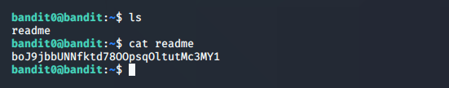
4. Password: boJ9jbbUNNfktd78OOpsqOltutMc3MY1

