OverTheWire

Bandit Level 1 → Level 2

Level Goal
The password for the next level is stored in a file called - located in the home directory

Commands you may need to solve this level
ls, cd, cat, file, du, find

Helpful Reading Material
- Google Search for “dashed filename”
- Advanced Bash-scripting Guide - Chapter 3 - Special Characters

----------------------------------------------------------------------------------------------------------------------------
1. Connect via ssh:
ssh bandit1@bandit.labs.overthewire.org -p 2220
The password is: boJ9jbbUNNfktd78OOpsqOltutMc3MY1

2. List the files in your home directory. (ls command)
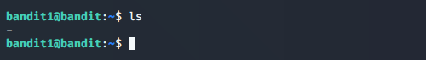

As you can see the file is named with a single dash. After reading the Helpful Reading Material I was able to read the file with this command.
3. cat ./-
4. Password: CV1DtqXWVFXTvM2F0k09SHz0YwRINYA9

