John S. Burke
Robert Munafo
EC527 – Professor Herbordt

Lab 1

Part 1

Which function is faster?

Overall, the the function that iterates forward is faster, but this only really becomes pronounced once the length of the matrix is around 800 elements or so. Until then it is roughly equal, but once the size is large, forward indexing becomes about 1.5 times faster. We first notice this in a macroscopic view, setting BASE to 0, with DELTA at 16, over 150 iterations.
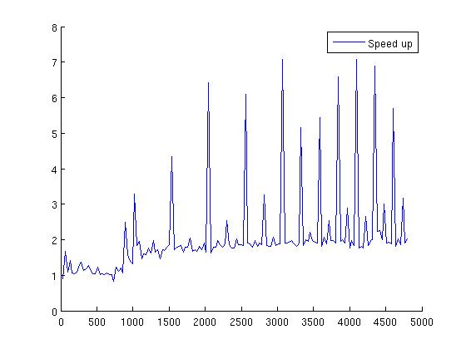
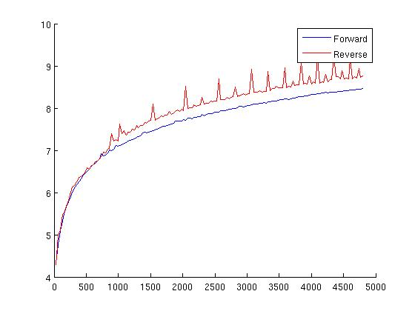
Left has the logarithm of cycles against number of elements, Right is the ratio of the two versus number of elements.

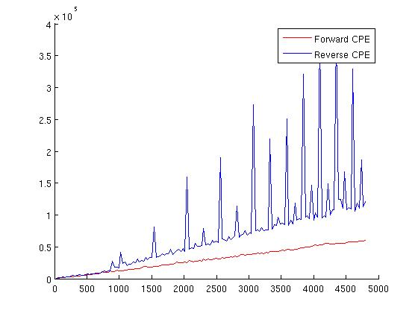
This behavior is further reflected in CPE versus number of elements:

Since the turning point on all accounts is just before 1000 elements, we focus in on a range around that point.
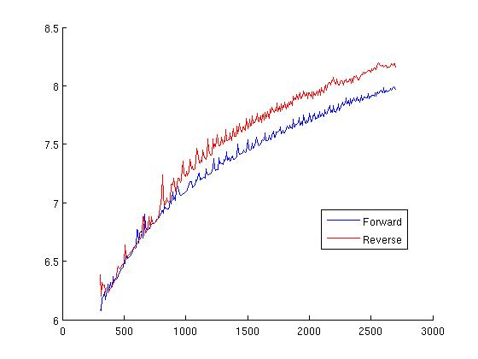
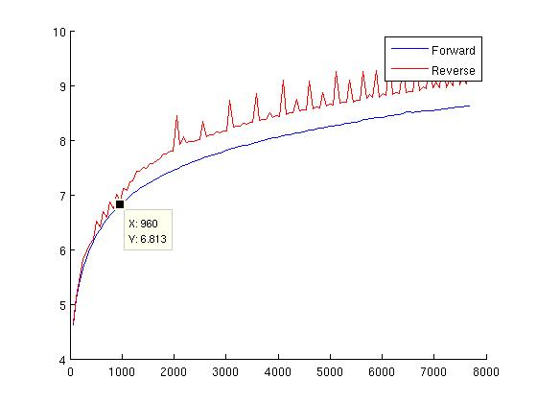
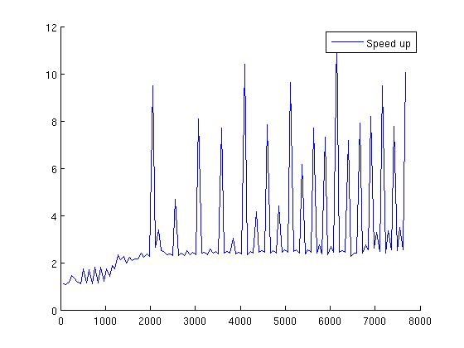
Here, we start looking in at 300 elements, stepping by 8 over 300 iterations. This is right about at the bend in the first figure, and it also shows us clearly where the two methods separate in performance. When we further look to the graph containing cycles per element versus elements, this is also the same time when the reverse method begins to show spikes. This behavior seems consistent across data types; for example when integers are used we have similarities to doubles, which were shown before:
Execution problems begin to occur around 20,000 elements or so. Just beyond this point with doubles calloc will fail to allocate, and even integer execution becomes very slow.

Part 2

Palteaus
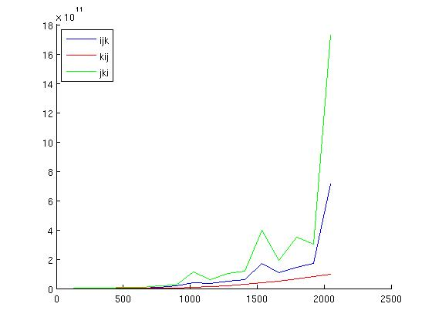

Graph showing Cycles versus elements for each version of interchanged loops for matrix multiply

The above graph shows the different perfomance of the various interchange flavors, with kij being the clear best in the large scheme; however, this does not make clear any plateaus, so we shall focus on each flavor individually.

ijk
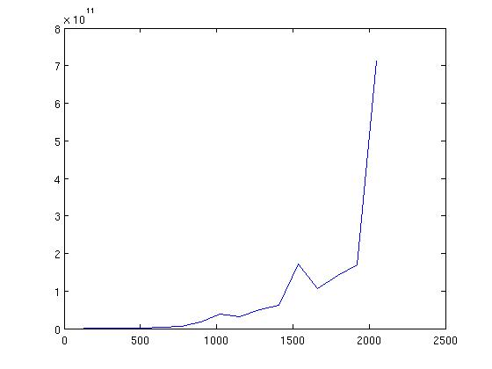
At around 1000 elements until just before 1500 we have a plateau, and then another somewhere aroung 1700 until just before 2000.

jki
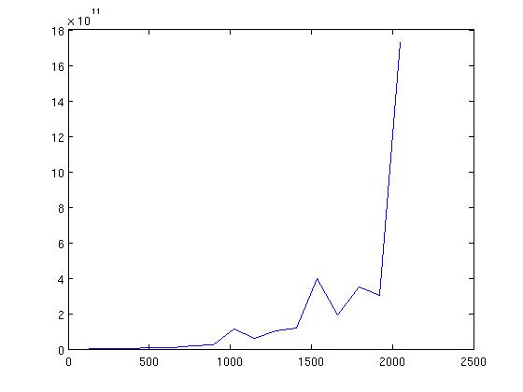
The two previous plateuas are a bit more pronounced. From about 1200 to just before 1500 elements again we see flatness. However, now from 1700 until just before 2000 there seems to be a plateau.

kij
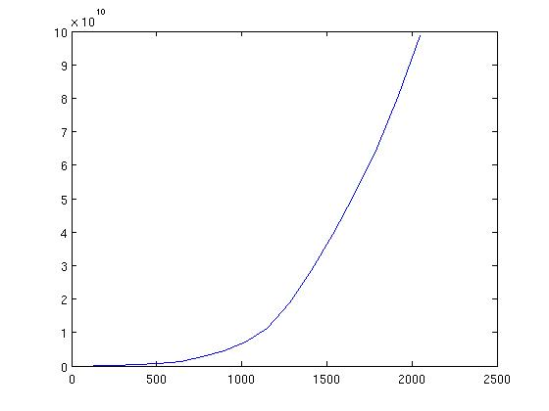

kij initially shows no trace of plateaus except maybe the very beginning which really looks more like it's fitting a sort of parabolic trend.

