BASH SCRIPTING:

* Kernel main functions:
- System memory management
- Software program management
- Hardware management
- Filesystem management

* System memory management:
The kernel manages the physical memory (ram) and uses a part of the hard drive as well as a memory, swap space.
The sum of both is the Virtual memory

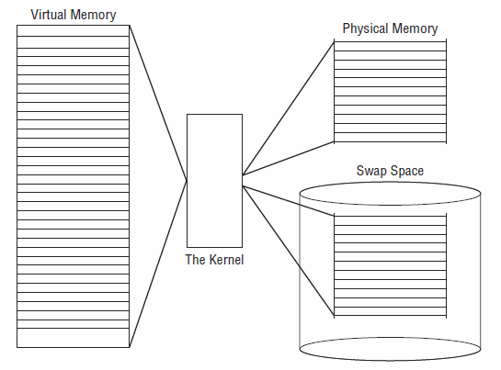

The memory locations are grouped into blocks called PAGES, the kernel locates the pages in the physical memory and in the swap space. The kernel have a table with all the location of the pages and which pages are in use and the ones that are idle.

The idle pages are being send to the swap space –> swapping out (even if there is ram available)
Swapping on, when the kernel make room in the ram after a program request of a memory page.

