Repl.it

Run → Ctrl + Enter
Run → Command + Enter (Mac)

Comment/Uncomment a line: Ctrl + /

Debug code online step by step
Or download the program Thonny

Day 1:

Input Function:

What is this: Input will get you what the user is typing in console.

input(promt for the user) → inside of parenthesys we have what is going to be printed in the screen and will wait till we type something:

input(“What is your name? ”) → if you execute this will wait till you type your name or whatever.

Then if you’ve typed “John” will be substituted and added into it like: input(“John ”)

So input(“What is your name? ”) will be replaced by what you typed.

If you run the program and type John:
What is your name? John

input(“What is your name? ”) will be replaced by John.

You can print John if you do this:
print("Hello " + input("What is your name: "))

You will get:
What is your name: John
Hello John

Exercise 1.3:

Ask me to type my name and the program will tell you how much letters the name have:

Option 1, One line:
print(len(input("What is your name? ")))

Option 2, two lines:
name = input("What is your name? ")
print(len(name))

Python Variables:

Using the previous exercise:
print(len(input("What is your name? ")))

We can use variables like this:

name = input("What is your name? ")
length = len(name)

print(length)

Exercise 1.4:
Switch values of variables.
Give to variable A, the value of variable B and viceversa.

My solution:  a = input("a: ")  b = input("b: ")  cafe = a  milk = b  a = milk  b = cafe  print("a: " + a)  print("b: " + b) | Teacher’s solution:  a = input("a: ")  b = input("b: ")  a = c  a = b  b = c  print("a: " + a)  print("b: " + b)
Result:  a: AAAAA  b: BBBBB  a: BBBBB  b: AAAAA | Result:  a: AAAAA  b: BBBBB  a: BBBBB  b: AAAAA

Variable names:
length1 = 10 → good
1length = 10 → not allowed to start variable names with numbers

user_name = “John” → good
user name = “John” → not allowed, the variable name have to be a single item without spaces.

Is not recommended to use function names as variable names, like print, len or so.

Final project: https://repl.it/@appbrewery/band-name-generator-start#main.py

Exercise:

#1. Create a greeting for your program.

#2. Ask the user for the city that they grew up in.

#3. Ask the user for the name of a pet.

#4. Combine the name of their city and pet and show them their band name.

#5. Make sure the input cursor shows on a new line, see the example at:
# https://band-name-generator-end.appbrewery.repl.run/

My solution:  print("This program creates a band name:")  print("---------------------------------")  city = input("In which city did you grew up? ")  pet = input("Tell me the name of your pet ")  space = " "  print( city + space + pet ) | Teacher’s solution:  print("Welcome to the band name generator.")  city = input("Which city did you grow up in?\n")  pet = input("What is the name of a pet?\n")  print("Your band name cound be: " + city + " " + pet)
Result:  This program creates a band name:  ---------------------------------  In which city did you grew up? Figueres  Tell me the name of your pet Boris  Figueres Boris | Result:  Welcome to the band name generator.  Which city did you grow up in?  Bristol  What is the name of a pet?  Rabbit  Your band name cound be: Bristol Rabbit

Day 2:

Data Types:

String:

“ ” → Anything between quotes or double quotes will be trated as a string (text).
“1234” → this will be treated as a string.

print(“Hello” [4] ) → this will print the last character, o

print("123" + "456") → this will give you: 123456

Integer:

print(123 + 456) → 579

Tip: Use underscore (_) to write large integer numbers and to split them in order to make it easy to visualize:

123_123_3534 → will be interpreted like this: 1231233534

Float:

3.23423
242343.640

Boolean:
True
False

Both starting with Capitals and without quotation marks, otherwhise it would turn them into strings.

Function Types:

type() → it gives you the type of data.

Example:
num_char = len(input("What is your name? ")) → num_char is an integer

print("Your name has " + num_char + "characters.") → this gives error because you can NOT add
strings + integers, only the same data type.

To know the type of the data you are using, use the type() function.
print(type(num_char)) → <class ‘int’>
Convert a data type to a string:

You can use the type function to investigate which data type you are using.
With type function you can CONVERT one datatype to another.

To make work the previous exercise convert the integer to string:

num_char = len(input("What is your name? "))

new_num_char = str(num_char)

print("Your name has " + new_num_char + " characters.")

We convert the variable num_char to a string and we give it a new name, now the program will work because the whole print statement is adding strings:

What is your name? sfgsdfgsfgsfgs
Your name has 14 characters.

Exercise 2.1:

Type two numbers and add them, so 23 will be 2 + 3 = 5

My solution:  two_digit_number = input("Type a two digit number: ")  first = int(two_digit_number[0])  second = int(two_digit_number[1])  print(first + second) | Teacher’s solution:  two_digit_number = input("Type a two digit number: ")  first_digit = two_digit_number[0]  second_digit = two_digit_number[0]  result = int(first_digit) + int(second_digit)  print(result)
Result:  Type a two digit number: 23  5 | Result:  Type a two digit number: 87  15

Teacher’s explanation:

First we have to know which is the data type of the variable two_digit_number
print(type(two_digit_number)) → which is a <class ‘str’>

Mathematical Operations in Python:

3 + 4
5 - 2
3 * 7
6 / 3 → the result will be a float, 2.0 in this examples
** exponent, when you want to raise a number to a power
2 ** 3 → two 3 times is 8. 2 * 2 * 2 = 8

Order of the operations:

If you have different operations in the same line of code, there is an order that the program will follow.

The rule to remember is PEMDAS:
- Parentheses ()
- Exponents **
- Multiplication * and Division / → they are equal important. First coming wins
- Addition + and Substraction - → they are equal important. First coming wins

Example:
print( 3 * 3 + 3 / 3 - 3)

First will do the mutiplication, 3 * 3 = 9 →is first because is the first operation on the left.
Second the division, 3 /3 = 1.0 → float, ran the second after the multiplication because comes after.
Third the addition, 9 + 1.0 = 10.0
Last the substraction, 10.0 - 3 = 7.0

Example 2: Make that operation to have 3 as result
print( 3 * (3 + 3) / 3 - 3)

First the parenthesy, 3 + 3 = 6
Second the multiplication because is the first on the left, 3 * 6 = 18
Third de division, 18 / 6 = 6
Last the substraction, 6 - 3 = 3

[Interactive Coding Exercise] BMI Calculator:

Exercise 2.2:

Calculate the BMI

My solution:  height = input("enter your height in m: ")  weight = input("enter your weight in kg: ")  height = float(height)  weight = float(weight)  print(int(height / (weight * weight ))) | Teacher’s solution:  height = input("enter your height in m: ")  weight = input("enter your weight in kg: ")  bmi = int(weight) / float(height) ** 2  bmi_as_int = int(bmi)  print(bmi_as_int)
Result:  enter your height in m: 80  enter your weight in kg: 1.75  26 | Result:  enter your height in m: 80  enter your weight in kg: 1.75  26

Number Manipulation and F Strings in Python:

Round the number:
If you are dividing a number it will give you a float.

You can limit the decimals appearing on the right after the colon by using round.

Example:

print(8 / 3) → 2.6666666666666665

print(round(8 / 3)) → 3

print(round(8 / 3, 2)) → 2.67

print(round(2.6666666, 2)) → 2.67

Use the floor edition:

print(8 / 3) → 2.6666666666666665 → float number

print(8 // 3) → 2 → int number

Using variables:

result = 4/2 → 2
result *= 3 → 2 x 3
print(result) → 6

score = 0
score += 1
print(score) → 1

Change datatypes: f-String

We can not use different datatypes to operate in the same line, if you use a string + int the program will fail.

To make it work until now we are converting the data, to str in the below example:
score = 0
print("Your score is: " + str(score))

But we can use f-String to make it much more easy:

score = 0
height = 1.8
isWinning = True

print(f"Your score is {score}, your height is {height}, you are winning is {isWinning} ")

→ Your score is 0, your height is 1.8, you are winning is True

We are calling the variables with {}

Exercise:

If you live 90 years you will have 32850 days, 4680 weeks and 1080 months.

Calculate how much time will be using you age as a reference and comparing it with 90 years.

Ask for your age and do the math:
days = age - 90 * 365
weeks = age - 90 * 52
months = age - 90 * 12

My solution:  age = input("What is your current age? ")  age = int(age)  days = (90 - age) * 365  weeks = (90 - age) * 52  months = (90 - age) * 12  print(f"You have {days} days, {weeks} weeks, and {months} months left.") | Teacher’s solution:  age = input("What is your current age? ")  age_as_int = int(age)  years_remaining = 90 - age_as_int  days_remaining = years_remaining * 365  weeks_remaining = years_remaining * 52  months_remaining = years_remaining * 12  message = f"You have {days_remaining} days, {weeks_remaining} weeks, and {months_remaining} months left."  print(message)
Result:  What is your current age? 40  You have 18250 days, 2600 weeks, and 600 months left. | Result:  What is your current age? 40  You have 18250 days, 2600 weeks, and 600 months left.

Variation after cheking teacher’s example:

age = input("What is your current age? ")

age = 90 - int(age)

days = age * 365
weeks = age * 52
months = age * 12

print(f"You have {days} days, {weeks} weeks, and {months} months left.")

Tip Calculator:

My solution:  print("Welcome to the tip calculator")  print("")  bill = int(input("What was the total bill? $"))  percent = int(input("How much tip would you like to give? 10, 12, or 15? "))  people = int(input("How many people to split the bill? "))  percent_correct = percent / 100  percent_bill = bill * percent_correct  total = bill + percent_bill  result = total / people  print(f"Each person should pay: ${result}") | Teacher’s solution:  print("Welcome to the tip calculator")  bill = float(input("What was the total bill? $"))  tip = int(input("How much tip would you like to give? 10, 12, or 15? "))  people = int(input("How many people to split the bill?"))  tip_as_percent = tip / 100  total_tip_amount = bill * tip_as_percent  total_bill = bill + total_tip_amount  bill_per_person = total_bill / people  final_amount = round(bill_per_person, 2)  print(f"Each person should pay: ${final_amount}")
Result:  Welcome to the tip calculator  What was the total bill? $150  How much tip would you like to give? 10, 12, or 15? 12  How many people to split the bill? 5  Each person should pay: $33.6 | Result:  Welcome to the tip calculator  What was the total bill? $100  How much tip would you like to give? 10, 12, or 15? 10  How many people to split the bill?5  Each person should pay: $22.0

Another approach from the teacher:

bill = float(input("What was the total bill? $"))
tip = int(input("How much tip would you like to give? 10, 12, or 15? "))
people = int(input("How many people to split the bill? "))

bill_with_tip = bill * (1 + tip /100) → we simplify in one line three operations
bill_per_person = bill_with_tip / people
final_amount = round(bill_per_person, 2)

print(f"Each person should pay: ${final_amount}")

Another approach from the teacher: To show two decimals allways.

bill = float(input("What was the total bill? $"))
tip = int(input("How much tip would you like to give? 10, 12, or 15? "))
people = int(input("How many people to split the bill?"))

tip_as_percent = tip / 100
total_tip_amount = bill * tip_as_percent
total_bill = bill + total_tip_amount
bill_per_person = total_bill / people
final_amount = round(bill_per_person, 2)
final_amount = “{:.2f}”.format(bill_per_person) → this will show allways two decimal digits. *

print(f"Each person should pay: ${final_amount}")

* Depence on the amount of the bill the result will show only one decimal digit, like:
bill = 150
tip = 12
people = 5

final_amount = 33.6

But the prices have to show two decimal digits.
To always show two digits we can use the format function.

final_amount = “{:.2f}”.format(bill_per_person)

Day 3: Control Flow and Logical Operators:

01/26/2021

Flow control with if/else statements.

Flow control diagram example:

If you are taller than 120 cm you can ride the rollercoaster
If (else) you are shorter than 120 cm you can NOT ride it.
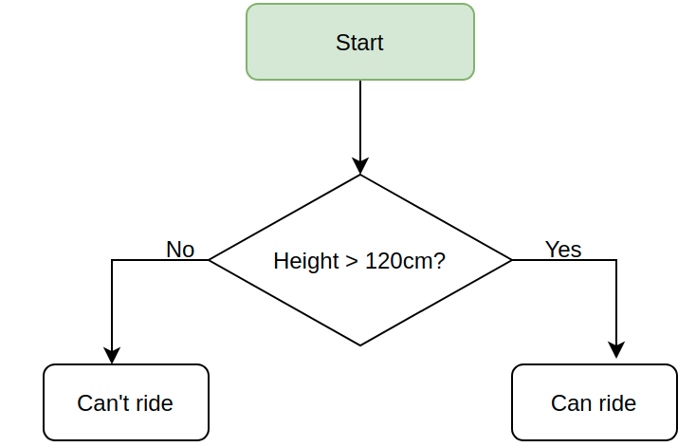

Exercise:

If you are taller or equal to 120 you can ride:

print("Welcome to the rollercoaster!")

height = int(input("What is your height in cm? "))

if height >= 120:
print("You can ride the rollercoaster!")

else:
print("Sorry, you have to grow taller before you can ride.")

Comarison Operators:
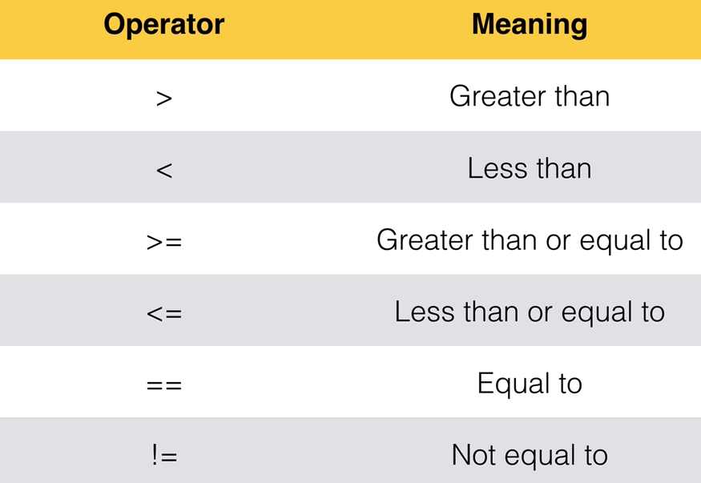

Odd or Even? Introducing the Modulo

Modulo: → %
Will divide a number by another number and will give you the remainder of that division.

You can use modulo to know if a number is even or odd.

If the division of a number by another gives you a reminder, like 14 /4 = 3,5 you will know that the number is odd because will give you a reminder, ,5 in this example.

Example: 7 % 2

Seven split into portions of 2 is:
2 + 2 + 2 + 1

Seved divided by 2 can be divided 3 times (2 + 2 + 2) with a reminder of 1.

1 is what the modulo gives you.

If you run 7 % 2 in the console gives you 1:
7 % 2 = 1

Example 2: 7 % 3

3 + 3 + 1
7 % 3 = 1

Example 3: 14 % 4 (14 /4 = 3,5)

4 + 4 + 4 + 2
14 % 4 = 2

Exercise:

Tell me if the introduced number is odd or even

My solution:  number = int(input("Which number do you want to check? "))  odd_even = number % 2  if odd_even == 0:  print("This is an even number.")  else:  print("This is an odd number.") | Teacher’s solution:  number = int(input("Which number do you want to check? "))  if number % 2 == 0:  print("This is an even number.")  else:  print("This is an odd number.")
Result:  Which number do you want to check? 23452451  This is an odd number. | Result:  Which number do you want to check? 2342342423  This is an odd number.

Nested if statements and elif statements:

Nested If/Else statements:

Following the height example, if you are 120 cm or higher you can use the rollercoaster, if not (else) you can NOT.

Now if you are 120 or higher and you have 18 ages or more you will pay $12. If you are under 18 ages you will pay $7.

We will use nested if/else statements:

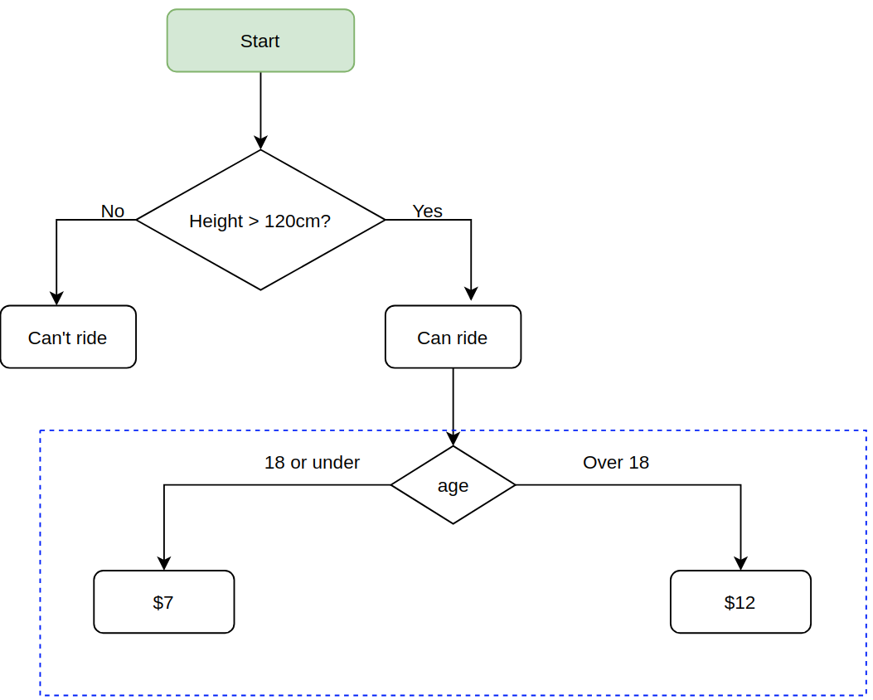
height = int(input("Tell me your heigh in cm: "))

if height >= 120:
print("You can ride the rollercoaster")
age = int(input("What is your age: "))
if age >= 18:
print("Please pay $12")
else:
print("Please pay $7")

else:
print("Sorry, you have to grow taller.")

If / elif /else:

If condition 1 is true do A
If 1 is not true check if condition 2 is true and if so do B

Finally, if none of the conditions are true do the ELSE
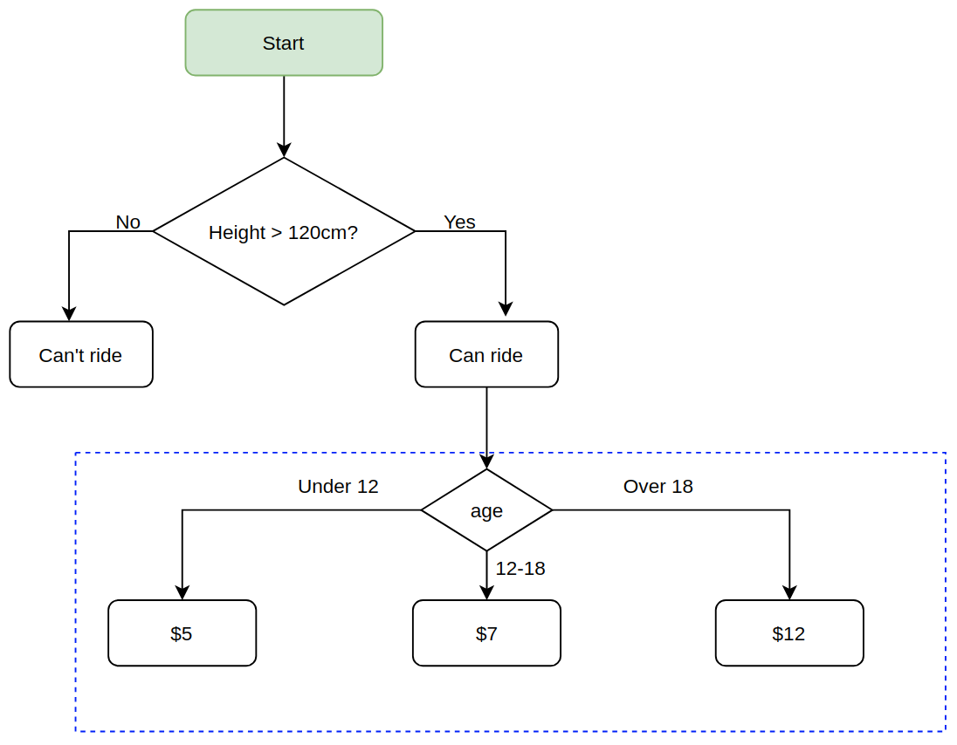
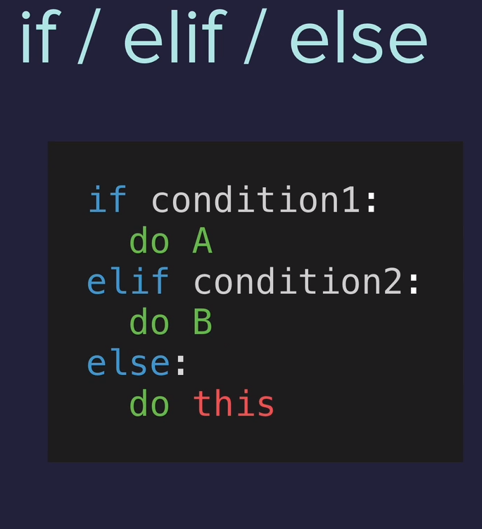

Now we will check if you have the correct height. If you are under 120 cm, game over.

If you have the correct height you have to tell us your age:

If you are 18 or over you have to pay $12
If you are between 12 and 18 you have to pay $7

And if you are not matching any of the above ages you have to pay $5.

height = int(input("Tell me your heigh in cm: "))

if height >= 120:
print("You can ride the rollercoaster")
age = int(input("What is your age: "))
if age < 12:
print("Please pay $5")
elif age >= 18:
print("Please pay $12")
else:
print("Please pay $7 ")

else:
print("Sorry, you have to grow taller.")

Exercise3.2 BMI Calculator 2

Ask for your height and weight.

If you are :
Under 18.5 they are underweight
Over 18.5 but below 25 they have a normal weight
Over 25 but below 30 they are slightly overweight
Over 30 but below 35 they are obese
Above 35 they are clinically obese.

Print the message in the solution highligting the medical condition.

My solution:  height = float(input("enter your height in m: "))  weight = float(input("enter your weight in kg: "))  bmi = round(weight / (height ** 2))  start = "\033[1m"  end = "\033[0;0m"  if bmi < 18.5:  print(f"Your BMI is {bmi},{start} you are underweight.{end}")  elif bmi >= 18.5:  if bmi < 25:  print(f"Your BMI is {bmi},{start} you have a {start}normal weight.{end}")  elif bmi > 25:  if bmi < 30:  print(f"Your BMI is {bmi}, you are {start}slightly. overweight.{end}")  elif bmi > 30:  if bmi <= 35:  print(f"Your BMI is {bmi}, you are {start}obese.{end}")  else:  print(f"Your BMI is {bmi}, you are {start}clinically obese.{end}") | Teacher’s solution:  height = float(input("enter your height in m: "))  weight = float(input("enter your weight in kg: "))  bmi = round(weight / (height ** 2))  if bmi < 18.5:  print(f"Your BMI is {bmi}, you are underweight.")  elif bmi < 25:  print(f"Your BMI is {bmi}, you are normal weight.")  elif bmi < 30:  print(f"Your BMI is {bmi}, you are overweight.")  elif bmi < 35:  print(f"Your BMI is {bmi}, you are obese.")  else:  print(f"Your BMI is {bmi}, you are clinically obese.")
Result:  enter your height in m: 1.7  enter your weight in kg: 70  Your BMI is 24, you have a normal weight. | Result:

