########## Helm: ###########

What is Helm: Package manager for Kubernetes.

Package manager: Is used for software installation.
- With a single command you can install the software/application that you want.
  - brew install nginx → on MacOs
  - apt install nginx → debian
  - yum install nginx → redhat
  - etc.
- Dependencies are resolved
- Does not require deep understanding of software
- Easier updates, upgrades, and removal. Usually via a single command.

Unmanaged software:
- Dependencies nightmare. If you install something it will never run right, you will have always an error with some part missing, but you never will get a message about what part is.

You will need to go to the documentation for hours trying everything. Could be some library, some shared file, etc.

- Each part of the application must be installed, updated, upgrated or removed separately.
- Requires in-depth knowledge of the application architecture.

Process of a package installation: Is pretty much the same across all package managers.
(Simplified model, there are many steps missing in the below example)

- Read Metadata: Packaged applications have accompanying data that indicates how it is installed, e.g., dependencies.

- Resolve Dependencies: Not only do we know what the application stack depends on, we also know where to get it and how to install it.

Somewhere in the metadata is indicated that we need additional parts. Those parts are gotten. They are downloaded, and then everything is installed.

- Installation: The pieces of the package are installed in order. This prevents failures by ensuring that requirements are met.

- Configuration: Once the package is installed components of a package may require post installation steps, e.g., if we are installing nginx we will need an index page, if we are installing a blogging software we will need to link it to the database, etc.

Why Package Management is better:
- Old Manual Way: Someone with knowledge of the application would need to create an installation plan, create a dependency plan, and install and configure the application.

- Package Management: Everything is in the package. Install is typically one command. Once installed, the application is ready to use.

How Helm manages packages in Kubernetes:
- Helm Chart: This is the definition of a K8s application. Helm uses this information along with a config map combined with some values. That Chart is used to define a released object.

So if I run a single command: helm install <package_name> it just install that package.

And everything that’s in that package gets installed in the way that they work together because someone who knows more about the way the package is deployed that me, has gone in and made that configuration so that the package manager understands it and successfully releases the k8s object.

- Least invasive change: In the event that there is a change to a release, Helm will only change what has been updated since last release.

If we do an update or upgrade Helm will make the least invasive change.

So if I update the version of my SQL database, or if I update the version of my front end containers, etc, I don’t have to tear down (destroy) the entire package.

Helm will simply increment up the front end container. It won’t tear down the whole back end. It won’t destroy all my storage. It makes the least invasive change.

- Running vs Desired State: If a Helm chart has been released, Helm can determine what the current state of the environment is vs the desired state and make changes as needed.

It knows what is deployed and knows what is currently running in the cluster. And whichever one you determined to be the source of the truth, is the one that’s going to get pushed.

So if I tell it that I want to update a package, and I make the change to the package in the desired state, it will push the running state out to the cluster. And it does this via the least invasive change.

- Release Tracking: Helm versions releases. This means that if something goes wrong, the release can be rolled back to a previous version.

What Helm can do for you, quick review:
- Single command Install: helm install and a chart can be released using a Helm repository.

- Provide insights for releases: With helm status command it is possible to see the details of the running state of a release

- Perform Simple Updates/Upgrades: With helm upgrade command you can apply changes to a chart (e.g., versioning a service) and helm will do the update for you.

- Provide the ability to Rollback: Helm tracks releases and versions them. By using the helm rollback command it is possible to revert to a previous release.

- Simplify Deployments: Charts can be created by the application expert and released by someone else with a single command.

- Single command Uninstall: By using helm uninstall the reverse of the installation can be done. This makes cleaner removal, as all components that are defined are also removed.

Deploying K8s without using Helm:
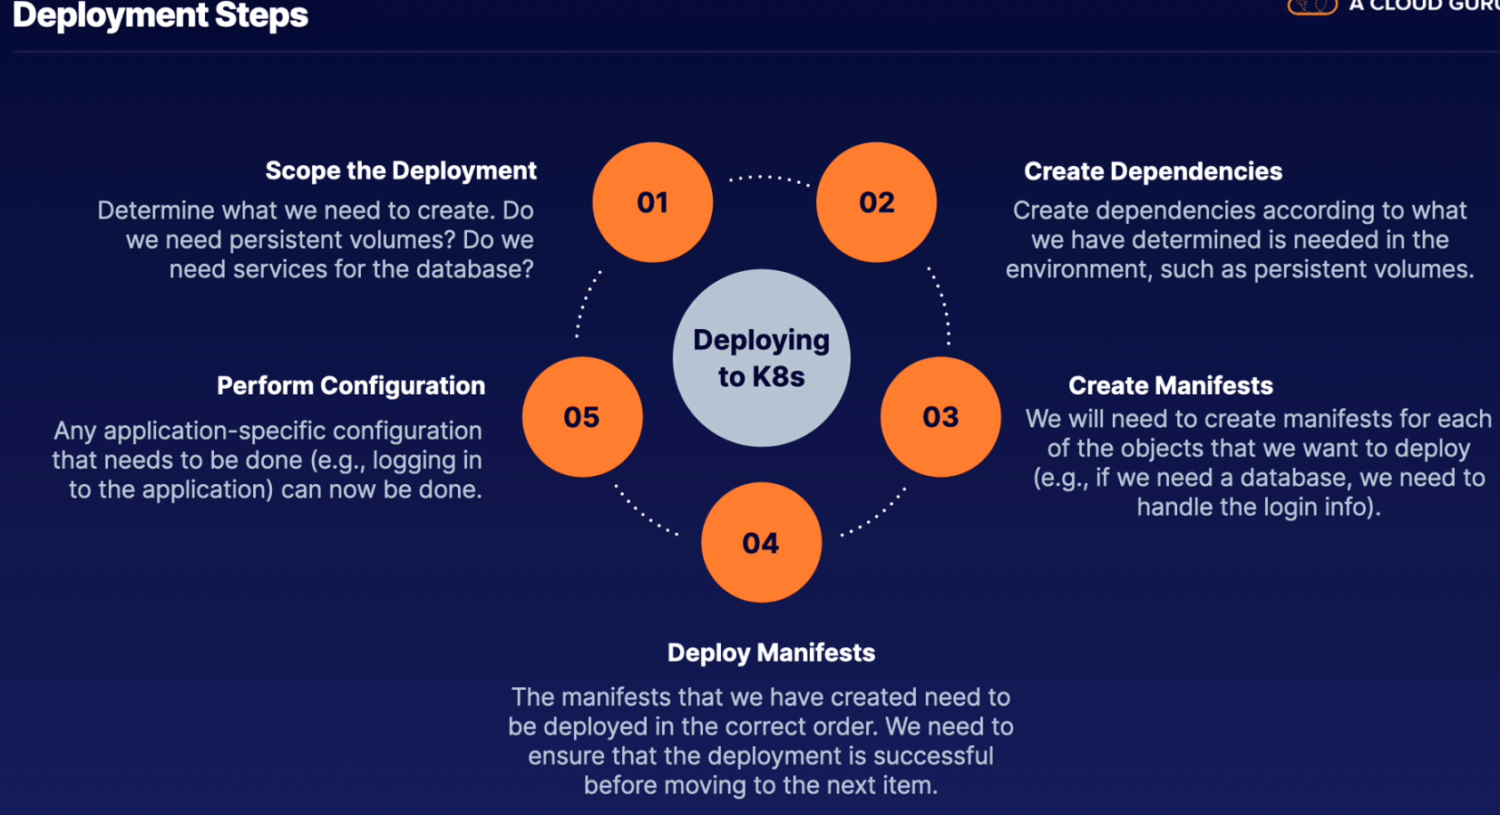
So, imagine you want to deploy a wordpress, we will use this github repo as example.

We will need to download and run separately all the yamls, then create the secrets and configmaps needed.

To upgrade or uninstall we will need to do it separately as well.

Deploying K8s using Helm: A wordpress application like in the above example.

Is a much simpler process, than the process of deploying to K8s using the traditional manifest system. This is a sales claim to sell Helm, so there are easier ways to deploy on k8s than the previous example.

Deployment Steps:
- Locate a Chart: For the majority of applications you may want to deploy, there is an existing chart.

These charts are located in a repository and can be deployed using some custom configurations.

- Deploy the Chart: With Helm, all parts of the application package can be deployed using a single command.

- Perform Configuration: Some applications you deploy may require post-installation configuration.

First update the repo: Like in linux, first make sure that the repository is up to date.
helm repo update

We will get the last versions of the software that was available in the repository.

Create the necessary resources like sc or pv.

Let’s install wordpress: We have to give a name to the release, demowp in this example.
helm install demowp stable/wordpress

You will be output with text giving you information for the configuration step, like what is the url of wp, the user, the password, etc.

In this example you will see two pods running:
demowp-wordpress
demowp-mariadb-0

Install another wp:
If you run the install command again by changing the release name from demowp to another_demowp it will deploy another wp with named another_demowp

heml install another_demowp stable/wordpress

But it will be in pending status because the pvc are bounded to the fist release. So you will need to create new pv and sc to run this another_demowp application.

Check the helm releases: Will show you 2 releases, demowp and another_demowp
helm ls

How to delete the release: All that was installed in that release will be removed, svc, depl, etc.
helm delete demowp

Installing Helm:

Installation Methods:
- Package Manager: The Helm community has made packages available for Homebrew, Chocolatey, and APT, as well as a Snap package.

- Provide Script: Helm has a provided script that will install Helm locally in bash. This scripts downloads, verifies and installs Helm.

- Manually: The Helm binary can also be used to install Helm. We will use the same process than the script above. Download the Helm tar.gz, extract it and move the helm binary to your local path, like /usr/local/bin and that’s it.

Post Installation Configuration:
- Once installed you will need to add repositories so Helm is able to download charts. It is recommended to update the repository once you have added it.
helm repo add stable https://charts.helm.sh/stable
helm repo update

- Ensure Helm search function is working correctly.
helm search repo wordpress

- Additionally, you might want to do a quick demo install to ensure Helm is able to install and delete a release correctly.
helm install demowp stable/wordpress
kubectl get pods
helm ls
helm delete demowp

Working with Chart Repositories:

What is a Chart Repository: Is an HTTP server that is capable of serving an index.yaml file.

This file contains the manifests of packaged charts and where they are located.

The index file for the repository can be created by using the helm repo index command and providing the directory which contains the package charts.

A packaged chart is a Helm chart that has been processed into a tar archive by Helm, typically using the helm package command and providing the chart name.

These archives have a .tgz extension.

So you can use the stable repository or you can create yours.

Example: We have a k8s cluster with helm installed.

We will create a directory called example and we will go inside → mkdir example
If we do a helm repo list we will see that we have stable version:
stable https://charts.helm.sh/stable
Download a couple of Charts with the fetch command:
helm fetch stable/jenkins
helm fetch stable/spark

This will download locally the jenkins and spark charts into the /example directory, do a ls -l and you will see both packaged charts, as .tgz extension.

Leave the /example directory, cd ../ and get the repo index:
helm repo index ./example/
is gonna grab those two files.

If you ls ./example/ you will see an index.yaml has been created. Now example will have 3 files, the two charts.tgz and index.yaml

If you cat index.yaml will show you the descriptions of the two charts.

Now I can put this index.yaml into a remote server and use it as a remote repository.

Commands to use with repositories: Create your own repository.

helm repo add <name of the repo> <URL of the repository> → adds the helm repository to your helm installation.
helm repo add custom https://chart_repo_on_my_web_server.com

helm repo list → shows locally cached repositories.
You will see two repos there, stable and custom

helm repo update → helm catches repository information locally and at times it needs to be updated.

helm repo remove <name of the repo>→ remove the repo from my helm.
helm repo remove stable

helm search repo spark → will show you the spark chart located in my local repository.

Modify the local chart:
I can go to /example/ unpack jenkins.tgz , modify it and push the changes to my custom repository.

Updating Releases in Helm:

Charts: Contains the scaffold of objects in k8s without specific versions or values.

When the chart is installed, the scaffold is combined with the values inside config maps and secrets to initiate objects in the k8s cluster.

This combination of chart and values (config maps and secrets) is called a Release. It creates the yaml, the manifest that is actually going to be released into the k8s cluster.

Values are the version and other information that a chart requires.

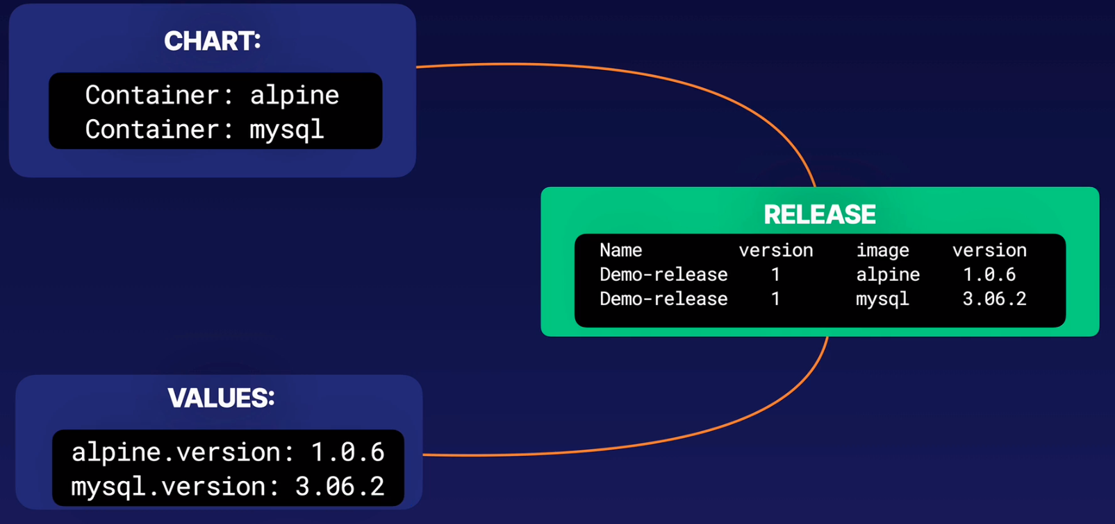
Status: helm status command can be used to see the current state of a release.

Helm keeps track of all the releases that were created with Helm and adds a version number for each named release.

Upgrade: helm upgrade command can be used to update a release. This can be done by specifying an updated chart or by modifying the release. Helm will only update what has been changed and increment the version.

You can use the upgrade command to update a running chart, e.g., if you want to test a change without having to save the change into the chart itself you can use helm upgrade into the running release, see if works and then save it into the chart itself.

So you will have a running config with one version of the application and the chart config with another version of the application.

Example:
Let’s say that you are running alpine=1.6 and you want to upgrade to alpine=1.1.6
helm upgrade Demo-release -set alpine.image=1.1.6
The running chart config will be incremented to the next revision number, in this case from revision 1 to revision 2.

If you check the pod description you will see the new version of alpine there.

If you check alpine.yaml file that is in our local disk you will see the old alpine=1.6

Basically here we are using the imperative way instead of the declarative one.

If you want to make this change permanent you can manually change it in the chart and deploy it.

