Terraform for Absolute Beginners:

Password:
ODI3453dfgdmbr

Types of Infrastructure as Code, IaC:

Configuration Management: Ansible, Puppet, Saltstack.

- Used to install software to already existing infrastructure resources, like servers, db, networking devices, etc.

- Maintains standard structure of code, which makes easier to manage an update as needed.
Can modify multiple resources at once.

- Version control, to reuse and distribute as needed.

- Idempotent, you can run the code multiple times that will produce the same effect than running it once. If you run the same configuration again it will detect it and won’t make any changes.

Server Templating: Docker, Packer, Vagrant

- Used to create a virtual machine or a container.

- Pre installed software and dependencies. You can find them in Custom IAM in AWS, Docker Hub, etc.

- Immutable infrastructure: Once created you can not modify them, the only option is to create a new one with the new specs and destroy the old one.

Provisioning tools: Terraform, CloudFormation.

- Deploy immutable infrastructure resources

- Servers, Databases, Network Components, etc.

- Multiple providers, Terraform is vendor agnostic.

Terraform:
- Useful as Infrastructure as a Code.
- Allows to deploy infrastructure across multiple platform, private and public.
  - It can deploy to multiple vendors by using Providers, which are managed by API.
    - Server providers: VMWare, AWS, Azure, physical machines, etc
    - Network providers: BigIp, ClodFlare, DNS, Palo Alto, Infoblox, etc
    - Monitoring and datamanagement tools: DataDog, Grafana, Auth0, etc
    - DB: Mysql, PostgreSQL, etc.

It uses hcl, Hashicorp Configuration Language, simple declarative language to define the infrastructure resources to be provisioned as blocks of code.

The configuration files have a .tf extension.
Phases: It works in 3 phases, Init, Plan and Apply.

- Init: Terraform initializes the project and identifies the providers to be used for the target environment.
- Plan: Terraform draws a plan to get to the target state.
- Apply: Makes the necessary changes required on the target environment to bring it in the desired state.

Resource: Every object that terraform manages is called a RESOURCE.
Can be a compute instance, a database server in the cloud, a physical server on prem, a file on a localhost, services, AIM user or groups, policies, db, everything.

Terraform manages the lifecycle of the resources from its provisioning, to configuration, to decomisioning.

Install terraform: Different platforms
Centos/Rhel:
sudo yum install -y yum-utils
sudo yum-config-manager --add-repo https://rpm.releases.hashicorp.com/RHEL/hashicorp.repo
sudo yum -y install terraform

Version used in the course: v0.13.0

HCL Basics: Hashicorp Configuration Language.

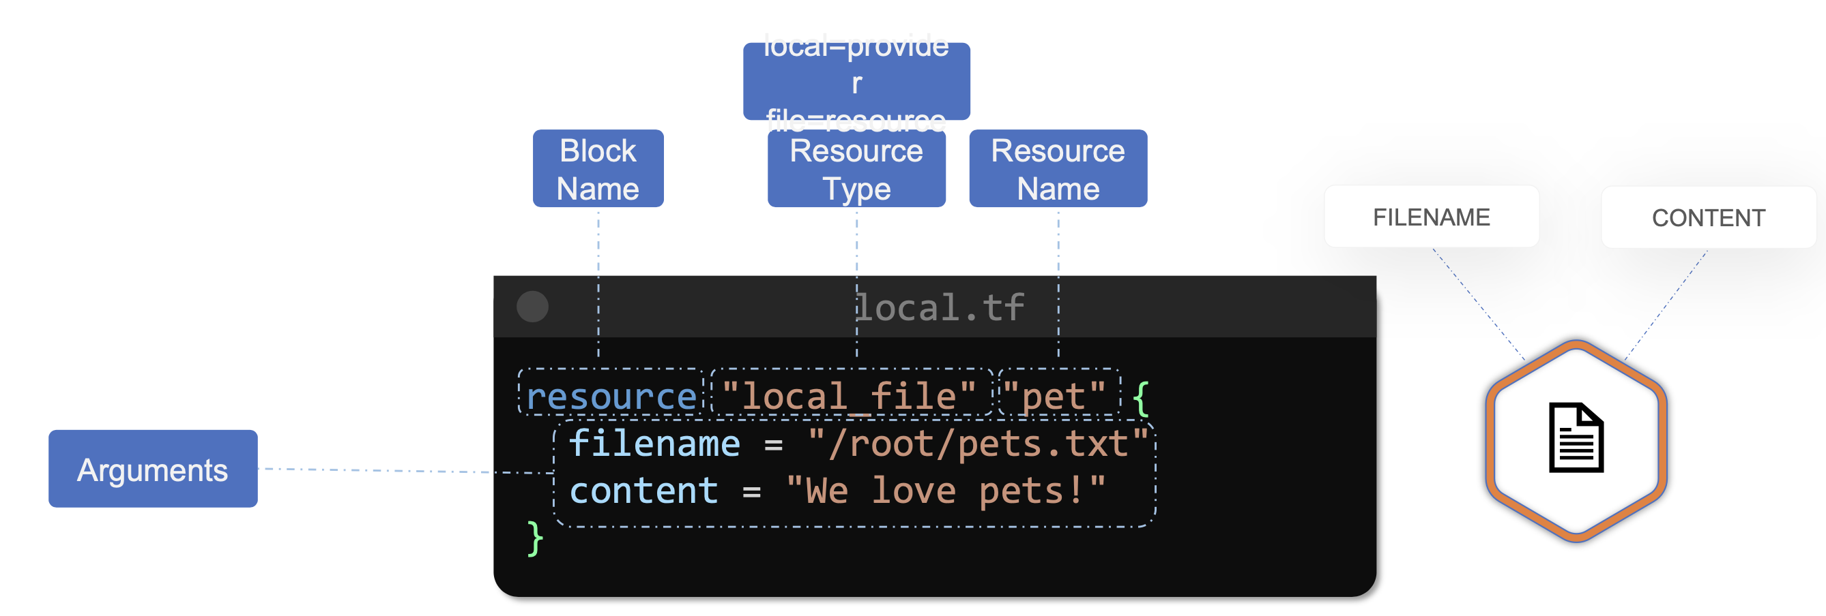

Example of resource file: To provisioning an aws instance.
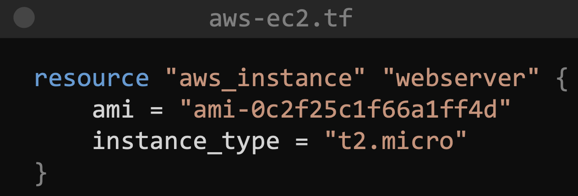
Resource Type: aws_instance
Resource Name: webserver
Arguments:
ami: ami-0cf25…….
instance_type: t2.micro

Another example of resource file: To create an aws s3 bucket.
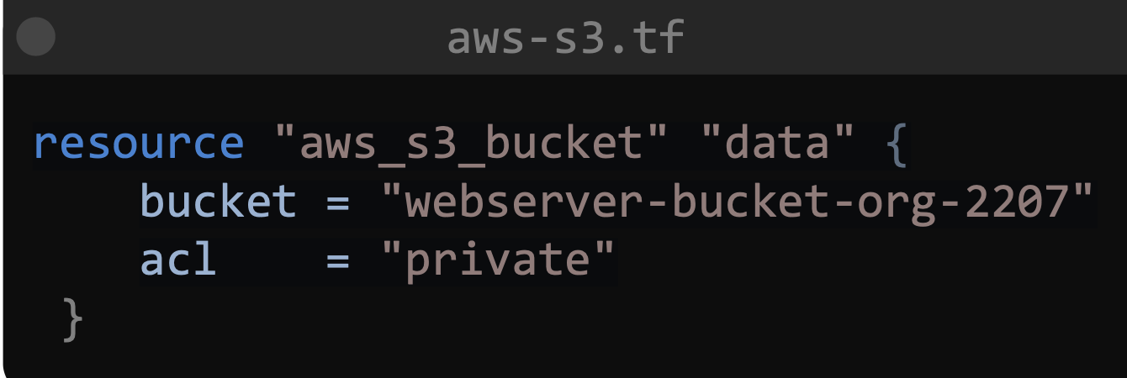
Resource type: aws_s3_bucket
Resource name: data
Arguments:
bucket = "webserver-bucket-o..
acl = "private"

Simple Terraform workflow:
- Write the configuration files
- Run the terraform Init command
- Terraform Plan command to review the configuration
- Apply the changes.

Commands:
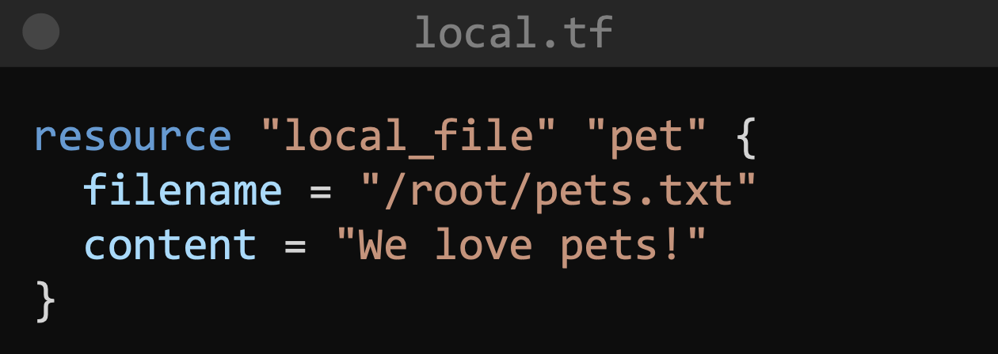

Once you have the configuration file (above) ready run:
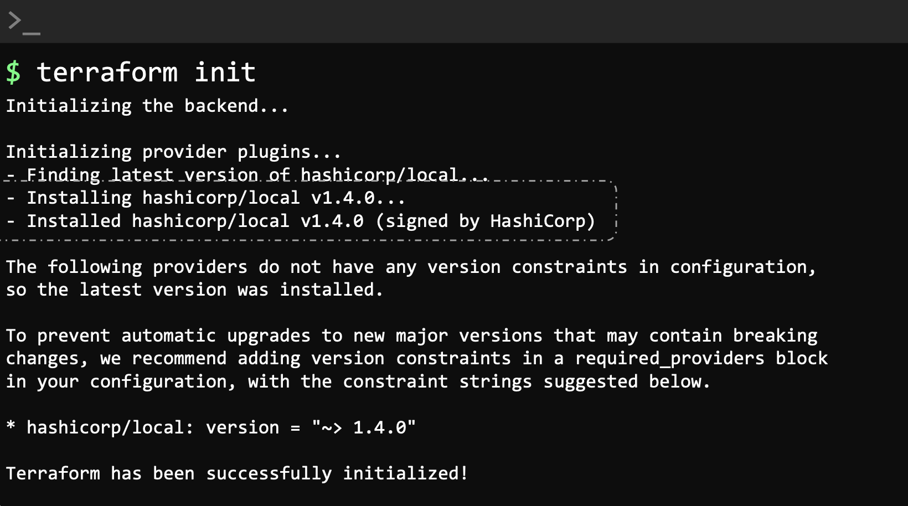

Init will check the configuration file and initialize the working directory where the .tf is.

One of the first things that init does is to understand that we are making use of the local provider, based on the resource type.

It will then download the plugging to be able to work on the resources declared in the .tf

From the output of this command we can see that has been installed a plugging called hashicorp/local

Check how the thing is gonna go with terraform plan:
This is a dry run, so its only showing what it would do if you run terraform apply.
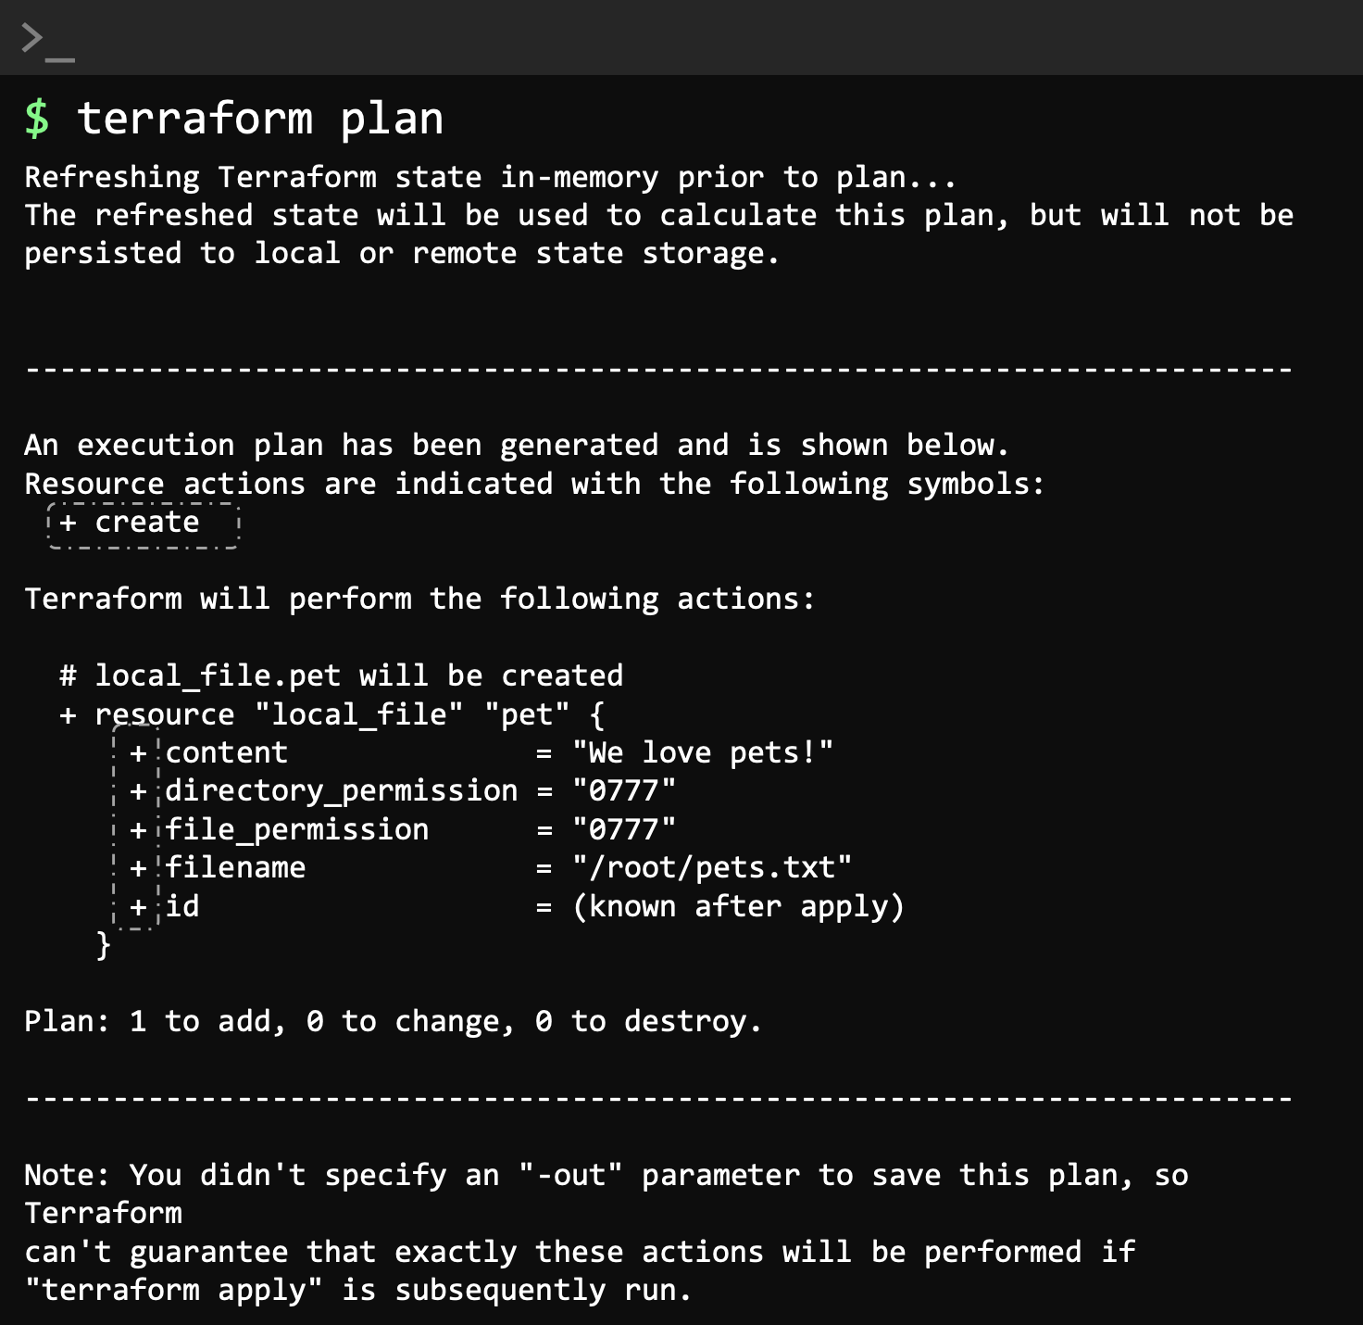

Apply the configuration: Will ask you to confirm with “yes”

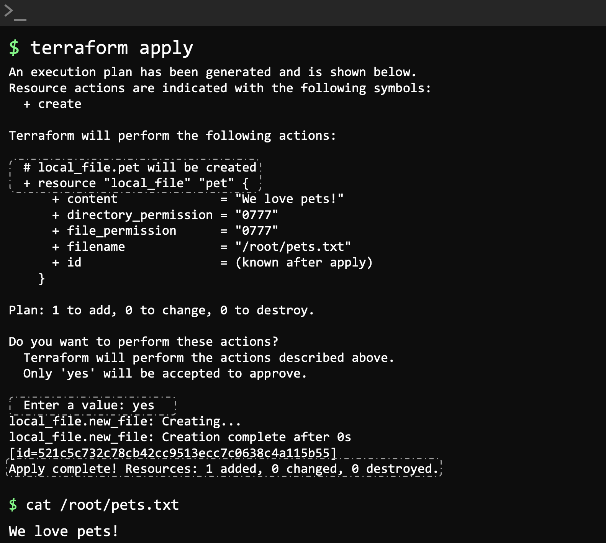
Once created run cat pets.txt to see it’s content and confirm its working.

Check the details of the resource: once created.

