########## CKS, Certified Kubernetes Security: ###########

CKS Resources:
https://github.com/ibrahimjelliti/CKSS-Certified-Kubernetes-Security-Specialist?utm_sq=gl0fgi8ycl

CKS Cloud Native Security Tutorial
https://tutorial.kubernetes-security.info/

CKS exam version 1.23
Ubuntu version 20.04

PodSecurityPolicies were deprecated on 1.21 but still included in the exam curriculum.

Setting up a cluster:

Use 3 Medium cloud sandboxes in the cloud playground.

Change hostnames to:
k8s-control
k8s-worker1
k8s-worker2

Edit /etc/hosts, add the private ip and the hostname of each server:
172.31.46.162 k8s-control
172.31.35.178 k8s-worker1
172.31.47.219 k8s-worker2

CRI: Install containerd on all nodes

Add some modules: This will start the modules every time the server starts up.
cat << EOF | sudo tee /etc/modules-load.d/containerd.conf
overlay
br_netfilter
EOF

sudo modprobe overlay → will enable the module immediatelly without having to restart the server

sudo modprobe br_netfilter → will enable the module immediatelly without having to restart the server

cat <<EOF | sudo tee /etc/sysctl.d/99-kubernetes-cri.conf
net.bridge.bridge-nf-call-iptables = 1
net.ipv4.ip_forward = 1
net.bridge.bridge-nf-call-ip6tables = 1
EOF

sudo sysctl --system

sudo apt-get update && sudo apt-get install -y containerd

sudo mkdir -p /etc/containerd

sudo containerd config default | sudo tee /etc/containerd/config.toml

sudo systemctl restart containerd

Disable swap: On all nodes
sudo swapoff -a

Check /etc/fstab if there is a line that will start swap in the next restart, remove it if there is a line.

Install kubeadm, kubelet and kubectl: on all nodes.
sudo apt-get update && sudo apt-get install -y apt-transport-https curl

curl -s https://packages.cloud.google.com/apt/doc/apt-key.gpg | sudo apt-key add -

cat << EOF | sudo tee /etc/apt/sources.list.d/kubernetes.list
deb https://apt.kubernetes.io/ kubernetes-xenial main
EOF

sudo apt-get update

sudo apt-get install -y kubelet=1.23.0-00 kubeadm=1.23.0-00 kubectl=1.23.0-00

sudo apt-mark hold kubelet kubeadm kubectl

Run kubead init: Control plane only.
sudo kubeadm init --pod-network-cidr 192.168.0.0/16 --kubernetes-version 1.23.0

mkdir -p $HOME/.kube

sudo cp -i /etc/kubernetes/admin.conf $HOME/.kube/config

sudo chown $(id -u):$(id -g) $HOME/.kube/config

Verify the cluster is working: kubectl get nodes

Install CNI:
kubectl apply -f https://docs.projectcalico.org/manifests/calico.yaml

Get token to join workers: This is already in the output of the kubeadm init command.
kubeadm token create --print-join-command

Join the worker nodes: Paste the output of the previous command in the worker nodes as a SUDO.
sudo kubeadm join …

Check the nodes are ready:
k get nodes

K8s Security Overview:

K8s Security: Refers to the techniques and processes used to protect k8s clusters and the application and data housed within them.

Layered Security Model: Means that we are not assuming that any one security layer is going to work 100% of the time, and we are securing everyting possible.

Layer security model ocuses on making every component as secure as possible.

Even if an attacker manages to compromise some aspect of the system, they are limited in what they can do.

Layers:
- The Cluster: The k8s cluster itself and its components must be secured. If someone can control the cluster, they could gain control of applications.

- Host Systems: The host systems and infrastructure used to run the cluster could serve as an attack vector. Protect them.

- Applications: The containerized applications and code running in your cluster could be compromised and used to interact with other applications or cluster components.

- Supply Chain: Container images and other files used to deploy applications could be used by attackers.

- Everything: Attackers can be creative. If something can be compromised or used in an unexpected way, it probably will be.

If we focus on securing all these different layers we can severely limit what attackers can do and we are not relying on a single point of failure where if an attacker breaks through that single layer of security, they have access to everything.

########## Cluster Setup: ###########

Restricting Default Access with NetworkPolicies: NetworkPolicies allows you to prevent or restrict network communication to and from Pods.

They are like firewals within your k8s cluster network.

Default Deny: Network policy to block all traffic except for what is explicitly allowed.

If one pod is compromised, the attacker won’t be able to communicate with the other pods via the cluster network.

Example: Block all inbound and outbound traffic for the nptest namespace

apiVersion: networking.k8s.io/v1
kind: NetworkPolicy
metadata:
name: default-deny-ingress
namespace: nptest # We apply this netpol only to nptest namespace
spec:
podSelector: {} # Empty podselector,{} curly brakets means all the pods
policyTypes: in that namespace
- Ingress

Now traffic within the nptest ns is block, you will have a connection timeout error.

Exam Tips:

- Use default deny network policy to block all network traffic to and/or from Pods in a namespace.

- Use an empty podSelector: {} to make the policy apply to all Pods in the namespace.

- Use the policyTypes field to block incoming traffic (ingress), outgoing traffic (egress), or both.

Allowing Limited Access with NetworkPolicies:

Network policies do not conflict; they are additive. If any policy or policies select a pod, thepod is restristed to what is allowed by the union of those policies ingress/egress rules.

This means that if all the ingress/egress traffic is denied, if there is a netpol explicitly allowing traffic between two specific pods, this specific traffic will be allowed.
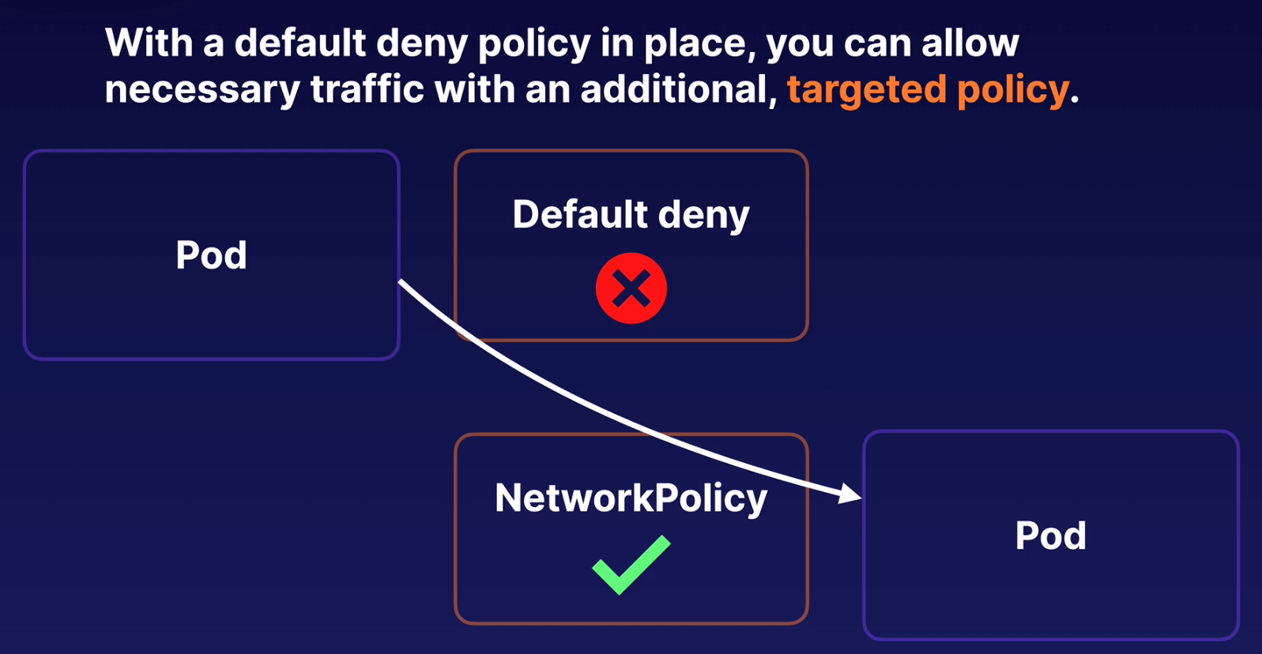
We can combine woth netpols, one denying all traffic and the targeted policy allowing specific traffic

spec.podSelector:
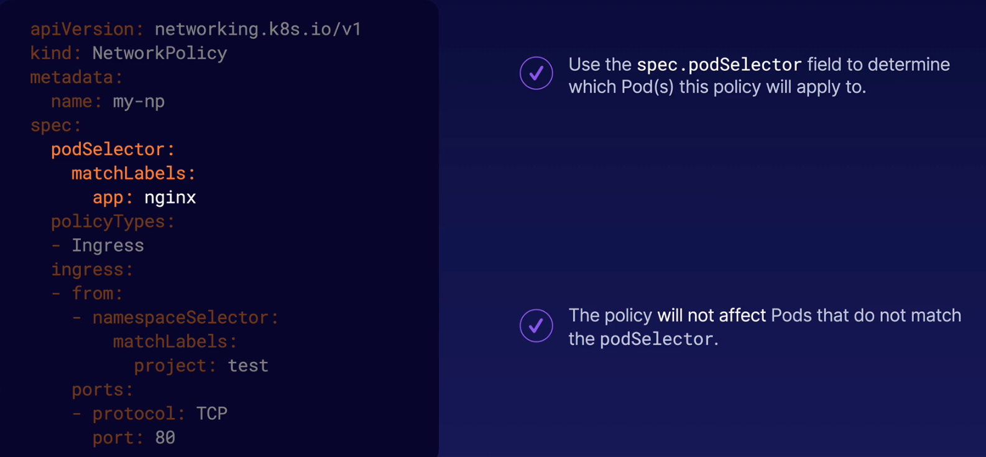
This network policy will be applied to all the pods that have the label app:nginx

Ingress / Egress Rules:
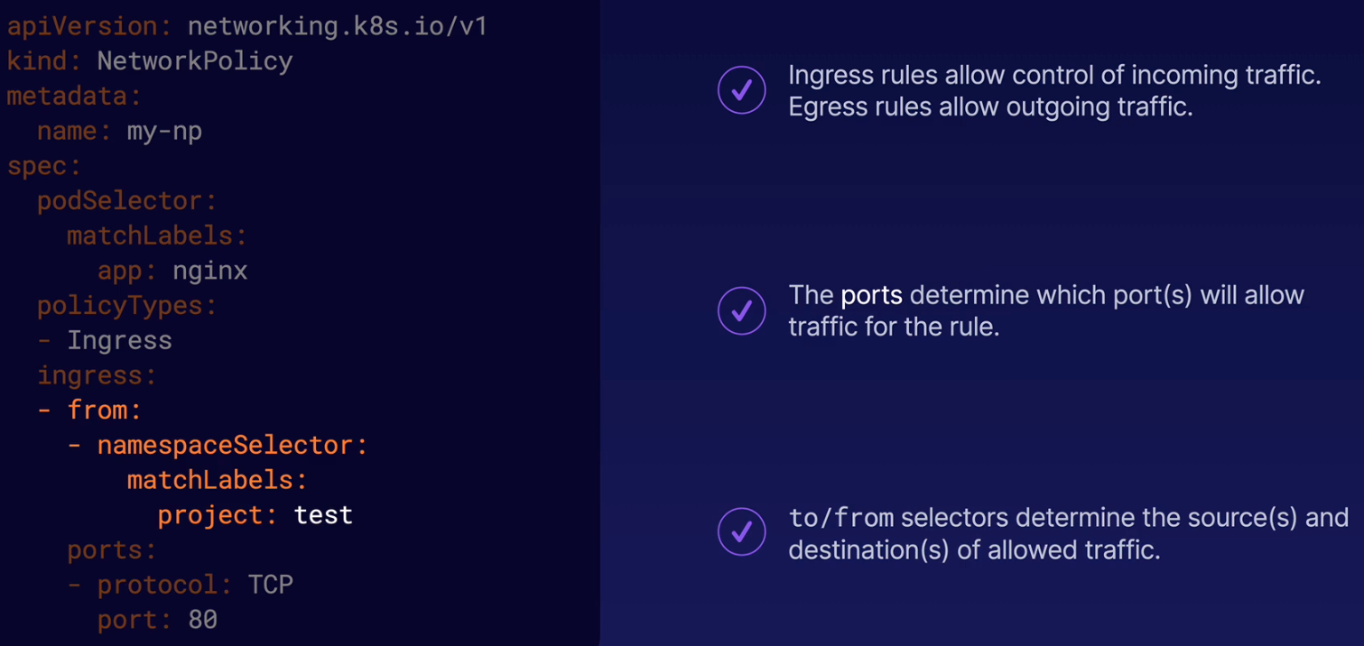
Variations: We use two selector to say which pods can connect us via the ingress rule.

First we check the namespace that have a label called project: test (we will add this label to the ns)
Second we check if the pod have a label called app: client

Both labels must match in the pod, if not you won’t be allowed to communicate with the pod with label app: nginx

- namespaceSelector:
matchLabels:
project: text
podSelector:
matchLabels:
app: client
Notice the difference if we add a hyphen to create another rule:

- namespaceSelector:
matchLabels:
project: text
- podSelector:
matchLabels:
app: client

Now we have two separate rules. With two arrays this says that if the pod is in the right namespace (namespaceSelector) the traffic is gonna be allowed even if the second rule (podSelector) is not matching.

And the opossite, if we match the podSelector the rule will be allowed even if the namespaceSelector is not matching.

Basically with two hyphens (two arrays) you are saying if this rule OR this rule is true, go ahead.

With one hyphen you are saying if this rule AND this rule are true go ahead.

Add a label to the NS:
kubectl label namespace nptest project=test

Create an Egress rule: With the ingress rule created earlier the traffic from the pods outside that match both labels (namespace and pod labels) won’t work yet.

We need to create an Egress rule to allow the traffic to go back to the external pod.

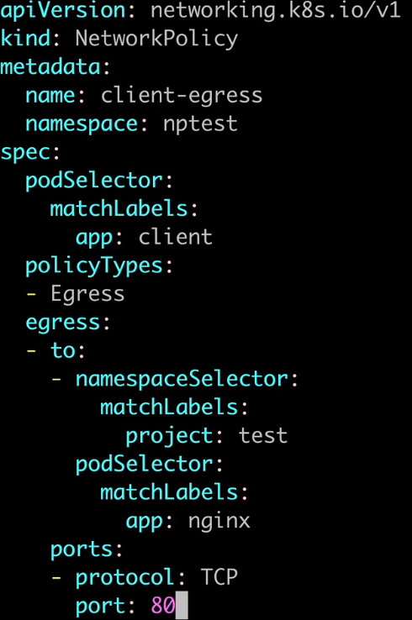
Now we use the podSelector to select the client pod, app: client

Policy type: egress

Allow to pods that have project: test label in the namespace and app: nginx label in the pod

This policy says:
In the namespace nptest, the pod with label app: client can send tcp traffic on the port 80 to pods with label project: test in the ns and the label app: nginx in the pod

Exam Tips:

- If any policy allows a particular type of traffic, it will be allowed. This means you can add targeted policies alongside a default policy to allow necessary traffic.

- You can use a policy’s podSelector to target the policy to specific Pod based upon their labels.

- You can use ingress/egress rules to specify Pods, namespaces, or IP addresses to allow traffic to and/or from.

- Pay attention to the difference between one rule with multiple selectors (one hyphen/array), and multiple rules (two or more hyphens/arrays)

Running a CIS Benchmark with kube-bench:

CIS: Center for Internet Security, non profit organization dedicated to promoting digital security.

CIS Benchmarks: Are a set of consensus-driven community standards and best practices for securing systems.

CIS Kubernetes Benchmarks: provides a guideline (recommendations) for securing k8s environments.

Kube-bench: is a tool that checks your cluster to see how well it conforms to the CIS Kubernetes Benchmark.

Is a long list of checks that is done automatically saving us a lot of time.

It generates a report that will tell you if your cluster have any security issue.

The kube-bench is a k8s job.

How to run it:
Logged into the control plane server, and download the yaml for both, the master server and the node server.

Download both on the control plane:

wget -O kube-bench-control-plane.yaml https://raw.githubusercontent.com/aquasecurity/kube-bench/main/job-master.yaml

wget -O kube-bench-node.yaml https://raw.githubusercontent.com/aquasecurity/kube-bench/main/job-node.yaml

Inspect the jobs and create them:
cat kube-bench-control-plane.yaml
cat kube-bench-node.yaml

kubectl create -f kube-bench-control-plane.yaml
kubectl create -f kube-bench-node.yaml

Check the status of the job and wait until the job pod enters in Completed state:
k get pods

Save the job pods logs to easily view the results:
kubectl logs control_plane_pod_job > kube-bench-results-control-plane.log
kubectl logs node_pod_job > kube-bench-results-node.log

View the results:
cat kube-bench-results-control-plane.log
cat kube-bench-results-node.log

Delete the job:
k delete job kube-bench-node

Exam Tips:

- Be aware of what the CIS K8s Benchmark is, set of standards and best practices for a secure k8s cluster.

- Be aware of what kube-bench is, a tool that automatically check your cluster to see if it conforms to the CIS k8s Benchmark standards and generate a report.

Kube-bench generates a report that gives you all the information and even tells you a little bit of what you might need to do to address those issues.

Fixing Security Issues Detected by a CIS Benchmark:

Exam Tips:

- The CIS Benchmark output includes remediation steps which you can use to address issues.

- kubeadm clusters uses a kubelet file located at /var/lib/kubelet/config.yaml on each node. Sometimes the remediation steps include the kubelet config file.

- In a kubeadm cluster, manifests files for control plane components (API server, etcd, controler manager, etc) can be found in /etc/kubernetes/manifests on the control plane server.

Implementing TLS with Ingress:

Ingress Review: An Ingress is a k8s object that manages access to Services from outside the cluster.

Can provide features on top of Services such as load balancing and TLS termination.

Ingress and TLS: Can provide TLS termination on top of Services.

It allows to an external user to communicate securely with the Ingress using https.
Then the Ingress will communicate with the internal Service using http.
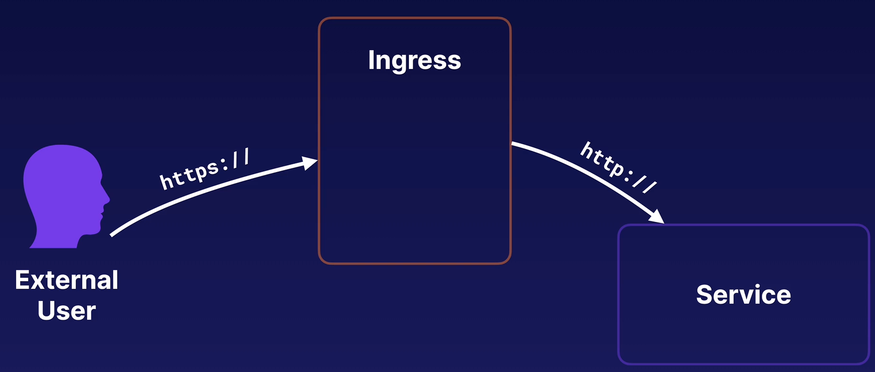
The communication between Ingress and the Service is plain http, which prevents you from having to worry about implementing TLS termination at a Service level. You can abstract that out at Ingress level.

Set up TLS into Ingress: Procedure
- Create a namespace, ingresstest
- Create a deployment with nginx
- Expose the deployment to a clusterIP service
- Test that the service/deployment works: curl service_clusterIP
- Create the certificate and the key:
openssl req -nodes -new -x509 -keyout tls-ingress.key -out tls-ingress.crt -subj "/CN=ingress.test"
- Encode the crt ad key with base64:
base64 accounts.crt | tr -d '\n'
base64 accounts.key | tr -d '\n'
- Create a secret to store the crt and key. Once created delete the yaml used to create it.
- Create an Ingress for the Service and TLS termination.

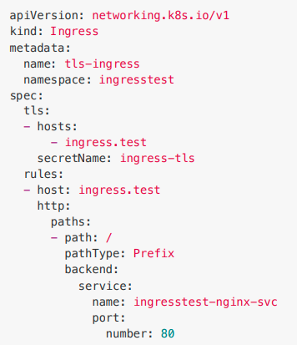
.spec.tls[].secretName: We inject the secret which contains the crt and key generated in the step 5

.spec.tls[].hosts: Maps ingress.test with the rules

backend.service: Maps Ingress with the Service

Another example: From the

Create a self-signed certificate and key for the accounts-svc Service:
openssl req -nodes -new -x509 -keyout accounts.key -out accounts.crt -subj "/CN=accounts.svc"

Exam Tips:

- You can implement TLS termination using an Ingres

- Store TLS certificates using a Secret. Pass the Secret to the Ingress using spec.tls[].secretName

- Bookmark the Ingress - TLS documentation for the exam.

Securing Node Endpoints:

Attack Surface: All the different components of your system that could potentially be attacked.

Be aware of what ports your nodes are using. Protect them by using network segmentation and firewalls to keep them save.

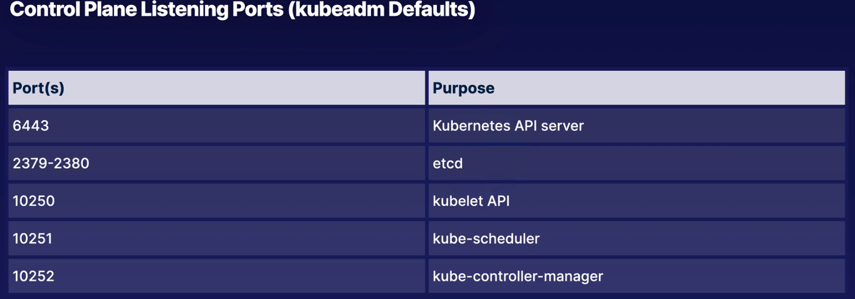
Default ports: For a kubeadm cluster.
These ports are going to be used by K8s it self. Probably you don’t want to be able to reach these ports from outside the network your k8s is using.

Worker node default ports: For a kubeadm cluster
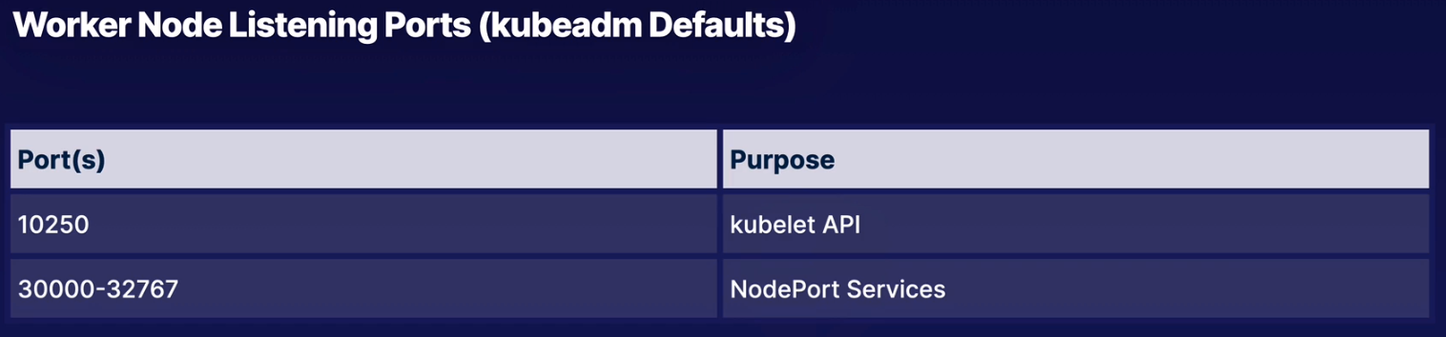
Try to limit the exposure of these ports as much as you can.

Exam Tips:

- k8s servers use certain ports to provide k8s functionality. Be aware that you may need to protect these ports in the real world.

Securing GUI Elements:

K8s GUI: Graphical User Interface provide visual interface for managing your cluster.

Kubernetes Dashboard is one example.

Secure it: K8s GUIs do present an additional attack surface. You have to secure those tools accordingly.

Like making sure that RBAC within the tool is set up correctly, or even locking down network access to the tool using network segmentation and firewalls.

Exam Tips:

- If you use GUI for k8s, be aware that they present a target for attack. Make sure you keep them secure.

Verifying Kubernetes Platform Binaries:

K8s Binaries: Are the executable files used to run k8s components. Kubectl, kubeadm, and kubelet all run on our servers using binaries.

When we built our cluster, we actually used package installation, like kubeadm, which verifies the binaries automatically.

But when manually installing binaries, you can verify that they have not been tampered with before running them.
Example of manually installing binaries: Downloading kubectl and putting that on your server.

K8s documentation
How to verify a binary: We use a checksum file. K8s provide checksum files for all their binaries.

The checksup contains a cryptographic hash calculated from the contents of a valid binary.

If your binary has been tampered with, like adding some malicious code to the kubectl binary, then it won’t match the checksum and we will be able to know that the file was tampered with before we downloaded it.

We want to manually install kubectl binary

- Check the current kubectl version: kubectl version --short --client → Client Version: v1.20.1

- Download the Checksum of the proper version of the kubectl
curl -LO "https://dl.k8s.io/<kubectl client version>/bin/linux/amd64/kubectl.sha256"
curl -LO "https://dl.k8s.io/v1.20.1/bin/linux/amd64/kubectl.sha256"

- Validate it:
echo "$(<kubectl.sha256) /usr/bin/kubectl" | sha256sum --check

Exercise:
Validate kubelet, kubectl and kube-apiserver binaries.

There is the file version.txt with the current version of the binaries, v1.23.4

Create an environment variable to store that version:
VERSION=$(cat version.txt)
echo $VERSION

Download the version of each binary:
curl -LO "https://dl.k8s.io/$VERSION/bin/linux/amd64/kubectl.sha256"
curl -LO "https://dl.k8s.io/$VERSION/bin/linux/amd64/kubelet.sha256"
curl -LO "https://dl.k8s.io/$VERSION/bin/linux/amd64/kube-apiserver.sha256"

Check each file with its checksum:
cloud_user@k8s-control:~/k8s-binaries$ echo "$(<kubectl.sha256) kubectl" | sha256sum --check
kubectl: OK

cloud_user@k8s-control:~/k8s-binaries$ echo "$(<kubelet.sha256) kubelet" | sha256sum --check
kubelet: FAILED
sha256sum: WARNING: 1 computed checksum did NOT match

cloud_user@k8s-control:~/k8s-binaries$ echo "$(<kube-apiserver.sha256) kube-apiserver" | sha256sum --check
kube-apiserver: OK

So, kubelet binary haven’t passed the checksum test, it has been modified, you DON’T have to run this binary because will infect your system. Delete the kubelet binary and report this to the website where was downloaded.

Exam Tips:

- When installing k8s binaries manually, you can validate the binary files using the checksum to ensure the binaries have not been altered.

########## Cluster Hardening: ###########

RBAC: Roles lives in a namespace. CusterRole work across all namespaces.
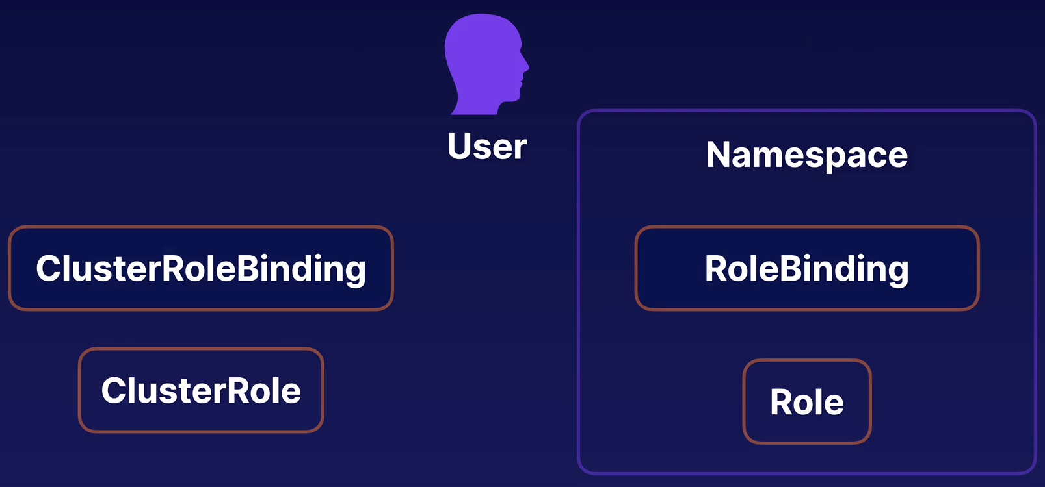

RoleBinding and ClusterRoleBinding attach Roles and ClusterRoles to users.
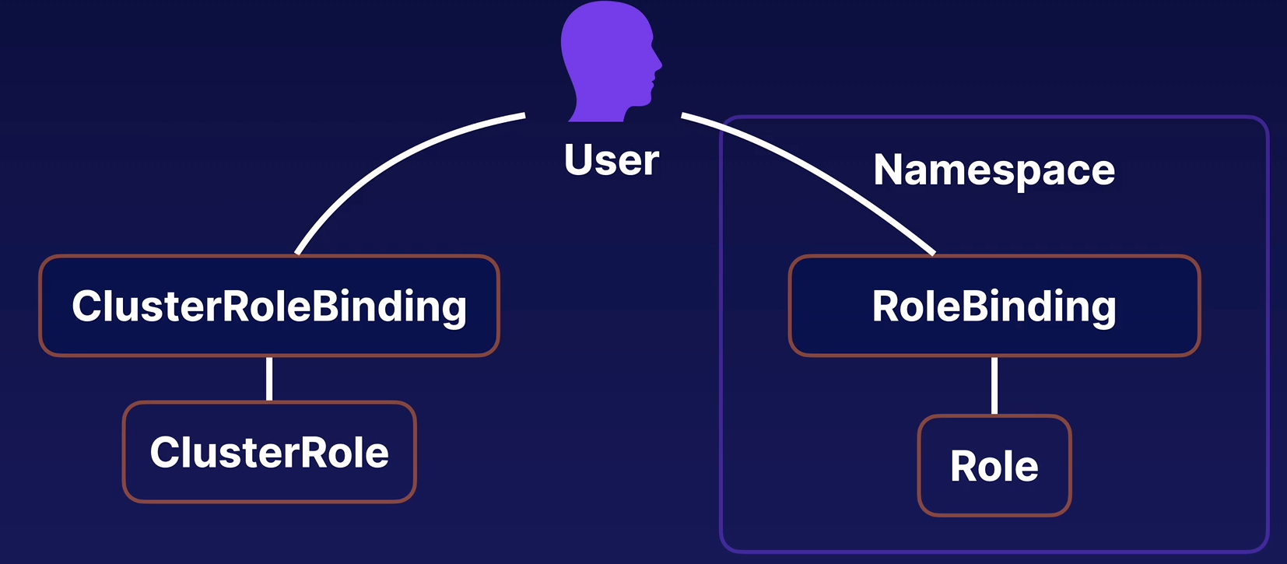

ServiceAccounts: Give Pods access to the k8s API. Their permissions are governed by regular RBAC objects.

I can use roles, clusterroles, rolebinding and clusterrolebinding with SA.

Make sure the ServiceAccount has only the necessary RBAC permissions.

Exam Tips:

- If a Container is compromised, an attacker could use the ServiceAccount to access the k8s API.

- Use k8s RBAC to control what SA can do and limit permissions to only what is necessary.

- Examine existing RoleBindings and ClusterRoleBindings to determine what pemissions a service account has.

- Design your RBAC setup in such a way that service accounts don’t have unnecessary permissions.

- You can bind multiple roles to an account. Use this to keep Roles separated rather than overloading them with a lot of permissions.

- You can bind a ClusterRole with a RoleBinding to provide the necessary permissions only within the RoleBinding’s namespace.

Restricting Access to K8s API:

K8s API: Is the HTTP interface to the cluster. When we use tools such as kubectl it is making request to this HTTP API called the K8s API.

Ways to limit access to the API:
- RBAC, give as less permissions as possible to the users/services accounts. If the attacker gains access to a compromised account will be limited for those limited permissions.

- Network segmentation / Firewalls: If the attacker tries to use an exploit to break into the API, by limiting the network access we will prevent him from even being able to attempt to reach the API.

K8s documentation

Keeping K8s Updated:

Shew versions

Keep k8s updated.

Things to know:

- Minor and Patch Versions: Minor versions are regularly patched. These patches often contain bug fixes and security fixes.

- Patch support period: The latest three minor versions receive patch support. Minor versions will receive patches for approximately one year.
- Security Patch Backports: Security patches are usually backported to active minor versions, but not always. It’s best to keep your cluster up to date.

Since version 1.19, major releases receive approximately one year of patch support.

########## System Hardening: ###########

Protect the Host OS: If the attacker gains access to the host OS he can compromise other hosts in the cluster as well as to compromize all the pods and application on the node.

Linux Namespaces: Feature of Linux Kernel that partitions kernel resources.

The key feature is that they isolate processes from each other. Each process sees its own personal view of the system (files, processes, network interfaces, hostname, etc)

By doing so you have a smaller footprint for security related concerns and a smaller blast radius for changes.

Kind of Linux Namespaces:
○ Mount (mnt)
○ Process ID (pid)
○ Network (net)
○ Inter-process communication (ipc)
○ UTS
○ User ID (user)

Containers use Linux Namespaces and cgroups to isolate them from the other containers. This meets the architectural style of microservices.

Command to create a namespace (not required for the CKS exam):
unshare --user --pid --map-root-user --mount-proc --fork bash

This command will create a new namespace with its own user and PID namespaces.
I map the root user to the new namespace (in other words, I have root privilege within the new namespace), mount a new proc filesystem, and fork my process (in this case, bash) in the newly created namespace.

Linux Control Groups, cgroups: Used to limit the amount of resources the process can consume.

OS Namespaces: Containers use them to isolate themselves from other containers and the host OS.

Don’t confuse OS Namespaces with K8s Namespaces, is a completely different concept.

In our k8s servers we have host Namespaces which are used by normal applications that are running directly on our host OS.

Containers run in completely separated Container Namespaces, and that creates some separation between containers and aswell between the host OS.
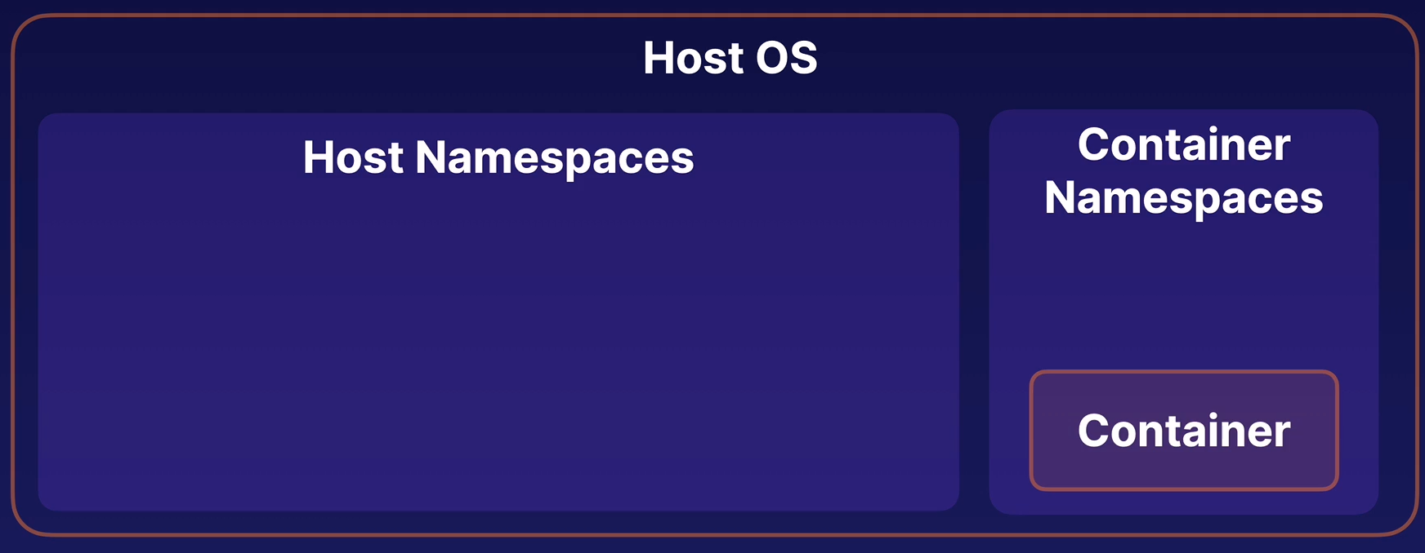
If a container is compromized the attacker can only operate within that container namespace and that isolation limits their hability to potentially compromise the host or other containers.

Use the host namespace in a Pod:
You can configure Pods to use a Host Namespace instead of their separated isolated container namespace, but this is a security risk.

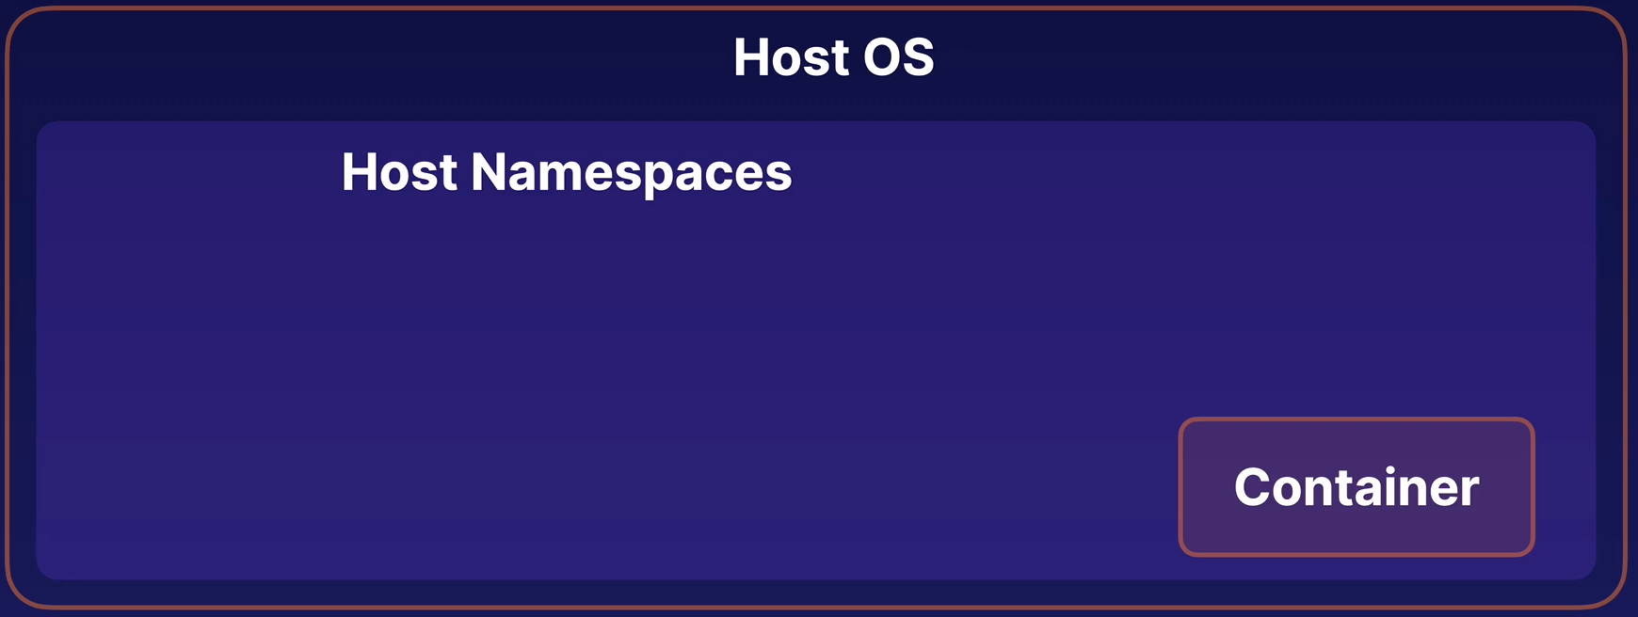

Why to do it:
You may need to do that if you have a container that needs to interact directly with the host for some reason but if that container is compromised the attacker has more hability to interact with various components of the host OS.

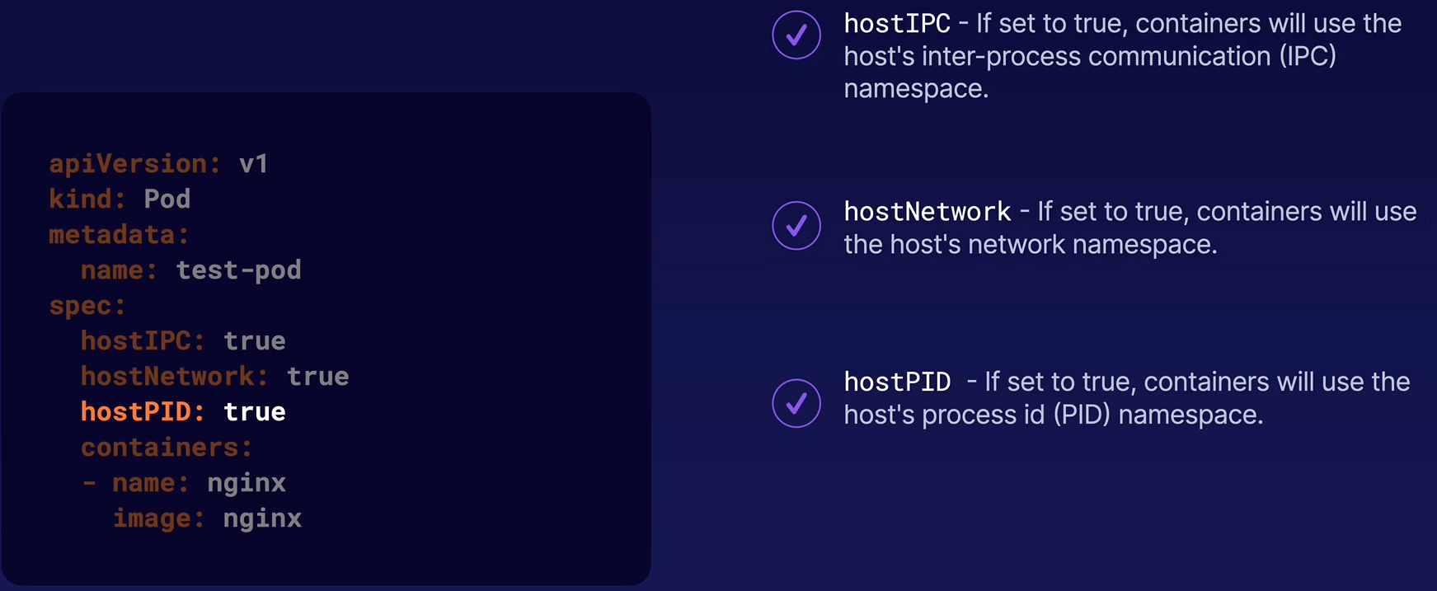
How to do it: Remember that this is a security risk
All of these settings are default to false.

Privileged mode: Allows containers to access host-level resources and capabilities, much like a non-container process running directly on the host.

Is another security risk.
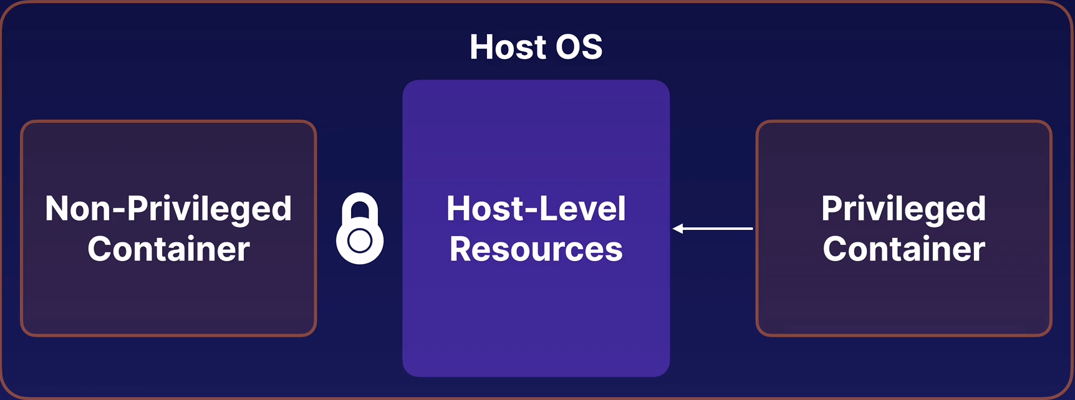

How to set it up: Remember that this is a security risk
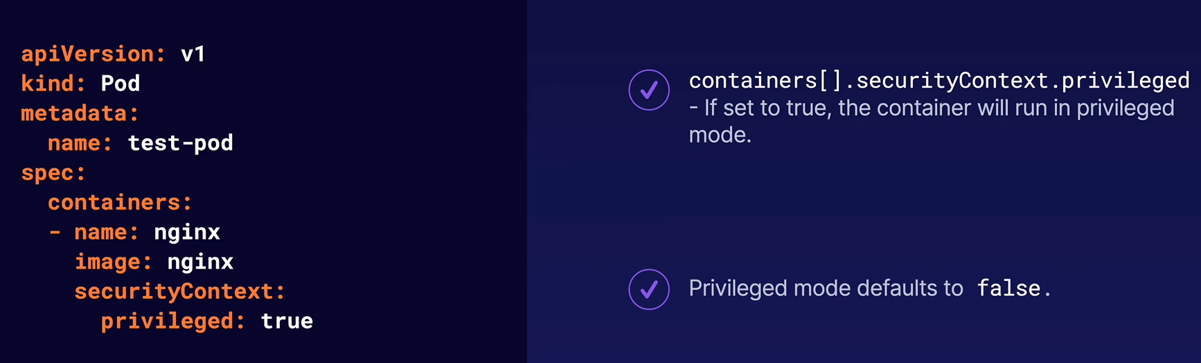

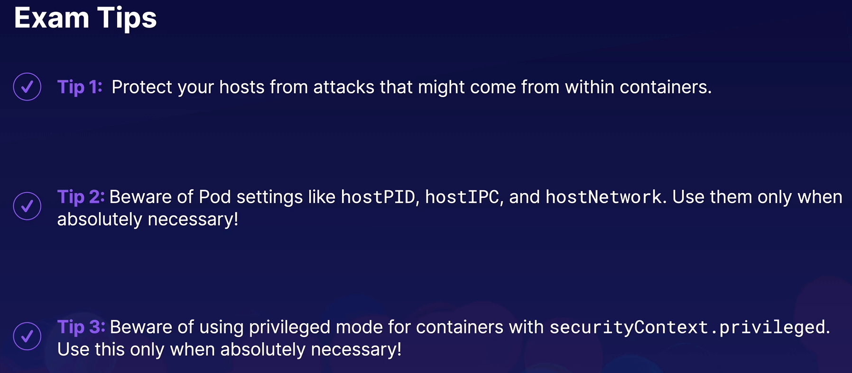

Minimizing IAM Roles:

IAM Roles: A way to provide permissions to access AWS resources.

Applications running within AWS can use AIM roles to obtain credentials and access resources in AWS.

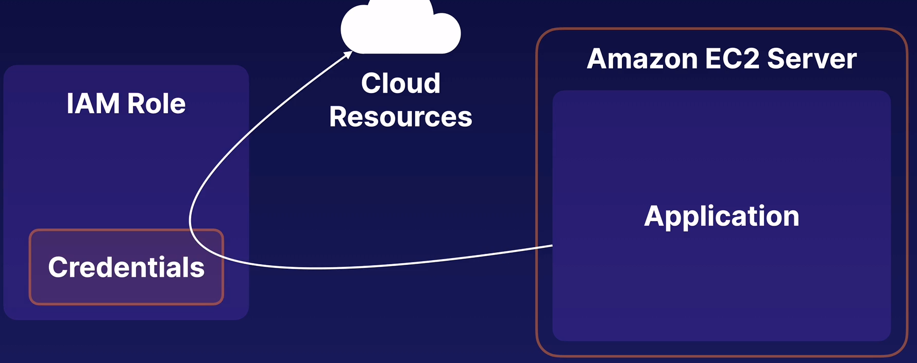
Why is this important for K8s: K8s containers running on AWS may be able to access IAM credentials and interact with resources in Amazon Cloud.

Things to keep in mind:

- Principle of least privilege: Make sure any IAM role assigned to your EC2 instance or other relevant resources have only the permissions they need, and no more.

- Block access: If your k8s applications do not need to use IAM, consider blocking access to IAM credentials (for EC2, IP address 169.254.169.254). You can block it by:
  - Firewalls on your host
  - K8s network policies
  - etc
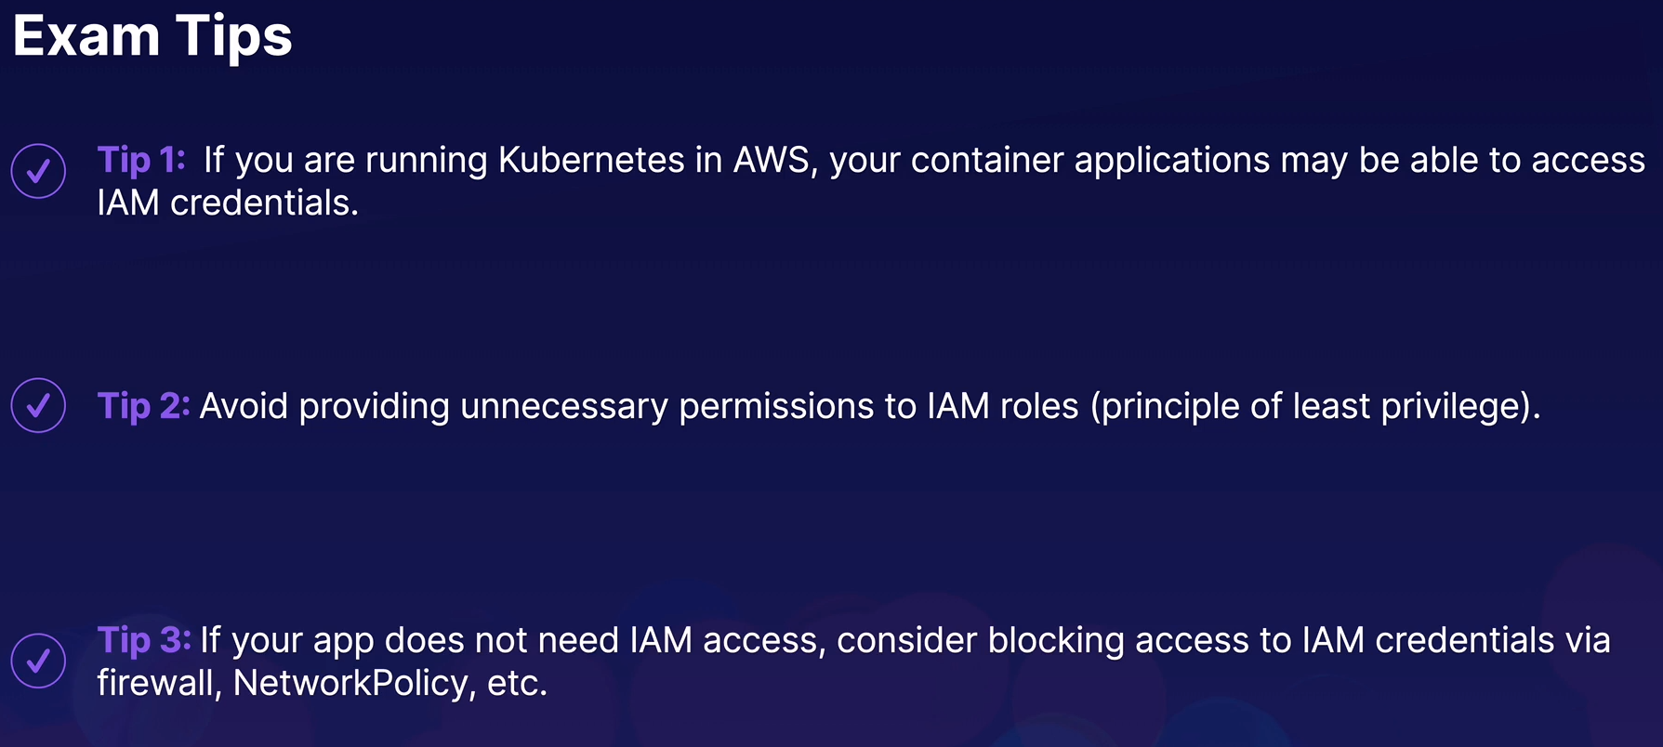

Exploring Network-Level Security:

The k8s Cluster Network: K8s uses a virtual cluster network to allow pods to communicate with other pods and services freely and transparently, regardless of which node they are on.

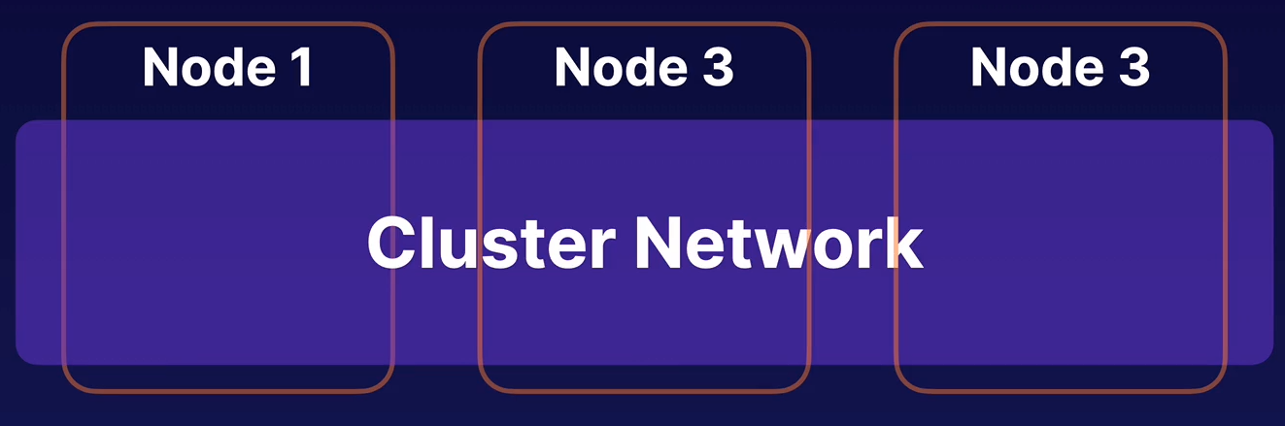
Limit access to the cluster network: from outside the cluster. By default anyone who can reach the cluster network can reach any Pod in the cluster.

Exploring AppArmor:

What AppArmor is: Linux Security Kernel Module.

Provides granular access control for programs running on Linux systems. Use AppArmor to control and limit what a program can do within the host OS.

AppArmor profile: Set of rules that define what a program can and cannot do.

For the CKS exam You don’t need to know all the details on how to write an AppArmor profile. Just need to understand what they are and how to work with and manage them.
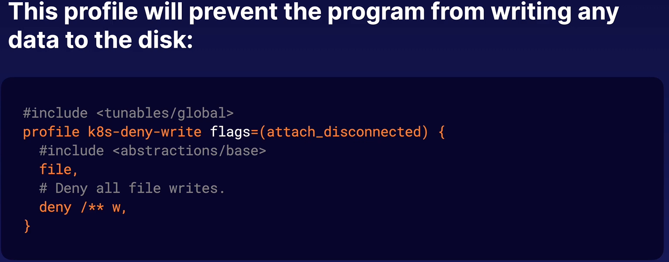
In this example the name of the profile is: k8s-deny-write

It denies any attempt by the application to write to any files on the disk.
Modes: An AppArmor profile can be loaded into AppArmor at the server level and activated in one of two modes:
- Complain Mode: Load a profile in complain mode, and AppArmor will simply generate a report on what the program is doing. This is useful for discovering what a progam does normally.

- Enforce Mode: Load a profile in enforce mode (sometimes called “enforcing” the profile), and AppArmor will actively prevent the program from doing anything that the profile does not allow.

Where to enable it: You have to enabel AppArmor on the server the Pod is running on, or the Pod won’t start.

So you have to set up the same AppArmor profiles in all the nodes of the cluster.

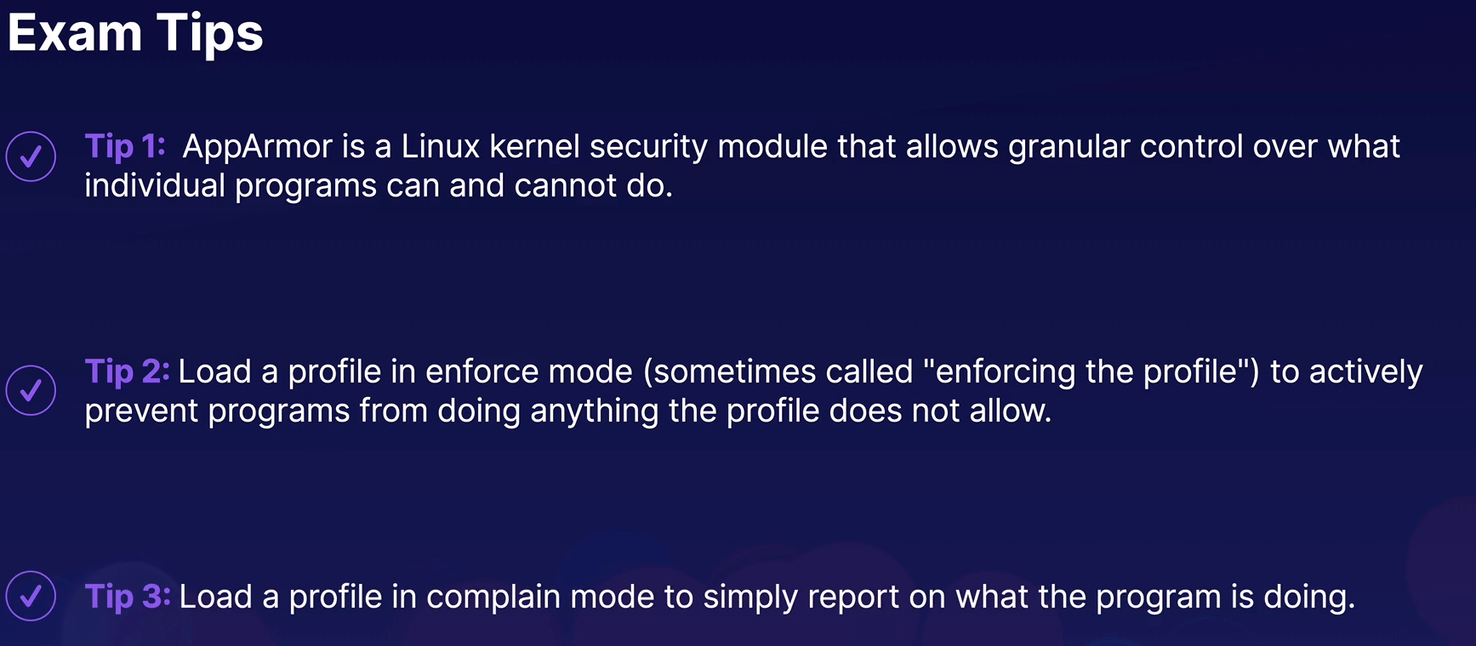

Using AppArmor in k8s Containers:

Apply AppArmor Profiles: An AppArmor profile can be stored in a file and applied using the apparmor_parser command:
sudo apparmor_parser /path/to/file
By default the command will load the profile in enforce mode. Use the -C flag for complain mode.
You will need to move the file to /etc/apparmor.d/ and change its owner to root

Do it in all nodes: load the same profile in all k8s nodes

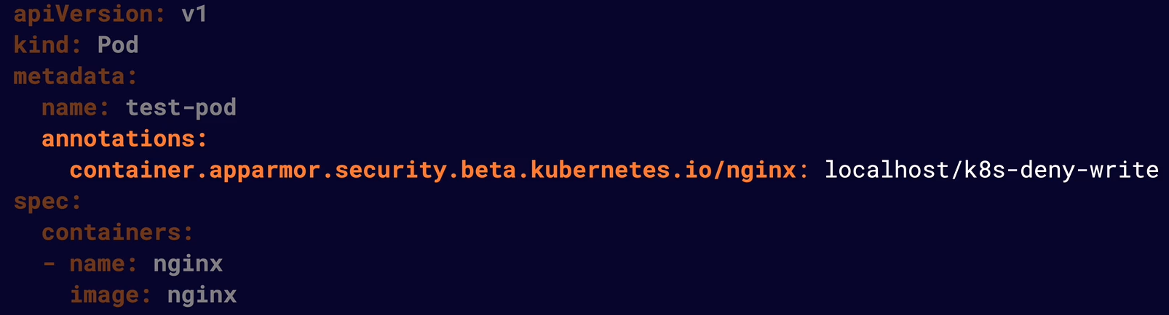
Inject the profile to the containers: You apply it by using annotations
The annotation name should begin with:
- container.apparmor.security.beta.kubernetes.io

- Followed by the name of the container: nginx in this example

- The annotation value should be localhost/ followed by the name of the AppArmor profile

K8s pod:
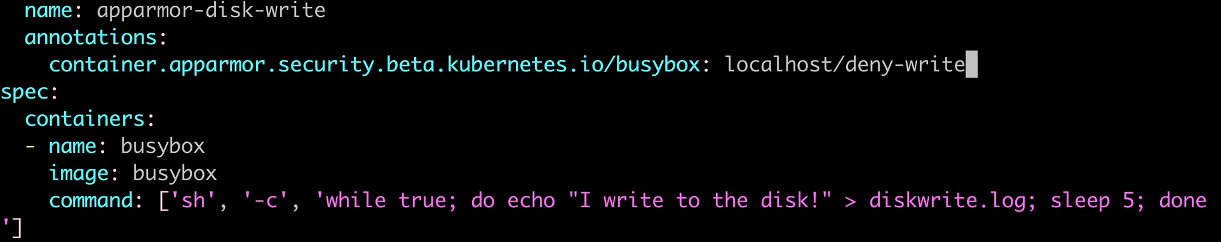
NOTE: Changed the image from nginx to busybox in this example.

Blocked status of the Pod: If you inject an AppArmor profile into a Pod and you didn’t applied the profile into all nodes, your pod will appear as:
READY STATUS
0/1 Blocked

You will need to create that profile in all the k8s nodes. Go to all nodes and create the profile:

sudo vi /etc/apparmor.d/k8s-deny-write
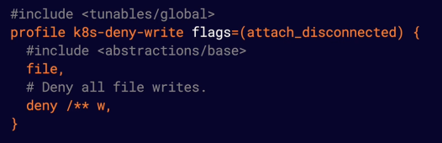

Apply the profile in all the nodes of the k8s cluster:

sudo apparmor_parser /path/to/profile

Now have to be workin: If you check k get pods you will see the status
READY STATUS
1/1 Running

Check the error logs of the pod:
k logs apparmor-disk-write

sh: can’t create diskwrite.log: Permission denied

Check diskwrite.log:
k exec apparmor-disk-write -- cat diskwrite.log → diskwrite.log No such file or directory, so the deny write profile works
Summary:

1 - Create and apply the AppArmor profile: REMEMBER to do it in all k8s nodes

vi k8s-deny-write
profile k8s-deny-write flags=(attach_disconnected) {
#include <abstractions/base>
file,
# Deny all file writes.
deny /** w,
}

sudo apparmor_parser /home/cloud_user/apparmor-k8s-deny-write

2- Move it and change permissions:
sudo cp /home/cloud_user/apparmor-k8s-deny-write /etc/apparmor.d/
sudo chown root:root /etc/apparmor.d/apparmor-k8s-deny-write

3 - Inject apparmor profile into the pod: And create the pod

apiVersion: v1
kind: Pod
metadata:
name: password-db
namespace: auth
annotations:
container.apparmor.security.beta.kubernetes.io/password-db: localhost/k8s-deny-write
spec:
containers:
- name: password-db
image: radial/busyboxplus:curl
command: ['sh', '-c', 'while true; do if echo "The password is hunter2" > password.txt; then echo "Password hunter2 logged."; else echo "Password log attempt blocked."; fi; sleep 5; done']

4 -Check that is working:
k logs -n auth password-db
sh: can't create password.txt: Permission denied
Password log attempt blocked.

k exec -n auth password-db -- cat password.txt
cat: can't open 'password.txt': No such file or directory
command terminated with exit code 1

Commands:
Check apparmor status:
sudo aa-status
sudo aa-status --prety-json

########## Minimizing Microservice Vulnerabilities: ###########

Managing Container Access with Security Context:

What is Security Context: Is a portion of the pod and container specification that allows you to provide special security and access control settings at the pod and container level.

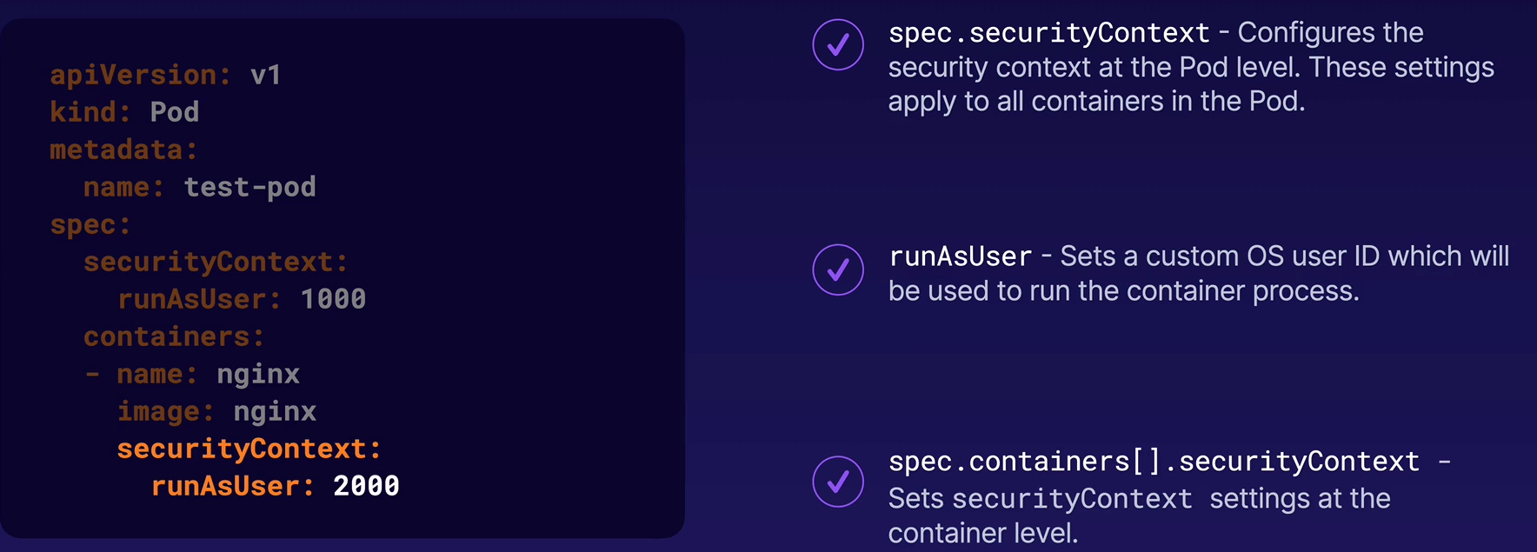
API reference POP Security context
API reference Container Security context

Example:

A securiy context at Pod level allowing the user 1000 to run it.

A security context at the Container level not allowing privilege scalation.
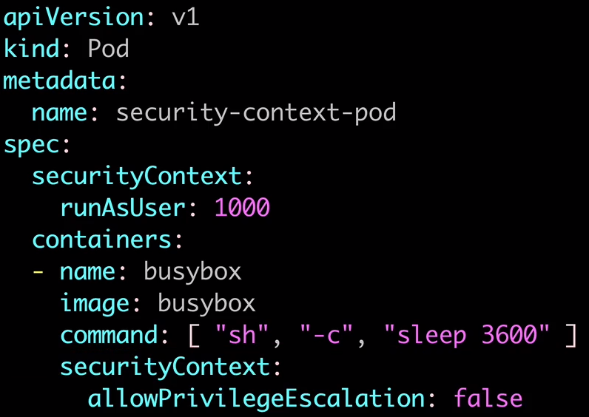

AAAAA

