CI / CD:

CI / CD: Software development best practice. Stands for Continuous Integration, Continuous Delivery or Continuous Deployment.

Make small changes and automate everything: Require to make small, incremental code changes. We automate as much as possible, example: code integration, build, test and deployment tasks.

And by doing that its possible to make code releases on a regular basis adding new features to the app/website and fixing bugs as well.

Modern companies like Google, Facebook, Netflix, AWS, etc pioneered this approach to releasing code, successfully applying thousands of changes per day without impacting the production systems.

By doing that they are able to bring to the market brand new features and services enabling these companies to became a very successful market leaders.

Continuous Integration: Integrating or merging the code changes frequently, at least one per day.

Continuous Delivery: Automating the build, test and deployment functions. Managed by humans.

Continuous Deployment: Fully automated release process. The code is deployed to Staging or Production as soon as it has successfully passed through the release pipeline.

Benefits of the CI/CD Approach:
- Automating is Good: Fast, repeatable, scalable, enables rapid deployment.

- Manual is Bad: Slow, error prone, inconsistent, unscalable, complex.

- Small changes: Test each code change and catch bugs while they are small and simple to fix.

Example Continuous Integration Workflow:

- Shared Code Repository: Multiple developers contributing to a shared code repo like git. Frequently merging or Integrating code updates, typically on a daily basis.

- Automated Build stage: When changes appear in the code repo this triggers an automated build of the new code.

- Automated Test step: Run automated tests to check the code locally before it is commited into the master code repo.

Example Continuous Delivery & Continuous Deployment Workflow:

- Code is Merged: After successful tests, the code gets merged to the master repo.

- Prepared for Deployment: Code is built, tested and packaged for deployment.

- Manual Decision: Humans may be involved in the decision to deploy the code. This is know as Continuous Delivery.

- Or Fully Automated: The system automatically deploys the new code as soon as it has been prepared for deployment. This is known as Continuous Deployment.

Udemy Course:

https://www.udemy.com/course/valaxy-devops/learn/
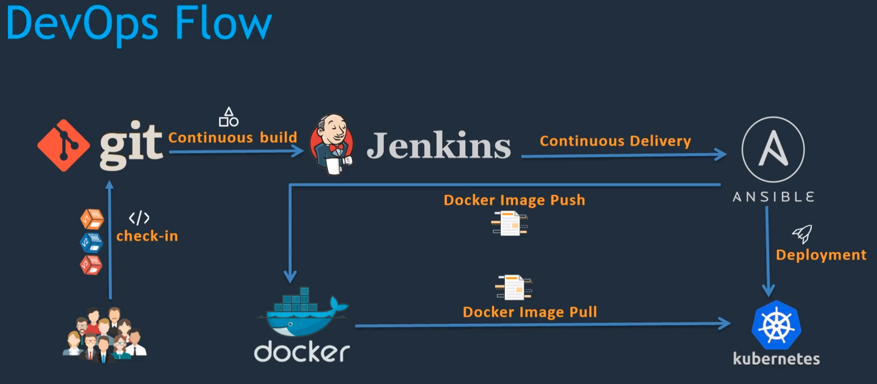

CI/CD (delivery and depoyment):
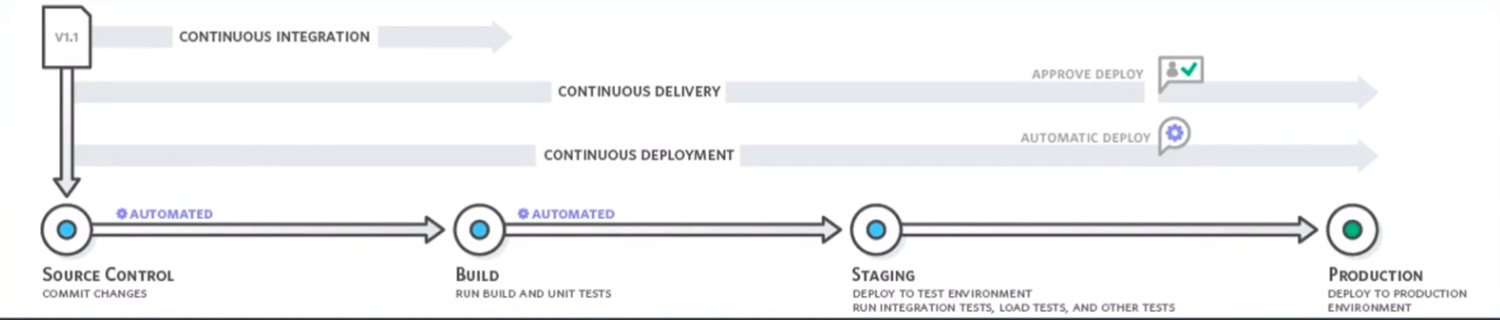
Continuous Integration:
- Developers push the code to the scm (source code management system, git in this example)

- Once the code is in the scm the CI tool, jenkins in this example, could be able to identify and pull the code automatically and run Build and Unit Tests. At the end of the Continuous integration process we will have an Artifact.
Continuous Delivery:
- Deploying this Artifact to the Target environment Staging environment we call this Continuous Delivery.

- In Staging run integration, load, performance and other tests.

- Once the tests looks fine the human intervention decides to deploys it to the Production environment or not.

Continuous Deployment:
- In Continuous Deployment once all the tests on Staging are ok is deployed automatically to Prod without human intervention.

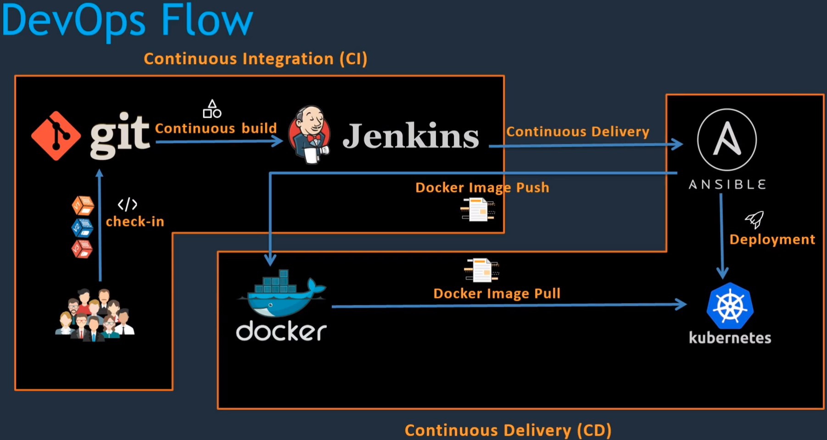

Install Jenkins
Installation process
Reset Jenkins Admin password

Create an Amazon Linux free tier EC2 instance. Create a Security Group opening the port 8080 to the world.

Install java: yum install java-1.8*
and add the path into the bash profile: find /usr/lib/jvm/java-1.8* | head -n 3

Install and start jenkins

Get into it http://34.240.125.165:8080 → take the correct ip from aws console

Don’t install any suggested pluggins yet, skip this step closing the tab.
Change the password in Admin user -- Configure -- change the pass. Keep it in a safe place, don’t lose it -- apply and save. Will kick you out from the app, refresh the page.

Set up java home path: Manage jenkins - Global Tool Configuration - Add JDK - JAVA_HOME - /usr/lib/jvm/java-1.8.0-openjdk-1.8.0.265.b01-1.amzn2.0.1.x86_64

apply and save.

Run First Jenkins Job:

New Item -- My_First_Job -- select free stile project, Ok -- Add description -- Build: Execute Shell -- Command: echo “Welcome to DevOps Project” apply & save

Run the job: Build Now

Install & setup Git:

In the server: yum install git -y

In jenkins, install the pluggins: Manaje Jenkins -- Manage Plugins -- Available -- search: github --
tick GitHub and Install without restart. Will install all the dependencies, git among them.

Set up git: Manage Jenkins -- Global Tool Configuration -- Git -- Name: github -- Path to Git executable: /usr/bin/git -- apply & save

Setup Maven:

Install maven

Follow the instructions. Check in the maven website the last version of maven, currently 3.6.3

Then install the plugins on jenkins, go to plugin manager like with git. Search for maven.

Tick Maven Integration, Maven Invoker -- install without restart.

Set up maven path. Manage Jenkins -- Global Tool Configuration -- Add Maven -- untick install automatically -- Name: M2_HOME , Maven_HOME: /opt/maven/apache-maven-3.6.3 -- apply & save.

