K8s = Kubernetes

W02TqnNPlo02

Containers: Are a bit like virtual machines, but they are smaller and start up faster.

Wrap software in independent portable packages, making it easy to quickly sun software in a variety of environments.

Helps to ensure high availability and make it easy to scale resources.

Containers let’s you to run a variety of software components across a cluster of generic software.

Container Runtime: Software that execute containers and manage container images on a node.

Docker is leading the container runtime market, but there are others like Lxd,Rkt (rocket) or Containerd.

Container orchestration tool (cot): The goal is to automate our application infrastructure and make it easy to manage.

If I want to scale up several containers to handle additional load, deploy new code to my entire cluster or ensure that multiple instances of a piece of software are spread across multiple servers for HA I can do it manually, taking a lot of time, or using a container orchestration tool.

Kubernetes: Is a container orchestration tool.
Was created by google to manage it’s infrastructure. Is an open source software maintained by several companies and is leading by far the cot market.

https://kubernetes.io/docs/tutorials/kubernetes-basics/
https://vimeo.com/245778144/4d1d597c5e

Can relocate the app components anytime. Takes care of the service discovery, scaling, load balancing, self healing, etc.

Under the hood, kubernetes uses an API server to manipulate docker (or the container run time)

run: sudo ps docker → you will see all the containers there.

POD: Smallest unit of kubernetes. Can be either a single container or group of containers.
All containers in a pod have the same IP
All pods in a cluster have unique IPs in the same IP space (range).

IP Space: If one pod in the worker 1 have 10.10.10.x the other pods in the same and other worker nodes will have an IP from the same range.

All the pods in the same cluster are in the same IP space.

Software defined network (SDN): Flannel by Coreos, Weave Net by WeaveWorks,etc.

CNI: Container network interface

All k8s networking have to follow these rules:
- All containers can communicate with all other containers without NAT
- All nodes can communicate with all containers (and vice versa) without NAT
- The IP address that the container sees itself as is the IP that other see it as.

Flannel: https://github.com/coreos/flannel/
It’s very simple to use, doesn’t have network policies like Calico or others,

You only have to run this command flannel installs everything:

kubectl apply -f https://raw.githubusercontent.com/coreos/flannel/master/Documentation/kube-flannel.yml

Flannel runs flanneld on each host.

DNS:
Containers that are in one namespace than need to reach containers in another namespace they have to do a full lookup to the DNS server for a record of the other namespace.

Minikube: Runs a single kubernetes node cluster using a virtual machine on my computer.

Web UI (Dashboard): Dashboard UI. Web based kubernetes user interface. Created by google and more companies. Quite similar to GCP UI.

Components: Kubernetes consist on multiple components working together in order to provide the overall functionality of a k8s cluster. Many of them are running as pods.

For control-plane (Master Node)
Can not contain pods or be responsible for running the application components.
Can be replicated for HA.

- API Server: Serves the k8s API, the primary interface for the cluster. Simple REST based web API. All cluster components (scheduler,controller manager,kubelet, kube-proxy, etc ) are pointing towards it to request information.

- Scheduler: Assigns your app to a worker node. Auto-detects which pod to assign to which node based on resources requirements, hardware constraints, etc.

- Controller Manager: Maintains the cluster. Handles node failures, replicating components, maintaining the correct amount of pods, etc.

Operates the cluster controllers:
- Node Controller: Responsible for noticing and responding when nodes go down.
- Replication Controller: Responsible for maintaining the correct number of pods for every replication controller object in the system
- Endpoints Controller: Populates the Endpoint object, example: joins services and pods
- Service Account & Token Controllers: Creates default account and API access tokens for new namespaces.

- etcd: Provides distributed, synchronized data storage for the cluster state. Not only stores the data, ensures that is synchronized across all the nodes. Stores the cluster configuration.

Is a database where all of the objects within the k8s cluster are described.

Recommended to back this up.

For all the individual nodes (workers, masters)
Responsible for running the application, monitoring it and providing the services that it needs.

- kubelet: Daemon. Runs and manages the containers on the node and talks to the API server.

Middle man between k8s API and the container runner. When a container need actually to be ran on a node, control-plane reaches out on that node and then the kubelet on that node instructs the container runner to go ahead and run that container.

Is not running as a pod, runs as a service: sudo systemctl status kubelet

- kube-proxy: Load balances traffic between application components.

Handles networking communications between nodes. Routes traffic. Writes firewall rules to the routing tables of each nodes to allow the traffic to be routed properly.

- Container runtime: Daemon.The program that runs the container (docker, rkt, containerd)

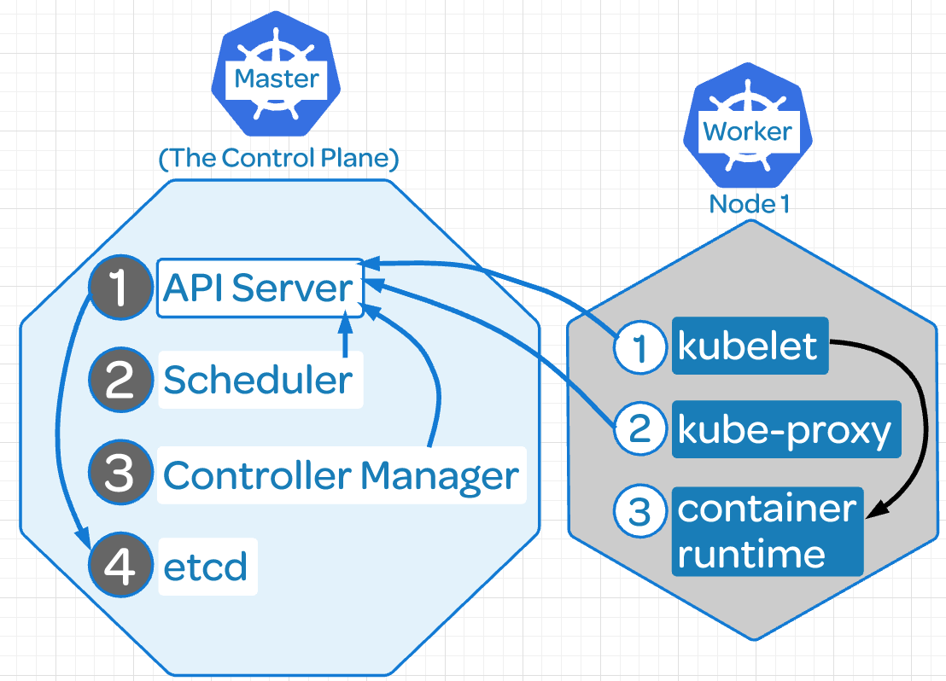

Declarative intent: Instead of having to manually check the cluster, k8s does this automatically it just says which status should be in.

Keystrokes: https://kubernetes.io/docs/reference/kubectl/cheatsheet/
See version:
- docker: sudo docker version
- kubeadm: sudo kubeadm version
- kubectl: sudo kubectl version

Get Nodes: kubectl get nodes

See all pods: kubectl get pods --all-namespaces -o wide
kubectl get pods -n kube-system
kubectl get pods -n <namespace> -w (w is like tail -f)

kubectl get nodes -o yaml
kubectl get nodes -o name
kubectl get nodes -o wide
Custom query to pods:
kubectl get pods -o custom-columns=POD:metadata.name,NODE:spec.nodeName --sort-by spec.nodeName -n kube-system

Describe nodes: kubectl describe nodes
kubectl describe

See deployment: kubectl get deployment
See services: kubectl get svc

Component Status: kubectl get componentstatus

Reset kubeadm: kubeadm reset → will remove the worker node from the cluster, then you can join the node again

Check logs: journalctl -u kubelet
/var/log/pods/(pod number)
kubectl get po --namespace kube-system -l app=flannel
kubectl logs --namespace kube-system <POD_ID> -c kube-flannel
kubectl logs --namespace kube-system kube-flannel-ds-amd64-2mwxm -c kube-flannel

See docker available versions: apt-cache madison docker-ce

Services: systemctl status kubelet

Configuration files: /etc/kubernetes/manifests/kube-controller-manager.yaml
Kube configuration: root/.kube/config

Check web server: kubectl exec busybox -- curl 10.244.1.4

Get inside a node:
kubectl exec -it nginx-7cdbd8cdc9-q9x78 /bin/bash
it stands for interactive

Do a loop to test autoscaling: hpa
while true; do wget -q -O http:/<your address here>; done

Check hpa: kubectl get hpa
Check hpa in live: whatch “kubectl get hpa”

Check who is the leader in HA:
kubectl get endpoints kube-scheduler -n kube-system -o yaml

Find the label applied to the etcd pod on the master node:
kubectl get pods --all-namespaces --show-labels -o wide

Delete a pod:
This will delete the pod but if is in a deployment the pod will be created again straigh away:
root@andrewjobson1c:~# kubectl delete pods -n myy-ns test-5bdd698494-7xx8b
pod "test-5bdd698494-7xx8b" deleted

Delete a deployment:
Here we are deleting the deployment test2 that have the namespace myy-ns
kubectl delete deployments test2 -n myy-ns

Alias:
alias kc='kubectl'
alias kgp='kubectl get pods'
alias kgs='kubectl get svc'
alias kgc='kubectl get componentstatuses’
alias kctx='kubectl config current-context’
alias kcon='kubectl config use-context’
alias kgc='kubectl config get-context'

Check state of etcd: etcdctl endpoint health

Enable kubernetes autocompletion:

There are two ways to do it:
1 -Source the completion script in your ~/.bashrc file:
echo 'source <(kubectl completion bash)' >>~/.bashrc

2 -Add the completion script to the /etc/bash_completion.d directory:
kubectl completion bash >/etc/bash_completion.d/kubectl

K8s Deployments:

Type of object on k8s. Allows you to automate the management of the pods.
Let’s you to specify a desired state for a set of pods.

Scaling: With a deployment you can specify the number of replicas (pods) you want and the deployment will create or remove pods to meed that number of replicas.

Deployment makes sure that the replicas are evenly spread out across your multiple worker nodes for HA and a lot more useful functionality like that.

Updates: With deployments, you can change the deployment image to a new version of the image.
The deployment will gradually replace existing containers with the new version in order to avoid downtime, not like ReplicaSets.

Instead of removing the old pods and spin up the new ones will gradually spin the new ones and gradually replace and remove the old pods on an incremental fashion without incurring in any downtime for the users.

Self-Healing: If one pod is destroyed in the deployment will be immediately replaced by a new one by the deployment.

If the deployment says that I need 4 replicas for my application and anything happens to reduce that number, the deployments will spin the necessary replicas to have 4 working.

cat <<EOF | kubectl create -f -
apiVersion: apps/v1
kind: Deployment
metadata:
name: nginx-deployment
labels:
app: nginx
spec:
replicas: 2
selector:
matchLabels:
app: nginx
template:
metadata:
labels:
app: nginx
spec:
containers:
- name: nginx
image: nginx:1.15.4
ports:
- containerPort: 80
EOF

It worked:
deployment.apps/nginx-deployment created

root@andrewjobson1c:~# kubectl get po
NAME READY STATUS RESTARTS AGE
nginx-deployment-9b644dcd5-wgbdc 1/1 Running 0 44s
nginx-deployment-9b644dcd5-ws6xk 1/1 Running 0 44s

root@andrewjobson1c:~# kubectl describe deployment nginx-deployment
Name: nginx-deployment
Namespace: default
CreationTimestamp: Fri, 05 Jul 2019 08:36:18 +0000
Labels: app=nginx
Annotations: deployment.kubernetes.io/revision: 1
Selector: app=nginx
Replicas: 2 desired | 2 updated | 2 total | 2 available | 0 unavailable
StrategyType: RollingUpdate
MinReadySeconds: 0
RollingUpdateStrategy: 25% max unavailable, 25% max surge
Pod Template:
Labels: app=nginx
Containers:
nginx:
Image: nginx:1.15.4
Port: 80/TCP
Host Port: 0/TCP
Environment: <none>
Mounts: <none>
Volumes: <none>
Conditions:
Type Status Reason
---- ------ ------
Available True MinimumReplicasAvailable
Progressing True NewReplicaSetAvailable
OldReplicaSets: <none>
NewReplicaSet: nginx-deployment-9b644dcd5 (2/2 replicas created)
Events:
Type Reason Age From Message
---- ------ ---- ---- -------
Normal ScalingReplicaSet 3m20s deployment-controller Scaled up replica set nginx-deployment-9b644dcd5 to 2

Deleting a pod, the deployment will spin up one new pod and will be operative is seconds.

root@andrewjobson1c:~# kubectl get po
NAME READY STATUS RESTARTS AGE
nginx-deployment-9b644dcd5-wgbdc 1/1 Running 0 44s
nginx-deployment-9b644dcd5-ws6xk 1/1 Running 0 44s

root@andrewjobson1c:~# kubectl delete pod nginx-deployment-9b644dcd5-ws6xk
pod "nginx-deployment-9b644dcd5-ws6xk" deleted

This will take a few seconds

NAME READY STATUS RESTARTS AGE
nginx-deployment-9b644dcd5-wgbdc 1/1 Running 0 44s
nginx-deployment-9b644dcd5-nvlmb 1/1 Running 0 7s

In bold the new pod created seven second ago.

Another Example:

Deploying nginx v1 with two replicas.

Update the nginx image, from v1 to v2:
root@andrewjobson1c:~/k8s_files# kubectl set image deployment.v1.apps/example-deployment nginx=darealmc/nginx-k8s:v2
deployment.apps/example-deployment image updated

See how the deployment takes care of removing the old pods (nginx v1) and creating the new ones (nginx v2)

First create a new one, example-deployment-56d5dfc87f (second 29)
The remove one of the old ones (second 25)
After that creates the second one
And then remove the last one of the old pods (second 22)
All this to avoid to lose the website.

root@andrewjobson1c:~/k8s_files# kubectl describe deployments example-deployment
[...]
OldReplicaSets: <none>
NewReplicaSet: example-deployment-56d5dfc87f (2/2 replicas created)
Events:
Type Reason Age From Message
---- ------ ---- ---- -------
Normal ScalingReplicaSet 11m deployment-controller Scaled up replica set example-deployment-6d98cb87fb to 2
Normal ScalingReplicaSet 29s deployment-controller Scaled up replica set example-deployment-56d5dfc87f to 1
Normal ScalingReplicaSet 25s deployment-controller Scaled down replica set example-deployment-6d98cb87fb to 1
Normal ScalingReplicaSet 25s deployment-controller Scaled up replica set example-deployment-56d5dfc87f to 2
Normal ScalingReplicaSet 22s deployment-controller Scaled down replica set example-deployment-6d98cb87fb to 0

Services:
Provide load balanced usage for a dynamic list of pods.
Pods are constantly being created and destroyed. To allow us to access to the application inside the pods we are using services.

Services are an abstraction layer on top of a set of pods. You can access the services rather than the pods.

If I do a request to a k8s service I’m going to get a response from one of the pods that is part of that service. And even if the list of the pods changes, the service is going to ensure that my request is always routed to one of the currently active pods that is part of the service.

cat << EOF | kubectl create -f -
kind: Service
apiVersion: v1
metadata:
name: nginx-service → name that the service will have
spec:
selector:
app: nginx
ports:
- protocol: TCP
port: 80
targetPort: 80
nodePort: 30080 → allows the service to be exposed externally, there are other better ways.
type: NodePort
EOF

- Check that the service is working:

root@andrewjobson1c:~# kubectl get svc
NAME TYPE CLUSTER-IP EXTERNAL-IP PORT(S) AGE
kubernetes ClusterIP 10.96.0.1 <none> 443/TCP 2d6h
nginx-service NodePort 10.110.240.122 <none> 80:30080/TCP 12h

The k8s service is there by default.

Do a call to the service internally:

root@andrewjobson1c:~# curl localhost:30080
<!DOCTYPE html>
<html>
<head>
<title>Welcome to nginx!</title>
<style>
body {
width: 35em;
margin: 0 auto;
font-family: Tahoma, Verdana, Arial, sans-serif;
}
</style>
</head>
<body>
<h1>Welcome to nginx!</h1>
<p>If you see this page, the nginx web server is successfully installed and
working. Further configuration is required.</p>

<p>For online documentation and support please refer to
<a href="http://nginx.org/">nginx.org</a>.<br/>
Commercial support is available at
<a href="http://nginx.com/">nginx.com</a>.</p>

<p><em>Thank you for using nginx.</em></p>
</body>
</html>

Do a call externally. Use the IP of the master node + the nodeport, 300800 in this example:

On your browser:

http://34.251.57.128:30080/

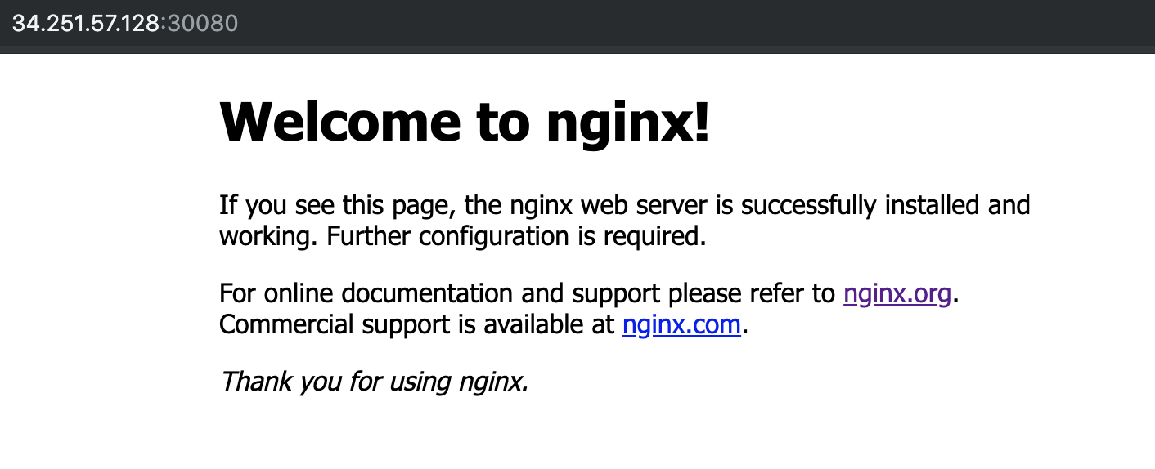

Another option:

You can expose the service to an already created deployment:

root@ip-10-0-1-109:~# kubectl expose deployment nginx --port 80 --type NodePort
service/nginx exposed

More tests:
We have 2 nginx pods and we created the service: my-awsome-service

root@andrewjobson1c:~/k8s_files# cat service-example.yml
kind: Service
apiVersion: v1
metadata:
name: my-awesome-service
spec:
selector:
app: nginx
ports:
- protocol: TCP
port: 32768
targetPort: 80

See the IPs of all the nodes of the service: endpoints
root@andrewjobson1c:~/k8s_files# kubectl describe service my-awesome-service
Name: my-awesome-service
Namespace: default
Labels: <none>
Annotations: <none>
Selector: app=nginx
Type: ClusterIP
IP: 10.108.195.105
Port: <unset> 32768/TCP
TargetPort: 80/TCP
Endpoints: 10.244.1.24:80,10.244.2.17:80
Session Affinity: None
Events: <none>

Check if nginx is running: Pick the port we configured when ran the service, 32768 in this example:

root@andrewjobson1c:~/k8s_files# curl --head 10.108.195.105:32768
HTTP/1.1 200 OK
Server: nginx/1.15.7
Date: Wed, 31 Jul 2019 14:29:19 GMT
Content-Type: text/html
Content-Length: 141
Last-Modified: Sat, 15 Dec 2018 04:13:27 GMT
Connection: keep-alive
ETag: "5c147f67-8d"
Accept-Ranges: bytes

Check the DNS from another container: because the pods can see the DNS

nslookup my-awsome-service

Will tell you the IP of the service, 10.108.195.105, and the whole domain my-awsome-service.default.svc.cluster.local

Lets scale 2 pods more: kubectl scale rs/frontend --replicas=4

Now we have 4 IPs
kubectl describe service my-awesome-service
[...]
Endpoints: 10.244.1.24:80,10.244.1.25:80,10.244.2.17:80 + 1 more...
[...]

Microservices:

Essentially microservices are an application architecture.

Until now we were using monolithic architecture, all the parts of the application are combined in one large executable file.

Microservices are small, independent services that work together to form a whole application.

Advantages:
- Scalability: If you need extra resources for a part of your application you can scale it for that specific part, not for the whole application like in monolithic applications.
- Cleaner code: The more small parts of the code, the cleaner tend to be and more easy to understand. Is easy to maintain because you can change code in one area without affecting the others.
- Reliability: If you have a bug in one area is less likely that the whole application is gonna be affected.
- Variety of tools: Different parts of the application can use different languages, frameworks and tools. The right tool can be used for every job.

K8s helps a lot to manage all this.

On the other hand microservices are quite complex to maintain.

Sample of microservice application: https://github.com/linuxacademy/robot-shop

Deploy microservices: Robot-shop

We are going to see how microservices works and how fast are the services deployed and running.

Download the robo-shop git repo that contains several ymls with deploys and services for each one of the applications needed to run it.

Mysql
mongodb
rabbitmq
nginx
java
nodejs
python
etc,

A lot of different technologies running separately and working over k8s that will bring the website up and working correctly.

1) Clone the repository:
cd ~/
git clone https://github.com/linuxacademy/robot-shop.git

2) Create a namespace: To put together all the services and be able to call them at once.

root@andrewjobson1c:~# kubectl create namespace robot-shop
namespace/robot-shop created

3) Deploy the app:
kubectl -n robot-shop create -f ~/robot-shop/K8s/descriptors/

Will run the ymls and will create the deploys and sevices.

Check how the containers are being created in live, like with tail -f

kubectl get pods -n robot-shop -w

Now you can access to the web application via browser: http://<ip_of_master_server>:30080 (port on web-service.yml)

4) Add an exta mongodb container:

Due the high number of users connecting to the web we need to scale another mongodb container:

kubectl edit deployment mongodb -n robot-shop

Change: replicas to 2

Check the status of the deployment:
kubectl get deployment mongodb -n robot-shop

Scale:

kubectl scale <?> nginx –replicas=5
Will add 5 nodes until the deployment nginx, so will modify the configuration and then always will have 5 replicas unless we change it.

Build HA kubernetes cluster:

Highly Available Topologies in Kubernetes

You can set up a HA k8s cluster:

- Stacked control plane nodes: This approach requires less infrastructure. The etcd members and control plane nodes are co-located.

- External etcd cluster: This approach requires more infrastructure. The control plane nodes and etcd members are separated.

All components on kubernetes can be replicated but only some of them can operate simultaneously.

Control manager and scheduler can only have 1 instance running at the same time, the rest will be on stand by.

* The leader elect option controls which master node is active and who is in stand by.

How to check who is the leader elect option:
The leader election mechanism is used by creating an end point resource, you can see it on the kube-scheduler yml:

kubectl get endpoints kube-scheduler -n kube-system -o yaml
kubectl get endpoints kube-controller-manager -n kube-system -o yaml

root@andrewjobson1c:~# kubectl get endpoints kube-controller-manager -n kube-system -o yaml
apiVersion: v1
kind: Endpoints
metadata:
annotations:
control-plane.alpha.kubernetes.io/leader: '{"holderIdentity":"andrewjobson1c.mylabserver.com_147bf56d-abfb-11e9-8f0e-02ea1481d388","leaseDurationSeconds":15,"acquireTime":"2019-07-21T21:04:17Z","renewTime":"2019-07-21T22:44:48Z","leaderTransitions":0}'
creationTimestamp: "2019-07-21T21:04:17Z"
name: kube-controller-manager
namespace: kube-system
resourceVersion: "8939"
selfLink: /api/v1/namespaces/kube-system/endpoints/kube-controller-manager
uid: 1a656ae9-abfb-11e9-a69f-02ea1481d388

Once becoming the leader it must periodically update the resource, happening every 2 second by default.

Minimum Resources:

HA Cluster | Required nodes | CPU | RAM | Total
Stacked control plane nodes | 3 Control Plane  3 Worker | 2 each node | 2 GB each node | 6 nodes  12 CPU  12 GB Ram
External etcd cluster | 3 Control Plane  3 etcd hosts  3 Worker | 2 each node | 2 GB each node | 9 nodes  18 CPU  18 GB Ram

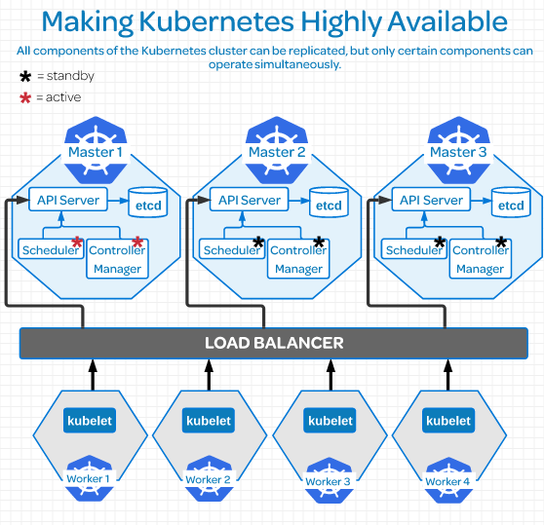

Replicate etcd:

***************************************************************************************Due to the distributed nature of etcd it’s instances can be in:

- Stacked etcd topology: Each control plane node creates a local etcd member, and the etcd member communicated only with the kube-apiserver of this node.

- External etcd topology: Etcd is external to the k8s cluster.

Etcd uses Raft Consensus Algorithm (Graphical explanation)which requires a majority in order to progress to the next state.

There must be more than half taking part on that state change. In order to have a majority you must have an ODD number of etcd instances therefore the minimum number of instances must be 3 to have a etcd external topology cluster.

Having 2 etcd instances is worst than having one because this reason.

On larger dev environments most of the time you won’t need more than 7 etcd instances.

Links:
Creating Highly Available Kubernetes Clusters with kubeadm
Operating a Highly Available etcd Cluster
Easy explanation of etcd consensus

Configuring Secure Cluster Communications:
Controlling Access to the Kubernetes API
Kubectl , command line tool: It’s a translator to the k8s API
API server provides a CRUD (Create, Read, Update,Delete) interface for querying and modifying the cluster state over a RESTful API.

Who can use CRUD, only:
- The client, like Users
- PODs

Let’s create a POD:
- We make the kubectl command to create a POD
- It sends a request to the API server via http POST request
- Goes to Authentication
- Authorization
- Admission
- Resource Validation
- The state is stored on the persistent datastore etcd
- API server returns a response.

Different plugins/modules: On each Authentication, authorization and Admission control phases there are multiple plugins allowing you find out different things about the request.

Authentication → Who is sending the request.
Authentication method can be determined by http heather or certificate.
Once found the request returns the username, user id and groups the client belongs to back to the API server.

Authentication modules include: Client Certificates, Password, and Plain Tokens, Bootstrap Tokens, and JWT Tokens (used for service accounts).

Authorization → Can this authenticated user perform the requested action on the requested resource?
Example: Can this user create a POD in this namespace?

Adminssion → If your request is Create, Modify or Delete a resource, like a pod, it’s sent to Admission Control.
If the request is to READ data, the Admission Control steep is skipped and is sent to ETCD

In admission control the requests goes through all the plugins allowing the plugins to modify the resource for different reasons.

Authentication - Authorization - Admission - Review

Resource Validation → The API server validates the object.

ETCD → The API server stores the object in etcd and returns a response. This is the object store.

Self signed certificate: Created when we create the cluster and is stored in $USER/.kube/config
It contains:
- certificate-authority-data
- Master server address: server: https://172.31.127.122:6443
- The Cluster: cluster: kubernetes
- The client certificate: client-certificate-data
- Client Key: client-key-data

This certificate contains the root certificate for the API server’s certificate, which is used in place of the system default root certificate.

If the system have multiple users, then the creator needs to share the certificate with other users.

All requests come from two different sources: (both go through the same auth process we saw above)
- The client, like a user
- A POD

Request from Users: RBAC (Role Based Access Control) this authorization module is used to prevent unauthorized users to modify the cluster state.

Manage RBAC: You manage RBAC by creating four resources in two groups:

Roles and cluster roles: What can be done?
Role: Namespaces resources
Cluster Role: Cluster level resources

Role Binding and cluster role binding: Who can do it?
Role Binding: Namespace Resources
Cluster Role Binding: Cluster lever resources

Examples:

Role: Create a Role named “pod-reader” that allows user to perform “get”, “watch” and “list” on pods:
kubectl create role pod-reader --verb=get --verb=list --verb=watch –resource=pods

Cluster Role: Create a ClusterRole named “pod-reader” that allows user to perform “get”, “watch” and “list” on pods:
kubectl create clusterrole pod-reader --verb=get,list,watch –resource=pods

Role Binding: Within the namespace “acme”, grant the permissions in the admin ClusterRole to a user named “bob”:
kubectl create rolebinding bob-admin-binding --clusterrole=admin --user=bob --namespace=acme

Cluster Role Binding: Across the entire cluster, grant the permissions in the cluster-admin ClusterRole to a user named “root”:
kubectl create clusterrolebinding root-cluster-admin-binding --clusterrole=cluster-admin --user=root

Requests from PODs: Services Accounts: Is how the POD authenticates to the API server

Configure Service Accounts for Pods

Represents the identity of the APP running on the POD and a token file holds the service account authentication token.

We can view this token file by going over to our POD by a shell and we can cat out the token:
cat /var/run/secrets/kubernetes.io/serviceaccount/token

When the app uses this token to connect the API server, the plugin authenticates the service account and passes the services account back to the API server core.

Get the service accounts in the cluster:
root@andrewjobson1c:~# kubectl get serviceaccounts
NAME SECRETS AGE
default 1 43h

If the service account is not specified on the PODs manifest then the default service account will be applied.

View service account token:
root@andrewjobson1c:~# kubectl get secrets
NAME TYPE DATA AGE
default-token-fsfdg kubernetes.io/service-account-token 3 43h

End to End Tests, e2e:

E2e tasks are good for two main reasons:
- Ensures that performance and respone of the app running in a pod is not compromised due the performance in a cluster.
- Ensures that the pods are in good health, there are no resource constraints or problem with deploying resouces.

Tools:
Kubetest: Interface for launching and running e2e tests.
Ju ju deploying cluster: Cloud validation and testing
Each cloud provider have his own version of a testing suite for their hosted kubernetes services.

Tests:
Run a simple nginx deployment:
root@andrewjobson1c:~# kubectl run nginx --image=nginx
kubectl run --generator=deployment/apps.v1 is DEPRECATED and will be removed in a future version. Use kubectl run --generator=run-pod/v1 or kubectl create instead.
deployment.apps/nginx created

View the deployments in your cluster:
root@andrewjobson1c:~# kubectl get deployments
NAME READY UP-TO-DATE AVAILABLE AGE
busybox 1/1 1 1 33h
nginx 1/1 1 1 31s
node-hello 1/1 1 1 33h

View the pods in the cluster:
kubectl get pods
kubectl get pods --all-namespaces

Use port forwarding to access a pod directly:
root@andrewjobson1c:~# kubectl port-forward nginx-7cdbd8cdc9-q9x78 8081:80
Forwarding from 127.0.0.1:8081 -> 80
Forwarding from [::1]:8081 -> 80

root@andrewjobson1c:~# curl --head http://127.0.0.1:8081
HTTP/1.1 200 OK
Server: nginx/1.17.2
Date: Wed, 24 Jul 2019 22:17:23 GMT
Content-Type: text/html
Content-Length: 612
Last-Modified: Tue, 23 Jul 2019 11:45:37 GMT
Connection: keep-alive
ETag: "5d36f361-264"
Accept-Ranges: bytes
Get Logs from a pod:
^Croot@andrewjobson1c:~# kubectl logs pod/nginx-7cdbd8cdc9-q9x78
127.0.0.1 - - [24/Jul/2019:22:17:23 +0000] "HEAD / HTTP/1.1" 200 0 "-" "curl/7.47.0" "-"

ReplicaSets: Set of pods that all share the same labels.

Are missing some of the features that we need to truly have HA and scalability. To do so we should use Deployments.

apiVersion: apps/v1
kind: ReplicaSet
metadata:
name: frontend
labels:
app: nginx
tier: frontend
spec:
replicas: 2
selector:
matchLabels:
tier: frontend
matchExpressions:
- {key: tier, operator: In, values: [frontend]}
template:
metadata:
labels:
app: nginx
tier: frontend
spec:
containers:
- name: nginx
image: darealmc/nginx-k8s:v1
ports:
- containerPort: 80

Create one: kubectl create -f replicas-example.yml

See the info or the replica pods: kubectl describe rs/frontend

See the IP of one pod:
kubectl get pods
kubectl describe pod frontend-9jrcw
[…]
IP: 10.244.2.15
Controlled By: ReplicaSet/frontend
[...]

Check if nginx is running:

curl 10.244.2.15
<head>
<h1> This is the Correct container! Congratulations!</h1>
</head>
<body>
<img src='k8slogo.png' height="550" width="550">
</body>

curl --head 10.244.2.15
HTTP/1.1 200 OK
Server: nginx/1.15.7
Date: Wed, 31 Jul 2019 13:25:47 GMT
Content-Type: text/html
Content-Length: 141
Last-Modified: Sat, 15 Dec 2018 04:13:27 GMT
Connection: keep-alive
ETag: "5c147f67-8d"
Accept-Ranges: bytes

Scale to 4 replicas:
root@andrewjobson1c:~# kubectl scale rs/frontend --replicas=4
replicaset.extensions/frontend scaled

Reduce to 1 replica:
root@andrewjobson1c:~# kubectl scale rs/frontend --replicas=1
replicaset.extensions/frontend scaled

Delete the ReplicaSet:
root@andrewjobson1c:~# kubectl delete rs/frontend
replicaset.extensions "frontend" deleted

