Terraform for Absolute Beginners:

Password:
ODI3453dfgdmbr

Types of Infrastructure as Code, IaC:

Configuration Management: Ansible, Puppet, Saltstack.

- Used to install software to already existing infrastructure resources, like servers, db, networking devices, etc.

- Maintains standard structure of code, which makes easier to manage an update as needed.
Can modify multiple resources at once.

- Version control, to reuse and distribute as needed.

- Idempotent, you can run the code multiple times that will produce the same effect than running it once. If you run the same configuration again it will detect it and won’t make any changes.

Server Templating: Docker, Packer, Vagrant

- Used to create a virtual machine or a container.

- Pre installed software and dependencies. You can find them in Custom IAM in AWS, Docker Hub, etc.

- Immutable infrastructure: Once created you can not modify them, the only option is to create a new one with the new specs and destroy the old one.

Provisioning tools: Terraform, CloudFormation.

- Deploy immutable infrastructure resources

- Servers, Databases, Network Components, etc.

- Multiple providers, Terraform is vendor agnostic.

Terraform:
- Useful as Infrastructure as a Code.
- Allows to deploy infrastructure across multiple platform, private and public.
  - It can deploy to multiple vendors by using Providers, which are managed by API.
    - Server providers: VMWare, AWS, Azure, physical machines, etc
    - Network providers: BigIp, ClodFlare, DNS, Palo Alto, Infoblox, etc
    - Monitoring and datamanagement tools: DataDog, Grafana, Auth0, etc
    - DB: Mysql, PostgreSQL, etc.

It uses hcl, Hashicorp Configuration Language, simple declarative language to define the infrastructure resources to be provisioned as blocks of code.

The configuration files have a .tf extension.
Phases: It works in 3 phases, Init, Plan and Apply.

- Init: Terraform initializes the project and identifies the providers to be used for the target environment.
- Plan: Terraform draws a plan to get to the target state.
- Apply: Makes the necessary changes required on the target environment to bring it in the desired state.

Resource: Every object that terraform manages is called a RESOURCE.
Can be a compute instance, a database server in the cloud, a physical server on prem, a file on a localhost, services, AIM user or groups, policies, db, everything.

Terraform manages the lifecycle of the resources from its provisioning, to configuration, to decomisioning.

Install terraform: Different platforms
Centos/Rhel:
sudo yum install -y yum-utils
sudo yum-config-manager --add-repo https://rpm.releases.hashicorp.com/RHEL/hashicorp.repo
sudo yum -y install terraform

Version used in the course: v0.13.0

HCL Basics: Hashicorp Configuration Language.

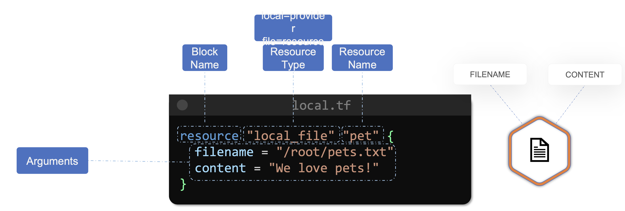

Example of resource file: To provisioning an aws instance.
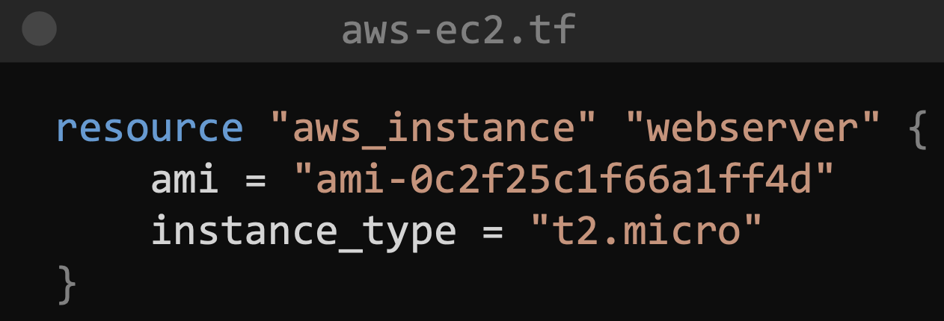
Resource Type: aws_instance
Resource Name: webserver
Arguments:
ami: ami-0cf25…….
instance_type: t2.micro

Another example of resource file: To create an aws s3 bucket.
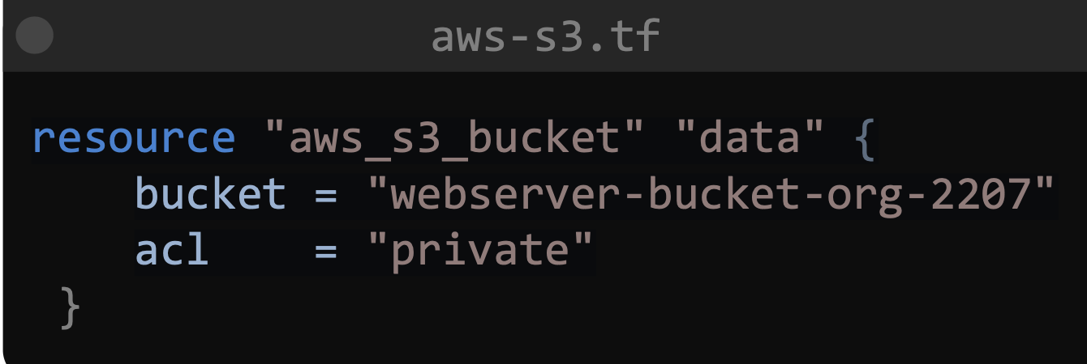
Resource type: aws_s3_bucket
Resource name: data
Arguments:
bucket = "webserver-bucket-o..
acl = "private"

Simple Terraform workflow:
- Write the configuration files
- Run the terraform Init command
- Terraform Plan command to review the configuration
- Apply the changes.

Commands:
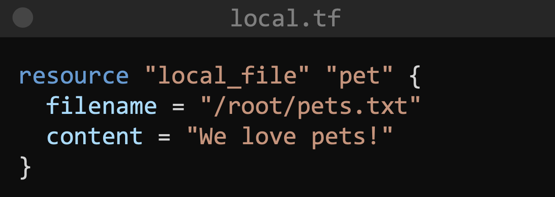

Once you have the configuration file (above) ready run:
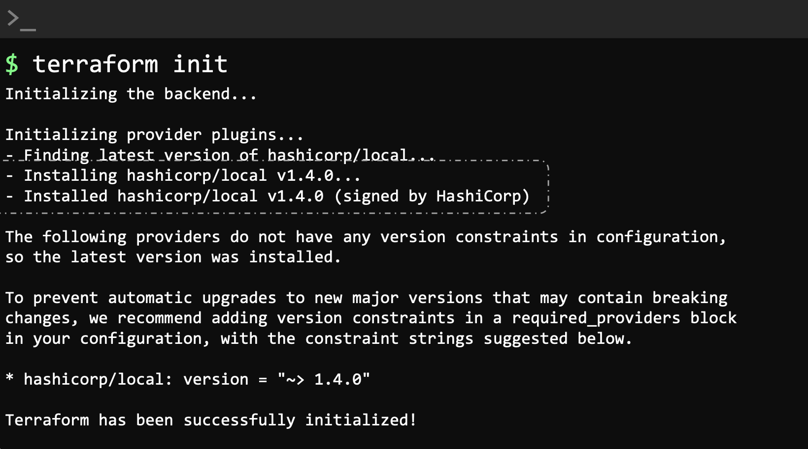

Init will check the configuration file and initialize the working directory where the .tf is.

One of the first things that init does is to understand that we are making use of the local provider, based on the resource type.

It will then download the plugging to be able to work on the resources declared in the .tf

From the output of this command we can see that has been installed a plugging called hashicorp/local

Check how the thing is gonna go with terraform plan:
This is a dry run, so its only showing what it would do if you run terraform apply.
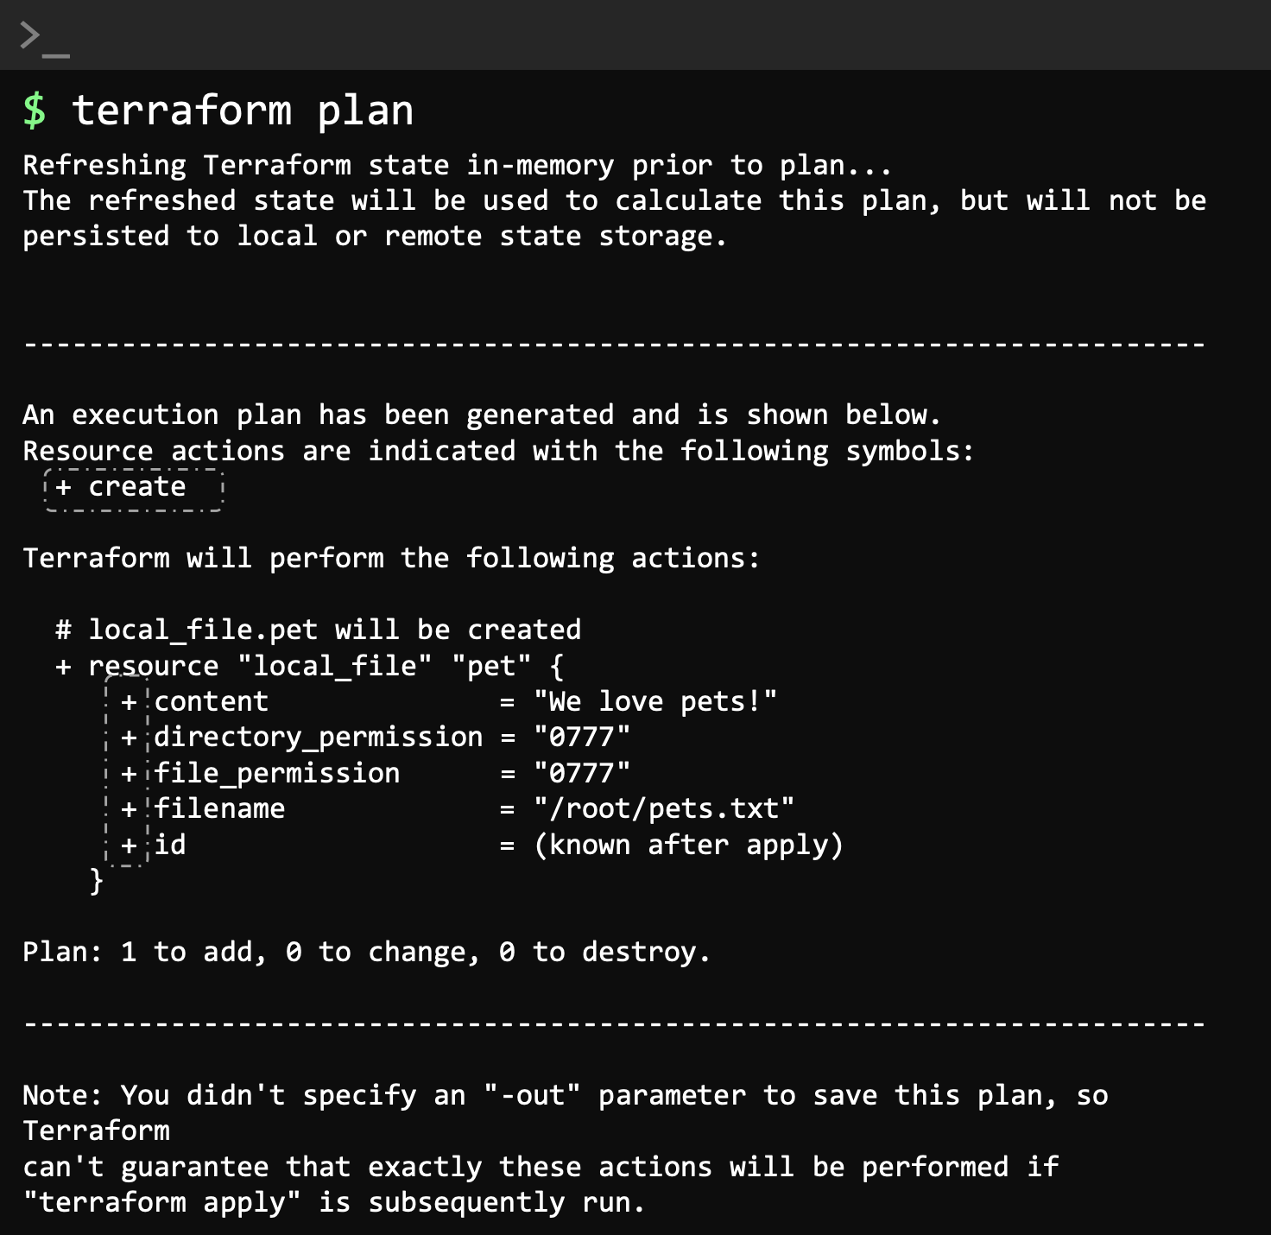

Apply the configuration: Will ask you to confirm with “yes”

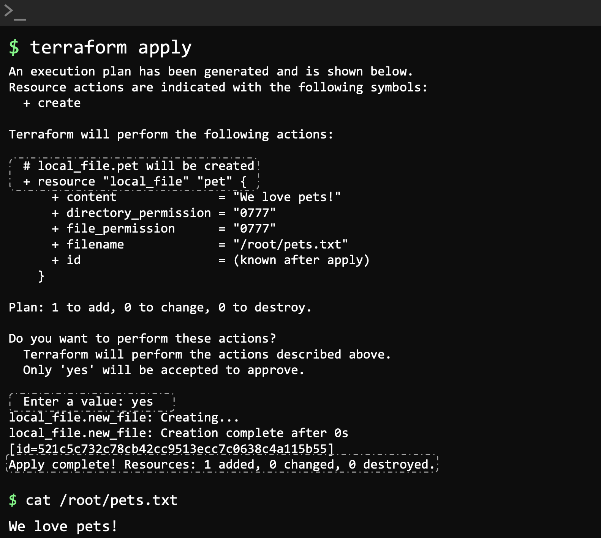
Once created run cat pets.txt to see it’s content and confirm its working.

Check the details of the resource: once created.

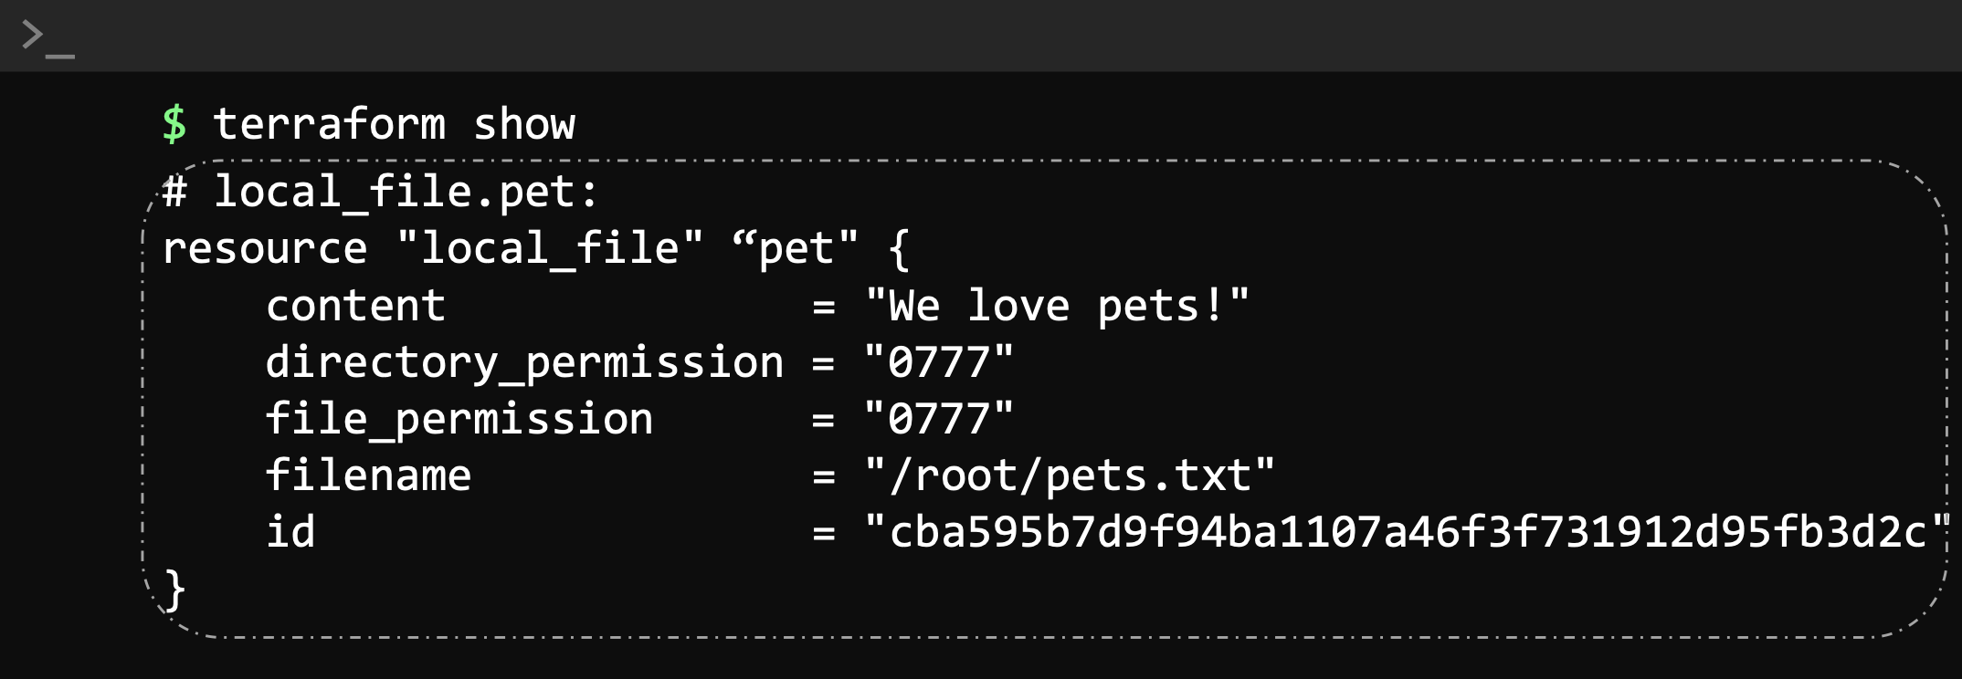

How to update and destroy resources:
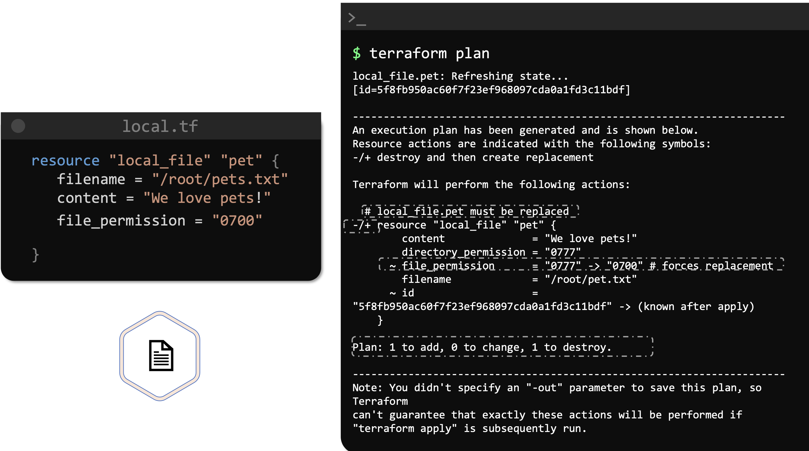
Update infrastructure: We update the pets.txt file by adding file permissions.

Running terraform plan we can see:

- The resource will be replaced.
- -/+ (in the middle of the file) implies that the resource will be deleted and recreated.
- Forces replacement line (in the middle) is responsible for the deletion and recreation.
- Even with a small change, terraform will delete the old file and create a new one with the requested permissions.

Terraform apply: to apply the changes, will ask you to type yes

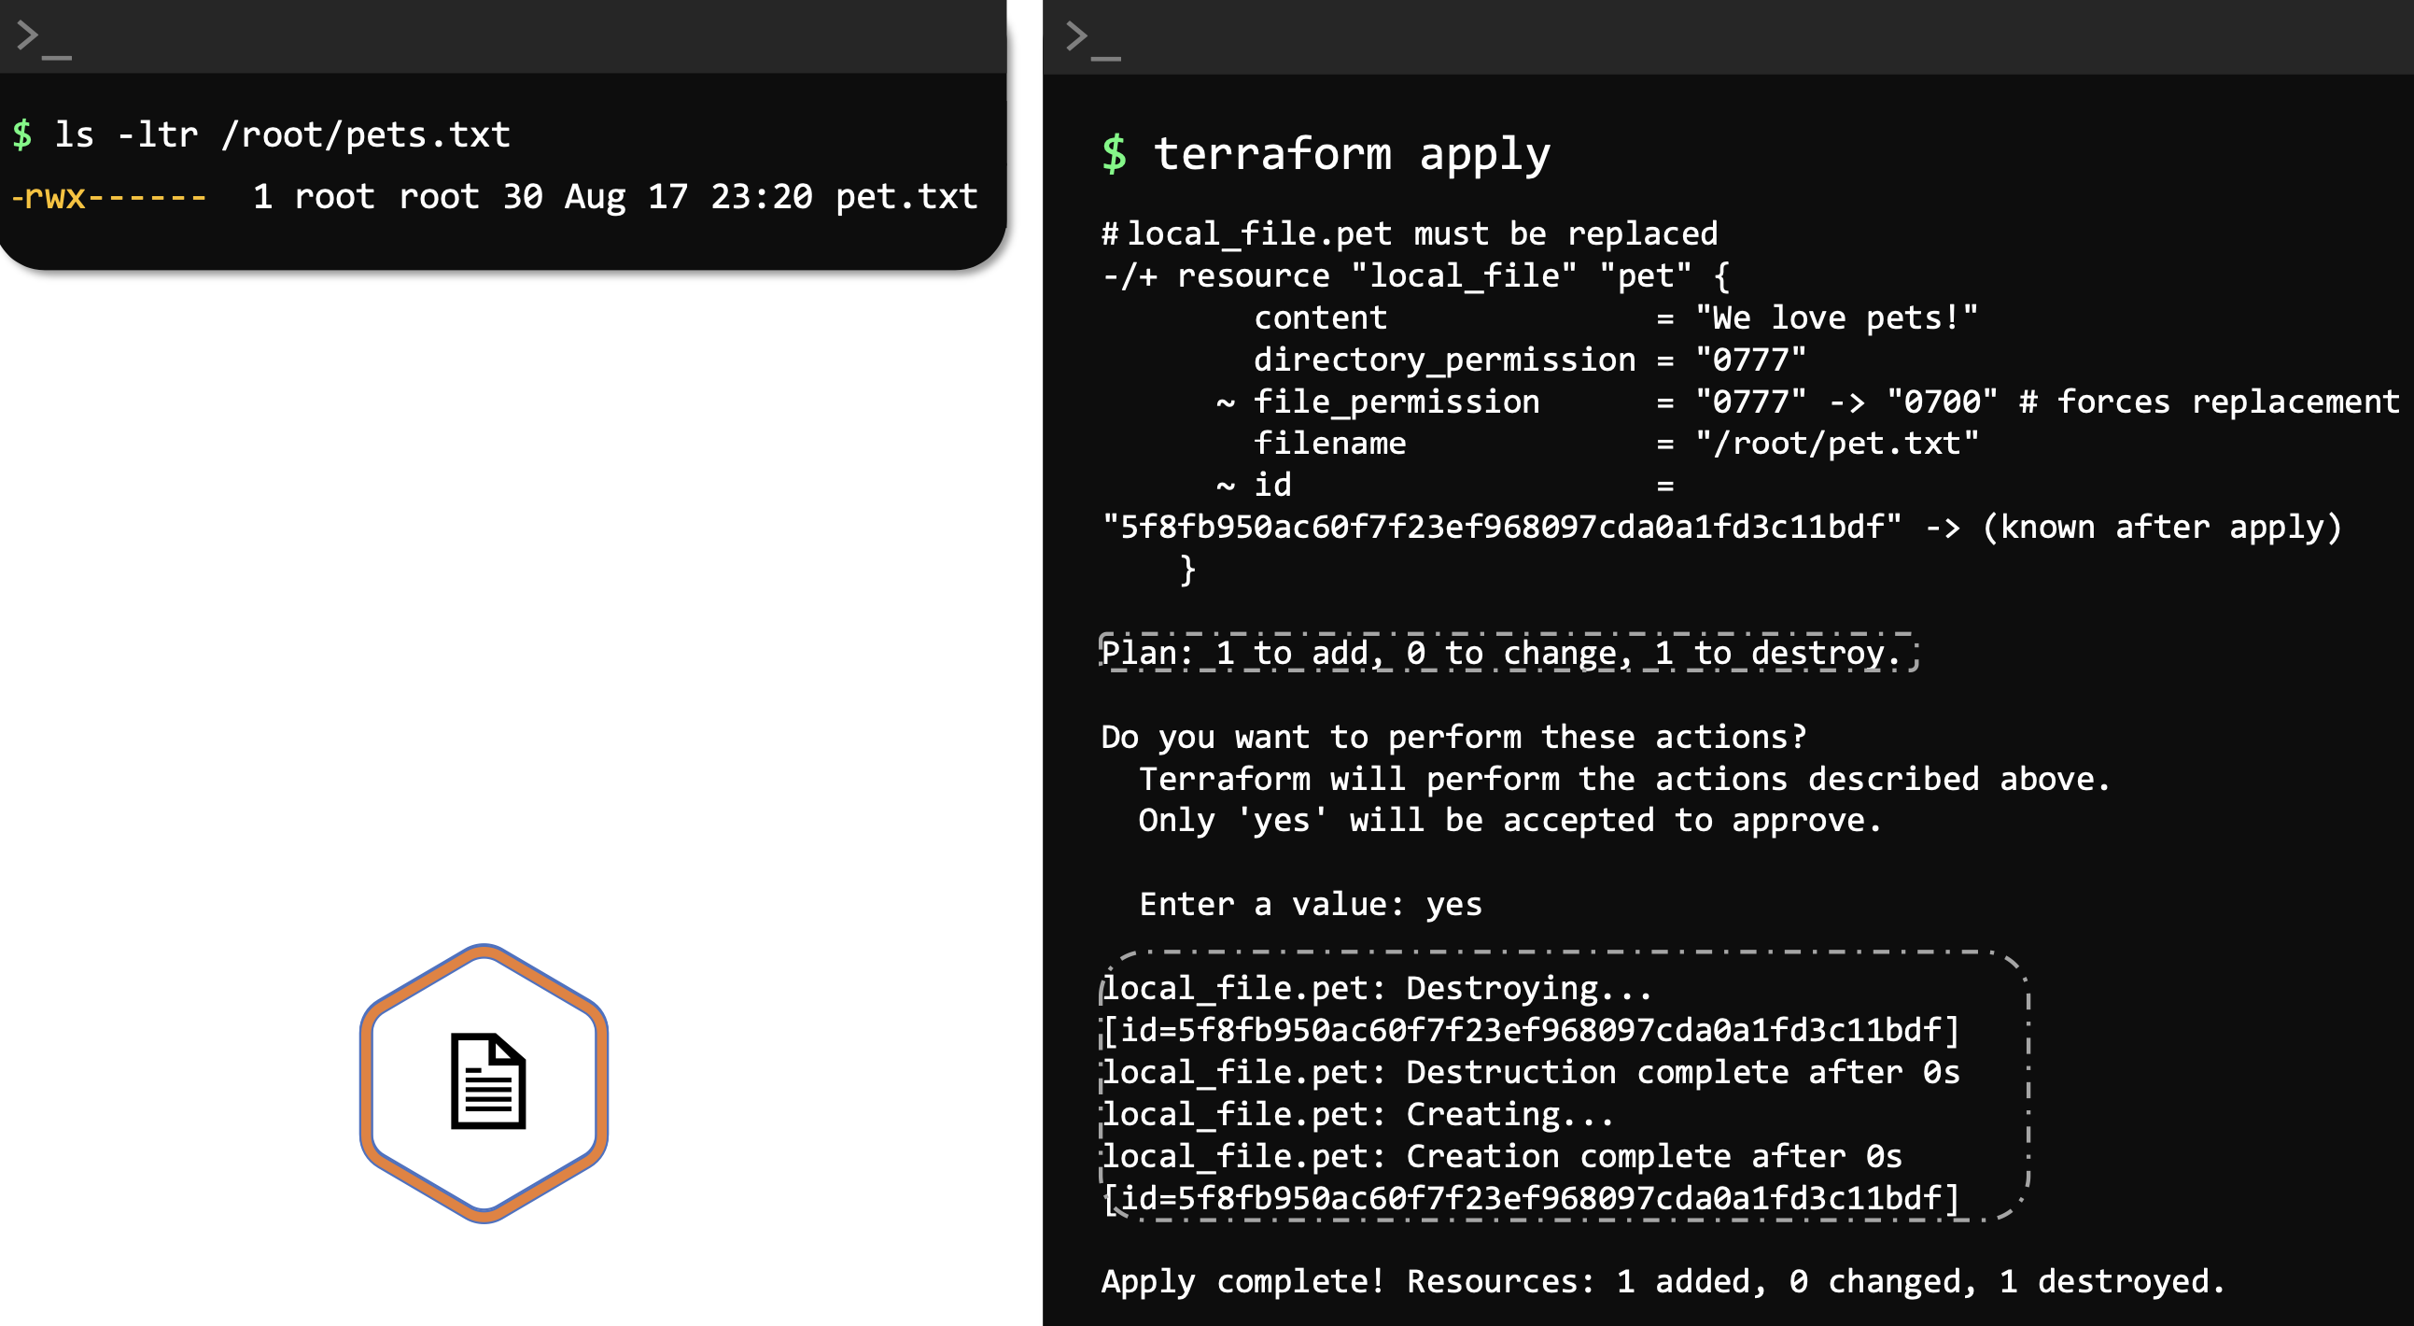

Terraform destroy: To delete the infrastructure completely. Will ask you to confirm with yes.
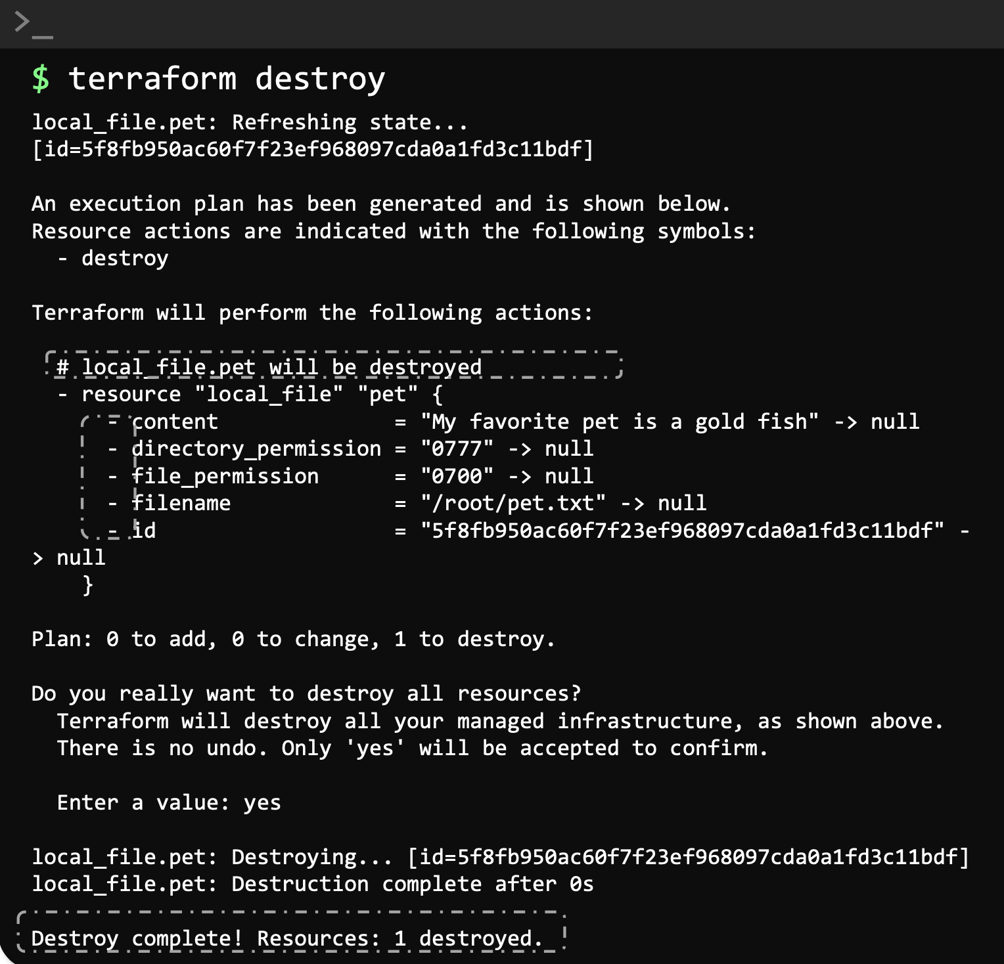

We can see that the resource and the arguments have a – symbol.

This indicates that the resource will be destroyed.

First lab: here

Plugging version: check it in the output of the terraform init command.

You need to run terraform init first. Once you run it it will create a hidden terraform file and a lot of subfiles in the current directory.

-----------------------------------------------------------------------------------------------------------------------
Using Terraform Providers:

Providers: Are the plugins that connects Terraform with the API of the companies like AWS, GCP, or the API of Docker and other products or companies, there are hundreds.

With it you can interact with it and create, modify, destroy,etc resources of that company.

For instance, when we specify the provider aws in the terraform file we will connect with aws api and we will be able to create, modify, destroy aws resources like ec2, s3, rds dbs, etc.

When we run terraform init within a directory containing configuration files, terraform downloads and installs plugins for the providers used within the configuration.

Where to find them: Are distributed by Hashicorp and publicly available at: https://registry.terraform.io/

Type of providers: There’s 3

- Official provider: Own and maintained by Hashicorp.
  - AWS
  - GCP
  - Azure
  - Local Provider
  - etc
- Parner provider: Own and maintain by a 3rd party technology company.
  - F5
  - DigitalOcean
  - etc

- Community providers: Published and maintained of individuals contributors of the Hashicorp community.

Downloaded into: Into the working directory where we ran terraform init, in this example: /root/terraform-local-file/.terraformpluggins

Plugin name: Also known as Source Address.
Identifier used by Terraform to locate and download the plugin from the registry.

Format of the plugin: hashicorp/local

Hashicorp = Organizational Namespace
local = type, name of the provider

Other examples:
hashicorp/aws
hashicorp/azure
hashicorp/google

Hosname: Can have a hostname on the front, which indicates where the plugin is located.
registry.terraform.io/hashicorp/local

If omited will use the above one.

Version installed: By default the last ones. We can specify a specific version if we need.

-----------------------------------------------------------------------------------------------------------------------
Configuration Directory:

You can have several configuration files:
Terraform will consider any .tf configuration file within the configuration directory.

Or all in one single file: Called main.tf by convenction

There are other convention files like, variables.tf, outputs.tf and provider.tf

-----------------------------------------------------------------------------------------------------------------------
Multiple Providers:

Till now we used a single provider, Local, to install stuff locally.

We can use several providers in the same conf file.

Here we will use the Random provider. You can use several
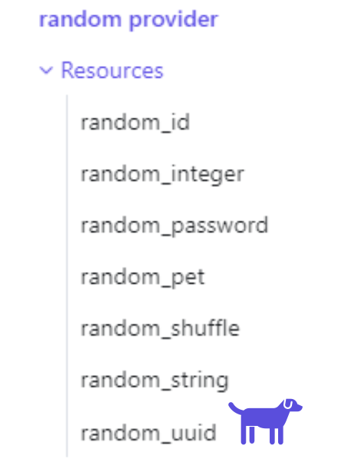
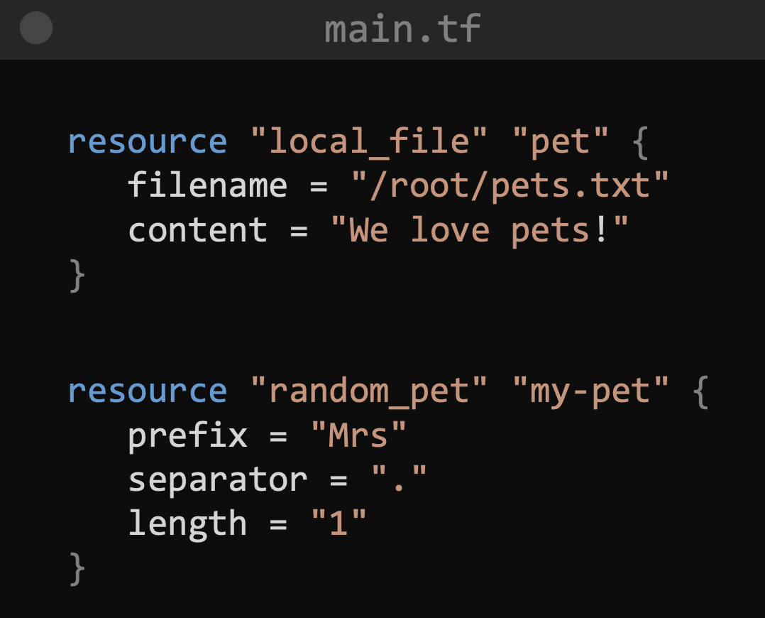

random_pet:
random is the provider
pet is the resource type

The resource is called
“my-pet”

We will use 3 arguments:
prefix, separator and length

Initialize the project: Now we have two resources, and therefore we have to initialize main.tf again to allow to install the new provider random

-----------------------------------------------------------------------------------------------------------------------
Using Input Variables:

You can create another file called variables.tf to add the variables there. Then you call the variables from main.tf.

This way you don’t need to hardcode the names of the things in main.tf.

Is like the ConfigMaps or Secrets in K8s. You modify variables.tf if you need to do any changes.

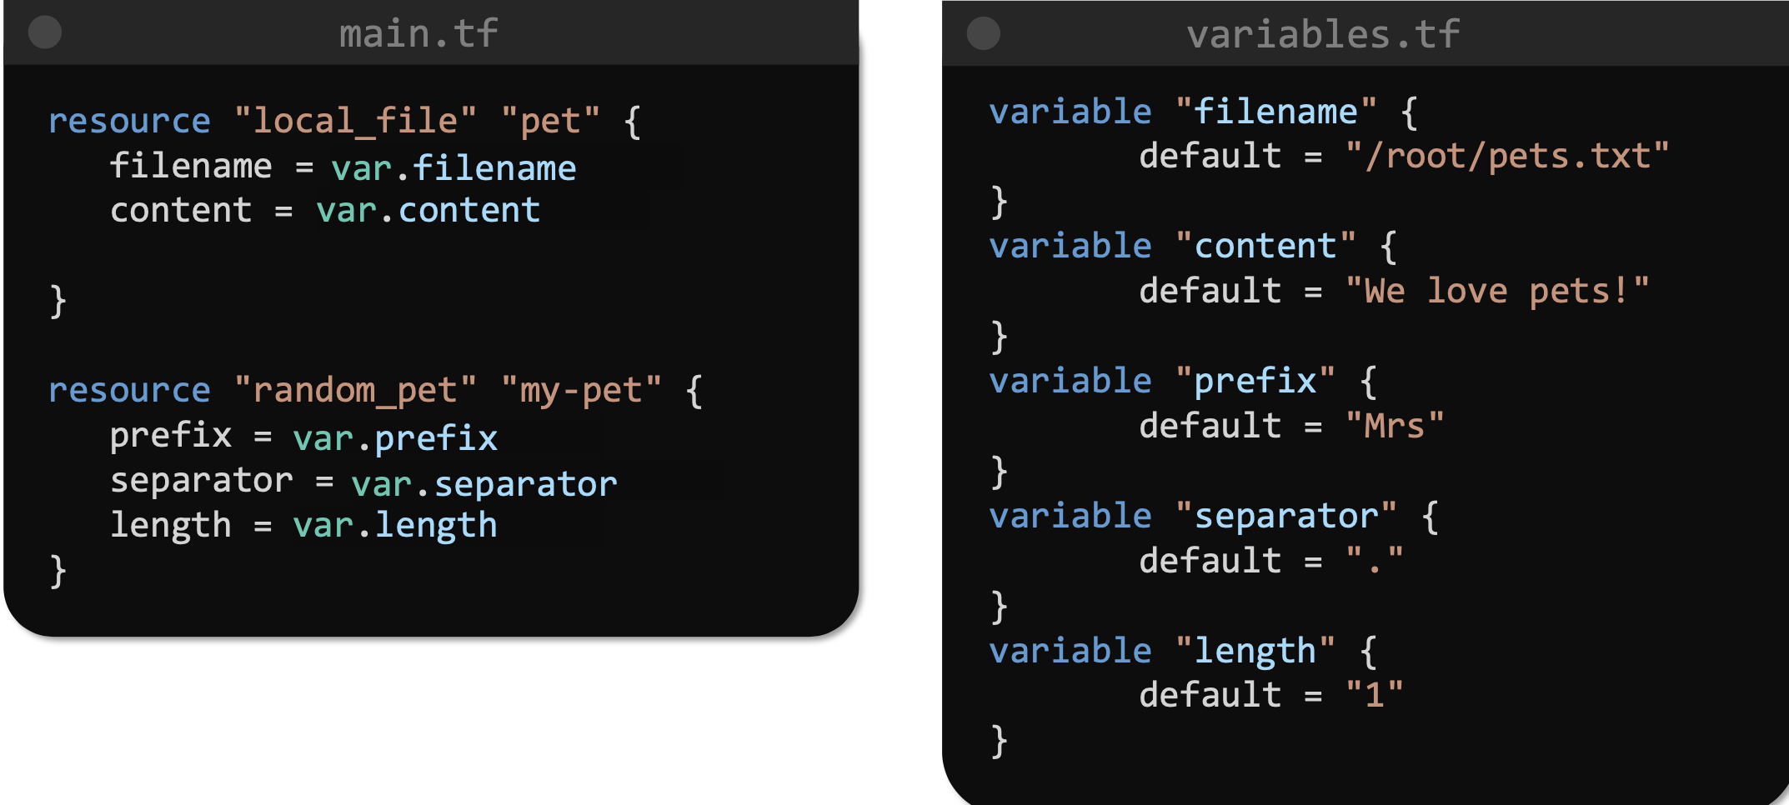

-----------------------------------------------------------------------------------------------------------------------
Understanding the variables block:

List: Like in python, [apple, lemon, pear]
apple → 0
lemon → 1
pear → 2
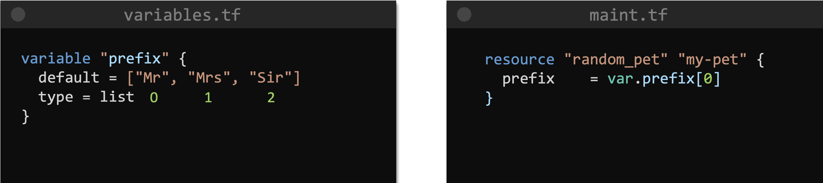

Map: Is like a dictionary in Python. Key value pairs.

To call it from main.tf:

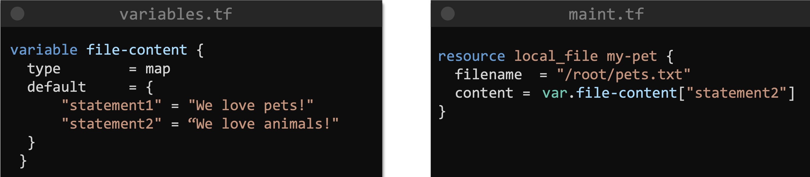

You have to declare the type of data, like if is string, int, etc.
Otherwise you will have an error. Here some lists

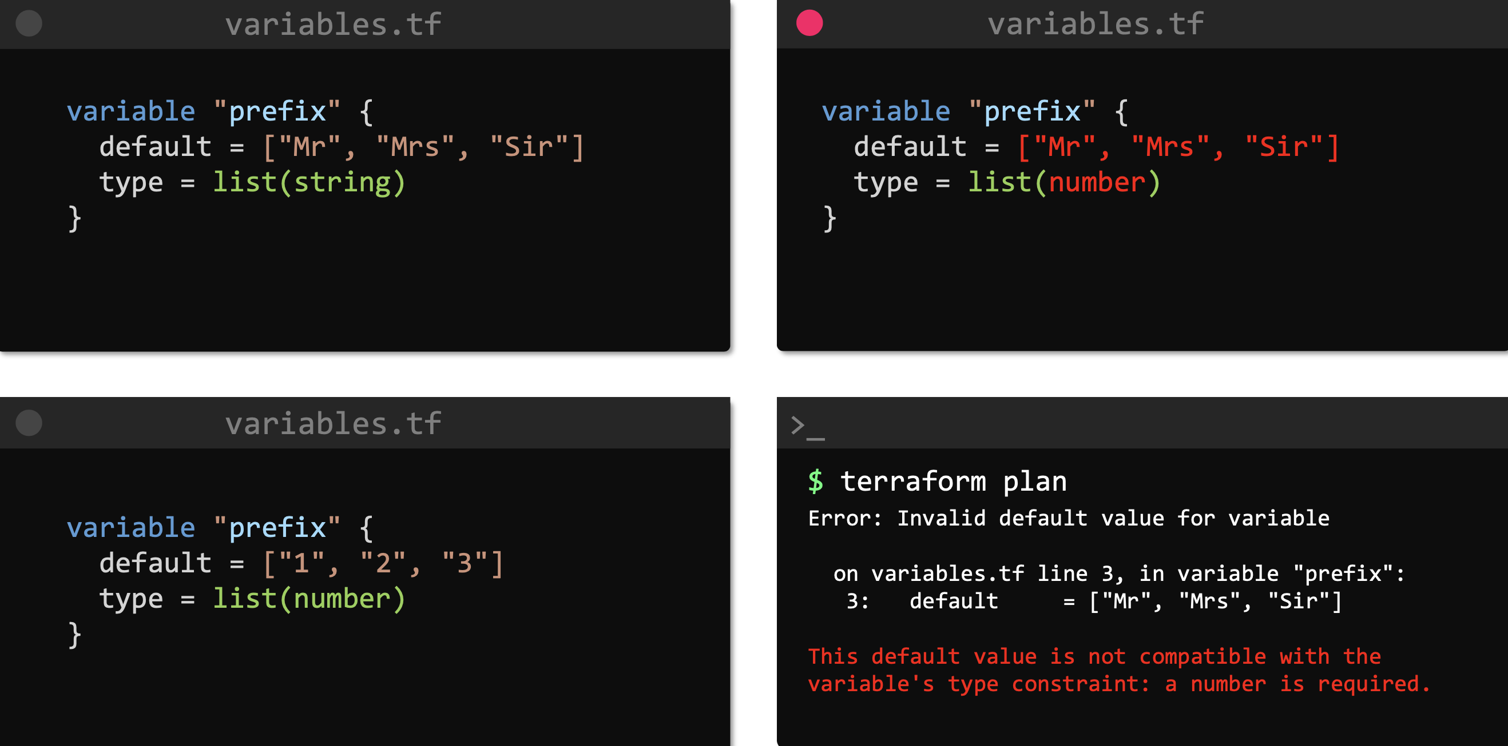

Here a Map:
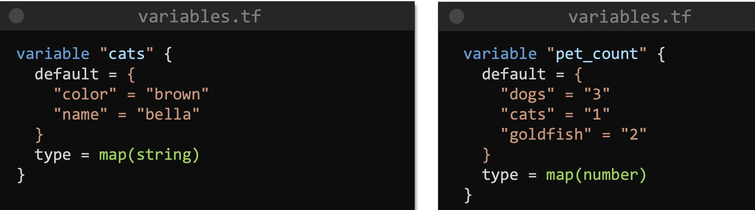

Set: Similar to a list but can NOT have duplicated elements.

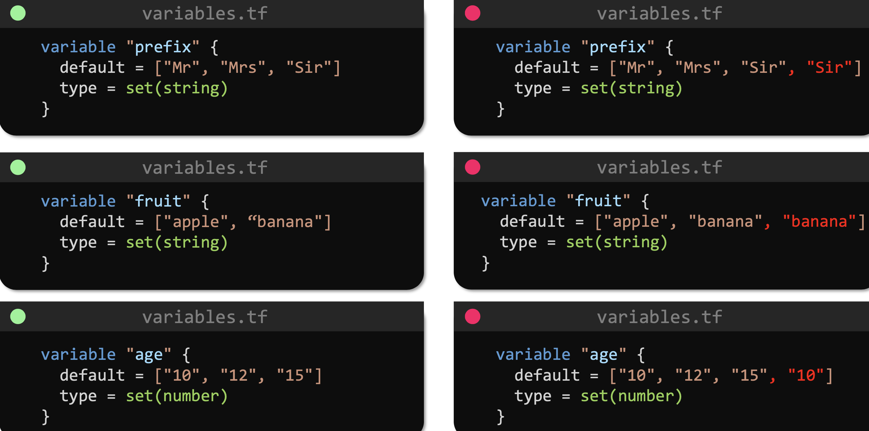

Objects: We can create complex data structures by combining all the variables types we’ve seen so far.

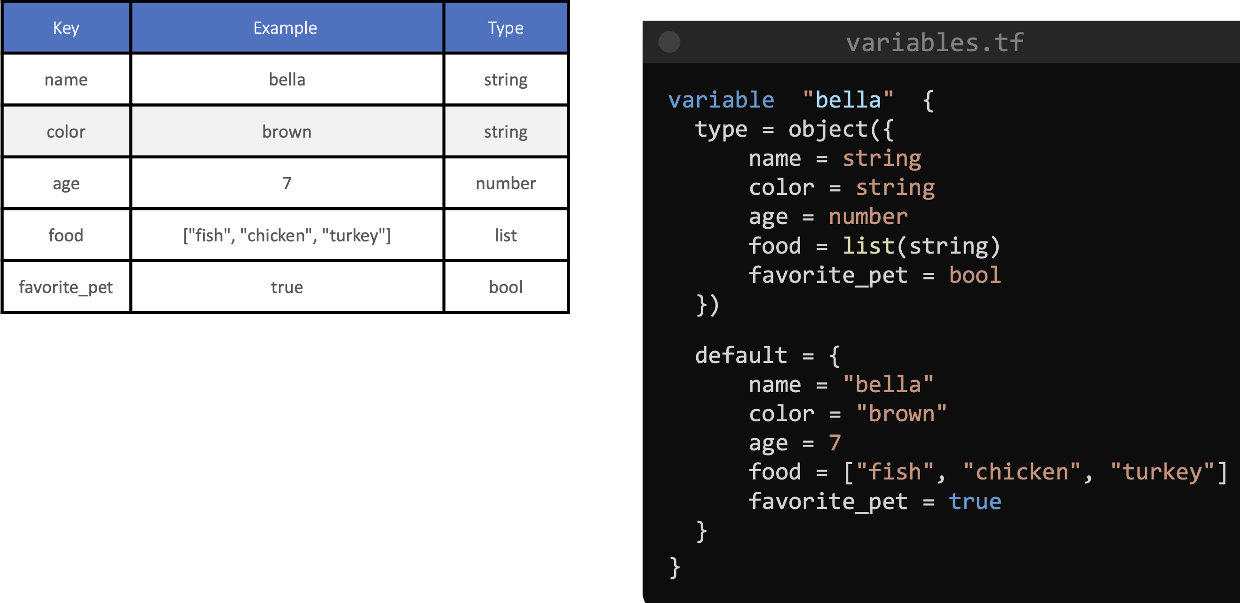

Tuples: Are like a list. Is different to lists because can use different variable types, like string, bool, number, etc.

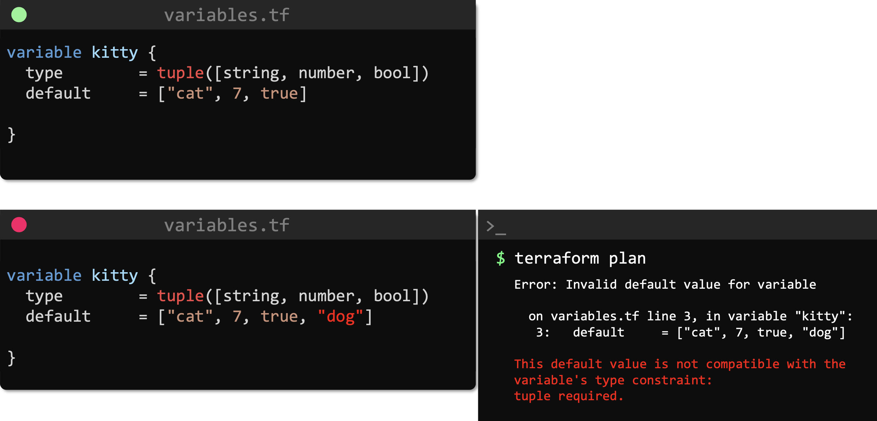

-----------------------------------------------------------------------------------------------------------------------
Using variables in Terraform:

