Dark trace:

Thread Tray:
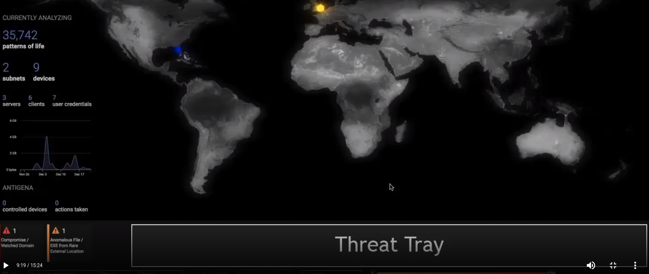
Model breaches:
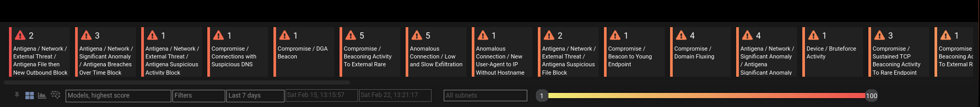
The result of AI algorithms are being displayed here. The higher the score the greater the risk of the breach.

Colour code:
Red= High priority
Ambar= Medium
Yelow= low
Gray= A model has been updated and has yet to trigger an alert

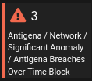
Number: The number of times this model has been breach.

Name and type of model breach

Hold mouse above the breach to have more info.

Default view: Is the one that the screenshot shows. You can customize it.

Cluster view: Displays area chard of model breaches.

Severity Slider: Allows you to display less relevant or more relevant security breaches.

Breach Log: When you click in a particular model breach.
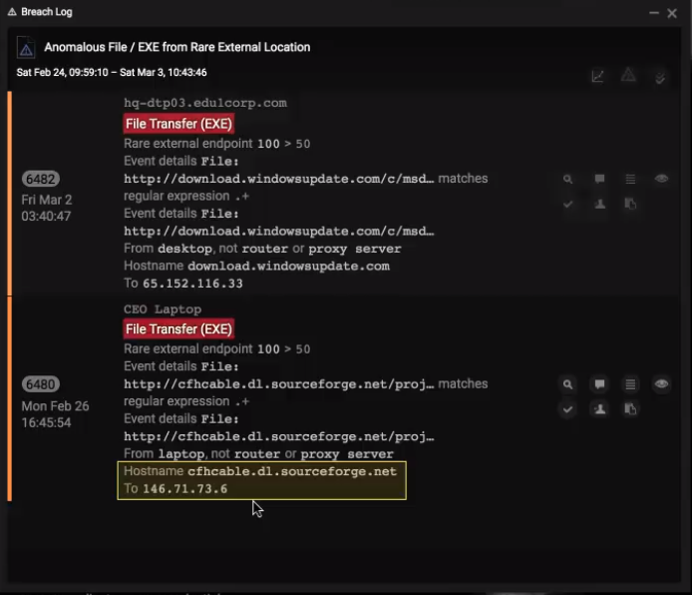

Rarity:

Model: Used to define a set of conditions which when match will alert the system to the occurrence of a particular event.
We can create or edit the existing ones.

