Terraform:

Password:
ODI3453dfgdmbr

Link to acloud videos

What is Terraform: Tool for building, changing and versioning infrastructure safely and efficiently, locally or in the cloud.

You can manage existing and popular service providers as well custom in house solutions.

This includes low level components such as compute instances, storage, networking, etc.
High level components such as DNS entries, Saas features, etc.

- Infrastructure as a Code: Infrastructure used as a high level configuration syntax. This allows your infrastructure to be versioned and treated as any other code. You can share it and reuse it.
- Execution plans: Terraform generates an execution plan with its planning step. This shows what terraform will do when you apply the configuration. This allows you to avoid any surprises when Terraform manipulates infrastructure.
- Resource Graph: Terraform builds graphs of all the resources, giving you greater insight into the creation and modification of any non-dependent resources.
- Change Automation: Complex changes can be applied into your infrastructure with minimal interaction. With the combination of the execution plan and the resource graph, you will know exactly what terraform will change and in what order. This will help to avoid many human errors.

Install Terraform: There are 4 ways.
- Manual installation: Download precompiled binary or you can compile it by source.
- Mac: Use homebrew as package manager to install it.
- Windows: Using chocolatery?
- Linux:
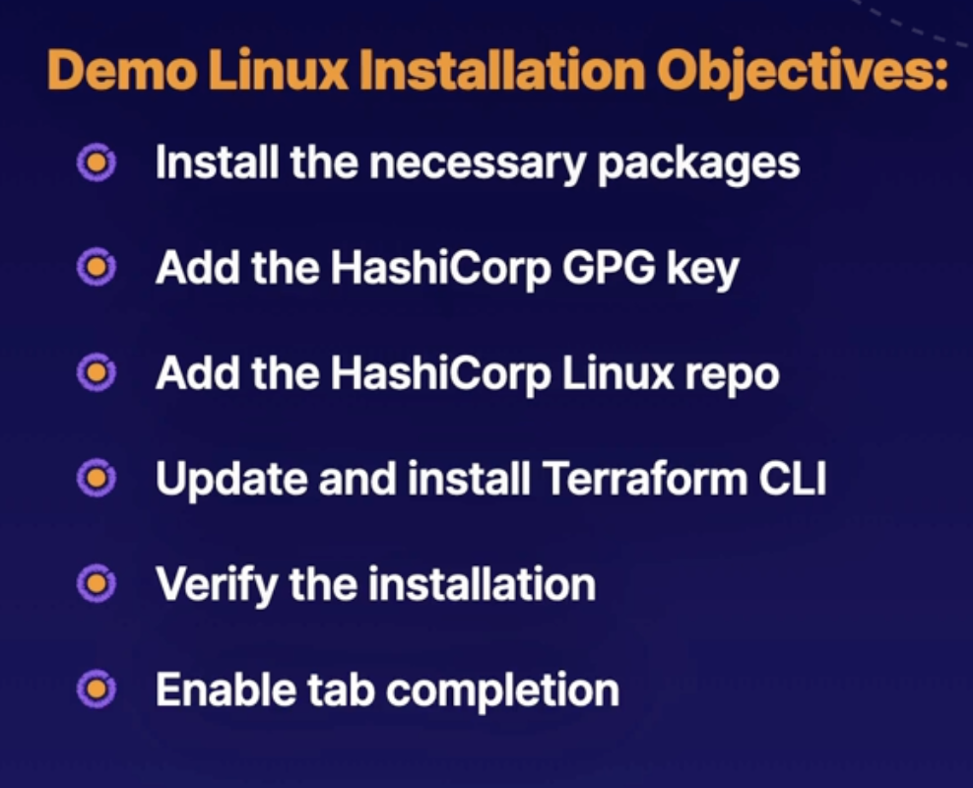

Install it on Centos/RHEL

Check that works with: terraform -help

Autocompletion should be already installed. At least for the last versions, check internet if not.

TO SOLVE: terraform -install-autocomplete doesn’t work.

Terraform CLI: Video here

terraform → is the basic command, type it and press enter to see all the subcommands.
terraform -install-autocomplete → offers bash tab autocompletion

Run a command outside your working directory:
terraform -chdir=PATH_TO/THE/PLACE (subcommand)

terraform init : Initializes a working directory containing your terraform conf. Files. This is the first command you should run after running a terraform configuration or even when you clone an existing one from git. Safe to run multiple times.

terraform plan : Is like a dry run for your conf. Will print out what your configuration is doing or is intended to do.

terraform plan -out <plan_name> → to send the output of the command to a file of my election.

terraform plan -destroy → Dry run of any destroy.

terraform apply : Will apply all the changes in my configuration.

terraform apply <plan_name> → to apply any specific plan.

terraform apply -target=(resource_name) → to apply it into a specific resource.

terraform apply -var my_variable=(variable) → to pass a variable via the cli.

terraform destroy: If my environment is temporary or I want to start fresh.

terraform providers: To pull up a list of the providers we are using.

Get help in the cli:
terraform apply -h → will show you the list of all the options available for terraform apply

Terraform Language:

It’s function is to declare resources. It represents infrastructure objects.
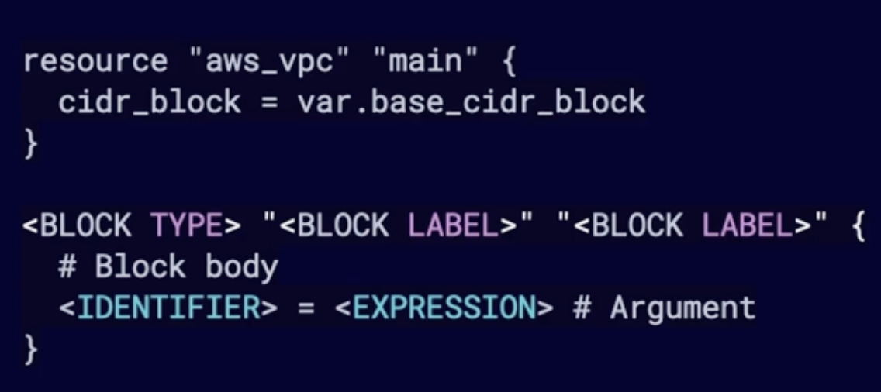
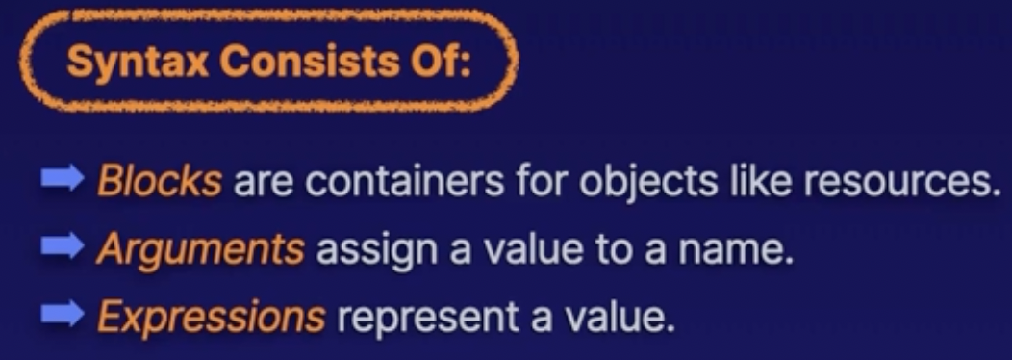

Terraform configuration language is declarative language, it describes an intended goal rather that steps to reach that goal.

Directories and files:

Plain text files with the .tf file extension are where code in Terraform language is stored.

You can use json too → .tf.json

All using UTF and can also use windows stile line endings (CRLF)

Modules: Are a collection of .tf and/or .tf.json files kept together in a directory.
A module consists of only the top level config files in the directory.
A nested directory is treated as a separate module and may not be automatically included.

Root module: Terraform configuration consists of a root module and a few child modules in the working directory where terraform is invoked.

Override file: Rare situation where you need to override a configuration.

Only use it in spacial circumstances.

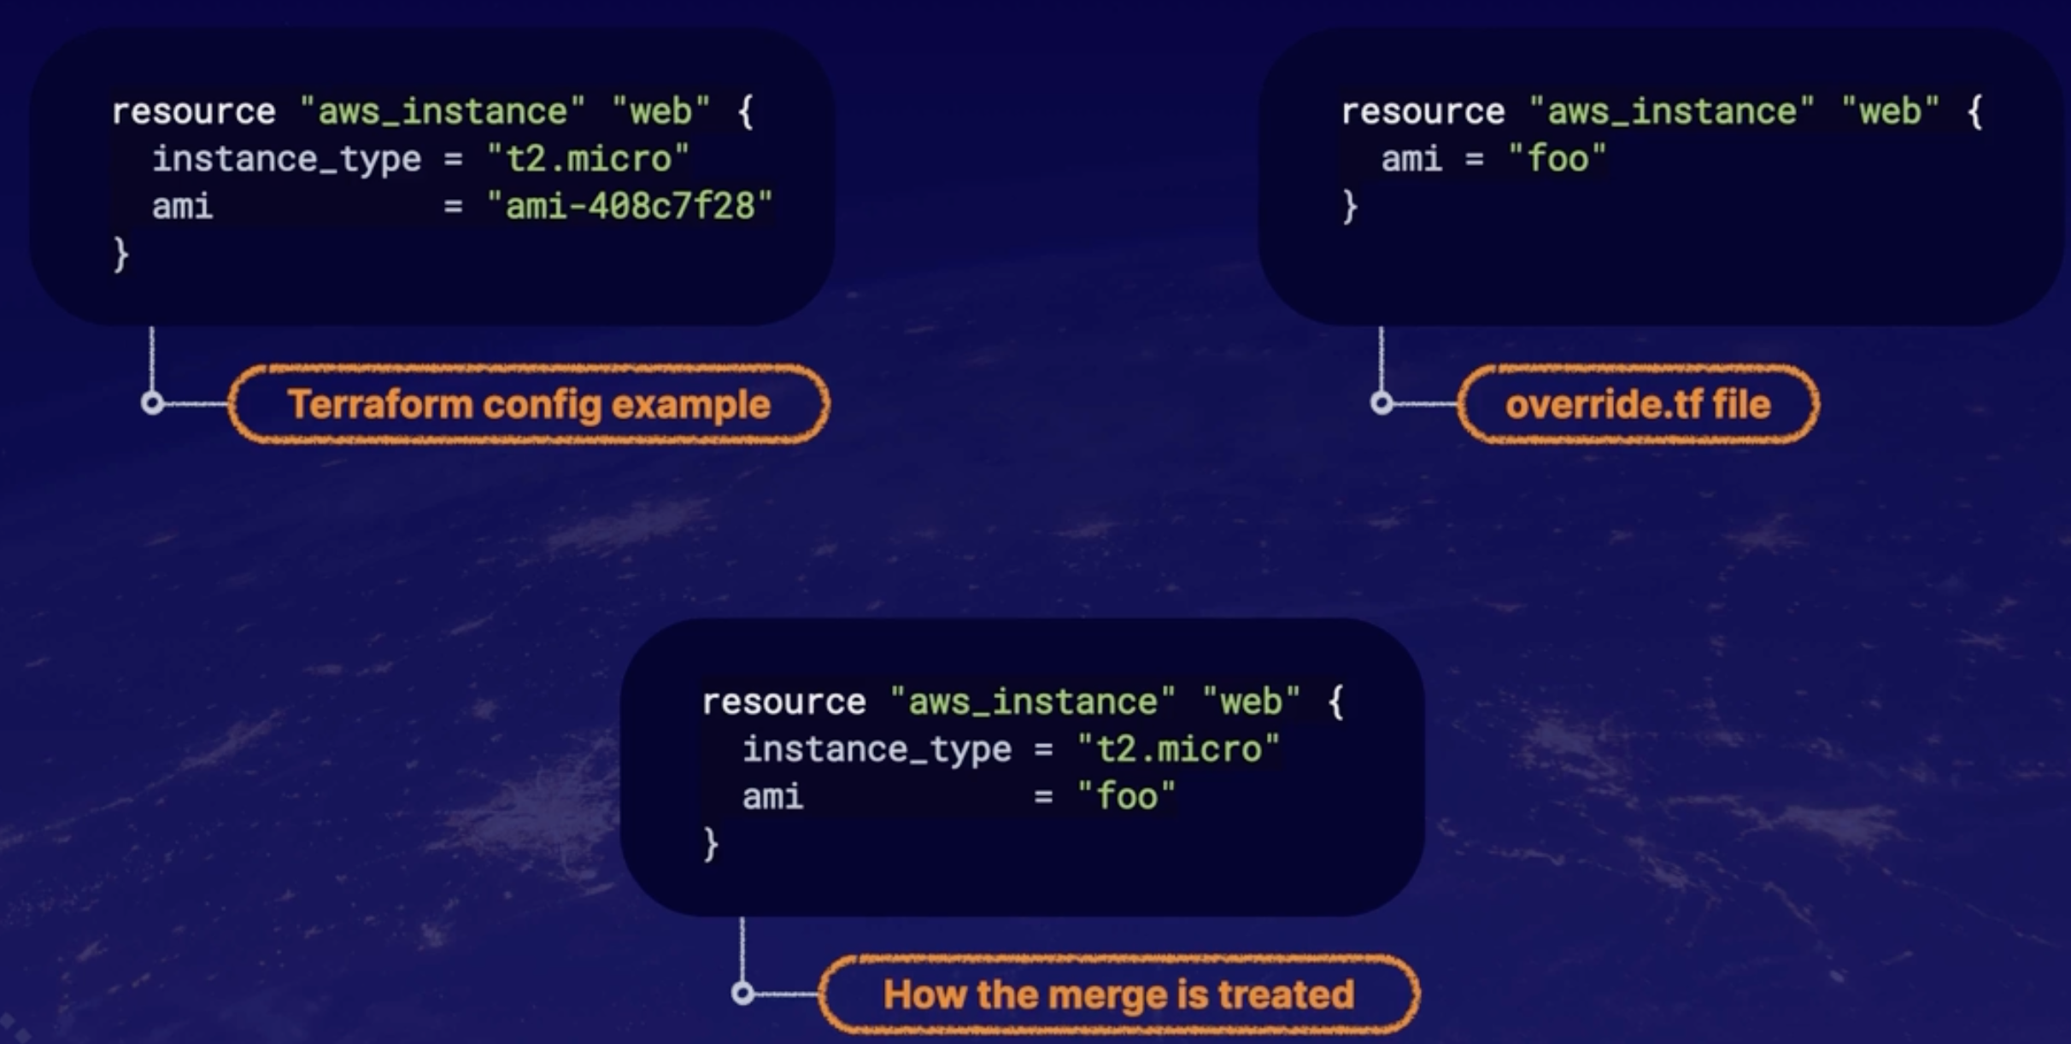
To do so is advisable to add a commentary in the original file.

Config sintax:
Argument assigns a value to a particular name.
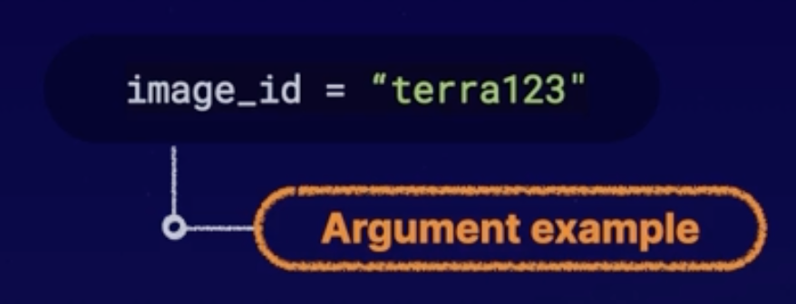

image_id = “terra123” → all this is the argument.

image_id → is the argument name.
terra123 → is the argument value.

Block:
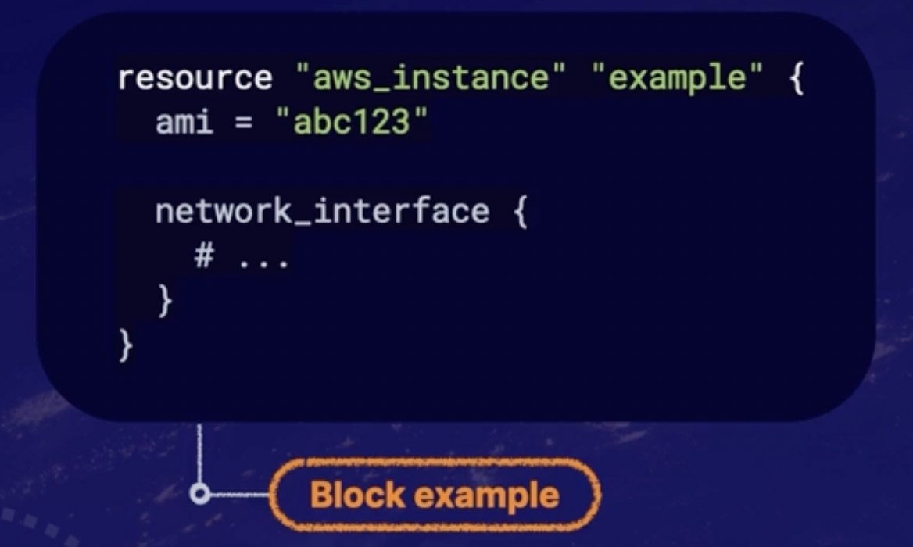

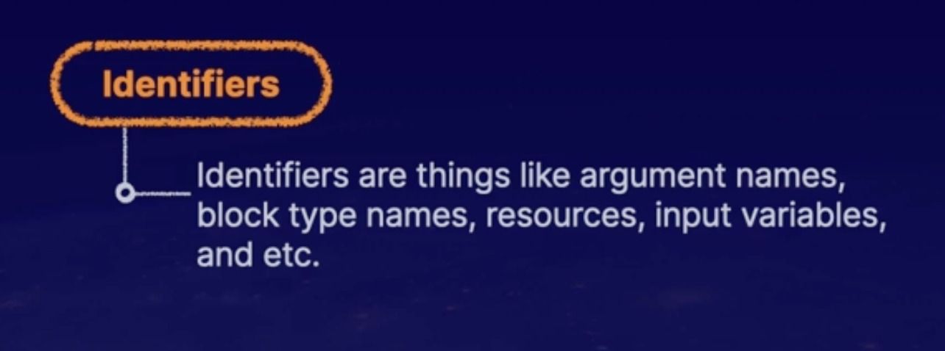

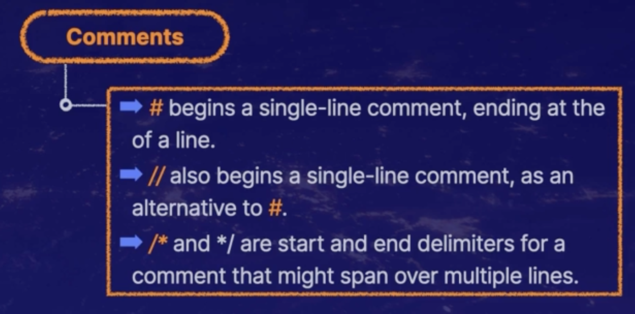

Json syntax vs Terraform (native) syntax:
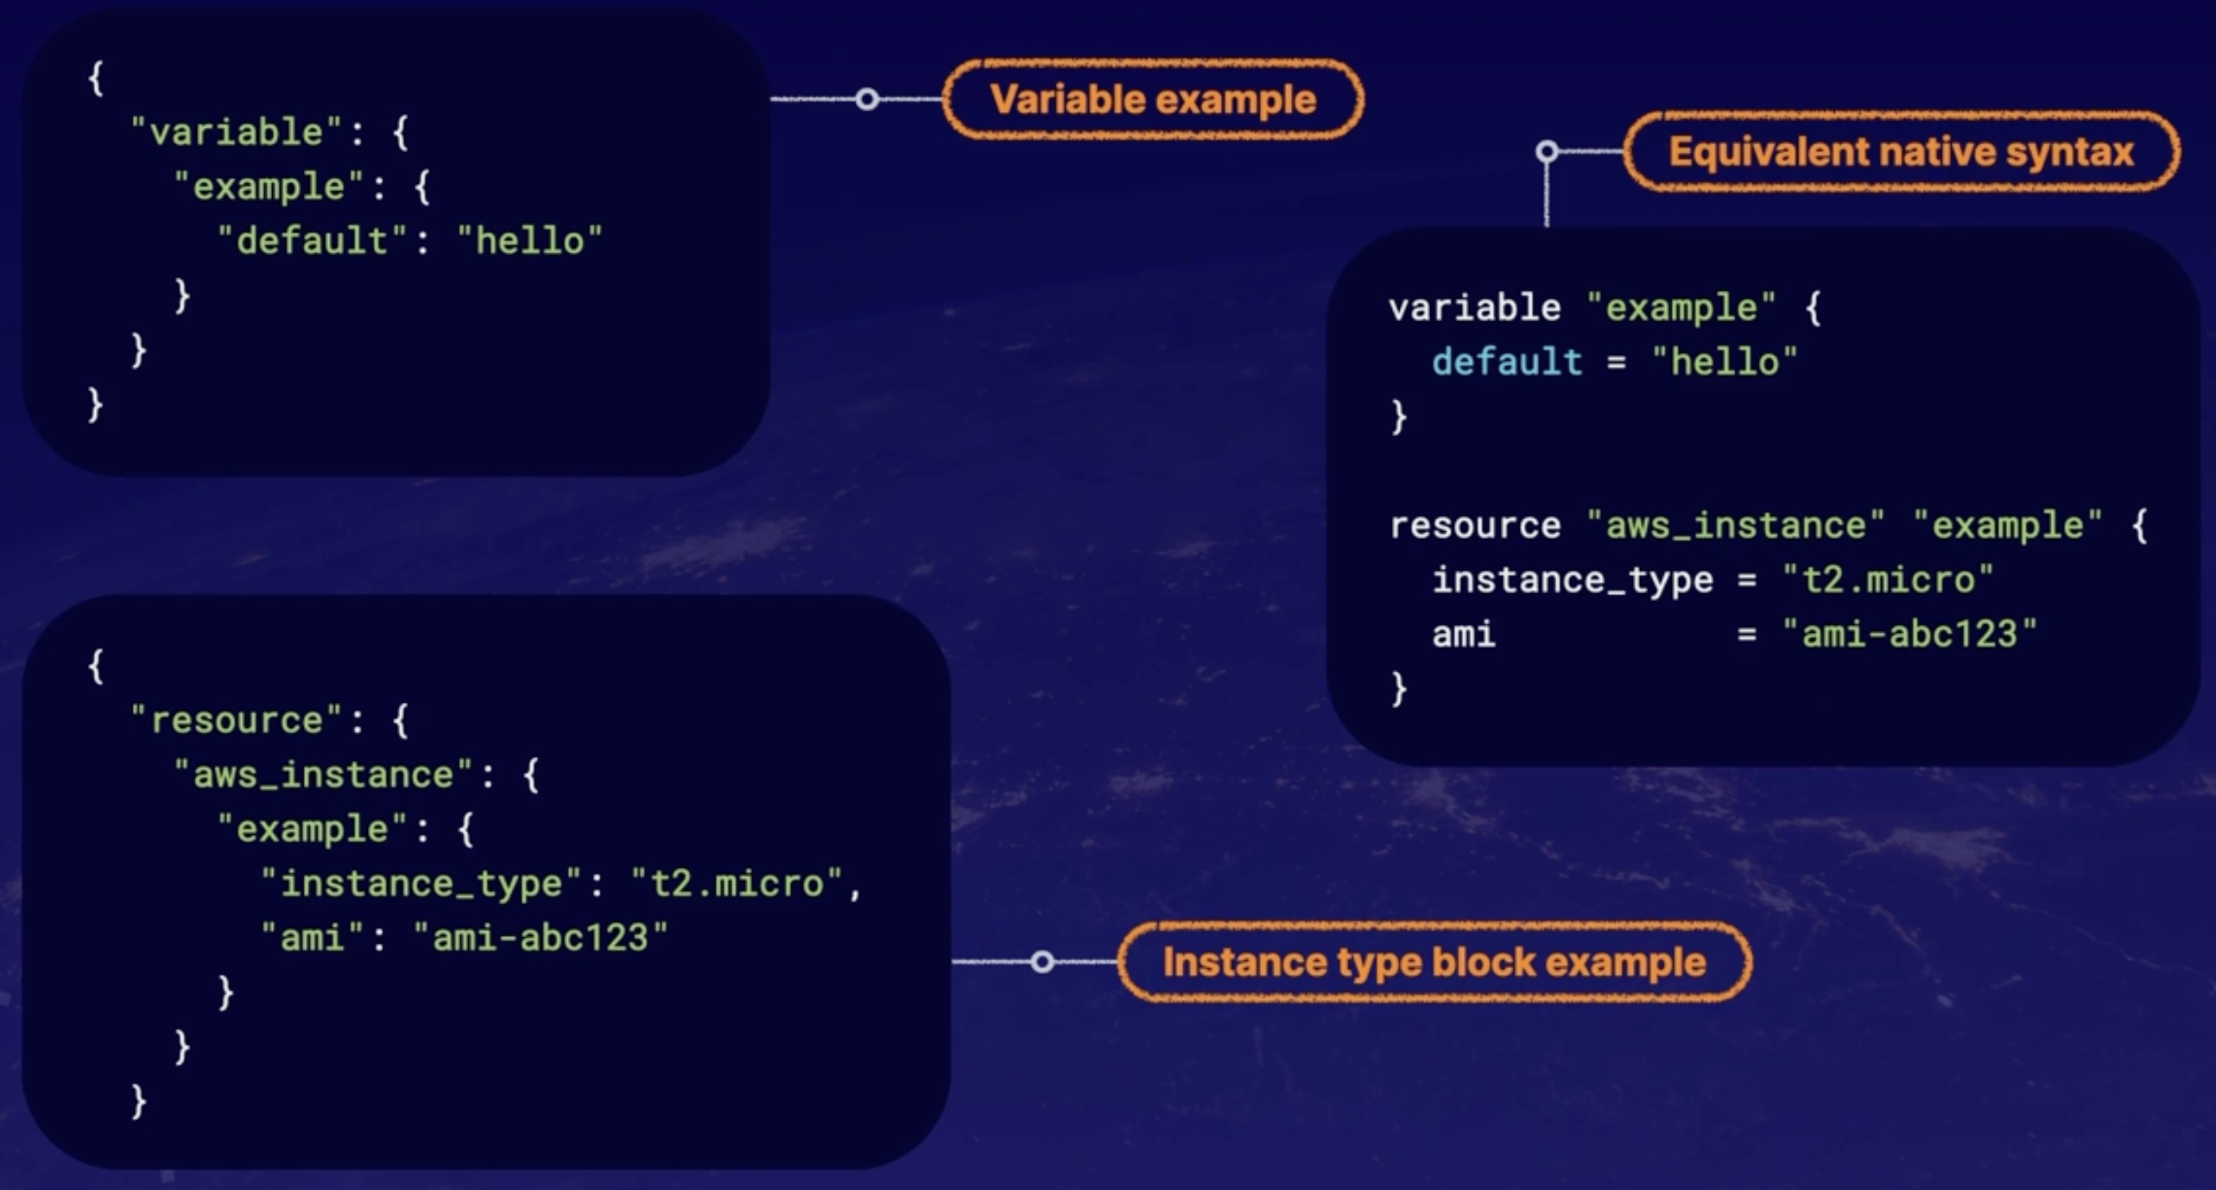

Another example, json and Terraform (native) syntax:
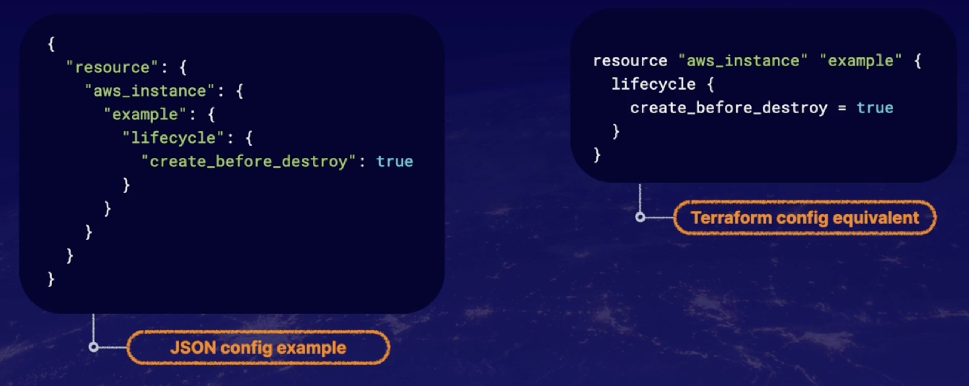

Working with resources:

