AWS Certified Solutions Architect Associate - SAA-C02

Exam Blue Print:
- 130 Minutes in Length
- 65 Questions (this can change)
- Multiple Choice
- 70% to pass. Results are between 100 and 1000 with 720 of passing score.
- Certification valid for 3 years.
- Scenario based questions.

Partner Program: To be part of the AWS partner program, which means you can create a consulting company to provide AWS services to your customers, you need to have a certain amount of certified profesionals.

There are 3 type of partner programs: Select, Advanced and Premier, and you will need the following amount for each one of them:
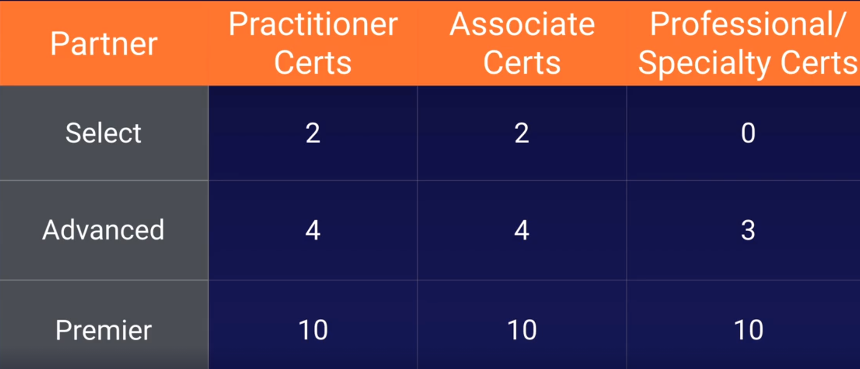

So if you want to be an Advanced partner for instance, you will need 4 Practitioners, 4 Associate certs and 3 professional certs.

Identity and Access Management 101

101 Means that is an introductory topic for a lecture. This is used in UK and the States.

IAM:
- Centralized control of the aws account
- Shared access to your AWS account.
- Granular Permissions (you can access to this serivce but not to that service)
- Identity Federation (including Cognito [Facebook, Linkedin, Google, etc], or AD). You can log in into the AWS console using the same user and password used in your windows or your facebook, etc account.
- Multifactor Authentication.
- Provide temporary access to users/devices and services where necessary (AIM Roles)
- Allows to set up your password rotation policy.
- Integrates with many AWS services.
- Supports PCI DSS Compliance. Compliance framework. When you are taking credit card details you need to be compliant with the framework.
Key Terms:
- Users: End Users such as people, employees of an organization, etc.

- Groups: A collection of users. Each user in a group will inherit the permissions of the group. For instance you may have a group with only access to S3. You may have another group to access EC2. If the user is in that group it will inherit the permissions of that group.

- Policies: Are made up of Policy documents. Are made in JSON and give permissions as to what a User/Group/Role is able to do.

- Roles: You create a role and assign it to an AWS resource. Is a way to allow one part of AWS to do something with another part.You may give a EC2 instance permissions to write files into a S3 bucket, etc. Roles isues that are valid for short durations.

AIM Dashboard: Services -- Security, Identity, & Compliance -- AIM

There you can see the link to send your users to log in into the console. This link includes the Account ID, the user will need to introduce his user and password.

https://082396398680.signin.aws.amazon.com/console

You can customize this link too by creating an alias. This is DNS change so the alias will need to be unique in the world:

https://testing1010.signin.aws.amazon.com/console

Root Account: Is the email address that your first signed up with. With the root account you are in God mode, you are able to do anything in AWS.

When you sign in for the first time you are recommended to do the following steps.

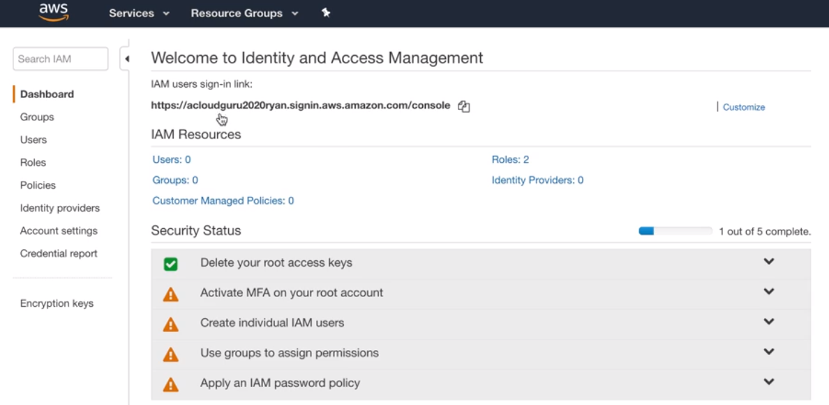

- Enable the 2FA:
Go to My Security Credentials (Top - Right, click on your user name) -- Activate MFA for your root account, click on Manage MFA -- Choose one of the 3 options, the app, the security key or other hardware.

If you choose to use an authenticator app is advisable to take a picture of the QR code and store it in a safe place. So if you lose your phone with the authenticaror app inside you will be able to enable it again by scaning the picture.

- Create individual AIM users:
Click on Manage Users -- Add user -- Select AWS access type (where this new user will access): Programmatic (creates key id and security key id) and/or aws management console.
Permissions: Create a Group, name it Developers and give it the permissions you want and hit Create Group, hit next until you create the user.

IMPORTANT: Store the access key and secret key generated, you will need them to log in into the servers. You won’t be able to retrieve that keys so you will lose it if you don’t store them after creating the user. You can email them to the user too.

- Apply an IAM Password Policy:
Manage Password Policy and enable the options you want, as much as better.

After applying everyting we have to see the following:
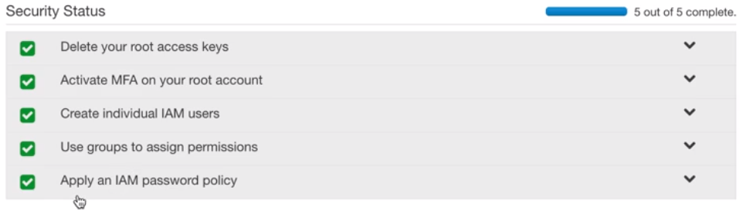

Change User Passwords:
If for some reason you need to change the user passwords, for the console or CLI access go to:
Users -- Select your user -- Security Credentials

There you can enable/disable or change the console password, generate new access keys, or enable and manage the 2FA.

Roles:
Go to Roles -- Create role -- AWS service, EC2 -- search and select s3 full access (s3f) -- role name: S3_Admin_Access -- create role

Create a Billing Alarm:

Go to CloudWatch -- Billing -- click the Create alarm in the center of the page, DON’T use the Create alarm in the top righ (specific alarm) -- You have to see a page that shows a graphic and several options to configure

You can get the same page using the Create alarm in the top righ doing -- Create alarm (top right button) -- Select metric -- Billing -- Total Estimated Charge -- tic USD -- Select metric

Once in the Specify metric and conditions -- Define the threshold value to 10 USD -- you can define the Period in which cloudwatch will check the billing alarm, by default is 6 hours -- hit Next when you are done.

Select an SNS topic: Create new topic -- name it as Billing_Alarm -- Email endpoint that will receive the notification… → add there your email (you will receive one email there and you will need to confirm that you want to subscribe to it) -- Create topic

Once subscribed (by confirming the email) hit next -- Name and description,Define a unique name: Billing Alarm and Alarm description: Send me an email if my bill goes over $10

You will be redirected to a preview page, hit Create alarm.

You will appear in the billing dashboard and you will see your new created alarm. Will appear as INSUFFICIENT for a while because you choose to check it automatically every 6 hours.

If you didn’t confirmed by email yet you will see Actions as pending, confirm the email and subscribe to it. Then go back to the console and hit the refresh button, you will see that now is not showing the pending message.

And that’s it, you will receive an alarm everytime your bill goes over $10.

Exam Tips:
How can you get automatic notifications if the bill goes over $X?
By creating a billing alarm in cloudwatch, wich uses an SNS topic.

S3 101

Provides a secure, durable, highly-scalable object storage.

Object-based storage. Flat files, documents, pictures, movies, etc.

Data is spread across multiple devices and facilities.

Files can be from 0 Bytes to 5TB and there is unlimited storage.

Files stored in Buckets (folders).

S3 is universal namespaced, Bucket names must be unique globally.

Names are global but you are storing buckets locally:
If you create a bucket in the default Region, East Virginia, the bucket will have the domain name:
https://my_bucket.s3.amazonaws.com

If you create the bucket in another region the domain name will be:
https://my_bucket.eu-west-1.amazonaws.com → if you are in Ireland Region for example.

Exam Tips:
-What code you receive back uploading a file? HTTP 200 code.
-S3 is object based storage, not suitable to install an OS or a database.
-You can turn on MFA Delete → to confirm via MFA if you want to delete a file.
-Read S3 FAQs

Objects consists in:
- Key: The object name.
- Value: The data, made up of a sequence of bytes.
- Version ID: Important for versioning.You have a file with a name, like: my_file. If you upload another file with the same name S3 will keep both and you will be able to go back to the previous version.
- Metadata: Data about data you are storing. Example this object belongs to Finance.
- Subresources:
  - Access Control Lists
  - Torrent
  - etc

Data Consistency model for S3:
- Read after Write consistency for PUTS of new Objects: You upload a file to S3 you will be able to read it inmediatelly.

- Eventual Consistency for overwrite PUTS and DELETES (can take some time to propagate): If you overwrite a file you will be able to access the old object for a few seconds. After that few seconds you will access to the new file. If you delete it you will see it for a few seconds too, is not immediate. The changes can take a little bit of time to propagate.

S3 Guarantees:
- Built for 99.99% availability
- AWS Guarantee 99.9% availability
- AWS Guarantee 11 x 9s durability for S3 information.

S3 Features:
- Tiered Storage Available
- Lifecycle Management. Automatic migration of objects to other S3 Storage Classes
- Versioning
- Encryption
- MFA Delete
- Secure your data using ACL and Bucket Policies

S3 Storage Classes: https://aws.amazon.com/s3/storage-classes/

All of them using Availability Zones ≥3 except S3 One Zone - IA

- S3 Standard: 99.99% Availability. 11x9s Durability.

- S3 - IA, Infrequently Accessed: Less frequently accessed data but requires rapid access to it. Low storage fee but you are charged a retrieval fee.

- S3 One Zone - IA: Lower cost and only one AZ. Data will be lost if the AZ is destroyed.

- S3 - Intelligent Tiering: Introduced in 2018. Uses AI to move data to the most cost-effective access tier without performance impact.

- S3 Glacier: Archive data. Secure, durable and low cost. Retrieve data configurable between minutes to hours. You can pay a fee to retrieve data faster.

- S3 Glacier Deep Archive: Cheapest option to store data. Retrieve data up to 12 hours

S3 Charges:
- Storage
- Requests
- Storage Management Pricing
- Data Transfer Pricing
- Transfer Acceleration: Uses Edge Locations. Stores data close to the end users lowering the latency.
- Cross Region Replication Pricing: You can automatically replicate a bucket in another region for high-availability and dissarter recovery. As soon as you upload an object this is automatically replicated in the other region.

Create an S3 Bucket:

Create a default bucket: Storage - S3 - Create Bucket - Add unique domain name - Create Bucket.

Upload an object: Select your new bucket - Object tab, Upload - leave all default - Upload

The bucket and the image won’t be reachable on inet.

Make Object public: Go to the bucket - Permissions - Block public access (bucket settings) , Edit - Untic block all public access - Save and confirm.

Now select the object you want to make public - Actions, Make public.

Go to the object Details, you will see the Object URL there, like https://teest1234569.s3.amazonaws.com/carlos_enrique.png

Exam Tips:

- Buckets names shares common namespace (Domain). You can not have the same bucket name as someone else, have to be unique for the whole world.

- In the Management console you see the buckets globally but you have to store them in a particular AZ.

- Cross Region Replication, CRR: You can replicate the content of one bucket to another bucket in another Region automatically.

- You can change the Storage class and encryption of your objects on the fly.

- Remember the storage classes.

- Transfer Acceleration: Uses Edge Locations and aws backbone network to get the object close to the end user in the other side of the world. Example: We upload a large file in London and we want the people of New Zealand to access it with low latency. You use TA to cache the file in an edge location close to NZ.

- Restrict Buckets Access:
  - Bucket Policies: Applies across the whole bucket.
  - Object Policies: Applies to individual files.
  - AIM Policies to User/Group: Applies to users and groups.

S3 Pricing Tiers:

S3 Charges:
- Storage
- Requests and Data Retrievals
- Data Transfer Pricing
- Storage Management & Replication Pricing
- Transfer Acceleration: Uses Edge Locations. Stores data close to the end users lowering the latency.
- Cross Region Replication Pricing: You can automatically replicate a bucket in another region for high-availability and dissarter recovery. As soon as you upload an object this is automatically replicated in the other region.

S3 Storage Cost

- S3 Standard:
  - First 50 TB / Month: $0.023 per GB
  - Next 450 TB / Month: $0.022 per GB
  - Over 500 TB / Month: $0.021 per GB

- S3 - Intelligent Tiering:
  - Exacly the same that S3 Standard but you have access to S3 IA Tier which is always $0.0125 per GB, which is half of the price of s3 standard.
  - Monitoring and Automation cost, $0.0025 per 1000 objects. (Every 1000 objects you have to pay this)

- S3 - IA:
  - All storage / Month: $0.0125 per GB

- S3 One Zone - IA:
  - All storage / Month: $0.001 per GB

- S3 Glacier:
  - All storage / Month: $0.004 per GB

- S3 Glacier Deep Archive:
  - All storage / Month: $0.00099 per GB

Exam Tips: Which Tier of S3 should I use for a given scenario.

Order from expensive to chepeast:
- S3 Standard
- S3 - Infrequent Access
- S3 - Intelligent Tiering → Uses S3 Standard and S3 - IA
- S3 One Zone - IA → Risk of losing data if the AZ dies.
- S3 Glacier
- S3 Glacier Deep Archive

S3 Security and Encryption:

By default all newly created buckets are private. You can set up access control to your buckets using:
- Bucket Policies → applied on Buckets
- Access Control Lists → applied on Objects

Buckets can be configured to create access logs which logs all requests made to th S3 buckets.This can be sent to another bucket and even another bucket in another account.

Types of Encryption: Exam Tip

- Encryption In Transit: When the browser uses https. Achieved by SSL/TLS. Encrypted between my computer and the server.

- Encryption At Rest: Is where we encrypt the data that will be stored.

  - Server Side: Where AWS helps you to encrypt the object:

    - S3 Managed Keys - SSE-S3 (Server Side Encryption). AWS manages the keys

    - AWS Key Management Service, Managed Keys - SSE-KMS. Managed by me and AWS together.

    - Server Side Encryption with Customer Provided Keys - SSE-C. You give AWS your keys, you can encrypt your S3 objects as well.

  - Client Side: You encrypt the object and then upload it to S3.

Encrypt an Object:
S3 - Select the bucket you want - Select the object you want to encrypt - Server-side encryption settings - Edit - Amazon S3 key (SSE-S3) - Save

Encrypt a Bucket: → Much more efficient
Select the bucket you want to encrypt - Properties - Default encryption, Edit - Enable, Amazon S3 key (SSE-S3) - Save changes

Now all objects that we put into this bucket will be encrypted.

S3 - Versioning:
Exam Tips:
- Stores all versions of an object (including all writes and even if you delete an object)

- Great backup tool.

- Once enabled Versioning can NOT be disabled, only suspended. You have to remove the bucket and create a new one to see it as disabled. If you make it suspended the new objects won’t be versioned but the old objects will keep it’s versions.

- Integrates Lifecycle rules

- It comes with MFA Delete capability, which can be used to provide an additional layer of security.

Create a bucket and upload an object:
Create the bucket as public and enable the Bucket Versioning.

Upload an object several times:
Create a notepad called Document.txt with the text: This is version 1.0

Upload it to the new bucket.

Modify the text to: This is Version 2.0 and upload it

Tick the List versions button, you will see both documents there, the lastly updated is the current document and the first document uploaded is the oldest version.

You have to make each document public to be reachable through internet. Every new version will need to be made public.

Delete an Object:
With the List versions unticket, you only can see the last object and not the old versions, click on Delete.

Type delete to confirm it.

This is NOT deleting the object, just made it dissapear from the list of objects.

Tick the List versioning and you will see it as Delete marker. Delete is hiding the current version from your view but it is still there marked as Delete marker.

Restore an object:
Select the Delete marker object and hit Delete. This will delete the Delete marker and will make the object available again.

Now you can see the document through internet again, the text will show:
This is version 3.0. Last version

Suspend Versioning:
This prevents the creation of new objects but preserves the old ones.

Delete objects:
You have to go one by one, each version of the object.

Tick the version you want to delete and hit Delete button -- confirm typing the text permanently delete -- Delete objects

You can tick all the versioned objects to delete them all together.

Lifecycle Management with S3
Exam Tips:

- What lifecycle is: Automates moving your objects between the different storage tiers.

- It allows you to delete objects to after X time.

- Can be used in conjunction with versioning, to move old versions of the objects.

Go to the bucket created in the previous lecture -- Management -- Create lifecycle rule:

Add a name: Main Lifecycle Rule

Choose a rule scope:

- Limit the scope of this rule using one or more filters
- This rule applies to all objects in the bucket (will ask you to ack)

Lifecycle rule actions:

- Transition current versions of objects between storage classes: Move the object to another storage class in X days.

- Transition previous versions of objects between storage classes: Move an old version of the object to another storage class in X days.

- Expire current versions of objects

- Permanently delete previous versions of objects: Delete an old version after X days

- Delete expired delete markers or incomplete multipart uploads

- When a lifecycle rule is scoped with tags, these actions are unavailable.

Transitions: You can add more transitions, example: After 30 days move the current version to Standard-IA and after 60 days move it to Gracier.

At the end you have a a Timeline summary informing of the rules created:

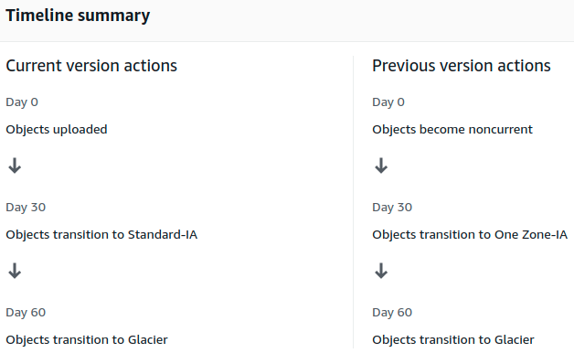

You can see, edit, disable, delete the rule going to Management in the bucket.

S3 Object Lock & Glacier Vault Lock

You can use S3 Object Lock to store objects using a write once, read many (WORM) model.
It helps you to prevent objects to being deleted or modified for a fixed amount of time or indefinitely.

You can use it to meet regularoty requirements that require WORM storage, or add extra layer of protection against object changes and deletion.

Modes:
- Governance Mode: You can grant some users special permissions to delete, alter an object or alter the retention settings. The rest of the users can not do anything.

- Compliance Mode: No one, not even the Root, can modify or delete the object version.It’s retention mode can NOT be changed and it’s retention period can not be shortened by no one, ensuring that the object version won’t be deleted or modified during the Retention Period.

Retention Periods:
Is the time that an object version will be protected against overwritten/delete actions. You set up the retention period.

At the end of the RP the object version can be overwritten or deleted unless you also placed a Legal Hold on the object version.

When you place a RP, AWS S3 stores a timestamp in the object version’s metadata to indicate when the RP expires.

Legal Holds:
Prevents an object version from being overwritten or deleted. Like the RP.

However a Legal Hold doesn’t have an associated retention period and remains in effect until removed the legal hold.

Legal Holds can be placed and removed by any user who has the s3:PutObjectLegalHold permission.

S3 Glacier Vault Lock: Is a way of locking objects into Glaciar similar to S3 Object Lock.

You can lock a Vault Lock policy with WORM for example and lock the policy for future edits. Once locked the policy can no longer be changed.

Exam Tips:

- Use S3 Object Lock to store objects using a WORM model, write once, read many.

- Object locks can be on individual objects or applied across the bucket as a whole.

- Object locks ome in two models:
  - Governance mode: The object can be modified if you have special permissions.
  - Compliance mode: No one can modify the object. You habe to wait utill the Retention Perion set is over.

- S3 Glaciar Vault Lock: To lock Objects inside glacier tier.

