Repl.it

Run → Ctrl + Enter
Run → Command + Enter (Mac)
Askpython documentation
Comment/Uncomment a line: Ctrl + /

Debug code online step by step
Or download the program Thonny

Day 1:

Input Function:

What is this: Input will get you what the user is typing in console.

input(promt for the user) → inside of parenthesys we have what is going to be printed in the screen and will wait till we type something:

input(“What is your name? ”) → if you execute this will wait till you type your name or whatever.

Then if you’ve typed “John” will be substituted and added into it like: input(“John ”)

So input(“What is your name? ”) will be replaced by what you typed.

If you run the program and type John:
What is your name? John

input(“What is your name? ”) will be replaced by John.

You can print John if you do this:
print("Hello " + input("What is your name: "))

You will get:
What is your name: John
Hello John

Exercise 1.3:

Ask me to type my name and the program will tell you how much letters the name have:

Option 1, One line:
print(len(input("What is your name? ")))

Option 2, two lines:
name = input("What is your name? ")
print(len(name))

Python Variables:

Using the previous exercise:
print(len(input("What is your name? ")))

We can use variables like this:

name = input("What is your name? ")
length = len(name)

print(length)

Exercise 1.4:
Switch values of variables.
Give to variable A, the value of variable B and viceversa.

My solution:  a = input("a: ")  b = input("b: ")  cafe = a  milk = b  a = milk  b = cafe  print("a: " + a)  print("b: " + b) | Teacher’s solution:  a = input("a: ")  b = input("b: ")  a = c  a = b  b = c  print("a: " + a)  print("b: " + b)
Result:  a: AAAAA  b: BBBBB  a: BBBBB  b: AAAAA | Result:  a: AAAAA  b: BBBBB  a: BBBBB  b: AAAAA

Variable names:
length1 = 10 → good
1length = 10 → not allowed to start variable names with numbers

user_name = “John” → good
user name = “John” → not allowed, the variable name have to be a single item without spaces.

Is not recommended to use function names as variable names, like print, len or so.

Final project: https://repl.it/@appbrewery/band-name-generator-start#main.py

Exercise:

#1. Create a greeting for your program.

#2. Ask the user for the city that they grew up in.

#3. Ask the user for the name of a pet.

#4. Combine the name of their city and pet and show them their band name.

#5. Make sure the input cursor shows on a new line, see the example at:
# https://band-name-generator-end.appbrewery.repl.run/

My solution:  print("This program creates a band name:")  print("---------------------------------")  city = input("In which city did you grew up? ")  pet = input("Tell me the name of your pet ")  space = " "  print( city + space + pet ) | Teacher’s solution:  print("Welcome to the band name generator.")  city = input("Which city did you grow up in?\n")  pet = input("What is the name of a pet?\n")  print("Your band name cound be: " + city + " " + pet)
Result:  This program creates a band name:  ---------------------------------  In which city did you grew up? Figueres  Tell me the name of your pet Boris  Figueres Boris | Result:  Welcome to the band name generator.  Which city did you grow up in?  Bristol  What is the name of a pet?  Rabbit  Your band name cound be: Bristol Rabbit

Day 2:

Data Types:

String:

“ ” → Anything between quotes or double quotes will be trated as a string (text).
“1234” → this will be treated as a string.

print(“Hello” [4] ) → this will print the last character, o

print("123" + "456") → this will give you: 123456

Integer:

print(123 + 456) → 579

Tip: Use underscore (_) to write large integer numbers and to split them in order to make it easy to visualize:

123_123_3534 → will be interpreted like this: 1231233534

Float:

3.23423
242343.640

Boolean:
True
False

Both starting with Capitals and without quotation marks, otherwhise it would turn them into strings.

Function Types:

type() → it gives you the type of data.

Example:
num_char = len(input("What is your name? ")) → num_char is an integer

print("Your name has " + num_char + "characters.") → this gives error because you can NOT add
strings + integers, only the same data type.

To know the type of the data you are using, use the type() function.
print(type(num_char)) → <class ‘int’>
Convert a data type to a string:

You can use the type function to investigate which data type you are using.
With type function you can CONVERT one datatype to another.

To make work the previous exercise convert the integer to string:

num_char = len(input("What is your name? "))

new_num_char = str(num_char)

print("Your name has " + new_num_char + " characters.")

We convert the variable num_char to a string and we give it a new name, now the program will work because the whole print statement is adding strings:

What is your name? sfgsdfgsfgsfgs
Your name has 14 characters.

Exercise 2.1:

Type two numbers and add them, so 23 will be 2 + 3 = 5

My solution:  two_digit_number = input("Type a two digit number: ")  first = int(two_digit_number[0])  second = int(two_digit_number[1])  print(first + second) | Teacher’s solution:  two_digit_number = input("Type a two digit number: ")  first_digit = two_digit_number[0]  second_digit = two_digit_number[0]  result = int(first_digit) + int(second_digit)  print(result)
Result:  Type a two digit number: 23  5 | Result:  Type a two digit number: 87  15

Teacher’s explanation:

First we have to know which is the data type of the variable two_digit_number
print(type(two_digit_number)) → which is a <class ‘str’>

Mathematical Operations in Python:

3 + 4
5 - 2
3 * 7
6 / 3 → the result will be a float, 2.0 in this examples
** exponent, when you want to raise a number to a power
2 ** 3 → two 3 times is 8. 2 * 2 * 2 = 8

Order of the operations:

If you have different operations in the same line of code, there is an order that the program will follow.

The rule to remember is PEMDAS:
- Parentheses ()
- Exponents **
- Multiplication * and Division / → they are equal important. First coming wins
- Addition + and Substraction - → they are equal important. First coming wins

Example:
print( 3 * 3 + 3 / 3 - 3)

First will do the mutiplication, 3 * 3 = 9 →is first because is the first operation on the left.
Second the division, 3 /3 = 1.0 → float, ran the second after the multiplication because comes after.
Third the addition, 9 + 1.0 = 10.0
Last the substraction, 10.0 - 3 = 7.0

Example 2: Make that operation to have 3 as result
print( 3 * (3 + 3) / 3 - 3)

First the parenthesy, 3 + 3 = 6
Second the multiplication because is the first on the left, 3 * 6 = 18
Third de division, 18 / 6 = 6
Last the substraction, 6 - 3 = 3

[Interactive Coding Exercise] BMI Calculator:

Exercise 2.2:

Calculate the BMI

My solution:  height = input("enter your height in m: ")  weight = input("enter your weight in kg: ")  height = float(height)  weight = float(weight)  print(int(height / (weight * weight ))) | Teacher’s solution:  height = input("enter your height in m: ")  weight = input("enter your weight in kg: ")  bmi = int(weight) / float(height) ** 2  bmi_as_int = int(bmi)  print(bmi_as_int)
Result:  enter your height in m: 80  enter your weight in kg: 1.75  26 | Result:  enter your height in m: 80  enter your weight in kg: 1.75  26

Number Manipulation and F Strings in Python:

Round the number:
If you are dividing a number it will give you a float.

You can limit the decimals appearing on the right after the colon by using round.

Example:

print(8 / 3) → 2.6666666666666665

print(round(8 / 3)) → 3

print(round(8 / 3, 2)) → 2.67

print(round(2.6666666, 2)) → 2.67

Use the floor edition:

print(8 / 3) → 2.6666666666666665 → float number

print(8 // 3) → 2 → int number

Using variables:

result = 4/2 → 2
result *= 3 → 2 x 3
print(result) → 6

score = 0
score += 1
print(score) → 1

Change datatypes: f-String

We can not use different datatypes to operate in the same line, if you use a string + int the program will fail.

To make it work until now we are converting the data, to str in the below example:
score = 0
print("Your score is: " + str(score))

But we can use f-String to make it much more easy:

score = 0
height = 1.8
isWinning = True

print(f"Your score is {score}, your height is {height}, you are winning is {isWinning} ")

→ Your score is 0, your height is 1.8, you are winning is True

We are calling the variables with {}

Exercise:

If you live 90 years you will have 32850 days, 4680 weeks and 1080 months.

Calculate how much time will be using you age as a reference and comparing it with 90 years.

Ask for your age and do the math:
days = age - 90 * 365
weeks = age - 90 * 52
months = age - 90 * 12

My solution:  age = input("What is your current age? ")  age = int(age)  days = (90 - age) * 365  weeks = (90 - age) * 52  months = (90 - age) * 12  print(f"You have {days} days, {weeks} weeks, and {months} months left.") | Teacher’s solution:  age = input("What is your current age? ")  age_as_int = int(age)  years_remaining = 90 - age_as_int  days_remaining = years_remaining * 365  weeks_remaining = years_remaining * 52  months_remaining = years_remaining * 12  message = f"You have {days_remaining} days, {weeks_remaining} weeks, and {months_remaining} months left."  print(message)
Result:  What is your current age? 40  You have 18250 days, 2600 weeks, and 600 months left. | Result:  What is your current age? 40  You have 18250 days, 2600 weeks, and 600 months left.

Variation after cheking teacher’s example:

age = input("What is your current age? ")

age = 90 - int(age)

days = age * 365
weeks = age * 52
months = age * 12

print(f"You have {days} days, {weeks} weeks, and {months} months left.")

Tip Calculator:

My solution:  print("Welcome to the tip calculator")  print("")  bill = int(input("What was the total bill? $"))  percent = int(input("How much tip would you like to give? 10, 12, or 15? "))  people = int(input("How many people to split the bill? "))  percent_correct = percent / 100  percent_bill = bill * percent_correct  total = bill + percent_bill  result = total / people  print(f"Each person should pay: ${result}") | Teacher’s solution:  print("Welcome to the tip calculator")  bill = float(input("What was the total bill? $"))  tip = int(input("How much tip would you like to give? 10, 12, or 15? "))  people = int(input("How many people to split the bill?"))  tip_as_percent = tip / 100  total_tip_amount = bill * tip_as_percent  total_bill = bill + total_tip_amount  bill_per_person = total_bill / people  final_amount = round(bill_per_person, 2)  print(f"Each person should pay: ${final_amount}")
Result:  Welcome to the tip calculator  What was the total bill? $150  How much tip would you like to give? 10, 12, or 15? 12  How many people to split the bill? 5  Each person should pay: $33.6 | Result:  Welcome to the tip calculator  What was the total bill? $100  How much tip would you like to give? 10, 12, or 15? 10  How many people to split the bill?5  Each person should pay: $22.0

Another approach from the teacher:

bill = float(input("What was the total bill? $"))
tip = int(input("How much tip would you like to give? 10, 12, or 15? "))
people = int(input("How many people to split the bill? "))

bill_with_tip = bill * (1 + tip /100) → we simplify in one line three operations
bill_per_person = bill_with_tip / people
final_amount = round(bill_per_person, 2)

print(f"Each person should pay: ${final_amount}")

Another approach from the teacher: To show two decimals allways.

bill = float(input("What was the total bill? $"))
tip = int(input("How much tip would you like to give? 10, 12, or 15? "))
people = int(input("How many people to split the bill?"))

tip_as_percent = tip / 100
total_tip_amount = bill * tip_as_percent
total_bill = bill + total_tip_amount
bill_per_person = total_bill / people
final_amount = round(bill_per_person, 2)
final_amount = “{:.2f}”.format(bill_per_person) → this will show allways two decimal digits. *

print(f"Each person should pay: ${final_amount}")

* Depence on the amount of the bill the result will show only one decimal digit, like:
bill = 150
tip = 12
people = 5

final_amount = 33.6

But the prices have to show two decimal digits.
To always show two digits we can use the format function.

final_amount = “{:.2f}”.format(bill_per_person)

Day 3: Control Flow and Logical Operators:

01/26/2021

Flow control with if/else statements.

Flow control diagram example:

If you are taller than 120 cm you can ride the rollercoaster
If (else) you are shorter than 120 cm you can NOT ride it.
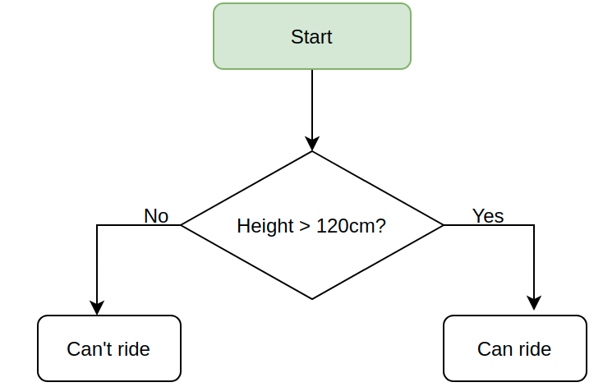

Exercise:

If you are taller or equal to 120 you can ride:

print("Welcome to the rollercoaster!")

height = int(input("What is your height in cm? "))

if height >= 120:
print("You can ride the rollercoaster!")

else:
print("Sorry, you have to grow taller before you can ride.")

Comarison Operators:
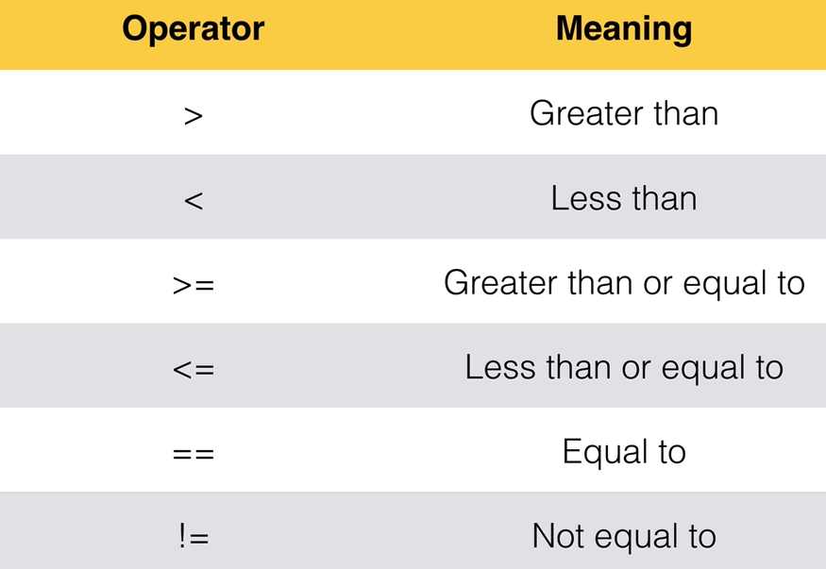

Odd or Even? Introducing the Modulo

Modulo: → %
Will divide a number by another number and will give you the remainder of that division.

You can use modulo to know if a number is even or odd.

If the division of a number by another gives you a reminder, like 14 /4 = 3,5 you will know that the number is odd because will give you a reminder, ,5 in this example.

Example: 7 % 2

Seven split into portions of 2 is:
2 + 2 + 2 + 1

Seven divided by 2 can be divided 3 times (2 + 2 + 2) with a reminder of 1.

1 is what the modulo gives you.

If you run 7 % 2 in the console gives you 1:
7 % 2 = 1

Example 2: 7 % 3

3 + 3 + 1
7 % 3 = 1

Example 3: 14 % 4 (14 /4 = 3,5)

4 + 4 + 4 + 2
14 % 4 = 2

Exercise:

Tell me if the introduced number is odd or even

My solution:  number = int(input("Which number do you want to check? "))  odd_even = number % 2  if odd_even == 0:  print("This is an even number.")  else:  print("This is an odd number.") | Teacher’s solution:  number = int(input("Which number do you want to check? "))  if number % 2 == 0:  print("This is an even number.")  else:  print("This is an odd number.")
Result:  Which number do you want to check? 23452451  This is an odd number. | Result:  Which number do you want to check? 2342342423  This is an odd number.

Nested if statements and elif statements:

Nested If/Else statements:

Following the height example, if you are 120 cm or higher you can use the rollercoaster, if not (else) you can NOT.

Now if you are 120 or higher and you have 18 ages or more you will pay $12. If you are under 18 ages you will pay $7.

We will use nested if/else statements:

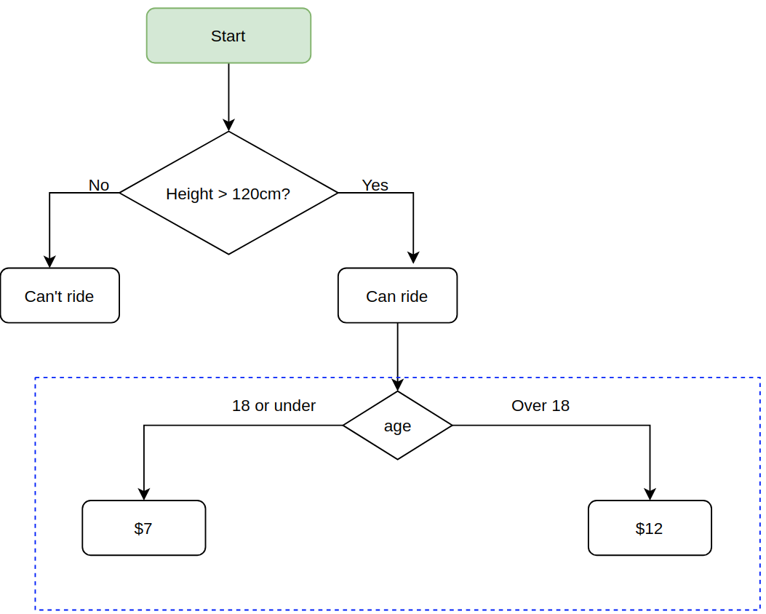
height = int(input("Tell me your heigh in cm: "))

if height >= 120:
print("You can ride the rollercoaster")
age = int(input("What is your age: "))
if age >= 18:
print("Please pay $12")
else:
print("Please pay $7")

else:
print("Sorry, you have to grow taller.")

If / elif /else:

If condition 1 is true do A
If 1 is not true check if condition 2 is true and if so do B

Finally, if none of the conditions are true do the ELSE
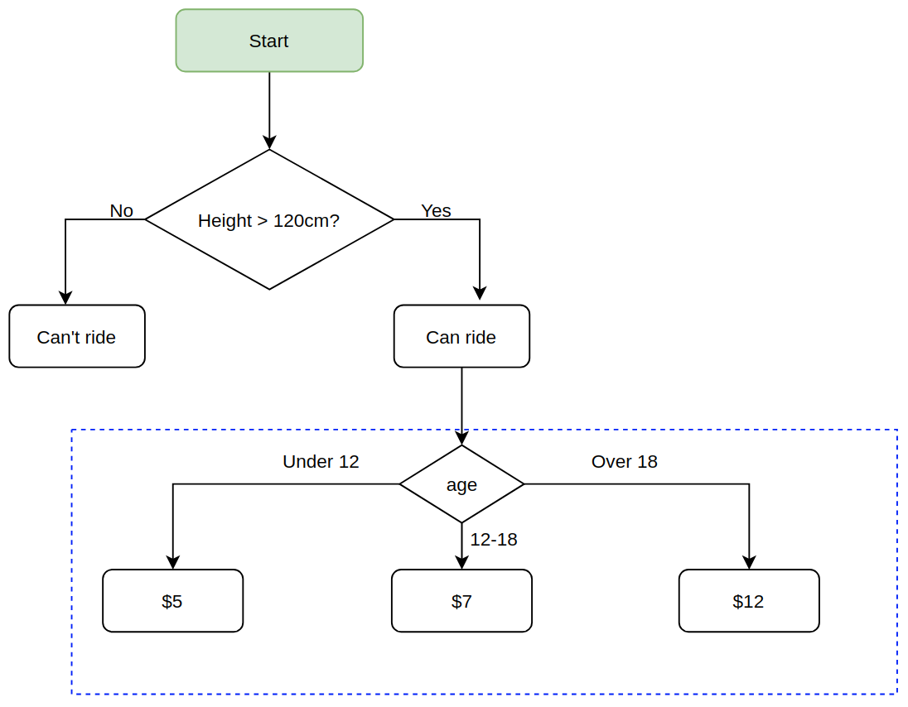
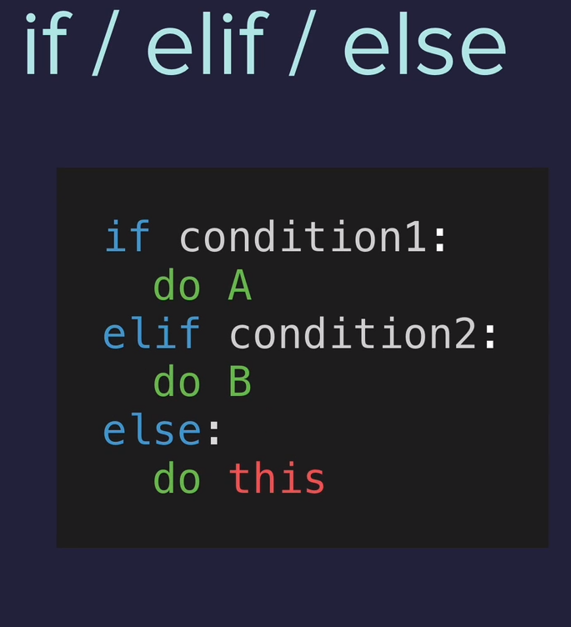

Now we will check if you have the correct height. If you are under 120 cm, game over.

If you have the correct height you have to tell us your age:

If you are 18 or over you have to pay $12
If you are between 12 and 18 you have to pay $7

And if you are not matching any of the above ages you have to pay $5.

height = int(input("Tell me your heigh in cm: "))

if height >= 120:
print("You can ride the rollercoaster")
age = int(input("What is your age: "))
if age < 12:
print("Please pay $5")
elif age >= 18:
print("Please pay $12")
else:
print("Please pay $7 ")

else:
print("Sorry, you have to grow taller.")

Exercise3.2 BMI Calculator 2

Ask for your height and weight.

If you are :
Under 18.5 they are underweight
Over 18.5 but below 25 they have a normal weight
Over 25 but below 30 they are slightly overweight
Over 30 but below 35 they are obese
Above 35 they are clinically obese.

Print the message in the solution highligting the medical condition.

My solution:  height = float(input("enter your height in m: "))  weight = float(input("enter your weight in kg: "))  bmi = round(weight / (height ** 2))  start = "\033[1m"  end = "\033[0;0m"  if bmi < 18.5:  print(f"Your BMI is {bmi},{start} you are underweight.{end}")  elif bmi >= 18.5:  if bmi < 25:  print(f"Your BMI is {bmi},{start} you have a {start}normal weight.{end}")  elif bmi > 25:  if bmi < 30:  print(f"Your BMI is {bmi}, you are {start}slightly. overweight.{end}")  elif bmi > 30:  if bmi <= 35:  print(f"Your BMI is {bmi}, you are {start}obese.{end}")  else:  print(f"Your BMI is {bmi}, you are {start}clinically obese.{end}") | Teacher’s solution:  height = float(input("enter your height in m: "))  weight = float(input("enter your weight in kg: "))  bmi = round(weight / (height ** 2))  if bmi < 18.5:  print(f"Your BMI is {bmi}, you are underweight.")  elif bmi < 25:  print(f"Your BMI is {bmi}, you are normal weight.")  elif bmi < 30:  print(f"Your BMI is {bmi}, you are overweight.")  elif bmi < 35:  print(f"Your BMI is {bmi}, you are obese.")  else:  print(f"Your BMI is {bmi}, you are clinically obese.")
Result:  enter your height in m: 1.7  enter your weight in kg: 70  Your BMI is 24, you have a normal weight. | Result:

Exercise 3.3

Type a year and tell me if it is a leap year or not, follow this rule:
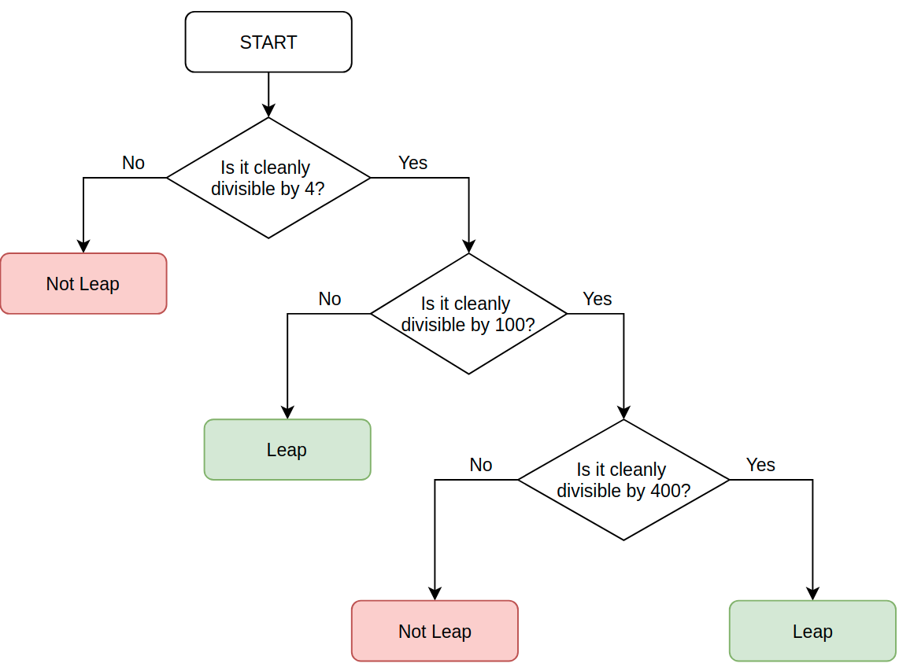
Example:
2000 ÷ 4 = 500 (Leap)
2000 ÷ 100 = 20 (Not Leap)
2000 ÷ 400 = 5 (Leap!)
-----
2100 ÷ 4 = 525 (Leap)
2100 ÷ 100 = 21 (Not Leap)
2100 ÷ 400 = 5.25 (Not Leap)

My solution:  year = int(input("Which year do you want to check? "))  year_4 = year % 4  year_100 = year % 100  year_400 = year % 400  if year_4 == 0 :  if year_100 == 0:  if year_400 == 0:  print("Leap year.")  else:  print("Not leap year.") | Teacher’s solution:  year = int(input("Which year do you want to check? "))  if year % 4 == 0:  if year % 100 == 0:  if year % 400 == 0:  print("Leap year.")  else:  print("Not leap year.")  else:  print("Leap year.")  else:  print("Not leap year.")
Result:  Which year do you want to check? 2002  Not leap year.  ---  Which year do you want to check? 2000  Leap year. | Result:  Which year do you want to check? 2002  Not leap year.  ---  Which year do you want to check? 2000  Leap year.

Multiple If Statements in Succession:

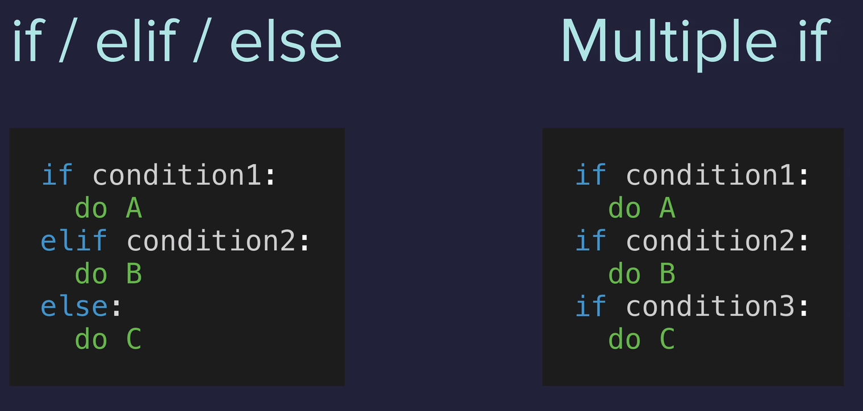

Until now with if / elif /else only one of the conditions will be executed.
But with Multiple if all will be executed if all of them are true.
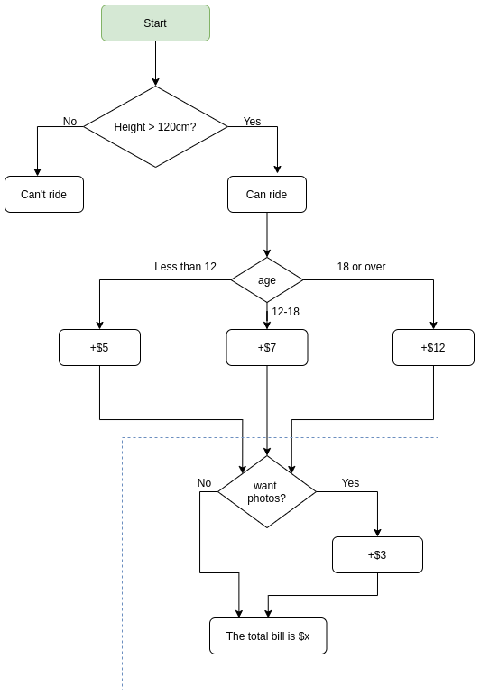
Using the previous rollercoaster code:

height = int(input("Tell me your heigh in cm: "))

if height >= 120:
print("You can ride the rollercoaster")
age = int(input("What is your age: "))
if age < 12:
print("Please pay $5")
elif age >= 18:
print("Please pay $12")
else:
print("Please pay $7 ")

else:
print("Sorry, you have to grow taller.")

Add into it the option to pay for the photo taken or not and if so add $3 to the final bill:

height = int(input("Tell me your heigh in cm: "))

bill = 0

if height >= 120:
print("You can ride the rollercoaster")

age = int(input("What is your age: "))
if age < 12:
print("Child tickets are $5")
bill = 5
elif age >= 18:
print("Adult tickets are $12")
bill = 12
else:
print("Youth tickets are $7 ")
bill = 7
photo = (input("Do you want the photo taken? Y or N: "))
if photo == "Y":
bill += 3
print(f"Your final bill is ${bill}")
else:
print("Sorry, you have to grow taller.")

Exercise 3.4: Ordering pizza.

Ask for the size, S, M or L
Ask if you whant to add extra peperoni: + $2 for S and + $3 for M and L
Ask if you want extra cheese: +$1 to all sizes.

My solution:  print("Welcome to Python Pizza Delivieries!\n")  pizza = input("What size pizza do you want? S, M or L: ")  bill = 0  if pizza == "S":  bill += 15  if pizza == "M":  bill += 20  if pizza == "L":  bill += 25  peperoni = input("Do you want peperoni? Y or N: ")  if peperoni == "Y":  if pizza == "S":  bill += 2  if pizza == "M" or pizza == "L":  bill += 3  cheese = input("Do you want extra cheese? Y or N: ")  if cheese == "Y":  bill += 1  print(f"Your bill is ${bill}") | Teacher’s solution:  print("Welcome to Python Pizza Deliveries!")  size = input("What size pizza do you want? S, M, or L ")  add_pepperoni = input("Do you want pepperoni? Y or N ")  extra_cheese = input("Do you want extra cheese? Y or N ")  bill = 0  if size == "S":  bill += 15  elif size == "M":  bill += 20  else:  bill += 25  if add_pepperoni == "Y":  if size == "S":  bill += 2  else:  bill += 3  if extra_cheese == "Y":  bill += 1  print(f"Your final bill is: ${bill}.")
Result:  Welcome to Python Pizza Delivieries!  What size pizza do you want? S, M or L: L  Do you want peperoni? Y or N: Y  Do you want cheese? Y or N: Y  Your bill is $29 | Result:  Welcome to Python Pizza Deliveries!  What size pizza do you want? S, M, or L M  Do you want pepperoni? Y or N Y  Do you want extra cheese? Y or N Y  Your final bill is: $24.

Logical Operators:

AND: Both have to be true → a AND b. If one of the is false then the result is false.
a = 12
a > 15 → false
a > 10 → true
a > 10 and a < 13 → true

OR: If one or both are true, the it’s true. Only when both are false will be evaluate to false.

NOT: Reverses the conditon. If the condition is false then becames true and if is true becames false.
a = 12
a > 15 → false
not a > 15 → true ,is reversing it.

Roller coaster exercise:
Add the ages between 45 and 55. If you age is equal or higher than 45 or equal or lower than 55 then the condition will evaluate to true.

height = int(input("Tell me your heigh in cm: "))

bill = 0

if height >= 120:
print("You can ride the rollercoaster")

age = int(input("What is your age: "))
if age < 12:
print("Child tickets are $5")
bill = 5
elif age >= 45 or age >= 55:
bill += 0
elif age >= 18:
print("Adult tickets are $12")
bill = 12
else:
print("Youth tickets are $7 ")
bill = 7
photo = (input("Do you want the photo taken? Y or N: "))
if photo == "Y":
bill += 3
print(f"Your final bill is ${bill}")
else:
print("Sorry, you have to grow taller.")

Love calculator, Day 3.5

My solution:  print("Welcome to the Love Calculator!")  name1 = input("What is your name? \n")  name2 = input("What is their name? \n")  # Convert the names to lowercase  name1 = name1.lower()  name2 = name2.lower()  # See name1 match with leters on "true"  name_t = name1.count("t")  name_r = name1.count("r")  name_u = name1.count("u")  name_e = name1.count("e")  # Sum up all name1 variables  name1 = name_t + name_r + name_u + name_e  # Convert name1 into a string for later concatenation  name1 = str(name1)  # See name2 match with leters on "love"  name_l = name2.count("l")  name_o = name2.count("o")  name_v = name2.count("v")  name_e = name2.count("e")  # Sum up all name2 variables  name2 = name_l + name_o + name_v+ name_e  # Convert name2 into a string for later concatenation  name2 = str(name2)  # Store its values in the variable  both = name1 + name2  # Convert both to int  both_int = int(both)  # If/elif/else statement  if both_int <10 or both_int <90:  print(f"Your score is {both_int}, you go together like coke and mentos.")  elif both_int >=40 and both_int <=50:  print(f"Your score is {both_int}, you are alright together.")  else:  print(f"Your score is {both_int}") | Teacher’s solution:  print("Welcome to the Love Calculator!")  name1 = input("What is your name? \n")  name2 = input("What is their name? \n")  combined_names = name1 + name2  lower_names = combined_names.lower()  t = lower_names.count("t")  r = lower_names.count("r")  u = lower_names.count("u")  e = lower_names.count("e")  first_digit = t + r + u + e  l = lower_names.count("l")  o = lower_names.count("o")  v = lower_names.count("v")  e = lower_names.count("e")  second_digit = l + o + v + e  score = int(str(first_digit) + str(second_digit))  if (score < 10) or (score > 90):  print(f"Your score is {score}, you go together like coke and mentos.")  elif (score >= 40) and (score <= 50):  print(f"Your score is {score}, you are alright together.")  else:  print(f"Your score is {score}.")
Result:  Welcome to the Love Calculator!  What is your name?  otto eastr  What is their name?  Paco Alves  Your score is 54, you go together like coke and mentos. | Result:  Welcome to the Love Calculator!  What is your name?  otto eastr  What is their name?  Paco Alves  Your score is 67.

Explanation:

Type two names, with surnames if you want.

Concatenate them to form a single line and make it lowercase.

Check how much times are appearing the same leters inside the single line and in the word “true” and the word “love”

Sum up the matches for true and store its value in a variable, can call it first_digit
Do the same for love and store it in second_digit. Both variables are integers

Concatenate both variables in order to store its value in a new variable called “score”
You have to convert the to variables to a string then sum up, then convert to integer:
int(str(first_digit) + str(second_digit))

Lastly use an if/elif/else statement to show results depending on the conditions we want.

What I did:
I’ve followed the same logic, except that I’ve missunderstood the exercise a little bit.

Instead of adding the first name and second name all toguether and then sum them up, I did it separatelly, name1 has been only calculated with “true” and name2 has been only calculated with “love”.

Day 3 Project: Treasure Island

ASCII Art

Create multiple lines of a string:

print('''
ASCII code here
more ASCII here
''')

My solution:  [ASCII Code]  print("Welcome to Treasure Island.")  print("Your mission is to find the treasure.")  crossroad = input('You\'re at a cross road. Where do you want to go? Type "left" or "right"\n')  if crossroad == "left":  lake = input('"You\'ve come to a lake. There is an island in the middle of the lake. Type "wait" to wait for a boat. Type "swim" to swim across.\n ')  # Lake  if lake == "wait":  door = input('You arrive at the island unharmed. There is a house with 3 doors. One red, one yellow and one blue. Which colour do you choose?\n ')  # Door  if door == "yellow":  print("You found the treasure! You Win!")  elif door == "red":  print("It's a room full of fire. Game Over.")  elif door == "blue":  print("You enter a room of beasts. Game Over.")  else:  print("You chose a door that doesn't exist. Game Over.")  else:  print("You get attacked by an angry trout. Game Over.")  else:  print("You fell into a hole. Game Over.") | Teacher’s solution:  print("Welcome to Treasure Island.")  print("Your mission is to find the treasure.")  choice1 = input('You\'re at a cross road. Where do you want to go? Type "left" or "right" \n').lower()  if choice1 == "left":  choice2 = input('You\'ve come to a lake. There is an island in the middle of the lake. Type "wait" to wait for a boat. Type "swim" to swim across. \n').lower()  if choice2 == "wait":  choice3 = input("You arrive at the island unharmed. There is a house with 3 doors. One red, one yellow and one blue. Which colour do you choose? \n").lower()  if choice3 == "red":  print("It's a room full of fire. Game Over.")  elif choice3 == "yellow":  print("You found the treasure! You Win!")  elif choice3 == "blue":  print("You enter a room of beasts. Game Over.")  else:  print("You chose a door that doesn't exist. Game Over.")  else:  print("You get attacked by an angry trout. Game Over.")  else:  print("You fell into a hole. Game Over.")
Result:  [ASCII Code]  Welcome to Treasure Island.  Your mission is to find the treasure.  You're at a cross road. Where do you want to go? Type "left" or "right"  left  "You've come to a lake. There is an island in the middle of the lake. Type "wait" to wait for a boat. Type "swim" to swim across.  wait  You arrive at the island unharmed. There is a house with 3 doors. One red, one yellow and one blue. Which colour do you choose?  yellow  You found the treasure! You Win! | Result:  the same than me.

The teacher have added a .lower() function to avoid capital letters. b

Day 4: Randomization and Python Lists:

Module: If you write your code all in the same page sometimes the code can be so long that will be very complicated to read and understand it.

We can split the code up into individual modules, where each module is responsible for different bit of functionality of your program.

If you have a project with many modules you can have colaboration, like when you build a car that you have several people working in different things of that car and not a single person doing everything.

Location of the modules:
They are stored in /usr/lib/python3.7/ in your local machine when you install Python

Import a module:
import random → importing the random module, now we will be able to use it in our code.

Random module: you can use it to create random things, like int, float, str, etc, example:

import random

random_integer = random.randint(1, 10)
print(random_integer)

Will print randomly one number between 1 and 10, both included.

randomint →is used to randomize integers

Create and use your own module:
Until now we are using a single python file to run our programs.

In your python gui, like replit, you will see the file main.py. You can create a new one and name it: my_module.py, then add this into it:

pi = 3.141559246

Now you can use the new module just by importing it, in this case in main.py

import random
import my_module

#random_integer = random.randint(1, 10)
#print(random_integer)

print(my_module.pi)

Random Float:
random.random() →Returns a float random number between 0.0 and 1.0 (1.0 is not included, the last one will be 0.99999999)

Example float random number: 0.3453453453

Exercise: Obtain a random float number between 0 and 5

My solution:  import random  random_float = random.uniform(0,5)  print(random_float) | Teacher’s solution:  import random  random_float = random.random()  random_float *= 5  print(random_float)
Result:  1.3703994497919314 | Result:  4.074776346266939

Exercise: Create a coin toss that will randomly tell you Heads or Tails.

My solution:  import random  random_thing = random.randint(0,1)  if random_thing == 0:  print("Tails")  else:  print("Head") | Teacher’s solution:  import random  random_side = random.randint(0, 1)  if random_side == 1:  print("Heads")  else:  print("Tails")
Result:  Head | Result:  Tails

Python Lists: [item1, item2]
Lists options

Data Structure: Way to store and organizing data in python.

Till now we were storing single variables, like: price = 100 , or high = 1,80

To store things like all the states of US you can have them all toghether in a variable called:
states_us.

In other cases you want to have order in the data structure, like people doing a queue, you want to know who is first, second, last, etc.

This is why we are using lists.

List are coming between square brakets: fruits = [item1, item2]
For strings use “” “” → fruits = [“apple”, “banana”, “orange”]
Before knowing lists: Using the US states as example
state1 = “Delaware”
state2 = “Pennsylvania”
etc,
etc,

With Lists:
states_of_america = [ “Delaware”, “Pennsylvania”, “item1”, “item2”, “item3”, etc ]

Lists benefits:
- You can use lists to store many peaces of related data.

- Also have an order, determined by the order on the list. When stored inside a variable, that order is not lost and you can use it later on when you need it.

Exercise: Print the name of one state inside the list

states_of_america = ["Alaska", "Alabama", "Arkansas", "American Samoa", "Arizona", "California", "Colorado", "Connecticut", "District ", "of Columbia", "Delaware", "Florida", "Georgia", "Guam", "Hawaii", "Iowa", "Idaho", "Illinois", "Indiana", "Kansas", "Kentucky", "Louisiana", "Massachusetts", "Maryland", "Maine", "Michigan", "Minnesota", "Missouri", "Mississippi", "Montana", "North Carolina", "North Dakota", "Nebraska", "New Hampshire", "New Jersey", "New Mexico", "Nevada", "New York", "Ohio", "Oklahoma", "Oregon", "Pennsylvania", "Puerto Rico", "Rhode Island", "South Carolina", "South Dakota", "Tennessee", "Texas", "Utah", "Virginia", "Virgin Islands", "Vermont", "Washington", "Wisconsin", "West Virginia", "Wyoming"]

print(states_of_america[1])

Alabama

Position of the index:
When you call an item inside a list you can use positive or negative numbers, example:

print(states_of_america[2]) → this will print the 3rd position in the list: Arkansas

print(states_of_america[-1]) → will print the last item on the list, Wyoming

Change items on the list:
states_of_america[4] = AriSona → now the 5th item on the list will be called AriSona instead of Arizona.

Add a single item into the list:
states_of_america.append(“PollaLand”) → append will add a single item at the end of the list.

Add more than one item:
states_of_america.append([“PollaLand”, “Ojeteland”]) → you add the items inside a list into the states_of_america list. The two items will be added at the end of the original list

"Wisconsin", "West Virginia", "Wyoming", “PollaLand”, “Ojeteland”]

Exercise 4.2:

Split method: Will take the items in a variable and will search for the separator that we specify, like a comma, and will add all these items in a list.

Example:

str_inp = “Helo,from,AskPython”
op = str_inp.split(“, ”) → this is a , and a empty space.
print(op)

[‘Hello’, ‘from’, ‘AskPython’] → separates all the items in the variable with a comma and a space.

Statement: Guess who is going to pay the dinner.

Type a few names separated by commas and an empty space, and the program will show you one of these names, which is who is going to pay the bill.

You can not use the .chose() method.

My solution:  names_string = input("Give me everybody's names, separated by a comma. ")  names = names_string.split(", ")  number = len(names)  import random  number_random = random.randint(0, number)  number_random -= 1  print(names [number_random]) | Teacher’s solution:  import random  names_string = input("Give me everybody's names, seperated by a comma. ")  names = names_string.split(", ")  num_items = len(names)  random_choice = random.randint(0, num_items - 1)  person_who_will_pay = names[random_choice]  print(person_who_will_pay + " is going to buy the meal today!")
Result:  AA | Result:  AAAAAAAA is going to buy the meal today!

IndexErrors and Working with Nested Lists:

IndexError: list index out of range:

This happens when you are calling an index inside a list that doesn’t contain any item. For instance:
You have the 50 states of USA in a list and you call the position 51, this will give you the out of range error.

Remember that the index starts with 0, so if there is 50 states in USA inside a list, the first one will be called by the number 0, and the last one will be the 49.

Nested Lists: You can have a list inside a list, example:

numbers = ["1", "2", "3", "4", "5"]
vowels = ["a", "e", "i", "o", "u"]

together = [numbers, vowels]

print(together)

[['1', '2', '3', '4', '5'], ['a', 'e', 'i', 'o', 'u']]

Print one element from one list:
numbers = ["1", "2", "3", "4", "5"]
vowels = ["a", "e", "i", "o", "u"]

together = [numbers, vowels]

print(together[1][3])

Day 4.3 Treasure Map:

My solution:  row1 = ["⬜️","⬜️","⬜️"]  row2 = ["⬜️","⬜️","⬜️"]  row3 = ["⬜️","⬜️","⬜️"]  map = [row1, row2, row3]  print(f"{row1}\n{row2}\n{row3}")  position = input("Where do you want to put the treasure? ")  position = str(position)  p_one = int(position[0]) -1  p_two = int(position[1]) -1  map[p_two][p_one] = "X"  print(f"{row1}\n{row2}\n{row3}") | Teacher’s solution:  row1 = ["⬜️","⬜️","⬜️"]  row2 = ["⬜️","⬜️","⬜️"]  row3 = ["⬜️","⬜️","⬜️"]  map = [row1, row2, row3]  print(f"{row1}\n{row2}\n{row3}")  position = input("Where do you want to put the treasure? ")  horizontal = int(position[0])  vertical = int(position[1])  map[vertical - 1][horizontal - 1] = "X"  print(f"{row1}\n{row2}\n{row3}")
Result:  Where do you want to put the treasure? 32  ['⬜️', '⬜️', '⬜️']  ['⬜️', '⬜️', 'X']  ['⬜️', '⬜️', '⬜️'] | Result:  Where do you want to put the treasure? 32  ['⬜️', '⬜️', '⬜️']  ['⬜️', '⬜️', 'X']  ['⬜️', '⬜️', '⬜️']

What do we have to do:
Mark in a map where is the treasure.

You have 9 boxes, 3 arrays of 3 like this:
['⬜️', '⬜️', '⬜️']
['⬜️', '⬜️', '⬜️']
['⬜️', '⬜️', '⬜️']

You have to type two numbers to point where the treasure is.
The first digit will be the columns and the second one will be the rows, so if you type 23 the X will go to:

['⬜️', '⬜️', '⬜️']
['⬜️', '⬜️', '⬜️']
['⬜️', 'X', '⬜️']

What I did:

-- Change the integer variable “position” to string in order to be able to separate the first item from the second in an list, and therefore being able to query both by separate, position[0], position[1]

Correction: Is not necessary to convert from integer to str because a method “input” stores it’s value as a string already.

-- Created p_one to store the value of the position 0, converting it to int and substracting -1
The same for p_two, in this case will be store the value of the position 1.

-- With the value of p_two and p_one I have the position where to place the X, change that position for an “X”

-- And that’s it, it will show the x where you want.

Project: Rock Paper Scissors

What do you choose? Type 0 for Rock, 1 for Paper or 2 for Scissors:
My solution:  import random  rock = '''  _______  ---' ____)  (_____)  (_____)  (____)  ---.__(___)  '''  paper = '''  _______  ---' ____)____  ______)  _______)  _______)  ---.__________)  '''  scissors = '''  _______  ---' ____)____  ______)  __________)  (____)  ---.__(___)  '''  number = int(input("What do you choose? Type 0 for Rock, 1 for Paper or 2 for Scissors: \n"))  choose = [rock, paper, scissors]  print(choose[number])  random_number = random.randint(0,2)  computer_selection = choose[random_number]  print(f"\n Computer choose: {computer_selection}")  if number == 0 and random_number == 2:  print("You win")  elif number == 0 and random_number == 1:  print("You lose")  elif number == 1 and random_number == 0:  print("You win")  elif number == 1 and random_number == 2:  print("You lose")  elif number == 2 and random_number == 1:  print("You win")  elif number == 2 and random_number == 0:  print("You win")  else:  print("Tie") | Teacher’s solution:  import random  <images here>  game_images = [rock, paper, scissors]  user_choice = int(input("What do you choose? Type 0 for Rock, 1 for Paper or 2 for Scissors.\n"))  if user_choice >= 3 or user_choice < 0:  print("You typed an invalid number, you lose!")  else:  print(game_images[user_choice])  computer_choice = random.randint(0, 2)  print("Computer chose:")  print(game_images[computer_choice])  if user_choice == 0 and computer_choice == 2:  print("You win!")  elif computer_choice == 0 and user_choice == 2:  print("You lose")  elif computer_choice > user_choice:  print("You lose")  elif user_choice > computer_choice:  print("You win!")  elif computer_choice == user_choice:  print("It's a draw")
Result:  What do you choose? Type 0 for Rock, 1 for Paper or 2 for Scissors:  2  _______  ---' ____)____  ______)  __________)  (____)  ---.__(___)  Computer choose:  _______  ---' ____)  (_____)  (_____)  (____)  ---.__(___)  You win | Result:  What do you choose? Type 0 for Rock, 1 for Paper or 2 for Scissors.  -23234234  You typed an invalid number, you lose!

Day 5: Python Loops

Using the for loop with Python Lists:

fruits = ["apple", "peach", "orange"]

for fruit in fruits:
print(fruit)

Day 5.1:

Calculate the average student height from a list of heights:

My solution:  student_heights = input("Input a list of student heights ").split()  for n in range(0, len(student_heights)):  student_heights[n] = int(student_heights[n])  total_heigh = 0  for add in student_heights:  total_heigh = add + total_heigh  average = total_heigh / (n +1)  print(round(average)) | Teacher’s solution:  student_heights = input("Input a list of student heights ").split()  for n in range(0, len(student_heights)):  student_heights[n] = int(student_heights[n])  total_height = 0  for height in student_heights:  total_height += height  print(f"total height = {total_height}")  number_of_students = 0  for student in student_heights:  number_of_students += 1  print(f"number of students = {number_of_students}")  average_height = round(total_height / number_of_students)  print(average_height)
Result:  Input a list of student heights 233 123 432  263 | Result:

Teacher’s solution explained:

# We ask the user to type several heights,and we split them into separated items like: 40 50 30 70

student_heights = input("Input a list of student heights ").split()

# The loop takes the items inside student_heights (four items) and convert them in integers one by one in each iteration of the loop@

for n in range(0, len(student_heights)):
student_heights[n] = int(student_heights[n])

# We create the variable total_height, and we add the items of student_heights list one by one, example:
First iteration: total_height (0) + height (40)
Second iteration: total_height (40) + height (50)
Third iteration: total_height (90) + height (30)
...

total_height = 0

for height in student_heights:
total_height += height
print(f"total height = {total_height}")

# We create the variable number_of_students, we iterate over student_heights, which have 4 items (40 50 30 70), and in every iteration we add +1 to the variable created, example:

First iteration: student is over the first position of the list, which is 40, then goes to number_of_students (0) and adds +1 to it, so it’s value is 1

Second iteration: student is in the second position of the list, which it’s value is 50, then number_of_students (1) and adds +1 to it, so it’s value is 2

Third iteration: student is in the third position of the list, which it’s value is 30, then number_of_students (2) and adds +1 to it, so it’s value is 3

Forth and last iteration: student is in the last position of the list, 70, number_of_students (3) + 1 is 4. The loop have no more items on the list so this is over

number_of_students = 0

for student in student_heights:
number_of_students += 1

print(f"number of students = {number_of_students}")

average_height = round(total_height / number_of_students)
print(average_height)

Day 5.2:

Calculate the highest number on a list.

Example: I want to know the maximum score of all the students.

My solution:  student_scores = input("Input a list of student scores ").split()  for n in range(0, len(student_scores)):  student_scores[n] = int(student_scores[n])  print(student_scores)  max_score = 0  for x in student_scores:  if x > max_score:  max_score = x  else:  max_score = max_score  print(f"The highest score in the class is {max_score}") | Teacher’s solution:  student_scores = input("Input a list of student scores ").split()  for n in range(0, len(student_scores)):  student_scores[n] = int(student_scores[n])  print(student_scores)  highest_score = 0  for score in student_scores:  if score > highest_score:  highest_score = score  print(f"The highest score in the class is: {highest_score}")
Result:  Input a list of student scores 78 65 89 86 55 91 64 89  [78, 65, 89, 86, 55, 91, 64, 89]  The highest score in the class is 91 | Result:  Input a list of student scores 78 65 89 86 55 91 64 89  [78, 65, 89, 86, 55, 91, 64, 89]  The highest score in the class is: 91

Day 5.3 Adding Evens Exercise

Meet the range function:
total = 0 → acomulator
for number in range(1, 101) → will count from 1 to 100
print(total)

You can add steeps to: range(1, 101, 5) → count from 1 to 100 jumping 5 each time, 1, 6,11, etc

Exercise: Sum up all the even numbers from 2 to 100 and print only the final total.

My solution:  total = 0  for i in range(0, 101, 2):  total += i  print(total) | Teacher’s solution:  #Write your code below this row 👇  even_sum = 0  for number in range(2, 101, 2):  # print(number)  even_sum += number  print(even_sum)  #or  alternative_sum = 0  for number in range(1, 101):  if number % 2 == 0:  # print(number)  alternative_sum += number  print(alternative_sum)
Result:  2550 | Result:  2550

Day 5.4
Exercise:
Print from 1 to 100 and:
- If the number is modulo 3 print Fizz.
- If the number is modulo 5 print Buzz
- If the number is modulo 3 and modulo 5 print FizzBuzz
- If not print the number

My solution:  for i in range(1, 101):  if i % 3 == 0:  i = "Fizz"  print(i)  elif i % 5 == 0:  i = "Buzz"  print(i)  elif i % 3 == 0 and i % 5 == 0:  i = "FizzBuzz"  print(i)  else:  print(i) | Teacher’s solution:  for i in range(1, 101):  if i % 3 == 0 and i % 5 == 0:  print("FizzBuzz")  elif i % 3 == 0:  print("Fizz")  elif i % 5 == 0:  print("Buzz")  else:  print(i)
Result:  1  2  Fizz  4  Buzz  Fizz  7  8  [...] | Result:  1  2  Fizz  4  Buzz  Fizz  7  8  [...]

Day 5 Project: Create a Password Generator

My solution: Simple solution  import random  letters = ['a', 'b', 'c', 'd', 'e', 'f', 'g', 'h', 'i', 'j', 'k', 'l', 'm', 'n', 'o', 'p', 'q', 'r', 's', 't', 'u', 'v', 'w', 'x', 'y', 'z', 'A', 'B', 'C', 'D', 'E', 'F', 'G', 'H', 'I', 'J', 'K', 'L', 'M', 'N', 'O', 'P', 'Q', 'R', 'S', 'T', 'U', 'V', 'W', 'X', 'Y', 'Z']  numbers = ['0', '1', '2', '3', '4', '5', '6', '7', '8', '9']  symbols = ['!', '#', '$', '%', '&', '(', ')', '*', '+']  print("Welcome to the PyPassword Generator!")  nr_letters= int(input("How many letters would you like in your password?\n"))  nr_symbols = int(input(f"How many symbols would you like?\n"))  nr_numbers = int(input(f"How many numbers would you like?\n"))  x = ''  y = ''  n = ''  for i in range(nr_letters):  random_index1 = random.randint(0, len(letters)-1)  end1 = letters[random_index1]  x += end1  for i in range(nr_symbols):  random_index2 = random.randint(0, len(symbols)-1)  end2 = symbols[random_index2]  y += end2  for i in range(nr_numbers):  random_index3 = random.randint(0, len(numbers)-1)  end3 = numbers[random_index3]  n += end3  print(x+y+n) | Teacher’s solution:  import random  letters = ['a', 'b', 'c', 'd', 'e', 'f', 'g', 'h', 'i', 'j', 'k', 'l', 'm', 'n', 'o', 'p', 'q', 'r', 's', 't', 'u', 'v', 'w', 'x', 'y', 'z', 'A', 'B', 'C', 'D', 'E', 'F', 'G', 'H', 'I', 'J', 'K', 'L', 'M', 'N', 'O', 'P', 'Q', 'R', 'S', 'T', 'U', 'V', 'W', 'X', 'Y', 'Z']  numbers = ['0', '1', '2', '3', '4', '5', '6', '7', '8', '9']  symbols = ['!', '#', '$', '%', '&', '(', ')', '*', '+']  print("Welcome to the PyPassword Generator!")  nr_letters= int(input("How many letters would you like in your password?\n"))  nr_symbols = int(input(f"How many symbols would you like?\n"))  nr_numbers = int(input(f"How many numbers would you like?\n"))  password = ""  for char in range(1, nr_letters + 1):  password += random.choice(letters)  for char in range(1, nr_symbols + 1):  password += random.choice(symbols)  for char in range(1, nr_numbers + 1):  password += random.choice(numbers)  print(password)
Result:  Welcome to the PyPassword Generator!  How many letters would you like in your password?  3  How many symbols would you like?  3  How many numbers would you like?  3  fQU*+$357 | Result:

My solution: Complicated solution  import random  letters = ['a', 'b', 'c', 'd', 'e', 'f', 'g', 'h', 'i', 'j', 'k', 'l', 'm', 'n', 'o', 'p', 'q', 'r', 's', 't', 'u', 'v', 'w', 'x', 'y', 'z', 'A', 'B', 'C', 'D', 'E', 'F', 'G', 'H', 'I', 'J', 'K', 'L', 'M', 'N', 'O', 'P', 'Q', 'R', 'S', 'T', 'U', 'V', 'W', 'X', 'Y', 'Z']  numbers = ['0', '1', '2', '3', '4', '5', '6', '7', '8', '9']  symbols = ['!', '#', '$', '%', '&', '(', ')', '*', '+']  print("Welcome to the PyPassword Generator!")  nr_letters= int(input("How many letters would you like in your password?\n"))  nr_symbols = int(input(f"How many symbols would you like?\n"))  nr_numbers = int(input(f"How many numbers would you like?\n"))  x = ''  y = ''  n = ''  for i in range(nr_letters):  random_index1 = random.randint(0, len(letters)-1)  end1 = letters[random_index1]  x += end1  for i in range(nr_symbols):  random_index2 = random.randint(0, len(symbols)-1)  end2 = symbols[random_index2]  y += end2  for i in range(nr_numbers):  random_index3 = random.randint(0, len(numbers)-1)  end3 = numbers[random_index3]  n += end3  all = x+y+n  l = list(all)  random.shuffle(l)  result = ''.join(l)  print(result) | Teacher’s solution:  import random  letters = ['a', 'b', 'c', 'd', 'e', 'f', 'g', 'h', 'i', 'j', 'k', 'l', 'm', 'n', 'o', 'p', 'q', 'r', 's', 't', 'u', 'v', 'w', 'x', 'y', 'z', 'A', 'B', 'C', 'D', 'E', 'F', 'G', 'H', 'I', 'J', 'K', 'L', 'M', 'N', 'O', 'P', 'Q', 'R', 'S', 'T', 'U', 'V', 'W', 'X', 'Y', 'Z']  numbers = ['0', '1', '2', '3', '4', '5', '6', '7', '8', '9']  symbols = ['!', '#', '$', '%', '&', '(', ')', '*', '+']  print("Welcome to the PyPassword Generator!")  nr_letters= int(input("How many letters would you like in your password?\n"))  nr_symbols = int(input(f"How many symbols would you like?\n"))  nr_numbers = int(input(f"How many numbers would you like?\n"))  password_list = []  for char in range(1, nr_letters + 1):  password_list.append(random.choice(letters))  for char in range(1, nr_symbols + 1):  password_list += random.choice(symbols)  for char in range(1, nr_numbers + 1):  password_list += random.choice(numbers)  print(password_list)  random.shuffle(password_list)  print(password_list)  password = ""  for char in password_list:  password += char
Result:  Welcome to the PyPassword Generator!  How many letters would you like in your password?  5  How many symbols would you like?  6  How many numbers would you like?  5  &0om*RZ#8a%7*51! | Result:

Day 6: Functions, Code Block and While Loops

Defining Python Functions:

You have to define the function with the def keyword + name of the function + () + :

def my_function():
print(“Hello”)
print(“Bye”)

Calling a funtion:

my_function()

This will print:

Hello
Bye

Exercise with Reboorg robot

def turn_right():
turn_left()
turn_left()
turn_left()

def all_together():
move()
turn_left()
move()
turn_right()
move()
turn_right()
move()
turn_left()

for i in range(6):
all_together()

While Loop:

When to choose while loop and when to use for loop:
For is to iterate a particular number of times, like to iterate all the contents of a list.

With While you don’t care what number in the secuence you are in, which item you are iterating through in a list.
You simply want to carry out some sort of functionality many times until some sort of condition that your set.

Infinite loop:
While loops are more dangerous compared with for loops because for loops will arrive to an end, like the end of the items in a list, or the end of the iterations requested.

But while loop may have no end, which you can overheat your resources, like:
while 5 > 3:
do this
and this

5 will be higher than 3 always, until you do something to change it, if not the loop will be running until the end of time.

Exercise Hurdle 2: | Exercise Hurdle 3:
def turn_right():  turn_left()  turn_left()  turn_left()  def all_together():  move()  turn_left()  move()  turn_right()  move()  turn_right()  move()  turn_left()  while not at_goal():  all_together() | def jump():  turn_left()  move()  turn_left()  turn_left()  turn_left()  move()  turn_left()  turn_left()  turn_left()  move()  turn_left()  while not at_goal():  if front_is_clear():  move()  elif wall_in_front(): → the teacher have used else  jump() instead of elif

Two ways to use the NOT:
while at_goal() != True: if at_goal is not true then...
all_together()

while not at_goal(): if at goal is not true then...
all_together()

Exercise Hurdle 4: | Teacher’s solution
def cross():  turn_left()  turn_left()  turn_left()  move()  turn_left()  turn_left()  turn_left()  def climb():  turn_left()  while wall_on_right() == True:  move()  if not wall_on_right():  cross()  while not wall_in_front():  move()  if wall_in_front() == True:  turn_left()  return  while not at_goal():  if front_is_clear() == True:  move()  else:  climb() | def turn_right():  turn_left()  turn_left()  turn_left()  def jump():  turn_left()  while wall_on_right():  move()  turn_right()  move()  turn_right()  while front_is_clear():  move()  turn_left()  while not at_goal():  if wall_in_front():  jump()  else:  move()

Final Project: Escaping the Maze Check after Day 15 lesson

Maze: | Teacher’s solution
def turn_right():  turn_left()  turn_left()  turn_left()  while not at_goal():  if right_is_clear():  turn_right()  move()  elif front_is_clear():  move()  else:  turn_left() | Same solution for the teacher. But 1/20 times the program runs it falls in a loop because is always going to the right.  The teacher recommends to wait until the Day 15 where this is explained because now as a beginner is a bit advanced for us.

