https://kodekloud.com/courses/json-path-quiz/lectures/11338834

All Ansible playbooks are written in yaml.

A yaml file is used to represent data, in this case configuration data.

Key-value pair: The data is represented in a key value pair.

Fruit, vegetable, liquid and meat are the values and apple, carrot, water and chiken are the pairs.

You must leave an space between the colon and the value.

Array / Lists: The dash represents that is an element on an Array.

Dictionary / Map: Set of properties grouped together under an item.In this example we try to represent nutrition information of two fruits. Calories, fat and carbs are different for each fruit.

You must have the same blank spaces (4) for each item. You must have iqual number of blank spaces before the properties of each single item so they are all aligned together.
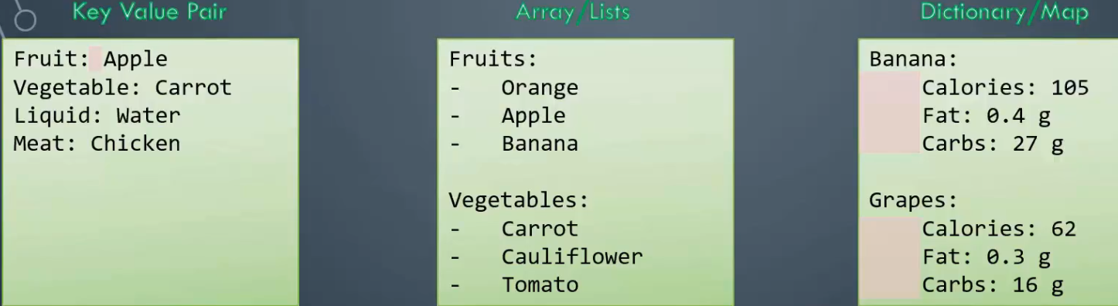
Incorrect: Calories have a value set so this will give an error telling that mapping values are not allowed here because calories already have a value set (105)
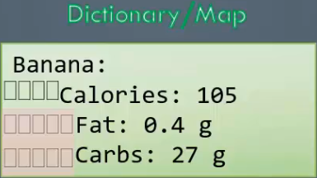

You can have list containing dictionaries containing lists. The number of spaces before each property is very important in yaml.
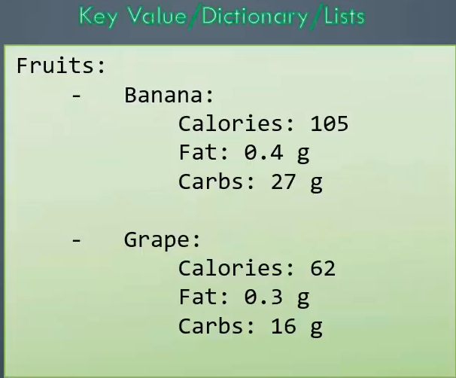

Dictionary vs List vs List of Dictionaries:

Dictionary: To store different information or properties of a single object we use Dictionaries.

In this simple dictionary we have the properties of a car defined in a key-value format.
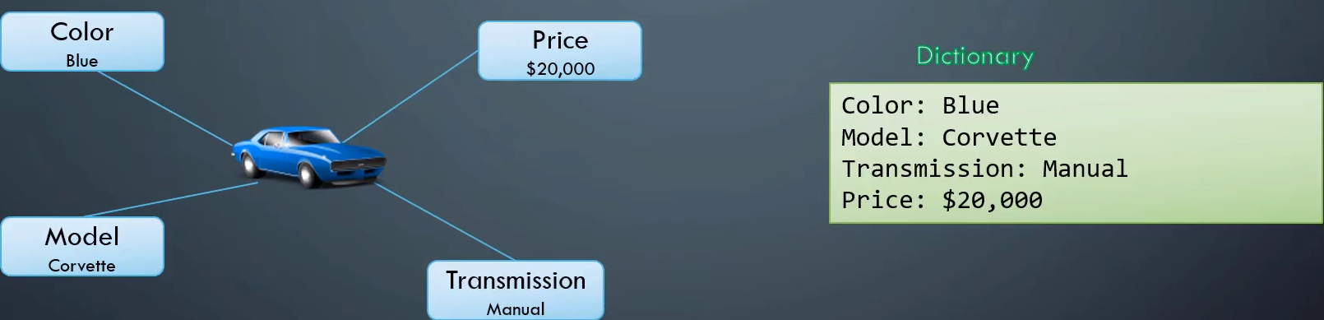

Dictionary in Dictionary: The single value of Model is now replaced with a small dictionary with two properties, Name and Year.
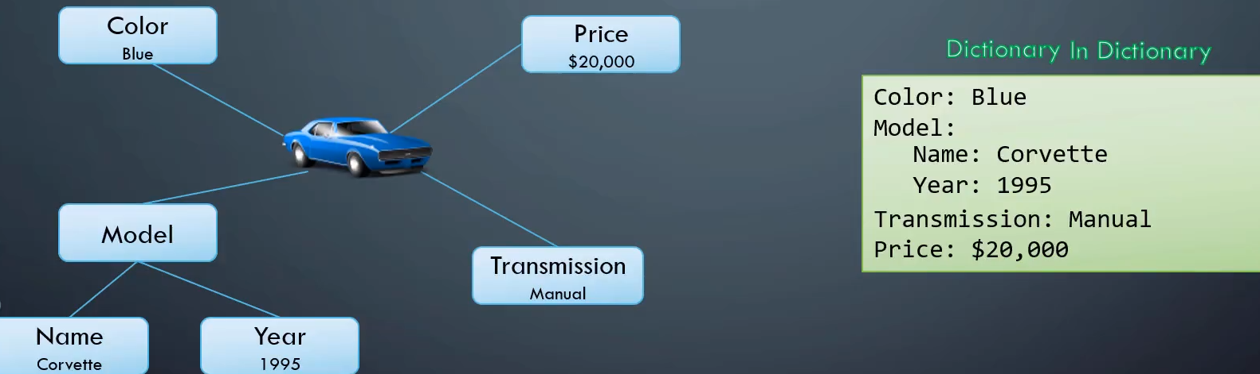

List of Strings: We want to store the name of 6 cars. The names are formed by the Color and the Model of the car.

To store this we will use a List or an Array because is multiple items of the same type of object.

We are storing only the names we have a single list of strings.
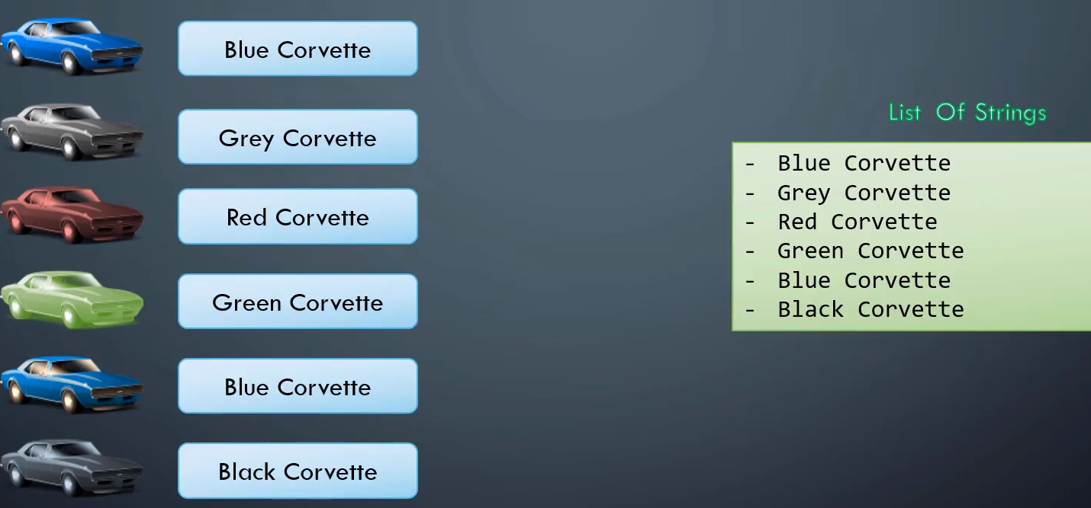
List of Dictionaries:
If we want to store all the information about each car.

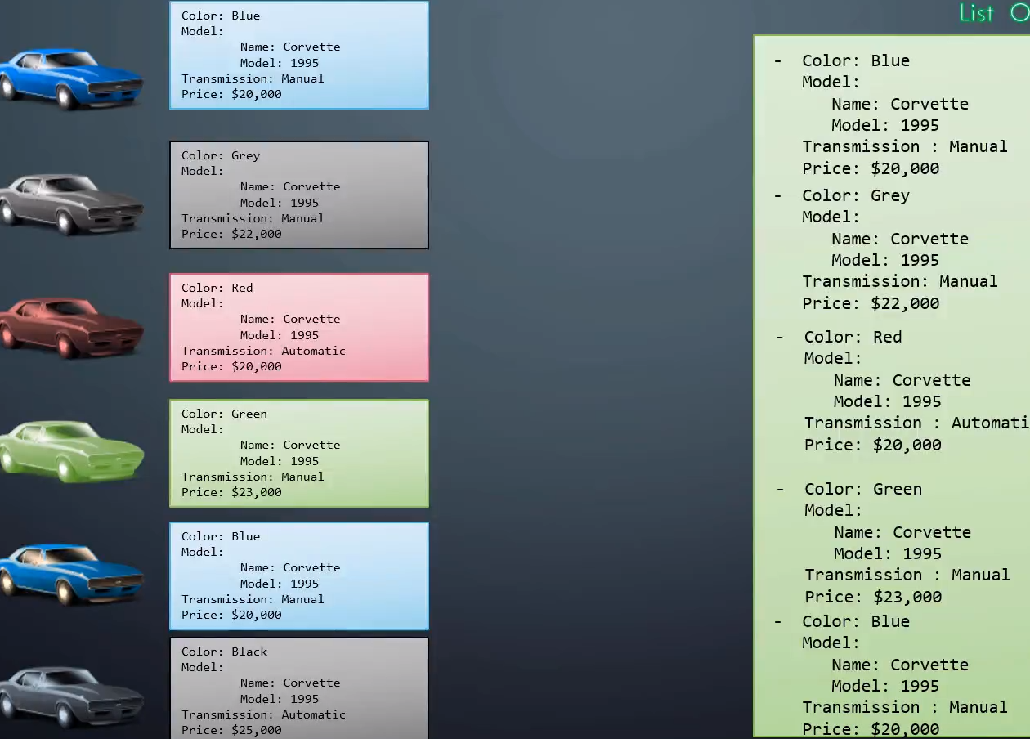

More differences:
Dictionary: Unordered collection

The order of properties is different.Fat and Carbs are ordered differently in both dictionaries and this doesn’t matter.

The properties can be defined in a different order but the Dictionaries will stil be the same as long as the values of the properties match.
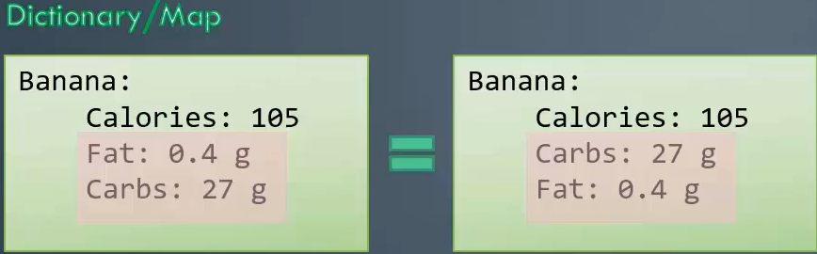

This is not the same of Lists or Arrays: Arrays are ordered collection.

The two list shown are NOT the same because the order is different.
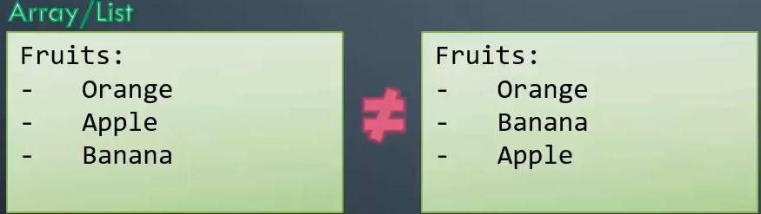

Examples:

Dictionary in Dictionary:
employee:
name: john
gender: male
age: 24

List of Dictionary:
employees:
-
name: john
gender: male
age: 24

Dictionary in Dictionary in Dictionary:
employee:
name: john
gender: male
age: 24
address:
city: edison
state: 'new jersey'
country: 'united states'

List of Dictionary in Dictionary:
employee:
name: john
gender: male
age: 24
address:
city: edison
state: 'new jersey'
country: 'united states'
payslips:
-
month: june
amount: 1400
-
month: july
amount: 2400
-
month: august
amount: 3400

JSON PATH:

JSON uses braces or curly brakets to organize data while yaml uses indentation:
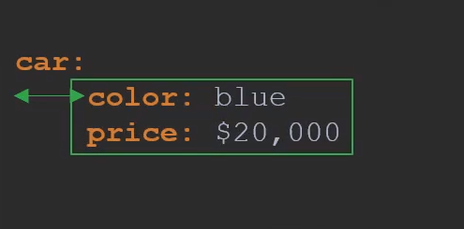
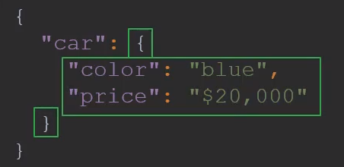

While in Yaml we use a - to denote an item in a list, in JSON we use [ to denote a list and each item within a list is separated by a comma.

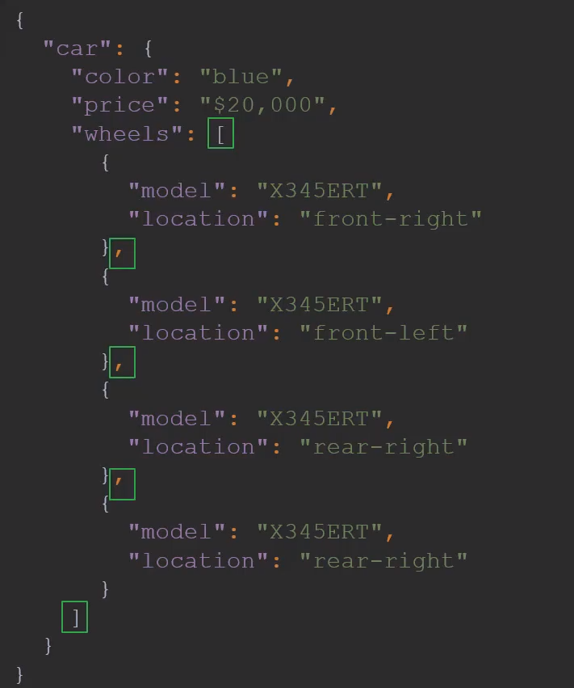
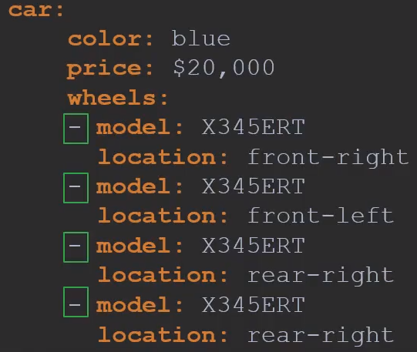

JSON and YAML can be converted easily to each other using online tool for example.

JSON PATH: Query language that can help you parse data represented in a JSON or yaml format.

Like SQL queries does, JSON PATH can query data too.

Sql query:
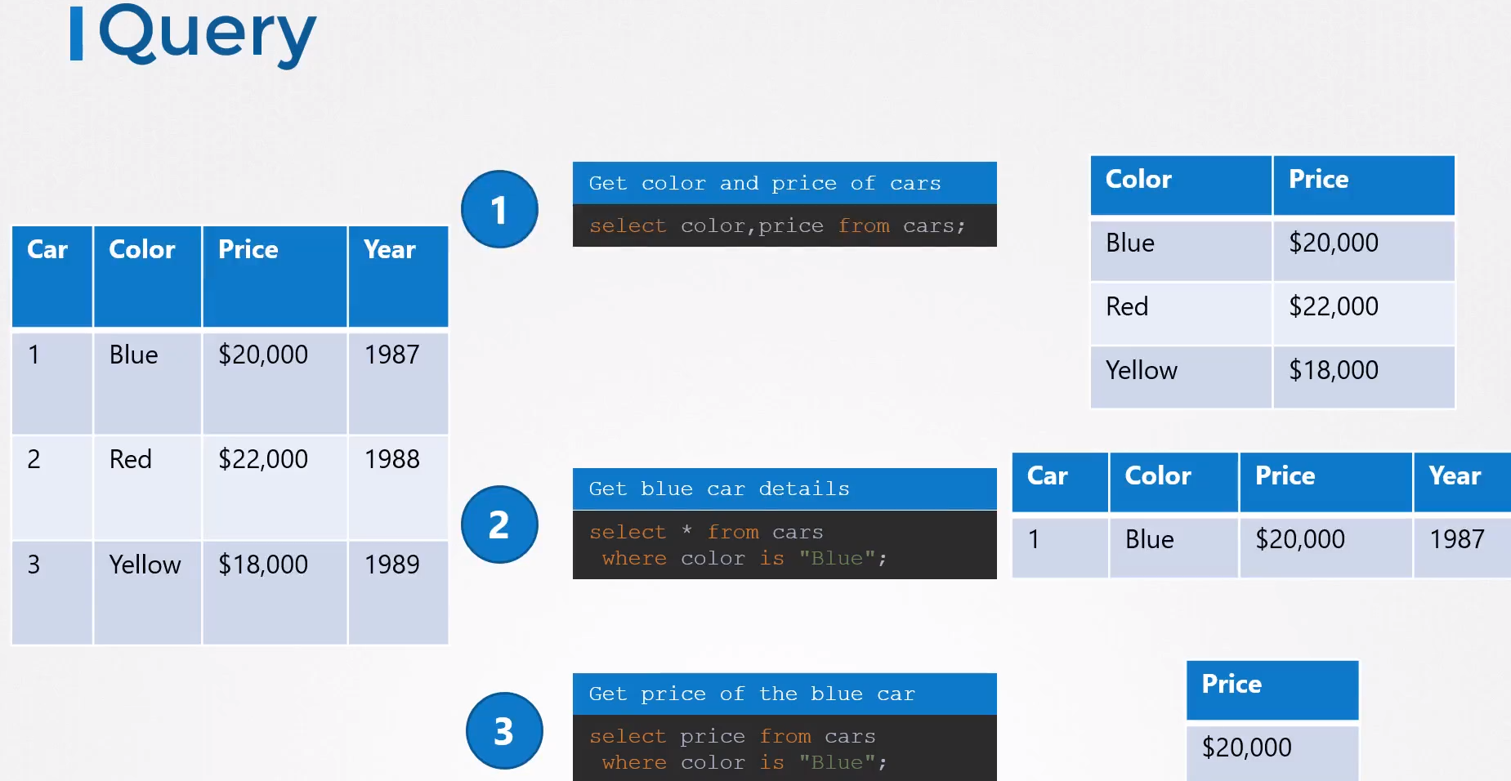

In that data that represents the color and price of the car we use the query car to get the color and price. The same if we want to get the data from bus.
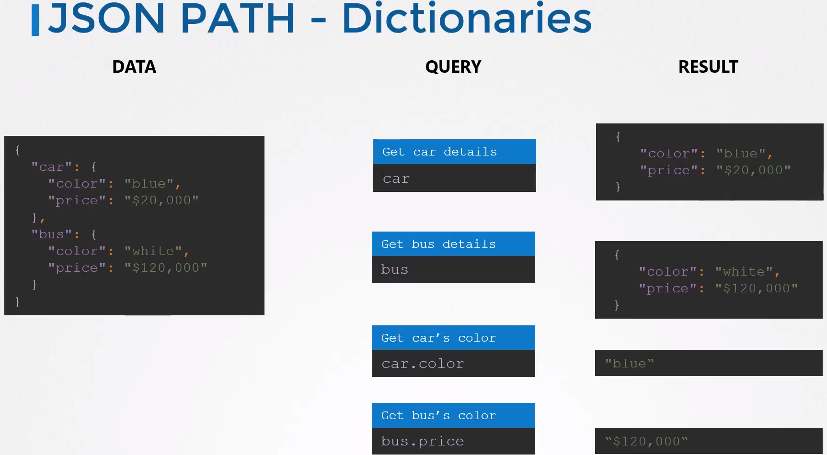
If you want an specific field like color use a dot. The dot notation helps you to select a particular field within a dictionary, car.color or bus.price.

Car and Bus are dictionaries.

Let’s encapsulate our dictionaries in another dictionary called vehicles.

To do the query you have to add vehicles. Whathever:
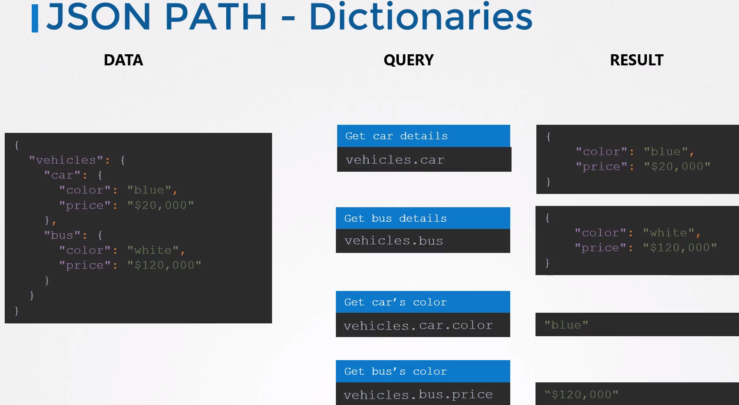

Root element: If you try to use the above queries it won’t work. You have to specify the top level Dictionary, which always is a $, when you are querying:
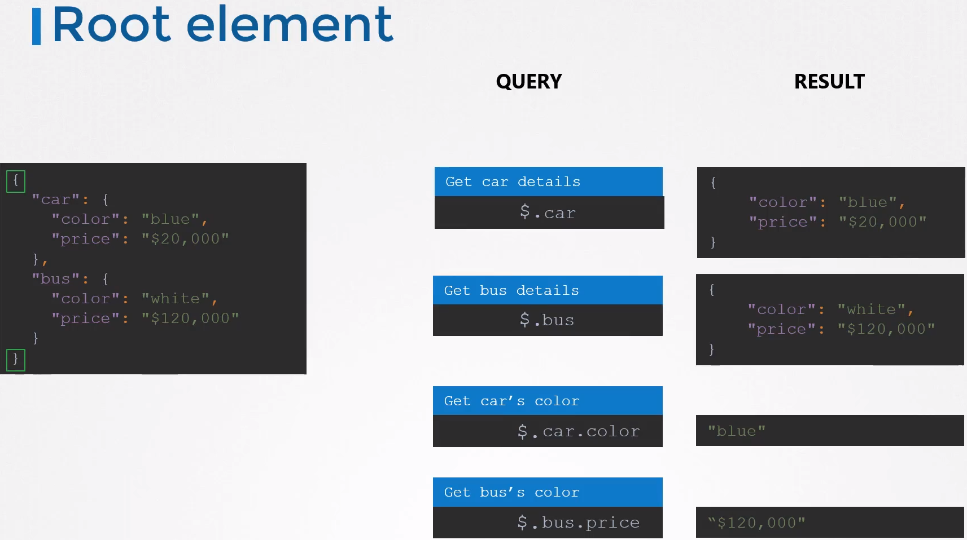

Now querying with the full path including the root element:
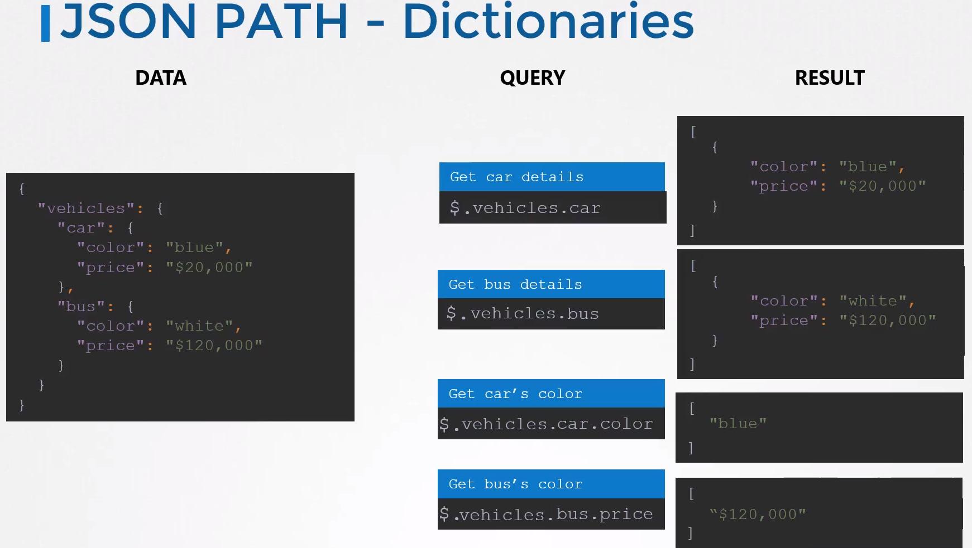
Results: All the results to the json path queries are incapsulated within an aray, which will be between a pair of square brakets [], like you can see above.

Lists or Arrays: To query a list you have to specify it’s index possition:
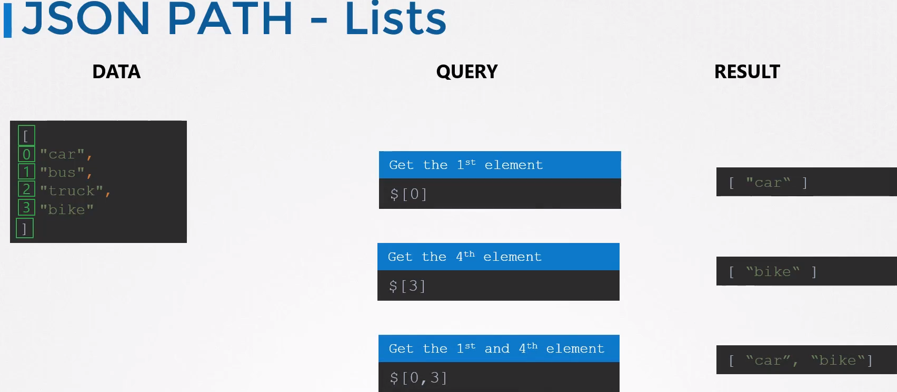

Dictionaries and Lists: How to query a list inside a dictionary.

Remember: Dots (.) are dictionaries and square brakets [] are lists or arrays

$.car.weels[1].model
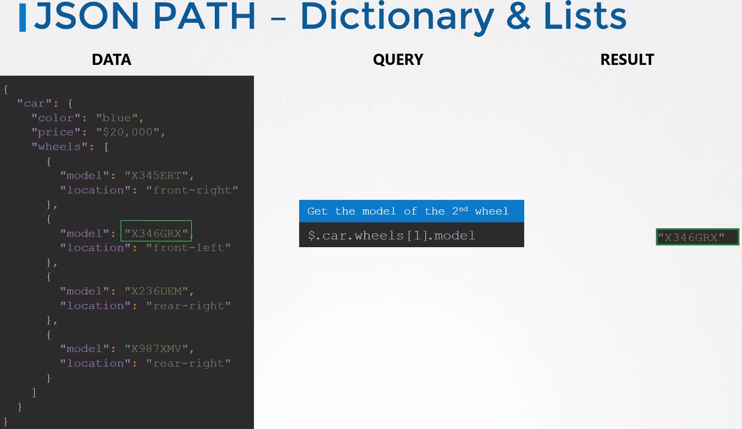

Criteria and Conditions: To query things based on certain criteria. Having a list of numbers, give me the ones above 40:
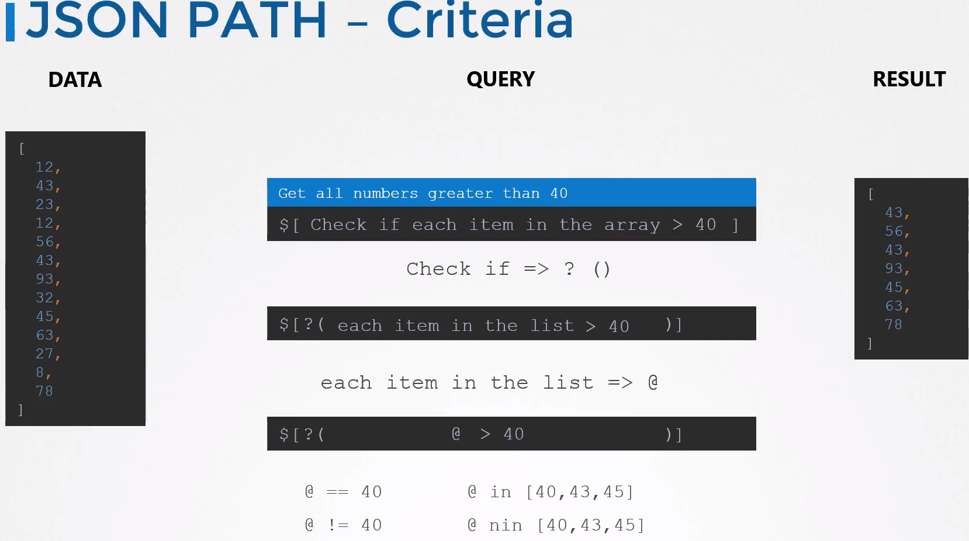
Example: We want to get all the numbers greater than 40

We start with the dollar symbol ($) as root element, and since the root element is an Array we will use the square brackets [] → so the query will looke like: $[ ]

Now we have to add the query. We what to know which numbers are higher than 40.

? We have to ask: check if there are numbers above (>) 40

We use ? to do that (to ask “check if”). We have to add brackets after it, like: ?( query_here )
The brackets are used to specify the criteria or filter.

So until now the whole sentence will look like this: $[?( query_here )]

@ Now we have to use the @ to say that we want to check any item in the list, in this example are all the numbers in the DATA section in the image above.

Now the query is: $[?( @ > 40 )]

There are other options like, equal to, non equal to, included in, not included in,example:
@ == 40
@ != 40
@ in [40,43,45] → get me the numbers that are inside the brackets
@ nin [40,43,45] → get me all the numbers except the ones between the brackets.

The shown here are a few of the field operators of the many available with json path.

More variations: Imagine that you want to know the model of the rear-right weel.
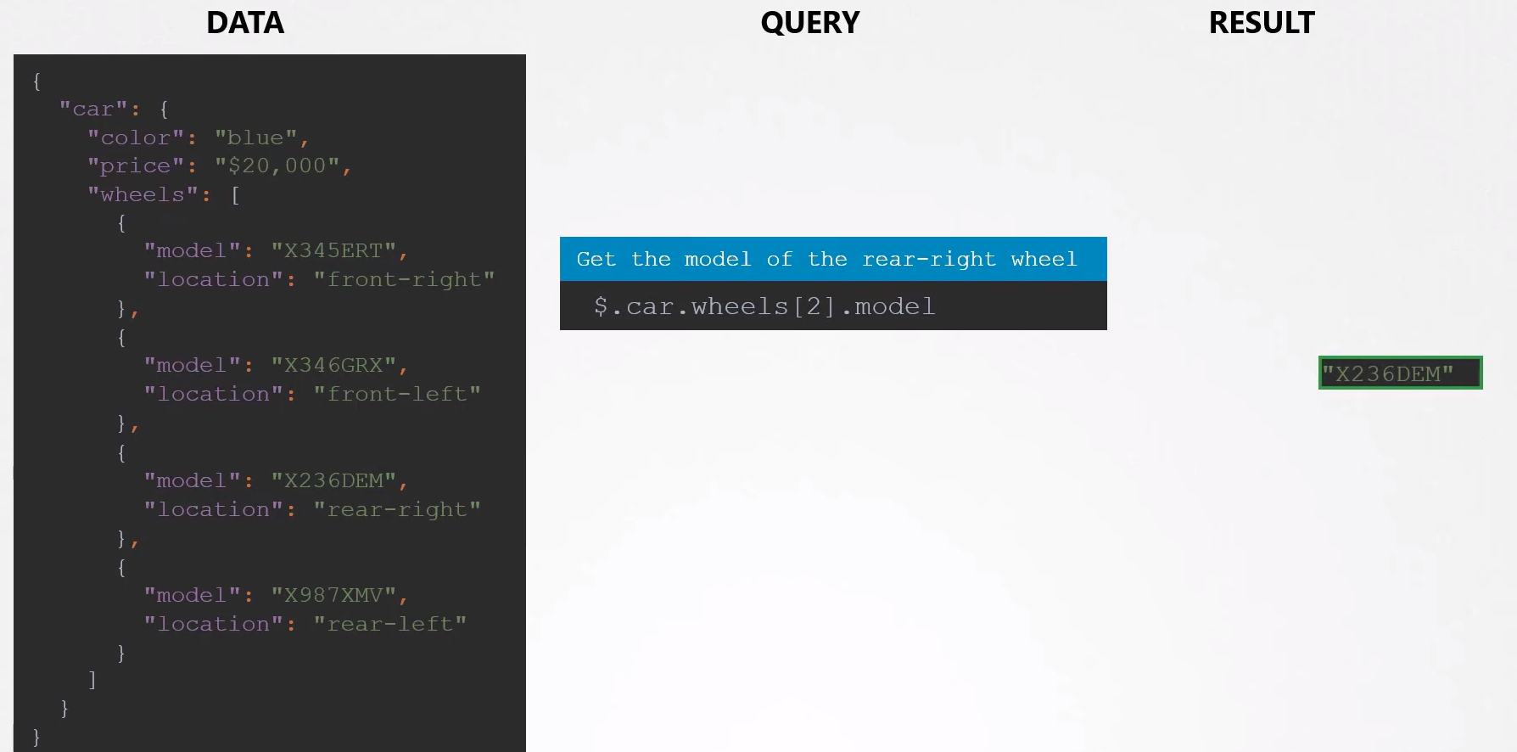
NOTICE that in this image the rear-right wheel is in the index position [2]

But the person introducing the data added it in the wrong place, as you can see in the image below rear-right is in the index possition [1] so we will get the wrong result. To fix this we can query for rear-right to get the model:

This query does:

In the root element dictionary $ ,the car dictionary, the wheels dictionary, chech in the list, if each item on the list have a location equal to rear-right show me the model.
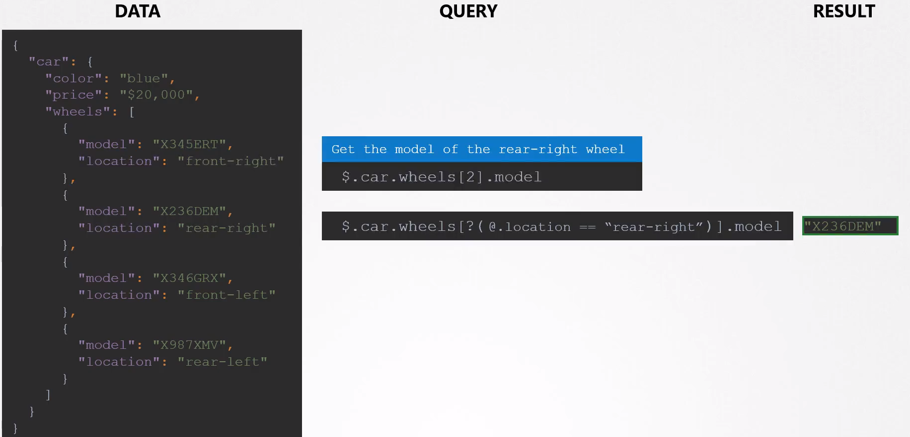
Here the first query: $.car.wheels[2].model will get you the wrong result, will show the index 2 which is now for the front-left wheel.

To find the value of the rear-right wheel we have to search for all the wheels and look for the rear-right: $.car.wheels[?(@.location == “rear-right”)]

Wild Cards:
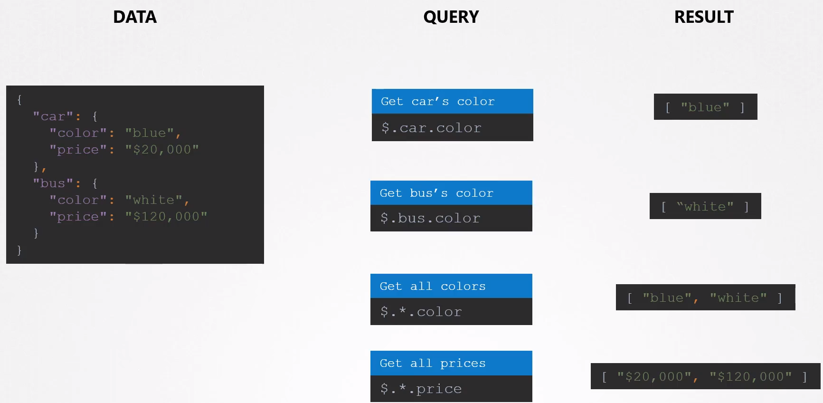
Get all colors or prices → wildcard *

In a List:
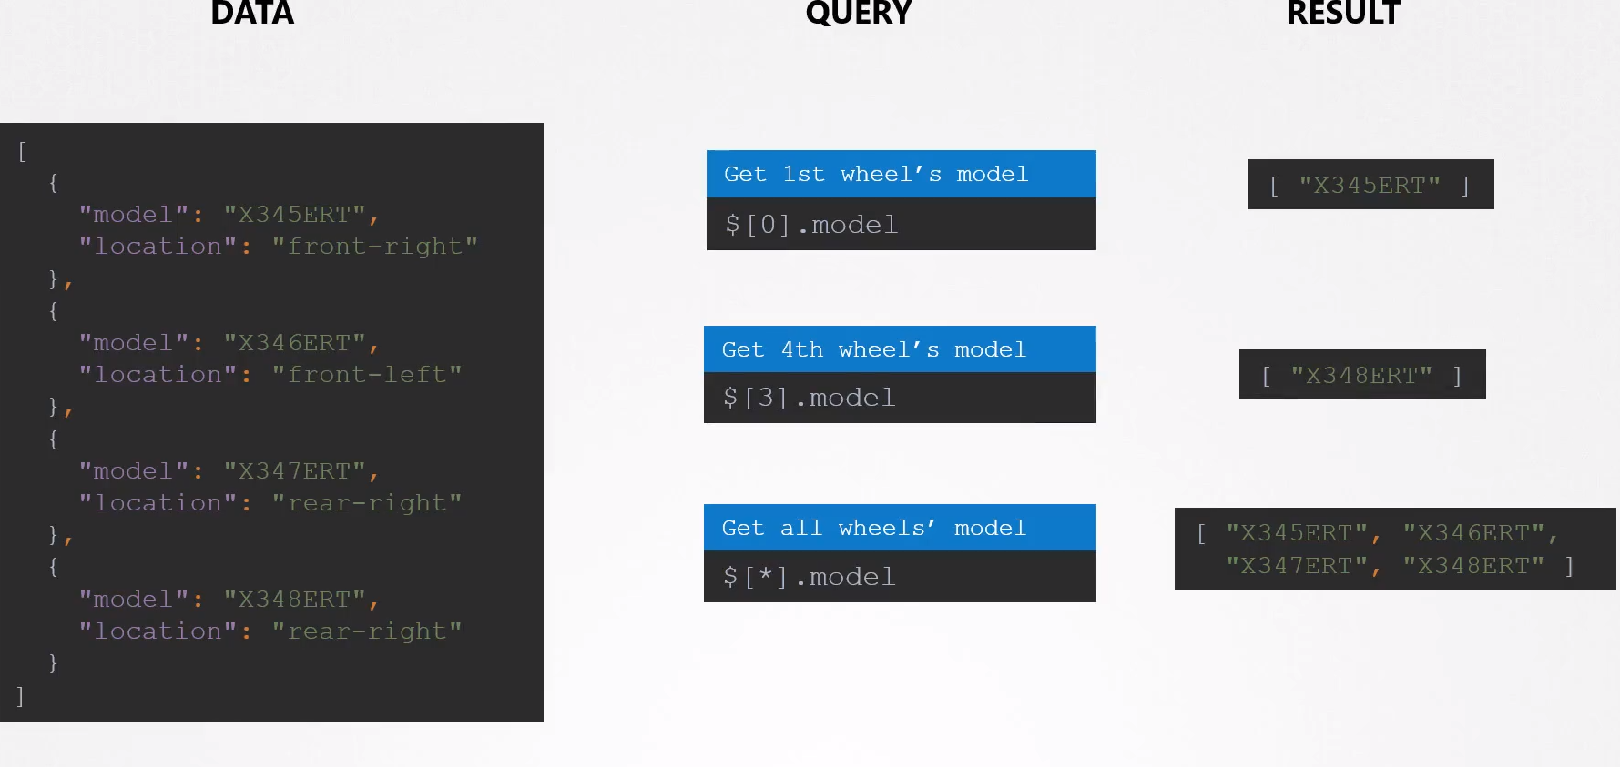

Mix both:
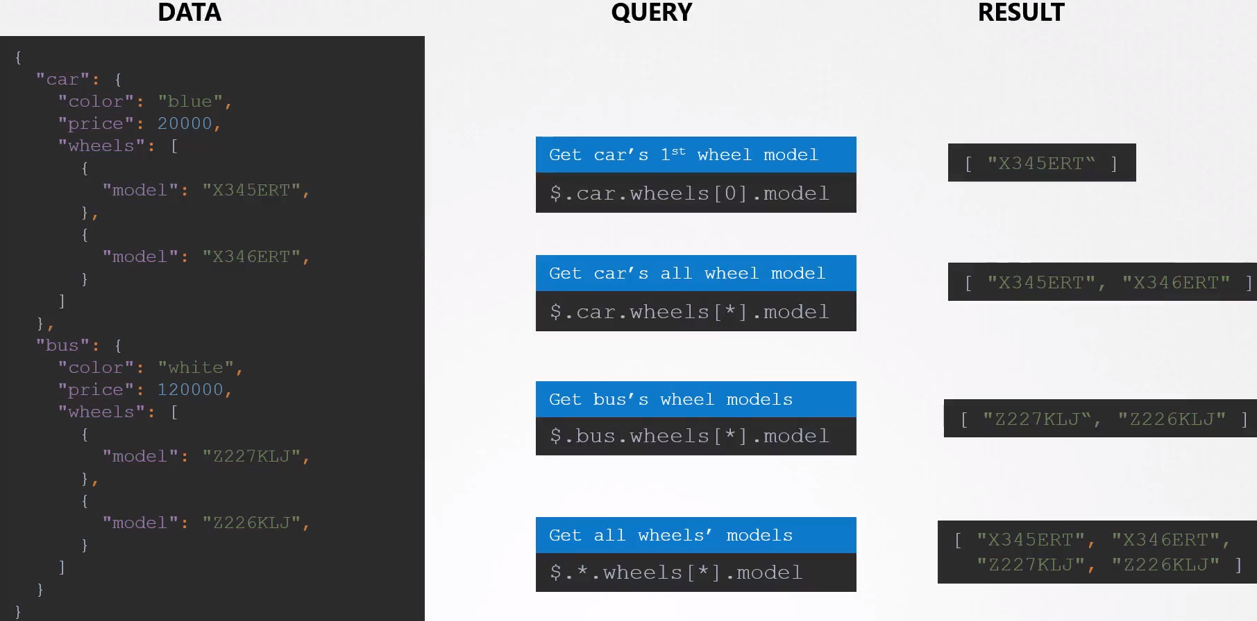

Cool queries: From the lab

Get me all the first name of the Novel prize laureates:
$.prizes[*].laureates[*].firstname

Get the first name of the 2014 laureates:
$.prizes[5].laureates[*].firstname

Lists:

Indexing, slicing, etc.

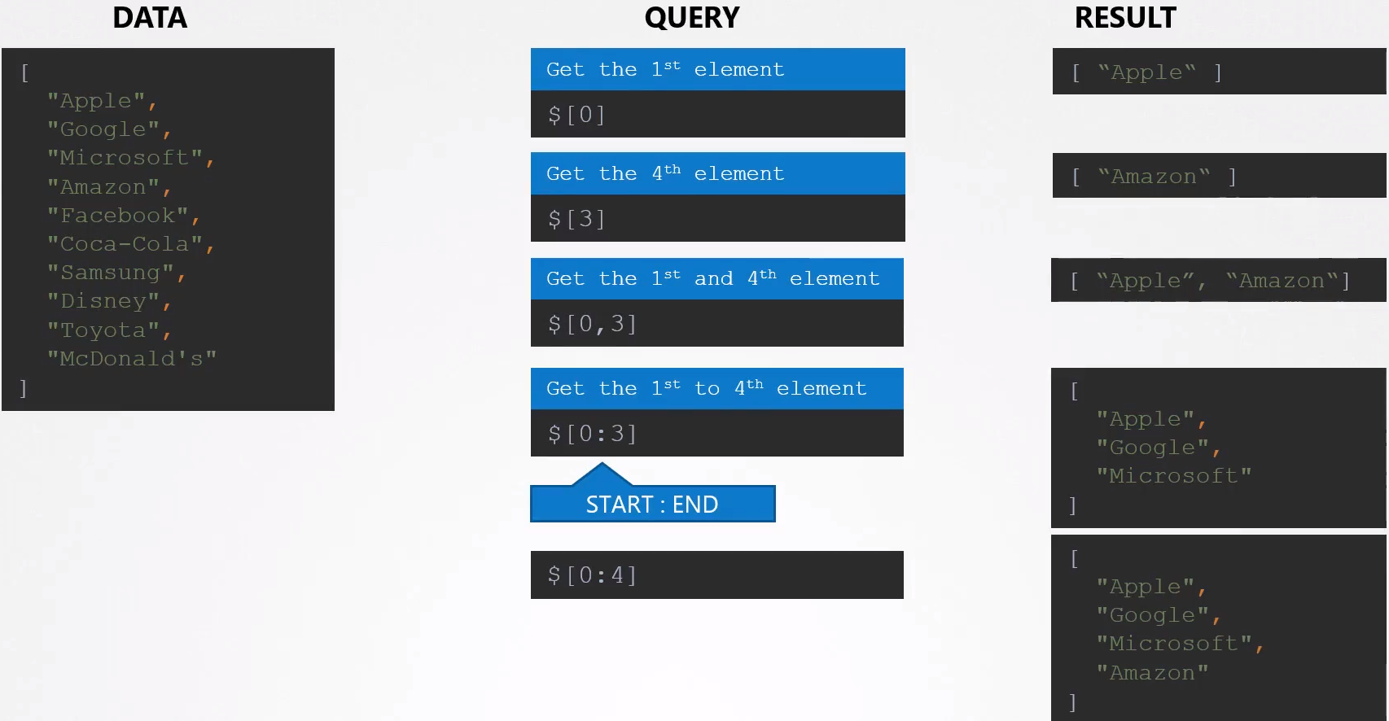

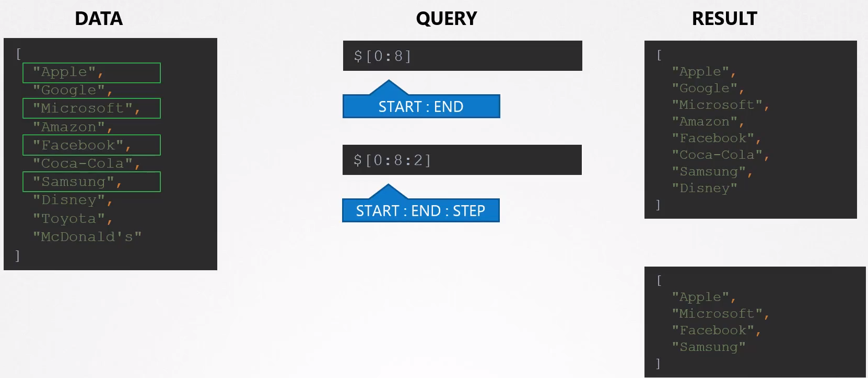
Show me every two items on the list:

Get the last item of the list: Watch out, in JSON you need to specify the last and first item.
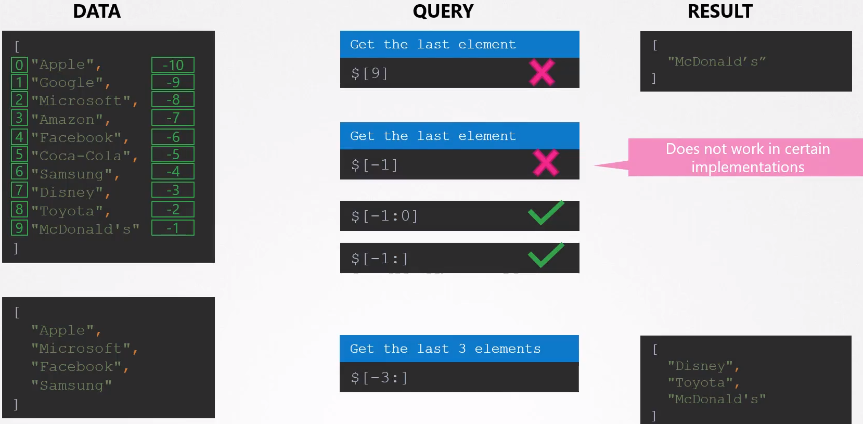

Cool queries:
Get from a long list of phrases from the 8th and the 3rd starting from the end:
$[-8:-2]

Show me the phone number of the first 5th users: $[0:5].phone
[
{
"age": 35,
"name": "Tameka Lane",
"gender": "female",
"phone": "+1 (850) 469-2827"
},
{
"age": 26,
"name": "Kristy Day",
"gender": "female",
"phone": "+1 (825) 558-2599"
},
{
"age": 36,
"name": "Nieves Hill",
"gender": "male",
"phone": "+1 (946) 495-3285"
},
{
"age": 30,
"name": "Dianna Holland",
"gender": "female",
"phone": "+1 (948) 406-2941"
},

Give me the age of the last 5th users:
$[-5:].age

JSON PATH in K8s:

Why JSON PATH: You have to request data from 100s of Nodes and 1000s of PODs, Deployments, Replicasets, etc.

You have to do it with the kubectl.

Using JSON PATH helps you to filter much better, Kubectl supports it. Allows you to use complex criteria.

Kubectl: Is the k8s CLI. Everytime you run a kubectl command it interacts with the k8s API through the kube-apiserver.

Kube-apiserver speaks the JSON language, so it returns the request of information in a JSON format.

And the kubectl on receiving the information in JSON converts it into a human readable format and print it out to our screen.

During that process a lot of information that came in is hidden in an effort to make the output readable by showing only the necessary details.

You can see additional details with -o wide option but this is not complete. There are still a lot more of details not being displayed, for example: the resource capacity available on these nodes, the taints set on the node, the conditions of the nodes,hardware, images, etc.

You can see it with the describe command, but what if you want to see it as a report.

With JSON PATH queries you can format and ouptput them like this:

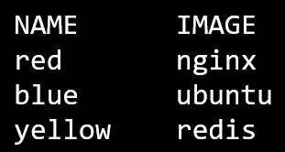

Steps to run a JSON PATH query in kubectl:


JSON PATH examples: You can merge queries together.
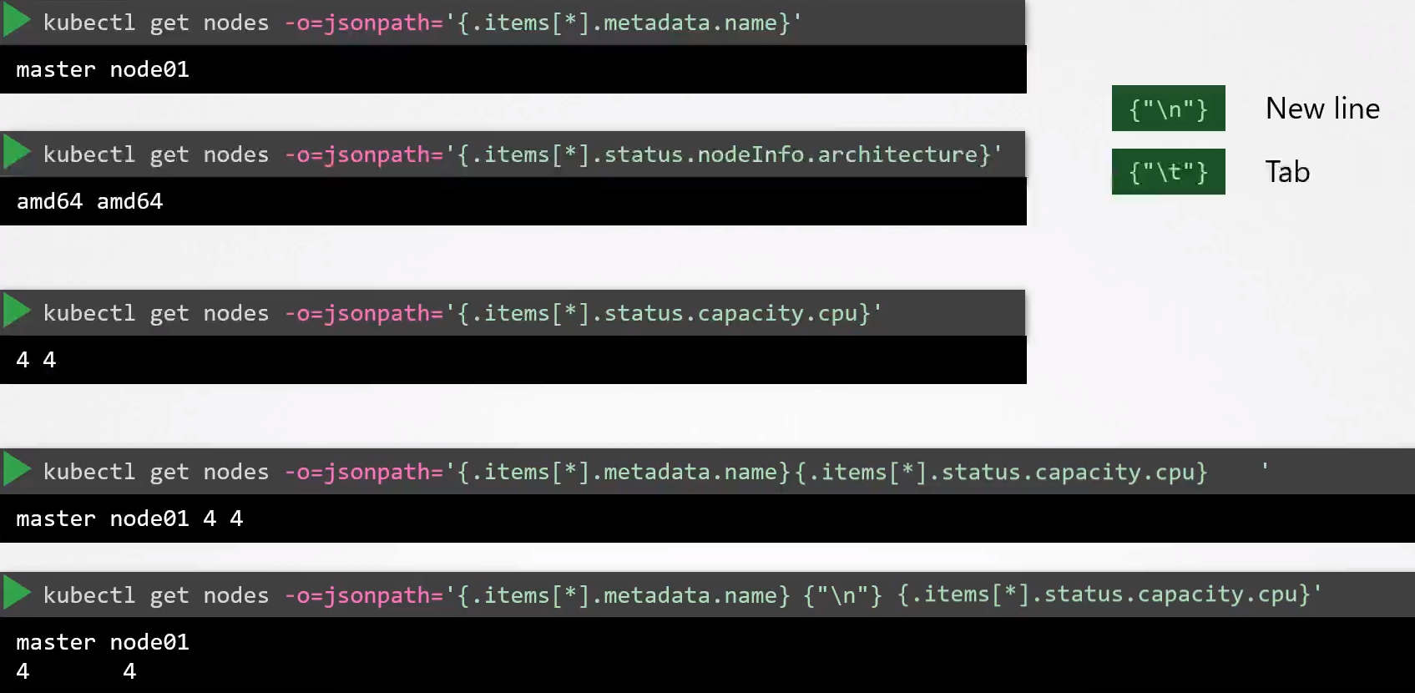
\n and \t to format as we want.

Not necessary for the exam

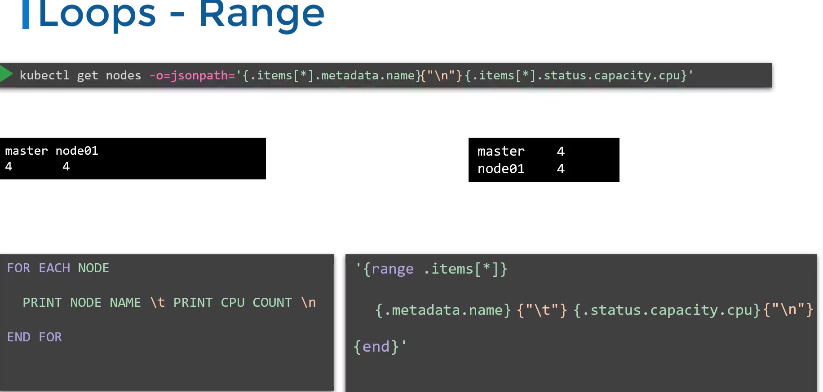

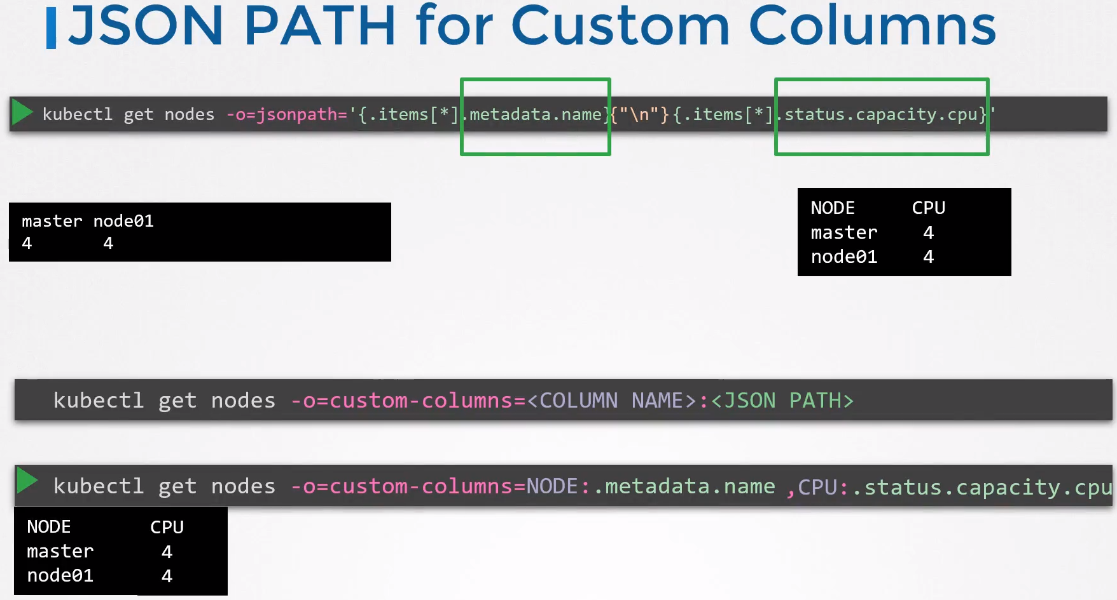

Sort option:

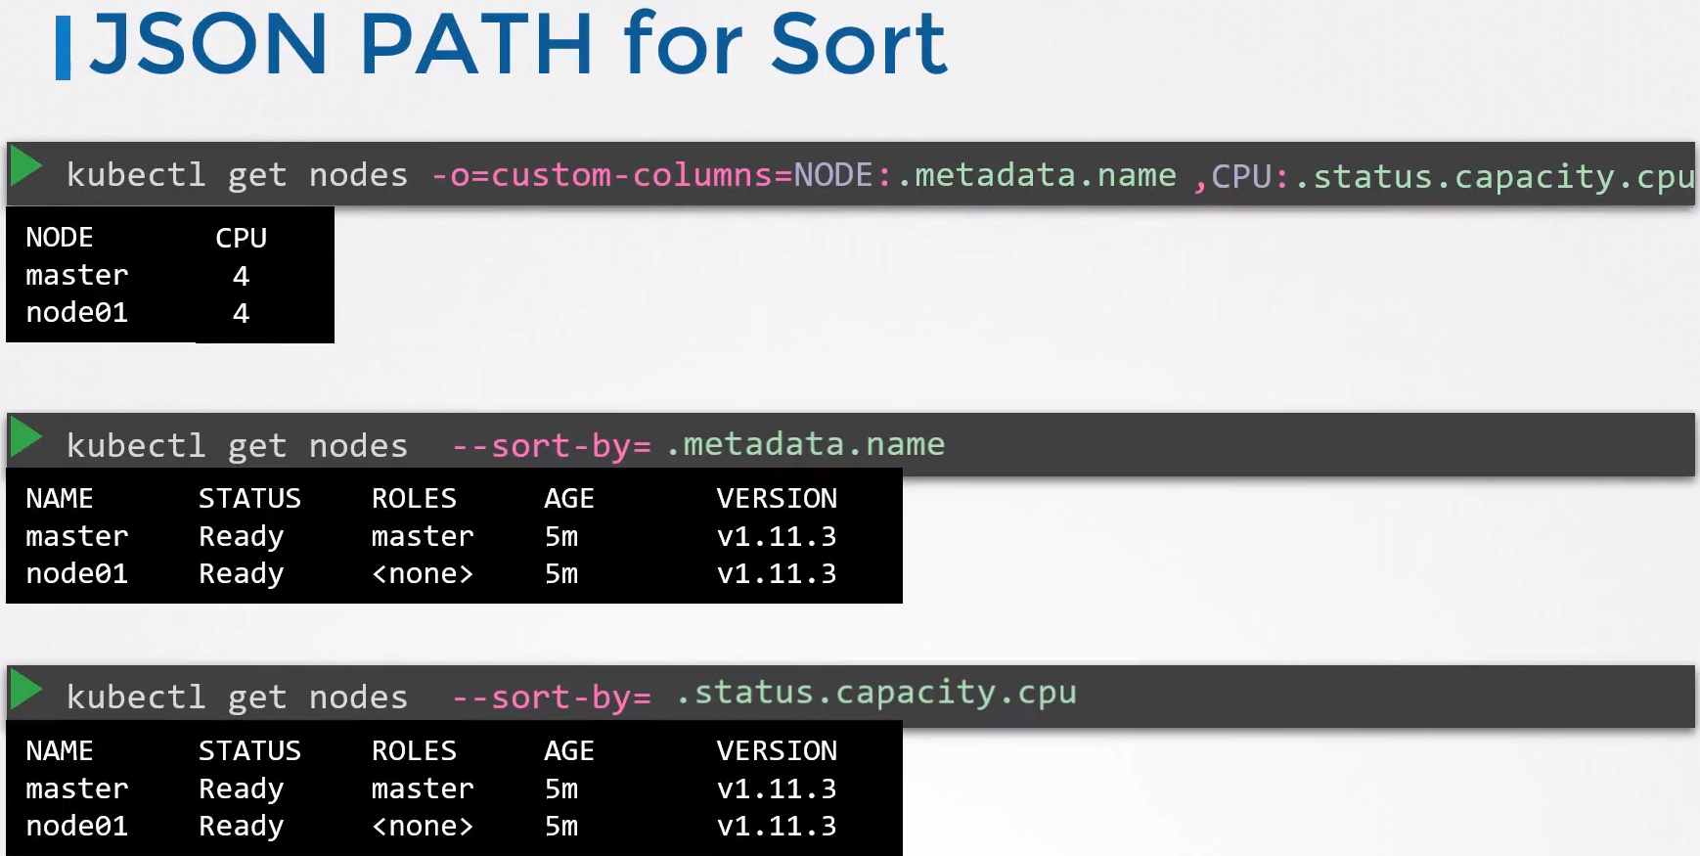

Examples:

Get the nodenames:
kubectl get nodes -o=jsonpath='{.items[*].metadata.name}'

Get the Image name:
kubectl get nodes -o jsonpath='{.items[*].status.nodeInfo.osImage}' > /opt/outputs/nodes_os.txt

kubectl config view --kubeconfig=my-kube-config -o jsonpath="{.users[*].name}" > /opt/outputs/users.txt

Sort by capacity:
kubectl get pv --sort-by=.spec.capacity.storage

controlplane $ k get persistentvolumes
NAME CAPACITY ACCESS MODES RECLAIM POLICY STATUS CLAIM STORAGECLASS REASON AGE
pv-log-1 100Mi RWX Retain Available 21m
pv-log-2 200Mi RWX Retain Available 21m
pv-log-3 300Mi RWX Retain Available 21m
pv-log-4 40Mi RWX Retain Available 21m

controlplane $ kubectl get pv --sort-by=.spec.capacity.storage
NAME CAPACITY ACCESS MODES RECLAIM POLICY STATUS CLAIM STORAGECLASS REASON AGE
pv-log-4 40Mi RWX Retain Available 21m
pv-log-1 100Mi RWX Retain Available 21m
pv-log-2 200Mi RWX Retain Available 21m
pv-log-3 300Mi RWX Retain Available 21m

controlplane $ kubectl get pv --sort-by=.spec.capacity.storage -o=custom-columns=NAME:.metadata.name,CAPACITY:.spec.capacity.storage
NAME CAPACITY
pv-log-4 40Mi
pv-log-1 100Mi
pv-log-2 200Mi
pv-log-3 300Mi

