K8s = Kubernetes

asdfas234$$

Diagram: https://app.lucidchart.com/documents/view/b1b62a6e-1266-41dd-b48d-3c44252fb88f/fB.lPxz788ce

Containers: Are a bit like virtual machines, but they are smaller and start up faster.

Wrap software in independent portable packages, making it easy to quickly run software in a variety of environments.

Helps to ensure high availability and make it easy to scale resources.

Containers let’s you to run a variety of software components across a cluster of generic software.

Container Runtime: Software that execute containers and manage container images on a node.

Docker is leading the container runtime market, but there are others like Lxd,Rkt (rocket) or Containerd.

Container orchestration tool (cot): The goal is to automate our application infrastructure and make it easy to manage.

If I want to scale up several containers to handle additional load, deploy new code to my entire cluster or ensure that multiple instances of a piece of software are spread across multiple servers for HA I can do it manually, taking a lot of time, or using a container orchestration tool.

Kubernetes: Is a container orchestration tool.
Was created by google to manage it’s infrastructure. Is an open source software maintained by several companies and is leading by far the cot market.

https://kubernetes.io/docs/tutorials/kubernetes-basics/
https://vimeo.com/245778144/4d1d597c5e

Can relocate the app components anytime. Takes care of the service discovery, scaling, load balancing, self healing, etc.

Under the hood, kubernetes uses an API server to manipulate docker (or the container run time)

run: sudo ps docker → you will see all the containers there.

POD: Smallest unit of kubernetes. Can be either a single container or group of containers.
All containers in a pod have the same IP
All pods in a cluster have unique IPs in the same IP space (range).

IP Space: If one pod in the worker 1 have 10.10.10.x the other pods in the same and other worker nodes will have an IP from the same range.

All the pods in the same cluster are in the same IP space.

Software defined network (SDN): Flannel by Coreos, Weave Net by WeaveWorks,etc.

CNI: Container network interface

All k8s networking have to follow these rules:
- All containers can communicate with all other containers without NAT
- All nodes can communicate with all containers (and vice versa) without NAT
- The IP address that the container sees itself as is the IP that other see it as.

Flannel: https://github.com/coreos/flannel/
It’s very simple to use, doesn’t have network policies like Calico or others,

You only have to run this command flannel installs everything:

kubectl apply -f https://raw.githubusercontent.com/coreos/flannel/master/Documentation/kube-flannel.yml

Flannel runs flanneld on each host.

DNS:
Containers that are in one namespace than need to reach containers in another namespace they have to do a full lookup to the DNS server for a record of the other namespace.

Minikube: Runs a single kubernetes node cluster using a virtual machine on my computer.

Web UI (Dashboard): Dashboard UI. Web based kubernetes user interface. Created by google and more companies. Quite similar to GCP UI.

Components: Kubernetes consist on multiple components working together in order to provide the overall functionality of a k8s cluster. Many of them are running as pods.

For control-plane (Master Node)
Can not contain pods or be responsible for running the application components.
Can be replicated for HA.

- API Server: Serves the k8s API, the primary interface for the cluster. Simple REST based web API. All cluster components (scheduler,controller manager,kubelet, kube-proxy, etc ) are pointing towards it to request information.

- Scheduler: Assigns your app to a worker node. Auto-detects which pod to assign to which node based on resources requirements, hardware constraints, etc.

- Controller Manager: Daemon. Maintains the cluster. Handles node failures, replicating components, maintaining the correct amount of pods, etc.

Operates the cluster controllers:
- Node Controller: Responsible for noticing and responding when nodes go down.
- Replication Controller: Responsible for maintaining the correct number of pods for every replication controller object in the system
- Endpoints Controller: Populates the Endpoint object, example: joins services and pods
- Service Account & Token Controllers: Creates default account and API access tokens for new namespaces.

- etcd: Provides distributed, synchronized data storage for the cluster state. Not only stores the data, ensures that is synchronized across all the nodes. Stores the cluster configuration.

Is a database where all of the objects within the k8s cluster are described.

Recommended to back this up.

For all the individual nodes (workers)
Responsible for running the application, monitoring it and providing the services that it needs.

- kubelet: Daemon. Runs and manages the containers on the node and talks to the API server.

Middle man between k8s API and the container runner. When a container need actually to be ran on a node, control-plane reaches out on that node and then the kubelet on that node instructs the container runner to go ahead and run that container.

Is not running as a pod, runs as a service: sudo systemctl status kubelet

- kube-proxy: Load balances traffic between application components.

Handles networking communications between nodes. Routes traffic. Writes firewall rules to the routing tables of each nodes to allow the traffic to be routed properly.

- Container runtime: Daemon.The program that runs the container (docker, rkt, containerd)

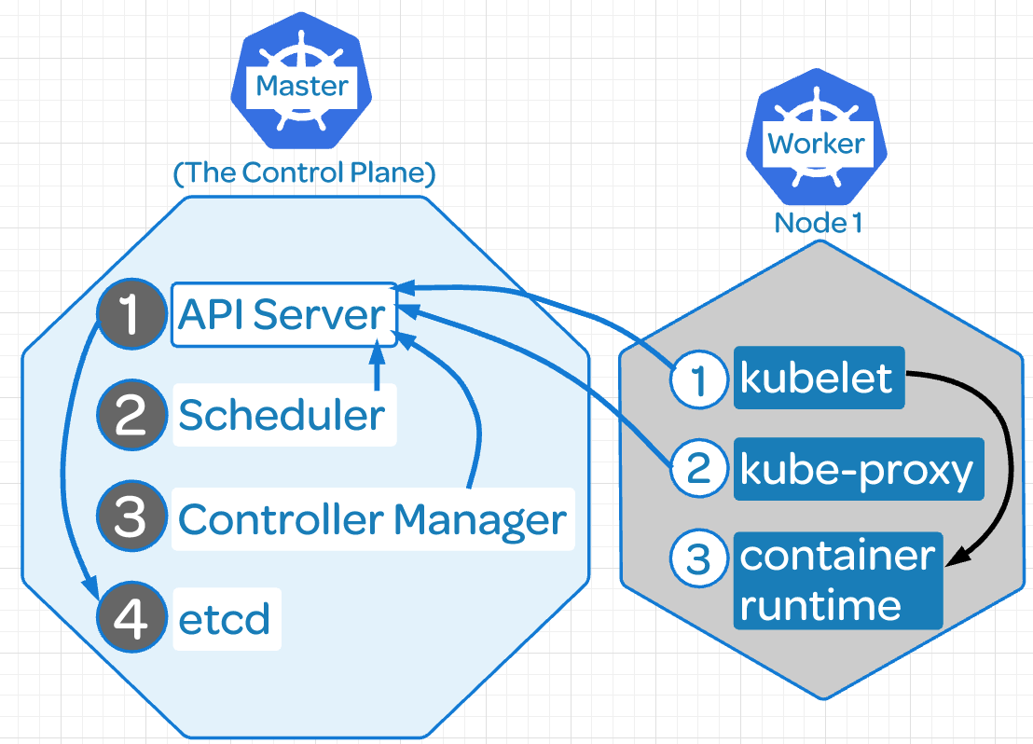

Declarative intent: Instead of having to manually check the cluster, k8s does this automatically it just says which status should be in.

Keystrokes: https://kubernetes.io/docs/reference/kubectl/cheatsheet/
See version:
- docker: sudo docker version
- kubeadm: sudo kubeadm version
- kubectl: sudo kubectl version

Get Nodes: kubectl get nodes

See all pods: kubectl get pods --all-namespaces -o wide
kubectl get pods -n kube-system
kubectl get pods -n <namespace> -w (w is like tail -f)
kubectl get pods name_of_the pod -o yaml (to see it’s configuration)
kubectl get nodes -o yaml
kubectl get nodes -o name
kubectl get nodes -o wide
Custom query to pods:
kubectl get pods -o custom-columns=POD:metadata.name,NODE:spec.nodeName --sort-by spec.nodeName -n kube-system

Describe nodes: kubectl describe nodes
kubectl describe

See deployment: kubectl get deployment
See services: kubectl get svc

Component Status: kubectl get componentstatus

Reset kubeadm: kubeadm reset → will remove the worker node from the cluster, then you can join the node again

Check logs: journalctl -u kubelet
/var/log/pods/(pod number)
kubectl get po --namespace kube-system -l app=flannel
kubectl logs --namespace kube-system <POD_ID> -c kube-flannel
kubectl logs --namespace kube-system kube-flannel-ds-amd64-2mwxm -c kube-flannel

See docker available versions: apt-cache madison docker-ce

Services: systemctl status kubelet

Configuration files: /etc/kubernetes/manifests/kube-controller-manager.yaml
Kube configuration: root/.kube/config

Check web server: kubectl exec busybox -- curl 10.244.1.4

Get inside a node:
kubectl exec -it nginx-7cdbd8cdc9-q9x78 /bin/bash
it stands for interactive

Do a loop to test autoscaling: hpa
while true; do wget -q -O http:/<your address here>; done

Check hpa: kubectl get hpa
Check hpa in live: whatch “kubectl get hpa”

Check who is the leader in HA:
kubectl get endpoints kube-scheduler -n kube-system -o yaml

Find the label applied to the etcd pod on the master node:
kubectl get pods --all-namespaces --show-labels -o wide

Delete a pod:
This will delete the pod but if is in a deployment the pod will be created again straigh away:
root@andrewjobson1c:~# kubectl delete pods -n myy-ns test-5bdd698494-7xx8b
pod "test-5bdd698494-7xx8b" deleted

Delete a deployment:
Here we are deleting the deployment test2 that have the namespace myy-ns
kubectl delete deployments test2 -n myy-ns

Alias:
alias kc='kubectl'
alias kgp='kubectl get pods'
alias kgs='kubectl get svc'
alias kgc='kubectl get componentstatuses’
alias kctx='kubectl config current-context’
alias kcon='kubectl config use-context’
alias kgc='kubectl config get-context'

Check state of etcd: etcdctl endpoint health

Enable kubernetes autocompletion:

There are two ways to do it:
1 -Source the completion script in your ~/.bashrc file:
echo 'source <(kubectl completion bash)' >>~/.bashrc

2 -Add the completion script to the /etc/bash_completion.d directory:
kubectl completion bash >/etc/bash_completion.d/kubectl

K8s Deployments:

Type of object on k8s. Allows you to automate the management of the pods.
Let’s you to specify a desired state for a set of pods.

Scaling: With a deployment you can specify the number of replicas (pods) you want and the deployment will create or remove pods to meet that number of replicas.

Deployment makes sure that the replicas are evenly spread out across your multiple worker nodes for HA and a lot more useful functionality like that.

Updates: With deployments, you can change the deployment image to a new version of the image.
The deployment will gradually replace existing containers with the new version in order to avoid downtime, not like ReplicaSets.

Instead of removing the old pods and spin up the new ones will gradually spin the new ones and gradually replace and remove the old pods on an incremental fashion without incurring in any downtime for the users.

Self-Healing: If one pod is destroyed in the deployment will be immediately replaced by a new one by the deployment.

If the deployment says that I need 4 replicas for my application and anything happens to reduce that number, the deployments will spin the necessary replicas to have 4 working.

cat <<EOF | kubectl create -f -
apiVersion: apps/v1
kind: Deployment
metadata:
name: nginx-deployment
labels:
app: nginx
spec:
replicas: 2
selector:
matchLabels:
app: nginx
template:
metadata:
labels:
app: nginx
spec:
containers:
- name: nginx
image: nginx:1.15.4
ports:
- containerPort: 80
EOF

It worked:
deployment.apps/nginx-deployment created

root@andrewjobson1c:~# kubectl get po
NAME READY STATUS RESTARTS AGE
nginx-deployment-9b644dcd5-wgbdc 1/1 Running 0 44s
nginx-deployment-9b644dcd5-ws6xk 1/1 Running 0 44s

root@andrewjobson1c:~# kubectl describe deployment nginx-deployment
Name: nginx-deployment
Namespace: default
CreationTimestamp: Fri, 05 Jul 2019 08:36:18 +0000
Labels: app=nginx
Annotations: deployment.kubernetes.io/revision: 1
Selector: app=nginx
Replicas: 2 desired | 2 updated | 2 total | 2 available | 0 unavailable
StrategyType: RollingUpdate
MinReadySeconds: 0
RollingUpdateStrategy: 25% max unavailable, 25% max surge
Pod Template:
Labels: app=nginx
Containers:
nginx:
Image: nginx:1.15.4
Port: 80/TCP
Host Port: 0/TCP
Environment: <none>
Mounts: <none>
Volumes: <none>
Conditions:
Type Status Reason
---- ------ ------
Available True MinimumReplicasAvailable
Progressing True NewReplicaSetAvailable
OldReplicaSets: <none>
NewReplicaSet: nginx-deployment-9b644dcd5 (2/2 replicas created)
Events:
Type Reason Age From Message
---- ------ ---- ---- -------
Normal ScalingReplicaSet 3m20s deployment-controller Scaled up replica set nginx-deployment-9b644dcd5 to 2

Deleting a pod, the deployment will spin up one new pod and will be operative is seconds.

root@andrewjobson1c:~# kubectl get po
NAME READY STATUS RESTARTS AGE
nginx-deployment-9b644dcd5-wgbdc 1/1 Running 0 44s
nginx-deployment-9b644dcd5-ws6xk 1/1 Running 0 44s

root@andrewjobson1c:~# kubectl delete pod nginx-deployment-9b644dcd5-ws6xk
pod "nginx-deployment-9b644dcd5-ws6xk" deleted

This will take a few seconds

NAME READY STATUS RESTARTS AGE
nginx-deployment-9b644dcd5-wgbdc 1/1 Running 0 44s
nginx-deployment-9b644dcd5-nvlmb 1/1 Running 0 7s

In bold the new pod created seven second ago.

Another Example:

Deploying nginx v1 with two replicas.

Update the nginx image, from v1 to v2:
root@andrewjobson1c:~/k8s_files# kubectl set image deployment.v1.apps/example-deployment nginx=darealmc/nginx-k8s:v2
deployment.apps/example-deployment image updated

See how the deployment takes care of removing the old pods (nginx v1) and creating the new ones (nginx v2)

First create a new one, example-deployment-56d5dfc87f (second 29)
The remove one of the old ones (second 25)
After that creates the second one
And then remove the last one of the old pods (second 22)
All this to avoid to lose the website.

root@andrewjobson1c:~/k8s_files# kubectl describe deployments example-deployment
[...]
OldReplicaSets: <none>
NewReplicaSet: example-deployment-56d5dfc87f (2/2 replicas created)
Events:
Type Reason Age From Message
---- ------ ---- ---- -------
Normal ScalingReplicaSet 11m deployment-controller Scaled up replica set example-deployment-6d98cb87fb to 2
Normal ScalingReplicaSet 29s deployment-controller Scaled up replica set example-deployment-56d5dfc87f to 1
Normal ScalingReplicaSet 25s deployment-controller Scaled down replica set example-deployment-6d98cb87fb to 1
Normal ScalingReplicaSet 25s deployment-controller Scaled up replica set example-deployment-56d5dfc87f to 2
Normal ScalingReplicaSet 22s deployment-controller Scaled down replica set example-deployment-6d98cb87fb to 0

Services:
Provide load balanced usage for a dynamic list of pods.
Pods are constantly being created and destroyed. To allow us to access to the application inside the pods we are using services.

Services are an abstraction layer on top of a set of pods. You can access the services rather than the pods.

If I do a request to a k8s service I’m going to get a response from one of the pods that is part of that service. And even if the list of the pods changes, the service is going to ensure that my request is always routed to one of the currently active pods that is part of the service.

cat << EOF | kubectl create -f -
kind: Service
apiVersion: v1
metadata:
name: nginx-service → name that the service will have
spec:
selector:
app: nginx
ports:
- protocol: TCP
port: 80
targetPort: 80
nodePort: 30080 → allows the service to be exposed externally, there are other better ways.
type: NodePort
EOF

- Check that the service is working:

root@andrewjobson1c:~# kubectl get svc
NAME TYPE CLUSTER-IP EXTERNAL-IP PORT(S) AGE
kubernetes ClusterIP 10.96.0.1 <none> 443/TCP 2d6h
nginx-service NodePort 10.110.240.122 <none> 80:30080/TCP 12h

The k8s service is there by default.

Do a call to the service internally:

root@andrewjobson1c:~# curl localhost:30080
<!DOCTYPE html>
<html>
<head>
<title>Welcome to nginx!</title>
<style>
body {
width: 35em;
margin: 0 auto;
font-family: Tahoma, Verdana, Arial, sans-serif;
}
</style>
</head>
<body>
<h1>Welcome to nginx!</h1>
<p>If you see this page, the nginx web server is successfully installed and
working. Further configuration is required.</p>

<p>For online documentation and support please refer to
<a href="http://nginx.org/">nginx.org</a>.<br/>
Commercial support is available at
<a href="http://nginx.com/">nginx.com</a>.</p>

<p><em>Thank you for using nginx.</em></p>
</body>
</html>

Do a call externally. Use the IP of the master node + the nodeport, 300800 in this example:

On your browser:

http://34.251.57.128:30080/

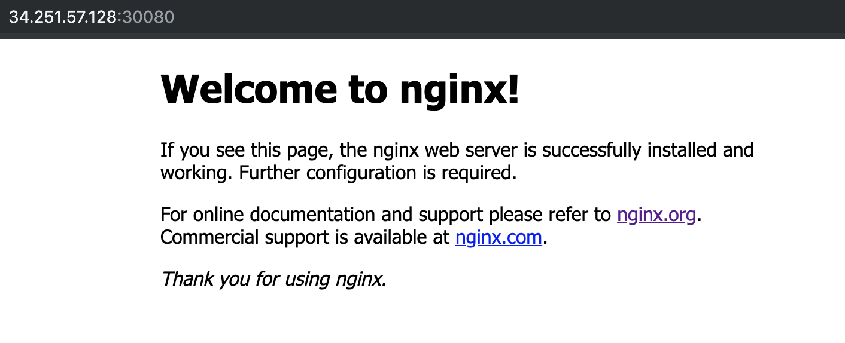

Another option:

You can expose the service to an already created deployment:

root@ip-10-0-1-109:~# kubectl expose deployment nginx --port 80 --type NodePort
service/nginx exposed

More tests:
We have 2 nginx pods and we created the service: my-awsome-service

root@andrewjobson1c:~/k8s_files# cat service-example.yml
kind: Service
apiVersion: v1
metadata:
name: my-awesome-service
spec:
selector:
app: nginx
ports:
- protocol: TCP
port: 32768
targetPort: 80

See the IPs of all the nodes of the service: endpoints
root@andrewjobson1c:~/k8s_files# kubectl describe service my-awesome-service
Name: my-awesome-service
Namespace: default
Labels: <none>
Annotations: <none>
Selector: app=nginx
Type: ClusterIP
IP: 10.108.195.105
Port: <unset> 32768/TCP
TargetPort: 80/TCP
Endpoints: 10.244.1.24:80,10.244.2.17:80
Session Affinity: None
Events: <none>

Check if nginx is running: Pick the port we configured when ran the service, 32768 in this example:

root@andrewjobson1c:~/k8s_files# curl --head 10.108.195.105:32768
HTTP/1.1 200 OK
Server: nginx/1.15.7
Date: Wed, 31 Jul 2019 14:29:19 GMT
Content-Type: text/html
Content-Length: 141
Last-Modified: Sat, 15 Dec 2018 04:13:27 GMT
Connection: keep-alive
ETag: "5c147f67-8d"
Accept-Ranges: bytes

Check the DNS from another container: because the pods can see the DNS

nslookup my-awsome-service

Will tell you the IP of the service, 10.108.195.105, and the whole domain my-awsome-service.default.svc.cluster.local

Lets scale 2 pods more: kubectl scale rs/frontend --replicas=4

Now we have 4 IPs
kubectl describe service my-awesome-service
[...]
Endpoints: 10.244.1.24:80,10.244.1.25:80,10.244.2.17:80 + 1 more...
[...]

Microservices:

Essentially microservices are an application architecture.

Until now we were using monolithic architecture, all the parts of the application are combined in one large executable file.

Microservices are small, independent services that work together to form a whole application.

Advantages:
- Scalability: If you need extra resources for a part of your application you can scale it for that specific part, not for the whole application like in monolithic applications.
- Cleaner code: The more small parts of the code, the cleaner tend to be and more easy to understand. Is easy to maintain because you can change code in one area without affecting the others.
- Reliability: If you have a bug in one area is less likely that the whole application is gonna be affected.
- Variety of tools: Different parts of the application can use different languages, frameworks and tools. The right tool can be used for every job.

K8s helps a lot to manage all this.

On the other hand microservices are quite complex to maintain.

Sample of microservice application: https://github.com/linuxacademy/robot-shop

Deploy microservices: Robot-shop

We are going to see how microservices works and how fast are the services deployed and running.

Download the robo-shop git repo that contains several ymls with deploys and services for each one of the applications needed to run it.

Mysql
mongodb
rabbitmq
nginx
java
nodejs
python
etc,

A lot of different technologies running separately and working over k8s that will bring the website up and working correctly.

1) Clone the repository:
cd ~/
git clone https://github.com/linuxacademy/robot-shop.git

2) Create a namespace: To put together all the services and be able to call them at once.

root@andrewjobson1c:~# kubectl create namespace robot-shop
namespace/robot-shop created

3) Deploy the app:
kubectl -n robot-shop create -f ~/robot-shop/K8s/descriptors/

Will run the ymls and will create the deploys and sevices.

Check how the containers are being created in live, like with tail -f

kubectl get pods -n robot-shop -w

Now you can access to the web application via browser: http://<ip_of_master_server>:30080 (port on web-service.yml)

4) Add an exta mongodb container:

Due the high number of users connecting to the web we need to scale another mongodb container:

kubectl edit deployment mongodb -n robot-shop

Change: replicas to 2

Check the status of the deployment:
kubectl get deployment mongodb -n robot-shop

Scale:

kubectl scale <?> nginx –replicas=5
Will add 5 nodes until the deployment nginx, so will modify the configuration and then always will have 5 replicas unless we change it.

Build HA kubernetes cluster:

Highly Available Topologies in Kubernetes

You can set up a HA k8s cluster:

- Stacked control plane nodes: This approach requires less infrastructure. The etcd members and control plane nodes are co-located.

- External etcd cluster: This approach requires more infrastructure. The control plane nodes and etcd members are separated.

All components on kubernetes can be replicated but only some of them can operate simultaneously.

Control manager and scheduler can only have 1 instance running at the same time, the rest will be on stand by.

* The leader elect option controls which master node is active and who is in stand by.

How to check who is the leader elect option:
The leader election mechanism is used by creating an end point resource, you can see it on the kube-scheduler yml:

kubectl get endpoints kube-scheduler -n kube-system -o yaml
kubectl get endpoints kube-controller-manager -n kube-system -o yaml

root@andrewjobson1c:~# kubectl get endpoints kube-controller-manager -n kube-system -o yaml
apiVersion: v1
kind: Endpoints
metadata:
annotations:
control-plane.alpha.kubernetes.io/leader: '{"holderIdentity":"andrewjobson1c.mylabserver.com_147bf56d-abfb-11e9-8f0e-02ea1481d388","leaseDurationSeconds":15,"acquireTime":"2019-07-21T21:04:17Z","renewTime":"2019-07-21T22:44:48Z","leaderTransitions":0}'
creationTimestamp: "2019-07-21T21:04:17Z"
name: kube-controller-manager
namespace: kube-system
resourceVersion: "8939"
selfLink: /api/v1/namespaces/kube-system/endpoints/kube-controller-manager
uid: 1a656ae9-abfb-11e9-a69f-02ea1481d388

Once becoming the leader it must periodically update the resource, happening every 2 second by default.

Minimum Resources:

HA Cluster | Required nodes | CPU | RAM | Total
Stacked control plane nodes | 3 Control Plane  3 Worker | 2 each node | 2 GB each node | 6 nodes  12 CPU  12 GB Ram
External etcd cluster | 3 Control Plane  3 etcd hosts  3 Worker | 2 each node | 2 GB each node | 9 nodes  18 CPU  18 GB Ram

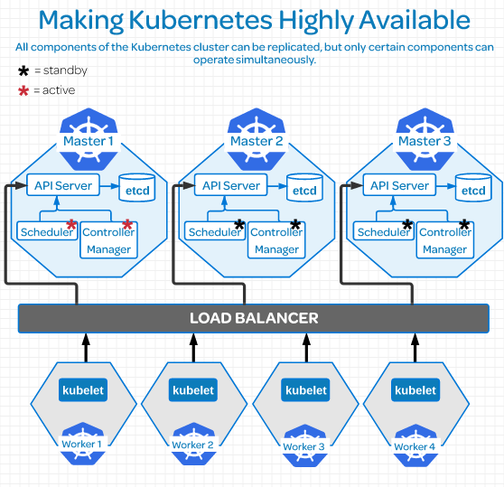

Replicate etcd:

***************************************************************************************Due to the distributed nature of etcd it’s instances can be in:

- Stacked etcd topology: Each control plane node creates a local etcd member, and the etcd member communicated only with the kube-apiserver of this node.

- External etcd topology: Etcd is external to the k8s cluster.

Etcd uses Raft Consensus Algorithm (Graphical explanation)which requires a majority in order to progress to the next state.

There must be more than half taking part on that state change. In order to have a majority you must have an ODD number of etcd instances therefore the minimum number of instances must be 3 to have a etcd external topology cluster.

Having 2 etcd instances is worst than having one because this reason.

On larger dev environments most of the time you won’t need more than 7 etcd instances.

Links:
Creating Highly Available Kubernetes Clusters with kubeadm
Operating a Highly Available etcd Cluster
Easy explanation of etcd consensus

Configuring Secure Cluster Communications:
Controlling Access to the Kubernetes API
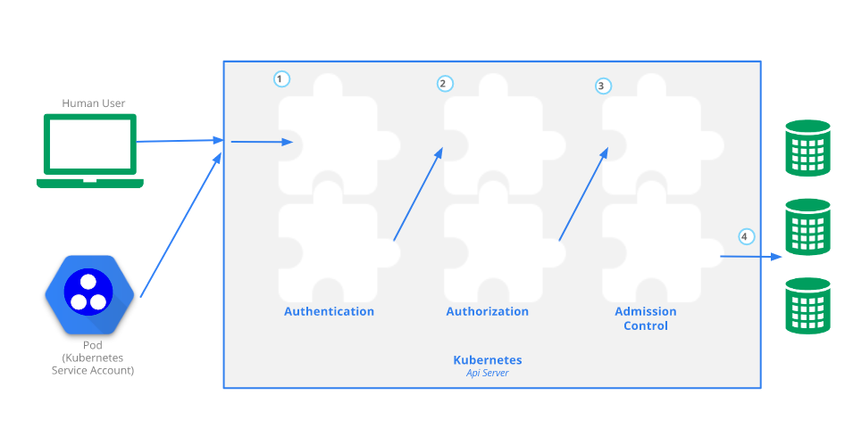
Kubectl , command line tool: It’s a translator to the k8s API
API server provides a CRUD (Create, Read, Update,Delete) interface for querying and modifying the cluster state over a RESTful API.

Who can use CRUD, only:
- The client, like Users
- PODs

Let’s create a POD:
- We make the kubectl command to create a POD
- It sends a request to the API server via http POST request
- Goes to Authentication
- Authorization
- Admission
- Resource Validation
- The state is stored on the persistent datastore etcd
- API server returns a response.

Different plugins/modules: On each Authentication, authorization and Admission control phases there are multiple plugins allowing you find out different things about the request.

Authentication → Who is sending the request.
Authentication method can be determined by http heather or certificate.
Once found the request returns the username, user id and groups the client belongs to back to the API server.

Authentication modules include: Client Certificates, Password, and Plain Tokens, Bootstrap Tokens, and JWT Tokens (used for service accounts).

Authorization → Can this authenticated user perform the requested action on the requested resource?
Example: Can this user create a POD in this namespace?

Adminssion → If your request is Create, Modify or Delete a resource, like a pod, it’s sent to Admission Control.
If the request is to READ data, the Admission Control steep is skipped and is sent to ETCD

In admission control the requests goes through all the plugins allowing the plugins to modify the resource for different reasons.

Authentication - Authorization - Admission - Review

Resource Validation → The API server validates the object.

ETCD → The API server stores the object in etcd and returns a response. This is the object store.

Self signed certificate: Created when we create the cluster and is stored in $USER/.kube/config
It contains:
- certificate-authority-data
- Master server address: server: https://172.31.127.122:6443
- The Cluster: cluster: kubernetes
- The client certificate: client-certificate-data
- Client Key: client-key-data

This certificate contains the root certificate for the API server’s certificate, which is used in place of the system default root certificate.

If the system have multiple users, then the creator needs to share the certificate with other users.

All requests come from two different sources: (both go through the same auth process we saw above)
- The client, like a user
- A POD

Request from Users: RBAC (Role Based Access Control) this authorization module is used to prevent unauthorized users to modify the cluster state.

Manage RBAC: You manage RBAC by creating four resources in two groups:

Roles and cluster roles: What can be done?
Role: Namespaces resources
Cluster Role: Cluster level resources

Role Binding and cluster role binding: Who can do it?
Role Binding: Namespace Resources
Cluster Role Binding: Cluster lever resources

Examples:

Role: Create a Role named “pod-reader” that allows user to perform “get”, “watch” and “list” on pods:
kubectl create role pod-reader --verb=get --verb=list --verb=watch –resource=pods

Cluster Role: Create a ClusterRole named “pod-reader” that allows user to perform “get”, “watch” and “list” on pods:
kubectl create clusterrole pod-reader --verb=get,list,watch –resource=pods

Role Binding: Within the namespace “acme”, grant the permissions in the admin ClusterRole to a user named “bob”:
kubectl create rolebinding bob-admin-binding --clusterrole=admin --user=bob --namespace=acme

Cluster Role Binding: Across the entire cluster, grant the permissions in the cluster-admin ClusterRole to a user named “root”:
kubectl create clusterrolebinding root-cluster-admin-binding --clusterrole=cluster-admin --user=root

Requests from PODs: Services Accounts: Is how the POD authenticates to the API server

Configure Service Accounts for Pods

Represents the identity of the APP running on the POD and a token file holds the service account authentication token.

We can view this token file by going over to our POD by a shell and we can cat out the token:
cat /var/run/secrets/kubernetes.io/serviceaccount/token

When the app uses this token to connect the API server, the plugin authenticates the service account and passes the services account back to the API server core.

Service account by default: If is not specified when creating the pod, the service account applied will be the default one.

This means that if you create the pod into another namespace, the service account will have permissions only for that namespace and not the rest, default namespace included, example:

Get the service accounts in the cluster:
root@andrewjobson1c:~# kubectl get serviceaccounts
NAME SECRETS AGE
default 1 43h

If the service account is not specified on the PODs manifest then the default service account will be applied.

View service account token:
root@andrewjobson1c:~# kubectl get secrets
NAME TYPE DATA AGE
default-token-fsfdg kubernetes.io/service-account-token 3 43h

End to End Tests, e2e:

E2e tasks are good for two main reasons:
- Ensures that performance and response of the app running in a pod is not compromised due the performance in a cluster.
- Ensures that the pods are in good health, there are no resource constraints or problem with deploying resources.

Tools:
Kubetest: Interface for launching and running e2e tests.
Ju ju deploying cluster: Cloud validation and testing
Each cloud provider have his own version of a testing suite for their hosted kubernetes services.

Tests:
Run a simple nginx deployment:
root@andrewjobson1c:~# kubectl run nginx --image=nginx
kubectl run --generator=deployment/apps.v1 is DEPRECATED and will be removed in a future version. Use kubectl run --generator=run-pod/v1 or kubectl create instead.
deployment.apps/nginx created

View the deployments in your cluster:
root@andrewjobson1c:~# kubectl get deployments
NAME READY UP-TO-DATE AVAILABLE AGE
busybox 1/1 1 1 33h
nginx 1/1 1 1 31s
node-hello 1/1 1 1 33h

View the pods in the cluster:
kubectl get pods
kubectl get pods --all-namespaces

Use port forwarding to access a pod directly:
root@andrewjobson1c:~# kubectl port-forward nginx-7cdbd8cdc9-q9x78 8081:80
Forwarding from 127.0.0.1:8081 -> 80
Forwarding from [::1]:8081 -> 80

root@andrewjobson1c:~# curl --head http://127.0.0.1:8081
HTTP/1.1 200 OK
Server: nginx/1.17.2
Date: Wed, 24 Jul 2019 22:17:23 GMT
Content-Type: text/html
Content-Length: 612
Last-Modified: Tue, 23 Jul 2019 11:45:37 GMT
Connection: keep-alive
ETag: "5d36f361-264"
Accept-Ranges: bytes
Get Logs from a pod:
^Croot@andrewjobson1c:~# kubectl logs pod/nginx-7cdbd8cdc9-q9x78
127.0.0.1 - - [24/Jul/2019:22:17:23 +0000] "HEAD / HTTP/1.1" 200 0 "-" "curl/7.47.0" "-"

ReplicaSets: Set of pods that all share the same labels.

Are missing some of the features that we need to truly have HA and escalability. To do so we should use Deployments.

apiVersion: apps/v1
kind: ReplicaSet
metadata:
name: frontend
labels:
app: nginx
tier: frontend
spec:
replicas: 2
selector:
matchLabels:
tier: frontend
matchExpressions:
- {key: tier, operator: In, values: [frontend]}
template:
metadata:
labels:
app: nginx
tier: frontend
spec:
containers:
- name: nginx
image: darealmc/nginx-k8s:v1
ports:
- containerPort: 80

Create one: kubectl create -f replicas-example.yml

See the info or the replica pods: kubectl describe rs/frontend

See the IP of one pod:
kubectl get pods
kubectl describe pod frontend-9jrcw
[…]
IP: 10.244.2.15
Controlled By: ReplicaSet/frontend
[...]

Check if nginx is running:

curl 10.244.2.15
<head>
<h1> This is the Correct container! Congratulations!</h1>
</head>
<body>
<img src='k8slogo.png' height="550" width="550">
</body>

curl --head 10.244.2.15
HTTP/1.1 200 OK
Server: nginx/1.15.7
Date: Wed, 31 Jul 2019 13:25:47 GMT
Content-Type: text/html
Content-Length: 141
Last-Modified: Sat, 15 Dec 2018 04:13:27 GMT
Connection: keep-alive
ETag: "5c147f67-8d"
Accept-Ranges: bytes

Scale to 4 replicas:
root@andrewjobson1c:~# kubectl scale rs/frontend --replicas=4
replicaset.extensions/frontend scaled

Reduce to 1 replica:
root@andrewjobson1c:~# kubectl scale rs/frontend --replicas=1
replicaset.extensions/frontend scaled

Delete the ReplicaSet:
root@andrewjobson1c:~# kubectl delete rs/frontend
replicaset.extensions "frontend" deleted

Logs:

1 - Clone the metrics server:
git clone https://github.com/linuxacademy/metrics-server

2 – Deploy the directory of the repository:
kubectl apply -f ~/metrics-server/deploy/1.8+/

3 - Access the metrics API: Makes sure that the API is responding
kubectl get --raw /apis/metrics.k8s.io/

4 – Check status nodes and pods:
kubectl top nodes
kubectl top pods --all-namespaces

Get the CPU and memory of pods with a label selector:
kubectl top pod -l run=<pod_name>

Get the CPU and memory of a specific pod:
kubectl top pod <pod_name>

Get the CPU and memory of the containers inside the pod:
kubectl top pods <pod_name> --containers

Upgrading the Kubernetes Cluster

The CKA curriculum refers to the API Server version, v1.14.1.
So you have to look for the kubelet version (server version), 1.13.8 in this example.
kubectl version --short

The process creates new images for the components: kube-apiserver, kube-controller-manager, kube-scheduler, etcd

And will swap to them once are working to minimize the downtime.

Check versions:

Kubectl version: We need to know the Server Version
root@andrewjobson1c:~# kubectl version --short
Client Version: v1.13.5
Server Version: v1.13.8 → API server that we need to upgrade

Kubelet version:
root@andrewjobson1c:~# kubectl get nodes
NAME STATUS ROLES AGE VERSION
andrewjobson1c.mylabserver.com Ready master 10d v1.13.5
andrewjobson2c.mylabserver.com Ready <none> 10d v1.13.5
andrewjobson3c.mylabserver.com Ready <none> 10d v1.13.5

All versions on all servers on the cluster:
root@andrewjobson1c:~# kubectl describe nodes |grep -i version
Kernel Version: 4.4.0-1088-aws
Container Runtime Version: docker://18.6.1
Kubelet Version: v1.13.5
Kube-Proxy Version: v1.13.5
Kernel Version: 4.4.0-1088-aws
Container Runtime Version: docker://18.6.1
Kubelet Version: v1.13.5
Kube-Proxy Version: v1.13.5
Kernel Version: 4.4.0-1088-aws
Container Runtime Version: docker://18.6.1
Kubelet Version: v1.13.5
Kube-Proxy Version: v1.13.5

Controller-Manager version:
kubectl get pods -n kube-system kube-controller-manager-andrewjobson1c.mylabserver.com -o yaml

[…]
image: k8s.gcr.io/kube-controller-manager:v1.13.8
[…]

Upgrade versions:

On the Master node:
1 – Unhold kubeadm → to allow the update
dpkg --get-selections |grep kube → to see what is holded
kubeadm hold

root@andrewjobson1c:~# sudo apt-mark unhold kubeadm
Canceled hold on kubeadm.

dpkg --get-selections |grep kube
kubeadm install

2 – Install kubeadm:
sudo apt install -y kubeadm=1.14.1-00

3 – Hold kubeadm again:
root@andrewjobson1c:~# apt-mark hold kubeadm
kubeadm set on hold.

4 – Confirm the new version:
root@andrewjobson1c:~# kubeadm version
kubeadm version: &version.Info{Major:"1", Minor:"14", GitVersion:"v1.14.1", GitCommit:"b7394102d6ef778017f2ca4046abbaa23b88c290", GitTreeState:"clean", BuildDate:"2019-04-08T17:08:49Z", GoVersion:"go1.12.1", Compiler:"gc", Platform:"linux/amd64"}

5 – Upgrade the rest of the components: Will show you what can we upgrade without doing anything else:

sudo kubeadm upgrade plan
[…]
COMPONENT CURRENT AVAILABLE
API Server v1.13.8 v1.14.4
Controller Manager v1.13.8 v1.14.4
Scheduler v1.13.8 v1.14.4
Kube Proxy v1.13.8 v1.14.4
CoreDNS 1.2.6 1.3.1
Etcd 3.2.24 3.3.10

You can now apply the upgrade by executing the following command:
kubeadm upgrade apply v1.14.4

root@andrewjobson1c:~# kubeadm upgrade apply v1.14.1
[preflight] Running pre-flight checks.
[upgrade] Making sure the cluster is healthy:
[upgrade/config] Making sure the configuration is correct:
[upgrade/config] Reading configuration from the cluster...
[upgrade/config] FYI: You can look at this config file with 'kubectl -n kube-system get cm kubeadm-config -oyaml'
[upgrade/version] You have chosen to change the cluster version to "v1.14.1"
[upgrade/versions] Cluster version: v1.13.8
[upgrade/versions] kubeadm version: v1.14.1
[upgrade/confirm] Are you sure you want to proceed with the upgrade? [y/N]:

[…]
[upgrade/successful] SUCCESS! Your cluster was upgraded to "v1.14.1". Enjoy!

6 – Done, check versions:
root@andrewjobson1c:~# kubectl version --short
Client Version: v1.13.5
Server Version: v1.14.1

7 – Unhold , Upgrade and hold back kubectl:
apt-mark unhold kubectl
apt install -y kubectl=1.14.1-00
apt-mark hold kubectl

Now client and server have the same version:
root@andrewjobson1c:~# kubectl version --short
Client Version: v1.14.1
Server Version: v1.14.1

8 – Kubelet now:
apt-mark unhold kubelet
apt install -y kubelet=1.14.1-00
apt-mark hold kubelet

Now we have the master node updated:
root@andrewjobson1c:~# kubectl get nodes
NAME STATUS ROLES AGE VERSION
andrewjobson1c.mylabserver.com Ready master 10d v1.14.1
andrewjobson2c.mylabserver.com Ready <none> 10d v1.13.5
andrewjobson3c.mylabserver.com Ready <none> 10d v1.13.5

9 – Now do the same to the worker nodes
Skip the master server parts, points 5 and 6.

Operating System Upgrades within a Kubernetes Cluster:

Remove a worker node for Maintenance:

1- Remove the pods of the node avoiding new ones to be scheduled there:
kubectl draing <node_name> --ignore-daemonsets

2- Watch as the node change status:
kubectl get nodes -w
You will see the node status as Ready, SchedulingDisabled

3- Schedule pods to the node after the maintenance:
kubectl uncordon <node_name>

Totally decommission a node:

1- Drain the node:
kubectl draing <node_name> --ignore-daemonsets

2- Delete the node from the cluster:
kubectl delete node <node_name>

3- Install a new server:
Install everything, docker,kubeadm,kubectl and kubelet

4- Join it to the cluster:
On the master server, generate the token: sudo kubeadm token generate

On the master server, generate the join command:
sudo kubeadm token create <paste the output of the previous command> --ttl 2h --print-join-command

On the new worker node, copy the string created on the previous command and paste it on the new worker node.

5- Verify that the node has been added correctly: kubectl get nodes

Backing Up and Restoring a Kubernetes Cluster:

Backing up the etcd Store
etcd Disaster Recovery Examples

1- Get the etcd binaries:
wget https://github.com/etcd-io/etcd/releases/download/v3.3.12/etcd-v3.3.12-linux-amd64.tar.gz

2- Unzip the compressed binaries:
tar xvf etcd-v3.3.12-linux-amd64.tar.gz

3- Move the files into /usr/local/bin:
sudo mv etcd-v3.3.12-linux-amd64/etcd* /usr/local/bin

4- Take a snapshot of the etcd datastore using etcdctl:
root@andrewjobson1c:~# sudo ETCDCTL_API=3 etcdctl snapshot save snapshot.db --cacert /etc/kubernetes/pki/etcd/server.crt --cert /etc/kubernetes/pki/etcd/ca.crt --key /etc/kubernetes/pki/etcd/ca.key
Snapshot saved at snapshot.db

5- View the help page for etcdctl:
ETCDCTL_API=3 etcdctl --help

6- View that the snapshot was successful:
root@andrewjobson1c:~# ETCDCTL_API=3 etcdctl --write-out=table snapshot status snapshot.db
+----------+----------+------------+------------+
| HASH | REVISION | TOTAL KEYS | TOTAL SIZE |
+----------+----------+------------+-----------------------------+
| 886df69b | 518353 | 1021 | 4.1 MB |
+----------+----------+------------+-----------------------------+

7- Store the snapshot on the certificates folder and do a backup:
/etc/kubernetes/pki/etcd/
sudo tar -zcvf etcd.tar.gz etcd

8- Copy the etcd directory outside of the server

Restore:
To do the restore operation you need the datastore snapshot and all the certificates files.

When you do the restore it creates and entirely new etc directory.

No matter how many nodes do you have in your cluster you must restore always the same snapshot.

The restore operation overwrites the memory ID and the cluster ID so no longer identify with the original cluster at all. The restore operation create a new entire cluster and replaces the etc keyspaces from that backup. You totally wipe and way the previous cluster.

If the node that is down is completely lost, the new node will need to have the same IP as the original.

Security: https://github.com/kabachook/k8s-security?utm_sq=g7fg3gt0uh

Cluster Communications:

Pods and Node Networking: https://linuxacademy.com/cp/courses/lesson/course/4018/lesson/1/module/327

Networking on k8s uses the old linux network namespaces. Another (better) explanation.

Namespaces: Cgroups are a metering and limiting mechanism, they control how much resources (CPU, memory) you can use. Namespaces limit what you can see.

Linux kernel provides 6 types of namespaces: pid, net, mnt, uts,ipc and user.

For instance, a process inside a pid namespace only sees processes in the same namespace. Thanks to the mnt namespace it’s possible to attach a process to it’s own filesystem.

So network (net) namespaces provide a brand-new network stack for all processes within the namespace.

Network namespaces: Contains its own network resources: interfaces, routing tables, etc.

Creates 2 interfaces, one on the node side (veth) and another in the POD side (will be renamed as eth0).

Networking within a Node: Minerva diagram.
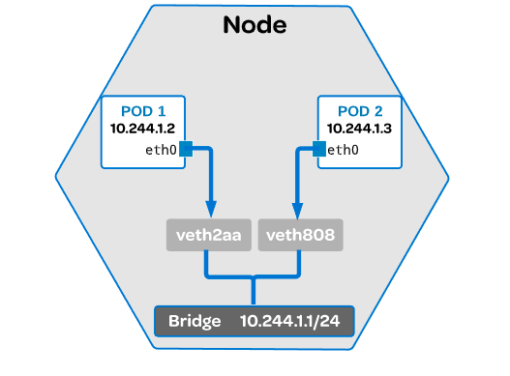

Each POD has an IP address associated with it. It receives this IP address from the virtual ethernet (veth) interface pair. One of this veth is given to the POD and renamed as eth0.

Bridge: Common linux ethernet bridge. It discovers the destination using an ARP request. Used to communicate on other veth network on the same node.

Commands:
View which node is running on: kubectl get pods -o wide
See the running containers in that node: sudo docker ps (pick the container id needed)
Get the container PID: sudo docker inspect --format ‘{{ .State.Pid }}’ (container id)

Get the IP address: nsenter -r (container PID) → you will see eth0@if6 or something similar.
In this example if6 is the interface 6 of the pod, so to know which one is do an ifconfig on the node and count until the 6th one, you will see that is a veth interface seeing how are they linked.

Networking Outside of the Node and CNI: Minerva diagram.
https://linuxacademy.com/cp/courses/lesson/course/4018/lesson/2/module/327

The CNI is managing the communications between nodes.

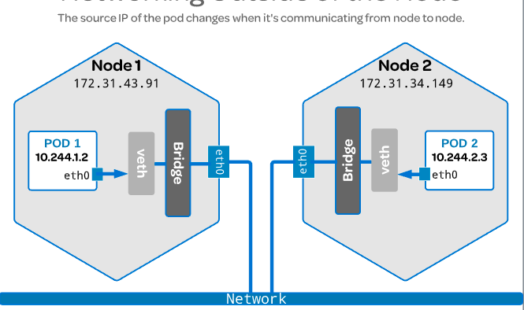
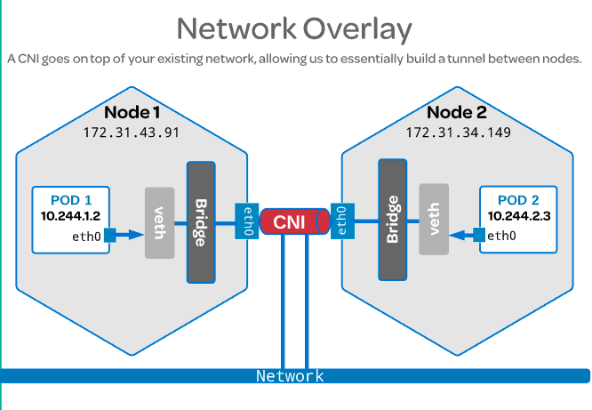

Once the CNI is installed it installs a network agent on each node, which ties the CNI interface.
Encapsulates the packets changing the source and destination from one node to another.

There is a mapping in the userspace where you can program all the POD IP addresses to the node IP addresses and when the packet reaches the other node is decapsulated and when reaches the bridge is moved to the proper POD.

The CNI is installed via plugin, is not a native k8s solution, like Flannel as CNI for instance.

When you run the below command you will install flannel as CNI:
kubectl apply -f https://raw.githubusercontent.com/coreos/flannel/master/Documentation/kube-flannel.yml

If you take a look to the yml you will see that is installing a lot of stuff, like cluster roles, cluster role binding, services, etc, etc. This kind of yml is called multi resouce yml.
To use the CNI you must notify the kubelet. Kubelet needs to know that the CNI is being used by setting the network plugging flag equal to the CNI.

We do that when we install the k8s cluster. Each CNI have a different command, flannel has this one:
sudo kubeadm init –pod-network-cidr=10.244.0.0/16

Service Networking: Linux academy. Minerva

Communicate outside of the cluster. When someone is trying to interact with your application or the app is trying to reach something outside of the cluster.

Pods are coming and going, or you can have problems with a single pod, then is easy to remove this failing one and change it for a brand new.

The cluster keep track of all this and determine where to send traffic coming in using services.
Avoiding to have a down time because a pod have been moved or deleted because have a new IP address or so.

A service provides just one virtual interface, behind the pods can be moved around, deleted, etc and from the outside everything is going to this virtual interface.

When a service is created in an API server, the API server notifies all kube-proxy agents about it.
Kube-proxy in this case is used to keep track of the endpoints and update IP tables so the traffic can be routed accordingly.

Endpoint: Object in the API server created automatically with the service, keeps a cache of the IP addresses of the pods in that service. Is a correlation between IP address plus port.

Commands:
View the spec of the services: kubectl get services -o yaml (you can see the cluster IP)
If you ping the cluster IP won’t work because a service is a logical grouping of IP and port pair.

View the services in the cluster: kubectl get services

View IP tables rules: sudo iptables-save |grep KUBE |grep nginx
Output example:
-A KUBE-SERVICES ! -s 10.244.0.0/16 -d 10.109.185.62/32 -p tcp -m comment --comment “default/nginx: cluster IP” -m tcp --dport 80 -j KUBE-MARK-MASQ

-s 10.244.0.0/16 : source, take anything from that range
-d 10.109.185.62/32: destination, send it to the IP of the service.

Get endpoints: kubetcl get endpoints

Load Balancer and Ingress Rules: Linux Academy Minerva

Load Balancer: Extension of the NodePort type of service.
It’s balancing the external access to the app through all the nodes that contain it. You need a public IP.

You can create it as a Service, you have to specify on “spec” the “type” LoadBalancer instead of a node type port service. We don’t specify a node port, k8s will choose this for us.

Ingress Rules: Like a load balancer but you can access multiple services with just a single IP address, with the lb you have only one external IP for each service.

COREDNS: Minerva. Linux academy.

K8s used to use Kube-dns, now is using Coredns as a native K8s DNS solution.

Have backwards compatibility with kube-dns, uses better the memory to avoid buffer overruns, supports TLS or Dot over DNS, easy to integrate with etcd and cloud benders to pull authoritative data into coredns.

Plugin and simplified architecture. Allows dns entries without touching the service discovery part.

We can see 2 pods running in the master node as a deployments.

There is a service performing loadbalancing for the dns server.

Commands: To troubleshooting DNS stuff you can create a busybox to run commands over it.
See coredns pods: kubectl get pods -n kube-system
See coredns deployments: kubectl get deployments -n kube-system
Get KUBE-DNS services: kubectl get services -n kube-system (you get kube-dns because it’s kept because it’s a legacy service).

Create busybox pod: kubectl create -f busybox.yaml
See pod resolve.conf: kubectl exec -t busybox – cat /resolve.conf (you will see in the “search” category different cluster.local entries which means that all queries for these dns entries will resolve)
Do nslookup: kubectl exec -t busybox -- nslookup kubernetes (this will work as explained in the previous command or use the whole hostname of the pod, service, etc.)

Get logs: kubectl logs coredns-34354fsfe-sdxw -n kube-system

Headless services: another example, and another more clear. Service without a clusterIP, will respond with a set of IPs instead of just one.

You have to create a service and you have to set the clusterIP policy to “None”.
Specify the app that you want to use the service.

DNS policies on pods: You can configure specific dns policies for a pod.
The default is cluster first which inherit the name resolution from the node the pod is running on.

So set spec.dnsPolicy: to “None” and specify the spec.dnsConfig:nameservers , spec.dnsConfig:searches and spec.dnsConfig:options to the ones that you need.

Once deployed that pod we can see in it’s /etc/resolve.conf the information added in the nameservers and search selectors before.

Pod Scheduling
Linux academy Minerva K8s documentation
What is this: To send the pod to the best node based on cpu, ram, disk, etc.

Default scheduler: The system does this automatically.

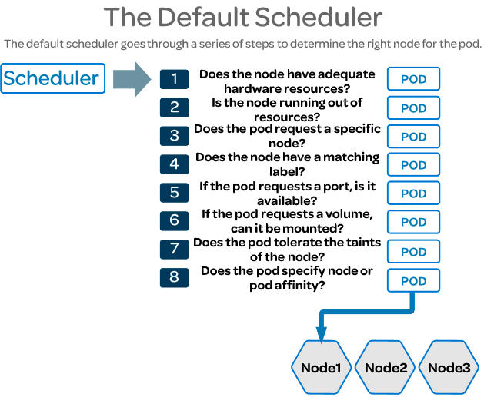

The scheduler does this automatically, will do a reasonable placement (e.g. spread your pods across nodes, not place the pod on a node with insufficient free resources, etc.). You can pod schedule manually too.

Why to manually schedule: You may want to schedule a pod to a particular node to save resources, or because the node have ssd, etc. There are many more possibilities as to why you would want to create your own scheduling rules.
Example: I have 2 availability zones in two different regions, AZ1 and AZ2 In AZ1 I have dedicated and shared servers. I want to send the pods to AZ1 and to the dedicated servers. Scheduling it manually I can do it.

Default scheduler: The system does this automatically.
If after all the checks scheduler have found more than one node he will select one using a round robin fashion.

nodeSelector: Used on Pods. Is the simplest recommended form to manually assign a pod to a node. Field of Pod.Spec that specifies a key-value pair. You have to create a label in the node and then you have to specify the nodeSelector in your Pod configuration:
Example:
Add the label disktype=ssd to the node kubernetes-foo…….
kubectl label nodes kubernetes-foo-node-1.c.a-robinson.internal disktype=ssd

Then add the nodeSelector in your pod yaml:

apiVersion: v1
kind: Pod
metadata:
name: nginx
labels:
env: test
spec:
containers:
- name: nginx
image: nginx
imagePullPolicy: IfNotPresent
nodeSelector:
disktype: ssd

Affinity and anti-Affinity: Is like nodeSelector but with more options, like language more expressive, indicate soft or hard preference,etc.

The key enhancements are:

- The affinity/anti-affinity language is more expressive. The language offers more matching rules besides exact matches created with a logical AND operation;

- You can indicate that the rule is "soft"/"preference" rather than a hard requirement, so if the scheduler can't satisfy it, the pod will still be scheduled;

- You can constrain against labels on other pods running on the node (or other topological domain), rather than against labels on the node itself, which allows rules about which pods can and cannot be co-located

The affinity feature consists of two types of affinity: "node affinity" and "inter-pod affinity/anti-affinity".

Node affinity is like the existing nodeSelector (but with the first two benefits listed above).

Inter-pod affinity/anti-affinity constrains against pod labels rather than node labels, as described in the third item listed above, in addition to having the first and second properties listed above.

Node affinity: Similar to nodeSelector, have to types:

requiredDuringSchedulingIgnoredDuringExecution: Hard. The rules MUST met it. Is like nodeSelector but with more expressive syntax.

preferredDuringSchedulingIgnoredDuringExecution: Soft. Specify preferences that the scheduler will try to met but will not guarantee.

Inter-pod affinity and anti-affinity: It looks for the labels on the pods already running on the node instead of labels on the nodes.

Commands:

Check the nodes: kubectl get nodes

Label a node:
kubectl label nodes <node-name> <label-key>=<label-value>
kubectl label nodes kubernetes-foo-node-1.c.a-robinson.internal disktype=ssd

Check labels: kubectl get nodes --show-labels

Full list of labels for a node: kubectl describe node "nodename"

Label node 1 as being located in availability zone 1:
kubectl label node chadcrowell1c.mylabserver.com availability-zone=zone1

Label node 2 as being located in availability zone 2:
kubectl label node chadcrowell2c.mylabserver.com availability-zone=zone2

Label node 1 as dedicated infrastructure:
kubectl label node chadcrowell1c.mylabserver.com share-type=dedicated

Label node 2 as shared infrastructure:
kubectl label node chadcrowell2c.mylabserver.com share-type=shared

This is the yaml for the deployment, pref-deployment.yaml

apiVersion: apps/v1
kind: Deployment
metadata:
name: pref
spec:
selector:
matchLabels:
app: pref
replicas: 5
template:
metadata:
labels:
app: pref
spec:
affinity:
nodeAffinity:
preferredDuringSchedulingIgnoredDuringExecution:
- weight: 80
preference:
matchExpressions:
- key: availability-zone
operator: In
values:
- zone1
- weight: 20
preference:
matchExpressions:
- key: share-type
operator: In
values:
- dedicated
containers:
- args:
- sleep
- "99999"
image: busybox
name: main

Create the deployment: kubectl create -f pref-deployment.yaml

Configure Multiple Schedulers:

Until now we were using the scheduler that is by default in the cluster, but we can create our own.
Then you can replace my scheduler with the built in one or make both to work together.

To do so, you have to:
- Create the scheduler (my-scheduler.yaml), copy it from here and modify the image to use yours, docker build required.
- Create a new RBAC stuff: role, role binding, cluster role and cluster role binding pointing to the new scheduler.
- Edit the exixting kube-scheduler add the new scheduler in rules.apiGroups.resouceNames.
- Create the new scheduler.
- Create the pods pointing to the new scheduler,

See whole configuration in /home/joaquim/Documents/repos/configure_multiple_schedulers

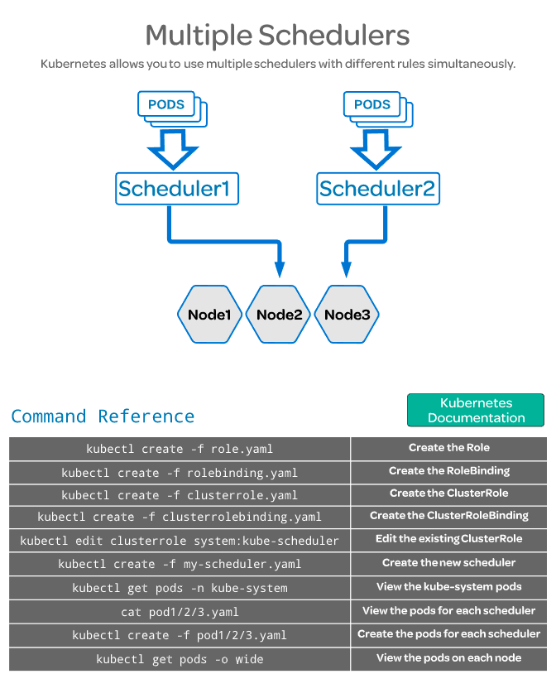

Scheduling Pods with Resource Limits and Label Selectors:
Linux Academy
Minerva
Udemy

Taints and Tolerations:

Taints: → on the nodes
Tells if the node can be scheduled or not.

The master node can not but the kube-system pods have a Toleration that allows them to be moved to the master node

Tolerations: → on the pods
Allow you to tolerate a taint, for example you don’t want to schedule nginx or other app pods to the master node but the kube-system pods must be moved there, so the k-system pods will have a toleration for a NoSchedule taint.

Commands:

See nodes/pods capacity,etc:
kubectl describe node → will; show all of them
kubectl describe node name_of_the_node

kubectl describe pod → will; show all of them
kubectl describe pod name_of_the_pod

Look at Capacity and Allocatable sections.

Check in the master node for the taints. You can see

kubectl describe node node1
[...]
Taints: node-role.kubernetes.io/master:NoSchedule --→ this is by default.
node.kubernetes.io/disk-pressure:NoSchedule
Unschedulable: false
[...]

Checking a worker node:
kubectl describe node node2
[…]
Taints: node.kubernetes.io/disk-pressure:NoSchedule
Unschedulable: false
[...]

Checking a kube-system POD:
kubectl get pod kube-proxy-k7g85 -n kube-system -o yaml |less

- effect: NoSchedule → so this means that you can jump this restriction in the node.
key: node.kubernetes.io/unschedulable
This pod will tolerate a node that is unschedulable.

CPU and memory requests:

You can specify the minimum amount of cpu and ram that a pod will need. Then the scheduler can move the pod to the node that have these resources.

The scheduler doesn’t looks for every individual resource to determine the best node.
Instead it uses the sum of resources requested by existing pods deployed on that node.

This is because the pod may not be using the full amount of resources requested at any given time.

Here you can see different limits in spec.containers.image.resources
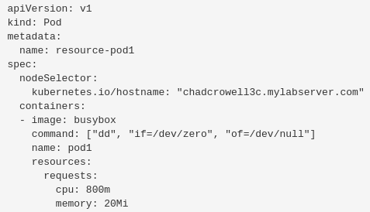
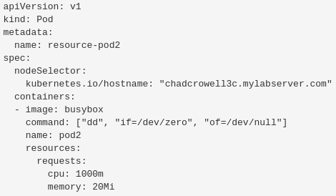

The m in 800m and 1000m means milicpu.

Hard limits: You can specify the limit of memory a pod can use.

Is not specified a pod can use the whole memory of the node. To avoid this we can apply limits.
This is not happening with the CPU that won’t let the pod to consume all of it.

apiVersion: v1
kind: Pod
metadata:
name: limited-pod
spec:
containers:
- image: busybox
command: ["dd", "if=/dev/zero", "of=/dev/null"]
name: main
resources:
limits:
cpu: 1
memory: 20Mi

Use the top command: This will show you the resources from the node, not the container.
kubectl exec -it POD_NAME top
kubectl exec -it busybox top

Modify memory limit:
Let’s say we have a pod called elephant that have a 10 Mi limit and we want to increase it to 20 Mi.

1st Generate the pod definition file from the existing elephant pod:
kubectl get pod elephant -o yaml > pod.yaml
2nd Edit pod.yaml to increase the memory limit.
3rd Delete the current elephant pod with the old limit: kubectl delete pod elephant
4th Create the new elephant pod with the new mem limit: kubectl create -f pod.yaml

DaemonSets and Manually Scheduled Pods:
Minerva
DaemonSet

Like replicasets, it helps you to deploy multiple instances of pods but it runs only one copy of the pod in each node.
When a new node is added to the cluster, a replica of the pod is automatically added to that node.
And if a node is removed from the cluster, the replica of the pod in that node will be deleted.

Deamonsets ensures that one copy of the pod is always present in all nodes of the cluster.

Why to use it:
For instance if you want to deploy a monitoring solution or a log collector for each node in the cluster.

Kube-proxy and the networking solution, like flannel, weave-net, etc, are daemon sets because have to run one instance on each node.

Create a daemon-set: Is like to create a replicaset, it only varies in the kind, which have to be DaemonSet instead of ReplicaSet.

Commands:
Get daemonsets: kubectl get daemonsets
kubectl get daemonsets -n kube-system
kubectl get ds -A →all namespaces

Describe it: kubectl describe daemonset name_of_it
kubectl describe ds name_of_it

Different ways to create a pod:

kubectl run: Deploys a docker container by creating a pod straight away. You have to specify the name the pod will have and the image to pull, which will be downloaded from the docker hub repository.

kubectl run nginx --image=nginx
kubectl run redis --image=redis
kubectl run my-jenkins --image=jenkins

Do kubectl run but not create the pod, send the output to a yaml file:
kubectl run pod_name –image=my_image --dry-run=client -o yaml > my_file.yaml

kubectl run redis --image=redis --dry-run=client -o yaml > redis.yaml

This will create this file:
cat redis.yaml

apiVersion: v1
kind: Pod
metadata:
creationTimestamp: null
labels:
run: redis
name: redis
spec:
containers:
- image: redis
name: redis
resources: {}
dnsPolicy: ClusterFirst
restartPolicy: Always
status: {}

Then you can run this yaml to create the pod: kubectl create -f redis.yaml

Manually creating a yaml: You can use .yaml .ymnl or .json files to do it.

All yaml have to have 4 mandatory fields:

apiVersion: Version of the k8s api you are using to create objects. Depending on the object you want to create you have to use the right version. It’s data is a String.

Kind: | Version:
POD | v1
Service | v1
ReplicaSet | apps/v1
Deployment | apps/v1

kind: Type of object you want to create, could be PODs, deployments, etc, etc. It’s data is a String.

metadata: Data about the object, it’s name, labels, etc. It’s data is a Dictionary. Everything under the metadata have to be placed a little bit to the right, names, labels, etc are children of metadata.
The spaces have to be the same between siblings.

Example:
metadata:
name: myapp-pod → string (str)
labels: → dictionary (dict) → you can add any label, type,location, etc.
app: myapp

metadata is parent of name and labels.
name and labels are siblings and children of metadata
app is children of labels

spec: Info about the containers, how much do we need, where to find the images,etc.

spec:
containers: → List (lst)/Array
- name: nginx-container → the dash (-) indicates that this is the first item in the list.
image nginx

- name: backend-container → you can specify more containers
image: redis

Replication Controllers: Is the older technology that is being replaced by the replicaSet.
The RC creates multiples instances of a pod, so in spec (specification) we create template section under spec to provide a pod template to be use by the RC to create replicas.

To define the pod template we can paste the metadata and spec info from a previous pod like in this example for instance. Skipping the apiversion and kind fields.
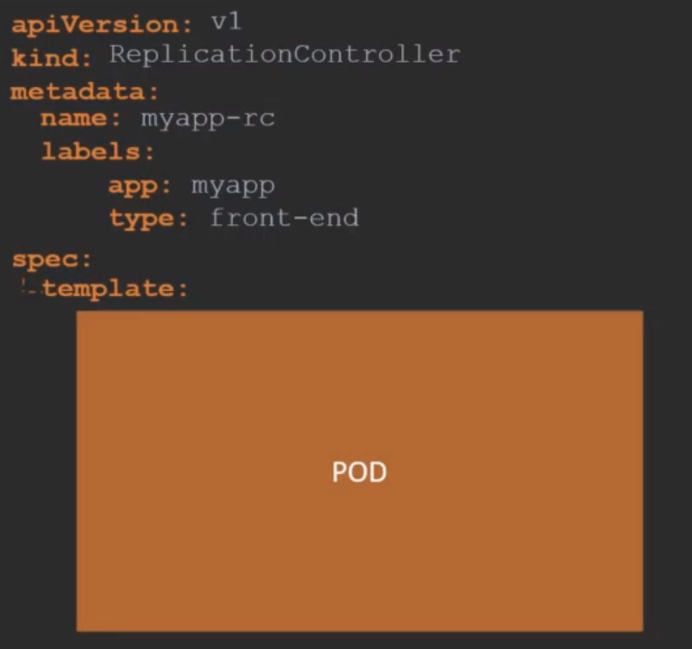
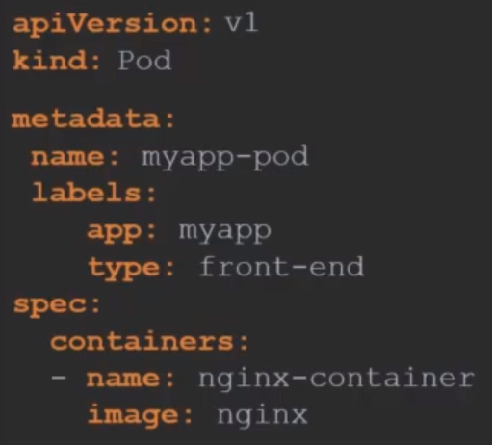

The metadata and spec fields coming from the pod must have the proper space from the left to make them childrens of spec.template, like we can see below.

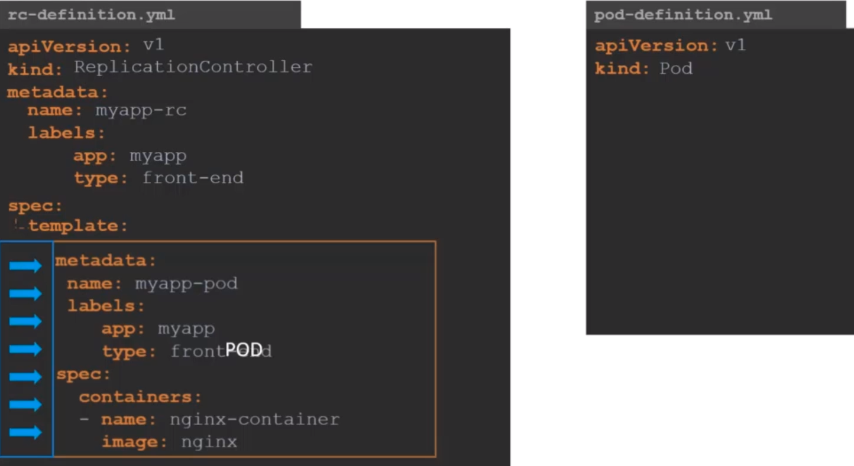
Here we have nested two definition files together. The RC being the parent and the pod definition being the child.

Now we have to add the replicas property to the spec of the RC to indicate how many replicas do we need for the RC.

The final file looks like this. Now we can deploy the RC: kubectl create -f rc-definition.yaml
This will create the replicationcontroller “myapp-rc”
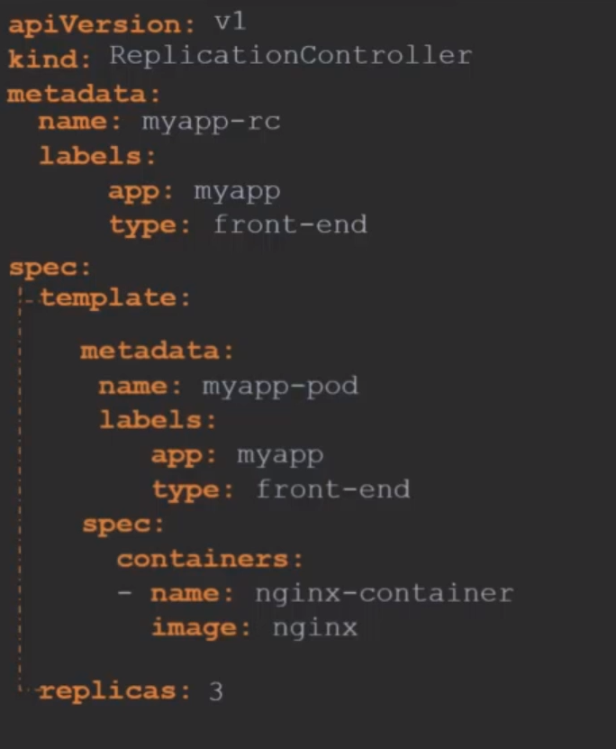

How to see the replication controllers:
kubectl get replicationcontroller

If you check the pods you will see that we have 3 with starting with the name: myapp-rc-… indicating that they are all created by the replication controller
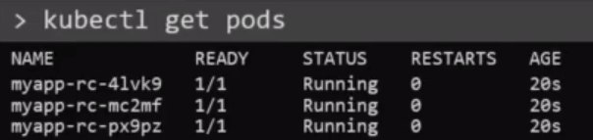

ReplicaSets: Are more or less like the replication controller.

The apiVersion: field must be apps/v1 if you add v1 you will have an error like this, v1 has no support for replica set.

There is a major difference between RC and RS, is the field selector

Selector section: Helps the RS to identify what pods fall under it. It is mandatory to include it.

Why to add the selector section: Because rs can also manage pods not created as part of the rs creation.

You can specify the selector in the replication controller but is not mandatory. In replica sets it is mandatory to include it.

Match Labels: Under selector we must specify the matchLabels: field
Matches the labels specified under it to the labels in the pod.
The replicaset selector also provides many other options for matching labels that were not available in the RC.

To create the replicaset:
kubectl create -f replicaset-definition.yaml

To see the replicasets:
kubectl get replicaset

Delete RS: kubectl delete replicaset myapp-replicaset → also deletes all underlying Pods

If you check the pods you will see that the name starts with the name of the replicaset + the random number.

Here a rs definition, notice the selector being a sibling of template and replicas.
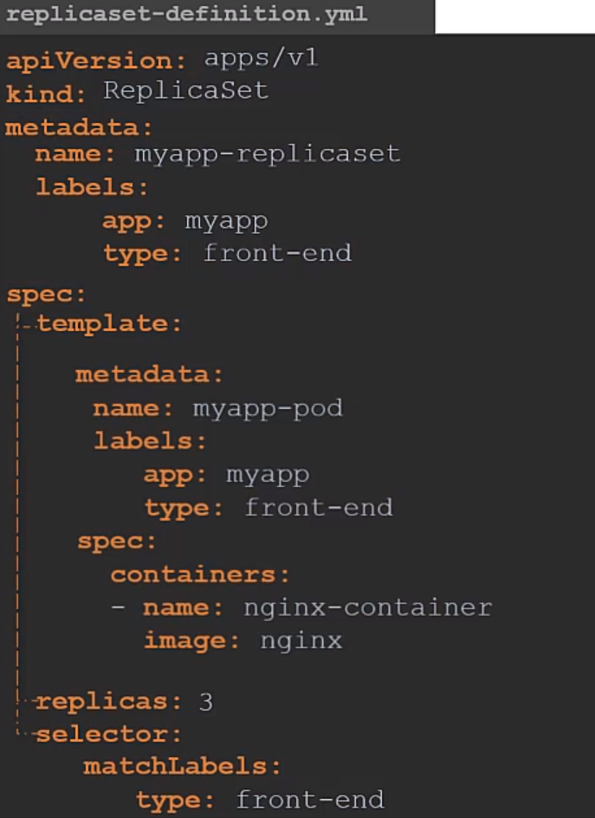

Labels and Selectors: You can use replica set to monitor already created pods, in case one fails the rs will replace it.

The role of the rs is to monitor the pods and if any of them fail deploy new ones. RS is in fact a process that monitors the pods.

How does the RS know what pods to monitor, there could be hundreds of pods in the cluster running different applications.

This is where labeling our pods during creation comes in handy. We can provide this labels as a filter for RS.

In the RS, under the selector section, we use the matchLabels filter and provide the same label that we used when creating the pod. This way the RS know which pods to monitor.
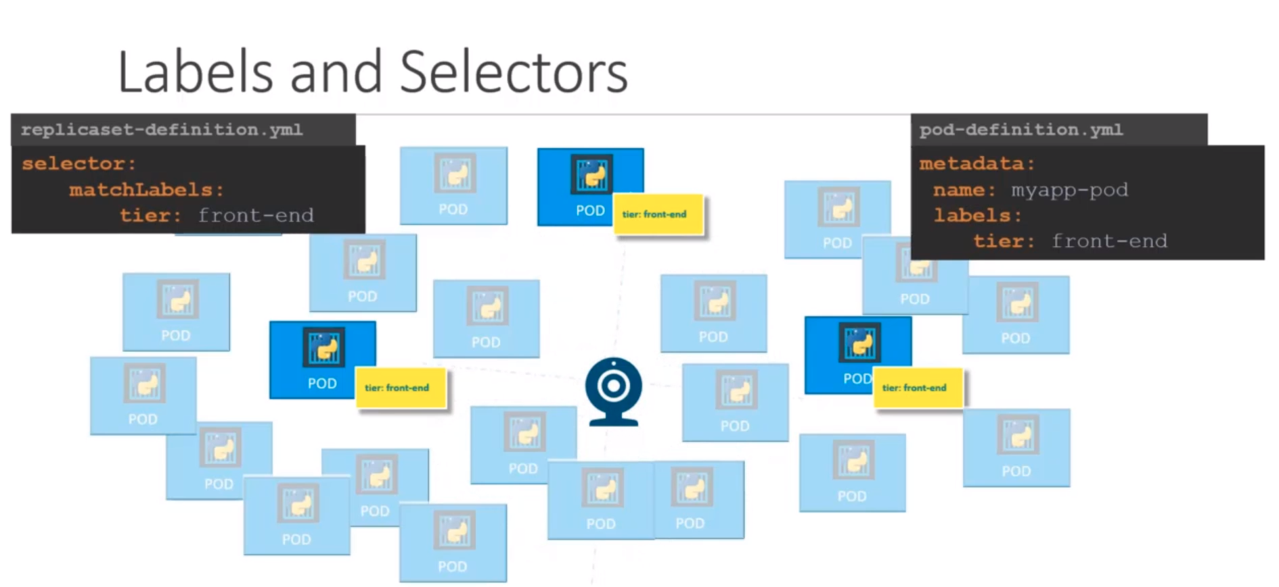
Scale Replica Set: There are different ways:
For instance we have 3 replicas and we want to scale to 6:

- Updating the replicas in the definition file: change in the yaml 3 for 6. Then run:
kubectl replace -f replicaset-definition.yaml

- Scale command over the .yaml:
kubectl scale --replicas=6 -f replicaset-definition.yaml

- Scale command directly into the process:
kubectl scale --replicas=6 replicaset (this is the type) myapp-replicaset (this is the name)
This option does not modify the .yaml, you will still have 3 replicas in the definition file.

- There are also options available to automatically scaling the RS based on load but this will be treated in the future.

