########## CKS, Certified Kubernetes Security: ###########

CKS Resources:
https://github.com/ibrahimjelliti/CKSS-Certified-Kubernetes-Security-Specialist?utm_sq=gl0fgi8ycl

CKS Cloud Native Security Tutorial
https://tutorial.kubernetes-security.info/

CKS exam version 1.23
Ubuntu version 20.04

PodSecurityPolicies were deprecated on 1.21 but still included in the exam curriculum.

Setting up a cluster:

Use 3 Medium cloud sandboxes in the cloud playground.

Change hostnames to:
k8s-control
k8s-worker1
k8s-worker2

Edit /etc/hosts, add the private ip and the hostname of each server:
172.31.46.162 k8s-control
172.31.35.178 k8s-worker1
172.31.47.219 k8s-worker2

CRI: Install containerd on all nodes

Add some modules: This will start the modules every time the server starts up.
cat << EOF | sudo tee /etc/modules-load.d/containerd.conf
overlay
br_netfilter
EOF

sudo modprobe overlay → will enable the module immediatelly without having to restart the server

sudo modprobe br_netfilter → will enable the module immediatelly without having to restart the server

cat <<EOF | sudo tee /etc/sysctl.d/99-kubernetes-cri.conf
net.bridge.bridge-nf-call-iptables = 1
net.ipv4.ip_forward = 1
net.bridge.bridge-nf-call-ip6tables = 1
EOF

sudo sysctl --system

sudo apt-get update && sudo apt-get install -y containerd

sudo mkdir -p /etc/containerd

sudo containerd config default | sudo tee /etc/containerd/config.toml

sudo systemctl restart containerd

Disable swap: On all nodes
sudo swapoff -a

Check /etc/fstab if there is a line that will start swap in the next restart, remove it if there is a line.

Install kubeadm, kubelet and kubectl: on all nodes.
sudo apt-get update && sudo apt-get install -y apt-transport-https curl

curl -s https://packages.cloud.google.com/apt/doc/apt-key.gpg | sudo apt-key add -

cat << EOF | sudo tee /etc/apt/sources.list.d/kubernetes.list
deb https://apt.kubernetes.io/ kubernetes-xenial main
EOF

sudo apt-get update

sudo apt-get install -y kubelet=1.23.0-00 kubeadm=1.23.0-00 kubectl=1.23.0-00

sudo apt-mark hold kubelet kubeadm kubectl

Run kubead init: Control plane only.
sudo kubeadm init --pod-network-cidr 192.168.0.0/16 --kubernetes-version 1.23.0

mkdir -p $HOME/.kube

sudo cp -i /etc/kubernetes/admin.conf $HOME/.kube/config

sudo chown $(id -u):$(id -g) $HOME/.kube/config

Verify the cluster is working: kubectl get nodes

Install CNI:
kubectl apply -f https://docs.projectcalico.org/manifests/calico.yaml

Get token to join workers: This is already in the output of the kubeadm init command.
kubeadm token create --print-join-command

Join the worker nodes: Paste the output of the previous command in the worker nodes as a SUDO.
sudo kubeadm join …

Check the nodes are ready:
k get nodes

K8s Security Overview:

K8s Security: Refers to the techniques and processes used to protect k8s clusters and the application and data housed within them.

Layered Security Model: Means that we are not assuming that any one security layer is going to work 100% of the time, and we are securing everyting possible.

Layer security model ocuses on making every component as secure as possible.

Even if an attacker manages to compromise some aspect of the system, they are limited in what they can do.

Layers:
- The Cluster: The k8s cluster itself and its components must be secured. If someone can control the cluster, they could gain control of applications.

- Host Systems: The host systems and infrastructure used to run the cluster could serve as an attack vector. Protect them.

- Applications: The containerized applications and code running in your cluster could be compromised and used to interact with other applications or cluster components.

- Supply Chain: Container images and other files used to deploy applications could be used by attackers.

- Everything: Attackers can be creative. If something can be compromised or used in an unexpected way, it probably will be.

If we focus on securing all these different layers we can severely limit what attackers can do and we are not relying on a single point of failure where if an attacker breaks through that single layer of security, they have access to everything.

########## Cluster Setup: ###########

Restricting Default Access with NetworkPolicies: NetworkPolicies allows you to prevent or restrict network communication to and from Pods.

They are like firewals within your k8s cluster network.

Default Deny: Network policy to block all traffic except for what is explicitly allowed.

If one pod is compromised, the attacker won’t be able to communicate with the other pods via the cluster network.

Example: Block all inbound and outbound traffic for the nptest namespace

apiVersion: networking.k8s.io/v1
kind: NetworkPolicy
metadata:
name: default-deny-ingress
namespace: nptest # We apply this netpol only to nptest namespace
spec:
podSelector: {} # Empty podselector,{} curly brakets means all the pods
policyTypes: in that namespace
- Ingress

Now traffic within the nptest ns is block, you will have a connection timeout error.

Exam Tips:

- Use default deny network policy to block all network traffic to and/or from Pods in a namespace.

- Use an empty podSelector: {} to make the policy apply to all Pods in the namespace.

- Use the policyTypes field to block incoming traffic (ingress), outgoing traffic (egress), or both.

Allowing Limited Access with NetworkPolicies:

Network policies do not conflict; they are additive. If any policy or policies select a pod, thepod is restristed to what is allowed by the union of those policies ingress/egress rules.

This means that if all the ingress/egress traffic is denied, if there is a netpol explicitly allowing traffic between two specific pods, this specific traffic will be allowed.
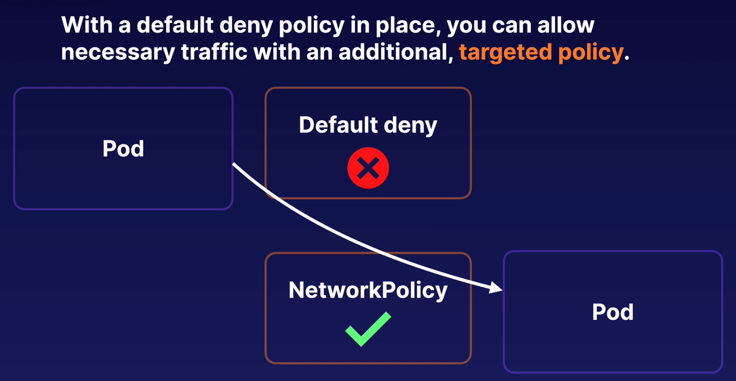
We can combine woth netpols, one denying all traffic and the targeted policy allowing specific traffic

spec.podSelector:
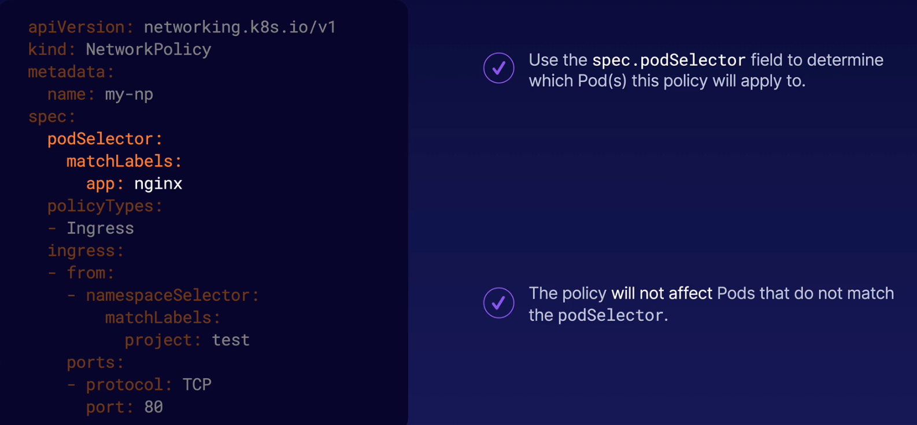
This network policy will be applied to all the pods that have the label app:nginx

Ingress / Egress Rules:
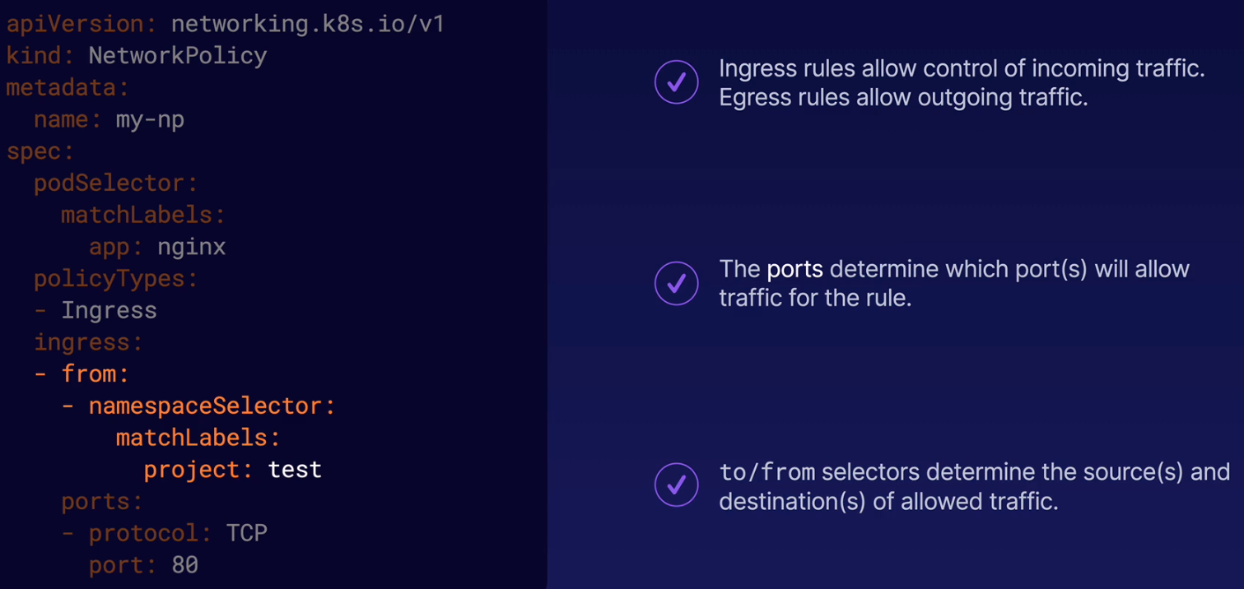
Variations: We use two selector to say which pods can connect us via the ingress rule.

First we check the namespace that have a label called project: test (we will add this label to the ns)
Second we check if the pod have a label called app: client

Both labels must match in the pod, if not you won’t be allowed to communicate with the pod with label app: nginx

- namespaceSelector:
matchLabels:
project: text
podSelector:
matchLabels:
app: client
Notice the difference if we add a hyphen to create another rule:

- namespaceSelector:
matchLabels:
project: text
- podSelector:
matchLabels:
app: client

Now we have two separate rules. With two arrays this says that if the pod is in the right namespace (namespaceSelector) the traffic is gonna be allowed even if the second rule (podSelector) is not matching.

And the opossite, if we match the podSelector the rule will be allowed even if the namespaceSelector is not matching.

Basically with two hyphens (two arrays) you are saying if this rule OR this rule is true, go ahead.

With one hyphen you are saying if this rule AND this rule are true go ahead.

Add a label to the NS:
kubectl label namespace nptest project=test

Create an Egress rule: With the ingress rule created earlier the traffic from the pods outside that match both labels (namespace and pod labels) won’t work yet.

We need to create an Egress rule to allow the traffic to go back to the external pod.

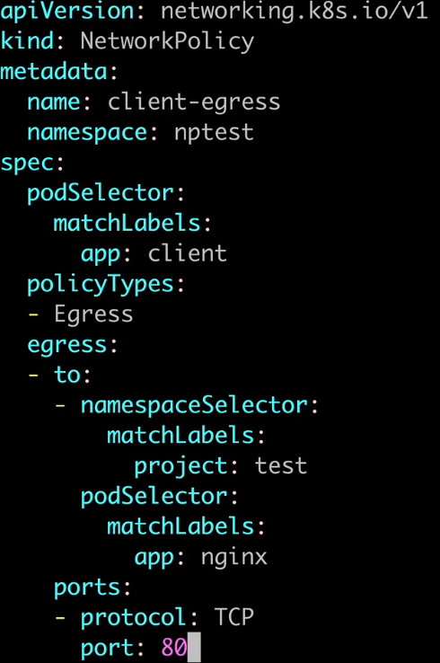
Now we use the podSelector to select the client pod, app: client

Policy type: egress

Allow to pods that have project: test label in the namespace and app: nginx label in the pod

This policy says:
In the namespace nptest, the pod with label app: client can send tcp traffic on the port 80 to pods with label project: test in the ns and the label app: nginx in the pod

Exam Tips:

- If any policy allows a particular type of traffic, it will be allowed. This means you can add targeted policies alongside a default policy to allow necessary traffic.

- You can use a policy’s podSelector to target the policy to specific Pod based upon their labels.

- You can use ingress/egress rules to specify Pods, namespaces, or IP addresses to allow traffic to and/or from.

- Pay attention to the difference between one rule with multiple selectors (one hyphen/array), and multiple rules (two or more hyphens/arrays)

