Repl.it

Run → Ctrl + Enter
Run → Command + Enter (Mac)

Askpython documentation

Comment / Uncomment a line:
Windows/linux: Ctrl + /
Mac: Command + /

Debug code online step by step
Or download the program Thonny

Day 1:

Input Function:

What is this: Input will get you what the user is typing in console.

input(promt for the user) → inside of parenthesys we have what is going to be printed in the screen and will wait till we type something:

input(“What is your name? ”) → if you execute this will wait till you type your name or whatever.

Then if you’ve typed “John” will be substituted and added into it like: input(“John ”)

So input(“What is your name? ”) will be replaced by what you typed.

If you run the program and type John:
What is your name? John

input(“What is your name? ”) will be replaced by John.

You can print John if you do this:
print("Hello " + input("What is your name: "))

You will get:
What is your name: John
Hello John

Exercise 1.3:

Ask me to type my name and the program will tell you how much letters the name have:

Option 1, One line:
print(len(input("What is your name? ")))

Option 2, two lines:
name = input("What is your name? ")
print(len(name))

Python Variables:

Using the previous exercise:
print(len(input("What is your name? ")))

We can use variables like this:

name = input("What is your name? ")
length = len(name)

print(length)

Exercise 1.4:
Switch values of variables.
Give to variable A, the value of variable B and viceversa.

My solution:  a = input("a: ")  b = input("b: ")  cafe = a  milk = b  a = milk  b = cafe  print("a: " + a)  print("b: " + b) | Teacher’s solution:  a = input("a: ")  b = input("b: ")  a = c  a = b  b = c  print("a: " + a)  print("b: " + b)
Result:  a: AAAAA  b: BBBBB  a: BBBBB  b: AAAAA | Result:  a: AAAAA  b: BBBBB  a: BBBBB  b: AAAAA

Variable names:
length1 = 10 → good
1length = 10 → not allowed to start variable names with numbers

user_name = “John” → good
user name = “John” → not allowed, the variable name have to be a single item without spaces.

Is not recommended to use function names as variable names, like print, len or so.

Final project: https://repl.it/@appbrewery/band-name-generator-start#main.py

Exercise:

#1. Create a greeting for your program.

#2. Ask the user for the city that they grew up in.

#3. Ask the user for the name of a pet.

#4. Combine the name of their city and pet and show them their band name.

#5. Make sure the input cursor shows on a new line, see the example at:
# https://band-name-generator-end.appbrewery.repl.run/

My solution:  print("This program creates a band name:")  print("---------------------------------")  city = input("In which city did you grew up? ")  pet = input("Tell me the name of your pet ")  space = " "  print( city + space + pet ) | Teacher’s solution:  print("Welcome to the band name generator.")  city = input("Which city did you grow up in?\n")  pet = input("What is the name of a pet?\n")  print("Your band name cound be: " + city + " " + pet)
Result:  This program creates a band name:  ---------------------------------  In which city did you grew up? Figueres  Tell me the name of your pet Boris  Figueres Boris | Result:  Welcome to the band name generator.  Which city did you grow up in?  Bristol  What is the name of a pet?  Rabbit  Your band name cound be: Bristol Rabbit

Day 2:

Data Types:

String:

“ ” → Anything between quotes or double quotes will be trated as a string (text).
“1234” → this will be treated as a string.

print(“Hello” [4] ) → this will print the last character, o

print("123" + "456") → this will give you: 123456

Integer:

print(123 + 456) → 579

Tip: Use underscore (_) to write large integer numbers and to split them in order to make it easy to visualize:

123_123_3534 → will be interpreted like this: 1231233534

Float:

3.23423
242343.640

Boolean:
True
False

Both starting with Capitals and without quotation marks, otherwhise it would turn them into strings.

Function Types:

type() → it gives you the type of data.

Example:
num_char = len(input("What is your name? ")) → num_char is an integer

print("Your name has " + num_char + "characters.") → this gives error because you can NOT add
strings + integers, only the same data type.

To know the type of the data you are using, use the type() function.
print(type(num_char)) → <class ‘int’>
Convert a data type to a string:

You can use the type function to investigate which data type you are using.
With type function you can CONVERT one datatype to another.

To make work the previous exercise convert the integer to string:

num_char = len(input("What is your name? "))

new_num_char = str(num_char)

print("Your name has " + new_num_char + " characters.")

We convert the variable num_char to a string and we give it a new name, now the program will work because the whole print statement is adding strings:

What is your name? sfgsdfgsfgsfgs
Your name has 14 characters.

Exercise 2.1:

Type two numbers and add them, so 23 will be 2 + 3 = 5

My solution:  two_digit_number = input("Type a two digit number: ")  first = int(two_digit_number[0])  second = int(two_digit_number[1])  print(first + second) | Teacher’s solution:  two_digit_number = input("Type a two digit number: ")  first_digit = two_digit_number[0]  second_digit = two_digit_number[0]  result = int(first_digit) + int(second_digit)  print(result)
Result:  Type a two digit number: 23  5 | Result:  Type a two digit number: 87  15

Teacher’s explanation:

First we have to know which is the data type of the variable two_digit_number
print(type(two_digit_number)) → which is a <class ‘str’>

Mathematical Operations in Python:

3 + 4
5 - 2
3 * 7
6 / 3 → the result will be a float, 2.0 in this examples
** exponent, when you want to raise a number to a power
2 ** 3 → two 3 times is 8. 2 * 2 * 2 = 8

Order of the operations:

If you have different operations in the same line of code, there is an order that the program will follow.

The rule to remember is PEMDAS:
- Parentheses ()
- Exponents **
- Multiplication * and Division / → they are equal important. First coming wins
- Addition + and Substraction - → they are equal important. First coming wins

Example:
print( 3 * 3 + 3 / 3 - 3)

First will do the mutiplication, 3 * 3 = 9 →is first because is the first operation on the left.
Second the division, 3 /3 = 1.0 → float, ran the second after the multiplication because comes after.
Third the addition, 9 + 1.0 = 10.0
Last the substraction, 10.0 - 3 = 7.0

Example 2: Make that operation to have 3 as result
print( 3 * (3 + 3) / 3 - 3)

First the parenthesy, 3 + 3 = 6
Second the multiplication because is the first on the left, 3 * 6 = 18
Third de division, 18 / 6 = 6
Last the substraction, 6 - 3 = 3

[Interactive Coding Exercise] BMI Calculator:

Exercise 2.2:

Calculate the BMI, Body Mass Index.
Weight in kilograms divided by height in meters squared

My solution:  height = input("enter your height in m: ")  weight = input("enter your weight in kg: ")  height = float(height)  weight = float(weight)  print(int(height / (weight * weight ))) | Teacher’s solution:  height = input("enter your height in m: ")  weight = input("enter your weight in kg: ")  bmi = int(weight) / float(height) ** 2  bmi_as_int = int(bmi)  print(bmi_as_int)
Result:  enter your weight in kg: 80  enter your height in m: 1.75  26 | Result:  enter your weight in kg: 80  enter your height in m: 1.75  26

Number Manipulation and F Strings in Python:

Round the number:
If you are dividing a number it will give you a float.

You can limit the decimals appearing on the right after the colon by using round.

Example:

print(8 / 3) → 2.6666666666666665

print(round(8 / 3)) → 3

print(round(8 / 3, 2)) → 2.67

print(round(2.6666666, 2)) → 2.67

Use the floor edition:

print(8 / 3) → 2.6666666666666665 → float number

print(8 // 3) → 2 → int number

Using variables:

result = 4/2 → 2
result *= 3 → 2 x 3
print(result) → 6

score = 0
score += 1
print(score) → 1

Change datatypes: f-String

We can not use different datatypes to operate in the same line, if you use a string + int the program will fail.

To make it work until now we are converting the data, to str in the below example:
score = 0
print("Your score is: " + str(score))

But we can use f-String to make it much more easy:

score = 0
height = 1.8
isWinning = True

print(f"Your score is {score}, your height is {height}, you are winning is {isWinning} ")

→ Your score is 0, your height is 1.8, you are winning is True

We are calling the variables with {}

Exercise:

If you live 90 years you will have 32850 days, 4680 weeks and 1080 months.

Calculate how much time will be using you age as a reference and comparing it with 90 years.

Ask for your age and do the math:
days = age - 90 * 365
weeks = age - 90 * 52
months = age - 90 * 12

My solution:  age = input("What is your current age? ")  age = int(age)  days = (90 - age) * 365  weeks = (90 - age) * 52  months = (90 - age) * 12  print(f"You have {days} days, {weeks} weeks, and {months} months left.") | Teacher’s solution:  age = input("What is your current age? ")  age_as_int = int(age)  years_remaining = 90 - age_as_int  days_remaining = years_remaining * 365  weeks_remaining = years_remaining * 52  months_remaining = years_remaining * 12  message = f"You have {days_remaining} days, {weeks_remaining} weeks, and {months_remaining} months left."  print(message)
Result:  What is your current age? 40  You have 18250 days, 2600 weeks, and 600 months left. | Result:  What is your current age? 40  You have 18250 days, 2600 weeks, and 600 months left.

Variation after cheking teacher’s example:

age = input("What is your current age? ")

age = 90 - int(age)

days = age * 365
weeks = age * 52
months = age * 12

print(f"You have {days} days, {weeks} weeks, and {months} months left.")

Tip Calculator:

My solution:  print("Welcome to the tip calculator")  print("")  bill = int(input("What was the total bill? $"))  percent = int(input("How much tip would you like to give? 10, 12, or 15? "))  people = int(input("How many people to split the bill? "))  percent_correct = percent / 100  percent_bill = bill * percent_correct  total = bill + percent_bill  result = total / people  print(f"Each person should pay: ${result}") | Teacher’s solution:  print("Welcome to the tip calculator")  bill = float(input("What was the total bill? $"))  tip = int(input("How much tip would you like to give? 10, 12, or 15? "))  people = int(input("How many people to split the bill?"))  tip_as_percent = tip / 100  total_tip_amount = bill * tip_as_percent  total_bill = bill + total_tip_amount  bill_per_person = total_bill / people  final_amount = round(bill_per_person, 2)  print(f"Each person should pay: ${final_amount}")
Result:  Welcome to the tip calculator  What was the total bill? $150  How much tip would you like to give? 10, 12, or 15? 12  How many people to split the bill? 5  Each person should pay: $33.6 | Result:  Welcome to the tip calculator  What was the total bill? $100  How much tip would you like to give? 10, 12, or 15? 10  How many people to split the bill?5  Each person should pay: $22.0

Another approach from the teacher:

bill = float(input("What was the total bill? $"))
tip = int(input("How much tip would you like to give? 10, 12, or 15? "))
people = int(input("How many people to split the bill? "))

bill_with_tip = bill * (1 + tip /100) → we simplify in one line three operations
bill_per_person = bill_with_tip / people
final_amount = round(bill_per_person, 2)

print(f"Each person should pay: ${final_amount}")

Another approach from the teacher: To show two decimals allways.

bill = float(input("What was the total bill? $"))
tip = int(input("How much tip would you like to give? 10, 12, or 15? "))
people = int(input("How many people to split the bill?"))

tip_as_percent = tip / 100
total_tip_amount = bill * tip_as_percent
total_bill = bill + total_tip_amount
bill_per_person = total_bill / people
final_amount = round(bill_per_person, 2)
final_amount = “{:.2f}”.format(bill_per_person) → this will show allways two decimal digits. *

print(f"Each person should pay: ${final_amount}")

* Depence on the amount of the bill the result will show only one decimal digit, like:
bill = 150
tip = 12
people = 5

final_amount = 33.6

But the prices have to show two decimal digits.
To always show two digits we can use the format function.

final_amount = “{:.2f}”.format(bill_per_person)

Day 3: Control Flow and Logical Operators:

01/26/2021

Flow control with if/else statements.

Flow control diagram example:

If you are taller than 120 cm you can ride the rollercoaster
If (else) you are shorter than 120 cm you can NOT ride it.
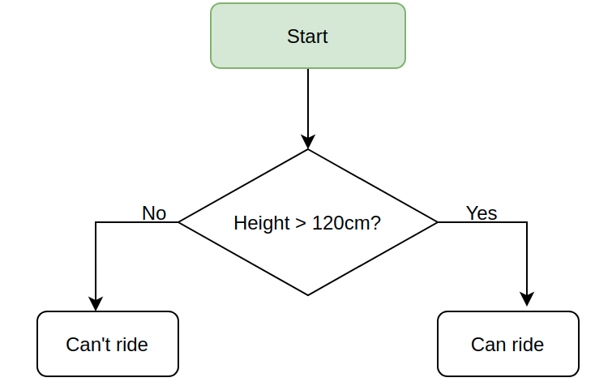

Exercise:

If you are taller or equal to 120 you can ride:

print("Welcome to the rollercoaster!")

height = int(input("What is your height in cm? "))

if height >= 120:
print("You can ride the rollercoaster!")

else:
print("Sorry, you have to grow taller before you can ride.")

Comarison Operators:
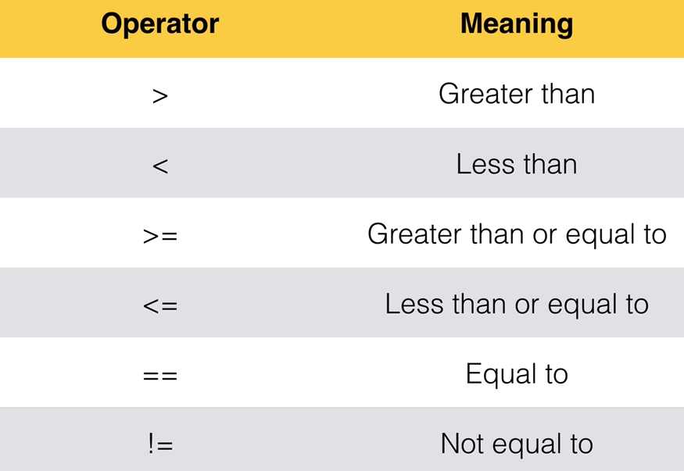

Odd or Even? Introducing the Modulo

Modulo: → %
Will divide a number by another number and will give you the remainder of that division.

You can use modulo to know if a number is even or odd.

If the division of a number by another gives you a reminder, like 14 /4 = 3,5 you will know that the number is odd because will give you a reminder, ,5 in this example.

Example: 7 % 2

Seven split into portions of 2 is:
2 + 2 + 2 + 1

Seven divided by 2 can be divided 3 times (2 + 2 + 2) with a reminder of 1.

1 is what the modulo gives you.

If you run 7 % 2 in the console gives you 1:
7 % 2 = 1

Example 2: 7 % 3

3 + 3 + 1
7 % 3 = 1

Example 3: 14 % 4 (14 /4 = 3,5)

4 + 4 + 4 + 2
14 % 4 = 2

Exercise:

Tell me if the introduced number is odd or even

My solution:  number = int(input("Which number do you want to check? "))  odd_even = number % 2  if odd_even == 0:  print("This is an even number.")  else:  print("This is an odd number.") | Teacher’s solution:  number = int(input("Which number do you want to check? "))  if number % 2 == 0:  print("This is an even number.")  else:  print("This is an odd number.")
Result:  Which number do you want to check? 23452451  This is an odd number. | Result:  Which number do you want to check? 2342342423  This is an odd number.

Nested if statements and elif statements:

Nested If/Else statements:

Following the height example, if you are 120 cm or higher you can use the rollercoaster, if not (else) you can NOT.

Now if you are 120 or higher and you have 18 ages or more you will pay $12. If you are under 18 ages you will pay $7.

We will use nested if/else statements:

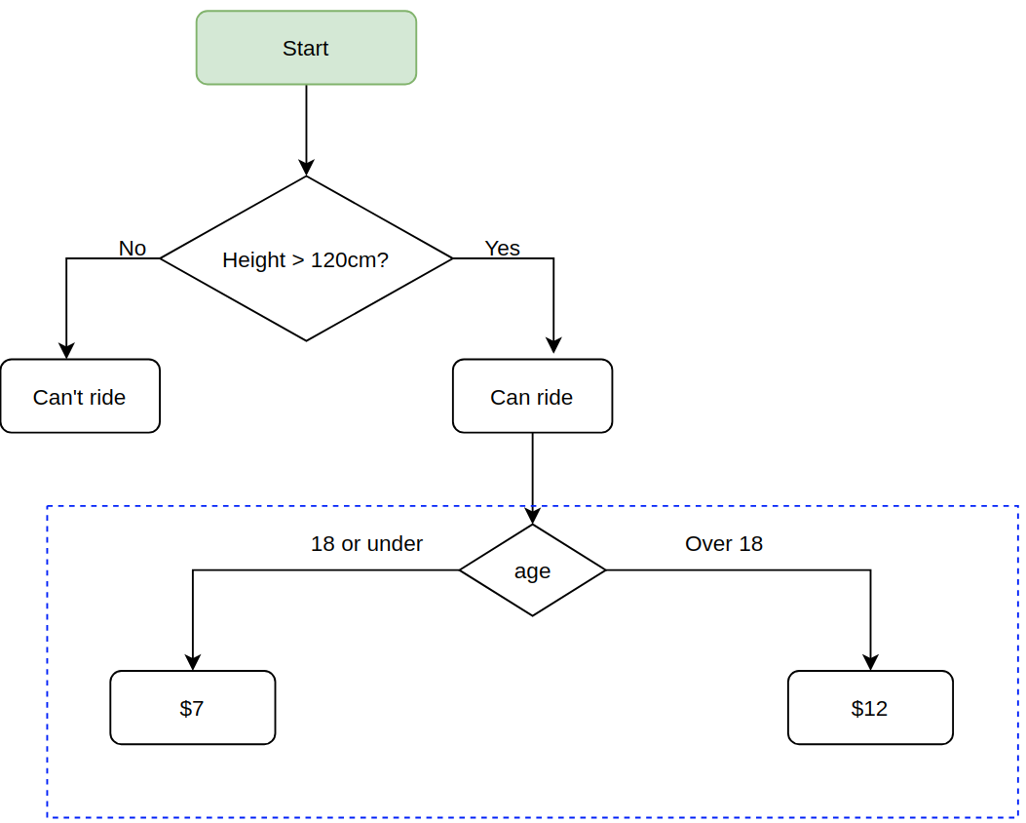
height = int(input("Tell me your heigh in cm: "))

if height >= 120:
print("You can ride the rollercoaster")
age = int(input("What is your age: "))
if age >= 18:
print("Please pay $12")
else:
print("Please pay $7")

else:
print("Sorry, you have to grow taller.")

If / elif /else:

If condition 1 is true do A
If 1 is not true check if condition 2 is true and if so do B

Finally, if none of the conditions are true do the ELSE
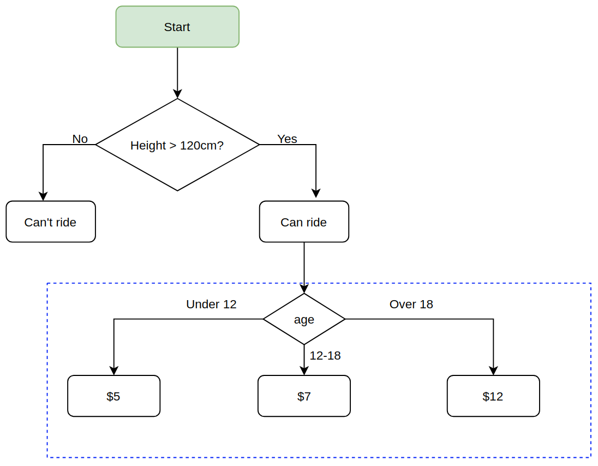
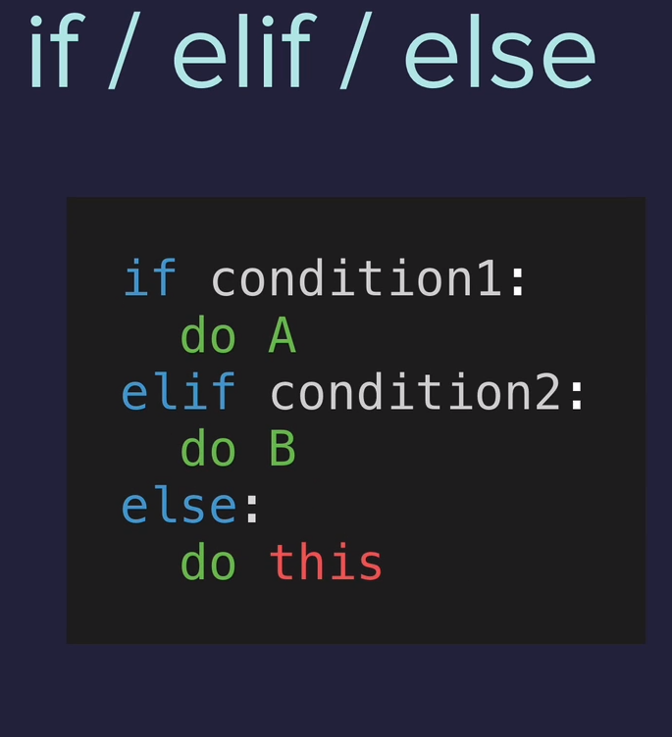

Now we will check if you have the correct height. If you are under 120 cm, game over.

If you have the correct height you have to tell us your age:

If you are 18 or over you have to pay $12
If you are between 12 and 18 you have to pay $7

And if you are not matching any of the above ages you have to pay $5.

height = int(input("Tell me your heigh in cm: "))

if height >= 120:
print("You can ride the rollercoaster")
age = int(input("What is your age: "))
if age < 12:
print("Please pay $5")
elif age >= 18:
print("Please pay $12")
else:
print("Please pay $7 ")

else:
print("Sorry, you have to grow taller.")

Exercise3.2 BMI Calculator 2

Ask for your height and weight.

If you are :
Under 18.5 they are underweight
Over 18.5 but below 25 they have a normal weight
Over 25 but below 30 they are slightly overweight
Over 30 but below 35 they are obese
Above 35 they are clinically obese.

Print the message in the solution highligting the medical condition.

My solution:  height = float(input("enter your height in m: "))  weight = float(input("enter your weight in kg: "))  bmi = round(weight / (height ** 2))  start = "\033[1m"  end = "\033[0;0m"  if bmi < 18.5:  print(f"Your BMI is {bmi},{start} you are underweight.{end}")  elif bmi >= 18.5:  if bmi < 25:  print(f"Your BMI is {bmi},{start} you have a {start}normal weight.{end}")  elif bmi > 25:  if bmi < 30:  print(f"Your BMI is {bmi}, you are {start}slightly. overweight.{end}")  elif bmi > 30:  if bmi <= 35:  print(f"Your BMI is {bmi}, you are {start}obese.{end}")  else:  print(f"Your BMI is {bmi}, you are {start}clinically obese.{end}") | Teacher’s solution:  height = float(input("enter your height in m: "))  weight = float(input("enter your weight in kg: "))  bmi = round(weight / (height ** 2))  if bmi < 18.5:  print(f"Your BMI is {bmi}, you are underweight.")  elif bmi < 25:  print(f"Your BMI is {bmi}, you are normal weight.")  elif bmi < 30:  print(f"Your BMI is {bmi}, you are overweight.")  elif bmi < 35:  print(f"Your BMI is {bmi}, you are obese.")  else:  print(f"Your BMI is {bmi}, you are clinically obese.")
Result:  enter your height in m: 1.7  enter your weight in kg: 70  Your BMI is 24, you have a normal weight. | Result:

Exercise 3.3

Type a year and tell me if it is a leap year or not, follow this rule:
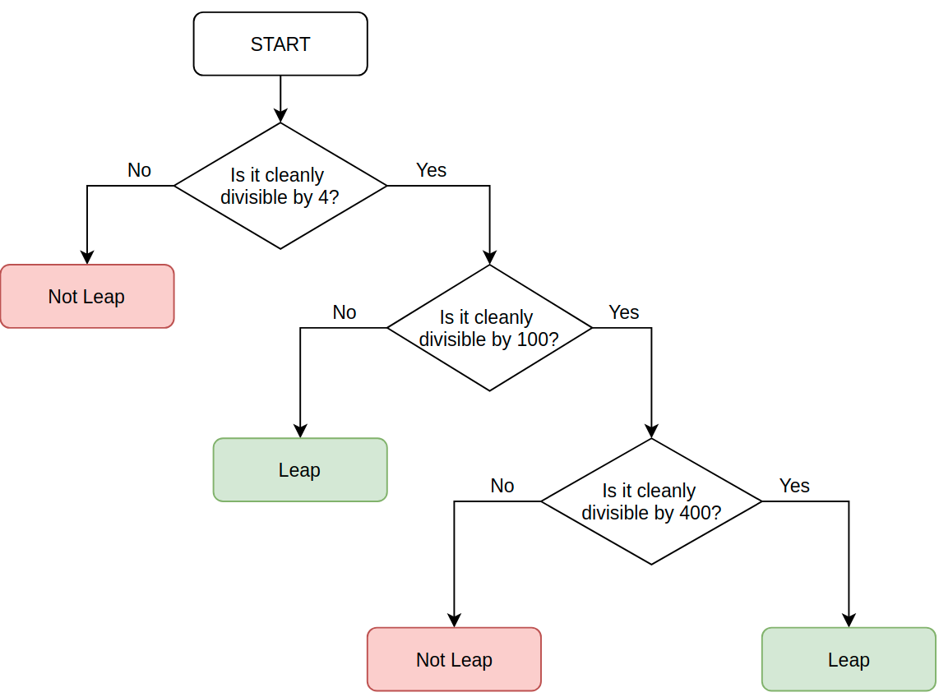
Example:
2000 ÷ 4 = 500 (Leap)
2000 ÷ 100 = 20 (Not Leap)
2000 ÷ 400 = 5 (Leap!)
-----
2100 ÷ 4 = 525 (Leap)
2100 ÷ 100 = 21 (Not Leap)
2100 ÷ 400 = 5.25 (Not Leap)

My solution:  year = int(input("Which year do you want to check? "))  year_4 = year % 4  year_100 = year % 100  year_400 = year % 400  if year_4 == 0 :  if year_100 == 0:  if year_400 == 0:  print("Leap year.")  else:  print("Not leap year.") | Teacher’s solution:  year = int(input("Which year do you want to check? "))  if year % 4 == 0:  if year % 100 == 0:  if year % 400 == 0:  print("Leap year.")  else:  print("Not leap year.")  else:  print("Leap year.")  else:  print("Not leap year.")
Result:  Which year do you want to check? 2002  Not leap year.  ---  Which year do you want to check? 2000  Leap year. | Result:  Which year do you want to check? 2002  Not leap year.  ---  Which year do you want to check? 2000  Leap year.

Multiple If Statements in Succession:

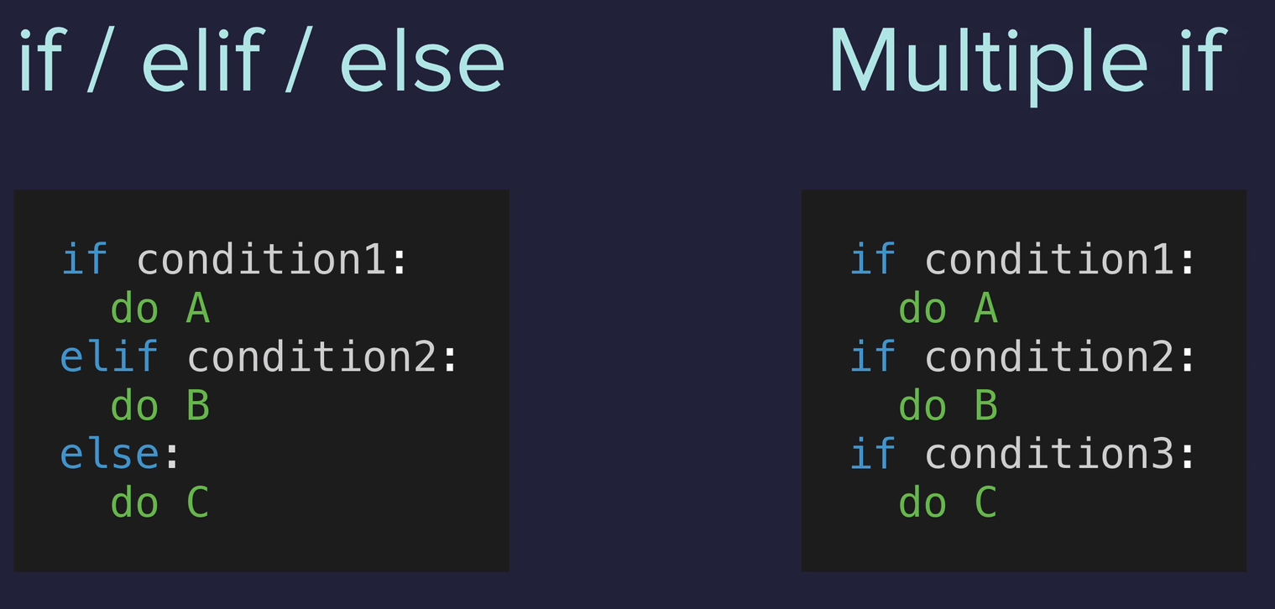

Until now with if / elif /else only one of the conditions will be executed.
But with Multiple if all will be executed if all of them are true.
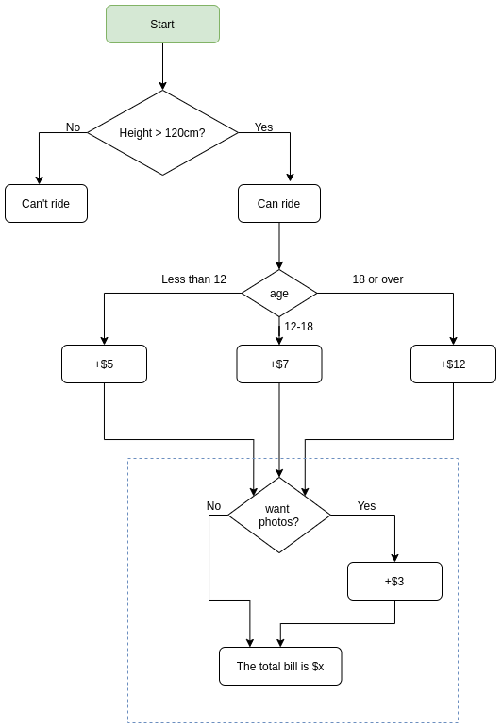
Using the previous rollercoaster code:

height = int(input("Tell me your heigh in cm: "))

if height >= 120:
print("You can ride the rollercoaster")
age = int(input("What is your age: "))
if age < 12:
print("Please pay $5")
elif age >= 18:
print("Please pay $12")
else:
print("Please pay $7 ")

else:
print("Sorry, you have to grow taller.")

Add into it the option to pay for the photo taken or not and if so add $3 to the final bill:

height = int(input("Tell me your heigh in cm: "))

bill = 0

if height >= 120:
print("You can ride the rollercoaster")

age = int(input("What is your age: "))
if age < 12:
print("Child tickets are $5")
bill = 5
elif age >= 18:
print("Adult tickets are $12")
bill = 12
else:
print("Youth tickets are $7 ")
bill = 7
photo = (input("Do you want the photo taken? Y or N: "))
if photo == "Y":
bill += 3
print(f"Your final bill is ${bill}")
else:
print("Sorry, you have to grow taller.")

Exercise 3.4: Ordering pizza.

Ask for the size, S ($15), M ($20) or L ($25)
Ask if you whant to add extra peperoni: + $2 for S and + $3 for M and L
Ask if you want extra cheese: +$1 to all sizes.

My solution:  print("Welcome to Python Pizza Delivieries!\n")  pizza = input("What size pizza do you want? S, M or L: ")  bill = 0  if pizza == "S":  bill += 15  if pizza == "M":  bill += 20  if pizza == "L":  bill += 25  peperoni = input("Do you want peperoni? Y or N: ")  if peperoni == "Y":  if pizza == "S":  bill += 2  if pizza == "M" or pizza == "L":  bill += 3  cheese = input("Do you want extra cheese? Y or N: ")  if cheese == "Y":  bill += 1  print(f"Your bill is ${bill}") | Teacher’s solution:  print("Welcome to Python Pizza Deliveries!")  size = input("What size pizza do you want? S, M, or L ")  add_pepperoni = input("Do you want pepperoni? Y or N ")  extra_cheese = input("Do you want extra cheese? Y or N ")  bill = 0  if size == "S":  bill += 15  elif size == "M":  bill += 20  else:  bill += 25  if add_pepperoni == "Y":  if size == "S":  bill += 2  else:  bill += 3  if extra_cheese == "Y":  bill += 1  print(f"Your final bill is: ${bill}.")
Result:  Welcome to Python Pizza Delivieries!  What size pizza do you want? S, M or L: L  Do you want peperoni? Y or N: Y  Do you want cheese? Y or N: Y  Your bill is $29 | Result:  Welcome to Python Pizza Deliveries!  What size pizza do you want? S, M, or L M  Do you want pepperoni? Y or N Y  Do you want extra cheese? Y or N Y  Your final bill is: $24.

Logical Operators:

AND: Both have to be true → a AND b. If one of the is false then the result is false.
a = 12
a > 15 → false
a > 10 → true
a > 10 and a < 13 → true

OR: If one or both are true, the it’s true. Only when both are false will be evaluate to false.

NOT: Reverses the conditon. If the condition is false then becames true and if is true becames false.
a = 12
a > 15 → false
not a > 15 → true ,is reversing it.

Roller coaster exercise:
Add the ages between 45 and 55. If you age is equal or higher than 45 or equal or lower than 55 then the condition will evaluate to true.

height = int(input("Tell me your heigh in cm: "))

bill = 0

if height >= 120:
print("You can ride the rollercoaster")

age = int(input("What is your age: "))
if age < 12:
print("Child tickets are $5")
bill = 5
elif age >= 45 or age >= 55:
bill += 0
elif age >= 18:
print("Adult tickets are $12")
bill = 12
else:
print("Youth tickets are $7 ")
bill = 7
photo = (input("Do you want the photo taken? Y or N: "))
if photo == "Y":
bill += 3
print(f"Your final bill is ${bill}")
else:
print("Sorry, you have to grow taller.")

Love calculator, Day 3.5

My solution:  print("Welcome to the Love Calculator!")  name1 = input("What is your name? \n")  name2 = input("What is their name? \n")  # Convert the names to lowercase  name1 = name1.lower()  name2 = name2.lower()  # See name1 match with leters on "true"  name_t = name1.count("t")  name_r = name1.count("r")  name_u = name1.count("u")  name_e = name1.count("e")  # Sum up all name1 variables  name1 = name_t + name_r + name_u + name_e  # Convert name1 into a string for later concatenation  name1 = str(name1)  # See name2 match with leters on "love"  name_l = name2.count("l")  name_o = name2.count("o")  name_v = name2.count("v")  name_e = name2.count("e")  # Sum up all name2 variables  name2 = name_l + name_o + name_v+ name_e  # Convert name2 into a string for later concatenation  name2 = str(name2)  # Store its values in the variable  both = name1 + name2  # Convert both to int  both_int = int(both)  # If/elif/else statement  if both_int <10 or both_int <90:  print(f"Your score is {both_int}, you go together like coke and mentos.")  elif both_int >=40 and both_int <=50:  print(f"Your score is {both_int}, you are alright together.")  else:  print(f"Your score is {both_int}") | Teacher’s solution:  print("Welcome to the Love Calculator!")  name1 = input("What is your name? \n")  name2 = input("What is their name? \n")  combined_names = name1 + name2  lower_names = combined_names.lower()  t = lower_names.count("t")  r = lower_names.count("r")  u = lower_names.count("u")  e = lower_names.count("e")  first_digit = t + r + u + e  l = lower_names.count("l")  o = lower_names.count("o")  v = lower_names.count("v")  e = lower_names.count("e")  second_digit = l + o + v + e  score = int(str(first_digit) + str(second_digit))  if (score < 10) or (score > 90):  print(f"Your score is {score}, you go together like coke and mentos.")  elif (score >= 40) and (score <= 50):  print(f"Your score is {score}, you are alright together.")  else:  print(f"Your score is {score}.")
Result:  Welcome to the Love Calculator!  What is your name?  otto eastr  What is their name?  Paco Alves  Your score is 54, you go together like coke and mentos. | Result:  Welcome to the Love Calculator!  What is your name?  otto eastr  What is their name?  Paco Alves  Your score is 67.

Explanation:

Type two names, with surnames if you want.

Concatenate them to form a single line and make it lowercase.

Check how much times are appearing the same leters inside the single line and in the word “true” and the word “love”

Sum up the matches for true and store its value in a variable, can call it first_digit
Do the same for love and store it in second_digit. Both variables are integers

Concatenate both variables in order to store its value in a new variable called “score”
You have to convert the to variables to a string then sum up, then convert to integer:
int(str(first_digit) + str(second_digit))

Lastly use an if/elif/else statement to show results depending on the conditions we want.

What I did:
I’ve followed the same logic, except that I’ve missunderstood the exercise a little bit.

Instead of adding the first name and second name all toguether and then sum them up, I did it separatelly, name1 has been only calculated with “true” and name2 has been only calculated with “love”.

Day 3 Project: Treasure Island

ASCII Art

Create multiple lines of a string:

print('''
ASCII code here
more ASCII here
''')

My solution:  [ASCII Code]  print("Welcome to Treasure Island.")  print("Your mission is to find the treasure.")  crossroad = input('You\'re at a cross road. Where do you want to go? Type "left" or "right"\n')  if crossroad == "left":  lake = input('"You\'ve come to a lake. There is an island in the middle of the lake. Type "wait" to wait for a boat. Type "swim" to swim across.\n ')  # Lake  if lake == "wait":  door = input('You arrive at the island unharmed. There is a house with 3 doors. One red, one yellow and one blue. Which colour do you choose?\n ')  # Door  if door == "yellow":  print("You found the treasure! You Win!")  elif door == "red":  print("It's a room full of fire. Game Over.")  elif door == "blue":  print("You enter a room of beasts. Game Over.")  else:  print("You chose a door that doesn't exist. Game Over.")  else:  print("You get attacked by an angry trout. Game Over.")  else:  print("You fell into a hole. Game Over.") | Teacher’s solution:  print("Welcome to Treasure Island.")  print("Your mission is to find the treasure.")  choice1 = input('You\'re at a cross road. Where do you want to go? Type "left" or "right" \n').lower()  if choice1 == "left":  choice2 = input('You\'ve come to a lake. There is an island in the middle of the lake. Type "wait" to wait for a boat. Type "swim" to swim across. \n').lower()  if choice2 == "wait":  choice3 = input("You arrive at the island unharmed. There is a house with 3 doors. One red, one yellow and one blue. Which colour do you choose? \n").lower()  if choice3 == "red":  print("It's a room full of fire. Game Over.")  elif choice3 == "yellow":  print("You found the treasure! You Win!")  elif choice3 == "blue":  print("You enter a room of beasts. Game Over.")  else:  print("You chose a door that doesn't exist. Game Over.")  else:  print("You get attacked by an angry trout. Game Over.")  else:  print("You fell into a hole. Game Over.")
Result:  [ASCII Code]  Welcome to Treasure Island.  Your mission is to find the treasure.  You're at a cross road. Where do you want to go? Type "left" or "right"  left  "You've come to a lake. There is an island in the middle of the lake. Type "wait" to wait for a boat. Type "swim" to swim across.  wait  You arrive at the island unharmed. There is a house with 3 doors. One red, one yellow and one blue. Which colour do you choose?  yellow  You found the treasure! You Win! | Result:  the same than me.

The teacher have added a .lower() function to avoid capital letters. b

Day 4: Randomization and Python Lists:

Module: If you write your code all in the same page sometimes the code can be so long that will be very complicated to read and understand it.

We can split the code up into individual modules, where each module is responsible for different bit of functionality of your program.

If you have a project with many modules you can have colaboration, like when you build a car that you have several people working in different things of that car and not a single person doing everything.

Location of the modules:
They are stored in /usr/lib/python3.7/ in your local machine when you install Python

Import a module:
import random → importing the random module, now we will be able to use it in our code.

Random module: you can use it to create random things, like int, float, str, etc, example:

import random

random_integer = random.randint(1, 10)
print(random_integer)

Will print randomly one number between 1 and 10, both included.

randint →is a function used to randomize integers

Create and use your own module:
Until now we are using a single python file to run our programs.

In your python gui, like replit, you will see the file main.py. You can create a new file and name it: my_module.py, then add this into it:

pi = 3.141559246

Now you can use the new module just by importing it, in this case in main.py

import random
import my_module

#random_integer = random.randint(1, 10)
#print(random_integer)

print(my_module.py)

Random Float:
random.random() →Returns a float random number between 0.0 and 1.0 (1.0 is not included, the last one will be 0.99999999)

Example float random number: 0.3453453453

Exercise: Obtain a random float number between 0 and 5

My solution:  import random  random_float = random.uniform(0,5)  print(random_float) | Teacher’s solution:  import random  random_float = random.random()  random_float *= 5  print(random_float)
Result:  1.3703994497919314 | Result:  4.074776346266939

Exercise: Create a coin toss that will randomly tell you Heads or Tails.

My solution:  import random  random_thing = random.randint(0,1)  if random_thing == 0:  print("Tails")  else:  print("Head") | Teacher’s solution:  import random  random_side = random.randint(0, 1)  if random_side == 1:  print("Heads")  else:  print("Tails")
Result:  Head | Result:  Tails

Python Lists: [item1, item2]
Lists options

Data Structure: Way to store and organizing data in python.

Till now we were storing single variables, like: price = 100 , or high = 1,80

To store things like all the states of US you can have them all toghether in a variable called:
states_us.

In other cases you want to have order in the data structure, like people doing a queue, you want to know who is first, second, last, etc.

This is why we are using lists.

List are coming between square brakets: fruits = [item1, item2]
For strings use “” “” → fruits = [“apple”, “banana”, “orange”]
Before knowing lists: Using the US states as example
state1 = “Delaware”
state2 = “Pennsylvania”
etc,
etc,

With Lists:
states_of_america = [ “Delaware”, “Pennsylvania”, “item1”, “item2”, “item3”, etc ]

Lists benefits:
- You can use lists to store many peaces of related data.

- Also have an order, determined by the order on the list. When stored inside a variable, that order is not lost and you can use it later on when you need it.

Exercise: Print the name of one state inside the list

states_of_america = ["Alaska", "Alabama", "Arkansas", "American Samoa", "Arizona", "California", "Colorado", "Connecticut", "District ", "of Columbia", "Delaware", "Florida", "Georgia", "Guam", "Hawaii", "Iowa", "Idaho", "Illinois", "Indiana", "Kansas", "Kentucky", "Louisiana", "Massachusetts", "Maryland", "Maine", "Michigan", "Minnesota", "Missouri", "Mississippi", "Montana", "North Carolina", "North Dakota", "Nebraska", "New Hampshire", "New Jersey", "New Mexico", "Nevada", "New York", "Ohio", "Oklahoma", "Oregon", "Pennsylvania", "Puerto Rico", "Rhode Island", "South Carolina", "South Dakota", "Tennessee", "Texas", "Utah", "Virginia", "Virgin Islands", "Vermont", "Washington", "Wisconsin", "West Virginia", "Wyoming"]

print(states_of_america[1])

Alabama

Position of the index:
When you call an item inside a list you can use positive or negative numbers, example:

print(states_of_america[2]) → this will print the 3rd position in the list: Arkansas

print(states_of_america[-1]) → will print the last item on the list, Wyoming

Change items on the list:
states_of_america[4] = AriSona → now the 5th item on the list will be called AriSona instead of Arizona.

Add a single item into the list:
states_of_america.append(“PollaLand”) → append will add a single item at the end of the list.

Add more than one item:
states_of_america.append([“PollaLand”, “Ojeteland”]) → you add the items inside a list into the states_of_america list. The two items will be added at the end of the original list

"Wisconsin", "West Virginia", "Wyoming", “PollaLand”, “Ojeteland”]

Exercise 4.2:

Split method: Will take the items in a variable and will search for the separator that we specify, like a comma, and will add all these items in a list.

Example:

STR_INPUT = “Helo,from,AskPython”
OP = STR_INPUT.split(“, ”) → this is a , and a empty space.
print(OP)

[‘Hello’, ‘from’, ‘AskPython’] → separates all the items in the variable with a comma and a space.

Statement: Guess who is going to pay the dinner.

Type a few names separated by commas and an empty space, and the program will show you one of these names, which is who is going to pay the bill.

You can not use the .chose() method.

My solution:  names_string = input("Give me everybody's names, separated by a comma. ")  names = names_string.split(", ")  number = len(names)  import random  number_random = random.randint(0, number)  number_random -= 1  print(names [number_random]) | Teacher’s solution:  import random  names_string = input("Give me everybody's names, seperated by a comma. ")  names = names_string.split(", ")  num_items = len(names)  random_choice = random.randint(0, num_items - 1)  person_who_will_pay = names[random_choice]  print(person_who_will_pay + " is going to buy the meal today!")
Result:  AA | Result:  AAAAAAAA is going to buy the meal today!

IndexErrors and Working with Nested Lists:

IndexError: list index out of range:

This happens when you are calling an index inside a list that doesn’t contain any item. For instance:
You have the 50 states of USA in a list and you call the position 51, this will give you the out of range error.

Remember that the index starts with 0, so if there is 50 states in USA inside a list, the first one will be called by the number 0, and the last one will be the 49.

Nested Lists: You can have a list inside a list, example:

numbers = ["1", "2", "3", "4", "5"]
vowels = ["a", "e", "i", "o", "u"]

together = [numbers, vowels]

print(together)

[['1', '2', '3', '4', '5'], ['a', 'e', 'i', 'o', 'u']]

Print one element from one list:
numbers = ["1", "2", "3", "4", "5"]
vowels = ["a", "e", "i", "o", "u"]

together = [numbers, vowels]

print(together[1][3])

Day 4.3 Treasure Map:

My solution:  row1 = ["⬜️","⬜️","⬜️"]  row2 = ["⬜️","⬜️","⬜️"]  row3 = ["⬜️","⬜️","⬜️"]  map = [row1, row2, row3]  print(f"{row1}\n{row2}\n{row3}")  position = input("Where do you want to put the treasure? ")  position = str(position)  p_one = int(position[0]) -1  p_two = int(position[1]) -1  map[p_two][p_one] = "X"  print(f"{row1}\n{row2}\n{row3}") | Teacher’s solution:  row1 = ["⬜️","⬜️","⬜️"]  row2 = ["⬜️","⬜️","⬜️"]  row3 = ["⬜️","⬜️","⬜️"]  map = [row1, row2, row3]  print(f"{row1}\n{row2}\n{row3}")  position = input("Where do you want to put the treasure? ")  horizontal = int(position[0])  vertical = int(position[1])  map[vertical - 1][horizontal - 1] = "X"  print(f"{row1}\n{row2}\n{row3}")
Result:  Where do you want to put the treasure? 32  ['⬜️', '⬜️', '⬜️']  ['⬜️', '⬜️', 'X']  ['⬜️', '⬜️', '⬜️'] | Result:  Where do you want to put the treasure? 32  ['⬜️', '⬜️', '⬜️']  ['⬜️', '⬜️', 'X']  ['⬜️', '⬜️', '⬜️']

What do we have to do:
Mark in a map where the treasure is.

You have 9 boxes, 3 arrays of 3 like this:
['⬜️', '⬜️', '⬜️']
['⬜️', '⬜️', '⬜️']
['⬜️', '⬜️', '⬜️']

You have to type two numbers to point where the treasure is.
The first digit will be the columns and the second one will be the rows, so if you type 23 the X will go to:

['⬜️', '⬜️', '⬜️']
['⬜️', '⬜️', '⬜️']
['⬜️', 'X', '⬜️']

What I did:

-- Change the integer variable “position” to string in order to be able to separate the first item from the second in an list, and therefore being able to query both by separate, position[0], position[1]

Correction: Is not necessary to convert from integer to str because a method “input” stores it’s value as a string already.

-- Created p_one to store the value of the position 0, converting it to int and substracting -1
The same for p_two, in this case will be store the value of the position 1.

-- With the value of p_two and p_one I have the position where to place the X, change that position for an “X”

-- And that’s it, it will show the x where you want.

Project: Rock Paper Scissors

What do you choose? Type 0 for Rock, 1 for Paper or 2 for Scissors:
My solution:  import random  rock = '''  _______  ---' ____)  (_____)  (_____)  (____)  ---.__(___)  '''  paper = '''  _______  ---' ____)____  ______)  _______)  _______)  ---.__________)  '''  scissors = '''  _______  ---' ____)____  ______)  __________)  (____)  ---.__(___)  '''  number = int(input("What do you choose? Type 0 for Rock, 1 for Paper or 2 for Scissors: \n"))  choose = [rock, paper, scissors]  print(choose[number])  random_number = random.randint(0,2)  computer_selection = choose[random_number]  print(f"\n Computer choose: {computer_selection}")  if number == 0 and random_number == 2:  print("You win")  elif number == 0 and random_number == 1:  print("You lose")  elif number == 1 and random_number == 0:  print("You win")  elif number == 1 and random_number == 2:  print("You lose")  elif number == 2 and random_number == 1:  print("You win")  elif number == 2 and random_number == 0:  print("You win")  else:  print("Tie") | Teacher’s solution:  import random  <images here>  game_images = [rock, paper, scissors]  user_choice = int(input("What do you choose? Type 0 for Rock, 1 for Paper or 2 for Scissors.\n"))  if user_choice >= 3 or user_choice < 0:  print("You typed an invalid number, you lose!")  else:  print(game_images[user_choice])  computer_choice = random.randint(0, 2)  print("Computer chose:")  print(game_images[computer_choice])  if user_choice == 0 and computer_choice == 2:  print("You win!")  elif computer_choice == 0 and user_choice == 2:  print("You lose")  elif computer_choice > user_choice:  print("You lose")  elif user_choice > computer_choice:  print("You win!")  elif computer_choice == user_choice:  print("It's a draw")
Result:  What do you choose? Type 0 for Rock, 1 for Paper or 2 for Scissors:  2  _______  ---' ____)____  ______)  __________)  (____)  ---.__(___)  Computer choose:  _______  ---' ____)  (_____)  (_____)  (____)  ---.__(___)  You win | Result:  What do you choose? Type 0 for Rock, 1 for Paper or 2 for Scissors.  -23234234  You typed an invalid number, you lose!

Day 5: Python Loops

Using the for loop with Python Lists:

fruits = ["apple", "peach", "orange"]

for fruit in fruits:
print(fruit)

Day 5.1:

Calculate the average student height from a list of heights:

My solution:  student_heights = input("Input a list of student heights ").split()  for n in range(0, len(student_heights)):  student_heights[n] = int(student_heights[n])  total_heigh = 0  for add in student_heights:  total_heigh = add + total_heigh  average = total_heigh / (n +1)  print(round(average)) | Teacher’s solution:  student_heights = input("Input a list of student heights ").split()  for n in range(0, len(student_heights)):  student_heights[n] = int(student_heights[n])  total_height = 0  for height in student_heights:  total_height += height  print(f"total height = {total_height}")  number_of_students = 0  for student in student_heights:  number_of_students += 1  print(f"number of students = {number_of_students}")  average_height = round(total_height / number_of_students)  print(average_height)
Result:  Input a list of student heights 233 123 432  263 | Result:

Teacher’s solution explained:

# We ask the user to type several heights,and we split them into separated items like: 40 50 30 70

student_heights = input("Input a list of student heights ").split()

# The loop takes the items inside student_heights (four items) and convert them in integers one by one in each iteration of the loop@

for n in range(0, len(student_heights)):
student_heights[n] = int(student_heights[n])

# We create the variable total_height, and we add the items of student_heights list one by one, example:
First iteration: total_height (0) + height (40)
Second iteration: total_height (40) + height (50)
Third iteration: total_height (90) + height (30)
...

total_height = 0

for height in student_heights:
total_height += height
print(f"total height = {total_height}")

# We create the variable number_of_students, we iterate over student_heights, which have 4 items (40 50 30 70), and in every iteration we add +1 to the variable created, example:

First iteration: student is over the first position of the list, which is 40, then goes to number_of_students (0) and adds +1 to it, so it’s value is 1

Second iteration: student is in the second position of the list, which it’s value is 50, then number_of_students (1) and adds +1 to it, so it’s value is 2

Third iteration: student is in the third position of the list, which it’s value is 30, then number_of_students (2) and adds +1 to it, so it’s value is 3

Forth and last iteration: student is in the last position of the list, 70, number_of_students (3) + 1 is 4. The loop have no more items on the list so this is over

number_of_students = 0

for student in student_heights:
number_of_students += 1

print(f"number of students = {number_of_students}")

average_height = round(total_height / number_of_students)
print(average_height)

Day 5.2:

Calculate the highest number on a list.

Example: I want to know the maximum score of all the students.

My solution:  student_scores = input("Input a list of student scores ").split()  for n in range(0, len(student_scores)):  student_scores[n] = int(student_scores[n])  print(student_scores)  max_score = 0  for x in student_scores:  if x > max_score:  max_score = x  else:  max_score = max_score  print(f"The highest score in the class is {max_score}") | Teacher’s solution:  student_scores = input("Input a list of student scores ").split()  for n in range(0, len(student_scores)):  student_scores[n] = int(student_scores[n])  print(student_scores)  highest_score = 0  for score in student_scores:  if score > highest_score:  highest_score = score  print(f"The highest score in the class is: {highest_score}")
Result:  Input a list of student scores 78 65 89 86 55 91 64 89  [78, 65, 89, 86, 55, 91, 64, 89]  The highest score in the class is 91 | Result:  Input a list of student scores 78 65 89 86 55 91 64 89  [78, 65, 89, 86, 55, 91, 64, 89]  The highest score in the class is: 91

Day 5.3 Adding Evens Exercise

Meet the range function:
total = 0 → acomulator
for number in range(1, 101) → will count from 1 to 100
print(total)

You can add steeps to: range(1, 101, 5) → count from 1 to 100 jumping 5 each time, 1, 6,11, etc

Exercise: Sum up all the even numbers from 2 to 100 and print only the final total.

My solution:  total = 0  for i in range(0, 101, 2):  total += i  print(total) | Teacher’s solution:  #Write your code below this row 👇  even_sum = 0  for number in range(2, 101, 2):  # print(number)  even_sum += number  print(even_sum)  #or  alternative_sum = 0  for number in range(1, 101):  if number % 2 == 0:  # print(number)  alternative_sum += number  print(alternative_sum)
Result:  2550 | Result:  2550

Day 5.4
Exercise:
Print from 1 to 100 and:
- If the number is modulo 3 print Fizz.
- If the number is modulo 5 print Buzz
- If the number is modulo 3 and modulo 5 print FizzBuzz
- If not print the number

My solution:  for i in range(1, 101):  if i % 3 == 0:  i = "Fizz"  print(i)  elif i % 5 == 0:  i = "Buzz"  print(i)  elif i % 3 == 0 and i % 5 == 0:  i = "FizzBuzz"  print(i)  else:  print(i) | Teacher’s solution:  for i in range(1, 101):  if i % 3 == 0 and i % 5 == 0:  print("FizzBuzz")  elif i % 3 == 0:  print("Fizz")  elif i % 5 == 0:  print("Buzz")  else:  print(i)
Result:  1  2  Fizz  4  Buzz  Fizz  7  8  [...] | Result:  1  2  Fizz  4  Buzz  Fizz  7  8  [...]

Day 5 Project: Create a Password Generator

My solution: Simple solution  import random  letters = ['a', 'b', 'c', 'd', 'e', 'f', 'g', 'h', 'i', 'j', 'k', 'l', 'm', 'n', 'o', 'p', 'q', 'r', 's', 't', 'u', 'v', 'w', 'x', 'y', 'z', 'A', 'B', 'C', 'D', 'E', 'F', 'G', 'H', 'I', 'J', 'K', 'L', 'M', 'N', 'O', 'P', 'Q', 'R', 'S', 'T', 'U', 'V', 'W', 'X', 'Y', 'Z']  numbers = ['0', '1', '2', '3', '4', '5', '6', '7', '8', '9']  symbols = ['!', '#', '$', '%', '&', '(', ')', '*', '+']  print("Welcome to the PyPassword Generator!")  nr_letters= int(input("How many letters would you like in your password?\n"))  nr_symbols = int(input(f"How many symbols would you like?\n"))  nr_numbers = int(input(f"How many numbers would you like?\n"))  x = ''  y = ''  n = ''  for i in range(nr_letters):  random_index1 = random.randint(0, len(letters)-1)  end1 = letters[random_index1]  x += end1  for i in range(nr_symbols):  random_index2 = random.randint(0, len(symbols)-1)  end2 = symbols[random_index2]  y += end2  for i in range(nr_numbers):  random_index3 = random.randint(0, len(numbers)-1)  end3 = numbers[random_index3]  n += end3  print(x+y+n) | Teacher’s solution:  import random  letters = ['a', 'b', 'c', 'd', 'e', 'f', 'g', 'h', 'i', 'j', 'k', 'l', 'm', 'n', 'o', 'p', 'q', 'r', 's', 't', 'u', 'v', 'w', 'x', 'y', 'z', 'A', 'B', 'C', 'D', 'E', 'F', 'G', 'H', 'I', 'J', 'K', 'L', 'M', 'N', 'O', 'P', 'Q', 'R', 'S', 'T', 'U', 'V', 'W', 'X', 'Y', 'Z']  numbers = ['0', '1', '2', '3', '4', '5', '6', '7', '8', '9']  symbols = ['!', '#', '$', '%', '&', '(', ')', '*', '+']  print("Welcome to the PyPassword Generator!")  nr_letters= int(input("How many letters would you like in your password?\n"))  nr_symbols = int(input(f"How many symbols would you like?\n"))  nr_numbers = int(input(f"How many numbers would you like?\n"))  password = ""  for char in range(1, nr_letters + 1):  password += random.choice(letters)  for char in range(1, nr_symbols + 1):  password += random.choice(symbols)  for char in range(1, nr_numbers + 1):  password += random.choice(numbers)  print(password)
Result:  Welcome to the PyPassword Generator!  How many letters would you like in your password?  3  How many symbols would you like?  3  How many numbers would you like?  3  fQU*+$357 | Result:

random.choice(letters) : Is for List/Arrays . Choses randomly one item of the list, like in this example a letter form the list letters.

My solution: Complicated solution  import random  letters = ['a', 'b', 'c', 'd', 'e', 'f', 'g', 'h', 'i', 'j', 'k', 'l', 'm', 'n', 'o', 'p', 'q', 'r', 's', 't', 'u', 'v', 'w', 'x', 'y', 'z', 'A', 'B', 'C', 'D', 'E', 'F', 'G', 'H', 'I', 'J', 'K', 'L', 'M', 'N', 'O', 'P', 'Q', 'R', 'S', 'T', 'U', 'V', 'W', 'X', 'Y', 'Z']  numbers = ['0', '1', '2', '3', '4', '5', '6', '7', '8', '9']  symbols = ['!', '#', '$', '%', '&', '(', ')', '*', '+']  print("Welcome to the PyPassword Generator!")  nr_letters= int(input("How many letters would you like in your password?\n"))  nr_symbols = int(input(f"How many symbols would you like?\n"))  nr_numbers = int(input(f"How many numbers would you like?\n"))  x = ''  y = ''  n = ''  for i in range(nr_letters):  random_index1 = random.randint(0, len(letters)-1)  end1 = letters[random_index1]  x += end1  for i in range(nr_symbols):  random_index2 = random.randint(0, len(symbols)-1)  end2 = symbols[random_index2]  y += end2  for i in range(nr_numbers):  random_index3 = random.randint(0, len(numbers)-1)  end3 = numbers[random_index3]  n += end3  all = x+y+n  l = list(all)  random.shuffle(l)  result = ''.join(l)  print(result) | Teacher’s solution:  import random  letters = ['a', 'b', 'c', 'd', 'e', 'f', 'g', 'h', 'i', 'j', 'k', 'l', 'm', 'n', 'o', 'p', 'q', 'r', 's', 't', 'u', 'v', 'w', 'x', 'y', 'z', 'A', 'B', 'C', 'D', 'E', 'F', 'G', 'H', 'I', 'J', 'K', 'L', 'M', 'N', 'O', 'P', 'Q', 'R', 'S', 'T', 'U', 'V', 'W', 'X', 'Y', 'Z']  numbers = ['0', '1', '2', '3', '4', '5', '6', '7', '8', '9']  symbols = ['!', '#', '$', '%', '&', '(', ')', '*', '+']  print("Welcome to the PyPassword Generator!")  nr_letters= int(input("How many letters would you like in your password?\n"))  nr_symbols = int(input(f"How many symbols would you like?\n"))  nr_numbers = int(input(f"How many numbers would you like?\n"))  password_list = []  for char in range(1, nr_letters + 1):  password_list.append(random.choice(letters))  for char in range(1, nr_symbols + 1):  password_list += random.choice(symbols)  for char in range(1, nr_numbers + 1):  password_list += random.choice(numbers)  print(password_list)  random.shuffle(password_list)  print(password_list)  password = ""  for char in password_list:  password += char
Result:  Welcome to the PyPassword Generator!  How many letters would you like in your password?  5  How many symbols would you like?  6  How many numbers would you like?  5  &0om*RZ#8a%7*51! | Result:

Day 6: Functions, Code Block and While Loops

A funcion is a word followed by (). There are built in functions like print(), len(), etc.
Or you have to call methods like random and then use one of its functions like random.randint()

Defining Python Functions: You can create (define) your own functions
You have to define the function with the def keyword + name of the function + () + :

def my_function():
print(“Hello”)
print(“Bye”)

my_function() → Calling the function. This will print:

Hello
Bye

Exercise with Reboorg robot
def turn_right():
turn_left()
turn_left()
turn_left()

def all_together():
move()
turn_left()
move()
turn_right()
move()
turn_right()
move()
turn_left()

for i in range(6):
all_together(

While Loop:

When to choose while loop and when to use for loop:
For is to iterate a particular number of times, like to iterate all the contents of a list.

With While you don’t care what number in the secuence you are in, which item you are iterating through in a list.
You simply want to carry out some sort of functionality many times until some sort of condition that your set.

Infinite loop:
While loops are more dangerous compared with for loops because for loops will arrive to an end, like the end of the items in a list, or the end of the iterations requested.

But while loop may have no end, which you can overheat your resources, like:
while 5 > 3:
do this
and this

5 will be higher than 3 always, until you do something to change it, if not the loop will be running until the end of time.

Exercise Hurdle 2: | Exercise Hurdle 3:
def turn_right():  turn_left()  turn_left()  turn_left()  def all_together():  move()  turn_left()  move()  turn_right()  move()  turn_right()  move()  turn_left()  while not at_goal():  all_together() | def jump():  turn_left()  move()  turn_left()  turn_left()  turn_left()  move()  turn_left()  turn_left()  turn_left()  move()  turn_left()  while not at_goal():  if front_is_clear():  move()  elif wall_in_front(): → the teacher have used else  jump() instead of elif

Two ways to use the NOT:
while at_goal() != True: if at_goal is not true then...
all_together()

while not at_goal(): if at goal is not true then...
all_together()

Exercise Hurdle 4: | Teacher’s solution
def cross():  turn_left()  turn_left()  turn_left()  move()  turn_left()  turn_left()  turn_left()  def climb():  turn_left()  while wall_on_right() == True:  move()  if not wall_on_right():  cross()  while not wall_in_front():  move()  if wall_in_front() == True:  turn_left()  return  while not at_goal():  if front_is_clear() == True:  move()  else:  climb() | def turn_right():  turn_left()  turn_left()  turn_left()  def jump():  turn_left()  while wall_on_right():  move()  turn_right()  move()  turn_right()  while front_is_clear():  move()  turn_left()  while not at_goal():  if wall_in_front():  jump()  else:  move()

Final Project: Escaping the Maze Check after Day 15 lesson

Maze: | Teacher’s solution
def turn_right():  turn_left()  turn_left()  turn_left()  while not at_goal():  if right_is_clear():  turn_right()  move()  elif front_is_clear():  move()  else:  turn_left() | Same solution for the teacher. But 1/20 times the program runs it falls in a loop because is always going to the right.  The teacher recommends to wait until the Day 15 where this is explained because now as a beginner is a bit advanced for us.

Alternative solution after retaking the studys years later:

def turn_right():
turn_left()
turn_left()
turn_left()
move()

while not at_goal():
if not wall_in_front():
if right_is_clear():
turn_right()
else:
move()
elif right_is_clear():
turn_right()

else:
turn_left()
# elif not front_is_clear() and not right_is_clear():
# turn_left()

Day 7: Hangman. While, for, not in, use different files:

Python import Statement

Import a file: Following the example of this exercise.

You are working in the file: main.py
But there are two .py files more in your python GUI, hangman_art.py and hangman_words.py.

Step 1: Call the module.

To use them in main.py you have to call them from main.py by importing them, like:
import hangman_art
import hangman_words (Notice that you don’t have to include the .py)

Step 2: Call the variable from the imported module.

Inside the module hangman_words we have the variable called word_list.
To use it we have to call the method + . (dot) + the name of the variable, like below using the module hangman_words and calling the variable word list:

chosen_word = random.choice(hangman_words.word_list)

Another example:

print(hangman_art.logo)

hangman_art is the module.
stages is the variable inside the hangman_art module.

Abreviation on import:
If we want to use only one variable or wathever from a module we can abreviate by calling the module like this:

from hangman_words import word_list

So then you can use the variable word_list like this:

chosen_word = random.choice(word_list)

Instead of:
chosen_word = random.choice(hangman_words.word_list)

Import several variables:
You can import several variables or wathever by doing this:
from hangman_art import logo, stages

So here you are importing the variables logo and stages

Import as statement:

import math as M

print(M.pi)

in / not in:
You can use it to check if, for example, a letter is in a word.

Explanation:
We have the variable display, which is a list/array, see below:
display = ['_', '_', 'a', '_', '_', '_', '_', '_']

This is used in the hangman game.

If we want to check if there is a under score sign in display we can do it like this:
if "_" in display:

This will return True because we have _ in the display variable.

Another example:

Check if a word contain certain letter:

word: apple
if “a” in word:

The condition will be True because “a” is in the word “apple”

Clear the screen after every attempt: If you are using repleit as a GUI

Import the module repleit and call the function clear:
from replit import clear

clear() → call it in the code.

Day 8: Function with Inputs, Arguments & Parameters. Ceasar Chipher.

Call the function: When you trigger the function whithin the code.
def greet():
print(“Hello”)

greet() → greet is “calling the function”

Functions with inputs: You can pass different data to the function by using variables.

def greet_with_name(name):
print(f"Hello {name}")
print(f"How are you {name}")

greet_with_name("John") → calling the function, John is the value of the variable “name”

Output:
Hello John
How are you John

You create the variable called “name”
Then you pass the data of the variable when you call the function, “John” in this example

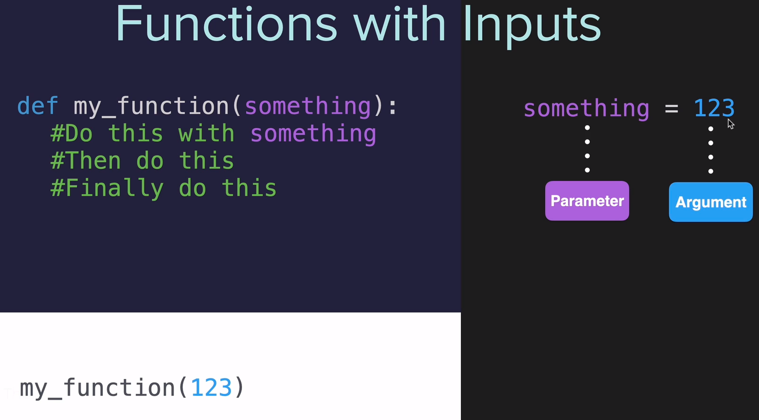
When we call the function called “my_function” and we pass over the data, “123” we are creating a variable called “something” with “123” as value.

Parameter and Argument:
In programing language, the variable “something” is called Parameter.

The value of the variable, 123, is called Argument.

Passing two parameters:

def greet_with(name,location): → We create the variables: name and location
print(f"The name is: {name}") → We use the variable name
print(f"The location is: {location}") → here we use location

greet_with("John","London") → And we call the function passing the values of both variables, John and London.

Positional Argument: The first Parameter gets assigned to the first Argument. The second Parameter to the second Argument. And so on.

The same with 3 Arguments:
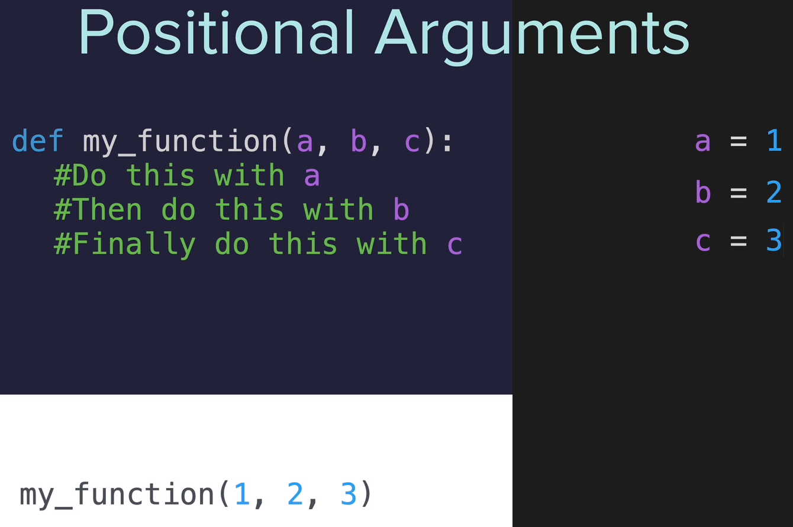

If you switch the Arguments in the function call:
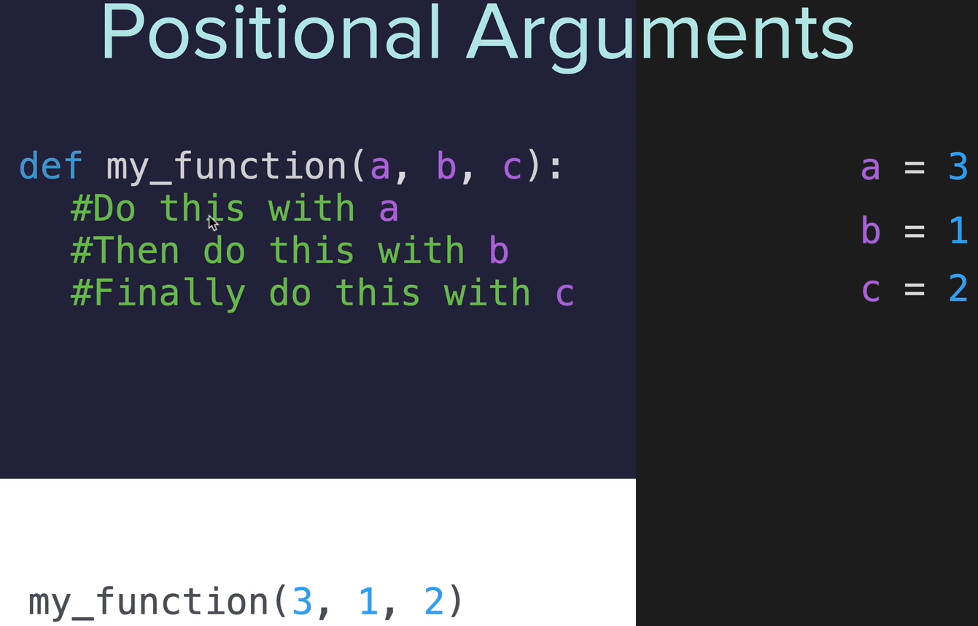

Keyword Arguments: When you assign the value to the variables in the Argument when calling the function.
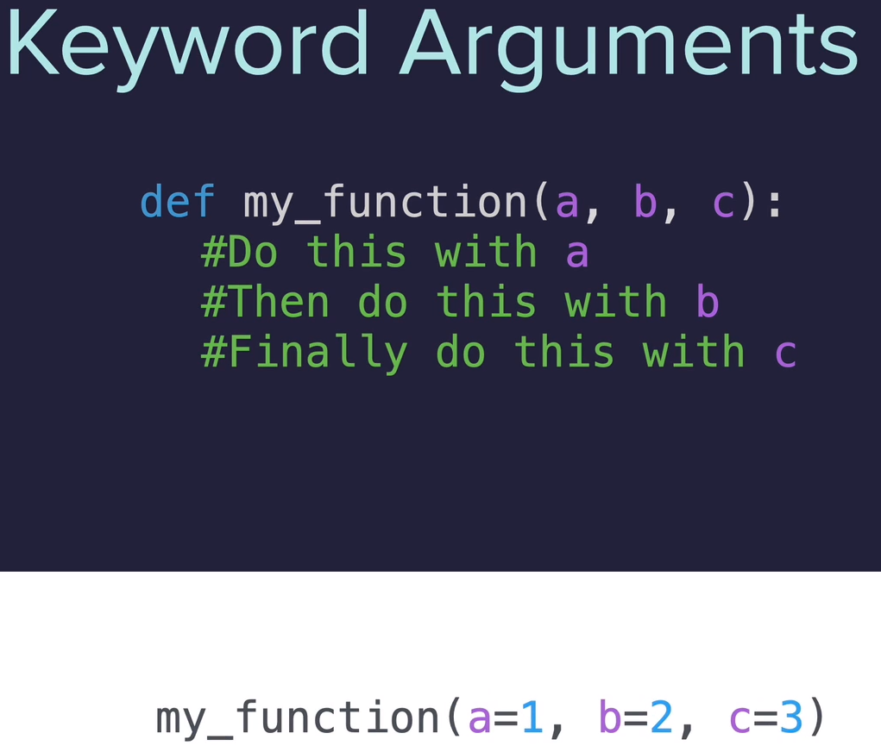

Now if you switch the Arguments, the value of the Parameters will be the same:
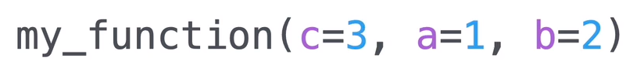

Example:
def greet_with(name,location): → Parameters name and location defined here.
print(f"The name is: {name}") → we call the Parameter “name”
print(f"The location is: {location}") → we call “location”

greet_with(location="London", name= "John") → We define the Arguments and we assing its value. Notice that are switched.

Round a number up: If you’re result is 1.6 and you need to round it up to 2.
import math
result = math.ceil(1.6)
print(result)
→ 2
Convert list to string:
print(f"\n{' '.join(encrypted)}")

Python List index() Method: Example: We have a list/array with all the alphabet, like:
alphabet = ['a', 'b', 'c', 'd', etc, etc ...]

And we want to know in which index is the letter ‘d’, we’ll do:
letter = alphabet.index(letter)
print(letter)

Output:
3

Trick to substract: Convert the number in negative.

Example from the Ceasar encryption exercies:
Type “encode” to encryp or type “decode” to decrypt.
Type the message.
Type the shift number

To encode we have to add (+) the shift number that we want to encrypt.
To decode we have to substract (-) the shift number.

Instead of using if/else, like:
if x == “encode”:
do this (for i in ….)
elif x == “decode”
do this other thing (for i in …….)

You can multiply the shift number * -1, doing lile this:

if x == “decode”:
shift *= -1 → this converts the shif in negative.

Global variables: Inside a function
You have to create a variable inside a function that you want to use outside it (globally).

To do so you have to declare the variable “global” inside the function, then you will be able to use the value of that variable outside the function, example:

def my_Function():
global x → inside the function, we declare the variable x as global
x = input(“Tell me your name”) → we ask your name and store it in x

my_Function → we call the function to make it run.
print(”Your name is: x”) → we print the content of x

Output:
Tell me your name
John

Your name is: John

Day 9: Dictionaries & Nesting.

Dictionaries: Works more or less like a real dictionary. Example of use, for students grades.
They are in the form of a table, key / value.
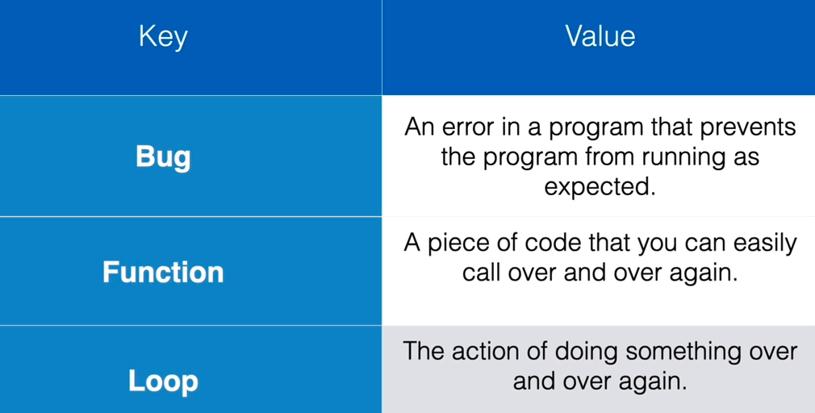

How to create it:
{key: Value}
Example:
{“Bug”: “An error in a program that prevents ….” }

Several entries in the same dictionary: Use commas.
Example:
{“Key1”: “Value1”, “Key2: “Value2”, etc }

Proper formating: Good practices.
Example following the screenshot above.
programming_dictionary = {
“Bug”: “An error in a program that prevents …”, → we have to indent one (1) space
“Function”: “A piece of code that you can ….”,
“Loop”: “The action of ...”, → finish it with a comma to allow us to add more key/value pairs.
} → to close it we don’t have to indent.

To add more key/values just add them at the end after the comma.

How to retrive it: By using square brackets like in lists/arrays, but we have to use the key.
Example using strings.
print(programming_dictionary[“Loop”])
Output:
The action of doing something over and over again.

Example using integers:
number_dictionary = {
123 = “Apples”,
456 = “Pears”,
}
print(programming_dictionary[123])
Output:
Apples

Add data programatically:
programming_dictionary[“For”] = “To do iterations ...”

Now if you print the dictionary you will see at the end the new key/value added.

print(programming_dictionary)

Empty dictionary: Is not a bad idea to create an empty dictionary when you create the program.
empty_dictionary = {}

Then you can add the key/values using the method explained above, x[“Car”] = “Method of transport ...”

Wipe (remove) an existing dictionary:
programming_dictionary= {} → this dictionary already had the information above, like loop, bug, function, etc.

Edit an item in a dictionary:
programming_dictionary[“Bug”] = “Bla,bla,bla,etc. ”
print(programming_dictionary[“Bug”])

Output:
Bla,bla,bla,etc.

Loop through a dictionary:
programming_dictionary = {"Bug": "An error in a program that prevents the program from running as expected.", "Function": "A piece of code that you can easily call over and over again."}

for i in programming_dictionary:
print(i) → only print the key (Bug and Function in this example)
print(programming_dictionary[i]) → will print the value in each iteration.

Output:
Bug
An error in a program that prevents the program from running as expected.
Function
A piece of code that you can easily call over and over again.

Print list inside dictionary inside another dictionary:
Print “Steak”
order = {
1. "starter": {1: "Salad", 2: "Soup"},
2. "main": {1: ["Burger", "Fries"], 2: ["Steak"]},
3. "dessert": {1: ["Ice Cream"], 2: []},
4. }

print(order["main"][2][0]) → [2] accesses the value with key 2, [0] gets the first item from the list.

If you want to print ['Steak'] → print(order["main"][2])

Exercise students scores.

Nesting: Puting one dictionary inside the other.

Simple Dictionary:
capitals = {
“France”: “Paris”,
“Germany”: “Berlin”,
}

Nest a List in a Dictionary: You want a travel log that shows the cities you visited in each country.
What you can NOT do:
travel_log = {
“France”: “Paris”,”Lille”, “Dijon” → this is wrong, only one value per key. The commas are showing several values.
}

Correct way, using Lists inside Dictionaries:
travel_log = {
“France”: [“Paris”,”Lille”, “Dijon” ], → now we have one key/value pair, and the value is a List.
“Germany”: [“Berlin”, “Hamburg”, “Stuttgart”],
}

You can nest a list within a list too:
[“A”, ”B”, [“C”, ”D”]]
But is not so usefull like nesing a List in a Dictionary or a Dictionary in a Dictionary.

Nest a Dictionary in a Dictionary:
travel_log = {
"France": {"cities_visited": ["Paris", "lille", "Dijon"]},
}

Several dictionaries: in the same dictionary.
travel_log = {
"France": {"cities_visited": ["Paris", "lille", "Dijon"], "total_visits": 12},
"Germany": {"cities_visited": ["Berlin", "Hamburg", "Stuttgard"], "total_visits": 8},
}

Nesting Dictionaries in Lists:
travel_log = [
{
"country": "France",
"cities_visited": ["Paris", "Lille", "Dijon"],
"total_visits": 12,
},
{
"country": "Germany",
"cities_visited": ["Berlin", "Hamburg", "Stuttgart"],
"total_visits": 5,
},
]

Append data into this shit: Exercise
travel_log = [
{
"country": "France",
"visits": 12,
"cities": ["Paris", "Lille", "Dijon"]
},
{
"country": "Germany",
"visits": 5,
"cities": ["Berlin", "Hamburg", "Stuttgart"]
},
]

def add_new_country(country_visited, times_visited,cities_visited):
new_country = {}
new_country["country"] = country_visited
new_country["visits"] = times_visited
new_country["cities"] = cities_visited
travel_log.append(new_country)

add_new_country("Russia", 2, ["Moscow", "Saint Petersburg"])
print(travel_log)

Output:
[{'country': 'France', 'visits': 12, 'cities': ['Paris', 'Lille', 'Dijon']}, {'country': 'Germany', 'visits': 5, 'cities': ['Berlin', 'Hamburg', 'Stuttgart']}, {'country': 'Russia', 'visits': 2, 'cities': ['Moscow', 'Saint Petersburg']}]

Exercise secret auction: To be ran in replit, the module replit will fail in other IDE.

from replit import clear
from art import logo
print(logo)

bids = {}
bidding_finished = False

def find_highest_bidder(bidding_record):
highest_bid = 0
winner = ""
# bidding_record = {"Angela": 123, "James": 321}
for bidder in bidding_record:
bid_amount = bidding_record[bidder]
if bid_amount > highest_bid:
highest_bid = bid_amount
winner = bidder
print(f"The winner is {winner} with a bid of ${highest_bid}")

while not bidding_finished:
name = input("What is your name?: ")
price = int(input("What is your bid?: $"))
bids[name] = price
should_continue = input("Are there any other bidders? Type 'yes or 'no'.\n")
if should_continue == "no":
bidding_finished = True
find_highest_bidder(bids)
elif should_continue == "yes":
clear()

Dictionaries: Get info from it.

bids = {"Angela": 123, "James": 321}

Get the key and value: (Angela and James)
for i in bids:
bid_amount = bids[i]
print(i)
print(bid_amount)

Output:
Angela → key
123 → value

The next iteration will have this output:
James
321

Add key/value into a dictionary:
bids = {"Angela": 123, "James": 321}

name = input(“What’s your name”)
price = int(input(“What’s your bid: $”))

bids[name] = price

Input:
Alice
555

New key/value introduced into the dict:
bids = {"Angela": 123, "James": 321, "Alice": 555}

Modify a value in the dict:
bids = {"Angela": 123, "James": 321, "Alice": 555}

name = input(“What’s your name”)
price = int(input(“What’s your bid: $”))

bids[name] = price

Input:
Alice
101

Value for Alice updated:
bids = {"Angela": 123, "James": 321, "Alice": 101}

Day 10: Functions with Outputs.

Functions with Outputs: Output keyword: return
To let the function to return a value. The return statement appears in the function means the end of the function.
If there is “return” doesn’t have output will show it as “none” in the function call.

How it works: Basic code
def my_function():
result = 3 * 2
return result → the output in this example is “6”

my_function() → you call the function. The function runs, and outputs “6”
and replaces the line of code where the function is called with “6”

result → The return keyword have replaced the my_function() call. You can save it in a variable like this:
my_output = result → which is 6

“Advanced code”:
def my_function():
return = 3 * 2

my_output = my_function() → So, this line first calls my_function, the function executes, return wathever is outputed and replaces the function call “my_function()" and the variable will store the output of the function → my_output = 6

Exercise: Use .title() to format the word to have capital the first letter and the rest lowercase:

def format_name(f_name, l_name):
formated_f_name = f_name.title()
formated_l_name = l_name.title()
print(f"{formated_f_name} {formated_l_name}")

format_name("jOHn","sMiTH")

Here we call the function, it formats the words to John Smith and prints it out.
Output:
John Smith

The same using the return method:
def format_name(f_name, l_name):
formated_f_name = f_name.title()
formated_l_name = l_name.title()
return f"{formated_f_name} {formated_l_name}"

format_name("jOHn","sMiTH")

Explanation:
f"{formated_f_name} {formated_l_name}" → becomes the output because we use “return”.

And when we use “return” in functions, the output replaces the part of the code where the function was called → format_name("jOHn","sMiTH")

We can save the output in a variable and print it out:

def format_name(f_name, l_name):
formated_f_name = f_name.title()
formated_l_name = l_name.title()
return f"{formated_f_name} {formated_l_name}"

formated_string = format_name("jOHn","sMiTH")
print(formated_string)

Return method improved: Just print the output.

def format_name(f_name, l_name):
formated_f_name = f_name.title()
formated_l_name = l_name.title()
return f"{formated_f_name} {formated_l_name}"

print(format_name("jOHn","sMiTH"))

Tip: Pass statement: Used if you don’t want to perform any action, known as the null operation.

Use it when you don’t have written the code but you need that the function to work.

def function_name(arg1, arg2,..., argN):
# Function's code goes here...
pass

Multiple return values: You can have several returns, the first one being ran will end the program.

def format_name(f_name, l_name):
if f_name == "" or l_name == "":
return "You didn't provided valid inputs."
f_name = first_f_name.title()
l_name = last_l_name.title()
return f"{f_name} {l_name}"

print(format_name(input("What's your first name? "),input("What's your last name? ")))

Here we have a return in the if statement. If the “if” is true will execute the first return, sending the message to the function call and ending the function.

If the first “if” is false will continue until reaches the other return.

Exercise leap year: Tell me the year and the month and will tell you how much days that month have.

If you ask for February, month 2, you will know if the year introduced is a leap year (29 days) or normal year (28 days).
My solution:  def is_leap(year):  if year % 4 == 0:  if year % 100 == 0:  if year % 400 == 0:  return True  else:  return False  else:  return True  else:  return False  def days_in_month(year, month):  month_days = [31, 28, 31, 30, 31, 30, 31, 31, 30, 31, 30, 31]  if is_leap(year) == False:  return month_days[month -1]  else:  month_days[1] = 29  return month_days[month -1]  #🚨 Do NOT change any of the code below  year = int(input("Enter a year: "))  month = int(input("Enter a month: "))  days = days_in_month(year, month)  print(days) | Teacher’s solution:  def is_leap(year):  if year % 4 == 0:  if year % 100 == 0:  if year % 400 == 0:  return True  else:  return False  else:  return True  else:  return False  def days_in_month(year, month):  month_days = [31, 28, 31, 30, 31, 30, 31, 31, 30, 31, 30, 31]  if month > 12 or month < 1:  return "Invalid month entered."  if month == 2 and is_leap(year):  return 29  return month_days[month - 1]  #Do NOT change any of the code below 👇  year = int(input("Enter a year: "))  month = int(input("Enter a month: "))  days = days_in_month(year, month)  print(days)  # Tests  import unittest  class MyTest(unittest.TestCase):  def test_1(self):  self.assertEqual(days_in_month(2018, 2), 28)  def test_2(self):  self.assertEqual(days_in_month(2020, 2), 29)  def test_3(self):  self.assertEqual(days_in_month(2019, 4), 30)  def test_4(self):  self.assertEqual(days_in_month(1045, 5), 31)  print("\n")  print('Running some tests on your code:')  print(".\n.\n.\n.")  unittest.main(verbosity=1, exit=False)
Output:  28 | Output:  28

Docstrings: To create documentation in your code. Is like a commentary started by hash (#) but let’s you to do as many lines as you need without having to type # every line.

How to use it:
Just before the definition of the function:
def my_function():
“”” Here my documentation. To close it use the same 3 “””
here your code

Now when you call the function you will be prompted with the info you created within the function when you put your mouse between the parenthesys in the function call.

my_function() → if you put the mouse between the parenthesis you will get the documentation created in the function.

Comments: You could use it as a multiline comment but is not recommended, to do so use #

103 Calculator part 1
Explanation after the code.
#Calculator

# Add
def add(n1,n2):
return n1 + n2

# Substract
def subtract(n1,n2):
return n1 - n2

# Multiply
def multiply(n1,n2):
return n1 * n2

# Divide
def divide(n1,n2):
return n1 / n2

# Dictionary:
operations = {
"+": add,
"-": subtract,
"*": multiply,
"/": divide
}

num1 = int(input("What's the first number: "))

for symbol in operations:
print(symbol)

operations_symbol = input("Pick a symbol from above: ")

num2 = int(input("What's the second number: "))

calculation_function = operations[operations_symbol]

answer = calculation_function(num1, num2)

print(f"{num1} {operations_symbol} {num2} = {answer}")

RESULT:
What's the first number: 10
+
-
*
/
Pick a symbol from above: *
What's the second number: 2
10 * 2 = 20
Explanation:
-- We create one function for each operation (* / + and -) with positional arguments (num1 and num2)

-- We create a dictionary with the operation as key and the name of each function as value. Notice that the value doesn’t have to be a string.

-- We ask input for num1 num2 and the operation we wanna do.

-- We check on the dictionary for the value (in this case the function name (multiply, add, etc)) given the key. So: calculation_function = operations[operations_symbol]
In calculation_function we now have the name of the function.

-- We call the function and we pass in the two numbers,num1 and num2.

Recursive function:
Video here

Following the calculator exercise above. Now ask the user if he wants to continue or not.
If so the calculator will use the answer from the previous calculation, let’s say: 20

My solution:  # Calculator  def add(n1,n2):  return n1 + n2  def subtract(n1,n2):  return n1 - n2  def multiply(n1,n2):  return n1 * n2  def divide(n1,n2):  return n1 / n2  operations = {  "+": add,  "-": subtract,  "*": multiply,  "/": divide  }  num1 = int(input("What's the first number: "))  for symbol in operations:  print(symbol)  operations_symbol = input("Pick a symbol from above: ")  num2 = int(input("What's the second number: "))  calculation_function = operations[operations_symbol]  answer = calculation_function(num1, num2)  print(f"{num1} {operations_symbol} {num2} = {answer}" "\n")  keep_going = True  while keep_going == True:  polla = input(f"Type 'y' to continue calculating with {answer}, or 'n' to exit: ")  if polla == 'y':  for i in operations:  print(i)  operations_symbol = input("Pick a symbol from above: ")  num2 = int(input("What's the second number: "))  calculation_function = operations[operations_symbol]  answer_2 = calculation_function(answer,num2)  print(f"{answer} {operations_symbol} {num2} = {answer_2}")  answer = answer_2  else:  keep_going = False | Teacher’s solution:  def add(n1, n2):  return n1 + n2  def subtract(n1, n2):  return n1 - n2  def multiply(n1, n2):  return n1 * n2  def divide(n1, n2):  return n1 / n2  operations = {  "+": add,  "-": subtract,  "*": multiply,  "/": divide  }  def calculator():  num1 = float(input("What's the first number?: "))  for symbol in operations:  print(symbol)  should_continue = True  while should_continue:  operation_symbol = input("Pick an operation: ")  num2 = float(input("What's the next number?: "))  calculation_function = operations[operation_symbol]  answer = calculation_function(num1, num2)  print(f"{num1} {operation_symbol} {num2} = {answer}")  if input(f"Type 'y' to continue calculating with {answer}, or type 'n' to start a new calculation: ") == 'y':  num1 = answer  else:  should_continue = False  calculator()  calculator()

Day 11: Blackjack project.

Recursion: Is a function that calls itself.

If you want to run again the same code, like in the calculator when you want to start over again asking the num1, num2 and the operation, you use Recursion.

What you have to do is to add all the code inside a function, call it calculator():
Then at the end of all the code you call the function calculator at the last line of the function calculator()

So you are calling the same function from the last line of the function itself.

When you reach the end of a function everything gets reset to the beginning, so keep_going will be True again. (See last line of my code above)

TO SOLVE:
Finish the program when the computer or the user has a black jack. Now is moving to the next functions.

Add the last card to the list and add it up.

My solution: Didn’t finished.  import random  from sys import exit  cards = [11, 2, 3, 4, 5, 6, 7, 8, 9, 10, 10, 10, 10]  # Choose x random cards for you and the computer and store them into two lists/arrays (which are below).  def choose_cards(n1):  global user_cards  user_cards = []  global comp_cards  comp_cards = []  for i in range(0,n1):  user_cards.append(random.choice(cards))  comp_cards.append(random.choice(cards))  # # Add up user and computer cards functions:  def add_user_cards():  global user_result  user_result = 0  for i in user_cards:  user_result += i  print(f"{user_cards} User Result: {user_result}")  def add_comp_cards():  global comp_result  comp_result = 0  for i in comp_cards:  comp_result += i  print(f"{comp_cards} Computer Result: {comp_result}")  # Detect if there is a black jack:  def black_jack():  if comp_result == 21:  print(f"\nBlack Jack. The computer has: {comp_result}\nYou lost.")  exit()  elif user_result == 21:  print(f"\nYour score is: {user_result}\nYou win")  exit()  # user_result = 25  # user_cards = [4,11,7]  # Check user score is >21 and if have Ace's will convert it to 1 (11 will be 1)  def above_21():  global user_result  if user_result > 21:  for i in user_cards:  print(i)  if i == 11:  i = 1  user_result -= 10  if user_result > 21:  print(f"You have {user_result}: You lose. ")  exit()  else:  print(f"The new result is: {user_result}")  # Ask the user if he want another card:  def more_cards():  another_card = input("\nDo you want another card? Type 'y' or 'n': ")  if another_card == "y":  user_cards.append((random.choice(cards)))  add_user_cards()  black_jack()  above_21()  ##### PROGRAM START: ######  # Choose 2 random cards for user and computer:  choose_cards(2)  # Add up user and computer cards:  add_user_cards()  add_comp_cards()  # Check if the computer or the user have black jack  black_jack()  # Do the user have ACE's? If so will convert it to 1 (11 will be 1)  above_21()  # Do you want another card?  more_cards() | Teacher’s solution:  import random  def deal_card():  """Returns a random card from the deck."""  cards = [11, 2, 3, 4, 5, 6, 7, 8, 9, 10, 10, 10, 10]  card = random.choice(cards)  return card  def calculate_score(cards):  """Take a list of cards and return the score calculated from the cards"""  if sum(cards) == 21 and len(cards) == 2:  return 0  if 11 in cards and sum(cards) > 21:  cards.remove(11)  cards.append(1)  return sum(cards)  def compare(user_score, computer_score):  if user_score > 21 and computer_score > 21:  return "You went over. You lose 😤"  if user_score == computer_score:  return "Draw 🙃"  elif computer_score == 0:  return "Lose, opponent has Blackjack 😱"  elif user_score == 0:  return "Win with a Blackjack 😎"  elif user_score > 21:  return "You went over. You lose 😭"  elif computer_score > 21:  return "Opponent went over. You win 😁"  elif user_score > computer_score:  return "You win 😃"  else:  return "You lose 😤"  def play_game():  user_cards = []  computer_cards = []  is_game_over = False  for _ in range(2):  user_cards.append(deal_card())  computer_cards.append(deal_card())  while not is_game_over:  user_score = calculate_score(user_cards)  computer_score = calculate_score(computer_cards)  print(f" Your cards: {user_cards}, current score: {user_score}")  print(f" Computer's first card: {computer_cards[0]}")  if user_score == 0 or computer_score == 0 or user_score > 21:  is_game_over = True  else:  user_should_deal = input("Type 'y' to get another card, type 'n' to pass: ")  if user_should_deal == "y":  user_cards.append(deal_card())  else:  is_game_over = True  while computer_score != 0 and computer_score < 17:  computer_cards.append(deal_card())  computer_score = calculate_score(computer_cards)  print(f" Your final hand: {user_cards}, final score: {user_score}")  print(f" Computer's final hand: {computer_cards}, final score: {computer_score}")  print(compare(user_score, computer_score))  while input("Do you want to play a game of Blackjack? Type 'y' or 'n': ") == "y":  play_game()

Day 12: Scope and number guessing.

Local scope: Exists within functions. If you call a variable outside of that function will give you NameError saying that is not defined.

Global scope: Available in all the code, within functions, no matter how deep it gets nested and also available outside the functions.

Namespace: The concept of global and local not only applies to variables, it applies to everything you defines, everything you give a name to, like a function name or variable.

Block scope: If you create a variable within a function it’s scope is Local.

But if you create a variable within an if ,while, for statement, etc, the variable is Global.

Using the same name in local and global variables: Is not a good idea, can cause a lot of trouble.

We have a variable within a function and the same variable outside the function.

In the code below that uses the local variable inside the function to increase the value of the variable outside.

enemies = 1

def increase_enemies():
enemies += 1

increase_enemies()
This will give you error because the local variable can not save nothing outside the function.

We can declare the local variable inside the function as global by doing this:
enemies = 1

def increase_enemies():
global enemies
enemies += 1

increase_enemies()

This will increase the value +1

But to use the same name in global and local scope variables is not a good idea at all because is confusing and prone to create bugs and errors.

How to modify a global variable from a local one:
Return the value:

enemies = 1

def increase_enemies():
return enemies + 1

enemies = increase_enemies()
print(enemies)
The result will be: 2

Global Scope: You can use global scope when you define Constants.

Constants: variables that you define and you never plan to change its value again.

Like the value of Pi.
pi = 3.14159

To differentiate it from normal variables there is a convention to do it by using uppercase:

PI = 3.14159
URL = “httls://www.google.com”
TWITTER_HANDLE = “@polla_enviangre”

Create titles and logos with ASCII:
https://patorjk.com/software/taag/#p=display&f=Graffiti&t=Type%20Something%20

Go to thew site, create the log and hit Select and copy.

Create the art.py to paste the logo:
In replit create a new file, call it art.py

Inside the file create the variable, logo and between “”” and “”” paste the ascii code.

logo = “””

and the logo here.

‘’’

Day 12 exercise: Link

My solution: Didn’t finished.  from random import *  from art import logo  print(logo)  # Greetings:  print("Welcome to the Number Guessing Game!\n\nI'm thinking of a number between 1 and 100.\n")  # Generate the random number:  random_number = randint(1,100)  # Show the number, for learning purposes:  print(f"Pssst, the correct answer is: {random_number}\n")  # Ask how many attempts:  attempts = input("Choose a difficulty. Type 'easy' or 'hard': ")  if attempts == "hard":  attempts = 4  print("\nYou have 5 attepts")  else:  attempts = 9  print("\nYou have 10 attepts")  # Ask the user for one number:  def guess_number():  return int(input("Make a guess: "))  number = guess_number()  # Check if your guess is correct, above or below:  end_of_game = False  while end_of_game != True:  if attempts == 0:  print("You've run out of guesses, you lose.")  end_of_game = True  elif number == random_number:  print("\nYou win.")  end_of_game = True  elif number < random_number:  print("\nToo low.")  print(f"\nYou have {attempts} attempts remaining to guess the number.")  attempts -= 1  number = guess_number()  elif number > random_number:  print("\nToo high")  print(f"/nYou have {attempts} attempts remaining to guess the number.")  attempts -= 1  number = guess_number() | Teacher’s solution:  from random import randint  from art import logo  EASY_LEVEL_TURNS = 10  HARD_LEVEL_TURNS = 5  #Function to check user's guess against actual answer.  def check_answer(guess, answer, turns):  """checks answer against guess. Returns the number of turns remaining."""  if guess > answer:  print("Too high.")  return turns - 1  elif guess < answer:  print("Too low.")  return turns - 1  else:  print(f"You got it! The answer was {answer}.")  #Make function to set difficulty.  def set_difficulty():  level = input("Choose a difficulty. Type 'easy' or 'hard': ")  if level == "easy":  return EASY_LEVEL_TURNS  else:  return HARD_LEVEL_TURNS  def game():  print(logo)  #Choosing a random number between 1 and 100.  print("Welcome to the Number Guessing Game!")  print("I'm thinking of a number between 1 and 100.")  answer = randint(1, 100)  print(f"Pssst, the correct answer is {answer}")  turns = set_difficulty()  #Repeat the guessing functionality if they get it wrong.  guess = 0  while guess != answer:  print(f"You have {turns} attempts remaining to guess the number.")  #Let the user guess a number.  guess = int(input("Make a guess: "))  #Track the number of turns and reduce by 1 if they get it wrong.  turns = check_answer(guess, answer, turns)  if turns == 0:  print("You've run out of guesses, you lose.")  return  elif guess != answer:  print("Guess again.")  game()

Day 13: Debugging, how to find and fix a problem.

Basically this lesson that shows different bugged codes that you have to fix, really basic ones till the last one that requires to change several things.

The teacher recommends to use the print statement when you have problems to find where the problem is, you can use thoony and other tools too.

Day 14: Higher Lower game:

This exercise compares the followers that two famous instagram accounts have and ask you to guess who have more, choosing between A or B, like Cristiano Ronaldo and Tom Cruise.

If you are right you have one point and a new famous instagram account is compared with the previous one you choose. If you are wrong the game is over and will display you the number of points achieved.

My solution: Didn’t finished.  import random  data = [  {  'name': 'Instagram',  'follower_count': 346,  'description': 'Social media platform',  'country': 'United States'  },  {  'name': 'Cristiano Ronaldo',  'follower_count': 215,  'description': 'Footballer',  'country': 'Portugal'  },  {  'name': 'National Geographic',  'follower_count': 135,  'description': 'Magazine',  'country': 'United States'  }  ]  # Get me the number of dictionaries,choose one random number to use it as index  # and return it's content:  def get_random():  return data[random.randint(0, (len(data) - 1))]  # Save the dictionary key value in variables A and B  A = (get_random())  B = (get_random())  # Print the content of the values and ask the user to choose A or B:  print(f"Compare A: {A['follower_count']} {A['name']}, a {A['description']}, from {A['country']}.")  print(f"Against B: {B['follower_count']} {B['name']}, a {B['description']}, from {A['country']}.")  # Ask the user to choose A or B:  user_choose = input("\nWho has more followers? Type 'A' or 'B': ")  # Check who have more users: A or B  def check_correct():  if A['follower_count'] < B['follower_count']:  answer_computer = "B"  return answer_computer  elif A['follower_count'] > B['follower_count']:  answer_computer = "A"  return answer_computer  else:  answer_computer = "B"  return answer_computer  #score = 0  # Compare if my selection have more users that the computer:  def compare():  score = 0  if user_choose == check_correct():  score += 1  return "You're right! Current score: {score}"  else:  game = False  return "Sorry, that's wrong. Final score: {score}"  game = True  while game == True:  print(check_correct())  print(compare())  # Idea  # def check_correct():  # if user_choose['follower_count'] > | Teacher’s solution:  from game_data import data  import random  from art import logo, vs  from replit import clear  def get_random_account():  """Get data from random account"""  return random.choice(data)  def format_data(account):  """Format account into printable format: name, description and country"""  name = account["name"]  description = account["description"]  country = account["country"]  # print(f'{name}: {account["follower_count"]}')  return f"{name}, a {description}, from {country}"  def check_answer(guess, a_followers, b_followers):  """Checks followers against user's guess  and returns True if they got it right.  Or False if they got it wrong."""  if a_followers > b_followers:  return guess == "a"  else:  return guess == "b"  def game():  print(logo)  score = 0  game_should_continue = True  account_a = get_random_account()  account_b = get_random_account()  while game_should_continue:  account_a = account_b  account_b = get_random_account()  while account_a == account_b:  account_b = get_random_account()  print(f"Compare A: {format_data(account_a)}.")  print(vs)  print(f"Against B: {format_data(account_b)}.")  guess = input("Who has more followers? Type 'A' or 'B': ").lower()  a_follower_count = account_a["follower_count"]  b_follower_count = account_b["follower_count"]  is_correct = check_answer(guess, a_follower_count, b_follower_count)  clear()  print(logo)  if is_correct:  score += 1  print(f"You're right! Current score: {score}.")  else:  game_should_continue = False  print(f"Sorry, that's wrong. Final score: {score}")  game()

Day 15: Local Development Environment. IDE.
Coffe Machine.

IDE: Integrated Development Environment.

Software that will help you while you are creating your code, like highlighting when you do an error, giving advice, etc.

Install Python:
https://www.python.org/downloads/ → Get the last version for your computer. 3.11.3 in my case.

In the video the teacher is installing in Windows the version 3.8.2. She asked to check the box “Add Python 3.8 to PATH” but in Mac this option is not displayed in the installation process and is not necessary, if you see the folder with the files means that all is ok.

Install PyCharm:
https://www.jetbrains.com/pycharm/download/#section=mac → install the Community version
Drag PyCharm to the applications folder.

Create a project:
New project – name it as you wish (Demo) – Base interpreter: select the Python version you’ve installed before, 3.11 in my example – Create.

Main.py is already created, but if not do:
In the project right click on Demo folder (or control + left click on it) – New – File – main.py

main.py already have a basic code,

Run a program: Hit the run button to see it working, or control + r (which is ^ + R) the output will be something like this:

/Users/joaquim/PycharmProjects/Demo/venv/bin/python /Users/joaquim/PycharmProjects/Demo/main.py
Hi, PyCharm

Process finished with exit code 0

Hi PyCharm is the output of the program, the rest in info, like the exit code, etc.

Shortcuts: https://www.jetbrains.com/help/pycharm/mastering-keyboard-shortcuts.html

Cool stuff:
- Refactor Rename: You can change the name of a function that is repeated several times, example:

You have a function called my_function()

You call this function several times in the code.

If you want to change the name to the function, for example to “add” you have to go one by one in each place where is called.

But you can change the name at once by using refactor:
Right click on the name you want to change – Refactor – Rename – insert the new name you want to put “add” in this example – Refactor

You will see that Refactor is showing you which places will be renamed → Hit “Do Refactor” to apply the changes.

- Difference between find and replace and Refactor:
Refactor is intelligent enough to change only the name of the function or variable we want to change.

If you use find and replace will change all the places in where you have the word you want to change, example.

Find and replace my_function for add.
If you have a print(“my_function is a function”) it will change it for:
print(“add is a function”) and you don’t want this to happen.

Refactor will change the name of the function when it is indeed a function.

- Built-In Linter: Converts the code to the style guide conventions to make it consistent and easy to read by others developers.

Your code will work anyway without applying linter.

Linter will make it more easy to read by others by following the style guide, like how much spaces you have to leave in the body of a function, how much indentation spaces must have a tab (four), maximum line length, etc.

Python developers uses PEP 8 style guide.

PyCharm apply all those PEP 8 rules d

- Local history: PyCharm keeps the history changes of your code.

You can see the changes you did and revert things to previous state.

- View Structure: Breaks down the code in variables and functions in a side bar.
Then you can click in the variable you want and will send you there without having to scroll.

- TODO Traking: Create a list of tasks that will appear in it’s own window at the bottom. You can click on every item of the list and will send you to that part of the code, where you written the line.

To create it write: # TODO → once you do it the text will appear in yellow, example:
# TODO: 2 Check resources sufficient to make drink order.

Coffee Machine Project:

My solution: Didn’t finished.  MENU = {  "espresso": {  "ingredients": {  "water": 50,  "coffee": 18,  },  "cost": 1.5,  },  "latte": {  "ingredients": {  "water": 200,  "milk": 150,  "coffee": 24,  },  "cost": 2.5,  },  "cappuccino": {  "ingredients": {  "water": 250,  "milk": 100,  "coffee": 24,  },  "cost": 3.0,  }  }  resources = {  "water": 300,  "milk": 200,  "coffee": 100,  "money": 0,  }  import sys  # TODO: 0 Variables and Constants. Get the values of the ingredients and money. Get into variables and declare the value of each coin:  # Coins constants declaration:  QUARTERS = 0.25  DIMES = 0.10  NICKLES = 0.05  PENNIE = 0.01  # TODO: 1 Prompt user by asking “What would you like? (espresso/latte/cappuccino):” and "report" and "off"  def choose():  coffe = input("What would you like? (espresso/latte/cappuccino): ").lower()  if coffe == "espresso":  return "espresso"  elif coffe == "latte":  return "latte"  elif coffe == "cappuccino":  return "cappuccino"  elif coffe == "off":  return "off"  elif coffe == "report":  return "report"  # user_selection variable  # TODO: 2 Turn off machine when typed "off"  def turn_off():  if user_selection == "off":  apaga = False  return apaga  # TODO: 3 Print inventory when typed: "report"  def show_report():  if user_selection == "report":  print(f"\nWater: {resources['water']}ml \nMilk: {resources['milk']}ml \nCoffee: {resources['coffee']}g \nMoney: ${resources['money']}")  # TODO: 4 Check if resources are sufficient:  def enought_resources():  if water_need > water_have:  print("Sorry there is not enough water.")  if milk_need > milk_have:  print("Sorry there is not enough milk.")  if coffee_need > coffee_have:  print("Sorry there is not enough coffee.")  # TODO: 5 Process coins: Ask for the coins and return it's total value.  def process_coins():  print("Please insert coins.")  user_quarters = int(input("how many quarters?: "))  user_dimes = int(input("how many dimes?: "))  user_nickles = int(input("how many nickles?: "))  user_pennies = int(input("how many pennies?: "))  total_user = QUARTERS * user_quarters + DIMES * user_dimes + NICKLES * user_nickles + PENNIE * user_pennies  return round(total_user, 3)  # TODO: 6 Check the money the user have inserted and how much the coffee costs.  def check_transaction():  price = MENU[user_selection]['cost']  if total_user >= price:  total = round(total_user - price, 3)  print(f'Here is ${total} in change.')  else:  print("Sorry that's not enough money. Money refunded.")  # TODO: 7 Make the coffee and deduce resources.  def make_coffee():  resources['water'] = water_have - water_need  resources['milk'] = milk_have - milk_need  resources['coffee'] = coffee_have - coffee_need  resources['money'] = money_have + MENU[user_selection]['cost']  print(  f"\nWater: {resources['water']}ml \nMilk: {resources['milk']}ml \nCoffee: {resources['coffee']}g \nMoney: ${resources['money']}")  print(f"Here is your {user_selection}. Enjoy!")  ############ PROGRAM STARTS: ################  apaga = True  while apaga != False:  user_selection = choose()  turn_off()  show_report()  # Resources I have:  water_have = resources['water']  milk_have = resources['milk']  coffee_have = resources['coffee']  money_have = resources['money']  # Resources I need:  water_need = MENU[user_selection]['ingredients']['water']  milk_need = MENU[user_selection]['ingredients']['milk']  coffee_need = MENU[user_selection]['ingredients']['coffee']  enought_resources()  total_user = process_coins()  check_transaction()  make_coffee() | Teacher’s solution:  MENU = {  "espresso": {  "ingredients": {  "water": 50,  "coffee": 18,  },  "cost": 1.5,  },  "latte": {  "ingredients": {  "water": 200,  "milk": 150,  "coffee": 24,  },  "cost": 2.5,  },  "cappuccino": {  "ingredients": {  "water": 250,  "milk": 100,  "coffee": 24,  },  "cost": 3.0,  }  }  profit = 0  resources = {  "water": 300,  "milk": 200,  "coffee": 100,  }  def is_resource_sufficient(order_ingredients):  """Returns True when order can be made, False if ingredients are insufficient."""  for item in order_ingredients:  if order_ingredients[item] > resources[item]:  print(f"​Sorry there is not enough {item}.")  return False  return True  def process_coins():  """Returns the total calculated from coins inserted."""  print("Please insert coins.")  total = int(input("how many quarters?: ")) * 0.25  total += int(input("how many dimes?: ")) * 0.1  total += int(input("how many nickles?: ")) * 0.05  total += int(input("how many pennies?: ")) * 0.01  return total  def is_transaction_successful(money_received, drink_cost):  """Return True when the payment is accepted, or False if money is insufficient."""  if money_received >= drink_cost:  change = round(money_received - drink_cost, 2)  print(f"Here is ${change} in change.")  global profit  profit += drink_cost  return True  else:  print("Sorry that's not enough money. Money refunded.")  return False  def make_coffee(drink_name, order_ingredients):  """Deduct the required ingredients from the resources."""  for item in order_ingredients:  resources[item] -= order_ingredients[item]  print(f"Here is your {drink_name} ☕️. Enjoy!")  is_on = True  while is_on:  choice = input("​What would you like? (espresso/latte/cappuccino): ")  if choice == "off":  is_on = False  elif choice == "report":  print(f"Water: {resources['water']}ml")  print(f"Milk: {resources['milk']}ml")  print(f"Coffee: {resources['coffee']}g")  print(f"Money: ${profit}")  else:  drink = MENU[choice]  if is_resource_sufficient(drink["ingredients"]):  payment = process_coins()  if is_transaction_successful(payment, drink["cost"]):  make_coffee(choice, drink["ingredients"])

Day 16: Object Oriented Programming (OOP):

Procedural Programming:
Is the paradigm we used until now, all the code in the same page, calling functions up and down, quite messy when the code grows, making complicated to track and understand what the code is doing.

We set up procedures or functions that do particular things, then one procedure leads to another procedure. Is the earliest paradigm in programming. Fortran of Cobol relies in Procedural Programming.

OOP: We try to model real-life objects. And those objects have things like Attributes and Methods that actually do things.

Attribute: Is a fancy way to call a variable. Is actually a variable attached to a particular object.

Method: A function that a particular module object can do.

Class: Is a blue print (template). With it you can create as many objects you want.
The objects is what we will use in our code.

Object: Individual objects that are generated from a Class (blueprint).
Combining some peace of data (attributes) and some functionality (methods) all together in the same thing.

Example:
We have a Class called Waiter.
We have a waiter called John. John is an Object

We can have as many objects as we want of the Class waiter.

Another example with car: How to write a class: It is written in Pascal Case.
car = CarBlueprint() → CarBlueprint() is the Class.

Car is the object that has been created by the CarBluePrint()

How to create an object: car = CarBlueprint()

Import module and use it’s class:
We will use the turtle module, used for teaching beginners.

Example 1:
import turtle

timmy = turtle.Turtle() → we create the object timmy by using the module turtle and the class Turtle()

Example 2: More simplified.
from turtle import Turtle

timmy Turtle()

This says: From the turtle module, import the Turtle class.

Run this program:
If you run:

from turtle import Turtle
timmy = Turtle()

print(timmy)

You will get:

<turtle.Turtle object at 0x104add2d0>

Turtle object and the turtle module and saved in 0x104add2d0 which is the location in the computer’s memory.

What can we do with the object: Following the car example.
Car is the object.
The attributes are speed = 0 and fuel = 32

To access the attributes: car.speed

from turtle import Turtle, Screen

timmy = Turtle()
print(timmy)

my_screen = Screen()
print(my_screen.canvheight)

my_screen → is the object
canvheight → is the attribute associated with Screen

Object Methods: car.stop()
car → object
stop() → function associated with that object, which is known as a method.

Clarification note → We use the Turtle method that draws a turtle in your screen and you can make it move and do different things.

To do so you will need to use the method Screen which is where the turtle will do his stuff.

The screen represents the window in which the turtle is going to show up.

Code:

from turtle import Turtle, Screen

timmy = Turtle()
print(timmy)
timmy.shape("turtle") → changes the object in the center of the canvas for a turtle shape.
timmy.color('red') → change the color of the turtle to red
timmy.forward(100) → move the turtle 100 paces forward.

my_screen = Screen()
print(my_screen.canvheight) → the height the window will have, 300x300 seems to be the default size.
my_screen.exitonclick() → will keep showing the screen until you click on it. Without this the window would appear one second and will disappear.

What we learnt:
How to create an object from a blueprint: → timmy = Turtle()
How to tap in into it’s attributes: my_screen.canvheight
How to call methods associated with the object: timmy.color(‘red’)

Python Packages: To use code that other developers have written the most common way is to use packages of code.

Differences between Package and Module:
A Packages is a whole lot of code, have much more code than a Module.

Where to get the Packages: From here https://pypi.org/

Install a package: There are tens of thousands of packages so you will need to install the package you need.
Turtle is already installed by default but normally you will need to install the package that you need.

Install PrettyTable: Which is a package to create tables easily.

In PyCharm – Settings – click into your project name (day-16-start in my case) – Python Interpreter – hit +button – introduce the name of the package (PrettyTable in this example) – select it from the list and hit Install Package

To remove it: in Python Interpreter, hit – button to uninstall the selected package.

To see it’s source code: Import the package, import prettytable
Right click – Go to – Implementations

But you can go to the documentation page in pypi.org and get what you need there.

Practice Modifying object Attributes and calling Methods:

from prettytable import PrettyTable

table = PrettyTable() → Create the Object
table.add_column('Porkemon Name',['Pistachu', 'SuPutamadre', 'Polla Enterprises' ]) → Create a column called:
table.add_column('Type',['Fuegorl', 'Water', 'Marica' ]) Pockemon name

table.align = 'l'

print(table)

+-------------------+---------+
| Porkemon Name | Type |
+-------------------+---------+
| Pistachu | Fuegorl |
| SuPutamadre | Water |
| Polla Enterprises | Marica |
+-------------------+---------+

Coffee Machine in OOP:

from menu import Menu, MenuItem
from coffee_maker import CoffeeMaker
from money_machine import MoneyMachine

money_machine = MoneyMachine() --> we create the Object money_machine from the Class MoneyMachine
coffee_maker = CoffeeMaker() --> the same here
menu = Menu()

is_on = True

while is_on:
options = menu.get_items()
choice = input(f"What would you like? ({options}): ").lower()
if choice == "off":
is_on = False
elif choice == "report":
coffee_maker.report()
money_machine.report()
else:
drink = menu.find_drink(choice) --> You passes the name of the drink, is checked in the object menu.
if coffee_maker.is_resource_sufficient(drink) and money_machine.make_payment(drink.cost):
coffee_maker.make_coffee(drink)

Day 17: Benefits of OOP. The Quiz project.

Create a Class: This one is gonna be empty for learning purposes.

class User: → We have to use the class keyword and then the class name, User in this example.
pass → The class will be empty, but if we put nothing it will show an error in the next line (user_1….), so to avoid it we use pass

user_1 = User() → We create the object user_1 from the class User. To initialize an object from a class we have to use ()

Naming for Classes:

PascalCase: We use it for naming Classes. The first letter of the phrase have to be capital.
Example: CarCamshaftPulley
CoffeeMaker
MoneyMachine

snake_case: All the letters are lowercase and separated by _ Used for naming everything else in Python.

camelCase: The first world is lower case. The rest are upper case. Not used in Classes.

Create an Attribute for that Class:
An Attribute is a variable that’s associated with an Object.

class User:
pass

user_1 = User()
user_1.id = “001” → To create the attribute use the object.name_of_the_attribute
user_1.username = “John” → Here we create the attribute username with value John.

print(user_1.username) → Run the program, you will see that is printing “John”

Constructor: Part of the blueprint that allows us to specify what should happen when an Object is being constructed.

Called in programming: Initializing an Object.

To create the Constructor we use a special function, the init function:
class Car:
def __init__(self):
#initialise attributes

Python interpreter knows that by using __init__ is a special function.

Special function is normally used to initialize the attributes.
Remember: The init function is gonna be called every time you create a new Object from this Class.

class User:

def __init__(self):
print("New user being created...")

user_1 = User()
user_1.id = "001"
user_1.username = "Angela"

print(user_1.username)

user_2 = User()
user_2.id = "002"
user_2.username = "Jack"

Every time we use User() the print statement will be ran, so in the above example will be printed twice because we are creating two Objects from the Class User()

End code: How we can reduce the thing. We declare the class User, then create the init function.

That function will create 2 Attributes (variables) and the value will be passed when we created the objects user_ and user_2.

class User: → We declare the Class.

def __init__(self, user_id, username): → Explained below
self.id = user_id → We set the Attribute user_id, we passed in its value, 001 and 002
self.username = username → we set the Attribute username, angela and jack.
self.followers = 0 --> Explained below

user_1 = User(“001”, “angela”) → Explained below.
user_2 = User(“002”, “jack”)

Explanation:
def __init__(self, user_id, username):

We use the special method __init__ to create the Constructor. Normally used to initialize the attributes.

The init function will be called every time you create a new object from the class User. Here is going to be called 3 times.
user_1 = User()
user_2 = User()
user_3 = User()

self → is the object being initialized.

user_id, username → you pass in as many parameters you need when an object gets constructed from the class, User in this example.

user_1 = User(“001”, “angela”) → We create the Object user_1 from the Class Username.
And we pass in to the __init__ function the values 001 and angela.

self.followers = 0 --> We want to add 0 followers to all the new users but is not necessary to pass in 0 every time you create the Object like this user_3 = User(“003”, “peter”, "0")

You know that all the new users will have 0 uses so is not necessary to pass in the 0, just create the Attribute and that’s it. Every new user will have by default 0 followers.

Adding Methods to a Class:

Attributes → are the things that the object Has.
Methods – are the things that the object Does.

class User:

def __init__(self, user_id, username):
self.id = user_id
self.username = username
self.followers = 0
self.following = 0

def follow(self, user):
user.followers += 1
user.following += 1

user_1 = User(“001”, “angela”)
user_2 = User(“002”, “jack”)

user_1.follow(user_2)
print(user_1.followers)
print(user_1.following)
print(user_2.followers)
print(user_2.following)

This will be the output:

0 → user_1 followers account
1 → user_1 following account
1 → user_2 followers account
0 → user_2 following account.

Quiz Exercise:
We will build a Quiz that will prompt you a question, you have to say if is True or False. It will tell you if you are right or wrong and will show you how much answers you did well. It will ask you 10 questions. Explanation below the code.

main.py  from question_model import Question  from data import question_data  from quiz_brain import QuizBrain  question_bank = [] # this will be a list of question Objects  # Iterate all the questions in data.py.Separate the questions and the answers,initialize the Object new_question by  # passing in the questions and answers into the __init__ constructor and store every object inside question_bank  for question in question_data:  question_text = question["question"]  question_answer = question["correct_answer"]  new_question = Question(question_text, question_answer)  question_bank.append(new_question)  # In the above code we do this to convert the data coming from data.py to Objects which will have the data as fail  # proof, easy to access and will have the autofill thing among other benefits.  # We create the quiz Object from QuizBrain Class  quiz = QuizBrain(question_bank)  # print(question_bank)  while quiz.still_has_questions():  quiz.next_question()  print("You've completed the Quiz")  print(f"Your final score was: {quiz.score}/{quiz.question_number}")  data.py  question_data = [  {"category": "Science: Computers",  "type": "boolean", "difficulty": "easy",  "question": "Linus Torvalds created Linux and Git.",  "correct_answer": "True",  "incorrect_answers": ["False"]},  {"category": "Science: Computers", "type": "boolean", "difficulty": "easy",  "question": "The programming language &quot;Python&quot; is based off a modified version of &quot;JavaScript&quot;.",  "correct_answer": "False", "incorrect_answers": ["True"]},  {"category": "Science: Computers", "type": "boolean", "difficulty": "easy",  "question": "Pointers were not used in the original C programming language; they were added later on in C++.",  "correct_answer": "False", "incorrect_answers": ["True"]},  {"category": "Science: Computers", "type": "boolean", "difficulty": "easy",  "question": "RAM stands for Random Access Memory.", "correct_answer": "True",  "incorrect_answers": ["False"]},  {"category": "Science: Computers", "type": "boolean", "difficulty": "easy",  "question": "Ada Lovelace is often considered the first computer programmer.",  "correct_answer": "True", "incorrect_answers": ["False"]},  {"category": "Science: Computers", "type": "boolean", "difficulty": "easy",  "question": "In most programming languages, the operator ++ is equivalent to the statement &quot;+= 1&quot;.",  "correct_answer": "True", "incorrect_answers": ["False"]},  {"category": "Science: Computers", "type": "boolean", "difficulty": "easy",  "question": "Time on Computers is measured via the EPOX System.",  "correct_answer": "False", "incorrect_answers": ["True"]},  {"category": "Science: Computers", "type": "boolean", "difficulty": "easy",  "question": "The Windows ME operating system was released in the year 2000.",  "correct_answer": "True", "incorrect_answers": ["False"]},  {"category": "Science: Computers", "type": "boolean", "difficulty": "easy",  "question": "The NVidia GTX 1080 gets its name because it can only render at a 1920x1080 screen resolution.",  "correct_answer": "False", "incorrect_answers": ["True"]},  {"category": "Science: Computers", "type": "boolean", "difficulty": "easy",  "question": "Linux was first created as an alternative to Windows XP.",  "correct_answer": "False", "incorrect_answers": ["True"]}] | quiz_brain.py  class QuizBrain:  def __init__(self, q_list): # q_list is receiving the question_bank (all the questions and answers).  self.question_number = 0  self.question_list = q_list  self.score = 0  def still_has_questions(self): #Check if you reached the end of the questions, if so return True  return self.question_number < len(self.question_list)  def next_question(self): # We select one question from the whole question_list.  current_question = self.question_list[self.question_number]  self.question_number += 1  user_answer = input(f"Q.{self.question_number}: {current_question.text} (True/False): ")  self.check_answer(user_answer, current_question.answer)  def check_answer(self, user_answer, correct_answer): #Check if the answer is correct or not and print proper info  if user_answer.lower() == correct_answer.lower():  self.score += 1  print("You got it right!")  else:  print("You are wrong")  print(f"The correct answer was: {correct_answer}.")  print(f"Your current score is: {self.score}/{self.question_number}.\n")  question_model.py  class Question:  def __init__(self, text, answer):  self.text = text  self.answer = answer

Explanation: The code will ask you one question, you have to answer True or False.

It will tell you if you are right or wrong, will show you the score and will ask you the next question. It will ask you 10 questions in total.

We will use OOP to write the above classes.

Output: See how it works. Here you can run the program
Q.1: The HTML5 standard was published in 2014. (True/False): False
That's wrong.
The correct answer was: True.
Your current score is: 0/1

Q.2: The first computer bug was formed by faulty wires. (True/False): False
You got it right!
The correct answer was: False.
Your current score is: ½

[…]

Q.9: In most programming languages, the operator ++ is equivalent to the statement '+= 1'. (True/False): False
That's wrong.
The correct answer was: True.
Your current score is: 4/9

Q.10: The IBM PC used an Intel 8008 microprocessor clocked at 4.77 MHz and 8 kilobytes of memory. (True/False): False
You got it right!
The correct answer was: False.
Your current score is: 5/10

You've completed the quiz
Your final score was: 5/10

Get new questions: Open Trivia
Go to API – select the number of questions, type, difficulty, etc – Generate API URL – copy the link and open it in a new tab – copy all the questions, which will be in JSON.

You will need to get rid of the following code:
{"response_code":0,"results":
[...]
}

Day 18: Turtle Graphics, Tuples and Importing Modules.

Change function/variable name in bunch:
We want to change timmy_the_turtle for a better name.
Select the name – right click – Refractor – Rename - add the new name: tim

from turtle import Turtle, Screen

timmy_the_turtle = Turtle()
timmy_the_turtle.shape("turtle")
timmy_the_turtle.color("red")

# Draw a square
timmy_the_turtle.forward(100)
timmy_the_turtle.left(90)
timmy_the_turtle.forward(100)
timmy_the_turtle.left(90)
timmy_the_turtle.forward(100)
timmy_the_turtle.left(90)
timmy_the_turtle.forward(100)
from turtle import Turtle, Screen

tim = Turtle()
tim.shape("turtle")
tim.color("red")

# Draw a square
tim.forward(100)
tim.left(90)
tim.forward(100)
tim.left(90)
tim.forward(100)
tim.left(90)
tim.forward(100)
tim.left(90)

Importing Modules:

There are different ways to import modules:

Importing the module only: If you are going to use something inside the module 2 or 3 times.

import turtle

tim = turtle.Turtle() → we have to say the module name (turtle) and then the Class Turtle()

Better option: From ... Import. We won’t need to constantly having to specify the module and Class all the time. Use this if you need to use the Class a lot.

from turtle import Turtle

tim = Turtle()
john = Turtle()
tom = Turtle()

from → keyword
turtle → module
import → keyword
Turtle → Thing in the module we want to import.

Import everything: Disadvantages: Is very confusing and the python community doesn’t recommend it. Avoid it.

from turtle import *

Aliasing Modules: To Create an alias for the name of the module. There are modules with long names. This help us to avoid to type the long name.

import turtle as t

tim = t.Turtle()

Installing Modules: The majority of the modules are NOT built in, so you have to install them.

There are modules packaged by the python standard library, like turtle, etc. But is a small library of code which contain just the basics. Is like the library we have in our home which is small.

If you need the whole world of python modules and packages you need the biggest library, Python Packages, https://pypi.org

Example: The heroes module helps you to create super heroes names.

If you import heroes you will have an error.

PyCharm will inform you and will let you to install it, do it.

Now you can run the code:
import heroes

print(heroes.gen())

Exercises:

Draw a dashed line:

from turtle import Turtle, Screen

tim = Turtle()
tim.shape("turtle")
tim.color("red")

for i in range(15):
tim.forward(10)
tim.penup()
tim.forward(10)
tim.pendown()

# Initialize the screen object from the Screen class and use the method exitonclick to keep the scree visible and
#close it when you click on it
screen = Screen()
screen.exitonclick()

Draw a triangle, square, pentagon, 6, 7, 8, 9, 10 sides:

360/number of sides gives you the angles.
from turtle import Turtle, Screen
import random

tim = Turtle()
tim.shape("turtle")
tim.color("red")

color = ["red", "orange", "yellow", "green", "blue", "purple", "pink", "brown"]
def draw_shape(num_sides):
angle = 360 / num_sides
for i in range(num_sides):
tim.forward(100)
tim.left(angle)

for shape_side_n in range(3, 11):
tim.color(random.choice(color))
draw_shape(shape_side_n)

# Initialize the screen object from the Screen class and use the method exitonclick to keep the scree visible and
#close it when you click on it
screen = Screen()
screen.exitonclick()

Draw a random walk:

from turtle import Turtle, Screen
import random

tim = Turtle()
tim.shape("turtle")
tim.speed(5)
tim.width(15)

color = ["red", "orange", "yellow", "green", "blue", "purple", "pink", "brown"]
directions = [0, 90, 180, 270]

for i in range(200):
tim.color(random.choice(color))
tim.forward(30)
tim.setheading(random.choice(directions))

# Initialize the screen object from the Screen class and use the method exitonclick to keep the scree visible and
#close it when you click on it
screen = Screen()
screen.exitonclick()

Tuples: Is like a List but you can not change it’s content. Is immutable

my_tuple = (1, 3, 8) → You use parentheses

my_tuple[2] = 3

You can NOT change it’s content like this:
my_tuple[2] = 12
Error, tuple object does not support item assignment

When to use it:
When you need a list but you don’t want its content to be changed.

How to change its content: Converting it to a list.
list(my_tuple)
[1, 3, 8]

Modification in the draw colour walk:
Instead of selecting randomly the colour from a list, the colour will be randomly selected from the red, green and blue pallet, to do so you have to do some changes.

import turtle
from turtle import Turtle, Screen
import random

tim = Turtle()
tim.shape("turtle")
turtle.colormode(255) --> we ask to use the 255 color mode, which reads r,g,b colours instead of a string like pink
tim.speed(5)
tim.width(15)

def random_color(): --> We create the method to choose a random color
r = random.randint(0, 255)
g = random.randint(0, 255)
b = random.randint(0, 255)
rgb = (r, g, b) --> we save it in a Tuple
tim.color(rgb) --> the output of the method that will be sent when is called

directions = [0, 90, 180, 270]

for i in range(200):
random_color() --> we call the random method that will bring the tim.color(rgb) color method.
tim.forward(30)
tim.setheading(random.choice(directions))

# Initialize the screen object from the Screen class and use the method exitonclick to keep the scree visible and
#close it when you click on it
screen = Screen()
screen.exitonclick()

Make a Spirograph:

My Solution:  from turtle import Turtle, Screen  import random  tim = Turtle()  turtle.colormode(255)  tim.speed(11)  def random_color():  r = random.randint(0, 255)  g = random.randint(0, 255)  b = random.randint(0, 255)  rgb = (r, g, b)  tim.color(rgb)  for _ in range(90): # 360 degres / 4 degres = 90 This will complete  random_color() # a full circle  tim.circle(100)  tim.left(4)  # Initialize the screen object from the Screen class and use the method exitonclick to keep the scree visible and  #close it when you click on it  screen = Screen()  screen.exitonclick() | Teacher Solution:  import turtle as t  import random  tim = t.Turtle()  t.colormode(255)  def random_color():  r = random.randint(0, 255)  g = random.randint(0, 255)  b = random.randint(0, 255)  color = (r, g, b)  return color  ########### Challenge 5 - Spirograph ########  def draw_spirograph(size_of_gap):  for _ in range(int(360 / size_of_gap)):  tim.color(random_color())  tim.circle(100)  tim.setheading(tim.heading() + size_of_gap)  draw_spirograph(5)  screen = Screen()  screen.exitonclick()

Hirsch Painting Project:

Install package in PyCharm:
Pycharm – Setting – go to your project – Python interpreter -- + -- search for the package (colorgram.py) – install the package – ok

Get the colour of an image: By using the module colorgram.py


import colorgram

rgb_colors = []
colors = colorgram.extract('image.jpg', 30)
for i in colors:
r = i.rgb.r
g = i.rgb.g
b = i.rgb.b
new_color =(r, g, b)
rgb_colors.append(new_color)

print(rgb_colors)
We extract 30 colours of the above image into the Object colors but they are in a format that we don’t need.

To convert it to tuples we do what you can see above.

The output will be something like this:
color_list = [(245, 243, 238), (246, 242, 244), (202, 164, 110), (240, 245, 241), (236, 239, 243), (149, 75, 50), (222, 201, 136), (53, 93, 123), (170, 154, 41), (138, 31, 20), (134, 163, 184), (197, 92, 73), (47, 121, 86), (73, 43, 35), (145, 178, 149), (14, 98, 70), (232, 176, 165), (160, 142, 158), (54, 45, 50), (101, 75, 77), (183, 205, 171), (36, 60, 74), (19, 86, 89), (82, 148, 129), (147, 17, 19), (27, 68, 102), (12, 70, 64), (107, 127, 153), (176, 192, 208), (168, 99, 102)]

Get rid of white colours:
The module colorgram.py is getting all the colours of the image, including the white background colours, and we don’t want to use them that’s why we have to get rid of them.

Look into the color_list for all 3 numbers close to 255 like (245, 243, 238), paste it in the link below and if its white remove it from the color_list
Go to https://www.w3schools.com/colors/colors_rgb.asp

Now remove all the code except color_list.

My Solution:  from turtle import Turtle, Screen  import turtle as t  import random  color_list = [(202, 164, 110), (149, 75, 50), (222, 201, 136), (53, 93, 123), (170, 154, 41), (138, 31, 20), (134, 163, 184), (197, 92, 73), (47, 121, 86), (73, 43, 35), (145, 178, 149), (14, 98, 70), (232, 176, 165), (160, 142, 158), (54, 45, 50), (101, 75, 77), (183, 205, 171), (36, 60, 74), (19, 86, 89), (82, 148, 129), (147, 17, 19), (27, 68, 102), (12, 70, 64), (107, 127, 153), (176, 192, 208), (168, 99, 102)]  tim = Turtle()  tim.speed("fastest")  tim.hideturtle()  math = -310  t.colormode(255)  def random_color():  r = random.randint(0, 255)  g = random.randint(0, 255)  b = random.randint(0, 255)  rgb = (r, g, b)  tim.color(rgb)  def go_to_left():  global math  tim.penup()  tim.goto(-340, math)  math += 50  def draw_line():  for i in range(9):  random_color()  tim.pendown()  tim.dot(20)  tim.penup()  tim.forward(50)  tim.pendown()  tim.dot(20)  for _ in range(10):  go_to_left()  draw_line()  screen = Screen()  screen.exitonclick() | Teacher:  import turtle as turtle_module  import random  turtle_module.colormode(255)  tim = turtle_module.Turtle()  tim.speed("fastest")  tim.penup()  tim.hideturtle()  color_list = [(202, 164, 109), (238, 240, 245), (150, 75, 49), (223, 201, 135), (52, 93, 124), (172, 154, 40), (140, 30, 19), (133, 163, 185), (198, 91, 71), (46, 122, 86), (72, 43, 35), (145, 178, 148), (13, 99, 71), (233, 175, 164), (161, 142, 158), (105, 74, 77), (55, 46, 50), (183, 205, 171), (36, 60, 74), (18, 86, 90), (81, 148, 129), (148, 17, 20), (14, 70, 64), (30, 68, 100), (107, 127, 153), (174, 94, 97), (176, 192, 209)]  tim.setheading(225)  tim.forward(300)  tim.setheading(0)  number_of_dots = 100  for dot_count in range(1, number_of_dots + 1):  tim.dot(20, random.choice(color_list))  tim.forward(50)  if dot_count % 10 == 0:  tim.setheading(90)  tim.forward(50)  tim.setheading(180)  tim.forward(500)  tim.setheading(0)  screen = turtle_module.Screen()  screen.exitonclick()

Day 19: Instances, State and Higher Order Functions.

We will pass a Function as an Input.
function_a(function_b) → notice that we don’t have to pass it with function_b() parentheses at the end.

Higher-order functions: Are functions that can accept other Functions as arguments or return functions as Results.

Function as arguments:
def apply_operation(operation, a, b): # (add, 2, 3)
return operation(a, b) # we call the function add and we pass 2, 3 as values

def add(a, b): # we receive the 2, 3 values and operate it
return a + b # we return the result (5) to the apply_operation function above. And apply_operation will return the # result to the result variable below.
def multiply(a, b):
return a * b

result = apply_operation(add, 2, 3) # Pass the add function as an argument
print(result)

In the above example, the apply_operation function takes an operation argument, which is expected to be a function. It then applies the provided operation to the given arguments a and b.

Function as Return Values:
def create_multiplier(n):
def multiply(x):
return x * n
return multiply

multiply_by_2 = create_multiplier(2) # Returns the multiply function with n = 2
result = multiply_by_2(5) # Calling the returned function
print(result) # Output: 10

multiply_by_3 = create_multiplier(3) # Returns the multiply function with n = 3
result = multiply_by_3(5) # Calling the returned function
print(result) # Output: 15

In this example, the create_multiplier function returns a nested function multiply.

The nested multiply function multiplies its argument x with the provided value n.

By calling create_multiplier with different values, we can obtain different multiplier functions.

What is used for: If we are waiting for events and then trigger a particular function.

Exercise: Telesketch.

from turtle import Turtle, Screen

# We initialize the Objects tim and my_screen from the correspondent classes.
tim = Turtle()
my_screen = Screen()

def move_forwards():
tim.forward(10)

def move_backwards():
tim.backward(10)

def move_counter_clockwise():
tim.left(10)

def move_clockwise():
tim.right(10)

def clear_drawing():
tim.clear()
tim.penup()
tim.home()
tim.pendown()

my_screen.listen()

my_screen.onkey(key="w", fun=move_forwards)
my_screen.onkey(key="s", fun=move_backwards)
my_screen.onkey(key="a", fun=move_counter_clockwise)
my_screen.onkey(key="d", fun=move_clockwise)
my_screen.onkey(key="c", fun=clear_drawing)

my_screen.exitonclick()

Object State and Instances: In Oriented Object Programming

Instance:
timy = Turtle() → object = Class()
john = Turtle() → another object of the same Class
lisa = Turtle() → another object of the same Class

timy, john and lisa are separate Instances of the same Class.

Even having the same Class they can have different attributes and methods and they can do different things.

State:
Each Instance has its state, which are the particular attributes and methods for that particular instance.

Turtle Race Exercise:

from turtle import Turtle, Screen
import random

is_race_on = False
screen = Screen()
screen.setup(width=500, height=400)
user_bet = screen.textinput(title="Make your bet", prompt="Which turtle will win the race? Enter a color: ")
colors = ["red", "orange", "yellow", "green", "blue", "purple"]
y_positions = [-70, -40, -10, 20, 50, 80]
all_turtles = []

#Create 6 turtles
for turtle_index in range(0, 6):
new_turtle = Turtle(shape="turtle")
new_turtle.penup()
new_turtle.color(colors[turtle_index])
new_turtle.goto(x=-230, y=y_positions[turtle_index])
all_turtles.append(new_turtle)

if user_bet:
is_race_on = True

while is_race_on:
for turtle in all_turtles:
#230 is 250 - half the width of the turtle.
if turtle.xcor() > 230: # x cordinate
is_race_on = False
winning_color = turtle.pencolor() # Pen color is the color of turtle's body.
if winning_color == user_bet:
print(f"You've won! The {winning_color} turtle is the winner!")
else:
print(f"You've lost! The {winning_color} turtle is the winner!")

#Make each turtle move a random amount.
rand_distance = random.randint(0, 10)
turtle.forward(rand_distance)

screen.exitonclick()

Day 20: Snake game part 1. Animation and Coordinates.

Create the snake body: Show 3 squares in the screen.

My Solution:  from turtle import Turtle, Screen  my_screen = Screen()  my_screen.setup(width=600, height=600)  my_screen.bgcolor("black")  my_screen.title("My Snake Game")  def turtle_shape(x_side, y_side):  new_square = Turtle(shape="square")  new_square.color("white")  new_square.setposition(x=x_side, y=y_side)  turtle_shape(0, 0)  turtle_shape(-20, 0)  turtle_shape(-40, 0)  my_screen.exitonclick() | Teacher:  from turtle import Turtle, Screen  my_screen = Screen()  my_screen.setup(width=600, height=600)  my_screen.bgcolor("black")  my_screen.title("My Snake Game")  starting_position = [(0, 0 ), (-20, 0), (-40, 0)]  for position in starting_position:  new_segment = Turtle(shape="square")  new_segment.color("white")  new_segment.goto(position)  my_screen.exitonclick()

Move the snake:

My Solution: | Teacher:  from turtle import Turtle, Screen  import time  my_screen = Screen()  my_screen.setup(width=600, height=600)  my_screen.bgcolor("black")  my_screen.title("My Snake Game")  my_screen.tracer(0) # We have to turn off the animation. We will use mys_scree.update at the precise place to turn it on when we need.  starting_position = [(0, 0 ), (-20, 0), (-40, 0)]  segments = []  # Creates 3 instances/objects, adds shape, color, and more stuff and stores them into a list.  for position in starting_position:  new_segment = Turtle(shape="square")  new_segment.color("white")  new_segment.penup()  new_segment.goto(position)  segments.append(new_segment)  # Move the snake and make the tail follow the head of the snake.  game_is_on = True  while game_is_on:  my_screen.update()  time.sleep(0.1)  for seg_num in range(len(segments) - 1, 0, -1):  new_x = segments[seg_num -1].xcor()  new_y = segments[seg_num -1].ycor()  segments[seg_num].goto(new_x, new_y)  segments[0].forward(20)  my_screen.exitonclick()

Create snake food:

Main.py  from turtle import Screen  from snake import Snake  import time  my_screen = Screen()  my_screen.setup(width=600, height=600)  my_screen.bgcolor("black")  my_screen.title("My Snake Game")  my_screen.tracer(0) # We have to turn off the animation. We will use mys_screen.update at the precise place to turn it on when we need.  snake = Snake()  my_screen.listen()  my_screen.onkey(snake.up, "Up")  my_screen.onkey(snake.down, "Down")  my_screen.onkey(snake.left, "Left")  my_screen.onkey(snake.right, "Right")  game_is_on = True  while game_is_on:  my_screen.update()  time.sleep(0.1)  snake.move()  my_screen.exitonclick() | Snake.py  from turtle import Turtle  STARTING_POSITIONS = [(0, 0 ), (-20, 0), (-40, 0)]  MOVE_DISTANCE = 20  UP = 90  DOWN = 270  LEFT = 180  RIGHT = 0  class Snake:  def __init__(self):  self.segments = []  self.create_snake()  self.head = self.segments[0]  def create_snake(self):  for position in STARTING_POSITIONS:  new_segment = Turtle(shape="square")  new_segment.color("white")  new_segment.penup()  new_segment.goto(position)  self.segments.append(new_segment)  def move(self):  for seg_num in range(len(self.segments) - 1, 0, -1):  new_x = self.segments[seg_num -1].xcor()  new_y = self.segments[seg_num -1].ycor()  self.segments[seg_num].goto(new_x, new_y)  self.head.forward(MOVE_DISTANCE)  def up(self):  if self.head.heading() != DOWN:  self.head.setheading(UP)  def down(self):  if self.head.heading() != UP:  self.head.setheading(DOWN)  def left(self):  if self.head.heading() != RIGHT:  self.head.setheading(LEFT)  def right(self):  if self.head.heading() != LEFT:  self.head.setheading(RIGHT)

Day 21: Snake game part 2. Inheritance and List Slicing.

Detect collision with food:

main.py  In bold the new lines created:  snake = Snake()  food = Food()  my_screen.listen()  my_screen.onkey(snake.up, "Up")  my_screen.onkey(snake.down, "Down")  my_screen.onkey(snake.left, "Left")  my_screen.onkey(snake.right, "Right")  game_is_on = True  while game_is_on:  my_screen.update()  time.sleep(0.1)  snake.move()  # Detect collision with food  if snake.head.distance(food) < 15: # if distane is less than 15 it will colide  food.refresh() | food.py  from turtle import Turtle  import random  class Food(Turtle):  # We create the food, give it color and shape and we send it to a random location ( refresh() ) within the window.  def __init__(self):  super().__init__()  self.shape("circle")  self.penup()  self.shapesize(stretch_len=0.5, stretch_wid=0.5)  self.color("blue")  self.speed("fastest")  self.refresh()  def refresh(self):  random_x = random.randint(-280, 280)  random_y = random.randint(-280, 280)  self.goto(random_x, random_y)

Create a scoreboard:

Scoreboard.py  from turtle import Turtle  ALIGNMENT= "center"  FONT = ("Courier", 24, "normal")  class Scoreboard(Turtle):  def __init__(self):  super().__init__()  self.score = 0  self.hideturtle()  self.color("white")  self.penup()  self.goto(0, 270)  self.update_scoreboard()  def update_scoreboard(self):  self.write(f"Score: {self.score}", align=ALIGNMENT, font=FONT )  def increase_score(self):  self.score += 1  self.clear()  self.update_scoreboard() | Main.py  scoreboard = Scoreboard()  # Detect collision with food  if snake.head.distance(food) < 15: # if distane is less than 15 it will colide  food.refresh()  scoreboard.increase_score()

Detect collision with wall:

scoreboard.py  def game_over(self):  self.goto(0, 0)  self.write("Game Over", align=ALIGNMENT, font=FONT ) | main.py  # Detect collision with food.  if snake.head.distance(food) < 15: # if distane is less than 15 it will colide  food.refresh()  scoreboard.increase_score()  # Detect collision with wall.  if snake.head.xcor() > 280 or snake.head.xcor() < -280 or snake.head.ycor() > 280 or snake.head.ycor() < -280:  game_is_on = False  scoreboard.game_over()

Detect collision with tail:

snake.py:  def create_snake(self): # This function with add_segment will create the snake.  for position in STARTING_POSITIONS:  self.add_segment(position)  def add_segment(self, position):  new_segment = Turtle(shape="square")  new_segment.color("white")  new_segment.penup()  new_segment.goto(position)  self.segments.append(new_segment)  def extend(self): # Add a new segment to the snake  self.add_segment(self.segments[-1].position()) | main.py:  # Detect collision with tail. If head collides with any segment in the tail trigger game_over  for segment in snake.segments:  if segment == snake.head:  pass  if snake.head.distance(segment) < 10:  game_is_on = False  scoreboard.game_over()

Final Code:

main.py:  from turtle import Screen  from snake import Snake  from food import Food  from scoreboard import Scoreboard  import time  screen = Screen()  screen.setup(width=600, height=600)  screen.bgcolor("black")  screen.title("My Snake Game")  screen.tracer(0)  snake = Snake()  food = Food()  scoreboard = Scoreboard()  screen.listen()  screen.onkey(snake.up, "Up")  screen.onkey(snake.down, "Down")  screen.onkey(snake.left, "Left")  screen.onkey(snake.right, "Right")  game_is_on = True  while game_is_on:  screen.update()  time.sleep(0.1)  snake.move()  #Detect collision with food.  if snake.head.distance(food) < 15:  food.refresh()  snake.extend()  scoreboard.increase_score()  #Detect collision with wall.  if snake.head.xcor() > 280 or snake.head.xcor() < -280 or snake.head.ycor() > 280 or snake.head.ycor() < -280:  game_is_on = False  scoreboard.game_over()  #Detect collision with tail.  for segment in snake.segments:  if segment == snake.head:  pass  elif snake.head.distance(segment) < 10:  game_is_on = False  scoreboard.game_over()  screen.exitonclick()  scoreboard.py  from turtle import Turtle  ALIGNMENT = "center"  FONT = ("Courier", 24, "normal")  class Scoreboard(Turtle):  def __init__(self):  super().__init__()  self.score = 0  self.color("white")  self.penup()  self.goto(0, 270)  self.hideturtle()  self.update_scoreboard()  def update_scoreboard(self):  self.write(f"Score: {self.score}", align=ALIGNMENT, font=FONT)  def game_over(self):  self.goto(0, 0)  self.write("GAME OVER", align=ALIGNMENT, font=FONT)  def increase_score(self):  self.score += 1  self.clear()  self.update_scoreboard() | snake.py:  from turtle import Turtle  STARTING_POSITIONS = [(0, 0), (-20, 0), (-40, 0)]  MOVE_DISTANCE = 20  UP = 90  DOWN = 270  LEFT = 180  RIGHT = 0  class Snake:  def __init__(self):  self.segments = []  self.create_snake()  self.head = self.segments[0]  def create_snake(self):  for position in STARTING_POSITIONS:  self.add_segment(position)  def add_segment(self, position):  new_segment = Turtle("square")  new_segment.color("white")  new_segment.penup()  new_segment.goto(position)  self.segments.append(new_segment)  def extend(self):  self.add_segment(self.segments[-1].position())  def move(self):  for seg_num in range(len(self.segments) - 1, 0, -1):  new_x = self.segments[seg_num - 1].xcor()  new_y = self.segments[seg_num - 1].ycor()  self.segments[seg_num].goto(new_x, new_y)  self.head.forward(MOVE_DISTANCE)  def up(self):  if self.head.heading() != DOWN:  self.head.setheading(UP)  def down(self):  if self.head.heading() != UP:  self.head.setheading(DOWN)  def left(self):  if self.head.heading() != RIGHT:  self.head.setheading(LEFT)  def right(self):  if self.head.heading() != LEFT:  self.head.setheading(RIGHT)  food.py  from turtle import Turtle  import random  class Food(Turtle):  def __init__(self):  super().__init__()  self.shape("circle")  self.penup()  self.shapesize(stretch_len=0.5, stretch_wid=0.5)  self.color("blue")  self.speed("fastest")  self.refresh()  def refresh(self):  random_x = random.randint(-280, 280)  random_y = random.randint(-280, 280)  self.goto(random_x, random_y)

Day 22: Pong

Sections of the code:
- Create the screen.
- Create and move a paddle
- Create another paddle
- Create the ball and make it move
- Detect collision with wall and bounce
- Detect collision with paddle
- Detect when paddle misses
- Keep score

Final Code:

main.py:  from turtle import Turtle, Screen  from paddle import Paddle  from ball import Ball  from scoreboard import Scoreboard  import time  # Create the screen and give it size, color and title.  screen = Screen()  screen.setup(width=800, height=600)  screen.bgcolor("black")  screen.title("My Pong Game")  screen.tracer(0) # --> Turn off the animation. Then the right_paddle gets created and we update the image after it.  # Initialize Right and Left paddles from Paddle class and pass in starting positions in a Tuple  r_paddle = Paddle((350, 0))  l_paddle = Paddle((-350, 0))  # We initialize ball from Ball class. Ball inherits methods and attributes from Turtle class.  ball = Ball()  # Initialize this one. Inherits Turtle class too. It provides color, hides the turtle, penup, position for the two scores, etc.  scoreboard = Scoreboard()  # Enable screen listening to detect the keys you press and run the methods go_up or go_down if you press the arrows up and down or w or s.  screen.listen()  screen.onkey(r_paddle.go_up, "Up")  screen.onkey(r_paddle.go_down, "Down")  screen.onkey(l_paddle.go_up, "w")  screen.onkey(l_paddle.go_down, "s")  # To update the image, "tracer" disable the animation and "update" method shows a picture of the current image.  game_is_on = True  while game_is_on:  time.sleep(0.1) # We slow the screen because the ball goes too fast  screen.update() # Update the screen, is like to show a picture of the screen in every iteration of the while loop.  ball.move() # We got the ball to move with every refresh of the screen.  # Detect collision with top wall  if ball.ycor() > 280 or ball.ycor() < -280:  ball.bounce_y() # it detects when the ball hits the top or bottom of the screen.  # Detect collision with paddle  if ball.distance(r_paddle) < 50 and ball.xcor() > 320 or ball.distance(l_paddle) < 50 and ball.xcor() < -320:  ball.bounce_x()  # Detect when R paddle misses:  if ball.xcor() > 380:  ball.reset_position()  scoreboard.l_point() # We call the method l_point which adds +1 scoreboard(self).l_point attribute  # Detect when L paddle misses:  if ball.xcor() < - 380:  ball.reset_position()  scoreboard.r_point()  screen.exitonclick()  scoreboard.py  from turtle import Turtle  ALIGNMENT = "center"  FONT = ("Courier", 80, "normal")  class Scoreboard(Turtle):  def __init__(self): # Constructor method.Initializes the attributes of the Scoreboard object, color, pen,etc.  super().__init__()  self.color("white")  self.penup()  self.hideturtle()  self.l_score = 0  self.r_score = 0  self.update_scoreboard() # We call this method to initialy display the scores.  # We create a separated function to update the scoreboard. We could leave all in the constructor method  # but by Single Responsibility Principle we should use the constructor to generate the object only  # and update_scoreboard to update the score. All methods should be doing only one task by its own  # function promotes code organization, reusability, readability, and maintainability  def update_scoreboard(self):  self.clear() # We need to clear the screen everytime, otherwise the numbers will appear on top of the  #last one.0, 1, 2, etc on top of each other  self.goto(-100, 200)  self.write(self.l_score, align=ALIGNMENT, font=FONT)  self.goto(100, 200)  self.write(self.r_score, align=ALIGNMENT, font=FONT)  def l_point(self):  self.l_score += 1  self.update_scoreboard()  def r_point(self):  self.r_score += 1  self.update_scoreboard() | paddle.py:  from turtle import Turtle  VERTICAL = 5  HORIZONTAL = 1  # We create the Paddle class and we inherit the class Turtle, so now we have all the methods and attributes from turtle plus the ones we create for Paddle.  class Paddle(Turtle):  # We declare the init method providing the spects that the paddle (turtle) will have and where is gonna be located.  def __init__(self,starting_position): # We pass in x and y cordinades  super().__init__() # --> To use Class Inherit we need to call it like this.  self.shape("square")  self.color("white")  self.penup()  self.shapesize(VERTICAL, HORIZONTAL)  self.goto(starting_position) # We pass in the cordinades that we want (left or right paddle).  # Method go_up will move the paddle (turtle) up +20. We retrieve where the y and x cords are, we add +20 to y cord and we move the paddle to the new possition  def go_up(self): # We create the method go_up. ycor and xcor methods just says the current position of the turtle, y = vertical, x = horizontal  new_y = self.ycor() + 20 # ycor says the possition where the turtle is and we add +20 pixels to that possition.  self.goto(self.xcor(), new_y) # We ask to the turtle to move to the x cordinates (which is always 0) and the y cordinates wich is old ycord +20  def go_down(self):  new_y = self.ycor() - 20  self.goto(self.xcor(), new_y)  ball.py  from turtle import Turtle  class Ball(Turtle): # Create the class Ball and inherit all methods and attributes from class Turtle  def __init__(self): # Declare the init method and create the ball (turtle) shape, color, position, etc  super().__init__()  self.shape("circle")  self.color("white")  self.penup()  self.x_move = 10 # x cordinate value is 10 now  self.y_move = 10 # y cordinate value is 10 now  self.move_speed = 0.1 # The speed the ball will have when is created.  def move(self): # move the ball (turtle).  new_x = self.xcor() + self.x_move  new_y = self.ycor() + self.y_move  self.goto(new_x, new_y)  def bounce_y(self):  self.y_move *= -1 # reverse the numnber, if is possitive turn outs to negative and if negative it became positive.  self.move_speed *= 0.9 # Everytime the paddle touches the ball it increases the speed a little.  def bounce_x(self):  self.x_move *= -1  self.move_speed *= 0.9  def reset_position(self):  self.goto(0, 0)  self.move_speed = 0.1 # We set the speed to the original one.  self.bounce_x()

Day 23: Turtle Crossing Capstone Project

Final Code:

main.py:  import time  from turtle import Turtle, Screen  from player import Player  from car_manager import CarManager  from scoreboard import Scoreboard  screen = Screen()  screen.setup(width=600, height=600)  screen.tracer(0)  player = Player()  car_manager = CarManager()  scoreboard = Scoreboard()  screen.listen()  screen.onkey(player.go_up, "Up")  game_is_on = True  while game_is_on:  time.sleep(0.1)  screen.update()  car_manager.create_car() # Create a new car in every refresh of the screen  car_manager.move_cars() # Move each car 5 pixels in every refresh of the sceen  # Detect collision with the car  for car in car_manager.all_cars:  if car.distance(player) < 20:  game_is_on = False  scoreboard.game_over()  # Detect succesfull crossing:  if player.is_at_finish_line():  player.go_to_start()  car_manager.level_up()  scoreboard.increase_level()  screen.exitonclick()  scoreboard.py  from turtle import Turtle  from player import Player  FONT = ("Courier", 24, "normal")  class Scoreboard(Turtle):  def __init__(self):  super().__init__()  self.level = 1  self.hideturtle()  self.penup()  self.goto(-280, 250 )  self.update_scoreboard()  def update_scoreboard(self):  self.clear()  self.write(f"Level: {self.level}", align="left", font=FONT)  def increase_level(self):  self.level += 1  self.update_scoreboard()  def game_over(self):  self.goto(0, 0)  self.write(f"GAME OVER", align="center", font=FONT) | car_manager.py:  from turtle import Turtle  import random  COLORS = ["red", "orange", "yellow", "green", "blue", "purple"]  STARTING_MOVE_DISTANCE = 5  MOVE_INCREMENT = 10  class CarManager():  def __init__(self):  self.all_cars = []  self.car_speed = STARTING_MOVE_DISTANCE # We want to increase the speed each time the turtle crosses the line, this will help to do it.  def create_car(self):  random_chance = random.randint(1, 6) # Without this, too many cars are created. This reduces the creation to a tolerable amount  if random_chance == 1: # giving the turtle the option to have space to walk through the cars.  new_car = Turtle("square")  new_car.shapesize(1,2)  new_car.penup()  new_car.color(random.choice(COLORS))  random_y = random.randint(-250, 250) # Choses between -250 and 250 a nunber that will be use below.  new_car.goto(300, random_y) # This will generate the car in the indicated cordinates.  self.all_cars.append(new_car)  def move_cars(self): # Function to make the cars to move.  for car in self.all_cars: # Iterates in the car list  car.backward(self.car_speed) # and makes the car to move to the left. The speed is provided  # Each time the turtle croses the line will increase the speed of the cars by +10 pixels  def level_up(self):  self.car_speed += MOVE_INCREMENT  player.py  from turtle import Turtle  STARTING_POSITION = (0, -280)  MOVE_DISTANCE = 10  FINISH_LINE_Y = 280  class Player(Turtle):  def __init__(self): # Constructor method.  super().__init__()  self.shape("turtle")  self.penup()  self.go_to_start() # We call the function go_to_start to tell the turtle the STARTING_POSSITION  self.left(90)  def go_up(self):  self.forward(MOVE_DISTANCE)  def go_to_start(self):  self.goto(STARTING_POSITION)  def is_at_finish_line(self):  if self.ycor() > FINISH_LINE_Y:  return True  else:  return False

Day 24: Files, Directories and Paths

Write a letter to several people using a template.
We will use the open built-in function. Other built-in functions are: print(), len(), etc

We will use the methods: readlines(), strip(), replace, write(), read()

Me:  #TODO: Create a letter using starting_letter.txt  #for each name in invited_names.txt  #Replace the [name] placeholder with the actual name.  #Save the letters in the folder "ReadyToSend".  #Hint1: This method will help you: https://www.w3schools.com/python/ref_file_readlines.asp  #Hint2: This method will also help you: https://www.w3schools.com/python/ref_string_replace.asp  #Hint3: THis method will help you: https://www.w3schools.com/python/ref_string_strip.asp  # Add all the names of invited_names.txt into a list. Using method ".readlines()"  f = open("Input/Names/invited_names.txt", "r")  list_names = (f.readlines())  # Open and read the template  with open("Input/Letters/starting_letter.txt") as bbb:  template = bbb.read()  for i in list_names:  # Remove spaces at the begining and end of the string.  word = i.strip()  # Replace "[name]" in the starting_letter.txt for each name in the i iteration  replaced = template.replace("[name]", word)  # Save the letter in Output/ReadyToSend  filename = f"Output/ReadyToSend/letter_to_{word}.txt"  with open(filename, mode="w") as letter:  letter.write(f"{replaced}") | Teacher:  PLACEHOLDER = "[name]"  with open("./Input/Names/invited_names.txt") as names_file:  names = names_file.readlines()  with open("./Input/Letters/starting_letter.txt") as letter_file:  letter_contents = letter_file.read()  for name in names:  stripped_name = name.strip()  new_letter = letter_contents.replace(PLACEHOLDER, stripped_name)  with open(f"./Output/ReadyToSend/letter_for_{stripped_name}.txt", mode="w") as completed_letter:  completed_letter.write(new_letter)

Day 25: Working with CSV Data and the Pandas library

CSV: Comma Separated Values
Each peace of data is separated with a comma.

