Terraform:

Link to acloud videos

What is Terraform: Tool for building, changing and versioning infrastructure safely and efficiently, locally or in the cloud.

You can manage existing and popular service providers as well custom in house solutions.

This includes low level components such as compute instances, storage, networking, etc.
High level components such as DNS entries, Saas features, etc.

- Infrastructure as a Code: Infrastructure used as a high level configuration syntax. This allows your infrastructure to be versioned and treated as any other code. You can share it and reuse it.
- Execution plans: Terraform generates an execution plan with its planning step. This shows what terraform will do when you apply the configuration. This allows you to avoid any surprises when Terraform manipulates infrastructure.
- Resource Graph: Terraform builds graphs of all the resources, giving you greater insight into the creation and modification of any non-dependent resources.
- Change Automation: Complex changes can be applied into your infrastructure with minimal interaction. With the combination of the execution plan and the resource graph, you will know exactly what terraform will change and in what order. This will help to avoid many human errors.

Install Terraform: There are 4 ways.
- Manual installation: Download precompiled binary or you can compile it by source.
- Mac: Use homebrew as package manager to install it.
- Windows: Using chocolatery?
- Linux:
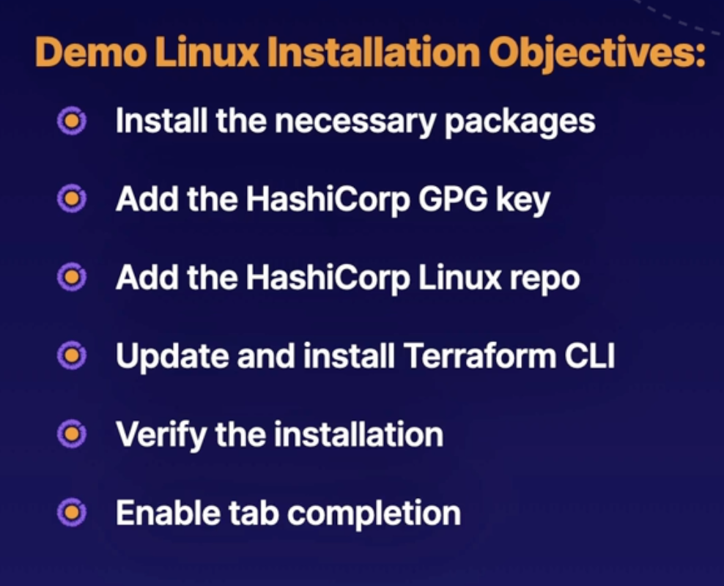

Password:
ODI3453dfgdmbr

Install it on Centos/RHEL

Check that works with: terraform -help

Autocompletion should be already installed. At least for the last versions, check internet if not.s

