1.

2.become: llegado

3.begun: empezado

4.

5.

6.brought: llevado/traido

7.

8.burst: explotado

9.bought: comprado

10.

11.

12.

13.

14.

15.

16.done: hecho

17.

17.

19.eaten: comido

20.

21.

22.felt: sentido

23.

24.

25.flown: volado

26.

27.forgotten: olvidado

28.

29.

30.

31.

32.

33.grown: crecido

34.had: tenido

35.heard: oído

36.hidden: escondido

37.

38.

39.

40.

41.

42.

43.

44.

45.

46.

47.lost: perdido

48.

49.met: encontrado/conocido

50.

51.

52.quit: dejado

53.

54.

55.

56.

57.run: corrido

58.

59.seen: mirado

60.

61.

62.sent: enviado

63.

64.shaken: sacudido

65.

66.sung: cantado

67.sat: sentado

68.slept: dormido

69.

70.

71.

72.

73.

74.

75.

|  |
| --- |
| 1. been |
| 1. become |
| 1. begun |
| 1. blown |
| 1. broken |
| 1. brought |
| 1. built |
| 1. burst |
| 1. bought |
| 10.caught |
| 11.chosen |
| 12.come |
| 13.cost |
| 14.cut |
| 15.delt |
| 16.done |
| 17.drunk |
| 18.driven |
| 19.eaten |
| 20.fallen |
| 21.fed |
| 22.felt |
| 23.fought |
| 24.found |
| 25.flown |
| 26.forbidden |
| 27.forgotten |
| 28.forgiven |
| 29.frozen |
| 30.got/gotten |
| 31.given |
| 32.gone |
| 33.grown |
| 34.had |
| 35.heard |
| 36.hidden |
| 37.3hit |
| 38.held |
| 39.hurt |
| 40.kept |
| 41.known |
| 42.laid |
| 43.led |
| 44.left |
| 45.let |
| 46.lain |
| 47.lost |
| 48.made |
| 49.met |
| 50.paid |
| 51.put |
| 52.quit |
| 53.read |
| 54.ridden |
| 55.rung |
| 56.risen |
| 57.run |
| 58.said |
| 59.seen |
| 60.sought |
| 61.sold |
| 62.sent |
| 63.set |
| 64.shaken |
| 65.shone |
| 66.sung |
| 67.sat |
| 68.slept |
| 69.spoken |
| 70.spent |
| 71.sprung |
| 72.stood |
| 73.stolen |
| 74.swum |
| 75.swung |

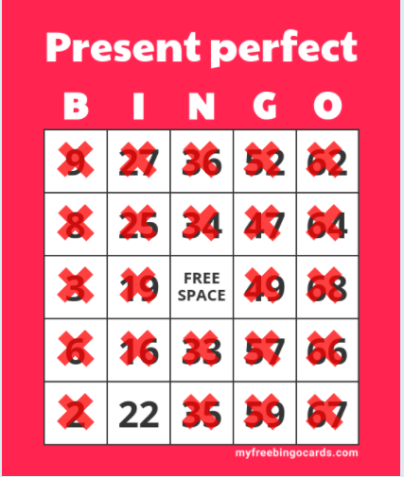

Faltaba el 22 ☹