ISM 2411 – LAB 1 Computer Vocabulary & File System Tour - Jonathan Scharf
Exercise 1. Trace a real file path
/Users/jonathanscharf/Downloads/PHI 1103 Synthesized Syllabus.pdf
- “/”
- “Users/jonathanscharf/Downloads”
- ‘PHI 1103 Synthesized Syllabus”
- “pdf”
Exercise 2. Map your project folder
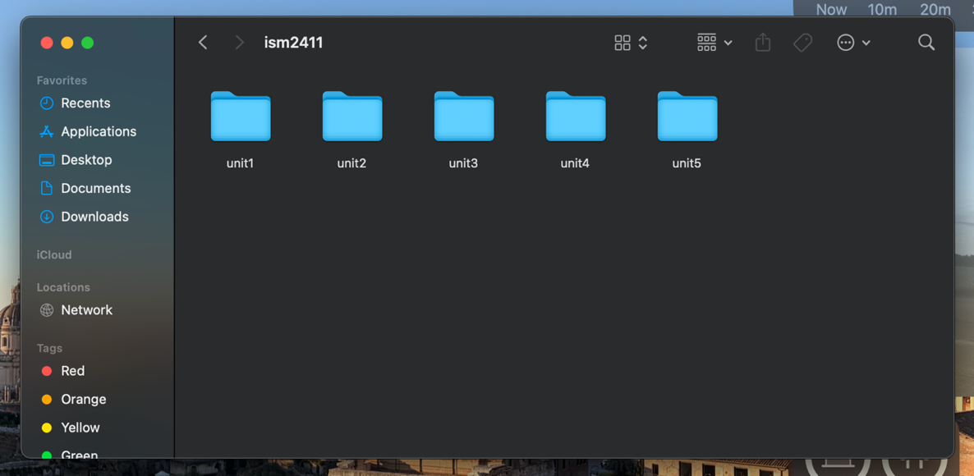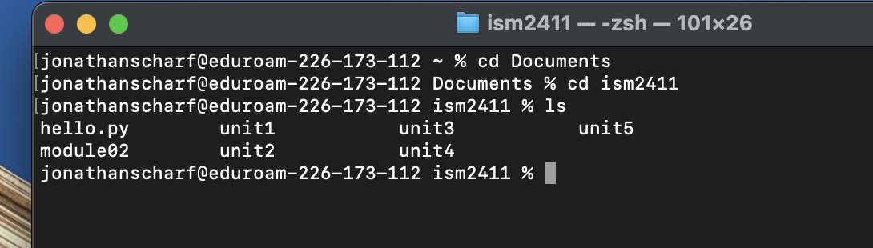

Exercise 3. Vocabulary Check
- CPU: The main brain of the computer that runs all the code and executes instructions. It can execute only one command at a time but can execute millions per second. (chef)
- RAM: The computer's short-term memory that holds the stuff you are working on right now while the computer is turned on. It gets completely cleared when you turn the computer off. (not saved) (what is on the station)
- Storage: The hard drive or SSD where all your files stay saved long-term, even after you shut down your computer. It holds a lot more than RAM, but it's slower. (pantry)
- File: A single saved piece of data or code on a computer, like a document or image.
- Directory: Just another word for a folder that holds files or other subfolders to keep things organized.
- Path: The address or route you follow through folders to find a specific file on your computer.
- Extension: The ending at the end of a file's name (like .py or .csv) that tells the computer what kind of file it is and what program to open it with.
- Program: A set of coded instructions you write to tell the computer to do a specific task.
- Interpreter: A program that reads code and runs it line-by-line right on the spot, which is how Python runs scripts without building them beforehand.

Exercise 4. Automation reflection
- Combining Data from Multiple Files
- Manually copying and pasting data from multiple separate spreadsheets into one master sheet.
- Can it be automated? Yes. A Python script can open every file in a folder, combine the data, and save a single file.
- Cleaning Up Formatting and Duplicates
- Going row-by-row to delete duplicate entries, remove blank lines, and fix mixed-up text capitalization.
- Can it be automated? Yes. Python can run clean-up rules across thousands of rows.
- Auto-fitting column widths
- Having to manually adjust column widths so the text inside is not truncated.
- Can it be automated? Yes. Python can automate this task so the column widths automatically adjust based on the text inside.

Exercise 5. Draw the directory tree
/home/alice/projects/q1_report/data/sales.csv
/home/alice/projects/q1_report/scripts/summary.py
/home/alice/projects/q2_report/data/sales.csv
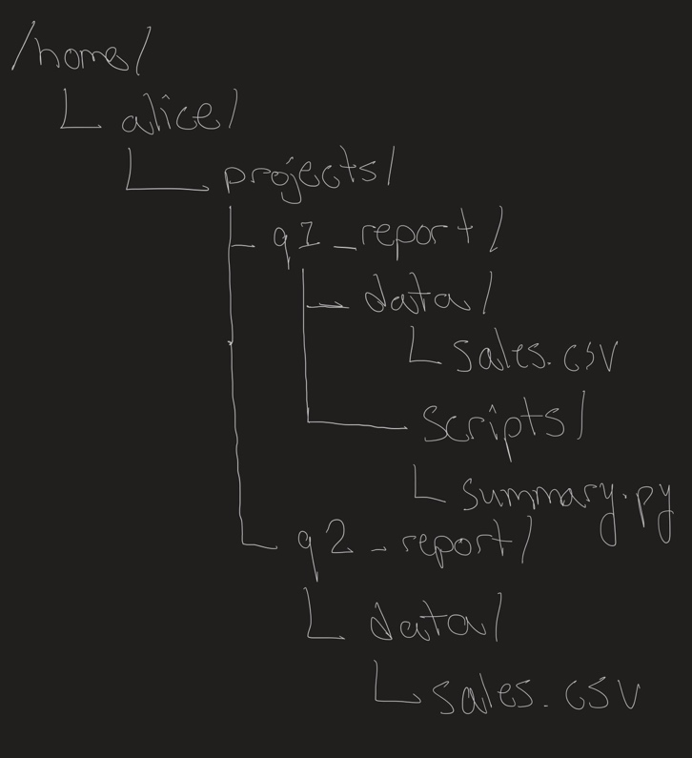
Relative Path from sales.csv in q2_report to summary.py
../../q1_report/scripts/summary.py

Exercise 6. RAM vs. Storage scenarios
(a) You edited a spreadsheet for an hour, and your laptop died. When you restart, your changes are gone.
RAM: changes were lost after restart because you did not save it because RAM does not auto-save.
(b) You try to open a CSV file and get an error saying the file cannot be found.
Storage: your file path is wrong, or the file is missing.
(c) Your Python script is running slowly when processing a 2 GB file.
Could be both (most likely RAM capacity).

Self-Assessment Questions

- Before this module, I did not know the difference between RAM, Storage, or CPU. So, I assumed that when you open an Excel file, it comes from your storage, and your main processor takes it over from there (I did not know what CPU meant). Now I know that when you open an Excel file, the system finds it on your storage and loads a copy of it into RAM. While it is in RAM, the CPU reads the contents of the file and displays it on the screen. All of this happens in a matter of seconds.
- I am least confident about the term ‘interpreter.’ I believe doing more research and reading on the essential terms of computer science will allow me to better understand the term.
- To automate the tasks I listed in Exercise 4, I would need to know how to effectively use Python. Like a language, I believe I would have to become fluent (or somewhat fluent) in Python. The tasks I listed could be very easy to automate, and I would be glad if they were.

