ISM 2411 Module 2 Lab: First Terminal Session & First Python Script
Exercise 1: Terminal Warm-Up
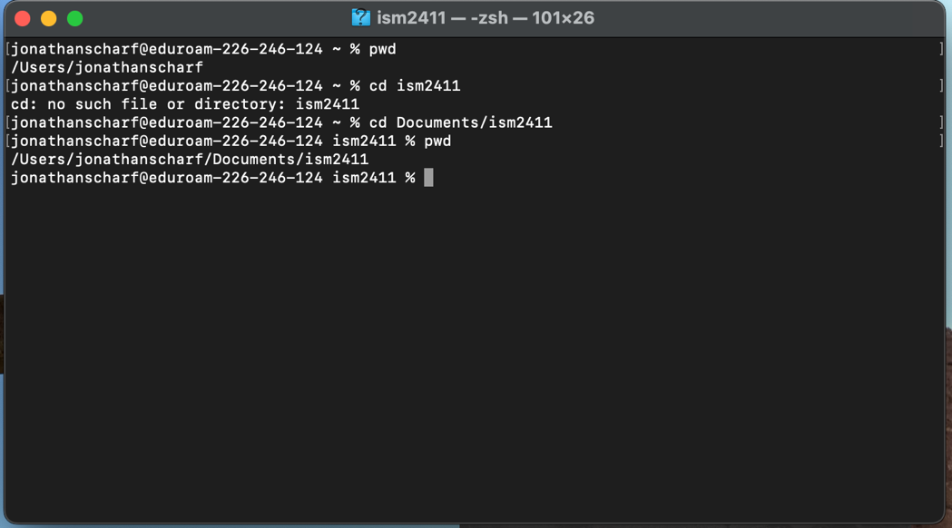

Exercise 2: Verify Python
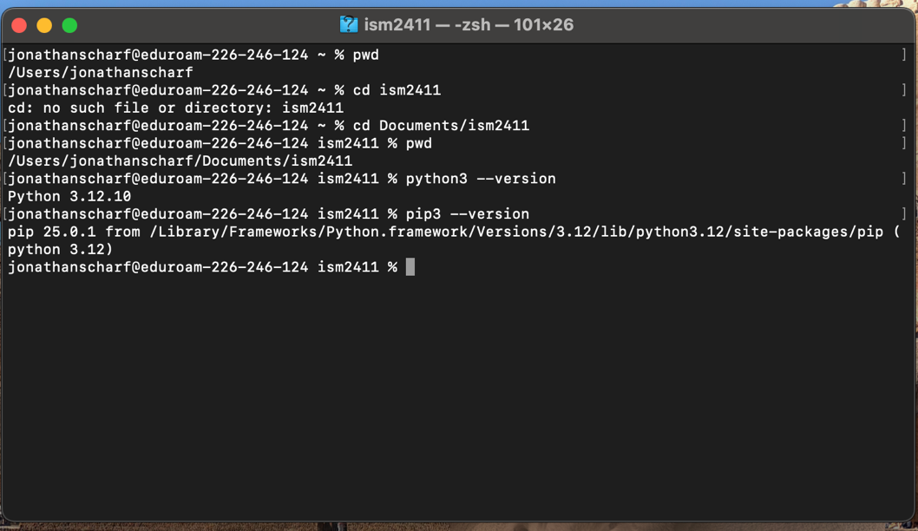

Exercise 3: Write hello.py
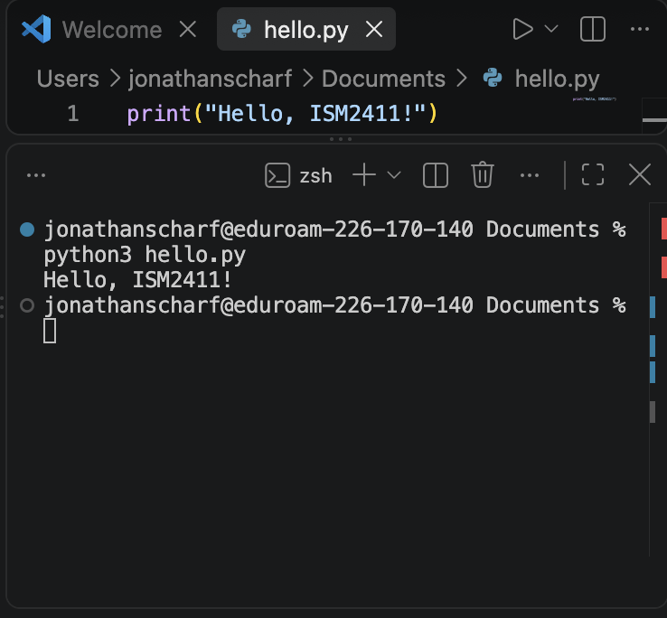
Exercise 4: Path practice
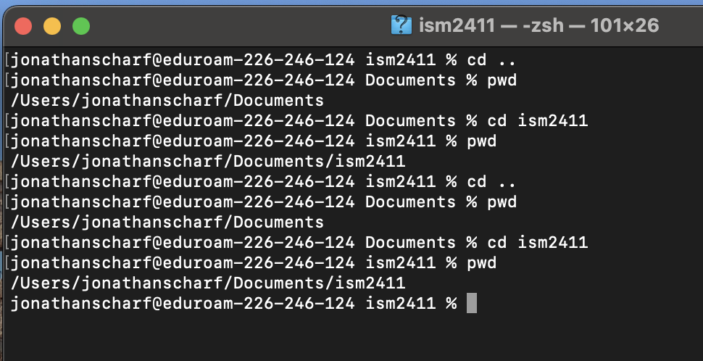

Exercise 5: Make a sub-project
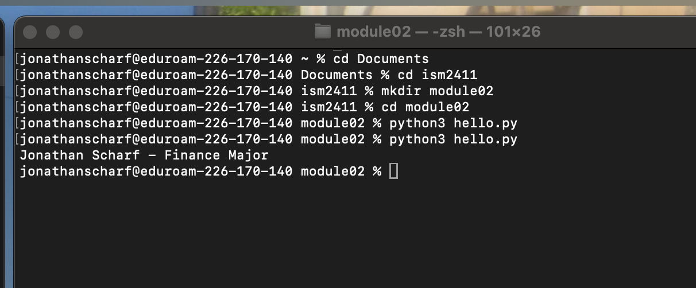

Exercise 6: Deliberate error experiment
File "/Users/jonathanscharf/Documents/ism2411/module02/hello.py", line 2, in <module>
primt("Jonathan Scharf")
^^^^^
NameError: name 'primt' is not defined. Did you mean: 'print'?
- Line number 2
- NameError
- “name ‘primt’ is not defined” means that Python tried to look up primt in its list of known names and found nothing. Python realizes that you probably meant ‘print’, so it adds “Did you mean ‘print’?” to its error to help you.
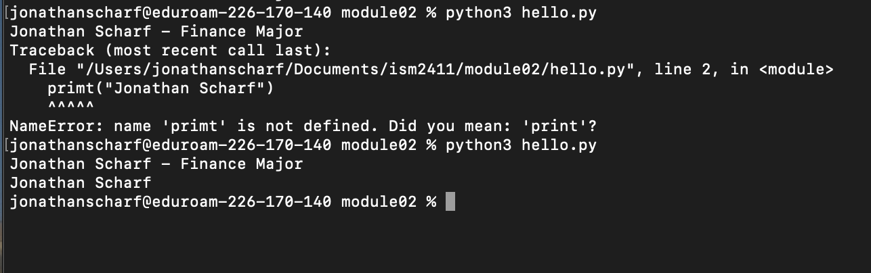

Exercise 7: Run from the wrong directory
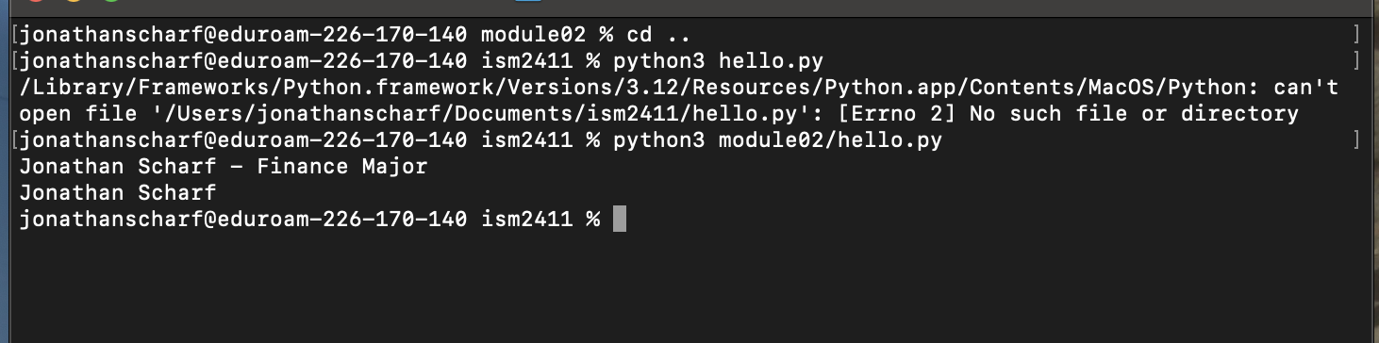
There is an error on the first attempt because you are asking Python to find a file (hello.py) in the folder ism2411. However, hello.py is not in that folder. It is in the subfolder module02 inside the folder ism2411. Python cannot search your entire computer to find files. It searches in the folder you are currently in. The second attempt uses the relative path module02/hello.py, meaning go inside module02 first, then run hello.py from there. That is why attempt one fails and attempt 2 works.

Self-Assessment Questions
- Before today, I had never used the terminal before. I use a Mac, and I had always gone to the Finder to create folders, organize my desktop, etc. Using only the terminal has changed my mental model. It has shown me that my folders and files are truly embedded in the device's storage of the device and not just in the chosen location on my desktop.
- When I encountered the error, my first instinct was to start changing things randomly, unfortunately. I was doing some practice of my own outside of the lab, and each time I got an error, I was quick to panic. This just means I am not educated enough on what the errors mean yet. Once I know what each error means, I will know how to correct each one, eliminating that instinct to mindlessly change things.
- I would have to use relative paths instead of absolute paths. Absolute paths are unique to that user because it has that “/User/”. This means Python would not work on any other user’s device than that one. Relative paths would make the code universal to all devices because it would eliminate that user uniqueness.

