2.3 安装 Prefix Cache 插件
python -m pip install -e ./plugins/prefix_cache

2.4 验证安装
ais-bench-prefix-cache --help

3.1 复制并修改配置
固定长度，prefix cache命中率为90%，数据来源指定样本，warmup。
cp ./plugins/prefix_cache/config_examples/scenario.example.json ./scenario.json

4.1修改配置
vi scenario.json
{
"schema_version": "1.0",
"run": {
"run_id": "gsm8k-token2048-prefix-cache-70_7",
"random_seed": 42,
"output_dir": "./outputs/gsm8k-token2048-prefix-cache-70_7"
},
"tokenizer": {
"path": "/home/weights/Qwen3-8B",
"block_size": 8,
"trust_remote_code": false
},
"corpus": {
"path": "ais_bench/datasets/gsm8k/test.jsonl",
"field": "question",
"selection": {
"mode": "indices",
"values": [0, 1]
}
},
"requests": {
"count": 10,
"input_length": {"mode": "fixed", "value": 131072},
"output_length": {"mode": "fixed", "value": 32}
},
"prefix_cache": {
"mode": "warmup",
"target_hit_rate": 0.9,
"seed_blocks": 1,
"groups": {"count": 2, "assignment": {"mode": "uniform"}},
"order": {"strategy": "interleave"}
},
"service": {
"inference_url": "http://127.0.0.1:8005/v1/completions",
"metrics_url": "http://127.0.0.1:8005/metrics",
"reset_url": "http://127.0.0.1:8005/reset_prefix_cache",
"model": "qwen3",
"dp_size": 1,
"assume_empty_cache": false
},
"validation": {"target_warning_pp": 1.0, "actual_warning_pp": 5.0},
"aisbench": {"config": "./prefix_cache_perf.py", "work_dir": "./outputs/aisbench", "extra_args": ["--num-warmups", "0"]}
}

5.1 执行inspect查看预跑结果
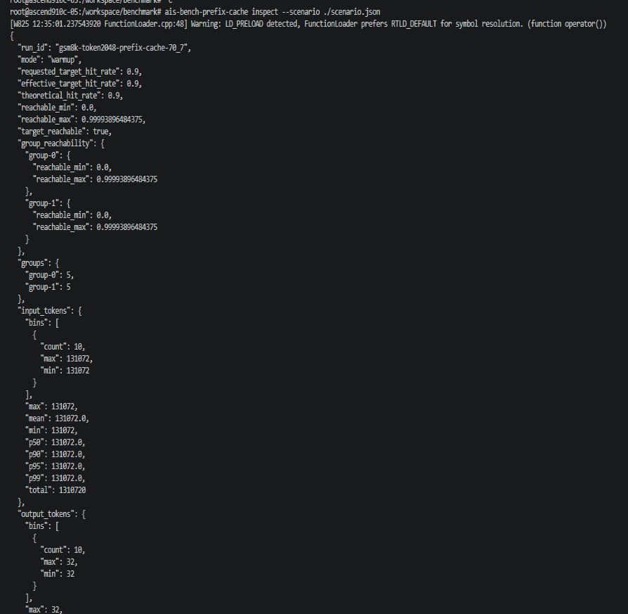
alt text

5.1 执行scenario查看产生结果
ais-bench-prefix-cache prepare –scenario ./scenario.json 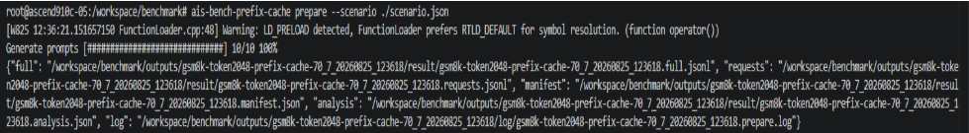
每条请求长度 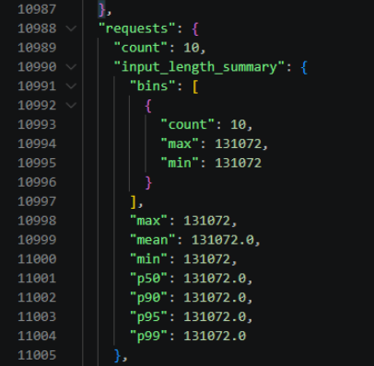
命中率，理论命中率 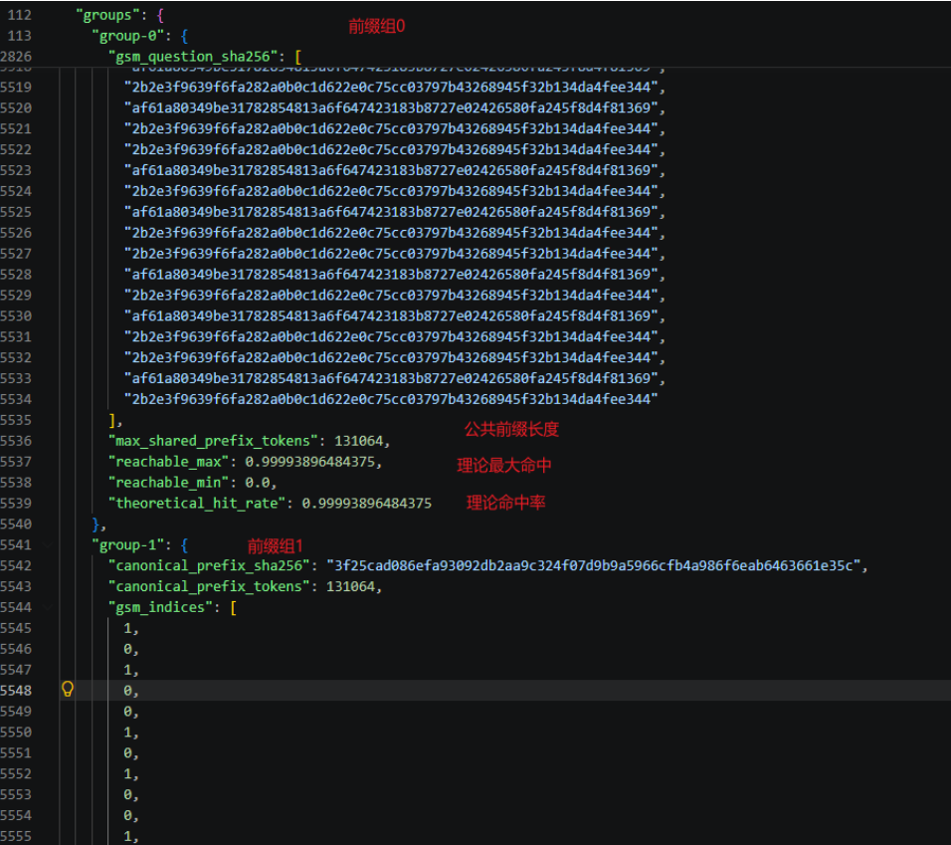
数据来源随机，指定长度，命中率50%,单前缀，，多dp，无预热cold模式
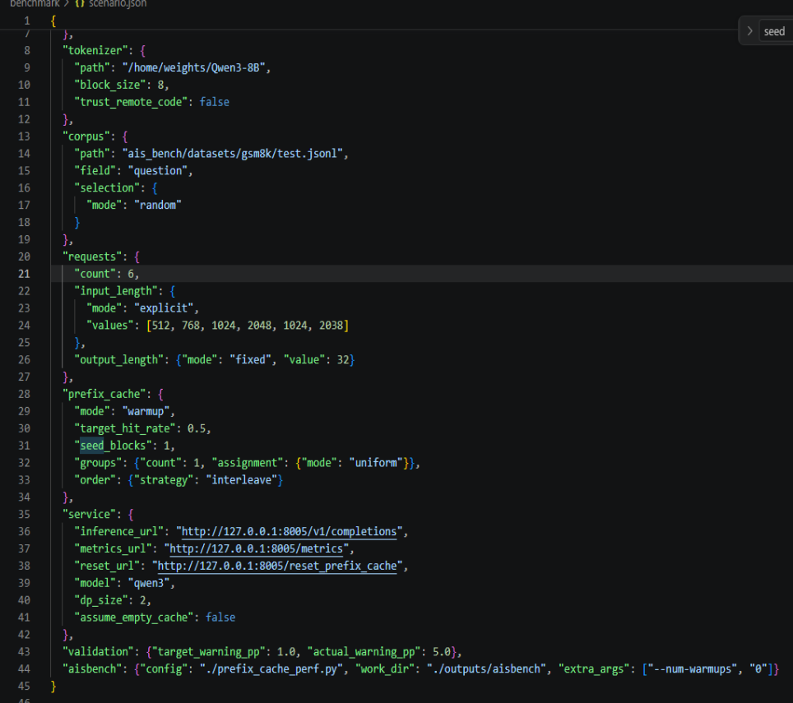
alt text
执行ais-bench-prefix-cache inspect –scenario ./scenario.json 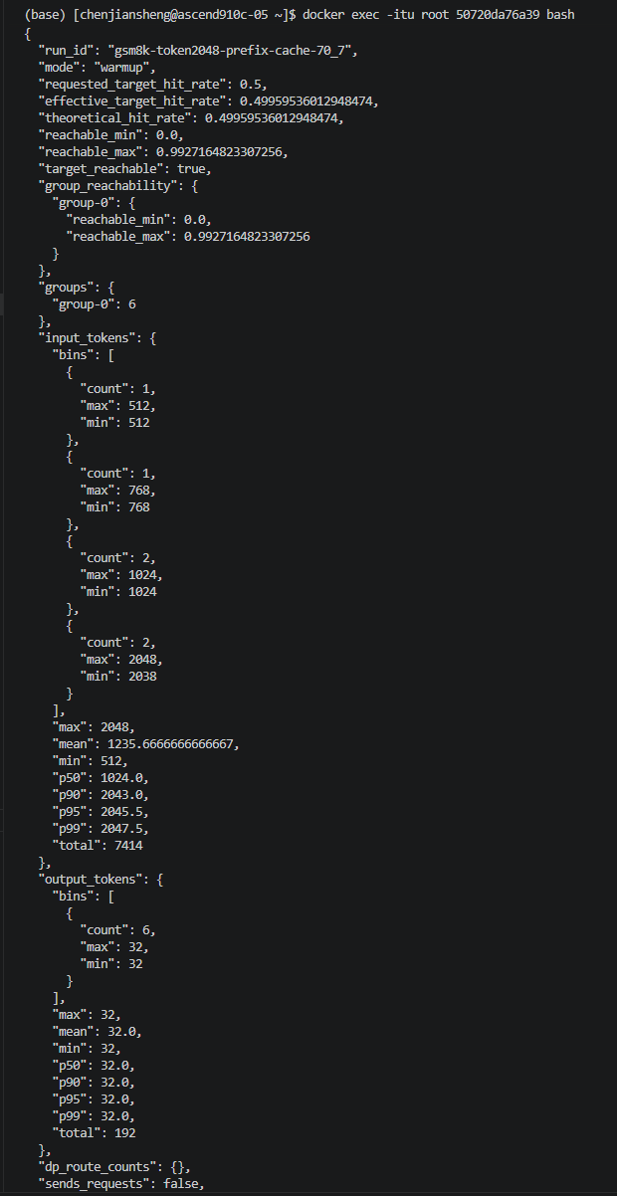
执行ais-bench-prefix-cache prepare –scenario ./scenario.json 生成产物
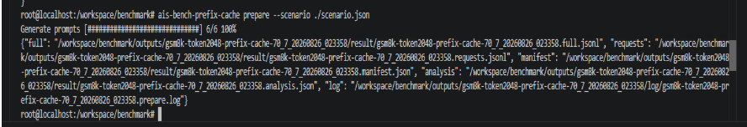
alt text
gsm8k-token2048-prefix-cache-70_7_20260826_023358.manifest.json 查看
{
"artifacts": {
"analysis": {
"bytes": 792,
"name": "gsm8k-token2048-prefix-cache-70_7_20260826_023358.analysis.json",
"path": "/workspace/benchmark/outputs/gsm8k-token2048-prefix-cache-70_7_20260826_023358/result/gsm8k-token2048-prefix-cache-70_7_20260826_023358.analysis.json",
"sha256_at_prepare": "a6cce7e755370394c06a3f844d429a2dc678b9555b2a7a079581978655b57612"
},
"full": {
"bytes": 37591,
"name": "gsm8k-token2048-prefix-cache-70_7_20260826_023358.full.jsonl",
"path": "/workspace/benchmark/outputs/gsm8k-token2048-prefix-cache-70_7_20260826_023358/result/gsm8k-token2048-prefix-cache-70_7_20260826_023358.full.jsonl",
"rows": 6,
"sha256": "24a2e62814b446da7d02f504d3933d82afa2848a0a014573cc1e21c9f3664b5f"
},
"requests": {
"bytes": 28190,
"name": "gsm8k-token2048-prefix-cache-70_7_20260826_023358.requests.jsonl",
"path": "/workspace/benchmark/outputs/gsm8k-token2048-prefix-cache-70_7_20260826_023358/result/gsm8k-token2048-prefix-cache-70_7_20260826_023358.requests.jsonl",
"rows": 6,
"sha256": "a7a3594d297a318665e496b5d9ea33c65a92c114657d2f087ff636ff5a0ca045"
}
},
"corpus_sha256": "f0eb4527e0a64e03db1eeba22a4cdd5806f14b8d8eeb41b2224151de64855ee5",
"divergence": {
"collision_status": "pass",
"request_count": 6,
"strategy": "globally_unique_seed_block",
"unique_request_blocks": 6
},
"dp": {
"cold_route_strategy": null,
"size": 2
},
"effective_config": {
"aisbench": {
"config": "./prefix_cache_perf.py",
"extra_args": [
"--num-warmups",
"0"
],
"work_dir": "./outputs/aisbench"
},
"corpus": {
"field": "question",
"path": "/workspace/benchmark/ais_bench/datasets/gsm8k/test.jsonl",
"selection": {
"mode": "random"
}
},
"prefix_cache": {
"groups": {
"assignment": {
"mode": "uniform"
},
"count": 1,
"overrides": {}
},
"minimum_non_shared_length": 8,
"mode": "warmup",
"order": {
"strategy": "interleave"
},
"seed_blocks": 1,
"target_hit_rate": 0.5
},
"requests": {
"count": 6,
"input_length": {
"mode": "explicit",
"values": [
512,
768,
1024,
2048,
1024,
2038
]
},
"output_length": {
"mode": "fixed",
"value": 32
}
},
"run": {
"output_dir": "/workspace/benchmark/outputs/gsm8k-token2048-prefix-cache-70_7_20260826_023358",
"overwrite": false,
"random_seed": 42,
"run_id": "gsm8k-token2048-prefix-cache-70_7_20260826_023358"
},
"schema_version": "1.0",
"service": {
"api_key_configured": false,
"assume_empty_cache": false,
"dp_size": 2,
"engine_label_map": {},
"inference_url": "http://127.0.0.1:8005/v1/completions",
"metrics_url": "http://127.0.0.1:8005/metrics",
"model": "qwen3",
"reset_url": "http://127.0.0.1:8005/reset_prefix_cache",
"timeout_seconds": 30
},
"tokenizer": {
"block_size": 8,
"path": "/home/weights/Qwen3-8B",
"revision": null,
"trust_remote_code": false
},
"validation": {
"actual_warning_pp": 5.0,
"target_warning_pp": 1.0
}
},
"effective_config_sha256": "8202dec96871ef8a742143596a8100c6a3fc87857827c6fd8d0ceda5b90c5ff4",
"groups": {
"group-0": {
"canonical_prefix_sha256": "526f4d3d8c054bd0078123356cb081d5092c6223b53dceda81e340e021bb906a",
"canonical_prefix_tokens": 1424,
"gsm_indices": [
714,
1201,
930,
909,
453,
868,
714,
1201,
930,
909,
453,
868,
714,
1201,
930,
909,
453,
868,
714,
1201,
930,
909,
453,
868
],
"gsm_question_sha256": [
"5cf9c68f4924c386bd63034055295e46c2a6791442501d919613fc97bb07862b",
"2e6bc1105e5c98e822fec30689fdba76d3ec019524d23c0b9650e1e31a00a7d3",
"35ca9ab30c488b97b740f779e422691b52bd4a91309a5bc360d59f7f99333372",
"f4ff034a99ca4c87819e0f39eb52884da33e8325bf1553f518a0704a3b9284ab",
"15d709c6a1ea1a1311decd569cfe2da6c1cc298cdf1e18fca24fcaae4f25d922",
"4bbece0d27fe35d055dab1d01b1ab694c8f585d2c80a414ba3f8374abf37e2a2",
"5cf9c68f4924c386bd63034055295e46c2a6791442501d919613fc97bb07862b",
"2e6bc1105e5c98e822fec30689fdba76d3ec019524d23c0b9650e1e31a00a7d3",
"35ca9ab30c488b97b740f779e422691b52bd4a91309a5bc360d59f7f99333372",
"f4ff034a99ca4c87819e0f39eb52884da33e8325bf1553f518a0704a3b9284ab",
"15d709c6a1ea1a1311decd569cfe2da6c1cc298cdf1e18fca24fcaae4f25d922",
"4bbece0d27fe35d055dab1d01b1ab694c8f585d2c80a414ba3f8374abf37e2a2",
"5cf9c68f4924c386bd63034055295e46c2a6791442501d919613fc97bb07862b",
"2e6bc1105e5c98e822fec30689fdba76d3ec019524d23c0b9650e1e31a00a7d3",
"35ca9ab30c488b97b740f779e422691b52bd4a91309a5bc360d59f7f99333372",
"f4ff034a99ca4c87819e0f39eb52884da33e8325bf1553f518a0704a3b9284ab",
"15d709c6a1ea1a1311decd569cfe2da6c1cc298cdf1e18fca24fcaae4f25d922",
"4bbece0d27fe35d055dab1d01b1ab694c8f585d2c80a414ba3f8374abf37e2a2",
"5cf9c68f4924c386bd63034055295e46c2a6791442501d919613fc97bb07862b",
"2e6bc1105e5c98e822fec30689fdba76d3ec019524d23c0b9650e1e31a00a7d3",
"35ca9ab30c488b97b740f779e422691b52bd4a91309a5bc360d59f7f99333372",
"f4ff034a99ca4c87819e0f39eb52884da33e8325bf1553f518a0704a3b9284ab",
"15d709c6a1ea1a1311decd569cfe2da6c1cc298cdf1e18fca24fcaae4f25d922",
"4bbece0d27fe35d055dab1d01b1ab694c8f585d2c80a414ba3f8374abf37e2a2"
],
"max_shared_prefix_tokens": 1424,
"reachable_max": 0.9927164823307256,
"reachable_min": 0.0,
"theoretical_hit_rate": 0.49959536012948474
}
},
"plugin_version": "0.1.2",
"prefix_cache": {
"adjusted": true,
"effective_target_hit_rate": 0.49959536012948474,
"minimum_non_shared_length": 8,
"mode": "warmup",
"reachable_max": 0.9927164823307256,
"reachable_min": 0.0,
"reason": "block alignment prevents an exact target hit count",
"requested_target_hit_rate": 0.5,
"target_absolute_difference_pp": 0.04046398705152554,
"target_reachable": true,
"target_signed_difference_pp": -0.04046398705152554,
"theoretical_hit_rate": 0.49959536012948474,
"validation_status": "PASS"
},
"requests": {
"count": 6,
"input_length_summary": {
"bins": [
{
"count": 1,
"max": 512,
"min": 512
},
{
"count": 1,
"max": 768,
"min": 768
},
{
"count": 2,
"max": 1024,
"min": 1024
},
{
"count": 2,
"max": 2048,
"min": 2038
}
],
"max": 2048,
"mean": 1235.6666666666667,
"min": 512,
"p50": 1024.0,
"p90": 2043.0,
"p95": 2045.5,
"p99": 2047.5
},
"output_length_summary": {
"bins": [
{
"count": 6,
"max": 32,
"min": 32
}
],
"max": 32,
"mean": 32.0,
"min": 32,
"p50": 32.0,
"p90": 32.0,
"p95": 32.0,
"p99": 32.0
},
"total_input_tokens": 7414
},
"run_id": "gsm8k-token2048-prefix-cache-70_7_20260826_023358",
"scenario_path": "/workspace/benchmark/scenario.json",
"scenario_sha256": "652a7e311d2a3c58517c7fd1877489bc16b6dc0ae4e1754d45afcc49c7ddedbc",
"schema_version": "1.0",
"tokenizer": {
"block_size": 8,
"class": "transformers.models.qwen2.tokenization_qwen2.Qwen2Tokenizer",
"fingerprint_sha256": "91f96ae6210c7412cf2132c497e327981a375318da1cb81db583f6a6773972c2",
"path": "/home/weights/Qwen3-8B",
"revision": null,
"special_token_ids": [
151643,
151644,
151645,
151646,
151647,
151648,
151649,
151650,
151651,
151652,
151653,
151654,
151655,
151656
],
"vocab_size": 151669
},
"warmup": {
"enabled": true,
"plan": [
{
"dp_rank": 0,
"group_id": "group-0",
"included_in_formal_statistics": false,
"input_tokens": 1432,
"max_tokens": 1,
"prompt": "James decides to pick some blueberries. It cost $20 to go picking and then another $1.5 per pound. He picked 30 pounds of blueberries. How much did he save compared to buying at the store for $2.5 a pound? There are 66 fish in the fish tank. One-third of the fish have red stripes, and 5/11 of the remaining fish have blue stripes. Altogether, how many fish have red stripes and blue stripes? When Sophie watches her nephew, she gets out a variety of toys for him. The bag of building blocks has 31 blocks in it. The bin of stuffed animals has 8 stuffed animals inside. The tower of stacking rings has 9 multicolored rings on it. Sophie recently bought a tube of bouncy balls, bringing her total number of toys for her nephew up to 62. How many bouncy balls came in the tube? Duncan's age eight years ago was two times Adam's age four years ago. If Duncan's age is 60 now, how old will Adam be in 8 years? Jenna starts out with 8 sapphires. She trades 3 sapphires for two rubies. If sapphires are worth $800 and rubies are worth $1200, how much money are all her jewels worth? A three-ounce box of flavored jello makes 10 small jello cups. Greg wants to make small jello cups for his son's outdoor birthday party. There will be 30 kids and he wants to have enough so that each kid can have 4 jello cups. Jello is currently on sale for $1.25. How much will he spend on jello? James decides to pick some blueberries. It cost $20 to go picking and then another $1.5 per pound. He picked 30 pounds of blueberries. How much did he save compared to buying at the store for $2.5 a pound? There are 66 fish in the fish tank. One-third of the fish have red stripes, and 5/11 of the remaining fish have blue stripes. Altogether, how many fish have red stripes and blue stripes? When Sophie watches her nephew, she gets out a variety of toys for him. The bag of building blocks has 31 blocks in it. The bin of stuffed animals has 8 stuffed animals inside. The tower of stacking rings has 9 multicolored rings on it. Sophie recently bought a tube of bouncy balls, bringing her total number of toys for her nephew up to 62. How many bouncy balls came in the tube? Duncan's age eight years ago was two times Adam's age four years ago. If Duncan's age is 60 now, how old will Adam be in 8 years? Jenna starts out with 8 sapphires. She trades 3 sapphires for two rubies. If sapphires are worth $800 and rubies are worth $1200, how much money are all her jewels worth? A three-ounce box of flavored jello makes 10 small jello cups. Greg wants to make small jello cups for his son's outdoor birthday party. There will be 30 kids and he wants to have enough so that each kid can have 4 jello cups. Jello is currently on sale for $1.25. How much will he spend on jello? James decides to pick some blueberries. It cost $20 to go picking and then another $1.5 per pound. He picked 30 pounds of blueberries. How much did he save compared to buying at the store for $2.5 a pound? There are 66 fish in the fish tank. One-third of the fish have red stripes, and 5/11 of the remaining fish have blue stripes. Altogether, how many fish have red stripes and blue stripes? When Sophie watches her nephew, she gets out a variety of toys for him. The bag of building blocks has 31 blocks in it. The bin of stuffed animals has 8 stuffed animals inside. The tower of stacking rings has 9 multicolored rings on it. Sophie recently bought a tube of bouncy balls, bringing her total number of toys for her nephew up to 62. How many bouncy balls came in the tube? Duncan's age eight years ago was two times Adam's age four years ago. If Duncan's age is 60 now, how old will Adam be in 8 years? Jenna starts out with 8 sapphires. She trades 3 sapphires for two rubies. If sapphires are worth $800 and rubies are worth $1200, how much money are all her jewels worth? A three-ounce box of flavored jello makes 10 small jello cups. Greg wants to make small jello cups for his son's outdoor birthday party. There will be 30 kids and he wants to have enough so that each kid can have 4 jello cups. Jello is currently on sale for $1.25. How much will he spend on jello? James decides to pick some blueberries. It cost $20 to go picking and then another $1.5 per pound. He picked 30 pounds of blueberries. How much did he save compared to buying at the store for $2.5 a pound? There are 66 fish in the fish tank. One-third of the fish have red stripes, and 5/11 of the remaining fish have blue stripes. Altogether, how many fish have red stripes and blue stripes? When Sophie watches her nephew, she gets out a variety of toys for him. The bag of building blocks has 31 blocks in it. The bin of stuffed animals has 8 stuffed animals inside. The tower of stacking rings has 9 multicolored rings on it. Sophie recently bought a tube of bouncy balls, bringing her total number of toys for her nephew up to 62. How many bouncy balls came in the tube? Duncan's age eight years ago was two times Adam's age four years ago. If Duncan's age is 60 now, how old will Adam be in 8 years? Jenna starts out with 8 sapphires. She trades 3 sapphires for two rubies. If sapphires are worth $800 and rubies are worth $1200, how much money are all her jewels worth? A three-ounce box of flavored jello makes 10 small jello cups. Greg wants to make small jello cups for his son's outdoor birthday party. There will be 30 kids and he wants to c n tr { t return w {",
"request_id": "warmup:group-0:0",
"shared_prefix_tokens": 1424
},
{
"dp_rank": 1,
"group_id": "group-0",
"included_in_formal_statistics": false,
"input_tokens": 1432,
"max_tokens": 1,
"prompt": "James decides to pick some blueberries. It cost $20 to go picking and then another $1.5 per pound. He picked 30 pounds of blueberries. How much did he save compared to buying at the store for $2.5 a pound? There are 66 fish in the fish tank. One-third of the fish have red stripes, and 5/11 of the remaining fish have blue stripes. Altogether, how many fish have red stripes and blue stripes? When Sophie watches her nephew, she gets out a variety of toys for him. The bag of building blocks has 31 blocks in it. The bin of stuffed animals has 8 stuffed animals inside. The tower of stacking rings has 9 multicolored rings on it. Sophie recently bought a tube of bouncy balls, bringing her total number of toys for her nephew up to 62. How many bouncy balls came in the tube? Duncan's age eight years ago was two times Adam's age four years ago. If Duncan's age is 60 now, how old will Adam be in 8 years? Jenna starts out with 8 sapphires. She trades 3 sapphires for two rubies. If sapphires are worth $800 and rubies are worth $1200, how much money are all her jewels worth? A three-ounce box of flavored jello makes 10 small jello cups. Greg wants to make small jello cups for his son's outdoor birthday party. There will be 30 kids and he wants to have enough so that each kid can have 4 jello cups. Jello is currently on sale for $1.25. How much will he spend on jello? James decides to pick some blueberries. It cost $20 to go picking and then another $1.5 per pound. He picked 30 pounds of blueberries. How much did he save compared to buying at the store for $2.5 a pound? There are 66 fish in the fish tank. One-third of the fish have red stripes, and 5/11 of the remaining fish have blue stripes. Altogether, how many fish have red stripes and blue stripes? When Sophie watches her nephew, she gets out a variety of toys for him. The bag of building blocks has 31 blocks in it. The bin of stuffed animals has 8 stuffed animals inside. The tower of stacking rings has 9 multicolored rings on it. Sophie recently bought a tube of bouncy balls, bringing her total number of toys for her nephew up to 62. How many bouncy balls came in the tube? Duncan's age eight years ago was two times Adam's age four years ago. If Duncan's age is 60 now, how old will Adam be in 8 years? Jenna starts out with 8 sapphires. She trades 3 sapphires for two rubies. If sapphires are worth $800 and rubies are worth $1200, how much money are all her jewels worth? A three-ounce box of flavored jello makes 10 small jello cups. Greg wants to make small jello cups for his son's outdoor birthday party. There will be 30 kids and he wants to have enough so that each kid can have 4 jello cups. Jello is currently on sale for $1.25. How much will he spend on jello? James decides to pick some blueberries. It cost $20 to go picking and then another $1.5 per pound. He picked 30 pounds of blueberries. How much did he save compared to buying at the store for $2.5 a pound? There are 66 fish in the fish tank. One-third of the fish have red stripes, and 5/11 of the remaining fish have blue stripes. Altogether, how many fish have red stripes and blue stripes? When Sophie watches her nephew, she gets out a variety of toys for him. The bag of building blocks has 31 blocks in it. The bin of stuffed animals has 8 stuffed animals inside. The tower of stacking rings has 9 multicolored rings on it. Sophie recently bought a tube of bouncy balls, bringing her total number of toys for her nephew up to 62. How many bouncy balls came in the tube? Duncan's age eight years ago was two times Adam's age four years ago. If Duncan's age is 60 now, how old will Adam be in 8 years? Jenna starts out with 8 sapphires. She trades 3 sapphires for two rubies. If sapphires are worth $800 and rubies are worth $1200, how much money are all her jewels worth? A three-ounce box of flavored jello makes 10 small jello cups. Greg wants to make small jello cups for his son's outdoor birthday party. There will be 30 kids and he wants to have enough so that each kid can have 4 jello cups. Jello is currently on sale for $1.25. How much will he spend on jello? James decides to pick some blueberries. It cost $20 to go picking and then another $1.5 per pound. He picked 30 pounds of blueberries. How much did he save compared to buying at the store for $2.5 a pound? There are 66 fish in the fish tank. One-third of the fish have red stripes, and 5/11 of the remaining fish have blue stripes. Altogether, how many fish have red stripes and blue stripes? When Sophie watches her nephew, she gets out a variety of toys for him. The bag of building blocks has 31 blocks in it. The bin of stuffed animals has 8 stuffed animals inside. The tower of stacking rings has 9 multicolored rings on it. Sophie recently bought a tube of bouncy balls, bringing her total number of toys for her nephew up to 62. How many bouncy balls came in the tube? Duncan's age eight years ago was two times Adam's age four years ago. If Duncan's age is 60 now, how old will Adam be in 8 years? Jenna starts out with 8 sapphires. She trades 3 sapphires for two rubies. If sapphires are worth $800 and rubies are worth $1200, how much money are all her jewels worth? A three-ounce box of flavored jello makes 10 small jello cups. Greg wants to make small jello cups for his son's outdoor birthday party. There will be 30 kids and he wants to a w < in a with g (",
"request_id": "warmup:group-0:1",
"shared_prefix_tokens": 1424
}
]
}
}
每组的命中率偏差，和总体命中率偏差 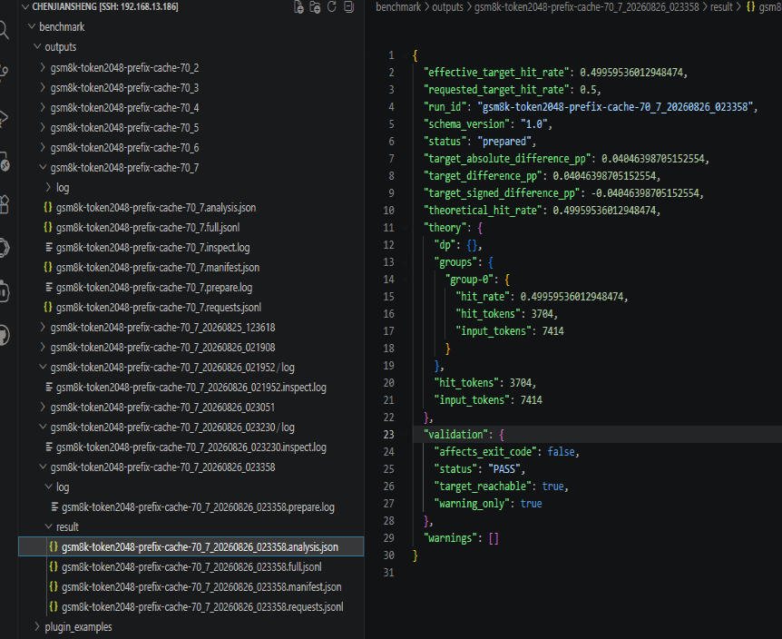
最后request.jsonl生成的产物 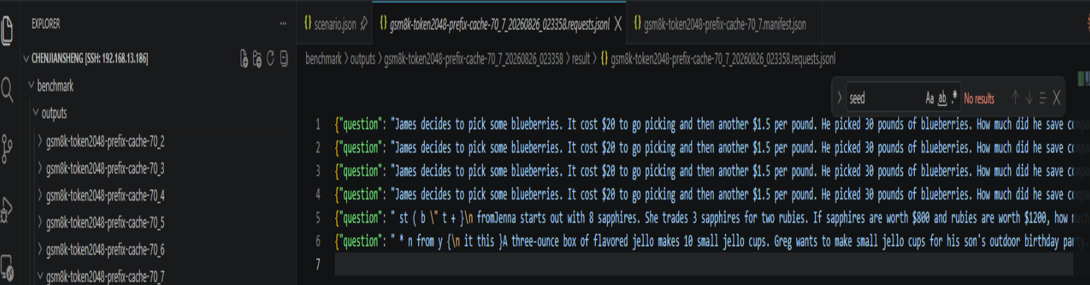
截断分布 命中率90%
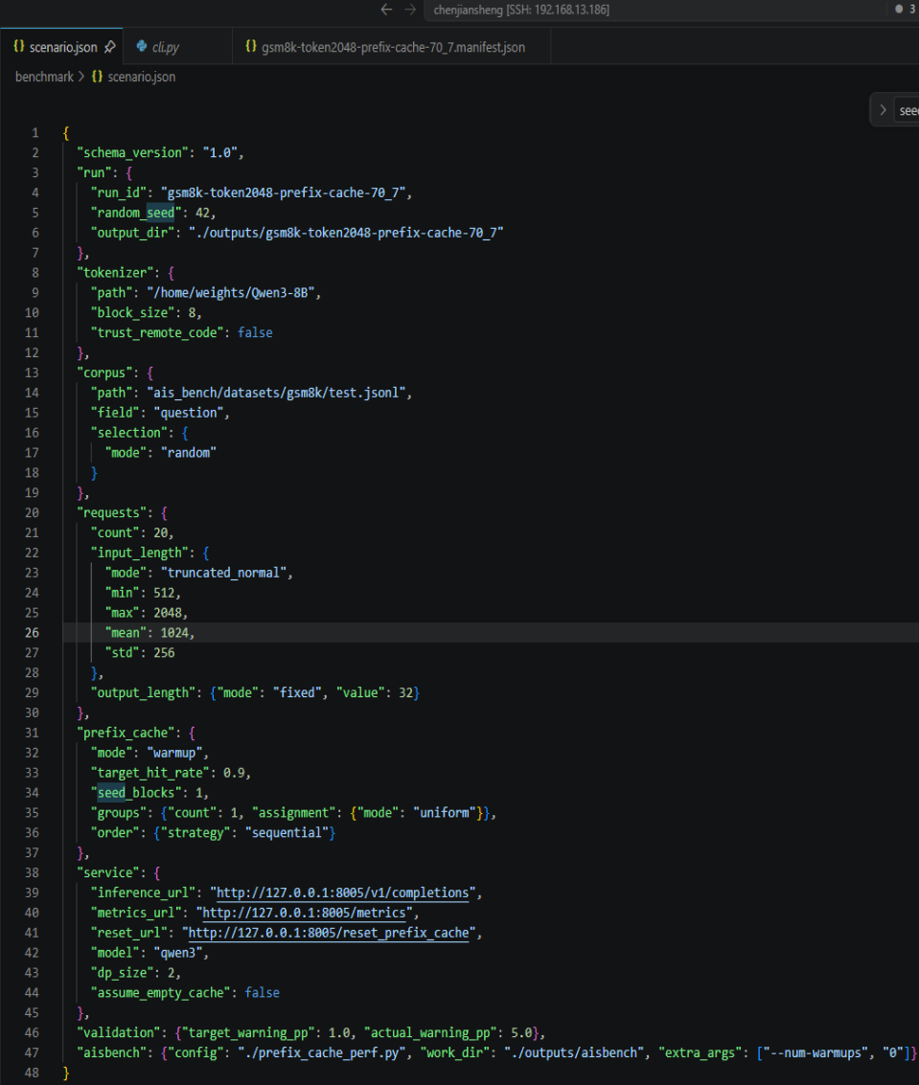
alt text
执行完ais-bench-prefix-cache inspect –scenario ./scenario.json后
{
"run_id": "gsm8k-token2048-prefix-cache-70_7",
"mode": "warmup",
"requested_target_hit_rate": 0.9,
"effective_target_hit_rate": 0.900014553922282,
"theoretical_hit_rate": 0.900014553922282,
"reachable_min": 0.0,
"reachable_max": 0.9888905059913646,
"target_reachable": true,
"group_reachability": {
"group-0": {
"reachable_min": 0.0,
"reachable_max": 0.9888905059913646
}
},
"groups": {
"group-0": 20
},
"input_tokens": {
"bins": [
{
"count": 1,
"max": 641,
"min": 641
},
{
"count": 1,
"max": 764,
"min": 764
},
{
"count": 1,
"max": 835,
"min": 835
},
{
"count": 7,
"max": 997,
"min": 956
},
{
"count": 3,
"max": 1054,
"min": 1035
},
{
"count": 3,
"max": 1109,
"min": 1083
},
{
"count": 2,
"max": 1204,
"min": 1192
},
{
"count": 2,
"max": 1360,
"min": 1322
}
],
"max": 1360,
"mean": 1030.65,
"min": 641,
"p50": 1016.0,
"p90": 1215.8000000000002,
"p95": 1323.8999999999999,
"p99": 1352.78,
"total": 20613
},
"output_tokens": {
"bins": [
{
"count": 20,
"max": 32,
"min": 32
}
],
"max": 32,
"mean": 32.0,
"min": 32,
"p50": 32.0,
"p90": 32.0,
"p95": 32.0,
"p99": 32.0,
"total": 640
},
"dp_route_counts": {},
"sends_requests": false,
"log": "/workspace/benchmark/outputs/gsm8k-token2048-prefix-cache-70_7_20260826_025353/log/gsm8k-token2048-prefix-cache-70_7_20260826_025353.inspect.log"
}
执行完 数据分布 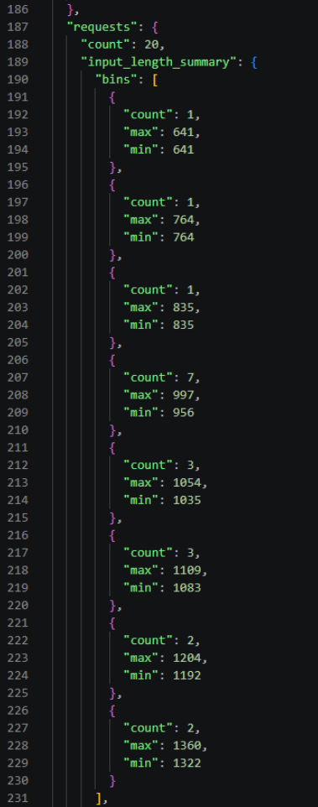
命中率： 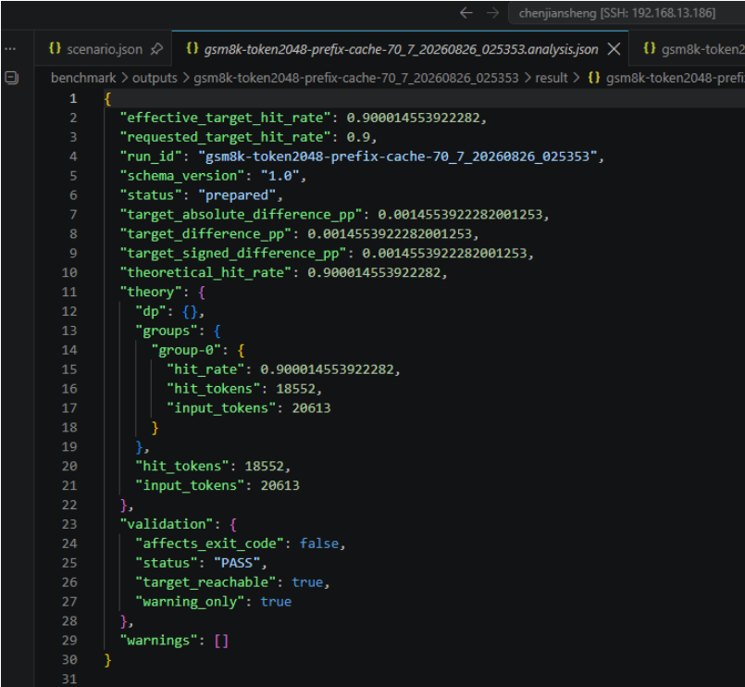
执行命令查看sha值是否被人改动 ais-bench-prefix-cache validate –manifest outputs/gsm8k-token2048-prefix-cache-70_7_20260826_025353/result/gsm8k-token2048-prefix-cache-70_7_20260826_025353.manifest.json
alt text

