1、docker 起vllm服务
vllm serve /home/weights/Qwen3.6-27B/ \
--served-model-name qwen3.6 \
--tensor-parallel-size 4 \
--max-model-len 262144 \
--dtype bfloat16 \
--gpu-memory-utilization 0.85 \
--max-num-seqs 4 \
--max-num-batched-tokens 16384 \
--reasoning-parser qwen3 \
--enable-auto-tool-choice \
--tool-call-parser qwen3_coder \
--port 8005

2、下载依赖
pip3 install -e ./ --use-pep517 -i https://mirrors.aliyun.com/pypi/simple/
pip3 install -r requirements/api.txt -i https://mirrors.aliyun.com/pypi/simple/
pip3 install -r requirements/extra.txt -i https://mirrors.aliyun.com/pypi/simple/

pip install pyarrow==15.0.0 -i https://mirrors.aliyun.com/pypi/simple/
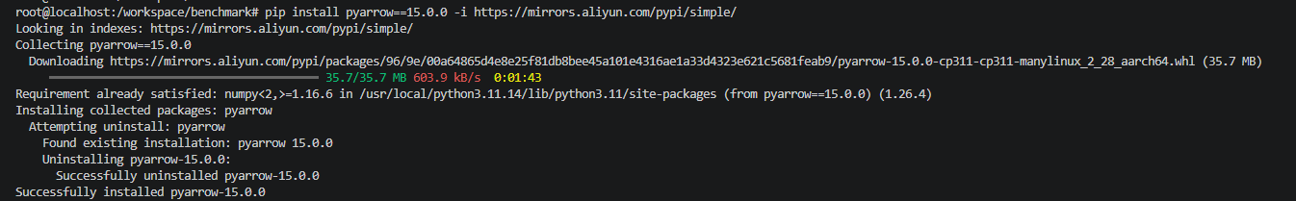

3、下载nltk包
https://github.com/nltk/nltk_data/archive/refs/heads/gh-pages.zip
将压缩包放置到aisbench启动的容器内。位置随意，建议放在workspace下。

unzip nltk_data-gh-pages.zip
mkdir nltk_data
mv nltk_data-gh-pages/packages/* nltk_data/
cd nltk_data
find . -name "*.zip" -exec sh -c 'unzip -o "$$1"−d"$$(dirname "$1")"' _ {} \;

在执行终端中执行export NLTK_DATA=/your/custom/path
比如nltk_data在容器内的路径为 /workspace/nltk_data
则export NLTK_DATA=/workspace/nltk_data
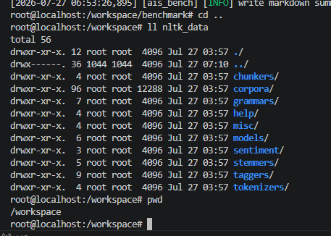

4、修改vllm_api_general_chat.py配置文件
from ais_bench.benchmark.utils.postprocess.model_postprocessors import extract_non_reasoning_content_raw
pred_postprocessor=dict(type=extract_non_reasoning_content_raw),
