Jake Schinto

Math 312

Homework 7

a.

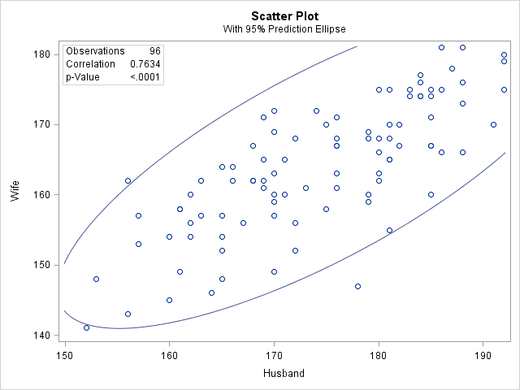

The scatterplot seems to moving in an upward trend as x increases. This signals that an association most likely exists and that a best fit line could be made, making a likely correlation between husband and wife heights.

b. 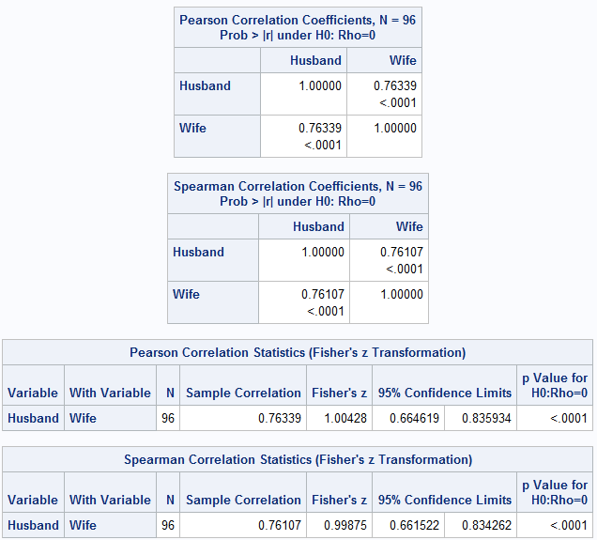

Looking at the Pearson and Spearman Coefficients we would reject the null hypothesis that Rho=0 because in both cases, the p-value is unusually small (<.0001). This means that Rho is not 0 and there is evidence of a correlation. In addition to that, by looking at the Fisher tables, there is a 95% Confidence interval shown and in both cases 0 is not within the range. Both prove that a correlation exists in this data set.

c.

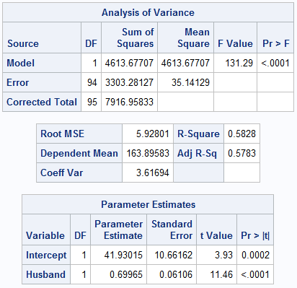

Looking at the Pr > F value and Pr > |t| for the Husband variable, we see that the p-value is unusually small (<.0001) and so we reject B1 = 0 and determine that some sloped regression line does exist.

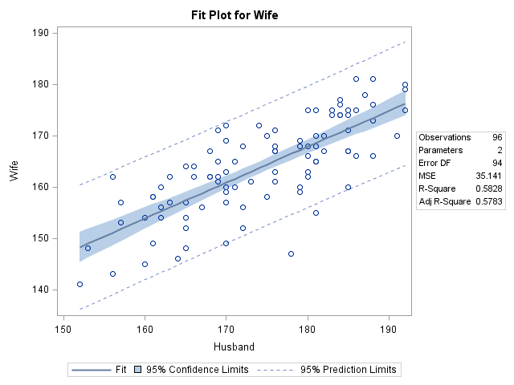

There were no serious violations, so the best fit line is shown above. The slope of the line means that there is most likely a positive correlation between the heights of husbands and wives.