**Search and Rescue Optimal Planning System (SAROPS)**

Thomas M Kratzke, Lawrence D Stone (Metron, INc, Reston, VA, USA)

John R Frost. U.S. Coast Guard. Office of Search and Rescue. Washington, DC 20593

Uses a Bayesian approach.

Computer aided search.

1. Environmental Data Server (EDS)
2. Simulator (SIM)
3. Planner – “produce operationally feasible search plans that maximize the increase in probability of detecting the object”

Uses an accordion search algorithm where a Search and Rescue Unit (SRU) sweeps up and down of a designated rectangle. During its sweep, an evaluation takes place utilizing a heuristic checking for the probability of success.

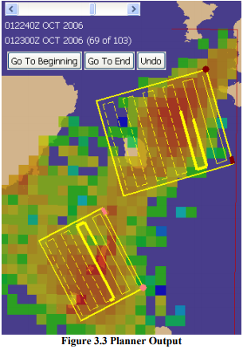

**Common Crime Scene Search Patterns**

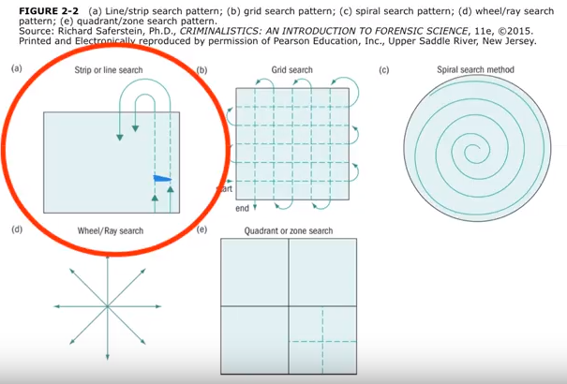

Definitions below are from: <http://wps.prenhall.com/chet_saferstein_forensic_1/85/21848/5593141.cw/-/5593167/index.html>

“Grid search: A search method employed by two or more people overlapping separate line searches forming a grid.”

“Line/strip search: A search method used by one or two investigators by walking in straight lines across the crime scene.”

“Quadrant/zone search: A search method in which the crime scene is divided into smaller sections (zones or quadrants) and team members are assigned to search each section. Each of these sections can be subdivided into smaller sections for smaller teams to search thoroughly.”

“Spiral search: A search method in which the investigator move in an inward spiral from the boundary to the center of the scene or in an outward spiral from the center to the boundary of a scene.”

“Wheel/ray search pattern: A search method employed by several people moving from the boundary straight toward the center of the scene (inward) or from the center straight to the boundary (outward).”

**Additional Quadrant and Octant Search**

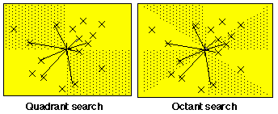

<http://www.kgs.ku.edu/Tis/surf3/s3search.html>

Personally I don’t fully understand these algorithms, however I included them for a couple of reasons. The first is that we could divide up our search space into quadrants similar to these. Secondly, is that if we did split up quadrants we could place random points within each quadrant that our robot would search at first. Then once these random points have been searched the robots could then do a systematic search of the remaining quadrant/zone.