Name: __Joshua Schmidt___ Date: ____10/3/2019______

Pledge: ______________________________________________________________________________

For each of the graphs below, list the order in which the vertices are visited in a **breadth-first search**, starting with vertex 1. If there are multiple vertices adjacent to a given vertex, visit the adjacent vertex with the lowest value first. Then repeat the process for **depth-first search**.

1. 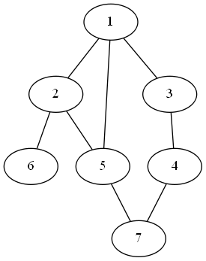

BFS: _____1 2 3 5 6 4 7________

DFS: ______1 2 5 7 4 3 6_______

1. 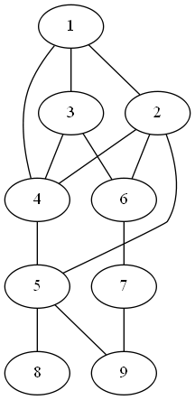

BFS: __________1 2 3 4 5 6 8 9 7______________

DFS: __________1 2 4 5 8 9 7 6 3______________

1. 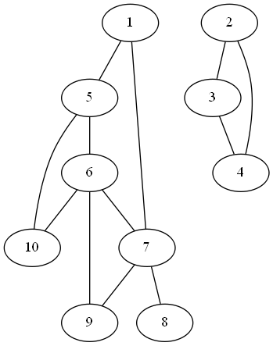

BFS: _________1 5 7 6 10 8 9 2 3 4____________________

DFS: _________1 5 6 7 8 9 10 2 3 4____________________

For each of the graphs below, list the order in which the vertices are visited in a **topological sort**, starting with vertex 1. If there are multiple vertices adjacent to a given vertex, visit the adjacent vertex with the lowest value first.

1. 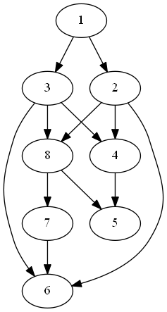

Topological sort: ______1 2 3 4 8 5 7 6__________________

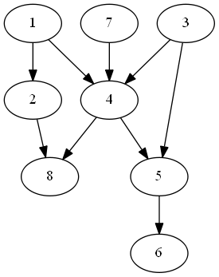

Topological sort: _______1 3 7 2 4 5 8 6____________________