**IDENTIFYING THE MAKE, MODEL, AGE, AND SIZE**

To identify the make, model, age, and size you will need to find the manufacturers label. Do this on the outdoor unit, whether it’s a split system or package system. On a package system, it is usually on the right side of the equipment, near where the gas and power connect to the system. On a split system, the label is often found on the same side as the refrigerant lines enter the system. On some older systems near the bottom right above the lines on newer systems closer to the top.

On this label, you will find lots of numbers and letters. The ones we are most interested in are the model and serial numbers. From these we can determine the age, size, and type of equipment.

**MAKE AND MODEL:**

The make should be pretty easy to figure out. Normally they have a logo prominently placed. If not, it can be found on the label pretty easily. The model is designated as a field on the label and is easy to identify. Each manufacturer categorizes their equipment differently. Some like Trane encode the efficiency of the equipment in the model, others do not. You can look up the model of your equipment, its features and efficiency using the model and make on the label and Google.

**SIZE**:

Basically all manufacturers encode the size or tonnage of their systems into the model number. Tonnage is a measure of BTU’s in 12,000 BTU increments. For example a 1 ton system would have 12,000 BTU’s. A 2.5 ton system would have 30,000 BTU’s. These are reflected in the model numbers near the middle and often followed by a letter.

Below are a couple examples to look at:

38EZA0**48**310 is a Carrier 48,000 BTU or 4 ton system

4TTZ00**48**A1000AA is a Trane 48,000 BTU or 4 ton system

If you are unable to read the label, you can look down into the condensing unit from the top to see the compressor and often use the compressor part number to determine the tonnage using Google.

**How to Find AC Tonnage**

The easiest place to look is on the AC unit itself. Go outside to the condensing unit and look for a data plaque mounted to the side. Find the model number. Within this string of letters and numerals, you should find an even, two-digit number. The possibilities on residential units range from 18 to 60**. Divide the number by 12 (which represents 12,000 Btu/hr, or one ton of cooling capacity) to get your AC unit’s tonnage.**

The numbers you are looking for and their corresponding tonnage:

* 18 = 1.5 tons
* 24 = 2 tons
* 30 = 2.5 tons
* 36 = 3 tons
* 42 = 3.5 tons
* 48 = 4 tons
* 60 = 5 tons

**What is AC Tonnage?**

Heating and air conditioning capacities are measured in British thermal units (Btu) per hour. One Btu is equivalent to the heat generated by a single birthday candle. It’s the amount of heat needed to raise the temperature of one pound of water by one degree.

The word “tonnage” is used to describe the cooling capacity of an air conditioner. **One ton of cooling is the rate of heat transfer needed to freeze 2,000 lbs** – **or one ton – of water in 24 hours. This is equivalent to 12,000 Btu/hr.**

**AGE**:

The age is generally encoded into the serial number. Many manufacturers do it differently and most have changed the way they do it over the years. Below are the most popular brands and how they encode the year within the last 20 years or so. For older equipment Google can be pretty helpful.

**Carrier/Payne/Bryant**

Carrier systems made in the last 20 years or so encode the week and year of manufacture within the first 4 digits. The first 2 are the week of the year (1-52) and the second are the year. For example 0199 would mean the system was made the first week of January in 1999

**Trane/American Standard**

Many Trane products have the date they were manufactured right on the label in the top right corner. Start there, if there isn’t a manufacturing date present then look at the serial number. There are 2 styles that were used within the last 20 years.

Style 1 starts with a letter which represents the manufacturing location and then 2 numbers which is the last 2 digits of the year manufactured (in 2000). For example C12A00152 means Clarksville Plant.

Style 2 starts with numbers and the first 2 numbers are the year. For example 1125KREAA was manufactured in 2011. This style also has the year of manufacture commonly listed on the label so you won’t need to decode the serial number.

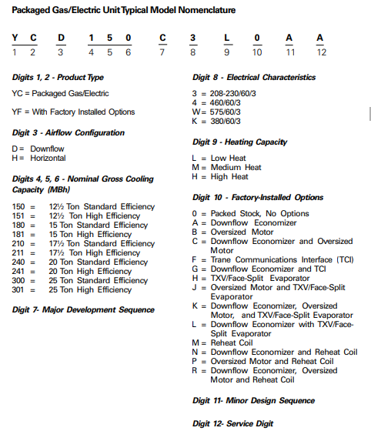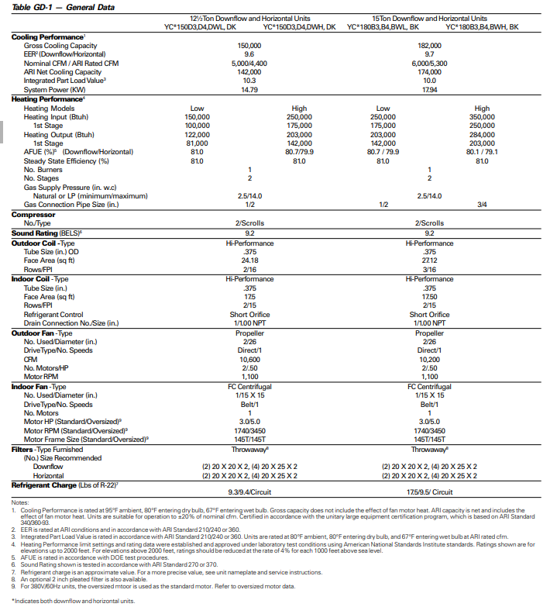

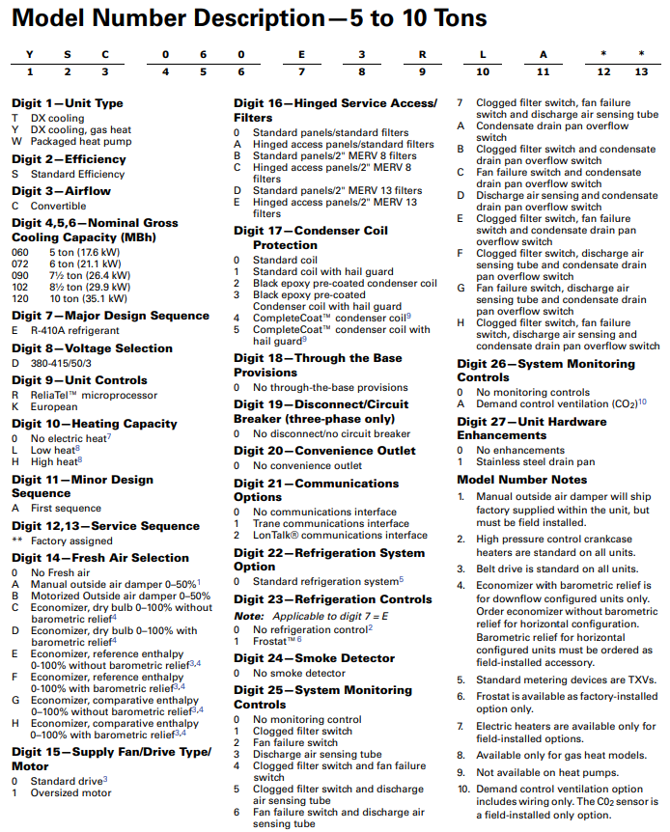

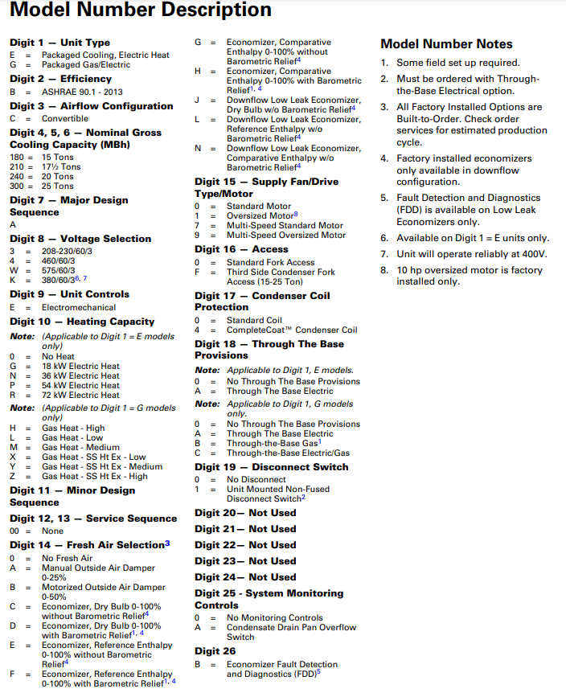

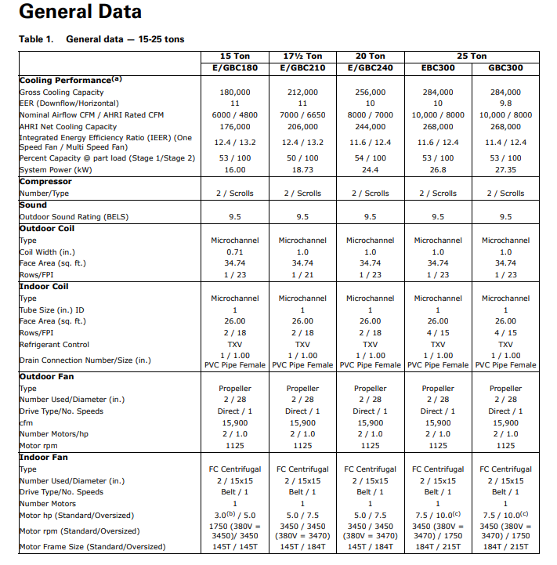

**Lennox**

Modern Lennox system serial numbers contain 4 numbers followed by a letter. The first 2 numbers represent the factory where they were manufactured, the second 2 numbers are the year and the letter is the month where A is January, B is February, etc. An example would be 5800A12345. 58 is the factory, 00 represents the year 2000 and A means it was manufactured in January.

**Goodman**

Goodman serial numbers are 10 digit numerical where the month and year are encoded in the first 4 digits. The year is the first 2 and the month the second 2. For example 1404123456 is manufactured is April 2014.

**Rheem/Ruud**

Modern Rheem systems use two styles of date encoded in the serial number.

Style 1 starts with a letter followed by the week and year of manufacture. W011012345 would be manufactured in January of 2010.

Style 2 follows the letter in the middle of the serial number with the week and year of manufacture. For example CB5D302F0998 would be manufactured in March of 1998.