
NSF Project
Reporting Format

This document has been developed to provide Principal Investigators (PIs), co-PIs, and research organizations with:
- A listing of the questions that will be asked in the new NSF project reporting format;
- Assistance in planning for the submission of the report; and
- A tool to help PIs collaborate with other contributors in answering these questions, if needed.

The project reporting service on Research.gov and the associated help documentation provides more detailed instructions and contextual assistance.

Note: NSF project reports are not cumulative and should always be prepared for the specific project reporting period only.

Accomplishments

You have the option of selecting “nothing to report” in this section.

What are the major goals of the project?
The overarching goal of the project is to test the following hypotheses:
H1. Virovory is a natural sink of marine viruses that rivals all other viral losses combined.
H2. Nutrient transfer from large enveloped dsDNA eukaryotic viruses is higher than from smaller virus particles.
H3. Virovory contributes more nutrition for heterotrophic protists in permanently or seasonally oligotrophic waters that in eutrophic marine ecosystems.

What was accomplished under these goals (you must provide information for at least one of the 4 categories below)?
Major Activities:
Martínez Group:

1- Produce axenic Emiliania huxleyi viruses (EhV, Nucleocytoviricota). Note: Axenic Rhoseophage V5 infectious to Ruegeria pomeroyi DSS-3 were produced and maintained by Assistant Research Scientist (postdoctoral researcher) Dr. Schreier prior to the start of this project.

2- Test heat and UV inactivation of EhVs. The idea behind this is to prevent new virus production during the grazing experiments if suitable host cells are present.

3- Isotopically label (¹³C + ¹⁵N) Emiliania huxleyi viruses (EhV, Nucleocytoviricota) and Rhoseophage V5.

4- Preparation of stocks of isotope-labelled viruses and virus-free high molecular weight dissolved organic matter (DOM) from virally lysed cells using tangential flow filtration to eliminate DOM smaller than a certain molecular weight (30 KDa MWCO for V5 and 300 kDa MWCO for EhV) and filtration through 0.1 µm (EhV) or 0.02 µm (V5) to obtain virus-free DOM. These DOM fractions are needed as controls for the grazing experiments.

5- Spring grazing experiments at the Bermuda Institute of Ocean Sciences.

Specific Objectives:
O1. Quantify viral removal rates, nutrient transfer efficiency, and viral C and N contributions to heterotrophic nutrition via factorial grazing experiments with representative Nucleocytoviricota and bacteriophages. Experiments will use environmental microbial communities from a nutrient-rich coastal site in Maryland (summer 2026; winter/spring 2027) and the oligotrophic Sargasso Sea at the Bermuda Atlantic Time Series (BATS, spring and fall 2026), capturing seasonal and trophic contrasts.).

O2. Develop an ordinary differential equation model of virovory and fit it to experimental data describing the loss rates of both types of viruses.

O3. Include a description of virovory in the Darwin Ecosystem Model to understand the large-scale impacts of virovory in the ocean.

Significant Results:
Martínez Group:

1- A Gephyrocapsa (Emiliania) huxleyi culture was made axenic using an antibiotic cocktail (Cefotaxime, carbenicillin, ampicillin, streptomycin). Antibiotic-treated cultures were maintained with xenic cultures at 16ºC in a 16:8 L:D incubator. After 2 growth-dilution cycles, aliquots of the cultures in exponential growth were fixed (0.25% glutaraldehyde), stained with SYBR Green I (0.5x), and analyzed using an Agilent Opteon Flow Cytometer to determine the presence (A, xenic control, not treated culture) or absence (B, axenic, antibiotic-treated culture) of bacteria diluted in half with TE-buffer.
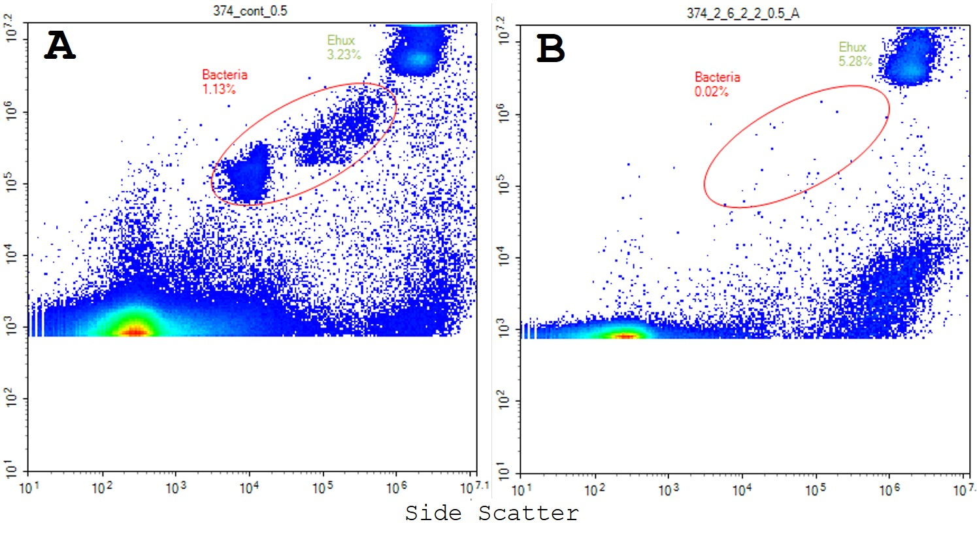
2- Heating EhVs eliminated their infectivity but led to a 9-fold (std=1.5) reduction in viral particles over a 6-day period. EhVs heated at 50ºC for 20 or 60 minutes were used to infect xenic G. huxleyi culture aliquots. Virus-free and non-treated virus-inoculated culture aliquots were maintained as controls. G. huxleyi infected with heat-treated EhVs grew comparably to the virus-free control, while the culture inoculated with non-treated EhVs declined in abundance over time (A). New EhV production was measured in the culture inoculated with non-treated EhVs, while a decay in viral particles was measured in the inoculations with heat-treated EhVs (B).

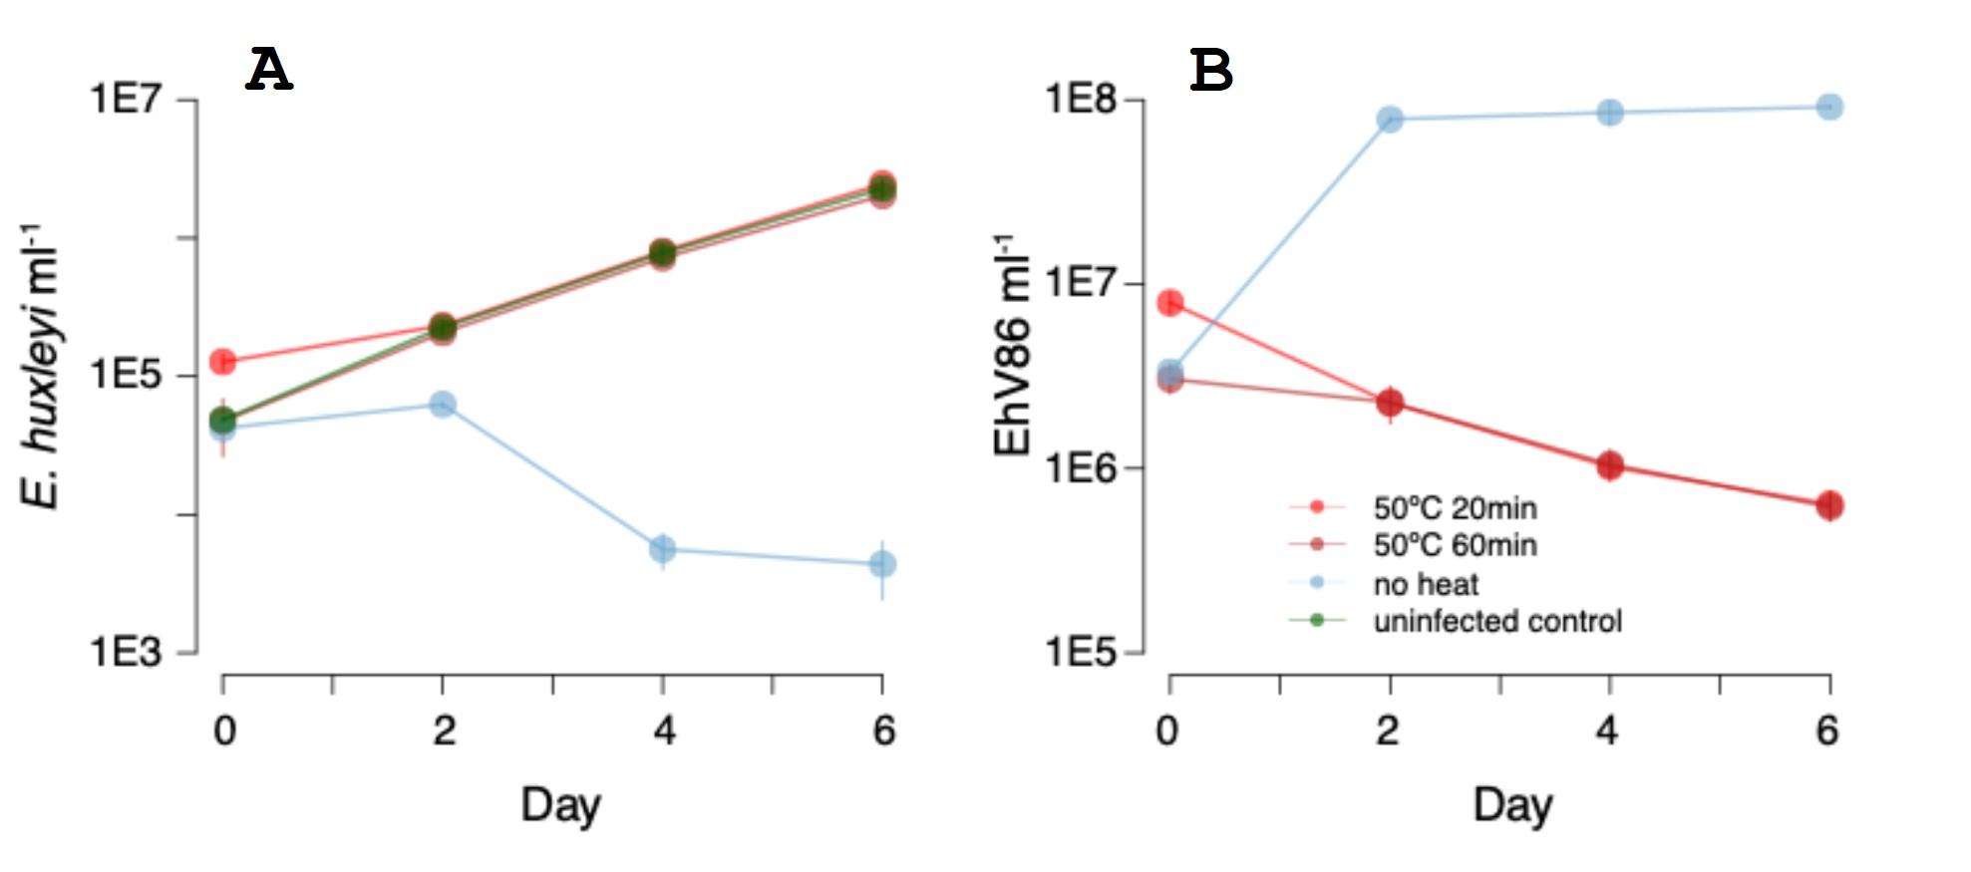
EhVs exposure to direct UV light eliminated viral infectivity but resulted in a 2.6-fold (std=0.3) reduction in viral particles over a 7-day period. G. huxleyi infected with UV-treated EhVs grew similarly to uninfected controls (A), and viral particles decreased modestly over the incubation period even in the absence of host (B).
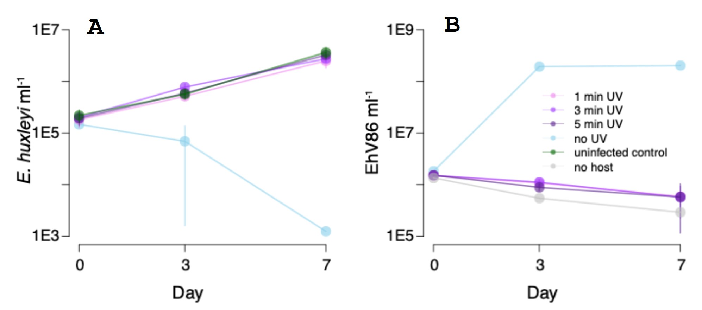
3- NanoSIMS analysis confirmed the isotopic enrichment of EhV particles (work perform at the Lawrence Livermore National Laboratory). @ Xavier - ANYTHING TO ADD HERE? AN IMAGE OR A TABLE?
Examples of G. hux (top) and EhV86 (bottom) isotopic enrichment. Left is abundance of 12C 14N, middle is 13C abundance, right is 15N abundane. Warmer colors indicate higher abundance of element.
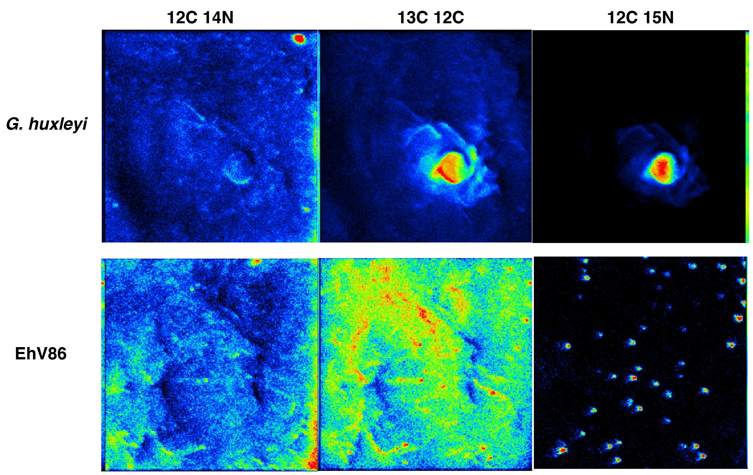

4- We obtained mostly DOM-free EhV stocks. While our procedure removed a substantial amount of DOM from the V5 lysates, they still contained a considerable DOM. This was due to the need to use small MWCO membrane to process the lysate because of the small V5-particle size. For the purpose of this study, we are considering viral particles as particulate organic matter, despite the commonly accepted operational definition of DOM as the fraction of OM smaller than 0.22 µm, which includes most known viruses. Lysates of virally-infected R. pomeroyi and G. huxleyi were filtered through 0.2 µm or 0.45 µm, respectively, to remove large cell debris. The filtrates were concentrated, and small dissolved organic matter (DOM) eliminated by tangential flow filtration with 30 KDa MWCO or 300 KDa MWCO, respectively. One half of each concentrated lysate was then filtered through a 0.02 µm or a 0.1 µm filter to remove V5 or EhV particles respectively and total DOC and TDN were measured in the size fractionated viral lysates (with and without viral particles) (analyses performed by Dr. Ouyang, UMCES-Horn Point Laboratory). The table below shows DOC and TDN concentrations for each viral lysate type and size fraction. The G. huxleyi viral lysate containing EhVs was concentrated using 300kDa TFF system and washed with ~1 L of ASW. Samples were taken for DOC and TDN analysis before (G. huxleyi viral lysate) and after concentration (concentrated EhVs). The ultra-filtrate of viral lysate was measured to determine low molecular weight-DOM (LMW-DOM) removal by tangential flow filtration with a 300 KDa MWCO cartridge. DOC from the LMW-DOM fraction was similar in concentration to the G. huxleyi viral lysate suggesting most DOC was <300kDa. EhV86 concentrated ~20-fold would have represented ~0.09 ppm DOC in the viral lysate adjusting for the ASW background DOC ((2.65 – 0.9)/20).

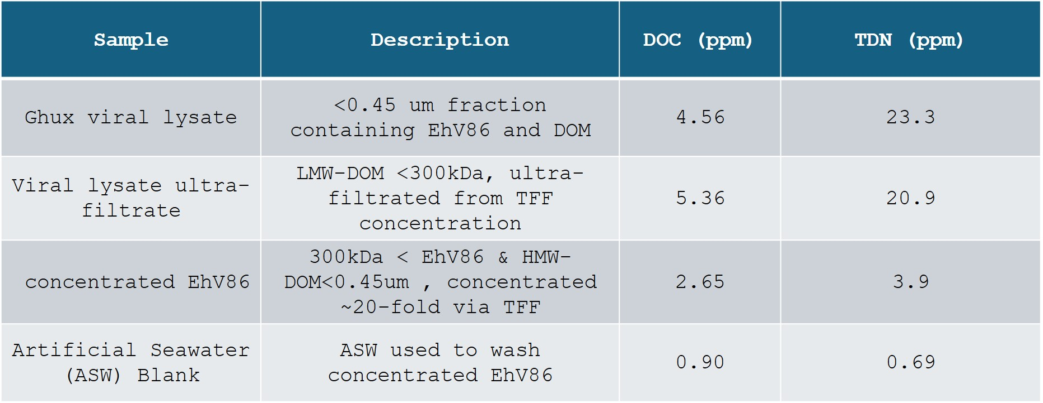

5- Completed a seven-day (4/22/2026-4/29/2026) grazing experiment at the Bermuda Institute of Ocean Sciences with seawater collected at BATS on 4/21/2026. At the time of submitting this report, we are running an analogous experiment (4/30/2026-5/6/2026) with seawater collected at BATS on 4/29/2026. The goal is to confirm reproducibility of findings with a site and season. The experimental design is depicted in the figure below:

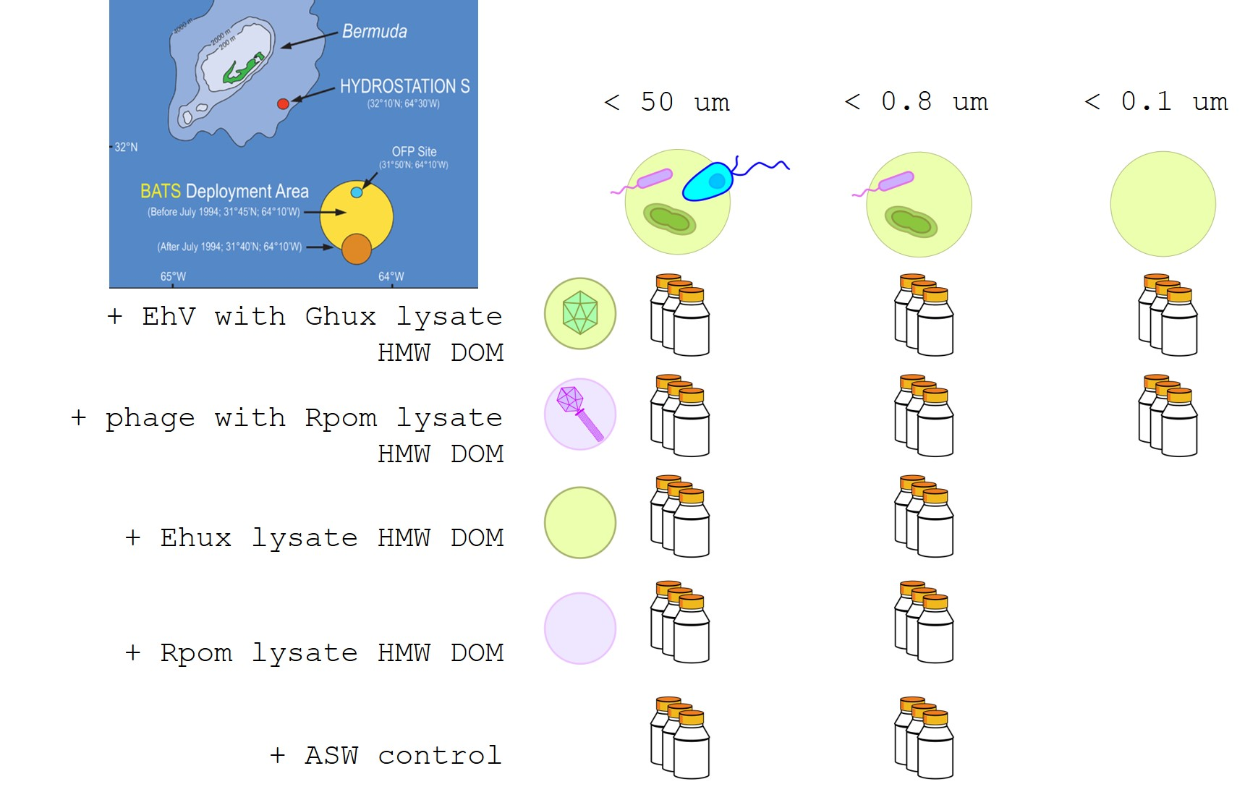
We collected and archived samples for flow cytometric enumeration of virus particles, bacteria, and protists on a daily basis, for epi-fluorescent microscopy and nanoSIMS analysis every other day, and for taxonomic characterization of the microbial communities at the beginning and end of the experiment.

Preliminary, qualitative microscopy exploration of the seawater collected at BATS for the incubation experiments revealed a range of autotrophs, heterotrophs, and putative mixotrophs.
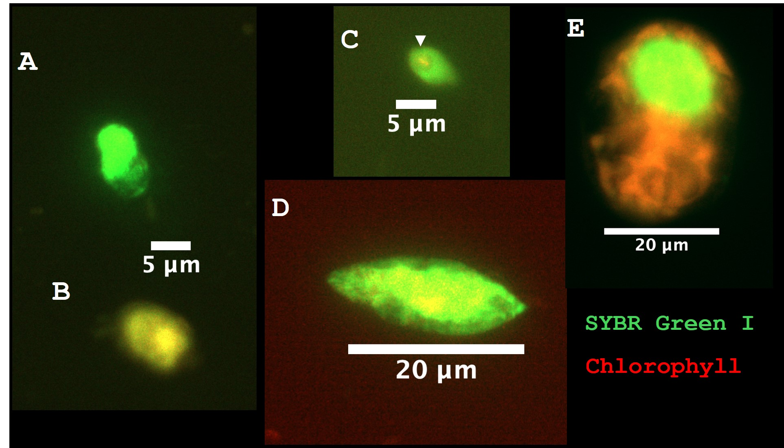
A= heterotroph protist,
B=mixotroph or autotroph,
C= Heterotrophic protist, white arrow showing ingested phytoplankton cell,
D=Heterotrophic protist,
E=Mixotroph or autotroph

Key outcomes or other achievements:

What opportunities for training and professional development has the project provided?

An Assistant Research Scientist/Postdoctoral Researcher (Dr. Schreier) has been recruited with funding from this award. This project is providing training in a research area new to him. So far, Dr. Schreier has been given a leadership role in designing and performing the experiments to deliver the project’s goals, with guidance and training from PI Martínez and through discussions with the rest of the project’s collaborators. This training is critical for shaping Dr. Schreier experience and becoming an independent senior scientist and a leader in the field.

@David, training at UTK?

How have the results been disseminated to communities of interest?
Martínez scientific presentations:
Apr 24, 2026, Bermuda Institute of Ocean Sciences, Wind Talks. Invited. Viral modulation of nutrient flow in the ocean: Viruses on the menu. (This presentation took place during the first round of experiments with BATS Spring seawater, the project idea, goals, and preliminary findings were shared. An audience of about 30 people included faculty, students, and visiting scientist).
Dec 2025 – Jan 2026, UMCES CBL, AL, HPL, IMET tenure talk. An ocean of viruses, an ocean of research opportunities. (This talk presented in person at each of the UMCES campus was a requirement for PI Martínez tenure application and included a component about virovory research plans and preliminary findings supported by this award).

Martínez outreach and broader education:
Developed and led a hands-on “SemiLab” during the SigmaCamp-2025 week-long science camp in Silverlake, Sharon, CT. This “SemiLab” included 10 students (ages 10-14) who worked in pairs to identify whether protists were infected by “mystery” virus isolates or ate them. By designing a simple factorial design, using culturing and cell counting techniques, the students could link specific host-virus pairs and explore if those same viruses were eaten by uncharacterized protists collected from a local lake (this could not be done with seawater due to logistics and camp location). At the end of the weeklong experiment, the students presented their findings to the group. The activity was well received. See student evaluations below.
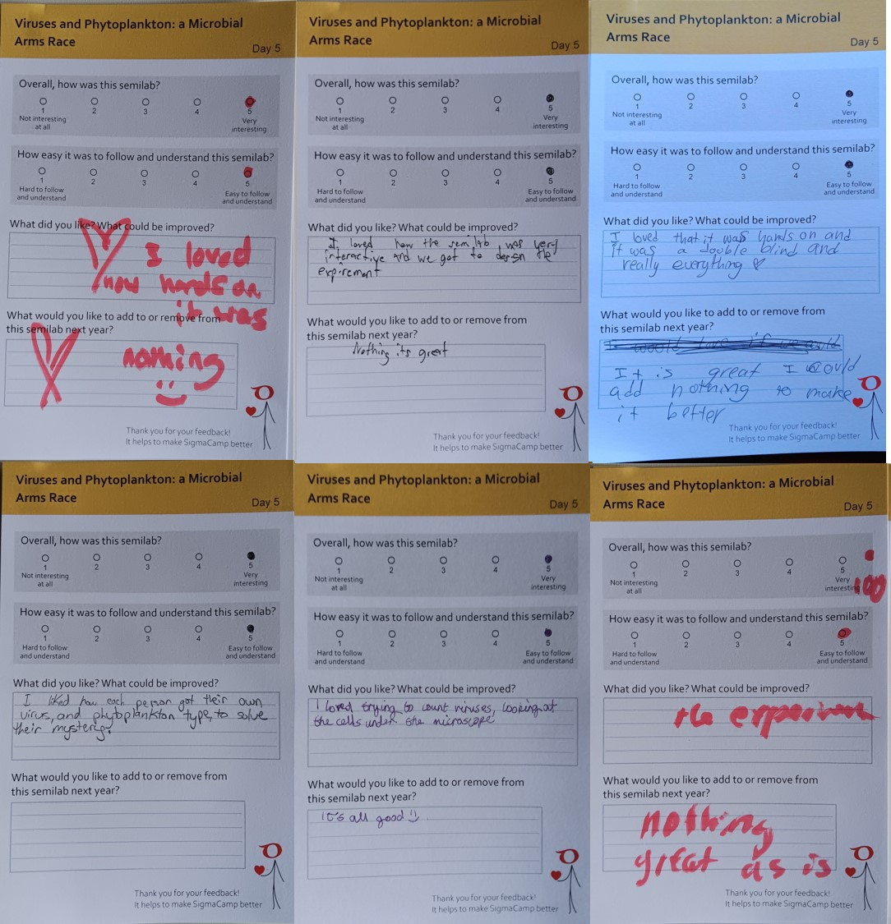

What do you plan to do during the next reporting period to accomplish the goals?

- Complete all seasonal viral loss/grazing experiments at BATS and coastal Atlantic sites.
- Work on data analyses and interpretation.
- Work on first manuscript.
@ David, Some of integration into models? Further modeling work to some extend?
Products
You have the option of selecting “nothing to report” in this section. There are no limitations to the number of entries you submit and you can also pull information directly from Thomson Search when using the online tool on Research.gov.
Within the Products section, you can list any products resulting from your project during the specified reporting period, such as:
Journals:
Books:
Book Chapters:
Thesis/Dissertations:
Conference Papers and Presentations:
Other Publications:
Technologies or Techniques:
Patents:
Inventions:
Licenses:
Websites:
Other Products: Created a project page in BCO-DMO https://www.bco-dmo.org/project/954424. A metadata form and the data management plan for this project are already included. Data from ongoing experiments will begin to be deposited as soon as it is curated.
Participants
There are no limits on the number of participants you list for this section; however, you must list participants who have worked one person month or more for the project reporting period. You have the option of selecting “nothing to report” in this section. For Research Experience for Undergraduates (REU) sites and supplements, specific questions will be listed in this section. The online service will also ask for additional information on participants such as:
- What individuals have worked on the project?
- What organizations have been involved as partners?
- Have other collaborators or contacts been involved?

What individuals have worked on the project?

Name | Most Senior Project Role | Nearest Person Month Worked
Joaquín Martínez Martínez | Lead PI (UMCES) | 3
Jeremy Schreier | Assistant Research Scientist (UMCES) | 4
Tianyin Ouyang | Assistant Research Scientist (UMCES) | 1

What other organizations have been involved as partners?
The online service will also ask you for additional information such as:
- Type of Partner Organization: National Laboratory
- Name: Lawrence Livermore National Laboratory
- Location: Livermore, California, USA
- Partner’s contribution to the project: Contracted services

Have other collaborators or contacts been involved?
Yes. Drs. Pain and Ouyang from UMCES-Horn Point Laboratory are new collaborators providing DOC and TDN analyses for this study at no additional cost to the project.
Impacts
What is the impact on the development of the principal discipline(s) of the project?
Nothing to report, yet

What is the impact on other disciplines?
Nothing to report, yet

What is the impact on the development of human resources?

This project offer significant opportunities for Dr. Schreier to develop expertise in the topic of eukaryotic marine viruses, acquire new analytical skills, and develop a broad network of new collaborators across the collaborating institutions and at BIOS, were field work is carried out. As the project advances, Dr. Schreier will attend and present results from this study at international science conferences, contribute to annual report preparation, and lead the preparation of manuscripts.

What is the impact on physical resources that form infrastructure?
Nothing to report

What is the impact on institutional resources that form infrastructure?
This award provided funds to purchase an Agilent Novocyte Opteon spectral flow cytometer equipped with three lasers. This instrument is critical for delivering the goals of the project. No other comparable instrument is available within UMCES.

What is the impact on information resources that form infrastructure?
Nothing to report

What is the impact on technology transfer?
Nothing to report

What is the impact on society beyond science and technology?
Educational impact and training/professional development. See references above about training of Assistant Research Scientist Dr. Schreier and SigmaCamp activity.
Changes / Problems
Changes in approach and reason for change:
- Change coastal sampling site from Maine to Maryland because of relocation of PI Martínez after submitting the proposal, but before receiving the award.
- Change phage model system from Sulfitobacter phage to Ruegeria phage, both are Roseophages, because the hired Assistant Research Scientist for this project already had the Ruegeria phage system available and has ample experience with the system. He isolated and characterized it. This has facilitated progress as it eliminated the need to get a phage system novel to our group and the required training and learning curve.
- Changed the order of the grazing experiments to start with a spring experiment with BATS water. This change was needed because of project start delays (see below) and to allow PI Martínez to travel to Bermuda and assist with the labor-intense experiments.

Actual or Anticipated problems or delays and actions or plans to resolve them:
Delays due to administrative hurdles and production obstacles due to tariffs on imports delayed the acquisition of the required flow cytometer until December 2025.

The process for recruiting a suitable Assistant Research Scientist/Postdoctoral researcher took approximately eight months after the project’s start date. Dr. Schreier joined the group in January 2026.

Changes that have a significant impact on expenditures:
Nothing to report

Significant changes in use or care of human subjects:
Nothing to report

Significant changes in use or care of vertebrate animals:
N/A

Significant changes in use or care of biohazards:
Nothing to report
Special Requirements
This report section is only available when Special Requirements are specifically noted in the solicitation and approved by the Office of Management and Budget.

NOTE: You may upload PDF files in support of the Special Requirements section. You may upload PDF files with a maximum file size of 10 MB each. There is no limit to the number of files uploaded.

