How to use the BSC
Symbol Key:
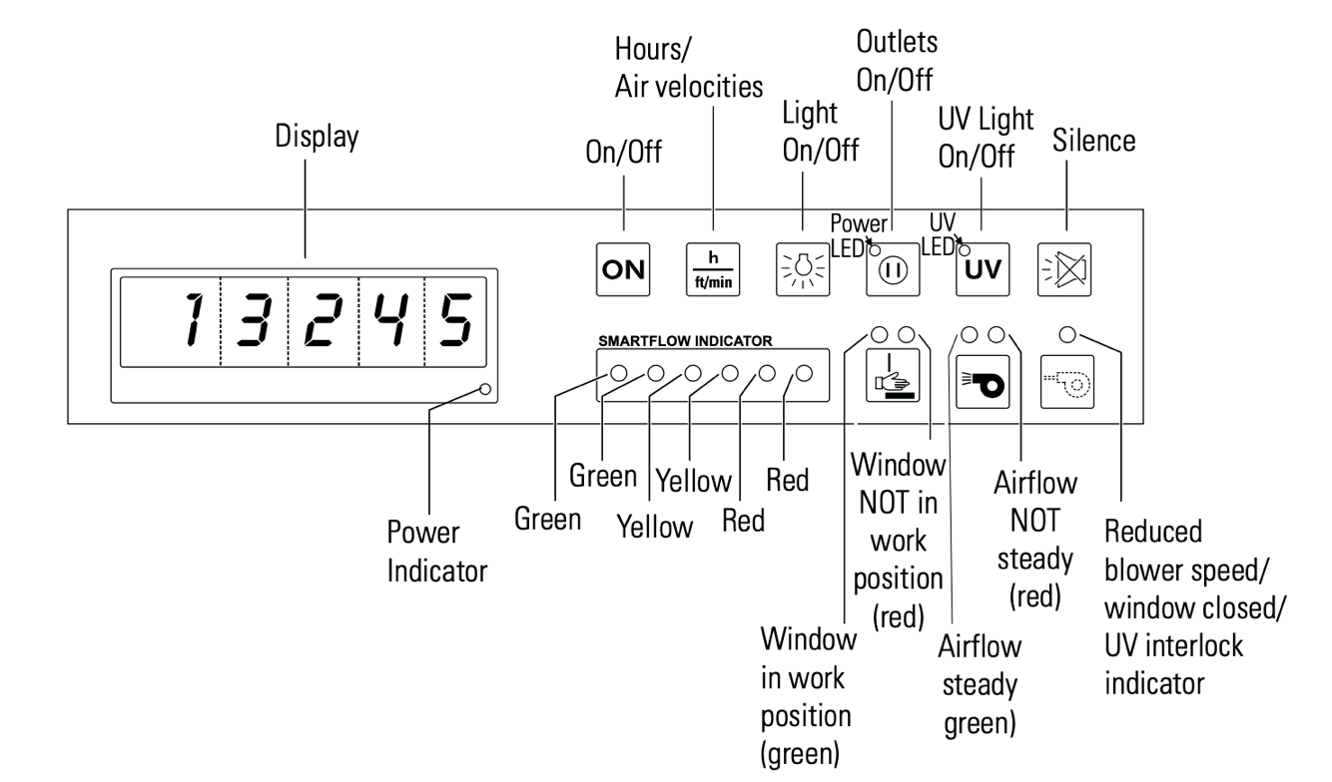

What is the ‘Smartflow indicator’? It displays the status of the fans. Green shows the fan and filters have power and capacity to respond to work. Yellow or red show that the cabinet is protecting you but that maintenance should be scheduled soon.

Properly opening and closing the cabinet:
- Turn the biosafety cabinet ON by holding the ON button for ~5 seconds. The display should read the hours the hood has been running
- To open the cabinet at the WORK position, move the sash to the top dimple (see figure 1-5)
  - Cabinet is in proper position when the LED in figure 1-6 is GREEN
  - Cabinet is not in the proper working position if the LED in figure 1-6 is RED
- To close the cabinet or place it in the ‘reduced mode’ position, move the sash to the lower dimple (see figure 1-7).
  - Cabinet is in the proper position when the LED in figure 1-8 is BLUE
  - Cabinet is not in the proper position when the LED in figure 1-8 is not lit
- When you are finished, turn the biosafety cabinet OFF by holding the ON button for ~5 seconds. The display should turn blank.
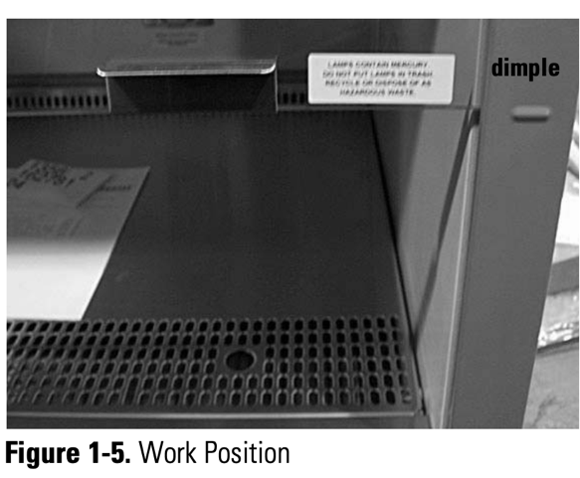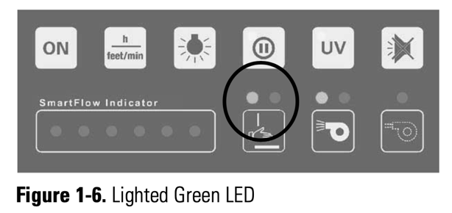
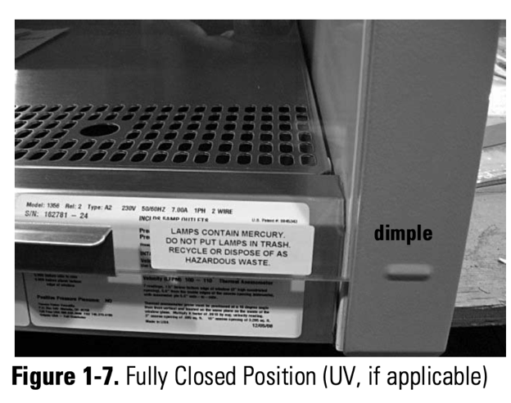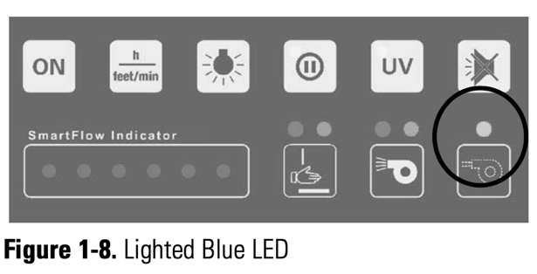

Using the BSC for sterile technique
- Turn the biosafety cabinet ON by holding the ON button for ~5 seconds. The display should read the hours the hood has been running
- Open the sash to the WORK position
- Wipe down the surface and any equipment that will enter the cabinet with 70% EtOH
- Make sure the back and front vents are cleared of materials to ensure proper airflow!
- Place your equipment into the cabinet
  - Don’t put biologics inside
  - Don’t put light sensitive materials inside
- Close the sash to the ‘reduced mode’ position
- Press the UV button to sterilize the unit. Timer is set for 30 mins. If less time is preferred, you can manually turn the UV off by pressing the button again
- Wipe down any incoming materials with a kimwipe saturated with 70% EtOH
- When working in the hood, use the metal arm rests to ensure that air flow is not compromised.
- When you are finished, turn the biosafety cabinet OFF by holding the ON button for ~5 seconds. The display should turn blank.

