Zeiss Axioscope 5 User Guide
Table of Contents
Zeiss Axioscope 5 User Guide 1
Zeiss Axioscope5 manual link 1
General start-up 1
Using the Zen System and Camera 1
DIC Microscopy (Colibri 7 does NOT need to be on) 3
Epifluorescent Microscopy 4

Zeiss Axioscope5 manual link
https://www.microscopeworld.com/content/manuals/Zeiss_Axioscope5-7-vario_manual.pdf

General start-up
- Turn on the computer, there is no password to log on
- Power on the microscope (on the front left of the scope is a switch). It takes ~5 seconds and you will see a green light turn on the front right side.
- Power on the Colibri 7 system by pressing the moon button
- Open Zen 3.1 Blue edition and click ‘Zen Pro’. This will take a few minutes to initialize hardware (Bottom left will show a loading bar and say ‘Initializing’. A message pops up about moving the manual component for the camera. Click OK, this seems like something that can be ignored.
- Microscope is now ready for use with cameras

Using the Zen System and Camera
- Once Zen 3.1 is started up, change the tab on the top left to ‘Acquire’
- Click on the dropdown menu right under ‘Acquire’ to choose a template Note: I made a few templates for what I was doing, SYBRGreen-mono, ChlA-Cy3-SYBRGreen-DAPI
  - Templates store the settings of the channels that you are interested in taking a picture of
  - For the ChlA-Cy3-SYBRGreen-DAPI template I have this set to use the RGB camera (Axiocam 305), I set the lightsource to the Colibri 7 and changed each LED to 40% power, with an exposure time on each at 100 ms, and each channel having the LED wavelength selected that I want to use.
  - I have channels arranged from highest to lowest wavelength, and they are checked off so that when an image is taken it goes in that order. The color box on the right of the channels is a hash because I want to see the RGB camera true color rather than pseudocolor
  - If you change the exposure on one channel, make sure to change the exposure on the other channels as needed – same with the camera. Note: I use the same exposure time across all channels and I never auto-expose because this usually will find a signal where there is none
- To display objective view on the computer, pull the silver pin out to direct the image to the cameras
- Ensure the camera slider is in the proper position for the camera being used:
  - For color image (RGB) set the camera in the Zen software to Axiocam 305 and push the camera slider in
  - For monocolor image set the camera in the Zen software to Axiocam 305 #2 and pull the camera slider out
  - Note: Having a monocolor camera and an RGB camera, to me, is confusing on a quad band pass filter. Monocolor cameras are better at detecting faint signal while RGB cameras detect true color. The trouble of the monocolor camera with a QBP filter is if you take a picture on DAPI, you don’t know if what you are seeing is a nucleus or chlorophyll, since they are both excited by UV. The problem with the RGB camera is that, while you see real color, each image that you take is now parse into 3 different color – a single DAPI image will need to be processed changing the R G and B to highlight what you are looking at. Taking a picture with 4 channels on the RGB camera really means you have 12 channels to parse through…
- Make sure you are highlighting the Channel you want to observe first, no need to uncheck everything, just make sure it is clicked on.
- Click ‘Live’ to view what is being observed in real-time. This will render quickly and will be not as clear as the picture taken. Alternatively, use ‘Continuous’ to see exactly what the camera is detecting – this renders slower but might be helpful for faint signals
- If what you are seeing is not ‘bright’ enough for you, there is a histogram slider on the bottom middle that you can play around with to change contrast – pictures taken will not be fixed. In other words, this does not change pixel intensity
- When you are ready to take a picture, turn off the ‘Live’ view and click ‘Snap’ or click the button at the base of the microscope by the coarse focus that has a little camera icon.
- To save an image, right click in the container on the right-hand side with the file and save as a .czi Note: czi files are proprietary and can be opened in the Zen Image Processing Software or in FIJI (Fiji Is Just ImageJ)

Pixel to known distance scale for camera FOV
Objective | Pixels | Known Distance
4x | 53.15 | 1000 um
10x | 106.5 | 1000 um
20x | 21.4 | 100 um
40x | 8.9 | 20 um
100x | 353.4 | 20 um

DIC Microscopy (Colibri 7 does NOT need to be on)
- Begin by changing the light to white light by pressing the button directly above the ‘Permanent/Eco’ switch on the right side of the microscope (Transmitted Light)
- Light intensity is controlled by the ‘LM-Set wheel’
- Ensure the filter wheel at the base of the microscope is open (i.e. has a number and not a closed circle), and that the aperture shutter is open
- Check that on the condenser BF is selected initially, and that you change to the appropriate DIC setting for the magnification being used
- Change the reflector turret position to 1 for DIC
- View specimen

Epifluorescent Microscopy
- Make sure the Colibri 7 system is powered on. Below are the LEDs this system has :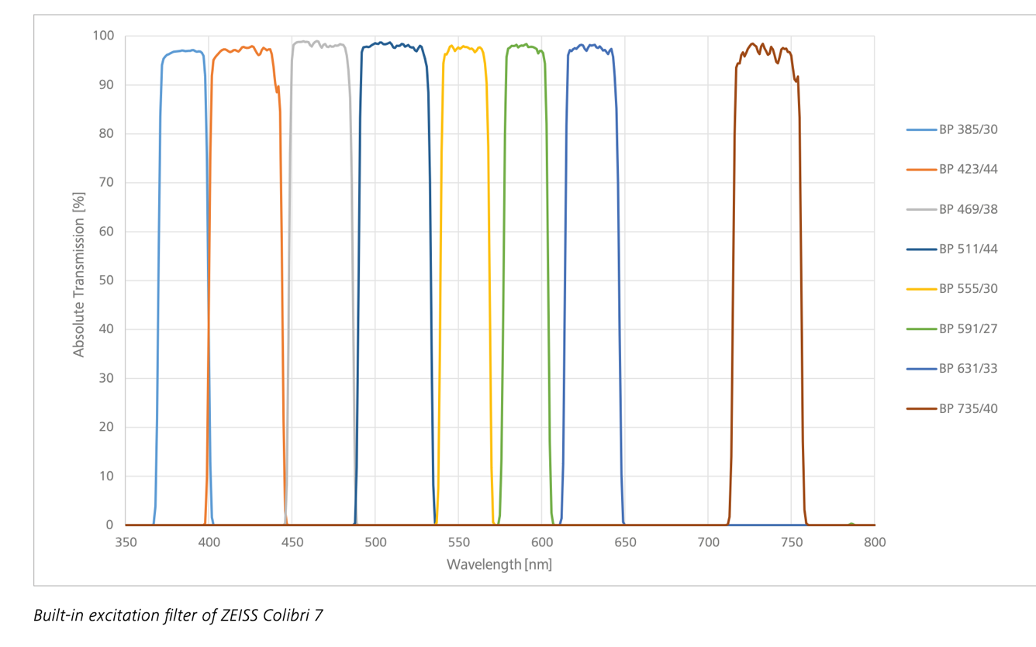
- Turn on Reflected Light by pressing the button above the Transmitted Light on the right side of the microscope (two buttons above the ‘Permanent/Eco’ switch)
- Ensure that the reflector turret is in the correct position for the LED being used
  - Position 2 is FS 90 HE LED
    - Beam splitter QBS 405+493+575+653
    - Emission filter QBP 425/30 + 514/30 + 592/25 + 709/100
    - This is a quad band pass filter suitable for DAPI, FITC, TRITC, and Cy5
  - Position 3 is FS 91 HE LED
    - Beam splitter TBS 450 +538 + 610
    - Emission filter TBP 467/24 + 555/25 + 687/145
    - This triple band pass filter suitable for CFP, YFP, and mCherry
  - Note: Take note that the emission filters let in multiple wavelengths of light! If you have probes or fluorophores that emit in multiple wavelengths be careful how you interpret what you see! ESPECIALLY if you are using the mono camera
- Place the object in place and turn on an LED by pressing the letter of the corresponding color on the Colibri 7 system. Turn the dial to change the LED intensity (Note: I never went higher than 40%)
- Keep in mind that if you want to take a picture using fluorophores from different filter sets, you need to manually change the filter, it is not automatic
- Turn off an LED by pressing the letter again.

