
PRESENTER GUIDE

Virginia Unmanned Systems Asset Map
  - A plain-language walkthrough for Ale and Chelsea to lead stakeholder interviews and screen-share demonstrations.
Audience: COSOLVE presenters and authorized stakeholder users
Use: Screen sharing, interviews, feedback collection, and follow-up review
Version: August 12, 2026
The one-sentence description This is a source-linked, living inventory of Virginia organizations, facilities, programs, infrastructure, and operating environments relevant to unmanned and autonomous systems.

Recommended demonstration route
- Start statewide. Orient the audience to the Virginia boundary, points, clusters, and matching asset list.
- Make it relevant. Filter by the stakeholder’s region, domain, capability, or mission area.
- Find a known organization. Search for the stakeholder’s organization or a familiar asset.
- Open one profile. Show the description, relevance, location precision, sources, and review status.
- Add one analytical layer. Choose only the layer that supports the discussion.
- Analyze a place. Use a regional summary, radius, rectangle, polygon, or visible map extent.
- Save the result. Copy the exact view link, save a private/shared view, or print a PDF.
- Close with corrections. Ask what is missing, inaccurate, outdated, or too precisely located.
Presenter principle Show one idea at a time. The map is most persuasive when it supports the conversation; turning on every filter and layer at once makes the evidence harder to understand.

Before the Call
Run this check about five minutes before screen sharing. The deployed site may take a short time to wake up after it has been idle.

Open and prepare
Open: cosolve-asset-map.onrender.com/map/
- Use your own account. Do not share passwords; another person can use the site only through an account created for them.
- Use a laptop or desktop. Chrome or Edge provides the most predictable screen sharing and PDF output.
- Start clean. Select Current appearance, click Clear all, click Reset, and leave only Asset points and Virginia boundary on.
- Choose one example. Have one relevant region, capability, organization, or test site ready for the interview.
- Protect the screen share. Close email, messages, private notes, password managers, and unrelated browser tabs.
- Prepare a fallback. Keep a recent PDF or screenshot available in case the internet or hosted service is temporarily unavailable.

If the first page is slow
Wait 30–90 seconds, then refresh once. A slow first load normally means the hosted service is waking up; it does not mean the data is missing. If the site still does not open, use the fallback and contact Jake or the COSOLVE site administrator after the call.

Opening language
Suggested script Today I’ll use the Virginia Unmanned Systems Asset Map to explore the people, places, programs, capabilities, and infrastructure we have documented. It is a working, source-linked inventory rather than a claim that every relevant asset is already included. I would especially value your help identifying missing records, correcting how assets are described, and pointing us to current public sources.

Know these four terms
Asset. An organization, facility, program, site, or other documented ecosystem resource.
Source-backed. A record has a public source but may still be awaiting full editorial review.
Editorially reviewed. A reviewer checked the record and its supporting source; the date is shown on the profile.
Location precision. The pin may be exact, a site or campus, a locality, or regional. The label tells the viewer how literally to interpret it.

The Main Map at a Glance
The workspace has three parts: filters on the left, the map and tools in the center, and matching asset records on the right. The three areas stay synchronized.
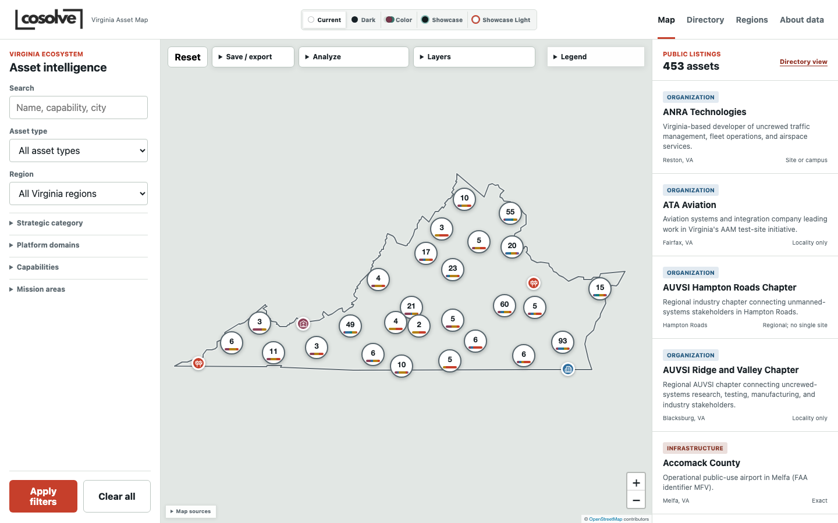
Default statewide view. Clusters summarize nearby points; the right-hand list shows the matching records.
Left: filters. Search and narrow the inventory by asset type, region, strategic category, platform domain, capability, or mission area.
Center: map. Pan, zoom, select points, open clusters, change layers, analyze an area, and save or present the view.
Right: asset list. Scan matching records, see location precision, and open a profile. Active filter chips appear above this list.
How filters combine Multiple choices inside the same filter group broaden the match; different filter groups narrow it. For example, selecting two capabilities finds either capability, while adding Hampton Roads requires the record to match the region as well.

Walkthrough: Find the Relevant Story
This is the recommended order for a stakeholder interview. The Click / Explain / Ask pattern gives the presenter both the action and the plain-language talking point.

1. Orient the audience statewide
Click: Leave filters clear and use Reset so the whole Virginia boundary is visible.
Explain: Each symbol is a documented asset. Numbered circles are clusters of nearby assets; the small color bars summarize their asset mix. Clicking or zooming expands a cluster.
Ask: Which part of Virginia or which part of the ecosystem should we focus on first?

2. Filter to the stakeholder’s interests
Click: Choose a Region or Asset type. Open Strategic category, Platform domains, Capabilities, or Mission areas only as needed, then click Apply filters.
Explain: The map and right-hand list now represent the same subset. Active filters are written above the results, and each chip can be removed individually.
Ask: Are these the categories you would use, or is an important way of describing the work missing?
Keep in mind: If the result count suddenly becomes small, check the active chips. Filters from different groups must all match.

3. Search for a familiar organization or place
Click: Type a name, capability, city, program, or source term in Search and apply it.
Explain: Search checks more than the title; it can match descriptions, relevance, current activity, location, taxonomy, sources, and related records. Matching names appear above their points on the map.
Ask: Is your organization represented? Is this the site that should be mapped?

4. Move between the map and the result list
Click: Click a result card to select its point, or click a point to open its map summary and profile link.
Explain: The list is useful for reading; the map is useful for spatial context. A record without a precise point may intentionally be mapped only to a locality or region.
Ask: Would a different facility, campus, entrance, or general location be more accurate or more appropriate to publish?
Useful interview moment If the stakeholder’s organization is absent, do not treat that as a failed demonstration. Use the gap to collect the correct name, location, role, public website, and contact route.

Walkthrough: Open the Evidence

5. Open one asset profile
Click: Select a record and open its full profile.
Explain: The profile separates what the asset is from why it matters. It also shows capabilities, mission areas, related assets, public contact information, location precision, sources, and record history where available.
Ask: Is the description accurate today? What role or current activity would you change?
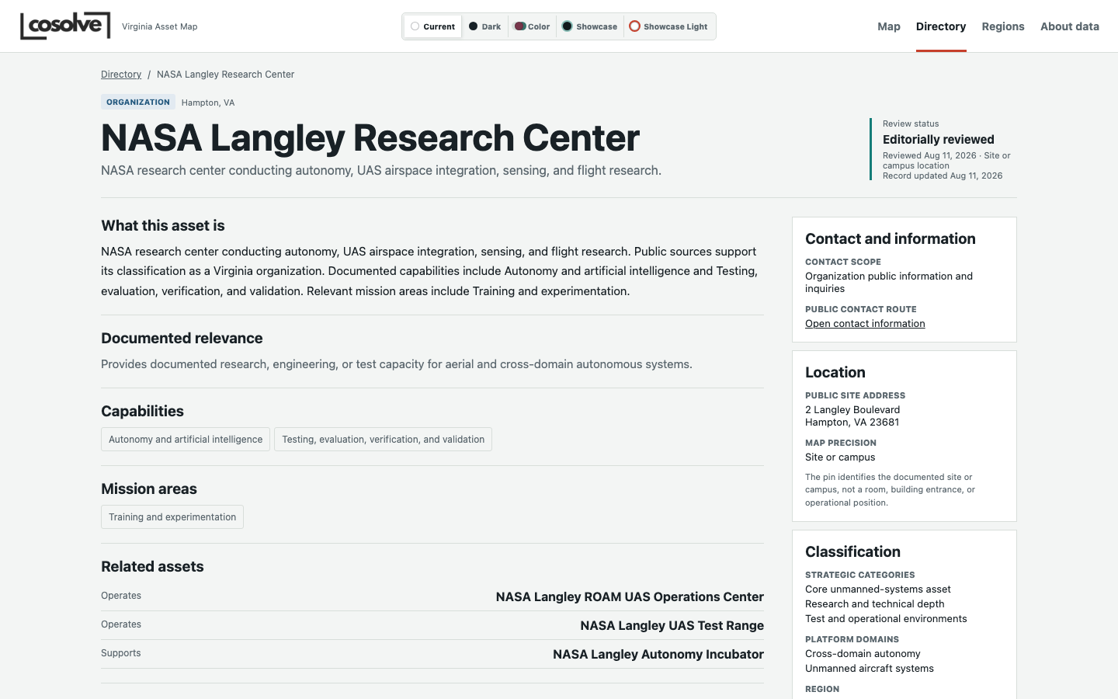
Example profile: review status and location precision appear near the title; supporting details are organized below.

6. Explain review status and sources
Click: Point to the Review status, reviewed date, map precision, and source links.
Explain: A reviewed record has been checked against a dated public source. A source-backed record may still be pending editorial review. The review date tells the audience when the evidence was last assessed.
Ask: What direct public webpage should we use to verify this record? Has anything changed since the displayed review date?
Keep in mind: Do not describe a source-backed record as verified unless the profile says it is editorially reviewed.

7. Collect a correction
Click: Use Suggest an update on the profile, or write down the correction and public source for follow-up.
Explain: A strong correction includes the exact field to change and a direct public source. The review team can then verify and publish the update without relying on memory from the call.
Ask: What exactly should change, and what public source supports it?

Walkthrough: Analyze, Save, and Close

8. Add one useful layer
Click: Open Layers and turn on one overlay relevant to the discussion—for example Ecosystem regions, County boundaries, FAA authorization ceilings, or UAS test facilities.
Explain: Layers add planning context to the same asset inventory. The legend updates when optional layers are visible. Basemaps can be changed to Street, Light, or Imagery.
Ask: Does this context change how you understand access, concentration, testing, or regional connections?
Keep in mind: Airspace layers are static planning references, not flight permission. Potential MPZ tracts are candidates, not federal designations.

9. Analyze a place or selected area
Click: Open Analyze. Use Nearby assets, Draw rectangle, Draw polygon, Use visible extent, or click an ecosystem region for Regional summary.
Explain: The selected area becomes the working subset in the right-hand list. Regional summary shows documented counts, asset mix, reviewed records, location quality, and leading capabilities.
Ask: What pattern matters here? What is absent because it is truly a gap, and what may simply be missing from the inventory?
Keep in mind: Regional totals and leading capabilities are counts of documented records, not rankings of quality, importance, or performance.

10. Export or preserve the exact view
Click: Open Save / export. Choose Save to my views, Copy view link, Print / save PDF, or Presentation mode. Area selections also offer Export selected CSV.
Explain: Saved views preserve map position, zoom, filters, layers, and rectangle or polygon selections. A copied link opens the same state. PDF output includes the filtered map and asset register.
Ask: Would this exact view be useful for a follow-up discussion or planning document?
Keep in mind: Because the pilot site is login-protected, anyone opening a shared link still needs an authorized account.

11. Close the interview with actionable feedback
Click: Return to the profile or filtered list and summarize the two or three corrections you heard.
Explain: The goal is not to prove the inventory is complete. The goal is to leave with specific, sourceable improvements and a clearer picture of how the stakeholder would use the viewer.
Ask: What are the three highest-priority additions or corrections we should address after this conversation?
Closing script Thank you. We will treat your feedback as proposed changes, verify it against public sources, and record the review before publishing. If you think of another correction, use Suggest an update or send the exact record and source to the COSOLVE team.

Feature Reference: Map Tools
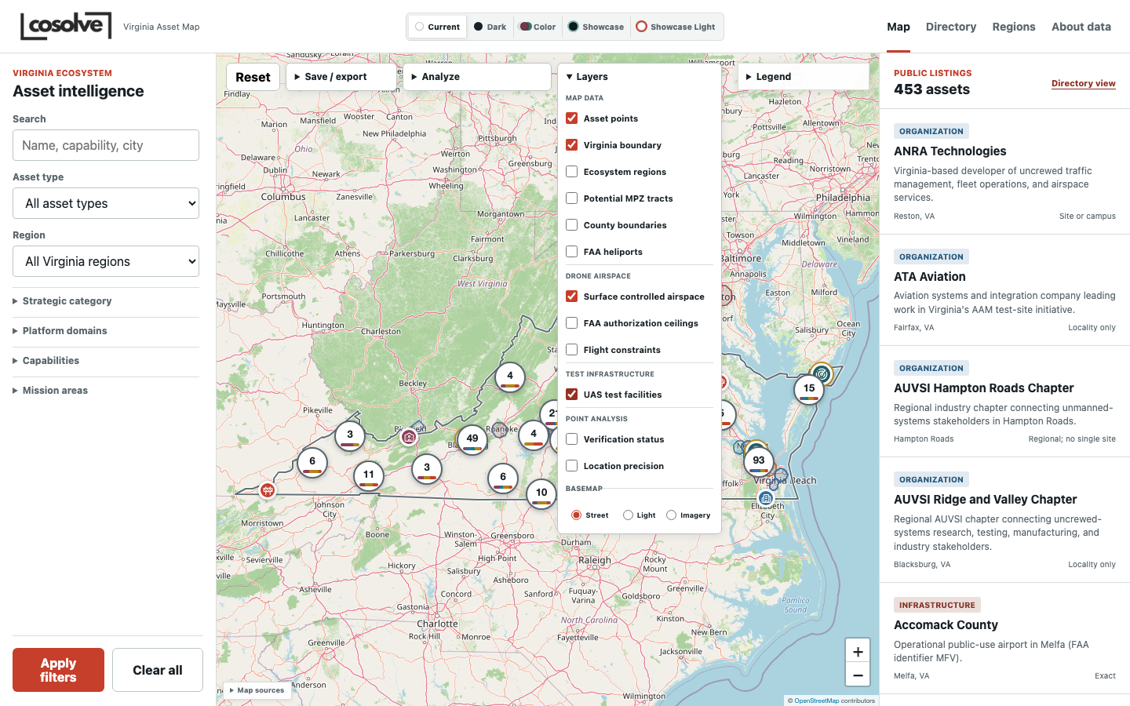
The Layers menu groups map data, drone airspace, test infrastructure, point analysis, and basemap choices.

Top controls
Reset. Returns to the statewide starting extent without changing the underlying data.
Save / export. Saves a reusable view, copies the exact link, prints a PDF, or enters Presentation mode.
Analyze. Finds nearby assets, selects an area, summarizes a region, or exports selected records.
Layers. Turns points and contextual map overlays on or off and changes the basemap.
Legend. Explains marker colors, symbols, cluster composition, and any active analytical overlays.
Map sources. Opens the compact source disclosure at the bottom of the map.

Map interaction
Point. Click to see a short record summary and open the full asset profile.
Cluster. Click or zoom to separate nearby assets. The number is the documented record count in that cluster.
Search label. When Search is active, matching record names appear above their points.
Zoom. Use the + / − controls, trackpad, or mouse wheel; drag to pan.
Presentation mode. Hides filters, results, and extra controls so the map can fill the screen. Press Escape or choose Exit Presentation to return.

Feature Reference: Layers
Asset points and the Virginia boundary are the only layers enabled by default. Add contextual layers one at a time.

Map data
Asset points. The mapped records in the current filter or analysis selection.
Virginia boundary. A clear Commonwealth outline that separates Virginia from surrounding states.
Ecosystem regions. COSOLVE working analytical groupings used for comparison and summary. They are not legal or administrative boundaries.
Potential MPZ tracts. Planning candidates associated with maritime prosperity zone analysis. They are not federal designations or findings of eligibility.
County boundaries. U.S. Census reference boundaries for counties and independent cities.
FAA heliports. FAA-recorded private-use heliport reference points. A point does not imply landing rights, public access, or flight authorization.

Drone airspace
Surface controlled airspace. FAA Class B, C, D, and surface Class E areas relevant to authorization planning. Drone operations generally require the appropriate authorization.
FAA authorization ceilings. UAS Facility Map grid cells and their published request-evaluation ceiling values. A ceiling is not permission and is not a universal legal flight limit.
Flight constraints. FAA national-security and special-use reference areas. This is static planning context; always check current FAA notices, restrictions, TFRs, and NOTAMs.

Test infrastructure
UAS test facilities. Published facilities such as the MARS UAS Airfield, NASA Langley UAS range/CERTAIN, and Virginia Tech Drone Park. Popups show available site dimensions, launch or takeoff information, access notes, aircraft scope, and constraints. Inclusion is not permission to enter or operate.

Point analysis
Verification status. Restyles points by reviewed, source-backed, stale, or other data-quality state.
Location precision. Restyles points by exact, site-level, locality, approximate, regional, or intentionally hidden precision.

Basemaps
Street. Best for roads, place names, and general orientation.
Light. Best for presentations, labels, and analytical overlays with less visual competition.
Imagery. Best for examining the physical setting of a site.
Do not stack everything If the map becomes hard to read, return to the Light basemap, turn off optional overlays, and add back only the one layer needed for the question.

Feature Reference: Analysis and Sharing

Analyze
Nearby assets. Finds records within 10, 25, 50, or 100 miles of the current map center.
Draw rectangle. Selects assets inside a box drawn on the map.
Draw polygon. Selects assets inside a custom multi-sided area.
Use visible extent. Treats the current map window as the analysis area.
Regional summary. Replaces the asset list with documented totals, point coverage, review coverage, asset mix, and leading capabilities for a region.
Export selected CSV. Downloads only the records inside the active rectangle, polygon, visible extent, or other current selection.
Clear analysis. Removes the selected area and returns the right panel to the normal matching asset list.

Save / export
Save to my views. Stores the current position, zoom, filters, layers, basemap, and area selection under a name. Choose private or allow anyone with the link.
Copy view link. Copies a URL that recreates the current map state. This is usually the fastest way to hand off a specific view.
Print / save PDF. Creates a presentation-ready map and asset register for the current filter or analysis selection. Wait for layers to finish loading before printing.
Presentation mode. Temporarily removes the workspace panels and opens the legend for a clean screen-share map.

Appearance choices
Current. The established light, work-focused interface.
Dark. The same layout in a dark color scheme.
Color. The same functions with a restrained atlas-style palette.
Showcase. A dark, image-led entrance and animated presentation treatment using Virginia imagery.
Showcase Light. The Showcase experience with a light COSOLVE palette.
Appearance versus Presentation mode Appearance changes the visual treatment and remains selected in that browser. Presentation mode is a temporary map-only view that hides working controls. Both use the same underlying records and filters.

Feature Reference: Other Pages

Directory
Use Directory when the stakeholder wants to read and compare records rather than reason spatially.
Same filters. Search and filter by the same asset types, regions, strategic categories, platform domains, capabilities, and mission areas used on the map.
Paginated record list. Scans the inventory in a denser, text-first format with sorting and profile links.
View on map. Carries the current filters back to the map so the same subset can be viewed spatially.
Save view. Authenticated users can preserve a directory search for later use.
Export CSV. Staff users can download the filtered working dataset when their permissions allow it.

Asset profile
Identity and relevance. Explains what the record is and why it is included.
Activity and collaboration. Records current public activity or partnerships only where a source and review date support the statement.
Capabilities and missions. Shows the classification labels used by the map filters.
Related assets. Connects documented programs, operators, facilities, and supporting organizations.
Sources and review. Shows public evidence, source status, review dates, and link checks.
Contact and location. Provides public contact routes, site address where supported, and an explicit location-precision label.
Record history. A collapsed history of meaningful changes; staff may see additional editor and reason details.
Suggest an update. Lets a stakeholder submit a correction and supporting source for review.

Regions
Use Regions to compare documented inventory counts and data-quality indicators across Virginia. Treat the numbers as coverage signals, not a ranking of regional strength.

About data
Use About data when someone asks where records come from, what verification means, how location precision works, or what limitations apply.

Admin and Sign out
Admin appears only for staff accounts. Sign out ends the current authenticated session. A stakeholder may browse with a separate authorized account without receiving editing access.

Questions to Ask Stakeholders
Use a few questions from each group. Do not turn the demonstration into a form-filling exercise.

Coverage and identity
- Which important organizations, facilities, programs, test sites, or operating environments are missing?
- Is the organization represented at the correct site, campus, locality, or region?
- Should any record be combined, separated, renamed, or removed as a duplicate?
- Is this a core unmanned-systems asset or a broader supporting ecosystem asset?

Capabilities and activity
- Are the platform domains, capabilities, mission areas, and strategic categories accurate?
- What current program, partnership, facility, contract, or operational role should be documented?
- What is the strongest public evidence for that activity?
- Which relationships between organizations or sites would make the ecosystem easier to understand?

Evidence, contacts, and sensitivity
- What direct public webpage should support this record?
- What public contact route should a serious stakeholder use?
- Is any published location more precise than is appropriate for security, privacy, or operational reasons?
- Who should review this information again, and on what cadence?

Do not overclaim
- Not an authoritative census. The inventory is designed to improve through review and sourced additions.
- Counts are not rankings. A higher count may reflect concentration, broader definitions, or more complete research.
- No inferred capability. An institution’s existence does not prove a specific unmanned-systems capability.
- No live operational picture. The site should not contain live movements, operational readiness, classified, CUI, export-controlled, or security-sensitive information.
- Airspace is not authorization. Always use current FAA sources and required operational approvals.
- Candidates are not designations. Potential MPZ tracts are planning references only.

Troubleshooting During a Demonstration
The first page is slow. Wait 30–90 seconds and refresh once. The hosted service may be waking up after inactivity.
Login fails. Check username or email, Caps Lock, and password. Use Forgot your password if configured; do not use or share another person’s credentials.
The site cannot be reached. Confirm internet access, reopen the deployed URL, and refresh once. Continue from a prepared PDF or screenshot if needed.
The map is blank. Refresh the page. If Directory still works, continue the discussion there and return to the map later.
Too few assets appear. Review the active filter chips above the asset list. Remove one chip or choose Clear all, then apply the intended filters again.
A numbered circle appears instead of a point. It is a cluster. Click it or zoom in to separate the nearby assets.
A record has no precise point. Check the profile’s location precision. Regional, generalized, and intentionally hidden records may not identify a single site.
A layer is slow or confusing. Wait for it to load, then use only that analytical layer. Switch to Light basemap or turn the layer off.
The layer menu is too tall. Scroll inside the Layers menu. On a small screen, collapse it after making the selection.
A shared link will not open. The recipient must have an authorized site account. Confirm the correct link was copied and, for saved views, that link sharing was enabled.
The PDF looks incomplete. Close open popups, wait for visible layers to finish loading, choose landscape orientation, and enable background graphics if the browser offers that option.
A stakeholder disputes a record. Acknowledge the correction, identify the exact field, and request a direct public source. Do not change its review status during the call.
Verification reports no verified public source. Open the record’s source, confirm the public link and date, mark that source verified, save it, and only then verify the asset.
A record was verified by mistake. In Admin, select the asset and use Mark selected records unverified. Then add an internal review comment explaining the reason.
A staff edit was wrong. Open History on the record, review the change, and restore the earlier version or contact the site administrator.
Safety rule Never enter classified information, CUI, export-controlled material, live operational details, personal phone numbers, credentials, or security-sensitive site details into the viewer or its internal notes.

After the Interview: Staff Workflow
Ale and Chelsea should use these steps only if Admin appears in the navigation and their account has permission for the relevant record. The safest practice is to take notes during the call and make evidence-based edits afterward.
- Record the request first. Open the asset in Admin and add an Internal review comment summarizing who raised the issue, what should change, and which source was provided.
- Open the public source. Confirm that it directly supports the organization, location, capability, activity, contact, or site-readiness claim being changed.
- Update only supported fields. Edit the identity, relevance, activity, taxonomy, location, contact, or site-readiness information that the source actually proves.
- Review the source entry. Confirm the source title, direct URL, source date, verification status and date, public visibility, and link-review status.
- Verify in the correct order. A record needs at least one dated, verified public source before it can be marked editorially reviewed.
- Leave an audit trail. Use a clear change reason. History records edits and supports rollback when needed.
- Escalate uncertainty. If evidence conflicts, the location is sensitive, or a claim cannot be verified publicly, leave the record unverified and ask the site administrator to review it.

What role-dependent access means
Authorized viewer. Can sign in, explore the map and directory, open profiles, and submit suggested updates.
Staff editor. May see Admin and edit the data areas granted to that account.
Publisher or superuser. Has broader publication, account, taxonomy, or system permissions. These should remain limited to designated administrators.
If a button or Admin section is not visible, the account does not currently have that permission. Do not share an administrator account to work around it.

End-of-call checklist
- Capture each proposed correction and the record it affects.
- Request a direct public source for every factual change.
- Note the correct location precision and any sensitivity concern.
- Identify the public contact route and responsible reviewer where possible.
- Save or copy the exact view discussed, when useful.
- Assign follow-up ownership and do not mark uncertain records verified.

Frequently Asked Questions

What exactly is this?
A source-linked interactive inventory for exploring Virginia’s unmanned and autonomous systems ecosystem across organizations, facilities, programs, infrastructure, capabilities, and regions.

How current is it?
Each profile can show source and review dates. It is intended to be maintained as a living resource, but any record is only as current as its latest documented review.

Where does the information come from?
Primarily public, preferably first-party sources. Profile pages show supporting sources, and Map sources explains the contextual map datasets.

Does ‘verified’ mean COSOLVE endorses the organization?
No. It means a reviewer confirmed the record against qualifying public evidence. It is not an endorsement, certification, ranking, or claim of operational readiness.

Can someone use the site without a screen share?
Yes, if a separate authorized account has been created for that person. The current pilot site is not open to anonymous visitors.

Can I share or download what I see?
Yes. Copy the exact view link, save a view, print a PDF, or export the current selected records. The recipient still needs an account while the site remains restricted.

Why are some pins approximate?
A public source may identify only a campus, locality, or region, or a more precise location may be inappropriate to publish. The precision label explains the limitation.

Can this replace FAA charts or flight-planning tools?
No. Airspace overlays provide static planning context only. Operators must use current FAA sources, restrictions, notices, and required approvals.

Are regional totals or leading capabilities rankings?
No. They summarize documented records in the current dataset. Coverage and classification differences can affect the totals.

What if something is wrong or missing?
Use Suggest an update or give the COSOLVE team the exact record, proposed correction, and a direct public source. Staff review the evidence before publication.
Final presenter reminder The strongest demonstration is not the one with the most clicks. It is the one that helps a stakeholder recognize a useful pattern, challenge the evidence constructively, and leave a specific source-backed improvement for the inventory.

