Improving Campus Entertainment

Author:

John Clay

Date:

3/31/2018

Addressed To:

The Association for Campus Entertainment (ACE)

It was past midnight, and I was frantically running through the UAH campus. Where is the flag? Better yet, where am I? A complete freshman, I found myself completely enthralled with this take on the classic icebreaker, Capture-the-Flag, along with about a hundred other students. Its excitement and atmosphere captivated me.

Everyone has a first memory of college. For some, it may be their first fraternity party; for others, the panicked realization that parking is non-existent. Whether for good or bad, all have a first memory of their college journey. Yet, the university experience does not end with first memory. Throughout their years of school, many discover exciting hobbies, develop new passions, and find long-lasting friendships.

However, these positive impacts on a student’s life can easily be mitigated by the business of school and the constant rush to meet deadlines. Unless there is a well designed system of social events, it is unfortunately easy to pursue a familiar individual schedule without branching out to discover all the diversity on a college campus. At the University of Alabama in Huntsville (UAH), much of the weight of planning such events falls on the Association for Campus Entertainment (ACE).

From comedians to bowling trips, ACE has offered a number of events with the intent of providing entertainment to students, despite their busy schedules. For the most part, ACE succeeds this objective. In my four years of attending UAH, I’ve attended several ACE events, finding many enjoyable, but often left slightly disappointed. While these events are generally well executed, I have been let down by a lack of variety in the events, scarcity of events, poor advertising, and scant campus utilization. With several proven fixes, ACE could easily pave the way to a more unified and pleasant campus.

**RATIONAL FOR A VARIETY IN EVENTS**

When hit by a craving for ice-cream, would you rather visit a shop showing off a variety of flavors, or one with only basic flavors? Most would opt for the former, as “variety is the spice of life.” Yet, ACE often reuses former event ideas rather than bringing in fresh event ideas. This can quickly lead to staleness and lack of student interest. As stated in an interview with professor and author Cassie Mogilner, “The reason variety makes you feel happier over…longer periods of time is because it keeps you engaged. It offsets that potential for boredom and burnout” (Knowledge@Wharton). A variety of events would aid students in their studies by keeping them active and engaged.

Admittedly, some events need to resurface often. For instance, the Silent Disco is always a huge hit, hosting hundreds of people every year. What makes these events so successful is their uniqueness and sheer fun. However, many simple rehashes, such as paint nights, would be better occasionally replaced with other uncommon events.

Furthermore, in my research, many sources cite the importance of colleges hosting clubs and activities fitting to a prospective student’s entertainment choices (Grove). If UAH offers a wider variety of events, we will appear more attractive to a wider variety of potential students. Not only will it attract a wider range of attendees, but it will also allow each participant to engage in meet and connect with others of different interests, building a connected, yet diverse, community at UAH.

**PROPROSITION FOR A VARIETY OF EVENTS**

Several different universities host exciting events that UAH would benefit also implementing. Here are a few examples: Music and Dance Festival, FallFest, and Circus.

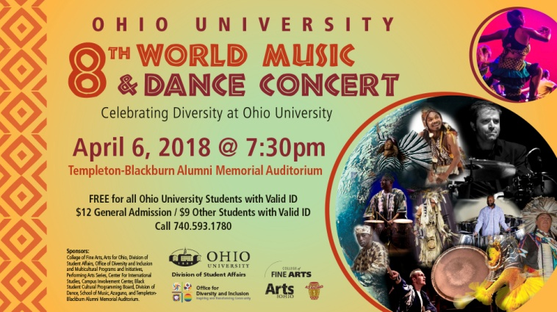**Music and Dance Festival**

Ohio University annually hosts a music and dance festival, bringing together and intermingling a diverse plethora of cultures (Ohio). ACE could change up the routine in events by throwing a similar festival centered on music and dance.

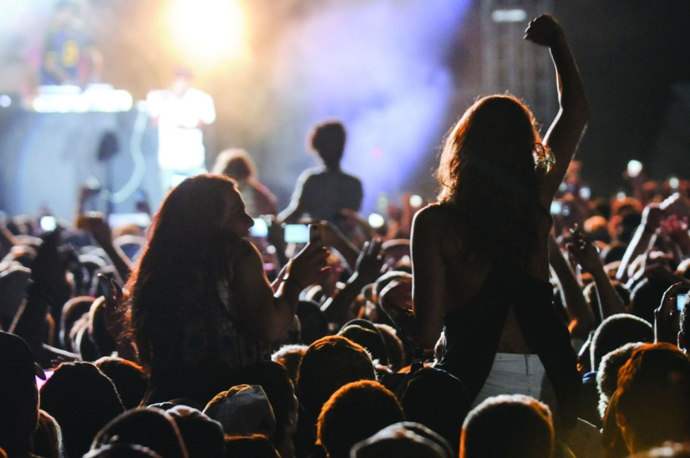**FallFest**

West Virginia University annually holds a wildly popular FallFest, bringing in often little known artists for a vivid outdoor concert (Walker). While UAH holds a number of “Week of Welcome” events, there’s hardly a defining event that kicks off the semester. A

huge outdoor concert or

similar large event could help fire up students for the rest of the semester’s journey.

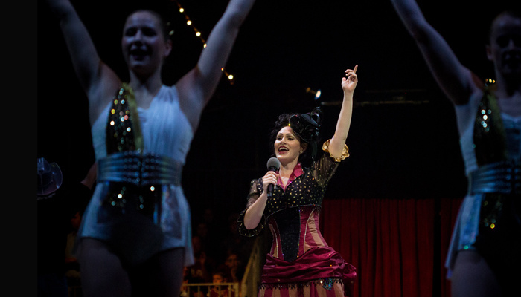**Circus**

Florida State University will be hosting a circus trip this Friday, free to all FSU students (FSU). While a circus trip may not be feasible for UAH, a circus event would be unique and interesting to attend. ACE could plan a similar daytrip.

Those are only a few examples of the vast expanse of events explored by colleges for entertainment. Some are huge and require a lot of planning, such as West Virginia’s FallFest, while others are more laid back like the dance workshops in Ohio University’s World Music & Dance Concert. Nevertheless, each is exciting and unique, a recipe for success.

**Rational for more events**

 Referring back to the ice cream analogy, while a variety in ice cream choices is attractive, so is a sheer multitude of choices. Giving students the power to choose from a large selection of events at different time throughout the week will allow for many proactive study breaks that ultimately boost morale and ability to focus on studies.

An article by Psychology Today states the importance of taking breaks by citing benefits such as positive health impacts, reduced fatigue, increased memory and learning, and refreshed drive (Selig). Regardless of these physical and mental advantages, more events gives students more opportunities to build lasting memories and friendships.

This brings up the question: how can ACE host numerous events that are exciting and various while not being too costly? In order to host events that are cost effective, weekday events should often be smaller, saving the bigger events for weekends. This will also prove beneficial to students during the week as large events can impede on much precious study time. There doesn’t have to be a direct correlation between money invested in an event and its success. College students are quite proficient at entertaining themselves without much help; they just need a meeting time and common theme. For example, my experience with the Capture-the-Flag game mentioned in the introduction was a blast with the sole investments being simply flags and advertisements. Having a simple rally point can be certainly provide loads of fun. Therefore, providing more events should not be drastic to ACE’s budget, and improve student life. Again, viewing other schools’ event line up can prove helpful.

**Proposition for more events**

**City Tour**

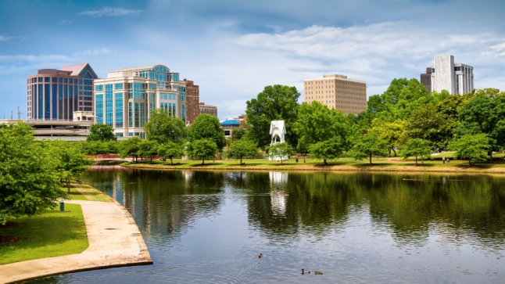Clemson University will soon be hosting an “Atlanta-Nashville Tour,” showing students around different cities and explaining growing sectors (Atlanta-Nashville). UAH could adopt a similar concept and have a “Huntsville Explore Day” where students ride bikes downtown, visit the Space and Rocket Center, and hit up a local food joint. This is particularly useful in introducing non-local students to the area, and most purchases will be in the students’ expense.

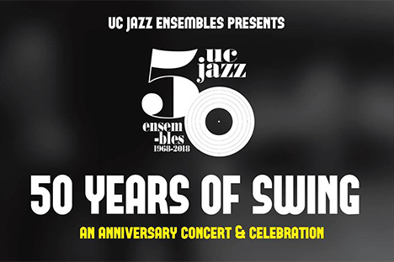**Swing Dance**

Berkeley University of California will be hosting a swing dance to live jazz music. ACE could throw a similar party. Live music is not a requirement if funds are a problem, but it would be a huge selling point. In fact, UAH already has a swing dancing club; why not collaborate with them to put a spotlight on a particular swing dance time? In this case, ACE would need not find a swing instructor or arrange music, as the swing dance club will handle all of that. ACE will simply advertise one of the swing dances, which could attract a number of students.

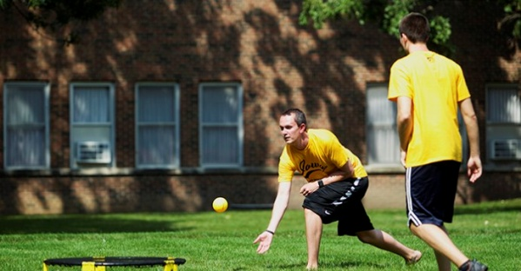**Spikeball**

The University of Iowa takes the yard game Spikeball so seriously they have intramural teams for it (Intramural). While UAH doesn’t need its own Spikeball intramural team, it’s always enjoyable to play yard games with others when taking a study break. ACE has hosted several such events in the past with success. Holding more of these types of socials should boast similar results.

As demonstrated, there are a number of easy, cheap, and entertaining events that ACE could host. This allows for a larger quantity of social gatherings, which offers plenty of study breaks, allows for more students to meet, and makes UAH a more connected, attractive school.

**Rational for better advertising**

Though more events covering wider spread of interests would indeed improve campus entertainment, better advertisement would allow for a larger

Works Cited

“Atlanta-Nashville Tour.” Clemson University,

calendar.clemson.edu/event/atlanta-nashville_tour#.WsLLWIjwZPY.

“Critic's Choice.” Berkeley Events, Berkeley University of California,

events.berkeley.edu/.

FSU Information Technology Services. “FSU Circus Home Home Show

Series.” Florida State University Calendar, calendar.fsu.edu/event/fsu_night_at_the_circus_2279#.WsGwnYjwZPY.

Grove, Allen. “Choosing the Perfect College.” ThoughtCo, 2 Nov. 2017,

www.thoughtco.com/choosing-the-perfect-college-786979.

Hughes, Anthony. “12 Ways to Stop Your Employees Getting Too Bored at

Work.” CoburgBanks, 15 Aug. 2016, www.coburgbanks.co.uk/blog/staff-retention/stop-employees-getting-bored/.

“Intramural Spikeball Registration.” The University of Iowa,

events.uiowa.edu/event/intramural_spikeball_registration_7893#.WsLP4YjwZPY.

Knowledge@Wharton, and Cassie Mogilner. “Knowledge@Wharton.”

Knowledge@Wharton, Wharton School, 25 Mar. 2015,

knowledge.wharton.upenn.edu/article/does-variety-fuel-happiness-at-work-and-in-life-it-depends/. Accessed 2 Apr. 2018.

“Ohio University 8th World Music & Dance Festival.” Ohio College of Fine Arts,

Ohio University, calendar.ohio.edu/site/finearts/event/ohio-university-8th-world-music--dance-festival-7/.

Selig, Meg. “How Do Work Breaks Help Your Brain? 5 Surprising

Answers.” Psychology Today, Sussex Publishers, 18 Apr. 2017, www.psychologytoday.com/us/blog/changepower/201704/how-do-work-breaks-help-your-brain-5-surprising-answers.

Walker, Chelsea. “Remembering Four Years of FallFest.” The Daily Athenaeum, 12

May 2015, www.thedaonline.com/opinion/columns/remembering-four-years-of-fallfest/article_6090f7fc-f381-11e4-a415-ff6aa44addc1.html.