Jake Close

Jsclose

14052879

Assignment 12

1. 19.8 #2
   1. We know that a node X will change behavior if its percentage of neighbors with the new behavior is greater than a threshold q. Here we see that q = 2/5. Looking at Node C, its two neighbors are E and F. We see that node E has 1 neighbor with behavior and one without. Thus ½ > 2/5 and Node E converts. Node F is neighbor with C, I and G. Its P is 1/3, which is less than 2/5 so it does not convert. Next, we look at node I, which is neighbors with E,F,K thus a P of 1/3. Again, this is less than the required threshold so it does not convert. By symmetry, we see that node H also converts. Thus only C,D,E,H are the only new adopters.
   2. The set of Nodes (F,G,J,I,K) has a clustering density of 2/3 which is larger than 3/5, consequentially blocking the behavior A from spreading throughout the network. We see that each node has at least 2 edges within the set and no more than one outside of it.
   3. Connecting Node C to I (or symmetrically node D to J) would create a cascade of behavior A in the network. After adding this edge, we observe that node E would adopt the behavior, then node I would now have p = 2/4 neighbors with the behavior and adopt, then node f would have p = 2/3 and K with p=1/2. After these nodes adopt, it would cascade throughout the other side of the graph.
2. 19.8#4
   1. Nodes 6,7,11
   2. There are no other pairs
   3. Clusters (1,4,5,6,10) , (7,3,8,9,12) , (13,11,14,15,16)
   4. If you only had two seeds nodes, there is no possible way to place them so that they are apart of all three clusters of cluster coefficient ½. In order for a cascade to occur, it must have at least one node inside the cluster and one node outside of the cluster, thus ½ . The third cluster would never adopt the new behavior because it would only ever have one neighbor with the new behavior. Consequentially they would only create a cascade within two cluster and would they would be unable to create a cascade into the third.
3. 19.8 #5
   1. The new payoff matrix would become:

|  |  |  |
| --- | --- | --- |
|  | A | B |
| A | a,a | x,x, |
| B | x,x | b,b, |

The payoff of switching to A is dqa + d(1-q)x

The payoff of switching to B is dqx + d(1-q)b

Adopt A when dqa + d(1-q)x > dqx + d(1-q)b

Dqa +dx –dqx > dqx + db-dqb

Dx – db > dqx – dqb +dqx –dqa

B-x > 2qx – qb –qa

B-x > q(2x-b-a)

Q > (B-x)/(2x-b-a)

1. 19.8#6
   1. No, the game will never fully be adopted by both floors. Since each student will only join the game if at least half of their friends play, the threshold is ½. Also, each student is friends with two members on their floor and one on the other floor. When a new game is introduced on a floor to 5 students, it will spread to the other 5 students on their floor since at least two of their three friends on the floor will have joined the game. However, the students on the other floor will only have 1 out of the three students on the floor join the game. Consequentially, the behavior will never cascade to the other floor and not all 20 students will adopt.
2. 19.8#7
   1. Let us consider the network of friends. If a person has a reinforced friend, one with whom the player has at least one other friend in common, we consider this person a strong tie. On the other hand, an unreinforced friend is considered a weak tie. People are more likely to hear about new ideas an innovation from their weak ties. However, in order to actually take the risk of adopting the new behavior, people tend to want more strong ties.

In the context of the game, embracing on a new, lengthy quest would be considered a risky new behavior. People are more likely to engage in the quest because they have many strong ties/ reinforced friends that are also participating or have taken the quest. They feel safer and see less risk in it because of there relationships. If we consider cheating to be not as risky of a new behavior, we can explain why it can be associated with weak ties or unreinforced edges. People can take the advice with little risk/cost because its from weak ties and they often hear this new unique information from a weak tie.

2. a)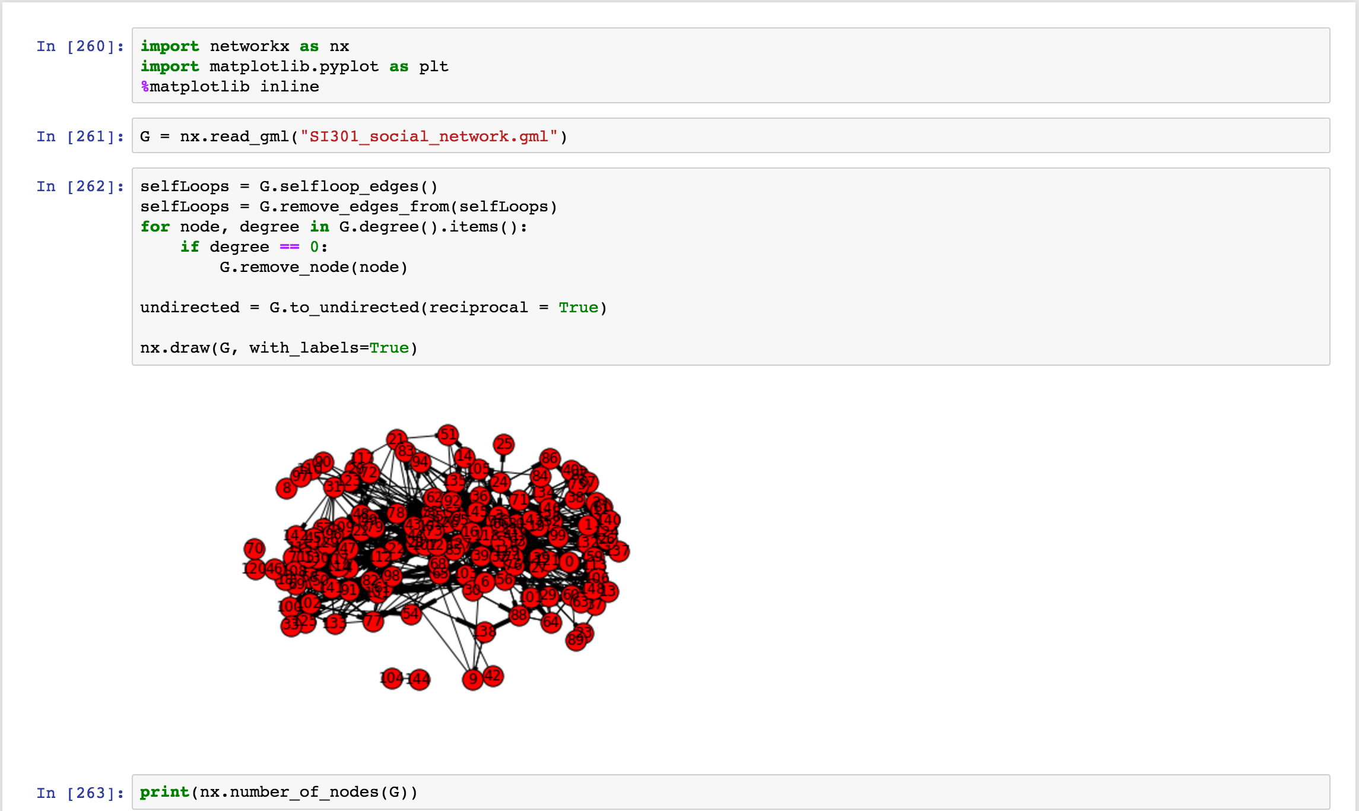

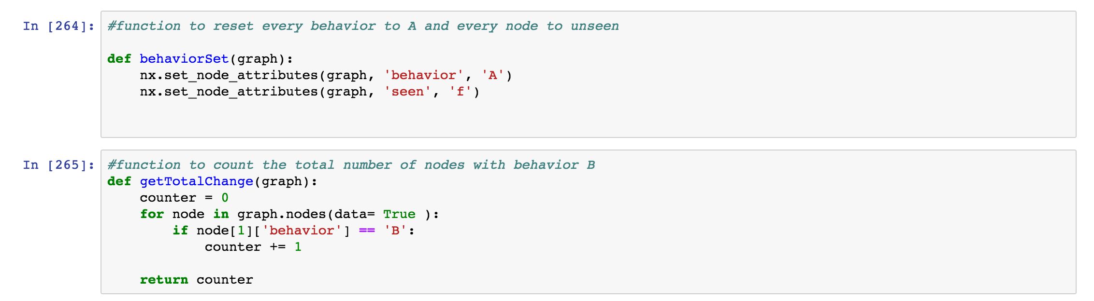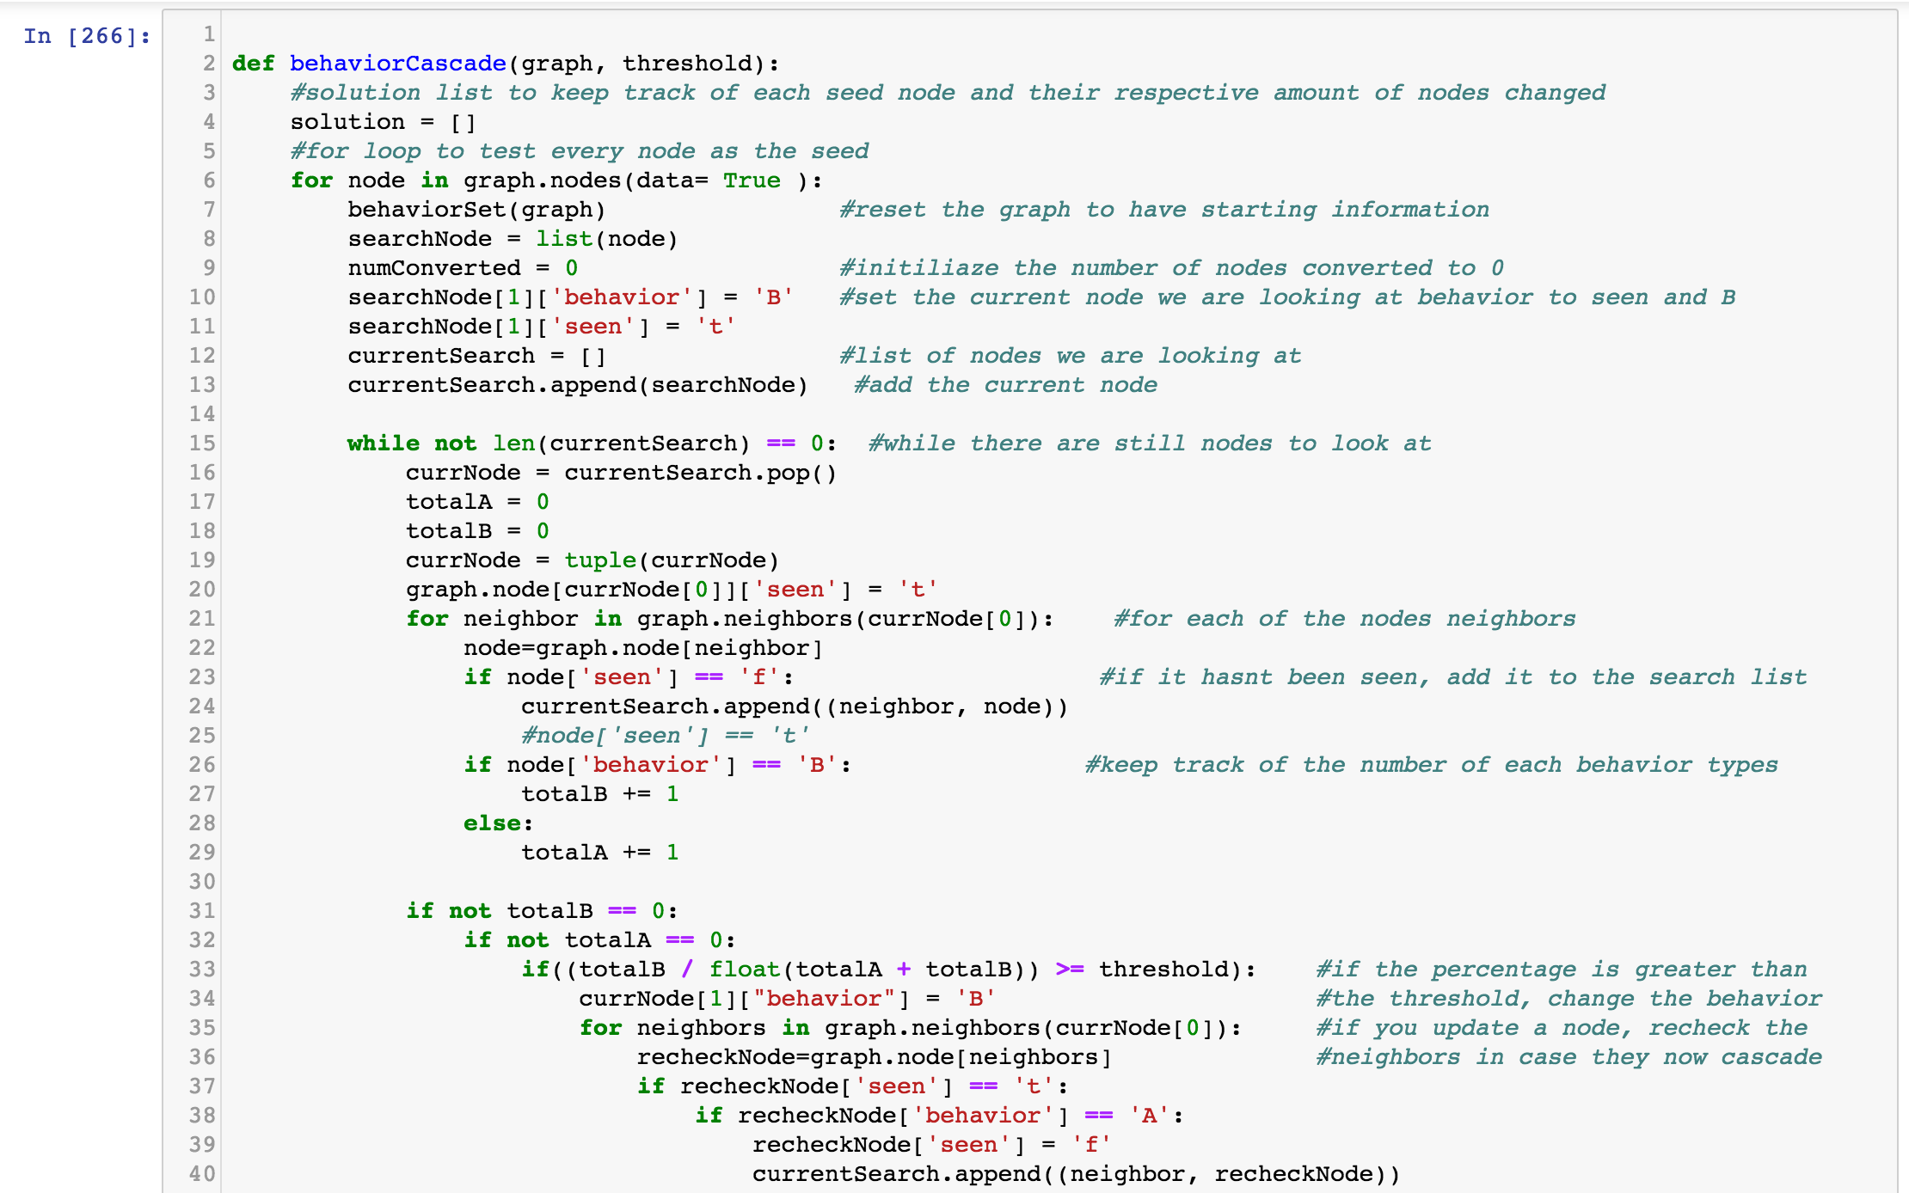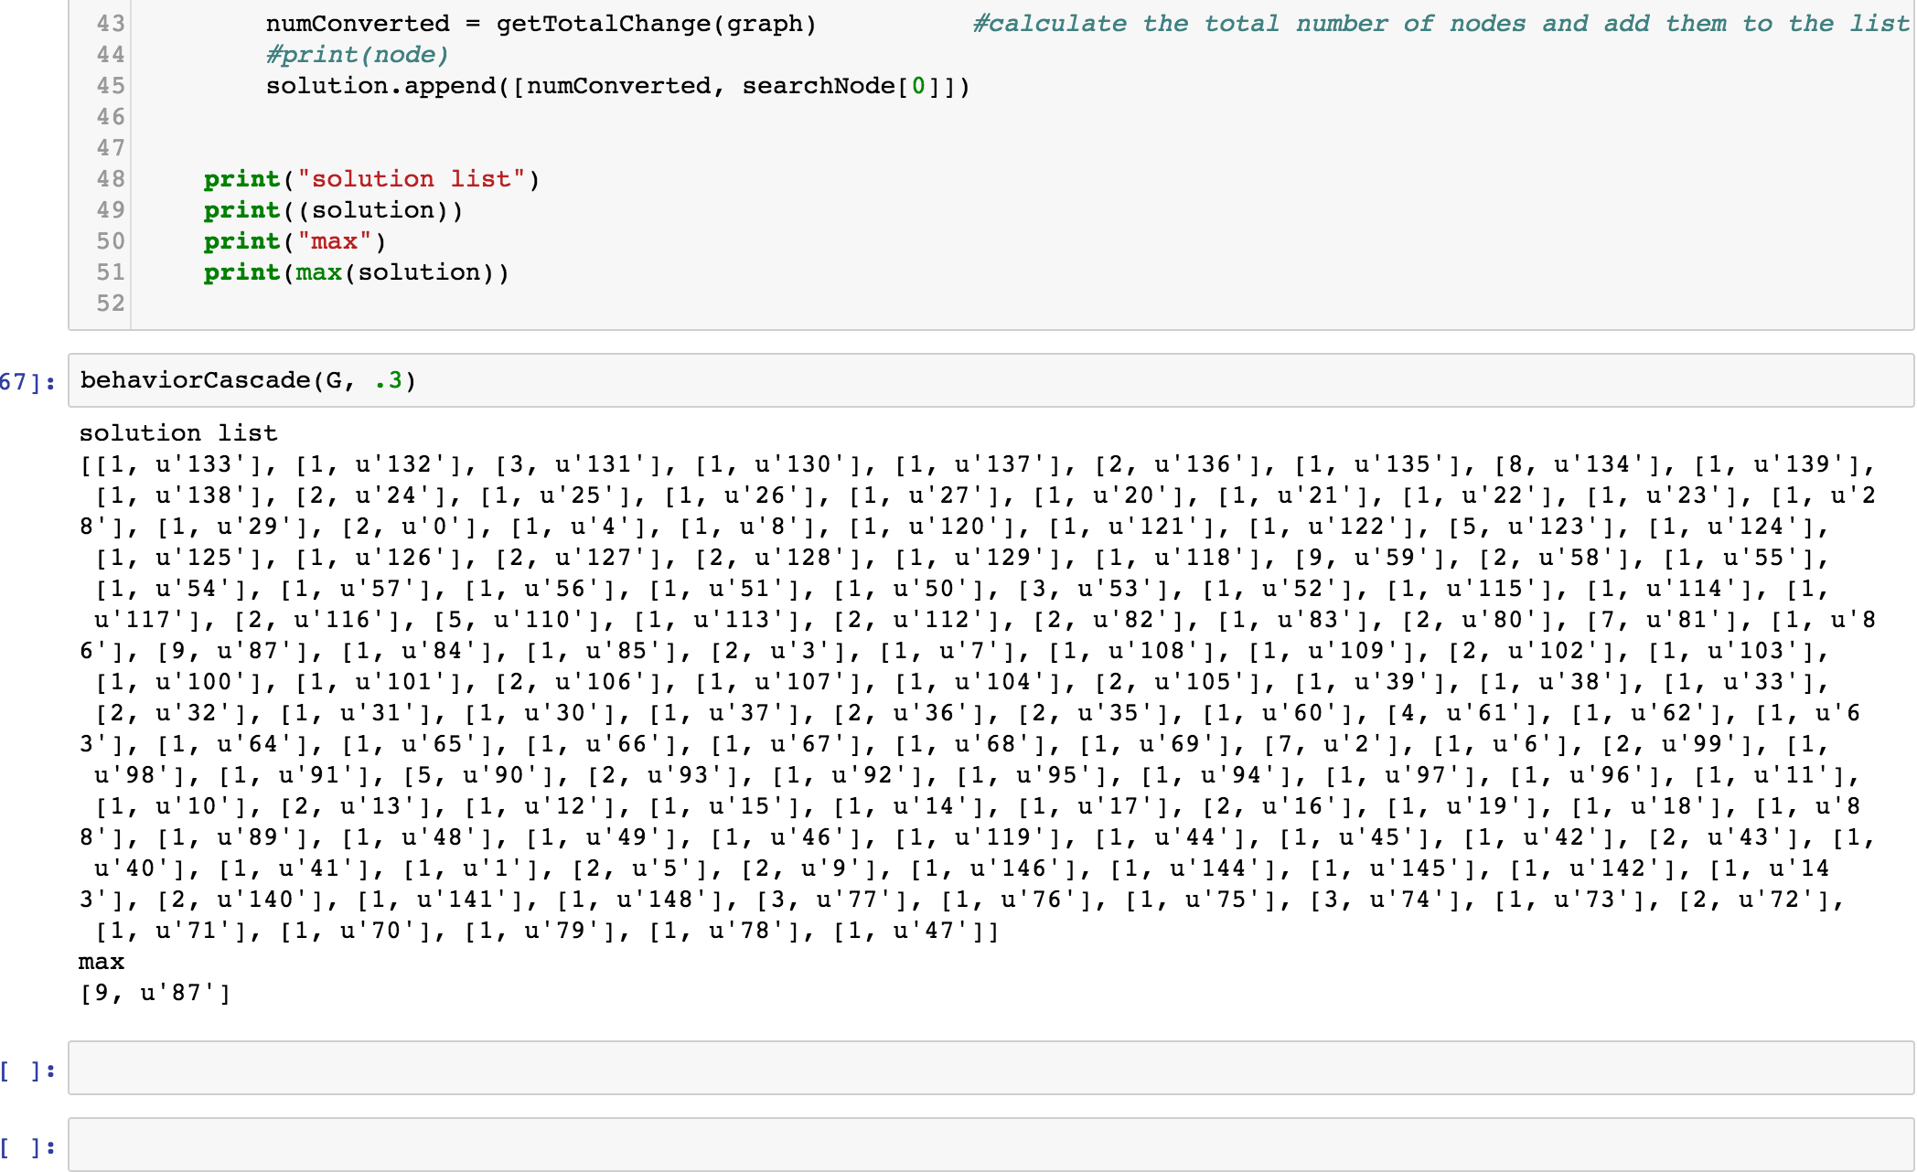

b)

Based on our code, we observe that the maximum number of nodes that converted their behaviors is not equal to the total number of nodes in the graph. Since we see that threshold of 3/10 did not cause a cascade throughout the network, we know that there must be a cluster of density 7/10