# Detailed Description of Project

The document includes detailed description of Elements used, with their input and expected outputs. Along with the interaction aspect between the components/elements.

## @ IBOutlet

The type qualifier IBOutlet is a tag applied to a property declaration so that the Interface Builder application can recognize the property as an outlet and synchronize the display and connection of it with Xcode.

@IBOutlet Variables

* UIImageView: conditionImageView(Vector asset)

The UIImageView holds the icons or svg for the weather indication to be

* Cloud if it is cloudy,
* Rainy if the weather indicates rainy, and
* Wind if the weather indicates windy

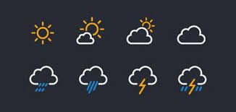

* UILabel: temperatureLabel()

TemperatureLabel will hold the weather information in Degree “Celsius” eg: “21 * C”

* UILabel: cityLabel

CityLabel holds the city name eg: “London”

* UITextField : searchTextField

The Textbox is for user to enter the location name in order to get the weather details with respect to the Geographical Location using GPS.

## @IBAction

IBAction is a keyword and return type in method declarations to denote that a particular method is connected to by an action.

All IBAction keywords are replaced by void because actions invoked by user interface controls are not expected to have a return value. “IBAction” is used by in place of the “return type” void for a method that receives an event sent from Interface Builder. The IBAction keyword allows the programmer to connect the source code to user interface objects in Interface Builder.

UIButton: searchPressed(_ sender:UIButton)