# Mobile Computing - iOS (or Android) Final Project Proposal

### Team Members:

Rohith Reddy Avisakula, Soujanya Janapatla

### Team Name:

Titans

### Overview:

We are planning on developing a "GeoWeather" which is a weather application, and through the process of building this app we will see how to work with API's and how to fetch live data from the internet. We will be developing an application which allows us to get the live weather data for the current location using the phone GPS. In addition, the app provides a search bar where the user can type in the name of the city that you want to check the weather and get the weather that way. Also it will have a feature to enable dark mode and see the interface of the mobile change accordingly.

#### Function Requirements of the application:

1. Create a dark-mode enabled app and use vector assets
2. Swift Protocol and the Delegate Design Pattern
3. Work with API's by making HTTP requests with URL Session
4. Use computed properties, closure, extensions and core location to get the GPS data

### Details:

The app uses a UITextField to get user input, working with weather API's in fetching the weather details using URLSession. Once we get the weather data back we shall parse it from a JSON format to a swift object using JSONDecoder,and also use the Core Location package to get the GPS data from the phone.

### Mockups:

Here is the Mockups created for the initial design:

<https://app.moqups.com/unsaved/4591c431/view/page/a215d1e55>

View 1 View 2 View 3

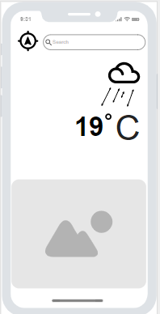 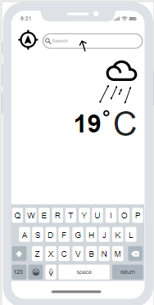 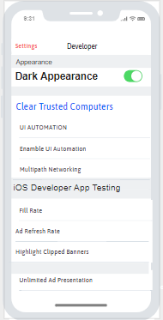

### Duties:

1. Rohith will be in charge of the UI screens and the dark-mode theme enabling functionality.
2. Soujanya will be incharge of understanding the fetching data weather details from API's and the usage of Core Location package.