# Mobile Computing - iOS (or Android) Final Project Proposal

## Team Members:

Rohith Reddy Avisakula,

Soujanya Janapatla

## Team Name:

Titans

## Detailed Description of Project

The document includes detailed description of Elements used, with their input and expected outputs. So far we had gathered the icons and background images needed for the application to switch between the themes. Also added form elements like input field, Labels, Text box and search button

 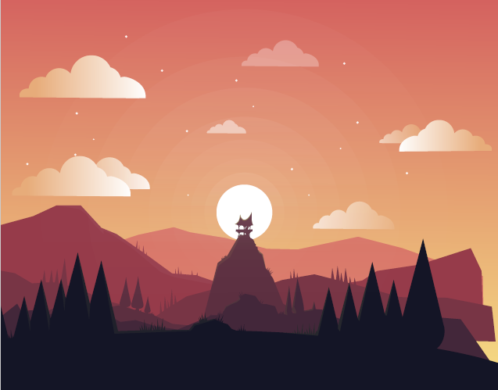

Work Distribution:

Rohith:

1. Gathered the vector images for the background both for light an ddark theme
2. Added form Elements like input text field, search button, labels

Soujanya:

1. I had imported and created an bg asset in the project
2. Fixed the constrains for the elements by defining its position and made it auto-layout properties