# Mobile Computing - iOS (or Android) Final Project Proposal

## Team Members:

Rohith Reddy Avisakula,

Soujanya Janapatla

## Team Name:

Titans

## Detailed Description of Project

The document includes detailed description of Elements used, with their input and expected outputs. So far we had gathered the icons and background images needed for the application to switch between the themes. Also added form elements like input field, Labels, Text box and search button

 

## Added Form Elements

We had incorporated form Elements such as:

@IBOutlet Variables

* UIImageView: conditionImageView(Vector asset)

The UIImageView holds the icons or svg for the weather indication to be

* Cloud if it is cloudy,
* Rainy if the weather indicates rainy, and
* Wind if the weather indicates windy
* UILabel: temperatureLabel()

TemperatureLabel will hold the weather information in Degree “Celsius” eg: “21 * C”

* UILabel: cityLabel

CityLabel holds the city name eg: “London”

* UITextField : searchTextField

The Textbox is for user to enter the location name in order to get the weather details with respect to the Geographical Location using GPS.

## @IBAction

IBAction is a keyword and return type in method declarations to denote that a particular method is connected to by an action.

UIButton: searchPressed(_ sender:UIButton)

This function takes the location name form the textbox and validates and returns the weather details back and updates he vector image and the temperature and location label.

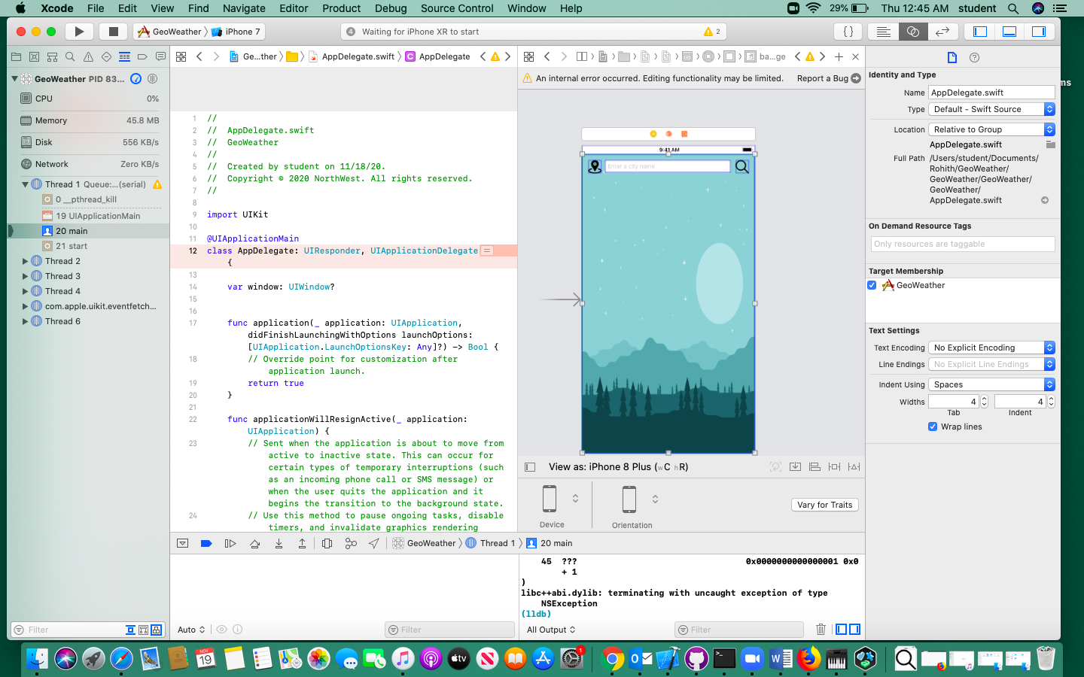

Work Distribution:

Rohith:

1. Gathered the vector images for the background both for light an ddark theme
2. Added form Elements like input text field, search button, labels

Soujanya:

1. I had imported and created an bg asset in the project
2. Fixed the constrains for the elements by defining its position and made it auto-layout properties

## Github URL

<https://github.com/jscodebit/GeoWeather>