R Notebook

jessica

# Introduction

This is an [R Markdown](http://rmarkdown.rstudio.com) Notebook. When you execute code within the notebook, the results appear beneath the code.

Try executing this chunk by clicking the Run button within the chunk or by placing your cursor inside it and pressing Ctrl+Shift+Enter.

# Methods

## Study site

plot(cars)

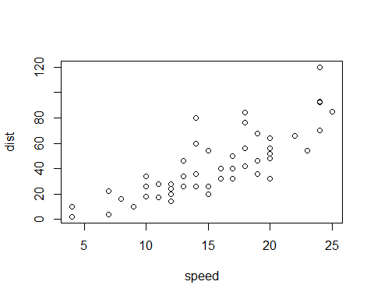

Add a new chunk by clicking the *Insert Chunk* button on the toolbar or by pressing *Ctrl+Alt+I*.

When you save the notebook, an HTML file containing the code and output will be saved alongside it (click the *Preview* button or press *Ctrl+Shift+K* to preview the HTML file).