Jared Scott

Group Homework 1

I211 – Group 10 ?

Part 1:

1. To see a list of the functions and methods included in the NumPy module, type print(dir(np))
2. To return a basic documentation for the NumPy module, type print(np.__doc__)

Part 2:

1. <https://docs.scipy.org/doc/numpy/>
2. NumPy stands for Numerical Python.
3. The main object provided by NumPy is called an ndarray.
4. Homogenous means the elements of the array are all the same data type. The array is a data structure that stores values of same data types. Multidimensional means that the array can have 1-3 arrays within it.
5. The 6 most important attributes for the main NumPy object is ndarray.size, ndarray.shape, ndarray.ndim, ndarray.dtype, ndarray.itemsize, and ndarray.data.
6. Items can be appended and deleted to a NumPy array once it is created.
7. NumPy arrays can be indexed and sliced.

Part 3:

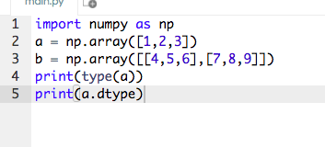

3.) The array a is made of an int64 data type.

4.)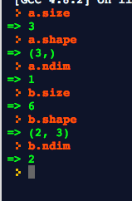

The .size attributes describes the number of items in an array. The first attribute in the .shape method is the number of rows, and the second is the number of columns. The attribute in the .ndim method is the number of dimensions in an array

B.)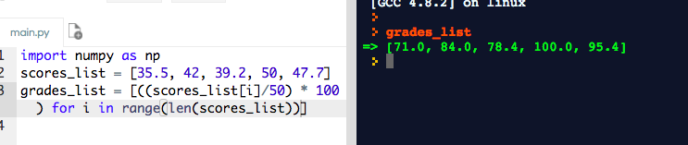

C.)

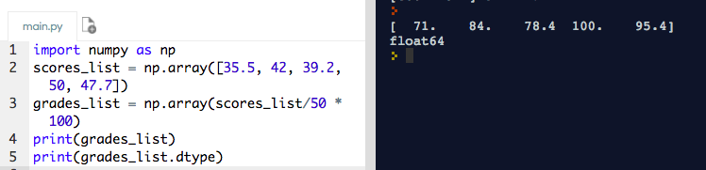

9. line 3 of code above

10. The type of data in grades is a float64 data type because it is a percentage

D.)

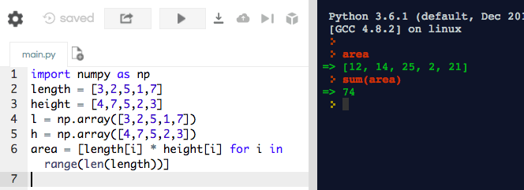

Code for Part D/E

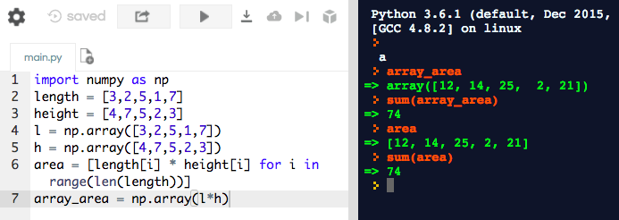

Code for Part D/F

Part 4:

1. <http://cs231n.github.io/python-numpy-tutorial/>
   1. Gives in depth examples and explains what to do
   2. Lists all of the different functions in NumPy and explains how to do them
   3. This is a great tool because it has a clean and understandable format that allows you to find what you are looking for easily when talking about NumPy
2. <https://www.tutorialspoint.com/numpy/numpy_data_types.htm>
   1. Lists all of the different data types and explains how to use it.
   2. Shows inputs and output in all examples
   3. This website is not as easy to navigate, but once you find what you are looking for it gives a broken down explanation that is easy to understand.
3. <https://stackoverflow.com/questions/12569452/how-to-identify-numpy-types-in-python>
   1. Stack overflow is a great tool to help figure out and debug issues.
   2. It also does a great job of answering questions about numpy
   3. For beginners, it gives multiple examples and perspectives on how to solve their questions. The nice part about stack overflow is that it is a community forum and allows users to understand that there are multiple ways to solve and debug when it comes to code and NumPy