# Sprint Retrospective – Sellers Crum

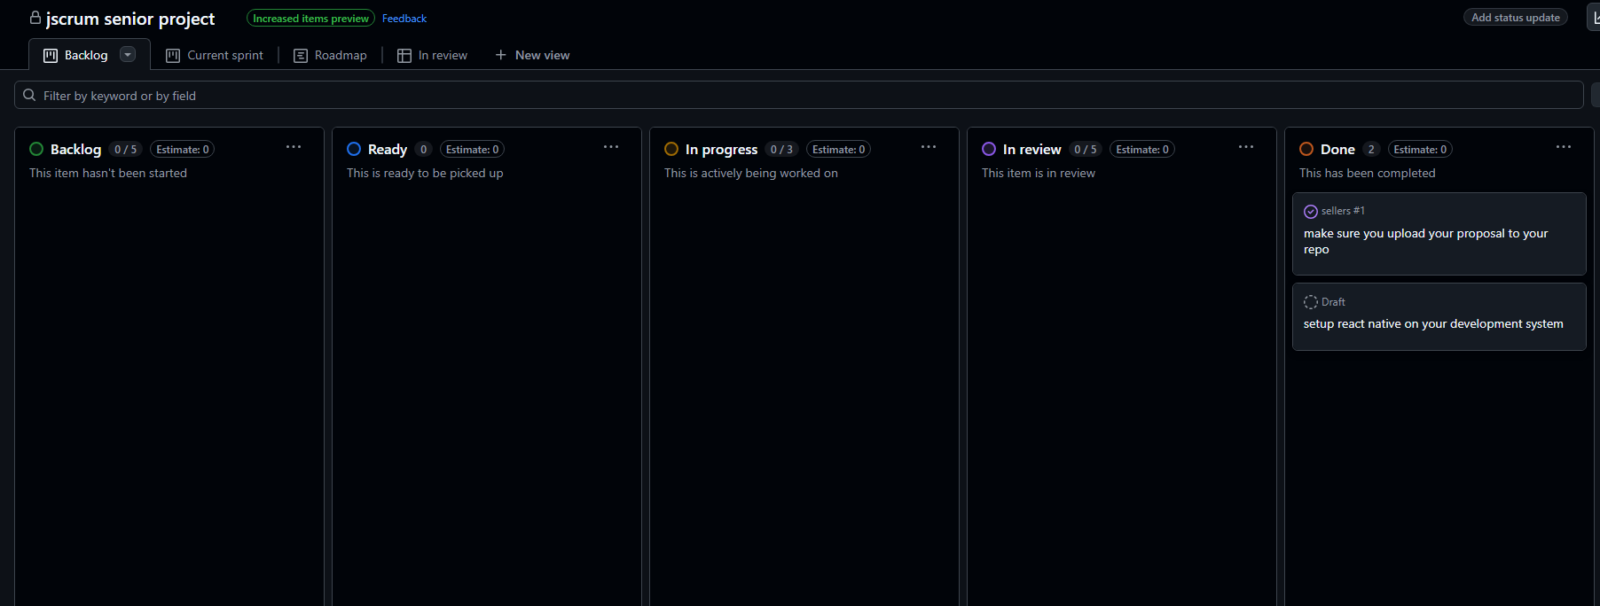

## Project Title

MyBikeTrafficApp

## Sprint Number

Sprint 1

## Sprint Duration

Jan 20 – Feb 2

## Date of Retrospective

Feb 2

## Sprint Goals

Set up react native and complete proposal draft

## Accomplishments

Both goals were accomplished in this sprint

## Challenges

React native is a complex application to get setup. Needed help from Dr. Toone.

## Next Steps

Continue development of app layout.