**The Analysis of User Reviews – Annotation Guideline V0.4**

1. **Introduction**

Thank you for helping us with our study! Your task (called annotation task) is to read **review sentences** from Amazon and Google Play app stores and to conduct a few micro-tasks your are asked for. This guide describes the instructions, which you should follow carefully in order to successfully conduct these micro-tasks. Together with this guide, you are provided with **Annotation Form** in the excel spreadsheet (see Figure 1). You will use this spreadsheet to conduct annotation. We recommend to print this guide and use it as a reference while annotating.

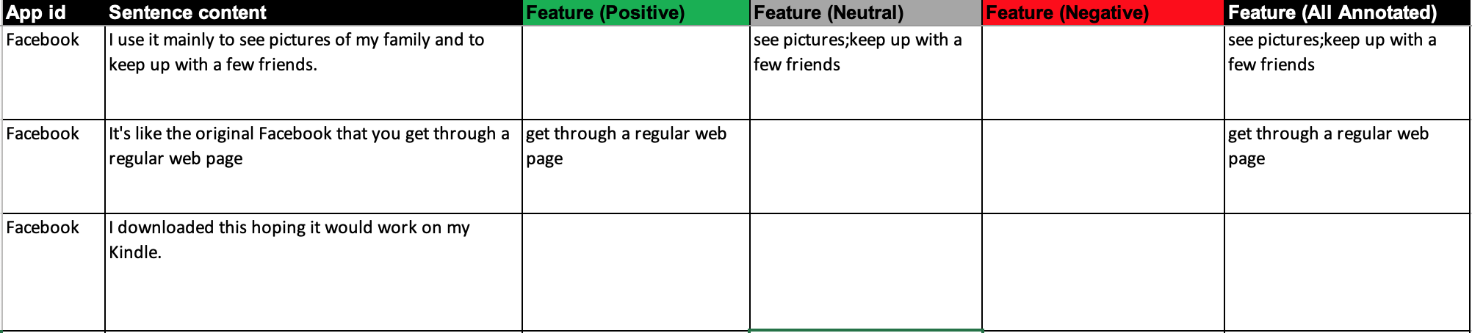

Figure 1. The Annotation Form with Exemplary Annotated Feature Expressions

Your task is to read **review sentences** that are assigned to you in the **Annotation Form** one by one. Each row in a spreadsheet includes *app id*, *sentence content*, *feature with positive sentiment polarity*, *feature with neutral sentiment polarity*, *feature with negative sentiment polarity* and *all the annotated features* no matter what sentiment polarity they are associated with(see Figure 1).

For each review sentence you will conduct the following tasks:

1. **Identify Feature Expression** in a review sentence.
2. **Identify Sentiment Polarity** associated to each identified feature expression.

You will annotate review sentences for 4 apps from Google Play: *WhatsApp, Twitter, Spotify, Photo Editor Pro* and 4 apps from Amazon: *eBay, Evernote, Facebook and Netflix.*

Before starting the annotation task, please read the descriptions of these apps available in the **Appendix A**, included at the end of this guideline.

1. **The Annotation Process**
2. Read carefully Annotation Guideline (this document).
3. Open Annotation Form in Excel Spreadsheet.
4. Read each review sentence.
5. Conduct annotation micro-tasks for each sentence in accordance with the guidelines provided below (see Section III).
6. Register time you spend on the annotation process.

If you cannot conduct annotation task in one go, please register the time you spend each time. We also highly recommend to use this guideline during annotation process as a support.

1. **The Description of Micro-Tasks**

The below sections describe each annotation micro-tasks. We also provide you with the definition of concepts your need to know to conduct each micro-task. Please, read them carefully.

**A. Identify Feature Expressions**

**Micro-Task 1:** Identify *feature expressions* in a review sentence.

**Definition (Feature and Feature expression):** a *feature* is a **user-visible functional** **attribute** of an app that is **intentionally** provided. a *feature* can be used to perform **a task** (“display contact”) by a user. A *feature* can be seen an app **functionality** (e.g., “send message”), a **module** (e.g., “user account”) providing **functionalities** (e.g. “delete account”, or “edit information”) or a **design component** (e.g., UI) providing **functional capabilities** (e.g., “configuration screen”, “button”). While *feature expression* is an actual sequence of words that appears in a review sentence and explicitly indicate a feature. Examples of feature expressions are:

* *"I love uploading pictures with the app"*
* *"The share link makes it so much easier to collaborate with colleagues"*
* *“My contact on WhatsApp is not visible”*
* *“Fast and Secure. With remarkable ability to send any file format”*

**Rules for conducting the Micro-Task 1:**

* Copy exact words denoting a feature expression.
* Annotate feature expression with those consecutive words which are necessary to **understand the meaning** of the feature expression (keeping logical meaning). Additional words, such as adjectives or articles, surrounding the feature expression should not be included in the annotation.
  + **Example:** “*WhatsApp can always reliably and quickly send my messages*”. It should result in *“send my messages”* rather than “*always reliably and quickly send my messages”.*
  + **Example:** “It's so great to be able to check my status on various bids, search for new items and place new bids all from my cell phone”.It should result in “check my status” rather than “check my status on various bids”
* If you find several feature expression in a review sentence, please **separate** them using **“;”** (semicolon without space), e.g. “send messge;receive message”.
* If there is only one feature expression in a sentence**, do not separate** it using “;” semicolon.
* Not every review sentence must contain a feature expression. There may be a review sentence that do not contain feature expressions at all.
* A phrase consisting of a verb and several nouns may describe several feature expressions. Please, write down each of these feature expressions separately.
  + **Example:** *“Synch my notes, photos and documents easily”,* it describes several feature expressions: “*synch my notes”*;“*synch photos”*;“*synch documents”*. If you happen to encounter such a phrase, please, write down each of these feature expression separately.
* A phrase consisting of verbs and a noun may describe several feature expressions. Please, write down each of these feature expressions separately.
  + **Example:** For instance, *“send and* receive *messages”,* it describes two feature expressions: “*send messages”*;“*receive messages”*.
* Do not annotate references to the app itself as feature expression.
  + **Example:** a sentence “Skype app is very useful”, or “I love the app” should not be annotated as a feature expression**.**
* Do not annotate qualities or other non-functional attributes of an app.
  + **Example**: “It's ok, but not like setting down with a good computer and fast online service, too hard to look at the small details.” “setting down with a good computer” is not a feature of an app, but it is rather a quality, i.e. “Efficiency” or “Performance”.
* **Always ask yourself** if something you annotate is **really** a feature of an app. Often user discusses qualities, non-functional attributes or something unrelated with an app.
  + **Example**: “Good app, could be a little lighter.” Little is not a feature. It does not provide any functionality. It is rather a quality. Do not mark qualities of the app.
  + **Example:** “This app lags BAD.” “Lags” is not a feature. It is a user opinion of app working slowly. That is an opinion about quality, i.e. “Efficiency”.
  + **Example**: “This app is amazing, so many options!”. There is no information about a specific feature. “many options” is a user opinion about the quality of an app. In particular, their “Functionality” or “Usability”.
  + **Example:** “Here and there they get out of sync but I know it had something to do with my network connection.” “Network connection” is not a feature of an app. It is a service a user has from their network provider.
  + **Example:** “Fantastic, Netflix has everything a movie buff could want for TV and now it is available for use in mobile form. “has everything” is not giving a concrete example of a feature. It is a user opinion about the quality of an app. In particular, their “Functionality” or “Usability”.
  + **Example:** “My TV is too old for streaming data and does not understand HD.” This information is not a feature and is not related to app. It is information about TV of a user but not the app.
  + **Example:** “The only reason why I got it in the 1st place is cause of the ps4 replace there unlimited music with this abomination”. “Unlimited music” is only a feature.

**B. Assess Sentiment**

**Micro-Task 2:** Assess **sentiment polarity** of each a feature expression you identified in a review sentence.

**Definition (sentiment and polarity):** a sentiment is a user attitude, a mental feeling or emotion toward something. Sentiment is characterized by their orientation, so-called polarity. The following sentiment polarities can be distinguished: *positive*, *neutral* or *negative*.

**Positive**: A *feature expression* has *positive* sentiment polarity when a user expresses their *positive* feelings towards this *feature expression*. Examples:

* *I like that Dropbox lets me upload my files. (positive opinion “like”)*
* *I love Facebook for sharing post among friend (positive opinion “love”)*
* *Now the sending messages works perfectly. (positive opinion “perfectly”)*

**Neutral**: A *feature expression* has *neutral* (neither *positive* nor *negative*) sentiment polarity when a user does not express their *positive* or *negative* feelings towards this *feature expression*. Examples:

* *Dropbox lets me upload my files. (no explicit sentiment)*
* *Need to be able to link my documents. (no explicit sentiment)*
* *After letting it send message it worked perfectly (no explicit sentiment)*
* *I can’t send message (no explicit sentiment).*

**Negative**: A *feature expression* has *negative* sentiment polarity when a user expresses their *negative* feelings towards this *feature expression*. Examples:

* *I hate the upload functionality from Dropbox (negative opinion “hate”)*
* *Also you can't rename files, what the heck? (negative opinion “What the heck ?”)*

**Rules for conducting the Micro-Task 2:**

* Feature expression can be annotated only with a single sentiment polarity.
* We are only interested in **sentiment polarity that is explicitly expressed** in a review sentence using **concrete words or sentence** .
* If **not positive** **neither** **negative sentiment** **polarity** was expressed on a feature expression, then we conclude that the **sentiment polarity** is **natural**.
  + **Example:** “I can’t send message”. The sentiment is neutral. A user says he or she cannot send message but we do not know about their sentiment polarity.
  + **Example:** “I can send message”. The sentiment is neutral. A user says he or she can send message but we do not know about their sentiment.
  + **Example**: “it send message slowly”. The sentiment polarity is negative. Word “slowly “indicates that it is a negative opinion about “send message”
* **Before** you decide on the sentiment polarity on a feature expression, **find a phrase** **expressing the sentiment polarity**. This can be **adjective**, **adverbs** or another **sentence** **commenting** on previously mentioned **feature**.
  + **Example**: “It's better to chat with friends.” Neutral, as the is “better” indicates that sentence structure but not the opinion about a feature.
  + **Example:** “My only complaint is that the little icons are not very self explanatory until one gets the hang of it.”. Cleary, a user is saying that this is a complaining, which means it is negative sentiment polarity.
  + **Example: “**It is everything I ever dreamed of in note taking!”. The sentiment is positive because a user even dream about such “note taking”.
  + **Example:** “Easy to search for items on eBay.” “Searching easy” is positive rather as a user is rather happy he or she can get result quickly and easy rather than difficult.
  + **Example: “**Like a well made rolltop desk, Evernote consistently provides storage in a convenient manner”. “Consistently / a convenient manner” words indicates that “storage” is not interrupted and work in a good manner. That is why the sentiment is positive.
* Ensure if the sentiment polarity word, phrase or sentence is about the feature expression or the other information in the sentence.
  + **Example**: “My TV is too old for streaming data and does not understand HD.” “Streaming data” is neutral because “too old expression” is about “My TV”.
* **Ask yourself** always, is a user positive, negative or natural about the feature expression. **Look at the facts, words that indicates the sentiment polarity** in a sentence, but **not your subjective** interpretation.
  + **Example**: “it send message slowly”. The sentiment polarity is negative. Would you be happy with sending message slowly?
  + **Example:** “it search for movies quickly”. The sentiment polarity is positive. Are you happy that searching is quick and not take much time. I think yes.
* If you did not find a phrase indicating sentiment polarity, then we assume the sentiment is natural.
  + **Example:** “After letting it buffer for awhile it worked perfectly”. “Buffer “feature is natural. The “perfectly” word refers to it, which is probably the app.
  + **Example: “**The choices are good and I get most of the movies I want to watch.” “Good” word indicates it is positive sentiment of a sentence, then user say he can get most he want. This indicates that he or she is happy.
  + **Example:** “not a real user of Facebook so I cannot really rate the application it gets and brings up page quickly”**. “**Quickly” word indicates that “gets and brings up page” is positive
  + **Example: “**It is extremely difficult to use PayPal if the person forgot their password and security question answers.” “difficult” word to use PayPal, it is rather negative.

**Appendix A. The Description of Apps**

This section includes the description of apps whose review sentences you will be annotating. Please, read them carefully so that you will understand the features provided by these apps.

**1. WhatsApp Messenger**

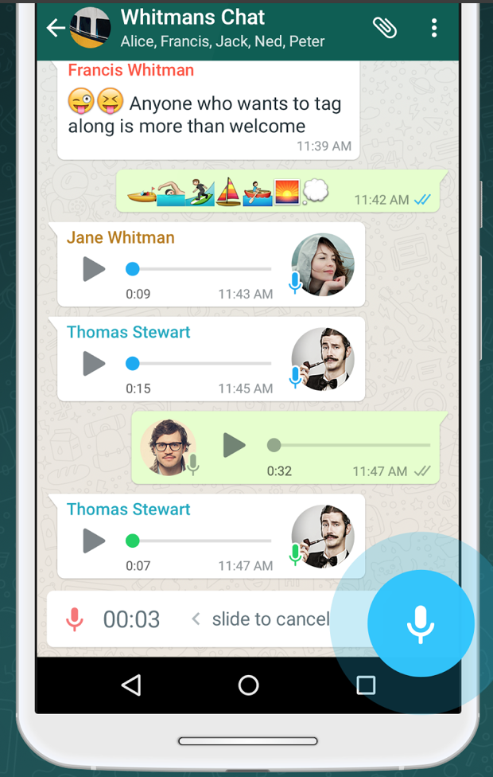

WhatsApp Messenger is a FREE messaging app available for Android and other smartphones. WhatsApp uses your phone's Internet connection (4G/3G/2G/EDGE or Wi-Fi, as available) to let you message and call friends and family. Switch from SMS to WhatsApp to send and receive messages, calls, photos, videos, documents, and Voice Messages.   
  
WHY USE WHATSAPP:

• NO FEES: WhatsApp uses your phone's Internet connection (4G/3G/2G/EDGE or Wi-Fi, as available) to let you message and call friends and family, so you don't have to pay for every message or call. There are no subscription fees to use WhatsApp.  
  
• MULTIMEDIA: Send and receive photos, videos, documents, and Voice Messages.  
  
• FREE CALLS: Call your friends and family for free with WhatsApp Calling, even if they're in another country. WhatsApp calls use your phone's Internet connection rather than your cellular plan's voice minutes.   
  
• GROUP CHAT: Enjoy group chats with your contacts so you can easily stay in touch with your friends or family.

• WHATSAPP WEB: You can also send and receive WhatsApp messages right from your computer's browser.

• NO INTERNATIONAL CHARGES: There's no extra charge to send WhatsApp messages internationally. Chat with your friends around the world and avoid international SMS charges.  
  
• SAY NO TO USERNAMES AND PINS: Why bother having to remember yet another username or PIN? WhatsApp works with your phone number, just like SMS, and integrates seamlessly with your phone's existing address book.

• ALWAYS LOGGED IN: With WhatsApp, you're always logged in so you don't miss messages. No more confusion about whether you're logged in or logged out.

• QUICKLY CONNECT WITH YOUR CONTACTS: Your address book is used to quickly and easily connect you with your contacts who have WhatsApp so there's no need to add hard-to-remember usernames.  
  
• OFFLINE MESSAGES: Even if you miss your notifications or turn off your phone, WhatsApp will save your recent messages until the next time you use the app.

• AND MUCH MORE: Share your location, exchange contacts, set custom wallpapers and notification sounds, email chat history, broadcast messages to multiple contacts at once, and more!

**2. Twitter**

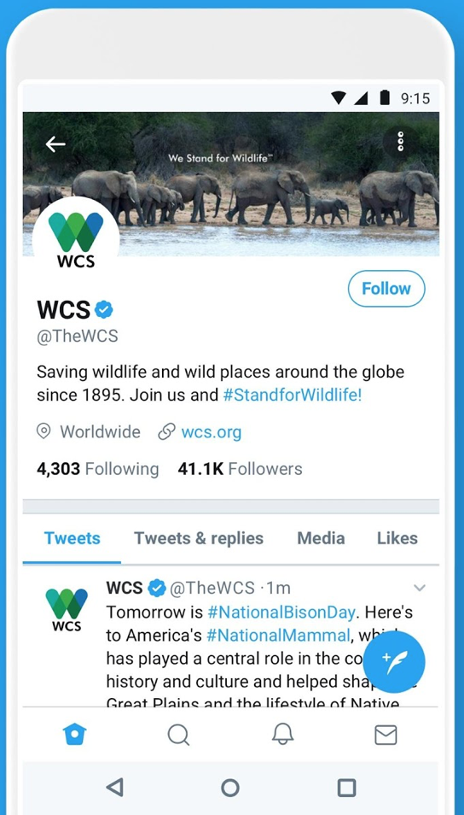From breaking news and entertainment to sports, politics, and everyday interests, when it happens in the world, it happens on Twitter first. See all sides of the story. Join the conversation. Watch live streaming events. Twitter is what’s happening in the world and what people are talking about right now.  
  
More highlights:   
  
- Watch premium and exclusive live streams directly from your mobile device. No account required.  
- Go Live with a tap or sit back and watch events unfold from around the world.  
  
Timeline  
- Discover what your favorite sports, news, politics, and entertainment thought leaders are talking about  
- Experience dynamic media — like photos, videos, and GIFs  
- Retweet, share, like, or reply to Tweets in your timeline  
- Write a Tweet to let the world know what’s happening with you  
  
Explore  
- See what topics and hashtags are trending now   
- Discover Moments, curated stories showcasing the very best of today’s biggest events  
- Get caught up on news headlines and videos  
- Relive the latest sports highlights  
- Be in the know about pop culture and entertainment  
- See what fun stories are going viral  
  
Notifications  
- Find out who started following you  
- Discover which of your Tweets were liked or Retweeted  
- Respond to replies or be alerted to Tweets you were mentioned in  
  
Messages  
- Chat privately with friends and followers  
- Share Tweets and other media  
- Create a group conversation with anyone who follows you

Profile  
- Customize your profile with a photo, description, location, and background photo  
- Look back at your Tweets, Retweets, replies, media, and likes  
  
Connect  
- Get suggestions on influential people to follow  
- Sync your contacts to find friends currently on Twitter or invite more

**3. Spotify**

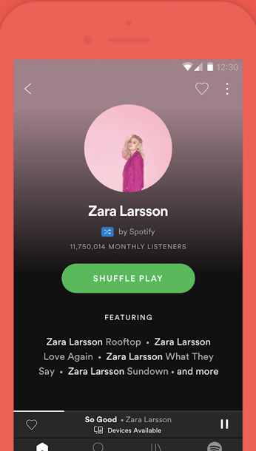Spotify is now free on mobile and tablet. Listen to the right music and podcasts, wherever you are.   
  
With Spotify, you have access to a world of music and podcasts. You can listen to artists and albums, or create your own playlist of your favorite songs. Want to discover new music? Choose a ready-made playlist that suits your mood or get personalized recommendations.  
  
Spotify also offers thousands of Podcasts, including originals that you can't find anywhere else. 

Listen for free on mobile  
• Play any artist, album, or playlist on shuffle mode

Listen for free on tablet  
• Play any song, any time  
  
Spotify Premium features  
• Play any song, any time on any device--mobile, tablet, or your computer  
• Download music for offline listening.  
• Enjoy amazing sound quality.  
• No ads – just uninterrupted music.  
• No commitment - cancel any time you like.

**4. Photo Editor**

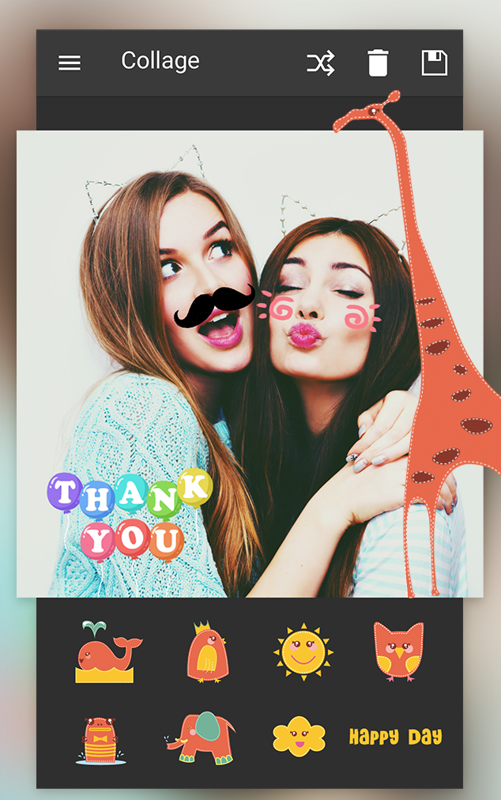* Photo Editor Pro is a powerful photo editor with  many amazing effects and filters !

* A very comprehensive photo editor and pretty much everything you could ever want to do on your phone!

* There are so many effects, stickers and features to apply to your photos!

* Photo Editor Pro is a fun and powerful photo editor that lets you quickly be pro, even if you’ve never edited a photo before

* Build in photo collage feature, Photo Editor Pro will give you the look you want in seconds.

* Transform photos with the tap of a finger. Use simple, yet powerful, photo editing tools to apply filters, adjust colors, and more!

**Key Features:**  
+ One-tap auto enhance   
+ Photo filters  
+ Gorgeous photo effects and frames  
+ Fun stickers  
+ Color balance  
+ Crop, rotate, and straighten your photo  
+ Adjust brightness, contrast, color temperature, and saturation  
+ Sharpen and blur  
+ Color temperature ("Warmth")  
+ Color Splash  
+ Focus (Tilt Shift)  
+ Draw and add text  
+ Create your own memes  
+ Photo collage feature help you combine multiple photos with various frame patterns   
+ Share to social network

**5. eBay**

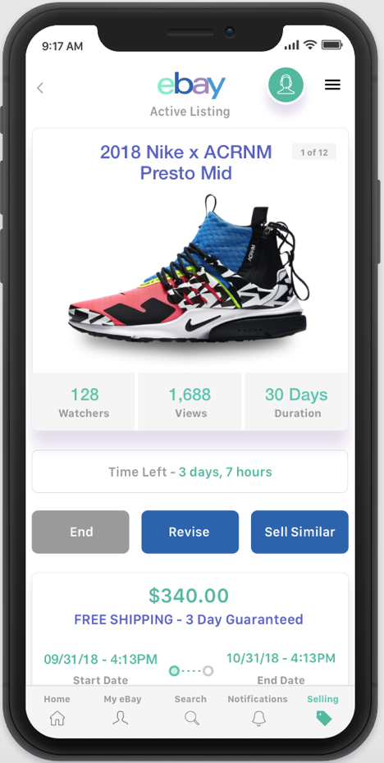Buy and sell on the go with eBay. Explore discount offers on best-selling brands in categories like clothes, beauty, home, electronics & more.   
  
Shop unbeatable deals and save money on your online shopping with free delivery!  
  
Search and buy great offers on your favorite items. Whether you want to upgrade to the latest iPhone or shop discount beauty deals, the world of eBay is yours to explore - all on your cell phone!   
  
Holiday shopping & January sales: don’t miss rock-bottom prices & unmissable bargains!  
  
Buy and sell with eBay, the home of online shopping deals & free delivery! Top 5 reasons to download:   
  
Beauty, home, DIY, used cars - search for offers in every category  
Explore top brands in electronics like Apple & Samsung  
Auction on the go: Sell items or bid on deals with ease  
Sell & save: From used cars to your old iPhone, make money with unused items  
Holiday deals right at your fingertips  
  
Buy, sell & auction in categories like:  
  
Clothes, fashion and outfits  
Buy women's, men's and children’s clothes  
Shopping deals on fall and winter fashion  
Offers on clothes, shoes and accessories for any occasion  
Used and new auto parts & vehicles  
Buy new & used cars from thousands of worldwide retailers  
Search & find trucks, SUVs and motorcycles  
Explore the best gear, helmets, gloves, jackets and more  
  
Cell phones, gadgets & electronics   
Shop bestselling brands like Apple and Samsung  
Buy the newest gadgets or cell phone at a bargain price  
Samsung Galaxy S8 or iPhone 8 from Apple? Find the best brands at the best prices   
  
Home, Garden and DIY  
Shop DIY offers for your home online  
Browse deals on garden tools and decorations  
Buy gadgets and decor for your home  
  
Discover eBay on your cell phone today! From online auction to daily deal, there’s something for everyone to discover.  
  
LANGUAGE SUPPORT  
English, French, Italian, German, Spanish, Portuguese, Russian, Polish, Dutch (Belgium + Netherlands)

## Product features:

* Search, Bid, Buy or Make offers on unique items from around the world
* List your items for sale in minutes (selling not available in all countries)
* Use the barcode scanner to find items, compare prices or start a new listing
* Get alerts about your eBay items and activity
* Track your packages
* Leave feedback
* Read and respond to eBay messages
* Save your favorite searches and sellers for quick access to the latest inventory
* Revise your listings and manage your eBay business on the go (selling not available in all countries)
* So much more. We'll spare you the details so you can start shopping now.

**6. Evernote**

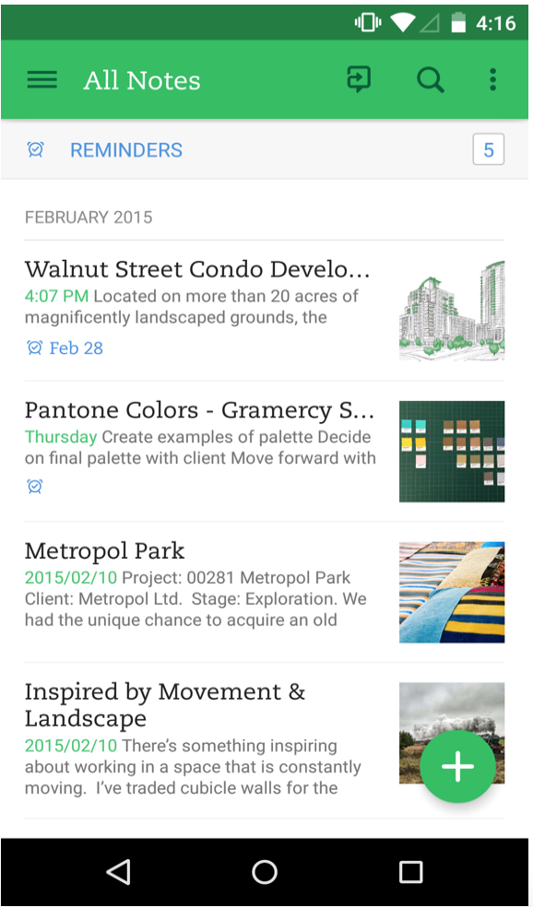GET ORGANIZED  
Evernote gives you the tools you need to keep your work effortlessly organized:  
• Write, collect and capture ideas as searchable notes, notebooks, checklists and to-do lists  
• Take notes in a variety of formats, including: text, sketches, photos, audio, video, PDFs, web clippings and more  
• Use camera capture to easily scan and comment on pieces of paper, including printed documents, business cards, handwriting and sketches  
• Attach Microsoft Office docs, PDFs and photos  
• Organize your receipts, bills and invoices  
• Use Evernote as a digital notepad and easy-to-format word processor for all your thoughts as they come  
  
SYNC ANYWHERE  
Evernote gives you the ability to sync and comment on content across all devices:  
• Sync everything automatically across any computer, phone or tablet   
• Start your task working on one device and continue on another without ever missing a beat  
• Add a passcode lock to the mobile app for more privacy  
  
SHARE YOUR IDEAS  
Evernote gives you the tools to share, discuss and collaborate productively with others:  
• Create, share and discuss with the people who help get your work done, all in one app  
• Search within pictures and annotate images to give quick feedback  
• Get inspired and brainstorm creative ideas with your team by working collaboratively in the same documents   
  
EVERNOTE IN EVERYDAY LIFE  
• Make personal checklists to keep your thoughts organized   
• Set reminders to keep on top of activities and write to-do lists  
• Gather, capture and store every thought you need to stay productive  
• Plan events such as holidays, weddings or parties

EVERNOTE IN BUSINESS  
• Create agendas, write memos and craft presentations   
• Annotate documents with comments and thoughts during team meetings, then share with colleagues   
• Get your projects underway faster and maximise productivity by letting multiple participants access and work on different aspects alongside each other  
  
EVERNOTE IN EDUCATION  
• Keep up with lecture notes so you don’t miss a vital thought  
• Clip and highlight articles from the web for academic research  
• Access and highlight searchable documents   
• Plan and collaborate for better academic group work  
• Discuss and annotate notes and drafts  
  
HOME SCREEN WIDGET  
Access Evernote easier and faster using the Home screen widget:  
• 1×1 widget - Need to quickly get to a note, capture something on camera, or search? Pull your favorite feature out of the app into a single icon to give you instant access  
• 4×1 Action bar - Select from 11 different actions to create your personal choice of shortcuts  
• 4×2 List widget - Shortcuts to key actions of your choosing as well as a list of notes. The type of note is up to you. Designate a specific notebook, use recent notes to get back into what you were just editing, or populate it with your reminders to stay aware of your to-dos

## Product features

* Write notes, checklists, and research
* Organize web articles, docs, and photos
* Discuss your work with others, right within the app

**7. Facebook**

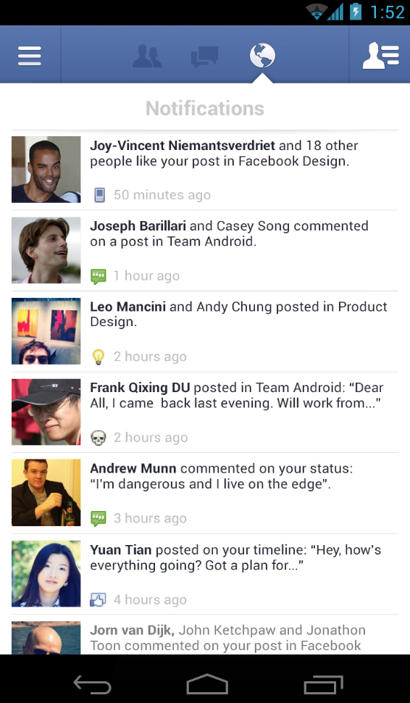Facebook app - Keeping up with friends is faster than ever. See what friends are up to on News Feed and share updates. Watch videos, play games and use your favorite apps.

## Product features

* See what friends are up to

* Share updates, photos and videos

* Get notified when friends like and comment on your posts

* Text, chat and have group conversations

* Play games and use your favorite apps

**8. Netflix**

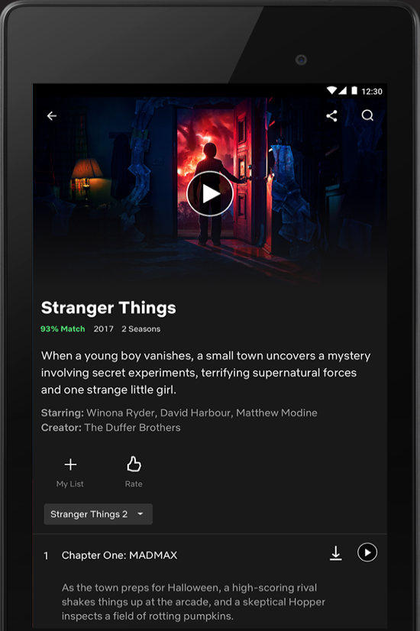

Netflix is the world's leading subscription service for watching TV episodes and movies on your phone. This Netflix mobile application delivers the best experience anywhere, anytime.  
  
Get the free app as a part of your Netflix membership and you can instantly watch thousands of TV episodes & movies on your phone.   
  
If you are not a Netflix member sign up for Netflix and start enjoying immediately on your phone with our one-month free trial.  
  
How does Netflix work?  
• Netflix membership gives you access to unlimited TV shows and movies for one low monthly price.   
• With the Netflix app you can instantly watch as many TV episodes & movies as you want, as often as you want, anytime you want.

• You can Browse a growing selection of thousands of titles, and new episodes that are added regularly.   
• Search for titles and watch immediately on your phone or on an ever expanding list of supported devices.  
• Rate your favorite shows and movies and tell us what you like so Netflix can help suggest the best titles for you.  
• Start watching on one device, and resume watching on another. Check out netflix.com for all the TVs, game consoles, tablets, phones, Blu-ray players and set top boxes on which you can watch Netflix.

## Product features

* Use your current Netflix membership on your Fire tablet
* Watch your favorite movies and TV shows as often as you want
* Resume watching where you left off on your TV or computer
* Browse movies and manage your instant queue
* Search by title or use genre listings