

**ASIA PACIFIC COLLEGE**

**School of Computing and Information Technologies**

**Escalation Management Module**

Submitted by:

ALABADO, Matthew Arnold

ALCONCEL, Alanis Watz

BALUBAL, Samantha Nicole

BRILLANTES, Rachel Anne

BURTON, Kathrine Danielle

PAMITTAN, Engel-Jan

Submitted to:

Mr. Manuel Sebastian S. Sanchez

October 26, 2017

**Table of Contents**

1. Introduction 1

1.1. Project Context 1

1.2. Purpose and Description 1

1.3. Statement and Objectives 2

1.3.1. General Objective 2

1.3.2. Specific Objectives 3

1.4. Scope and Limitations 3

2. Review of Related Literature/Systems 4

2.1. Local Literatures 4

2.2. Related Systems 5

3. Technical Background 11

3.1. Programming Language 11

3.2. Resource Requirements 12

3.2.1. Hardware Requirements 12

3.2.2. Software Requirements 13

3.2.3. Human Resource Requirements 14

4. The Existing System 15

4.1. Company Background 15

4.2. Description of the System 16

4.3. Problem Areas 16

5. The Proposed Project 16

5.1. System Overview 16

5.1.1. Event Table 17

5.2. Process Specification 18

5.2.1. Context Flow Diagram 18

5.2.2. Data Flow Diagram 18

5.2.3. Use Case Diagram 20

5.2.4. Fully Dressed Use Case 20

5.2.5. Activity Diagram 24

5.2.6. Sequence Diagram 26

5.3. Data Specification 27

5.3.1. Entity Relationship Diagram 27

5.3.2. Data Dictionary 28

6. Other Graphical Representation 31

6.1. Class Diagram 31

6.2. Object Diagram 32

6.3. Package Diagram 32

6.4. State Machine Diagram 33

6.5. Communication Diagram 34

6.6. Component Diagram 34

6.7. Deployment Diagram 35

6.8. Interaction Diagram 36

7. Methodology, Results, and Discussion 37

7.1. Methodology 37

7.2. Gap Analysis 38

# Introduction

## Project Context

Escalation is a process used to transfer the responsibility of performing a task to another employee who is often of higher rank or position. It is also a process to re-prioritize the level of certain service requests or tasks that need immediate action.

The client, Taal Vista Hotel considers a service request to be escalated if it was unattended or not acted upon by the promised time given by the hotel employee. To improve their service to their customers, Taal Vista Hotel gives utmost importance to the requests of their customers, let alone the ones that escalate frequently. The upper management is not aware if there are unattended services unless the customer comes up to the front desk and demands to see the manager. This is because the current escalation process included in Taal Vista Hotel is limited to just directly reporting it to the immediate supervisor with no documentation.

The team’s proposed solution is to create an Escalation Management Module that will be able to gather escalation data, assess employees’ capability to finish a task, and generate escalation reports that will help the Executive Managers improve the quality of services to their customers which will eventually decrease the number of escalated service requests.

## Purpose and Description

This module will track escalated service tickets, monitor ticket status and current escalation level, and send a notification to the next senior employee regarding an escalated service. There are four (4) levels of employees to whom the ticket will escalate to: Level 1 – Supervisor, Level 2 – Department Manager, Level 3 – Resident Manager, or Level 4 – General Manager.

The escalation of a service request to the next senior employee will be based on the Service Level Agreement (SLA), as a standard by the hotel to finish a certain request.

Notifications will be sent to the assigned employees through a mobile application. The notification will be about the task needed to be done and the responsibility to close the ticket.

Escalation reports that are generated by the module contain the details of the escalated service, the reason why it escalated, the number of times it escalated, and the details of the assigned employee. The reports will give the executive managers the information on why certain services are not met. Also, the information that will be reported by the employee from the escalation process can help identify reasons as to why some tasks are frequently unattended by their staff. The monthly or yearly escalation reports will help the Executive Managers formulate a forecast. The forecast will be used in the decision making of the managers on what precautionary actions are needed to be performed at a given time or season. The reports will lessen the possibility of services from escalating in the future and eventually have a solution to avoid the occurrence of escalated service requests.

## Statement and Objectives

### General Objective

Develop a solution for Taal Vista Hotel that will produce effective Escalation Reports from the gathered escalation data.

### Specific Objectives

* Develop an Escalation Management Module that has a seamless connection with the Service Request and Report System.
* Gather escalation data starting from the escalation of a service ticket until the ticket is closed.
* Formulate a forecast based on Escalation Reports and eventually decrease the number of escalations that occur within a month.

## Scope and Limitations

* The module will begin its process once a trigger is activated by an escalated service ticket from the Service Request and Report System or receptionist.
* The module will generate escalation reports based on the escalation process of unattended services.
* The module will focus on quality aspect of services in Taal Vista Hotel.
* The main users of the module are the Supervisor (Level 1 Employee), Department Manager (Level 2 Employee), Resident Manager (Level 3 Employee), General Manager (Level 4 Employee) of the Housekeeping and Engineering Department.

# Review of Related Literature/Systems

## Local Literatures

* Escalation Management as The Necessary Form of Incident Management Process

This study states that Escalation Management is widely used for Information Technology Service Management and is also part of Information Technology Infrastructure Library (ITIL) recommendations. In this study, escalation management is said to help ensure that unresolved problems do not linger and issues are promptly addressed. It states that the existence of escalation management can re-prioritize, re-assign, and monitor to a satisfactory completion.

In this study, it shows how escalation management is widely accepted and used in ITIL. It is also suggested and recommended to have such module to improve efficiency in service management and customer satisfaction.

* Complaints Management Procedure

In this study, the procedures of handling a complaint is discussed. It introduces three level of difficulties of complaints. Level 1 is identified and is dealt with the employees. Level 2 is defined and dealt by the head of the concerned management such as the Department Manager. Level 3 is referred to and should be dealt with the Director-General or anyone equivalent in rank. This is similar and relevant to the team’s proposed project because they also have different levels of management who are in charge.

## Related Systems

|  |  |  |
| --- | --- | --- |
| **SYSTEM NAME** | **COMMON FEATURES** | **UNIQUE FEATURES** |
| KNOWCROSS (KnowGlitch) | * Real-Time Communication | * Hotel Management Software |
| MANAGEENGINE SERVICEDESK PLUS | * Ticketing System * Real-Time Communication * Skills-Based Dispatching | * Email is converted to a ticket * Manage and Track all incidents |
| HOTELTAP | * Real-Time Communication | * Analytic Dashboards * Communication via text messaging * Provides hotel clients an overview of all the process in hotel anytime, anywhere. |
| FCS COMPUTER SYSTEMS (Guest Services) | * Mobile-Enabled * Task Escalation | * Smart Escalation * Intelligent job assignment |
| ALICE (CONCEIRGE) | * Mobile-Enabled * Ticketing System * Task-Tracking System | * Allows the staff to have access to their to-do lists through their mobile devices. |
| BUTLERPAD | * Smart Data (Task Escalation) | * Cloud-based * Effective communication technology |
| FIRECHAT | * Mobile-Enabled | * Sends message anytime, anywhere within specific range. |
| GESS (Guest Experience Software System) | * Task Escalation | * Automatic alert that notifies the employees |
| HOTELMGR | * Mobile-Enabled * Skill-Based Dispatching * Task-Tracking System | * Multilingual * Workflow Management * Request Prioritization |
| ORACLE ESCALATION MANAGEMENT | * Task-Tracking System | * Service Request and Task-Linking Capability * Ownership assignment * De-escalation & closure * Automatic notification (Escalation Progress) |

* KNOWCROSS

One feature that is relevant to the team’s project is KNOW GLITCH. KNOW GLITCH works when a guest informs the hotel about an issue they are facing, they simply click the feature and send their problems through the provided cellphone/tablet within the hotel and alerts the concerned departments about it. These issues are being track in real time, the compensation authorized and quest profiles are automatically updated. KNOW Glitch send pre-arrival reports the guest’s glitch history to help other hotel employee to solve future problems. The team chose this as a reference because its features are similar to the module being developed. It will also benefit the company because they will grow on resolving issues and to accommodate more loyal customers.

* MANAGEENGINE SERVICEDESK PLUS

ManageEngine ServiceDesk Plus is a software that provides companies to resolve and manage issues in no time. It reduces the end-user frustration that arises due to time consuming issue resolving process. This application is not just for PCs but also in smartphones or android tablets. This software’s features are relevant to the proposed module, since it tracks all incidents with a well-defined process and to be able to handle guest issues effectively.

* HOTELTAP

HotelTap is an application which helps the guests meet their expectations with communication, task completion, and maintenance. It also has Analytics Dashboard which provides tracking of real-time issues that will update managers status through text messages. Analytics Dashboard also organizes check-list, and to-do-list of their maintenance wherein clients can have an overview of what is happening regardless of time and place. It can also generate and daily reports that will notify the managers through their mobile devices. These features can be a reference that could be incorporated in the team’s proposed module to develop an effective escalation module for the client

* FCS

FCS is a software for hospitality operations management that has features called “Smart Escalation” and “Intelligent Job Assignment”. Smart Escalation monitor and every service request, it has intelligent escalation rules that ensure nothing is missed. This feature can help the team to have relevant feature that allows the staff of the hotel to monitor their task. Intelligent Job Assignment assigns jobs to the nearest staff on shift with the right skill set. Instant communications capabilities ensure everyone in on the same page. FCS Connect mobile apps for iOS and Android, enables staff to access the full capabilities of FCS Connect wherever they may be. It is related to the module because of the effective task delegation and communication technology.

* ALICE

This application has the entire service process of a hotel in a cellphone/tablet provided by the hotel. Customer can select any services through the cellphone or tablet present on the hotel. This application will help the team understand how the user interface will affect the guest. This application will also help us on how the process which the hotel is currently have. This application has a feature that connects both the customer and every department in a hotel. This is relevant to us because the team wants to develop and integrate its common features to the proposed module. It also has a feature called “Hotel Radio Substitute” which allows the staff to access their to-do list and assign tickets across all the departments and to replace the walkie-talkie which the team’s client wants. ALICE Concierge also have a feature of task management that can be incorporated to the proposed module. It is related to the module that will be developed because of task tracking and communication technology.

* BUTLERPAD

ButlerPad is a cloud-based application that has a feature called “Smart Data”, the task escalation feature, which sends alerts to departments of any unattended or delayed tasks, and encourages quick responses. It is related to the module that team will develop because of its effective communication technology among the departments in a hotel.

* FIRECHAT

FireChat is a free messaging mobile application which allows the user to send private messages regardless if there’s no an internet connection or cellular signal. It can be used anywhere as long as there are nearby users of FireChat. It is related to the system because of communication technology that allows the staff of the hotel to communicate even without internet connection or cellular signal.

* GESS

We chose GESS (Guest Experience Software System) because the software provides proper escalation by notifying concerned staff of departments by sending the automated alert on the progress of the incidents and its close of what module that the team is currently working on.

* HOTELMGR

HotelMGR has features of Workflow Management, request tracking, request prioritization, Skills-based dispatching, work ticket dispatch, work ticket tracking, multilingual, customization and is mobile-enabled. Individuals can accept and flag requests when completed. HotelMGR application does the request with the appropriate employees based on skill and can provide full management reporting.

* ORACLE ESCALATION MANAGEMENT

This application is the most useful and helpful for us because they are the closest application to what our project is and we are both focusing in escalation management.

# Technical Background

## Programming Language

* JAVA

Java is a programming language and computing platform that is fast, secure and reliable. From laptops to datacenters, cellphones to the internet. Java is the official language for Android Development which the group will eventually use for developing a mobile application for the proposed module.

* SQL (Standard Query Language)

SQL is a standard language for relational model, it is used to communicate with a database. SQL statements are used to perform tasks such as update on a database, or retrieve data from a database. The group will use SQL in updating the data needed and retrieve it for generating escalation reports that the client needs.

* PHP (Hypertext Preprocessor)

PHP (Hypertext Preprocessor) is a programming language that commonly executes on servers and is used in web development. It is the main language of Yii Framework that the group will use in developing the back-end of the proposed module.

## Resource Requirements

### Hardware Requirements

* ANDROID DEVICE

Should have 2 gigabytes of RAM and 1 gigabyte free of space of internal storage. It should be at least Android KitKat (v.4.4) or Higher

* ACCESS POINTS/WI-FI ROUTER

To access the website, the hotel needs at least 5MBPs or higher internet speed

* SERVERS

The server should at least have 3 terabytes of storage to store all necessary information needed and an I3 7100 processor, 8GB of RAM to help the computer run smooth and fast.

* COMPUTERS

Should have 1 terabyte of storage, Pentium G4560 processor and 4GB RAM

### Software Requirements

* ANDROID STUDIO

Android Studio provides the fastest tools for building applications on every type of Android device. The group will use the android studio to develop a mobile application for the client.

* SQLITE

SQLite is a relational database management system contained in a C programming library. It is embedded into the end program, SQLite is a popular choice as embedded database software for local/client storage in application software such as web browsers and widely deployed database engine used today by several widespread browsers, embedded system such as mobile phones. The group needs the MySQLite to store the data that the user input through their mobile phone.

* Firebase

The group will use Firebase in storing user’s input such as re-assigning the ticket owner, reasons for escalating, etc. using the mobile application. Firebase has many services and one of those is real-time database which is accessible through a REST API.

* Yii FRAMEWORK

Yii Framework is a high-performance, component-based PHP framework for developing large-scale web applications. The group will use Yii framework to develop a web-based application to manipulate the database for the proposed module.

* Ionic Framework

The group will use Ionic framework to develop a mobile application that will notify the employees in the hierarchy level of the module about an escalated ticket that is assigned to them. Ionic framework is an open-source SDK for hybrid mobile development which has tools that uses CSS, and HTML5.

### Human Resource Requirements

* IT Department

The module needs a team of moderator to maintain, fix bugs and to improve the overall performance of the proposed module.

* Supervisor

This person is the immediate contact of regular hotel employees regarding certain situations.

* Managers

Includes high-level employees such as Department Managers, Resident Managers, General Manager and Executive Managers

* Hotel Staff

These people are the ones who are given tasks and reports the status to the immediate supervisor

# The Existing System

## Company Background

As early as 1956, Tagaytay has been considered as one of the major tourist destinations in the Philippines, and Taal Vista Lodge (now Taal Vista Hotel) is one of the leading attractions in the area for its view of Taal Lake. One if its regular customers before was Henry Sy of SM Investments Corporation who is now the owner of the hotel. In 2002, Taal Vista Hotel was reconstructed but still embraced the style of the original lodge. A big part of the hotel was allocated for conference facilities and amenities for business and leisure activities. Taal Vista Hotel displays an example of a classic architecture and contemporary function. Their rooms are equipped with modern amenities and has the ambiance of the historic lodge before it even became a hotel. It also gives the guest the warm feeling with a touch of a modern flair. The cuisines that they serve are complimented by the history and modernity of the hotel which meets their tagline “where the past meets the present.”

## Description of the System

Taal Vista Hotel considers it an issue when a guest follows up regarding their initial request and when a guest personally comes to the Customer Service of the hotel to file an issue. The details of the filed issue are recorded in a system called FreshDesk which later will be analyzed by the staff in Guest Service Center to determine the department involved. The Guest Service Center will forward the information to the department head to assign the task to the appropriate personnel who will execute proper action to solve the issue. If the assigned task was completed, the assigned personnel needs to send a service completion report to the department head to serve as a verification that the filed issue has been resolved.

## Problem Areas

* Data is only stored in Freshdesk or Excel Spreadsheet
* There is a limited escalation process
* No way to gather or document escalation data
* There are no escalation reports that can be produced

# The Proposed Project

## System Overview

Escalation Management Module receives escalated tickets from the Service Request and Report System. The escalated tickets are service tickets are not closed within the given time limit. It is assumed that the client has a Ticket Manager which will be responsible for monitoring the tickets.

### Event Table



## Process Specification

### Context Flow Diagram

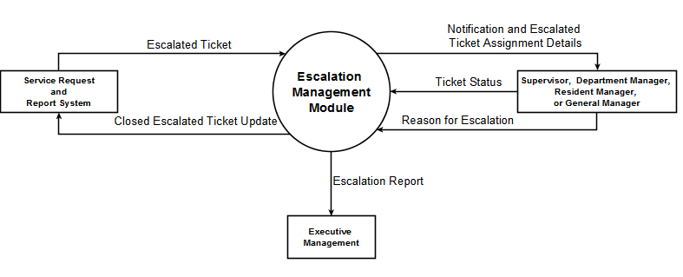

### Data Flow Diagram

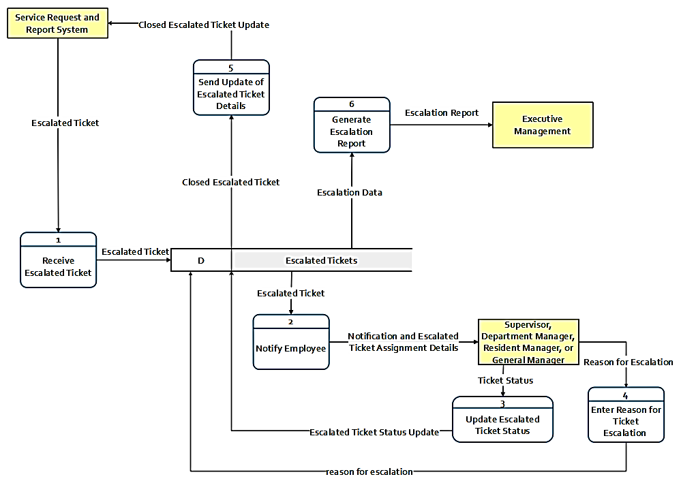



#### Level 1 Diagram of Notify Employee (Process 2)

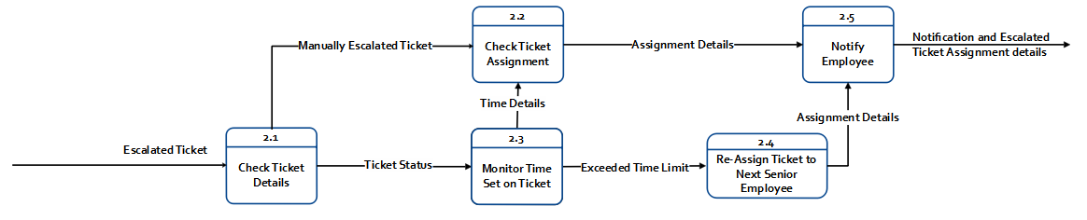

5.2.2.2.1 Level 2 Diagram of Notify Employee (Process 2.4)

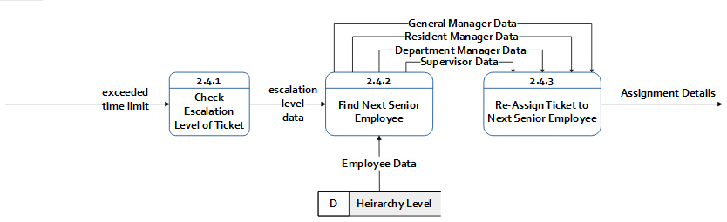

#### Level 1 Diagram of Update Escalated Ticket Status (Process 3)

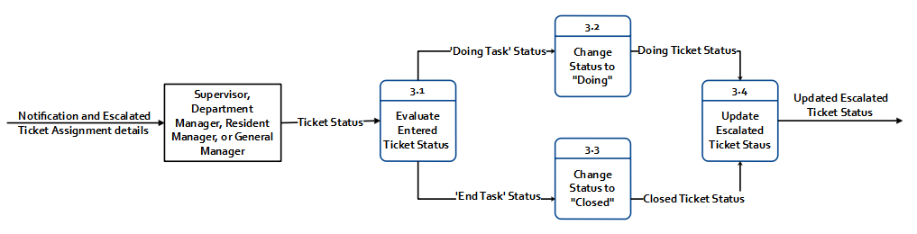

* + - 1. Level 1 Diagram of Generate Escalation Report (Process 6)

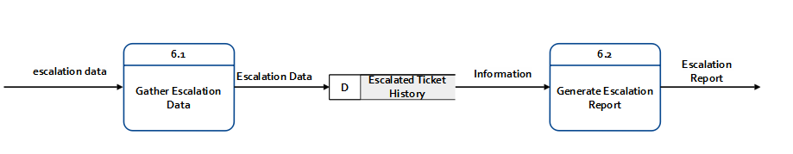

### Use Case Diagram

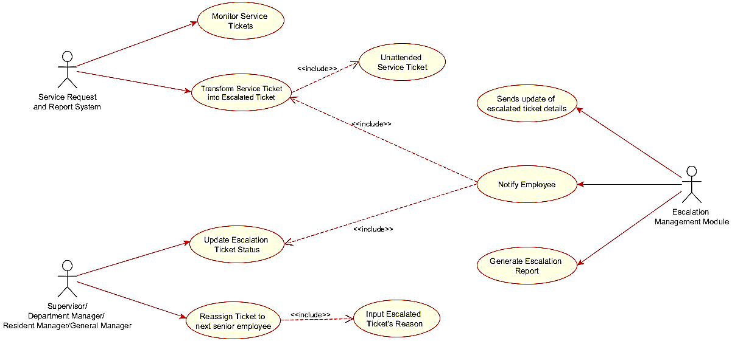

### Fully Dressed Use Case

|  |  |  |
| --- | --- | --- |
| Use Case Name: | Transform service ticket into escalation ticket | |
| Scenario: | Service request and report system transforms service ticket into escalation ticket | |
| Triggering Event: | service ticket has reach time limit | |
| Brief Description: | When service ticket has reach time limit, the service request and report system transform service tickets into escalated ticket | |
| Actors: | Service request and report system | |
| Related Use Case: | Includes: Unattended service ticket | |
| Stakeholders: | Service Request and Report System  Supervisor  Department Manager  Resident Manager  General Manager | |
| Preconditions: | Service ticket must exist  Service ticket must reach its time limit | |
| Postconditions: | Escalated Ticket must be created | |
| Flow of events: | Actor | Module |
| 1. Service request and report system creates service ticket 2. Service request and report system monitors service ticket 3. Service request and report system transforms service ticket to escalation ticket | * 1. service ticket reach time limit   3.1 stores escalation ticket details to database |
| Exception Conditions: |  | |

|  |  |  |
| --- | --- | --- |
| Use Case Name: | Update escalation ticket status | |
| Scenario: | Supervisor/Department Manager/Resident Manager/General Manager updates escalation ticket status | |
| Triggering Event: | Input escalation ticket task status | |
| Brief Description: | When the module notifies employee the Supervisor /Department Manager/Resident Manager/General Manager will update escalation ticket status | |
| Actors: | Supervisor  Department Manager  Resident Manager  General Manager | |
| Related Use Case: | N/A | |
| Stakeholders: | Supervisor  Department Manager  Resident Manager  General Manager | |
| Preconditions: | The module must notify the next senior employee first | |
| Postconditions: | Escalated Ticket status must be updated | |
| Flow of events: | Actor | Module |
| 1.1. Supervisor/Department Manager/Resident Manager/General Manager views notification  2. Supervisor/Department Manager/Resident Manager/General Manager updates escalation ticket status | 1. Notify employee  2.1 Stores updated escalation ticket status |
| Exception Conditions: |  | |

|  |  |  |
| --- | --- | --- |
| Use Case Name: | Reassign ticket to next escalation level | |
| Scenario: | Supervisor/Department Manager/Resident Manager/General Manager reassign ticket to next escalation level | |
| Triggering Event: | When appropriate employee to be assigned for the escalated ticket is a senior employee, the employee will reassign ticket to next senior employee | |
| Brief Description: | When the module notifies the Supervisor/Department Manager/Resident Manager/General Manager will update escalation ticket status | |
| Actors: | Supervisor  Department Manager  Resident Manager  General Manager | |
| Related Use Case: | Includes: Input escalated ticket’s reason | |
| Stakeholders: | Supervisor  Department Manager  Resident Manager  General Manager | |
| Preconditions: | Employee must input escalated ticket’s reason | |
| Postconditions: | Escalated Ticket must be forwarded to the next escalation level | |
| Flow of events: | Actor | Module |
| 1.1. Supervisor/Department Manager/Resident Manager/General Manager views notification   1. Supervisor/Department Manager/Resident Manager/General Manager input escalated ticket’s reason 2. Supervisor/Department Manager/Resident Manager/General Manager reassign ticket to next escalation level | 1. Notify employee  2.1. Sends escalated ticket to next senior employee  4. Generates escalation report |
| Exception Conditions: |  | |

### Activity Diagram

**5.2.5.1 From Service Request and Recovery System to Employees in the Hierarchy Level**

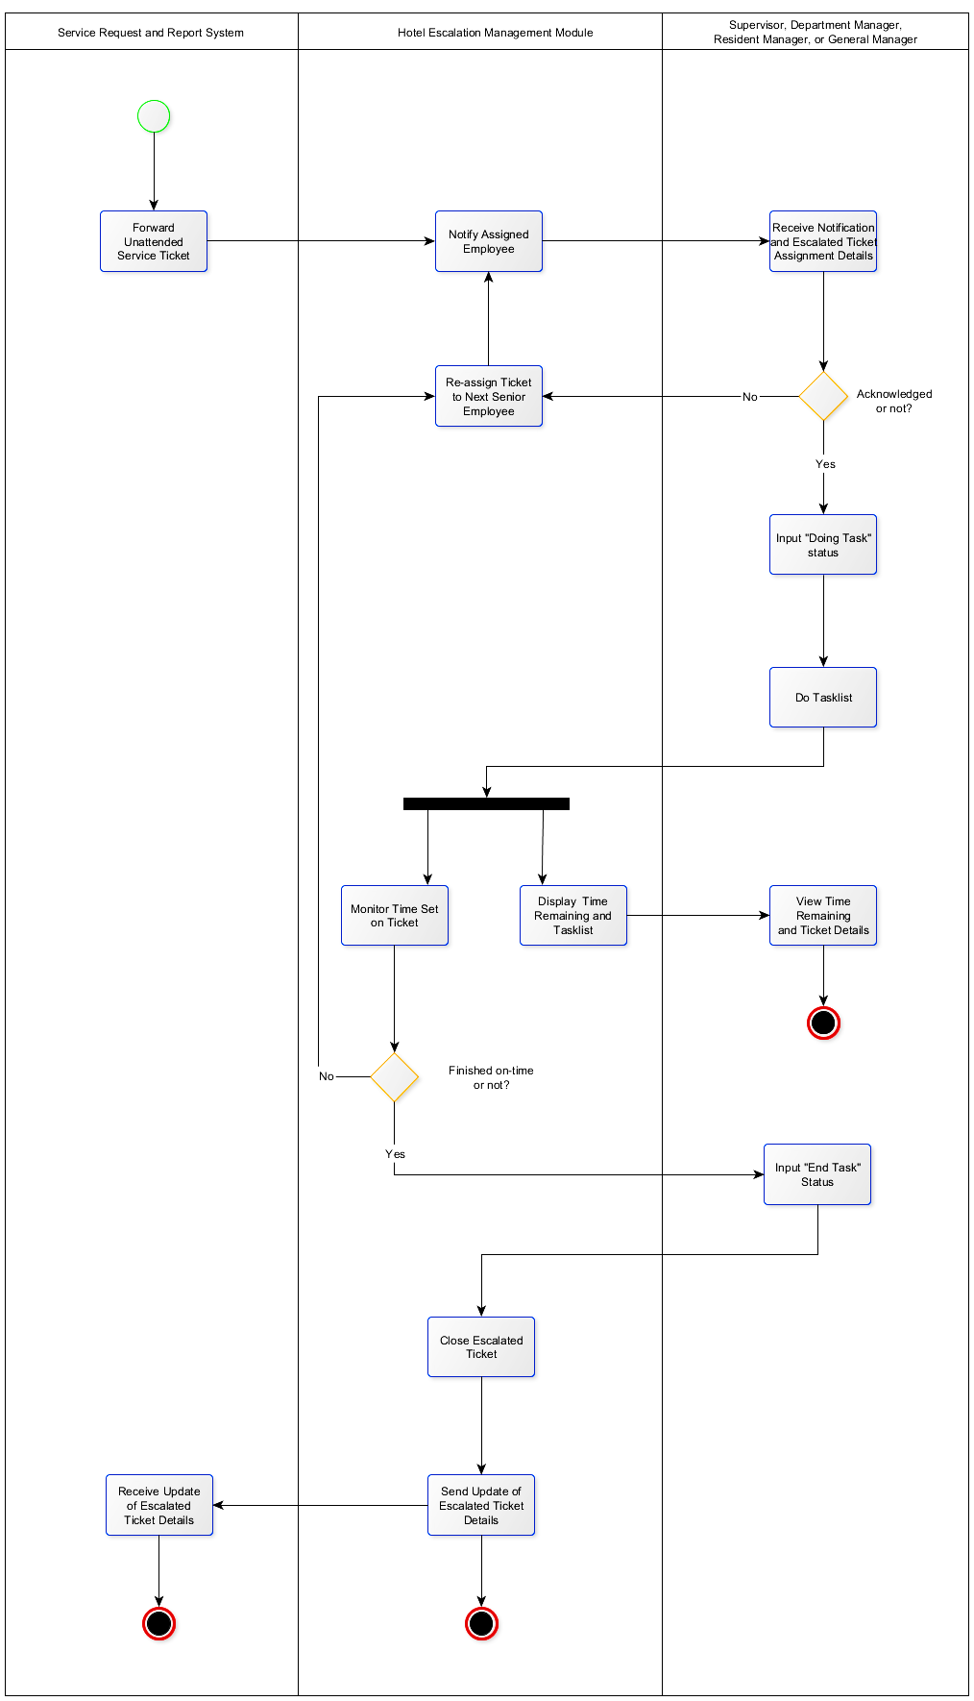

**Service Request and Report System**

**Escalation Management Module**

**Supervisor, Department Manager, Resident Manager, or General Manager**

5.2.5.2 Generation of Escalation Report

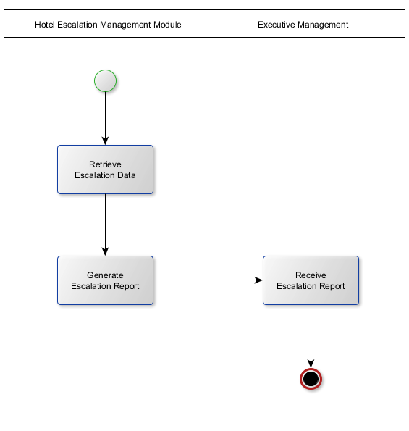

### Sequence Diagram

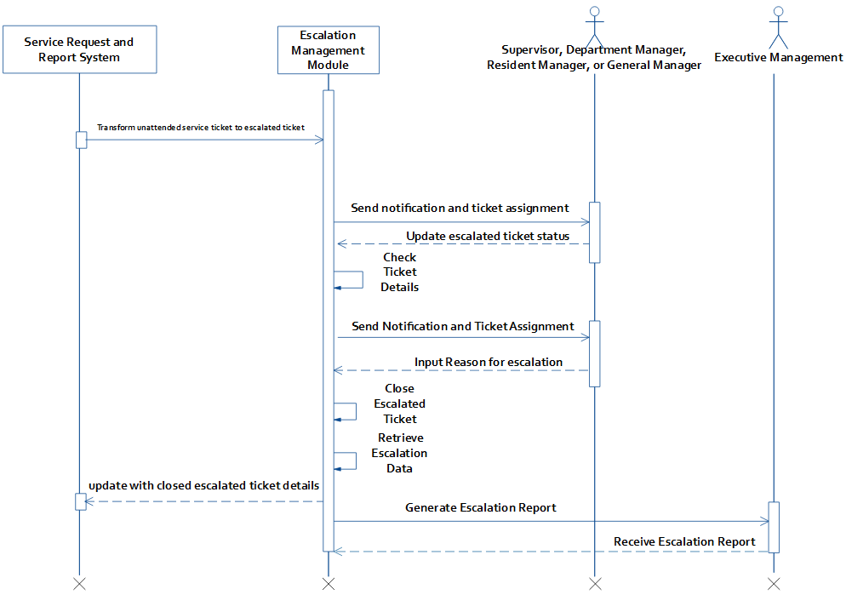

**Transform service ticket to escalated ticket**

## Data Specification

### Entity Relationship Diagram

### Data Dictionary

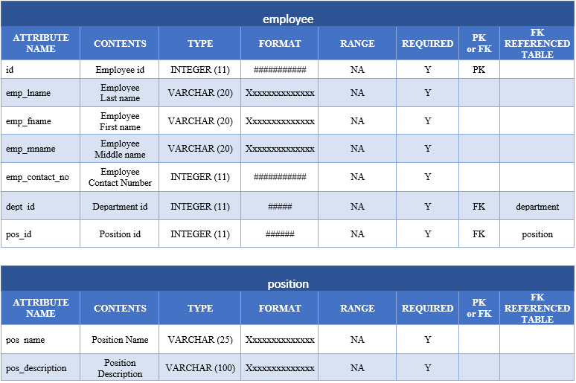

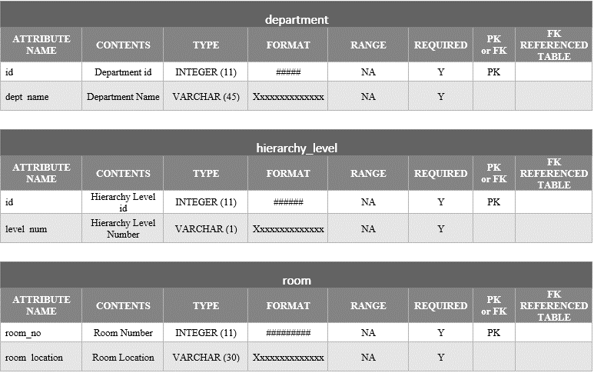

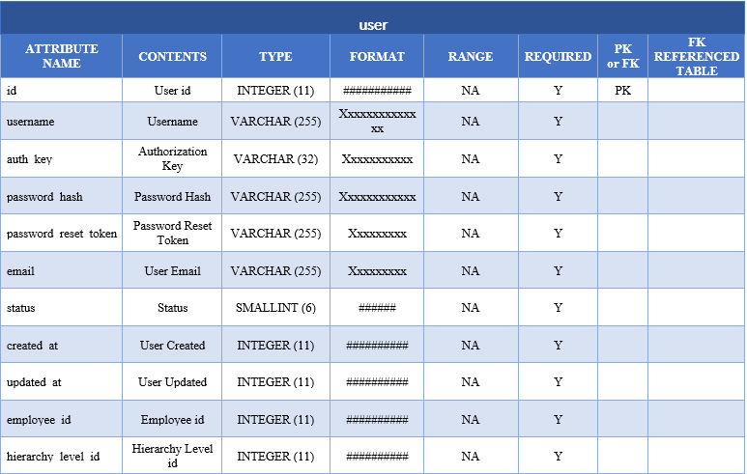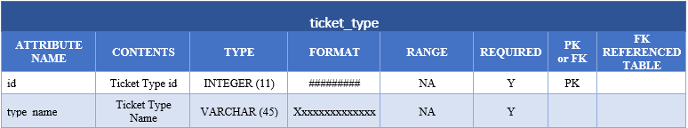

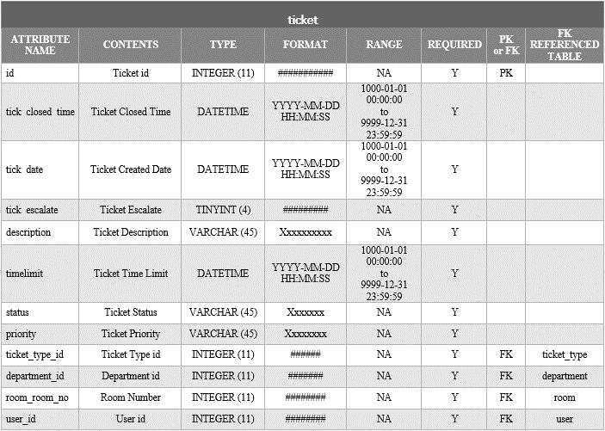

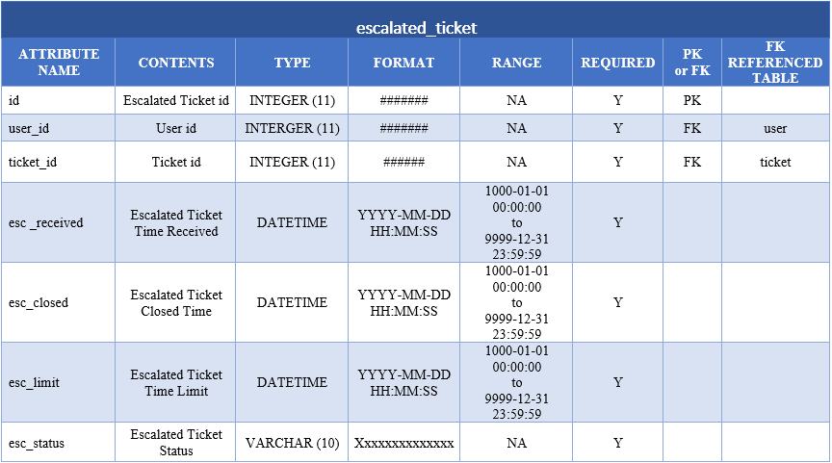

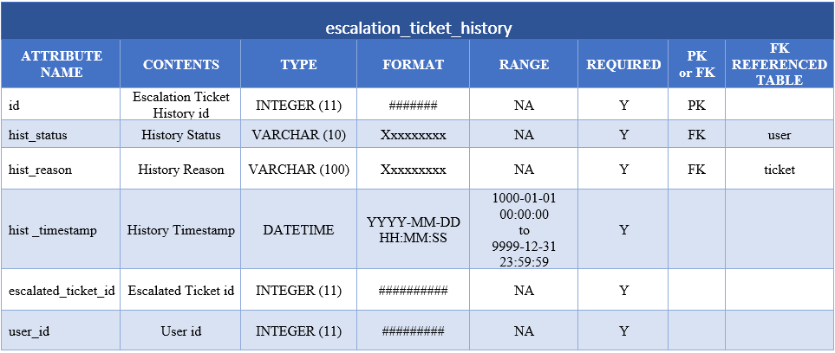

# Other Graphical Representation

## 6.1. Class Diagram

## 6.2. Object Diagram

## 6.3. Package Diagram

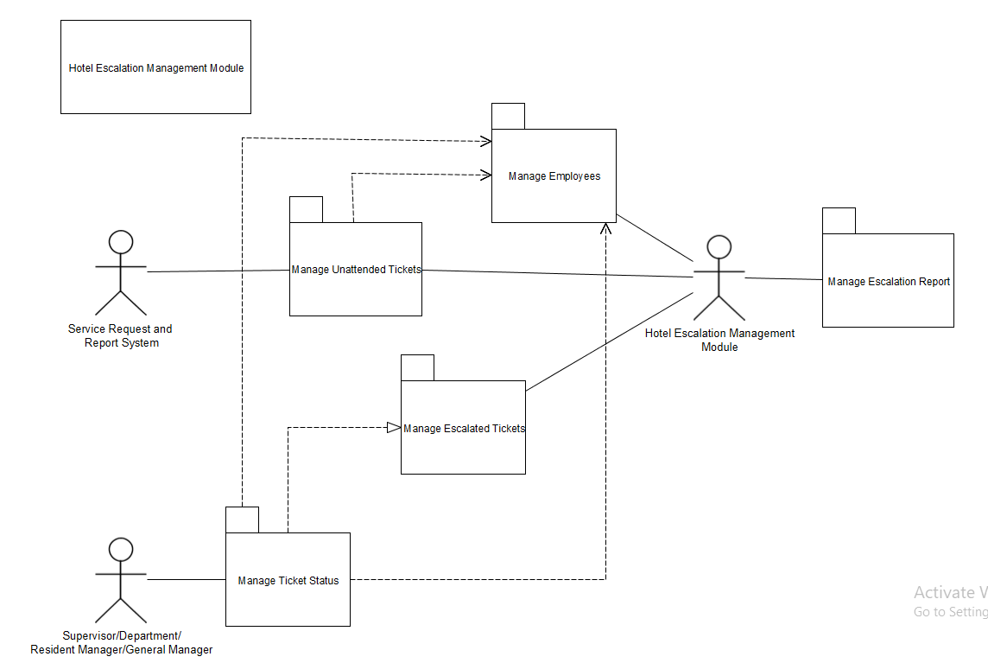

## 6.4. State Machine Diagram

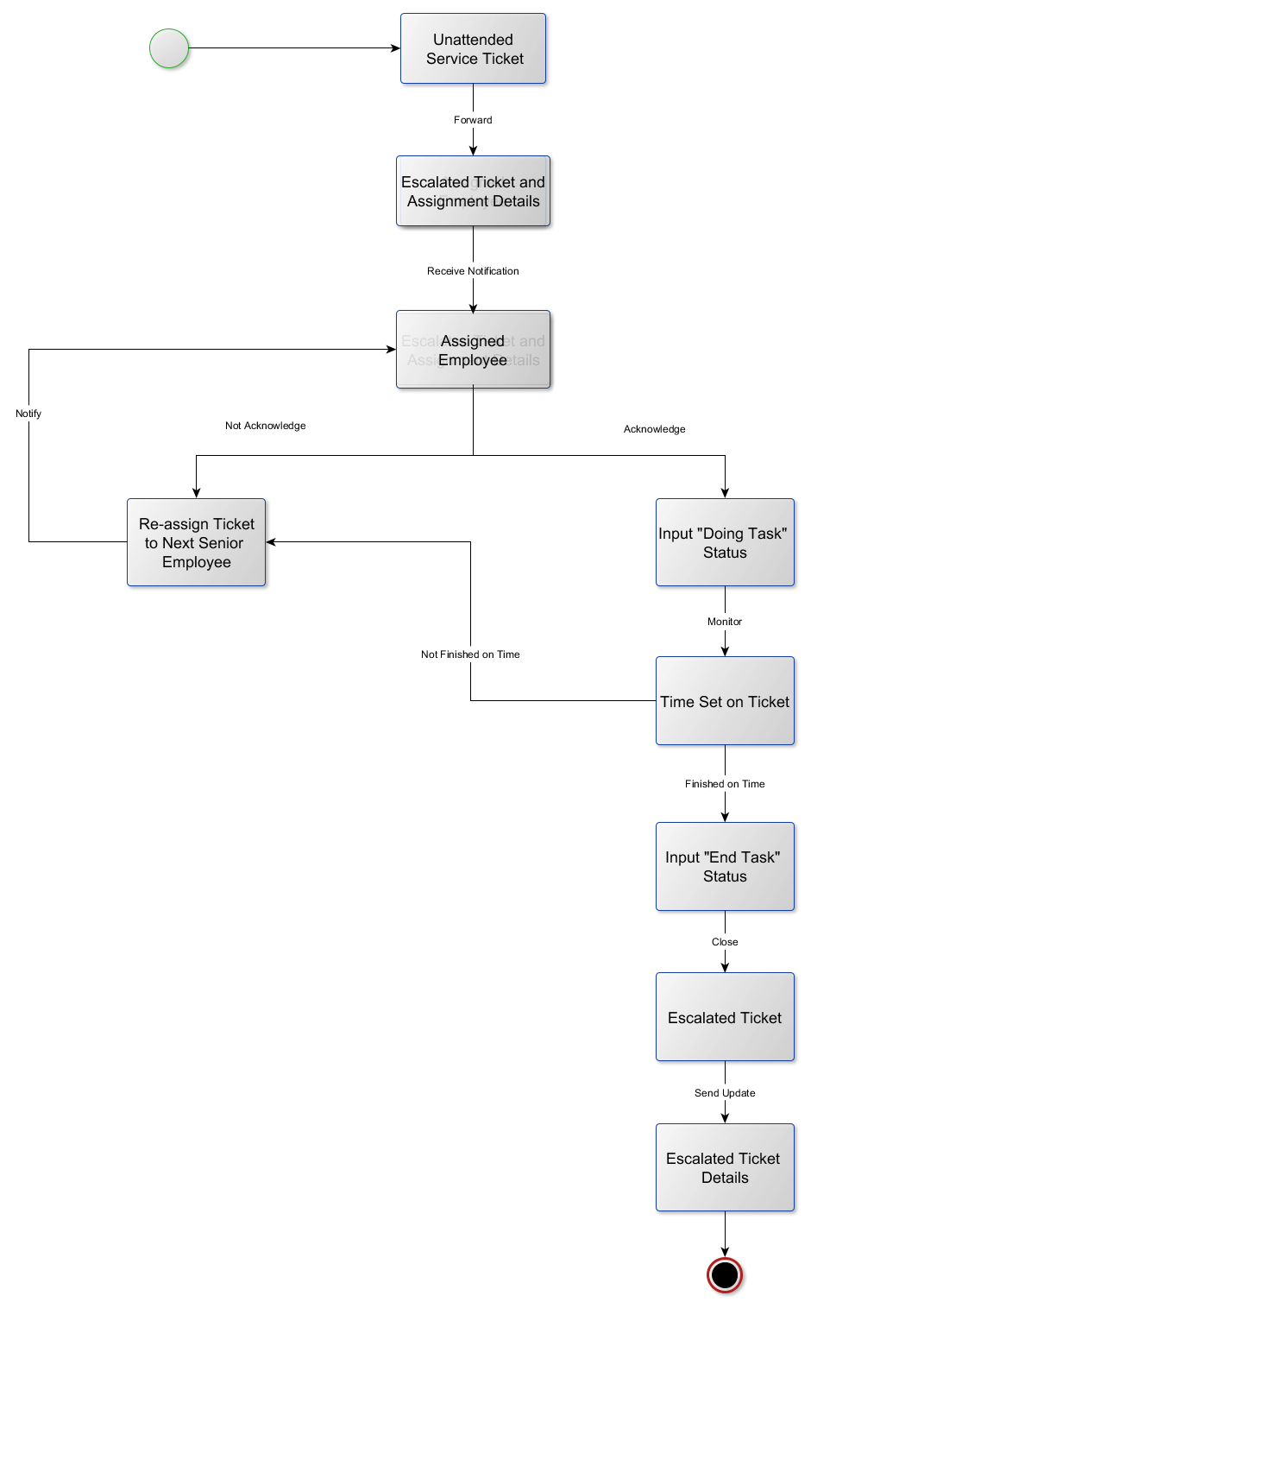

## 6.5. Communication Diagram

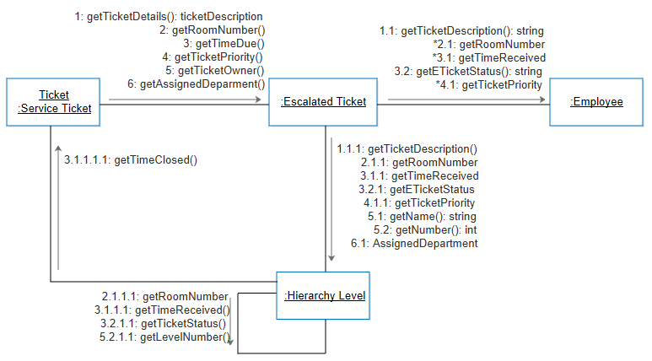

## 6.6. Component Diagram

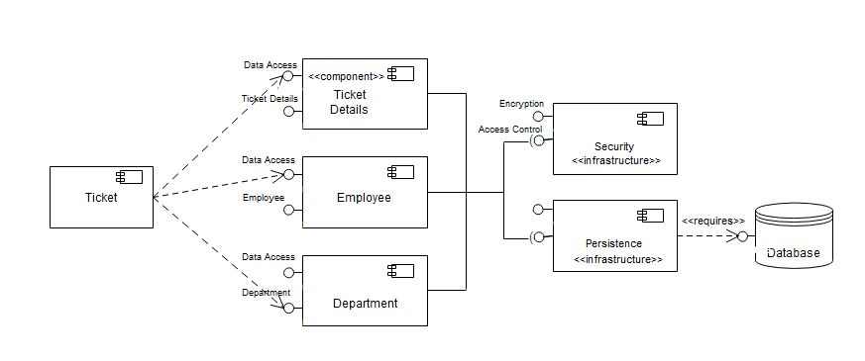

## 6.7. Deployment Diagram

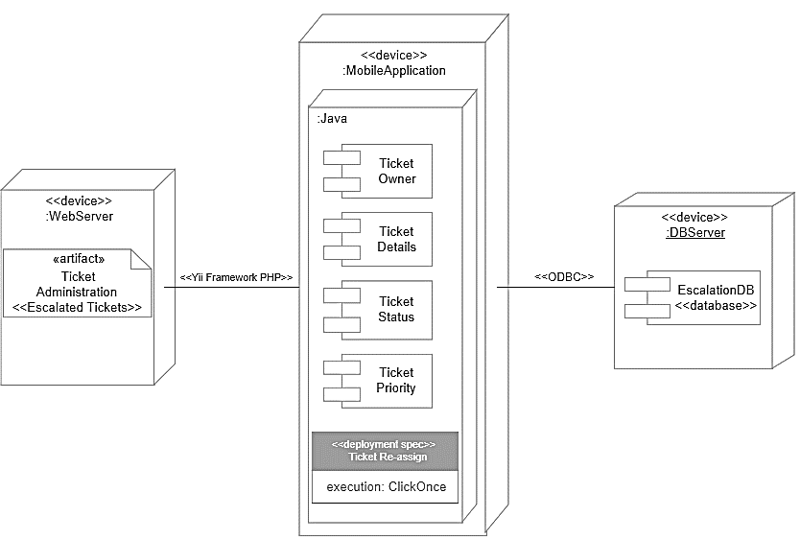

## 6.8. Interaction Diagram

# Methodology, Results, and Discussion

## Methodology

**Agile Methodology**

This is the methodology used to develop the Escalation Management Module for Taal Vista Hotel. Agile Methodology provides opportunities to assess the direction of the team’s project throughout the development lifecycle. For the team to present a partially working project for SYSADD, the team created a database which will define all the entities needed for the escalation module and next is to consolidate all the databases of the whole section to produce the master database and can have a back-end prototype which can Create, Read, Update and Delete Records with the use of Yii Framework. As for MCSPROJ, the first iteration is fifty percent (50%) of the prototype which was presented a week before the Midterm Defense. Second iteration is seventy percent (70%) on the day of the Midterm Defense. And the last iteration is on the Final Defense which will be a fully working Escalation Management Module.



## Gap Analysis

|  |  |  |
| --- | --- | --- |
| **USER REQUIREMENTS** | **CURRENT SYSTEM** | **PROPOSED CHANGES** |
| 1. Gather escalation data | Issues are recorded by the Guest Service Center using Freshdesk and Excel. | Develop an escalation management module that automatically gathers all the escalation data entered in to the module. |
| 2. Improve escalation process | Limited escalation processes | Develop an escalation management module that will receive service tickets which are not closed within the given SLA and will be re-assigned to the senior level employees. |
| 3. Identify how services can be improved through an escalation process. | Limited escalation processes | The escalation management module can generate escalation reports that can be used by the Executive Management for decision making. |
| 4. Ease of notification via hand-held devices. | Staff and other employees communicates using walkie-talkies and telephones. | The escalation management module will be a mobile application that will be installed in a smart phone.  The employees assigned with escalation levels will be notified regarding escalated service requests. |