Section: 31 / 4
Modeling Application State
- 34. Foreword on Redux2:16
- https://redux.js.org/ - react control view, redux control data.
- 35. What is Redux?2:45
- 36. More on Redux3:42
- 37. Even More on Redux!4:19
Section: 40 / 13
Managing App State with Redux
- 38. Putting Redux to Practice0:00
- 39. Reducers7:43
- C:\react_redux\ReduxCasts-master\book_list>npm install c:..book_list >npm start
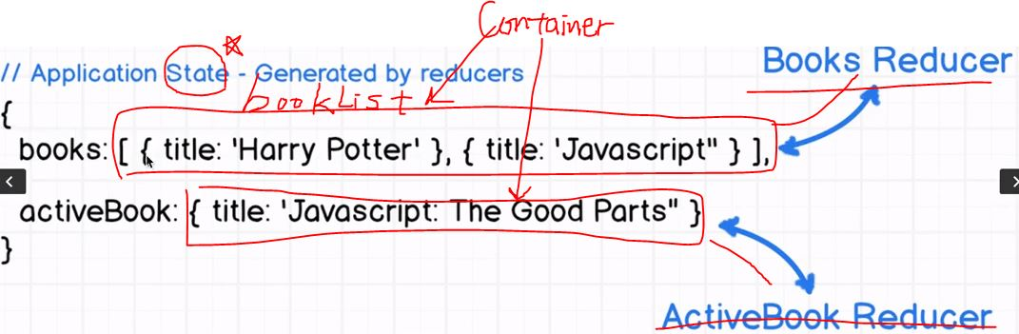
- 40. Containers - Connecting Redux to React7:23
- Only the most parent component use particular states need to be connected to Redux.(not App, but BookList, BookDetail) as container .
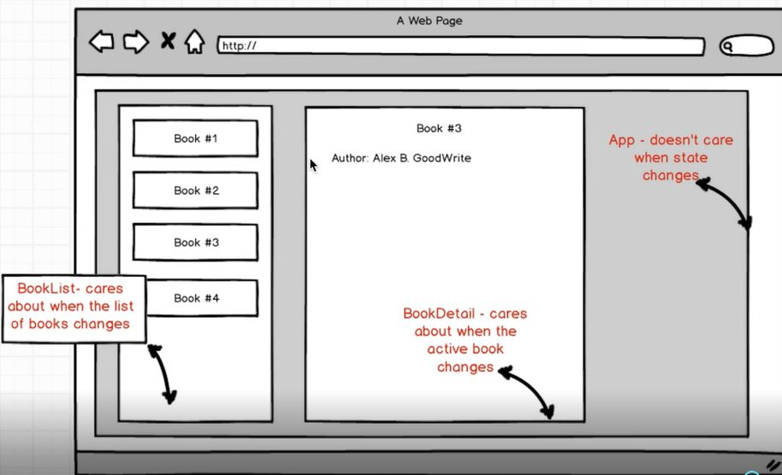
- 41. Containers Continued4:00
- 42. Implementation of a Container Class10:45
- 1. redux serves to construct the application state(contains books), react provide the view of state , two libraries are inherently disconnected, only using react-redux , we can connect them.
- - redux generate state object that contains books and map the state as props, the component. Because the state was updated. The container rerendered
- - containers are normal react component bonded with application state connected melded together.
- Whenever application state changed, the container rerendered as well.
- 2. application state generated by reducer function(reducer_books.js), BooksReducer(in index.js,
- import BooksReducer from './reducer_books';) always return an array of books, no matter whatever returned, same array through reduce, our component rerendered with list of books.
- 3.In index.js in reducers dir, func, combineReducers({books: BooksReducer)});
- this reducer add key to global application state called books, - so state's key(books), state's value(whatever returned from reducer, in this case, array of books, BooksReducer)
- 43. Containers and Reducers Review4:09
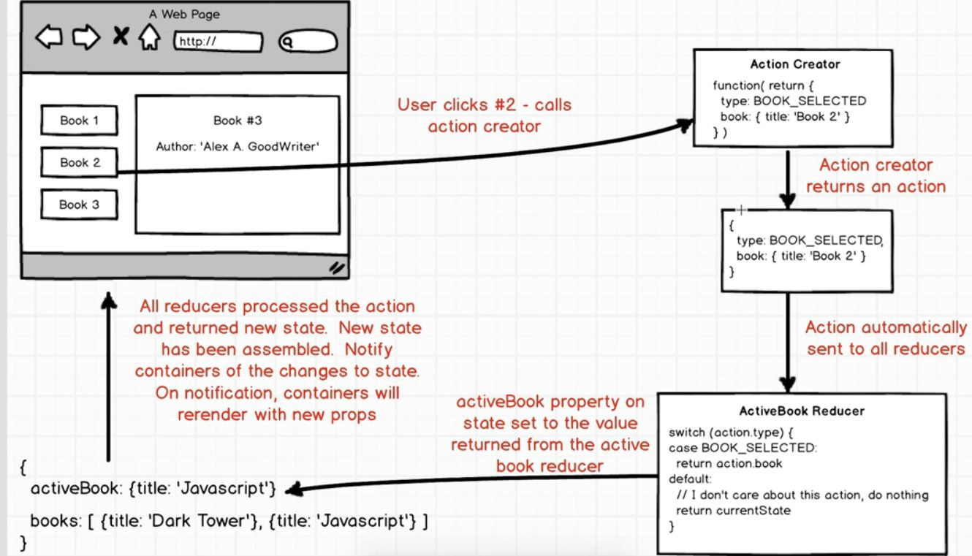
- 44. Actions and Action Creators7:31
- 45. Binding Action Creators9:41
- 46. Creating an Action6:45
- 47. Consuming Actions in Reducers7:16
- 48. Consuming Actions in Reducers Continued5:05
- 49. Conditional Rendering6:38
- 50. Reducers and Actions Review5:02
- Redux is in charge of managing Application State. State is single plain javascript
- Component State(this.state.asffkle, this.setState({asbssl:'lsaalsls'}) is different from Application State
- Reducer is charge of changing of states over time using action. Whevever action dipatched, it flow through all the different reducers, applications.
Section: 50 / 19
Intermediate Redux: Middleware
- 51. App Overview and Planning5:10
- https://openweathermap.org/api
- 52. Component Setup7:57
- SearchBar is responsible for calling actionCreator in redux.(When inputting data in SearchBar, “ Hey redux something happen, you need some data !”)
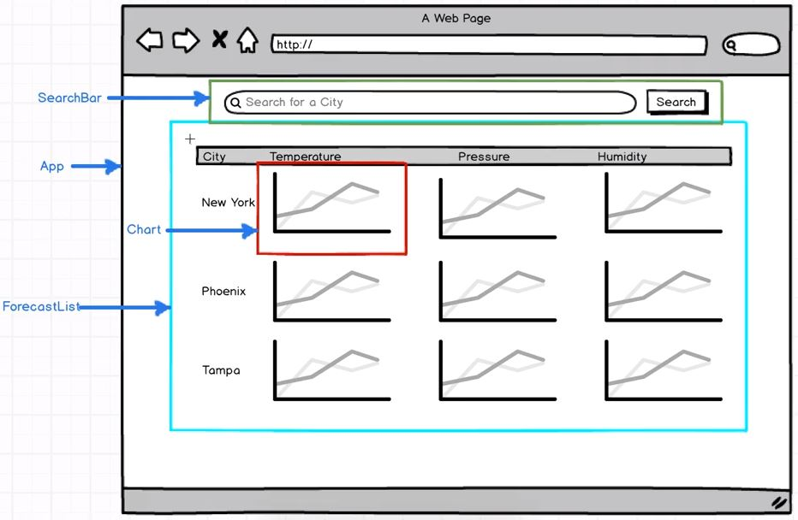
- 53. Controlled Components and Binding Context9:56
- 54. Form Elements in React6:28
- 55. Working with API's8:12
- 56. Introduction to Middleware7:27
- middleware manipulate , log, stop it , between actioncreator and reducer
- -redux-promise installed to help ajax request in application :
- C:\react_redux\myDev\weather>npm install –save redux-promise ( tow -)
- 57. Ajax Requests with Axios13:02
- C:\react_redux\myDev\weather>npm install –save axios
- Performing a GET request
- // Make a request for a user with a given ID
- axios.get('/user?ID=12345') //login in url
- .then(function (response) {
- console.log(response);
- })
- .catch(function (error) {
- console.log(error);
- });
- // Optionally the request above could also be done as
- axios.get('/user', {
- params: {
- ID: 12345
- }
- })
- .then(function (response) {
- console.log(response);
- })
- .catch(function (error) {
- console.log(error);
- });
- Performing a POST request
- axios.post('/user', { //logic separated from url
- firstName: 'Fred',
- lastName: 'Flintstone'
- })
- .then(function (response) {
- console.log(response);
- })
- .catch(function (error) {
- console.log(error);
- });
- 58. Redux-Promise in Practice10:15
- in browser, Network, forcast click , then can check json node result in Preview.
- 59. Redux-Promise Continued10:55
- 1. Browser, Console/ three, “Action received-redux/INIT, redux/PROBE_UNKNOWN_ACTION, redux/INIT” shown(action, same payload)- redux dispatched when first start up.
- 2.Reload browser, type in San Francisco,
- 1) From action creator :Action received- Requst: .. Promise :{[[PromiseStatus]]: “pending”, [[PromiseValue]]: unndefined}
- 2) From reducer: Action received – Object {type:“FETCH_WEATHER”, payload: Ojbect}
- 3. Redux promise is middleware , seize the incoming action, payload property. If payload property(value request) is promise, stop the action entirely. Once the request finished, it dispatch a new action of same type of FETCH_WEATHER but with payload of resolved request(promise resolved). In other words, unwraps the promise.

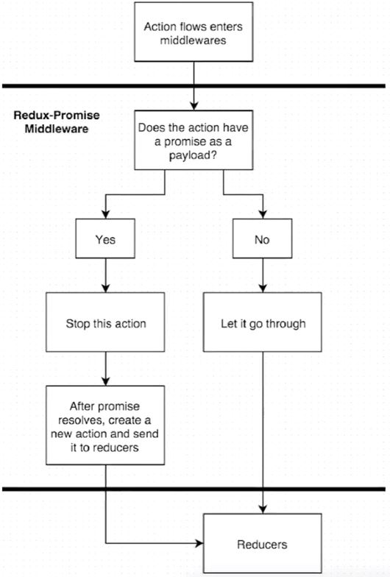
- 60. Avoiding State Mutations in Reducers9:53
- 61. Building a List Container6:53
- In app.js, import WeatherList from '../containers/weather_list';
- 62. Mapping Props to a Render Helper6:07
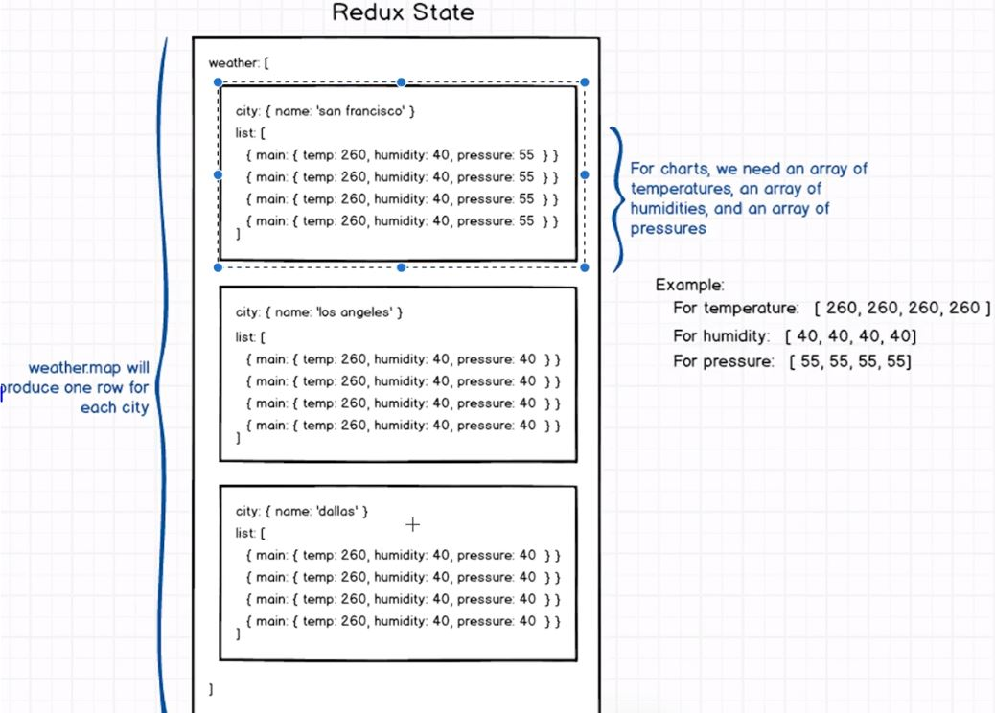
- 63. Quick Note0:00
- 64. Adding Sparkline Charts9:54
- npm i --save react-sparklines@1.6.0
- 65. Making a Reusable Chart Component6:00
- 66. Labeling of Units10:37
- 67. Google Maps Integration7:59
- 68. Google Maps Integration Continued7:16
- 69. Project Review4:59
Section: 60 / 30
React Router + Redux Form
- 70. Important Note - Do Not Skip!0:00
- 71. App Overview and Goals6:49
- 72. Exploring the Posts Api13:26
- 73. Installing React Router2:35
- 74. React Router - What is It?5:33
- 75. Setting Up React Router4:39
- 76. Route Configuration5:16
- 77. Nesting Of Routes8:02
- 78. IndexRoutes with React Router5:04
- 79. Back To Redux - Index Action5:50
- 80. Catching Data with Posts Reducer6:29
- 81. Catching Data with Posts Reducer Continued2:38
- 82. Fetching Data with Lifecycle Methods5:43
- 83. Fetching Data with Lifecycle Methods Continued6:50
- 84. Creating New Posts5:23
- 85. Navigation with the Link Component4:25
- 86. Forms and Form Submission10:12
- 87. More on Forms and Form Submission7:37
- 88. Passing Control to Redux Form7:51
- 89. CreatePost Action Creator11:21
- 90. Form Validation8:28
- 91. Form Validation Continued8:51
- 92. Navigating on Submit12:37
- 93. Posts Index4:31
- 94. Dynamic Route Params7:09
- 95. Loading Data on Render5:45
- 96. Handling Null Props5:31
- 97. Delete Action Creator7:07
- 98. Navigate on Delete2:25
- 99. ReactRouter and ReduxForm Wrapup7:02
Section: 70 / 13
Bonus - RallyCoding
- 100. Basics of Redux Thunk7:16
- 101. Combining Redux and Firebase12:16
- 102. Dynamic Forms with Redux Form14:42
- 103. Logicless Components with Reselect18:08
- 104. Data Loading Methods with Redux9:29
- 105. Animation of React Components12:33
- 106. The Best Way to Store Redux Data15:05
- 107. Four Most Common Errors with React and Redux12:02
- 108. Modals in React and Redux Apps18:43
- 109. Deployment of React/Webpack Apps23:15
- 110. BrowserHistory in Production19:46
- 111. React Integration with 3rd Party Libraries18:42
- 112. Introducing JSPlaygrounds for Rapid Prototyping12:18
Section: 80 / 2
More to Come!
- 113. Still want more React?0:00
- 114. React Source0:00
Section: 90 / 37
React Router + Redux Form
- 115. Important Note0:00
- 116. App Overview and Goals6:49
- 117. Posts API9:20
- https://reduxblog.herokuapp.com – redux blog post API Reference
- postman – arbitrary network request, chrome webstore / Postman
- 118. Quick Note0:00
- C:\react_redux\myDev\blog>npm install --save react-router-dom@4.0.0
- -npm install --save react-router@4.0.0 : wrong command(never use this one)
- 119. Installing React Router3:00
- 120. What React Router Does5:36
- Router intercept traditional clicking link on the web(User changes the URL → Request to Server
- → Server send back New HTML page to the Web page.)
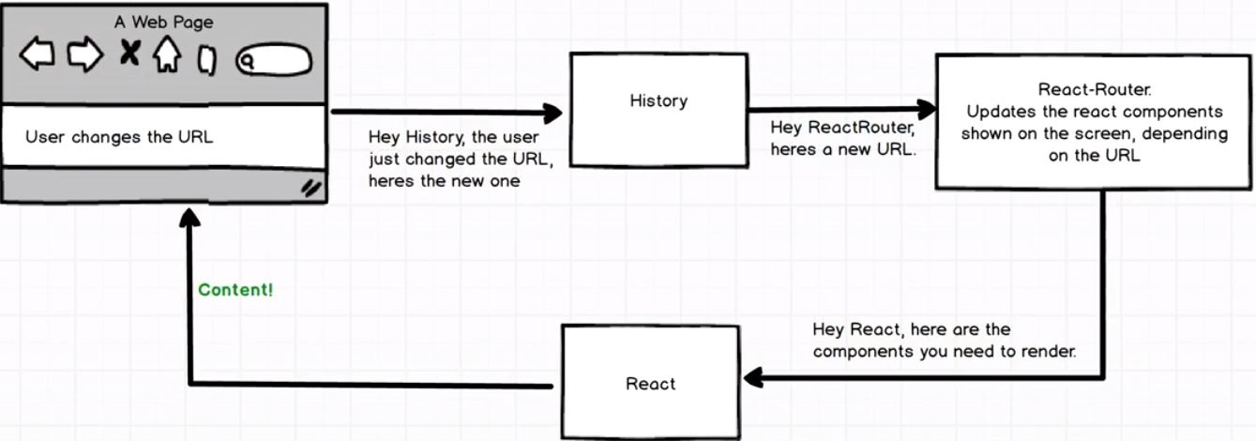
- 121. The Basics of React Router8:58
- C:\react_redux\myDev\blog>npm run start
- 122. Route Design6:31
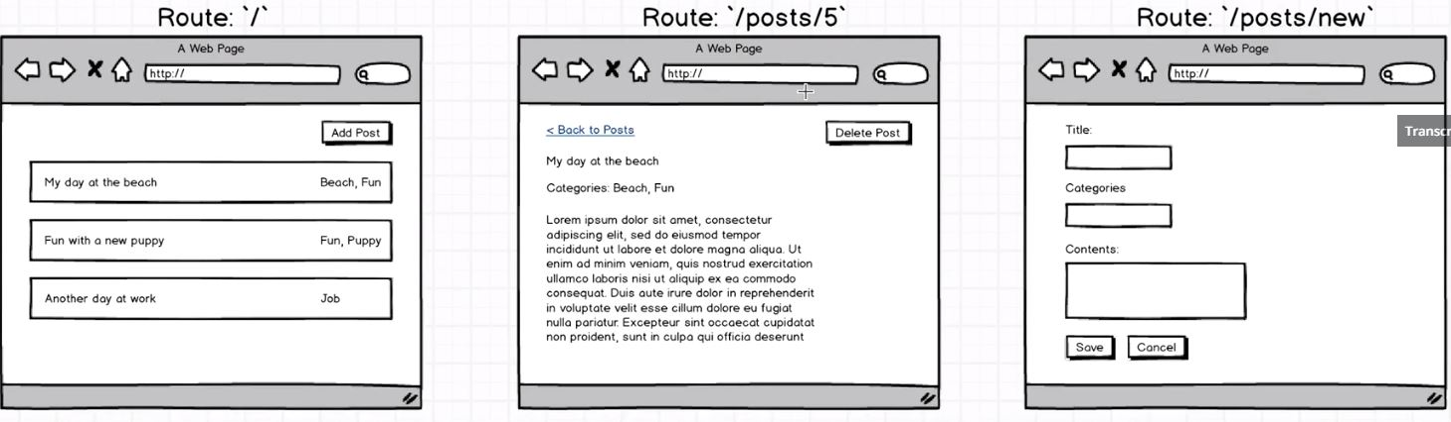

- 1.

- <Route path=”/” component={PostsIndex} />//import PostsIndex from “./components/posts_index”;
- <Route path=”/posts/:id” component={PostsShow} //import PostsShow from “./comp../posts_show”;
- <Route path=”/posts/new” component={PostsNew} //import PostsNew from “./comp../posts_new”;
- 123. Our First Route Definition5:57
- 124. State as an Object9:07 – no need to keep activePost stae , just use posts(array), then select the post that we want to show on screen.
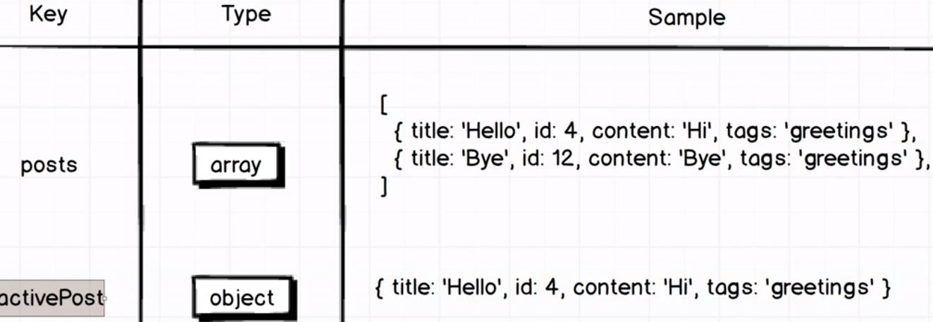
Store list of posts in Object rather than array. In Object key is id.
- 125. Back to Redux - Index Action7:07
- >npm install –save axios redux-promise
- 126. Implementing Posts Reducer10:29
- stephengrider.github.io/JSPlaygrounds/ → left panel : type javascript right : result shown.
- const posts = [
- {id: 4, title: "Hi" },
- {id: 25, title: "bye"},
- {id: 36, title: "Then"}
- ];
- posts
- _.mapKeys(posts, 'id') //array(posts), key to pull out of array('id')
→ {"4":{"id":4,"title":"Hi"},"25":{"id":25,"title":"bye"},"36":{"id":36,"title":"Then"}}
- const state =_.mapKeys(posts, 'id')
- state[4] → {"id":4,"title":"Hi"} , same with state["4"]
6
10
- 127. Action Creator Shortcuts8:06
- 128. Rendering a List of Posts9:19
- chrome Apps/ Postman/ type in POST , http://reduxblog.herokuapp.com/api/posts?key=YSPA1357 , Then Send !
- Then in localhost:8080 refresh.
- 129. Creating New Posts5:42
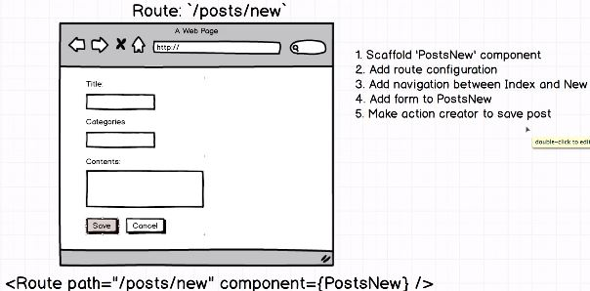
- 130. A React Router Gotcha4:44
- 131. Navigation with the Link Component5:58
- { .. Switch } from 'react-router-dom'; // Router path=”/” → always rood dir shown problem-> solved
- since first Route matched only show.
- 2. <Link > and <a class href=..> difference: <Link> no need http request from server. So
- If I remove className=”btn btn-primary” in Elements in chrome dev tool. → just like anchor tag.
- 132. Redux Form5:33
- redux-form.com // good documentation. /EXAMPLE section

Getting Started With redux-form
redux-form primarily consists of four things:
- A Redux reducer that listens to dispatched redux-form actions to maintain your form state in Redux.
- A React component decorator that wraps your entire form in a Higher Order Component (HOC) and provides functionality via props.
- A Field component to connect your individual field inputs to the Redux store.
- Various Action Creators for interacting with your forms throughout the application.

Implementation Guide

Step #1
The first thing that you have to do is to give the redux-form reducer to Redux. You will only have to do this once, no matter how many form components your app uses.

import { createStore, combineReducers } from 'redux'
import { reducer as formReducer } from 'redux-form'

const reducers = {
// ... your other reducers here ...
form: formReducer // <---- Mounted at 'form'
}
const reducer = combineReducers(reducers)
const store = createStore(reducer)
Note that, by default, the key used to pass the redux-form reducer to combineReducers should be named form. Although there is support for custom key names, see getFormState config for more details.

Step #2
Decorate your form component with reduxForm(). This will provide your component with props that provide information about form state and functions to submit your form.
Each input component must be placed inside the component prop of a Field component. The Field component will pass props such as value, onChange, onBlur, etc. to the React.DOM.input component to populate its value and listen for changes.

import React, { Component } from 'react';
import { Field, reduxForm } from 'redux-form';

class ContactForm extends Component {
render() {
const { handleSubmit } = this.props;
return (
<form onSubmit={handleSubmit}>
<div>
<label htmlFor="firstName">First Name</label>
<Field name="firstName" component="input" type="text"/>
</div>
<div>
<label htmlFor="lastName">Last Name</label>
<Field name="lastName" component="input" type="text"/>
</div>
<div>
<label htmlFor="email">Email</label>
<Field name="email" component="input" type="email"/>
</div>
<button type="submit">Submit</button>
</form>
);
}
}

// Decorate the form component
ContactForm = reduxForm({
form: 'contact' // a unique name for this form
})(ContactForm);

export default ContactForm;

You're done!
Well, almost. You will still need to:
- Do something with the data that has been submitted. It will be passed as JSON to your onSubmit function.

import ContactForm from './ContactForm';
class ContactPage extends React.Component {
submit = (values) => {
// Do something with the form values
console.log(values);
}
render() {
return (
<ContactForm onSubmit={this.submit} />
);
}
}
- Potentially set the form values initially, with the initialValues prop.

- C:\react_redux\myDev\blog>npm install –save redux-form@6.6.3
- 133. Setting Up Redux Form9:27 * REDUX-FORM : What does it do ?
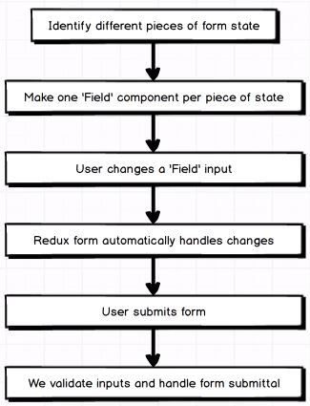
- 134. The Field Component10:49
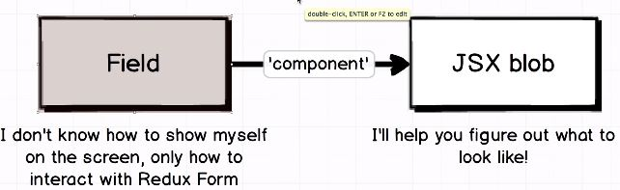
- 135. Generalizing Fields8:54
- formatting for nice looking.
- 136. Validating Forms10:31
- redux-form automatically validating input
- 137. Showing Errors to Users4:30
- 138. Handling Form Submittal9:30
- 139. Form and Field States6:06 : 3 states asf.
- 1)pristine : no user access this site, 2)touched: selected or focused input, focus out of input (User done some on fields, considered it completed !) 3) invalid: error msg invoked.
- 140. Conditional Styling7:06
- built-in css that is nice with Red outline.
- 1)Instead of className=”form-group”, use <div className=”form-group has-danger”>
- 2) <div className="text-help"> //Error being red
- { field.meta.touched ? field.meta.error : ''}
- </div>
3-1)const { meta } = field → { meta : meta } = field , so field.meta(key) = meta(value), So
We can change field.meta.touched → meta.touched ..
3-2) const {meta: {touched, error}} =field; So, meta.touched → touched, meta.error → error.
Since {meta : {touched(key):touched(value), error:error}} =field; → field.meta.touched(key)= touched(value)

- 141. More on Navigation3:11
- 1) Cancel button → Elements, a.btn.btn-danger/ Style/ element.style { : ; click !!! and type in margine-left : 5 px , which move Cancel button to right 10px..
- 2) add CSS w/ above effects to the project : css.js
- form a { margin-left: 5px; }
- 142. Create Post Action Creator10:05
- 143. Navigation Through Callbacks7:31
- Program based navigating, which is different from <Link > from router.(user click-> then navigate)
- 144. The Posts Show Component3:39
- 145. Receiving New Posts9:26
- return {...state, [action.payload.data.id]:action.payload.data};// fetch additional post and add them
- // into the overall state object.
- 146. Selecting from OwnProps11:27
- posts_show componentDidMount() { this.props.match.params.id; ..}//To access url w/ token inside url.-> match : objects that listed all different wild token(:id :commentId) existed inside url such as index.js <route path=”/posts/:id/:commentId” component={PostsShow} />
- 147. Data Dependencies5:32
- * <Route path="/posts/:id" component={PostsShow} /> *
- * * 0:{id: 230129, title: "new test", categories: "new", content: "new"}
- * http://localhost:8080/posts/230129 , → Error: Cannot read property 'title' of undefined !
- → const { post } = this.props; if (!post) { return <div>Loading...</div>; } //When we want access properties and elements of which record doesn't exist, //make sure access data, actually exists.
- 148. Caching Records6:13
- delete , navigation tag create
- 1) in posts_index.js,
- renderPost() {
- return (
- <li calssName=”list-group-item” key={post.id}>
- <Link>
- {post.title}
- </li>
- 149. Deleting a Post9:25
- 150. Wrapup9:10
- 151. Bonus!0:0

